

**Department of Computer Science**

**HITEC University, Taxila**

**BS Computer Science Program**

**(Batch 2022)**

**CS-206 Computer Organization & Assembly language 4(3+1)**

**Lab Folder**

**SPRING 2024**

**Instructor: Fatima Rauf**

**Submitted By:**

**Abdul Ahad (22-CS-071)**

**Lab Report # 6**

**Task 1:**

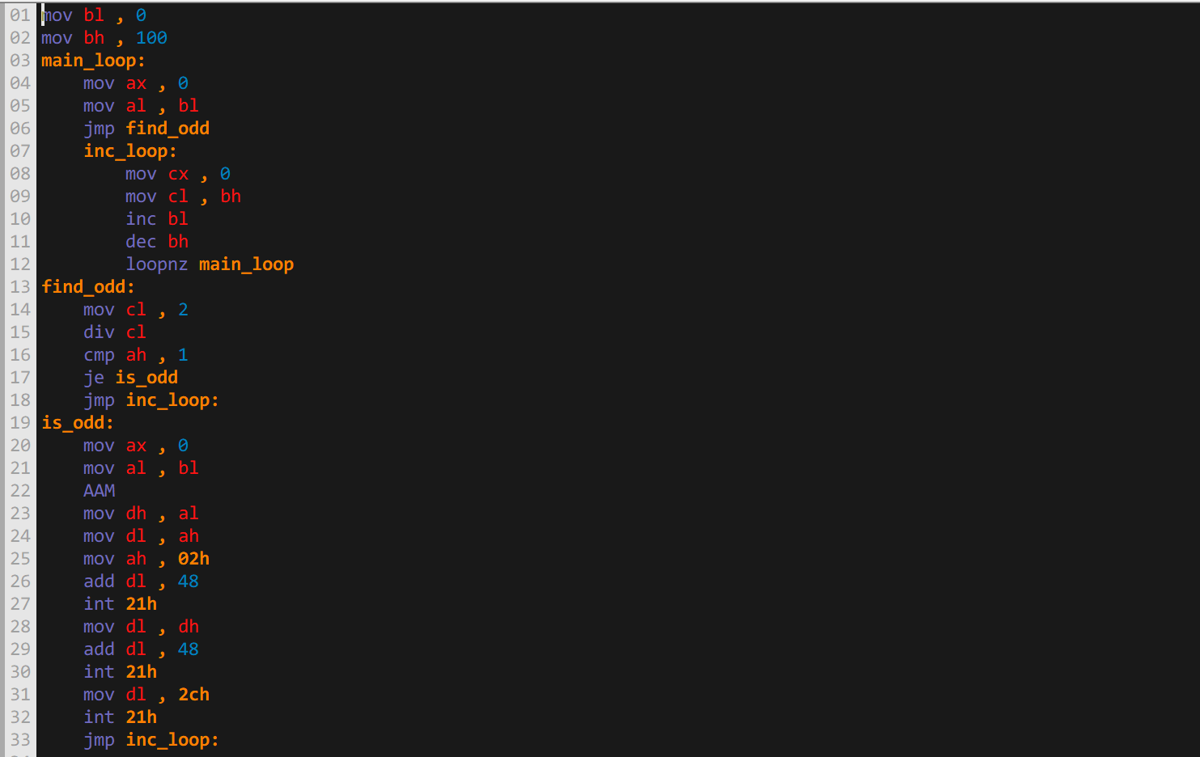

**Explanation:** The task was accomplished utilizing the loops, labels, compare statement and jump statement to print the odd number ranging between 1 to 100.

**Output:  
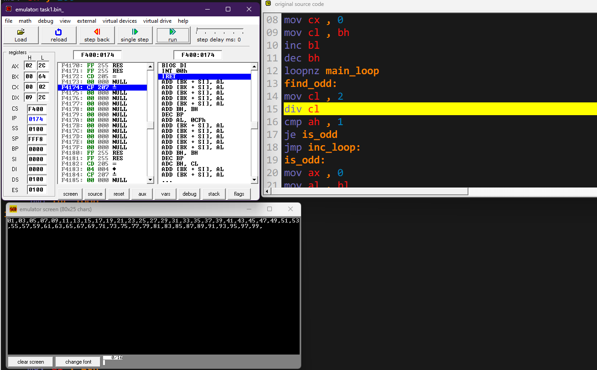**

**Task 2:**

**Code 1:**

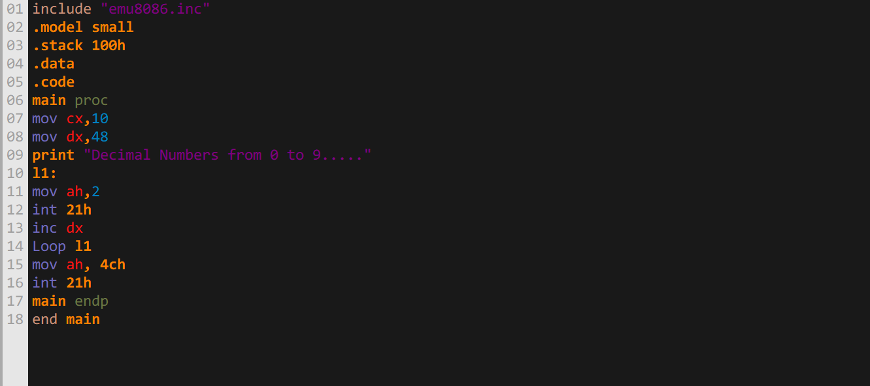

**Output 1:**

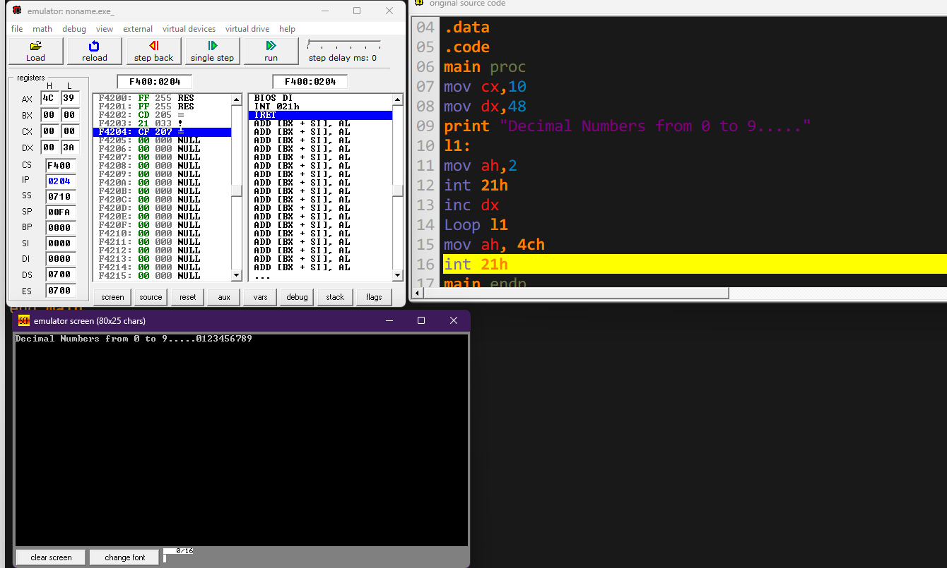

**Code 2:**

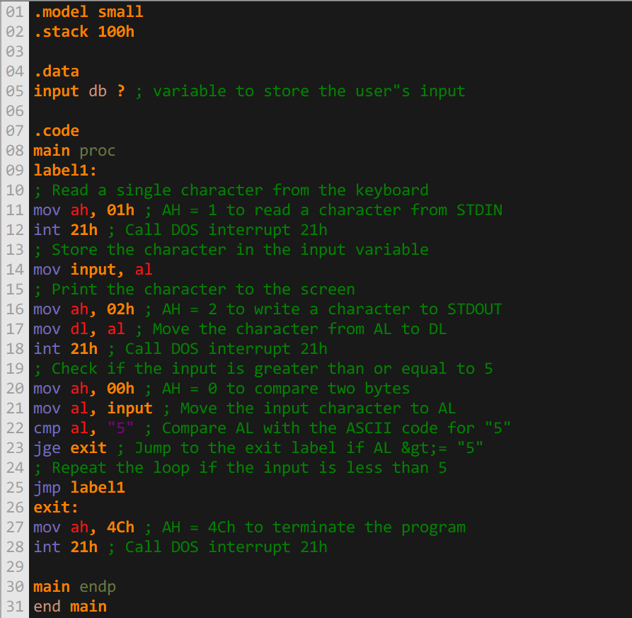

**Output 2:**

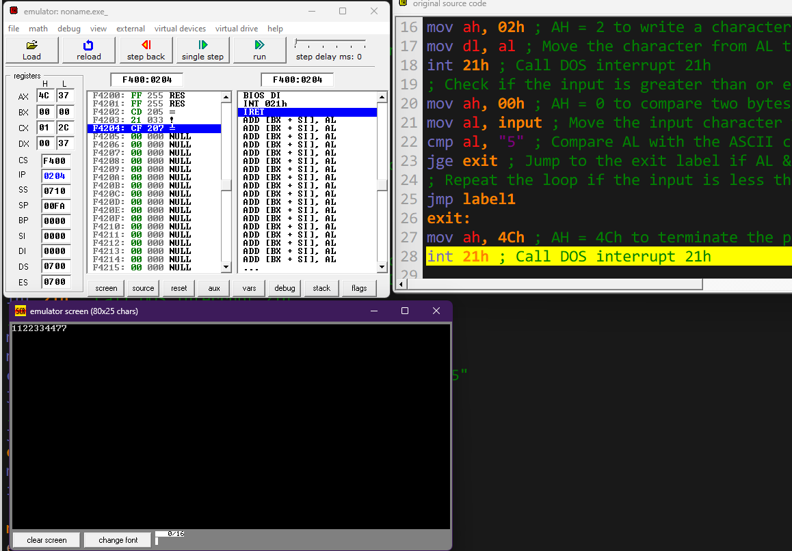

**Code 3:**

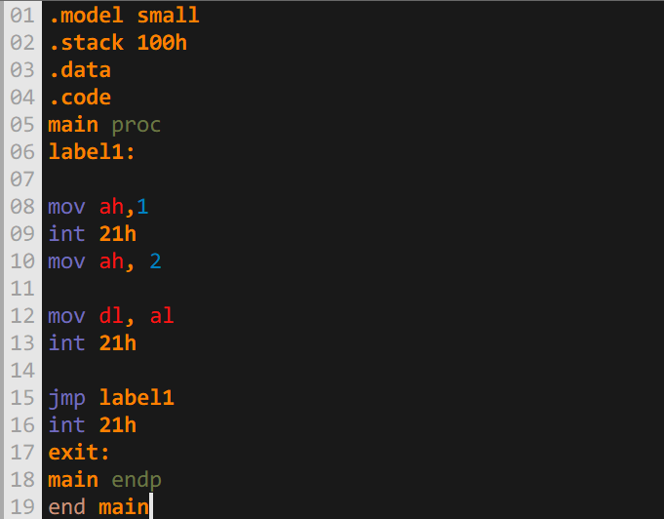

**Output 3:**

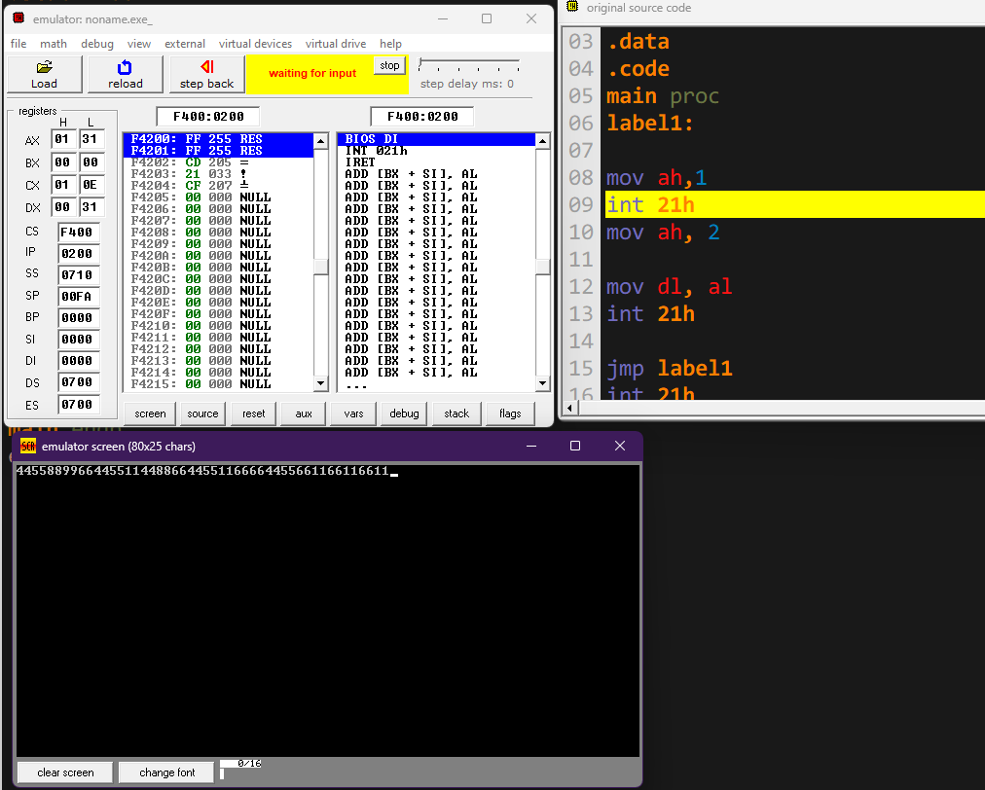

**Code 4:**

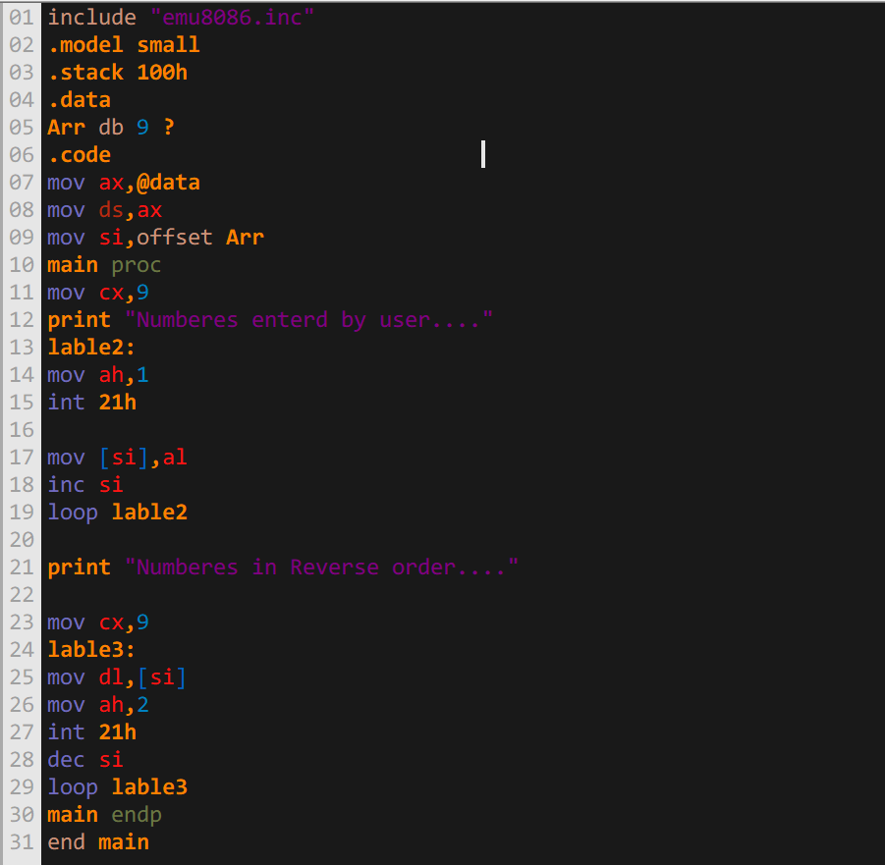

**Output 4:**

