

**Department of Computer Science**

**HITEC University, Taxila**

**BS Computer Science Program**

**(Batch 2022)**

**CS-206 Computer Organization & Assembly language 4(3+1)**

**Lab Folder**

**SPRING 2024**

**Instructor: Fatima Rauf**

**Submitted By:**

**Abdul Ahad (22-CS-071)**

**Lab Report # 7**

**Task 1:** Write a Procedure which when called, prints time on Console.

**Explanation:** we utilized the inbuild interrupts of the emu 8086 to perform the task. The interrupt calls with **2ah** and **2ch** allows us to collect the current date and time of the system.

**Code:**

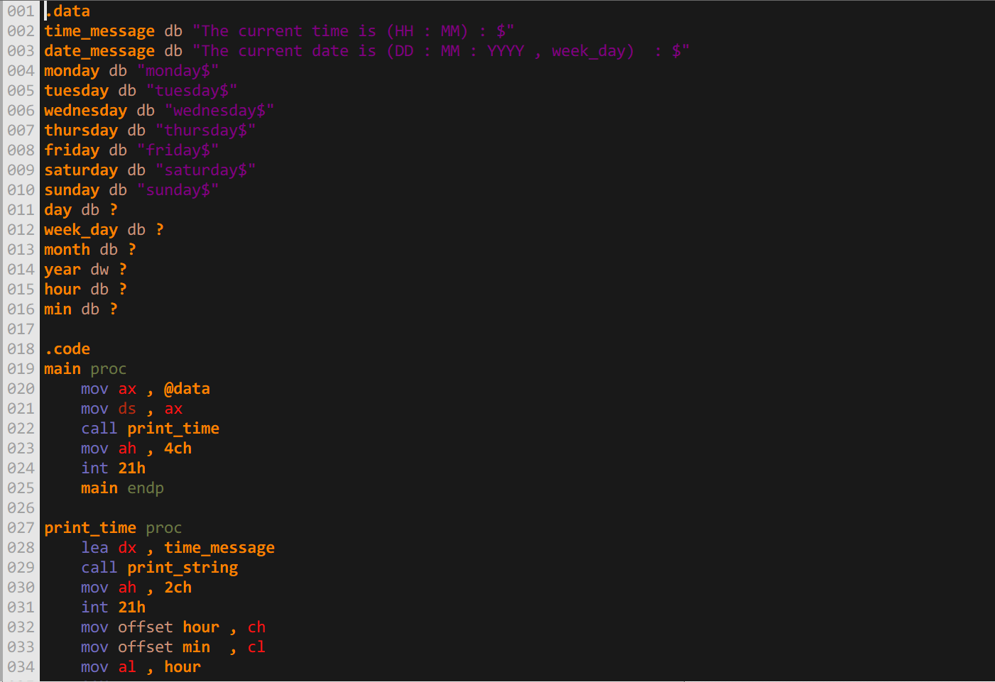

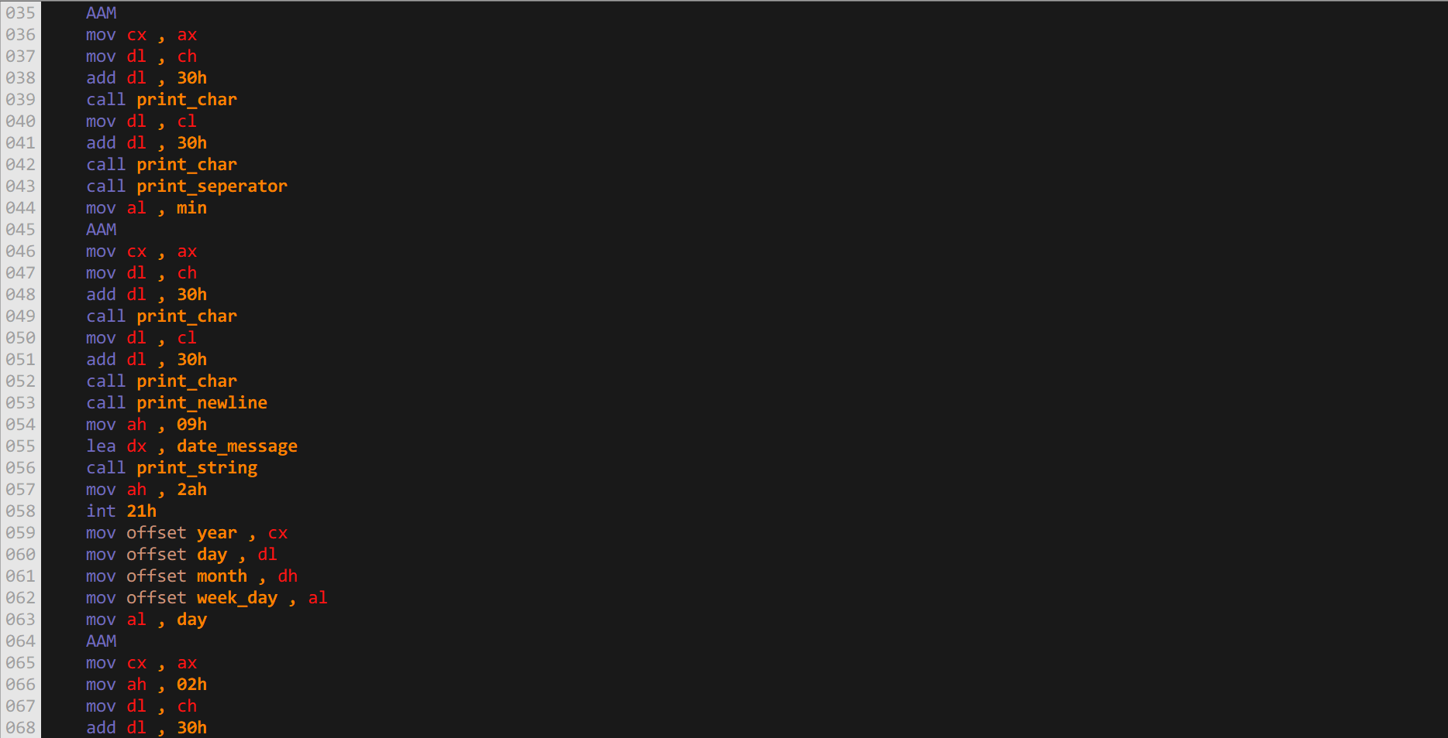

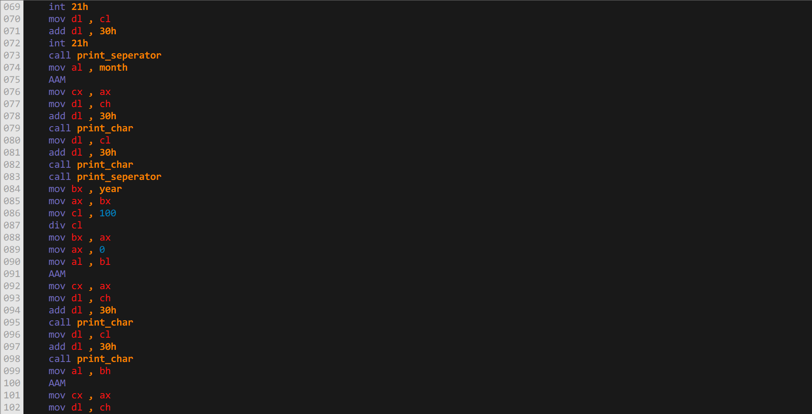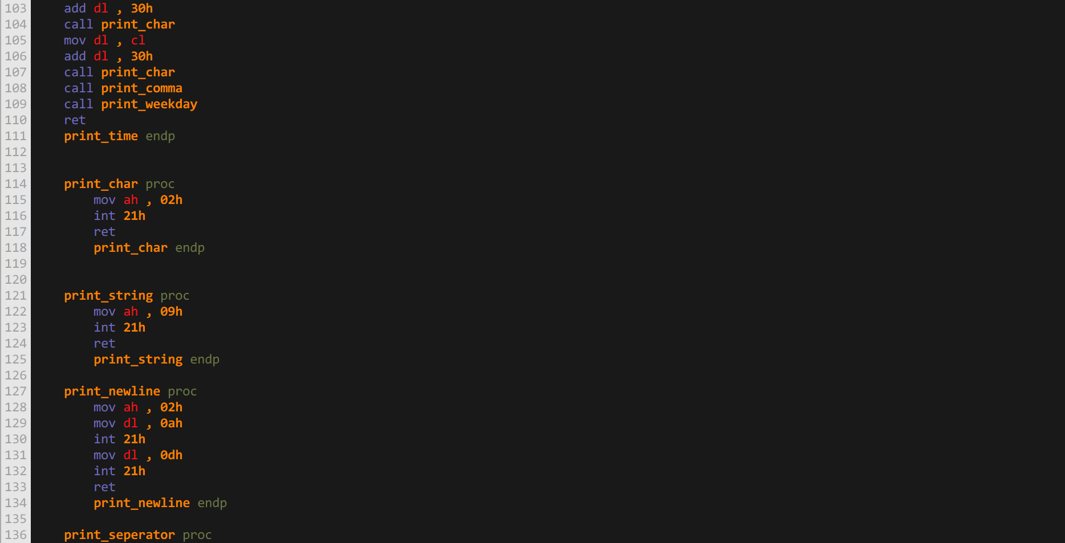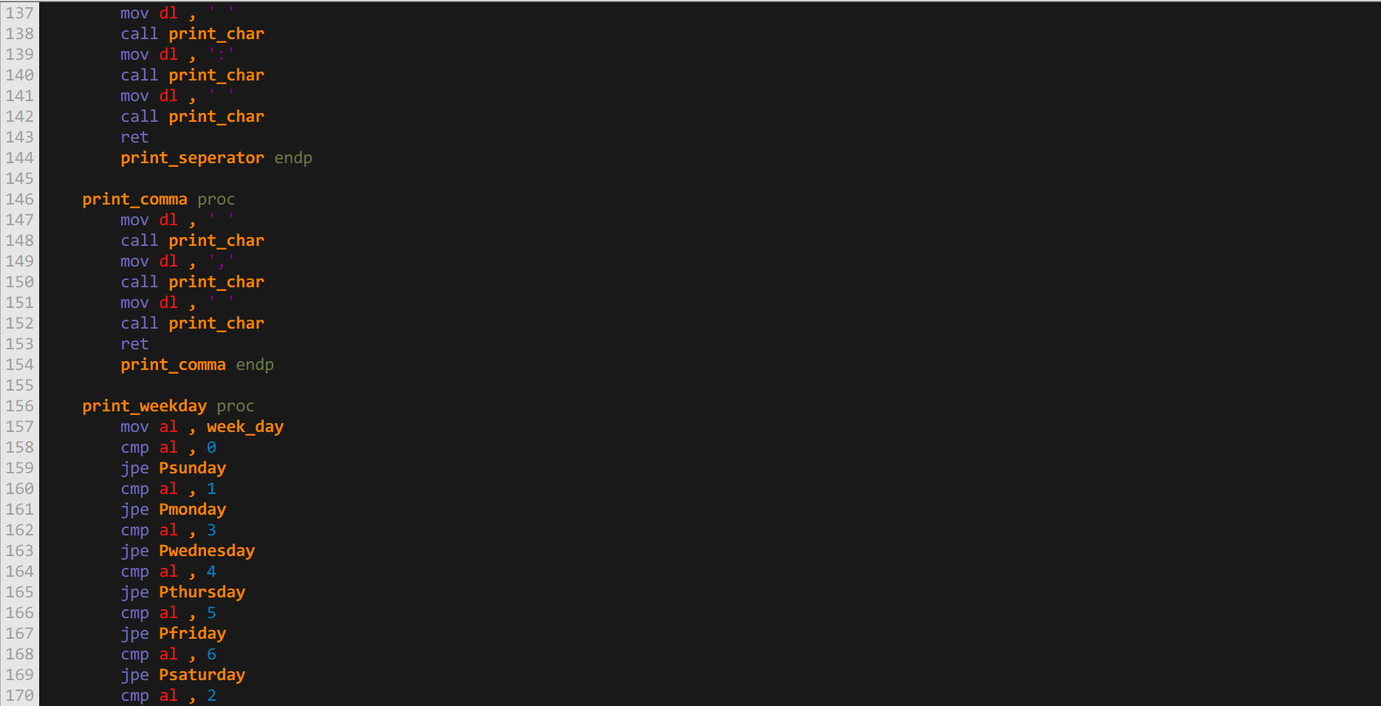

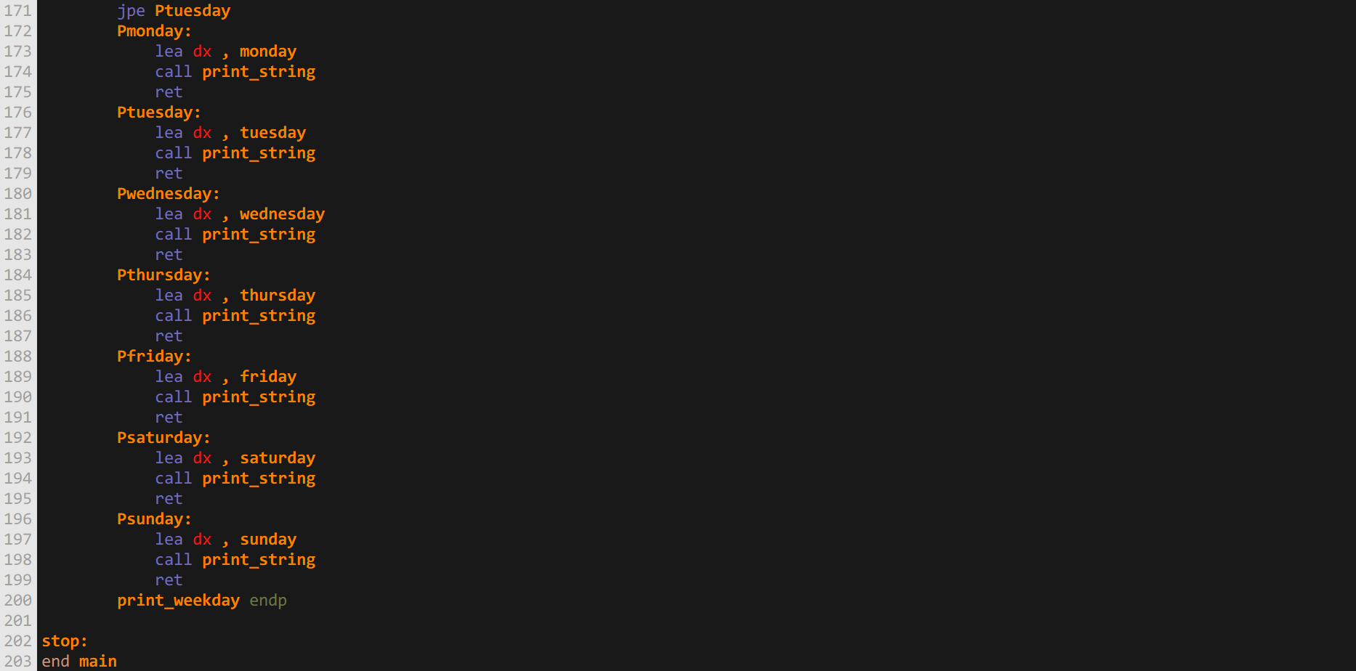

**Output:**

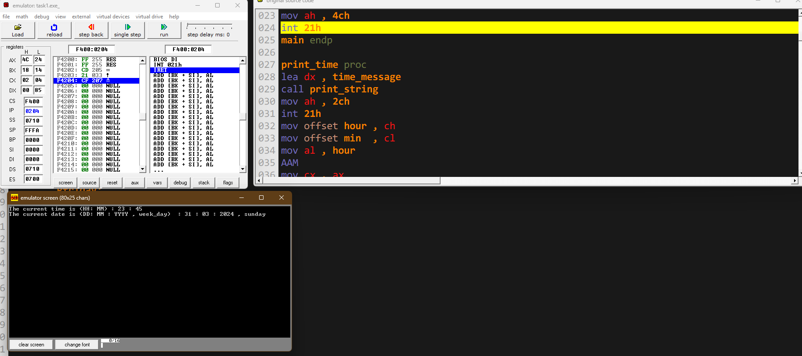

**Task 2:** Write a Procedure which takes 5 numbers as argument. Calculate sum of numbers and return the sum. Prints the sum in main procedure. You have to use Stack for Passing and Retrieving Arguments.

**Explanation:** To accomplish this task we utilized the stack mor our memory purpose to store and retrieve data.

**Code:**

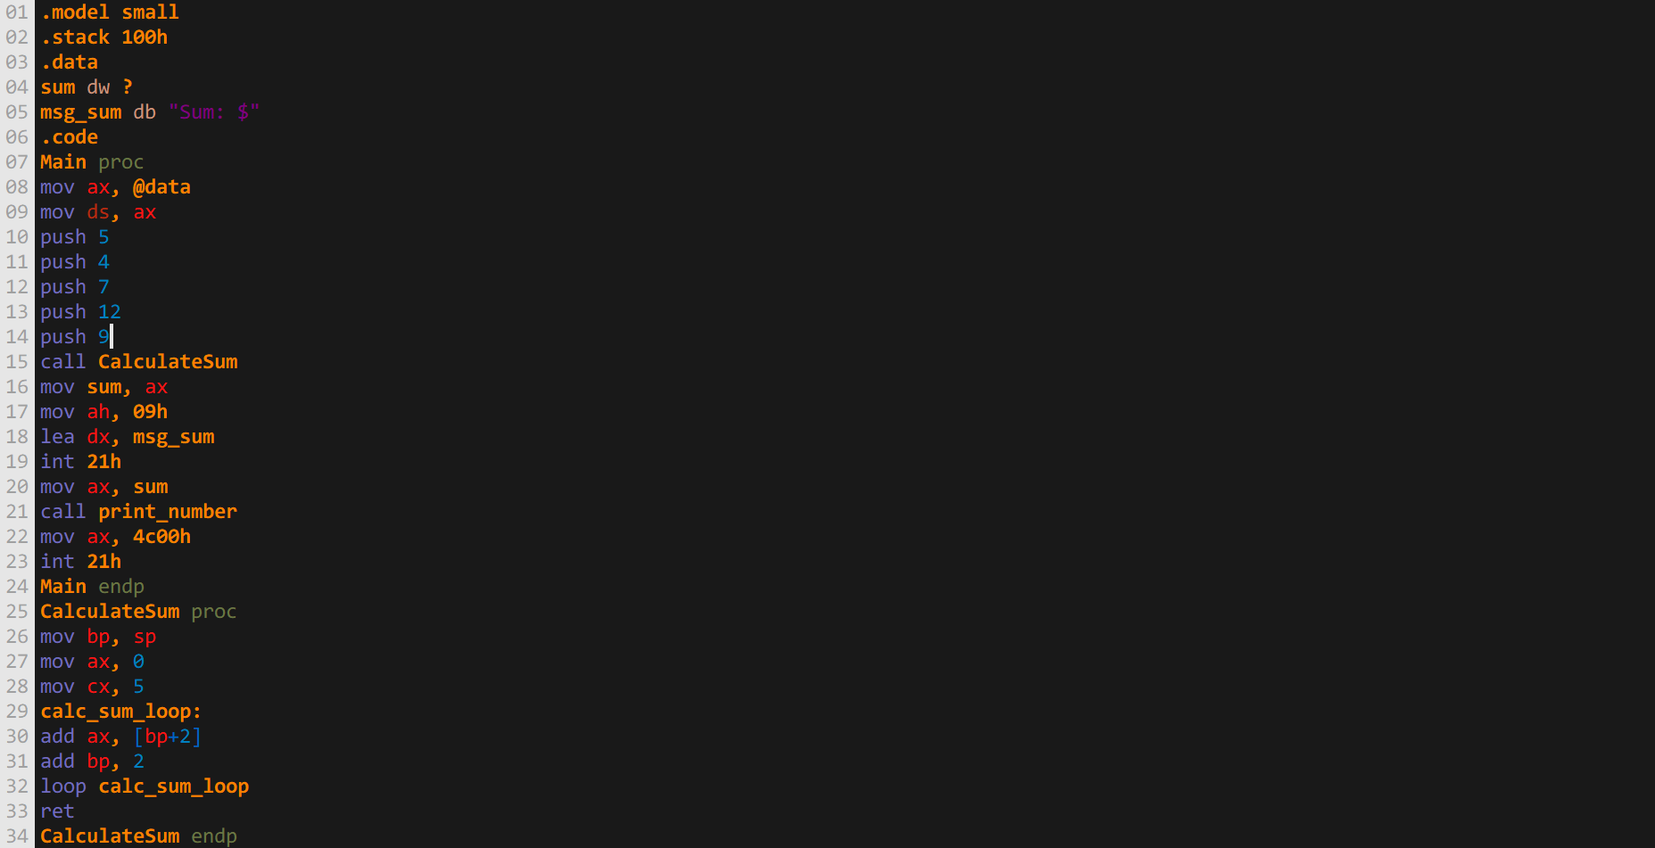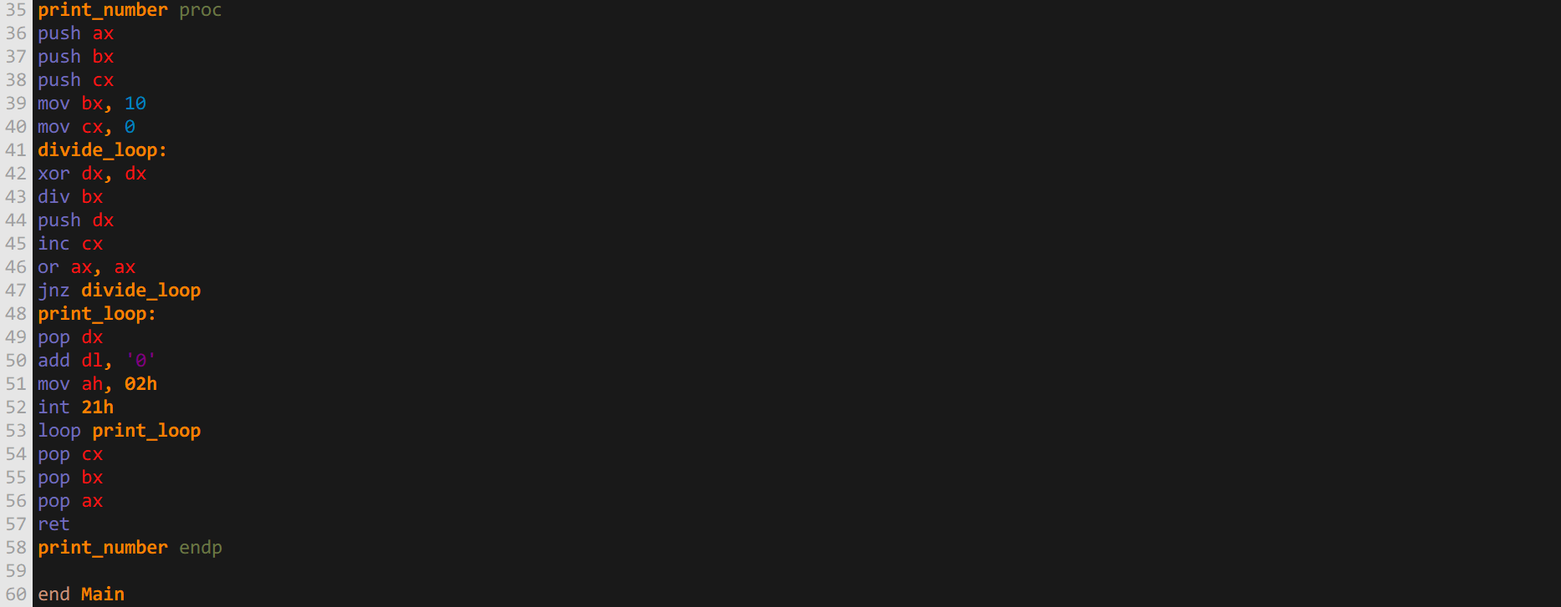

**Output:**

