

**Department of Computer Science**

**HITEC University, Taxila**

**BS Computer Science Program**

**(Batch 2022)**

**CS-206 Computer Organization & Assembly language 4(3+1)**

**Lab Folder**

**SPRING 2024**

**Instructor: Fatima Rauf**

**Submitted By:**

**Abdul Ahad (22-CS-071)**

**Lab Report # 8**

**Task 1:** To input a string at prompt, and display in reverse order.

**Answer:** We use the **STACK** type to perform the task as stack us **LIFO (Last in First Out)**

**Code:**

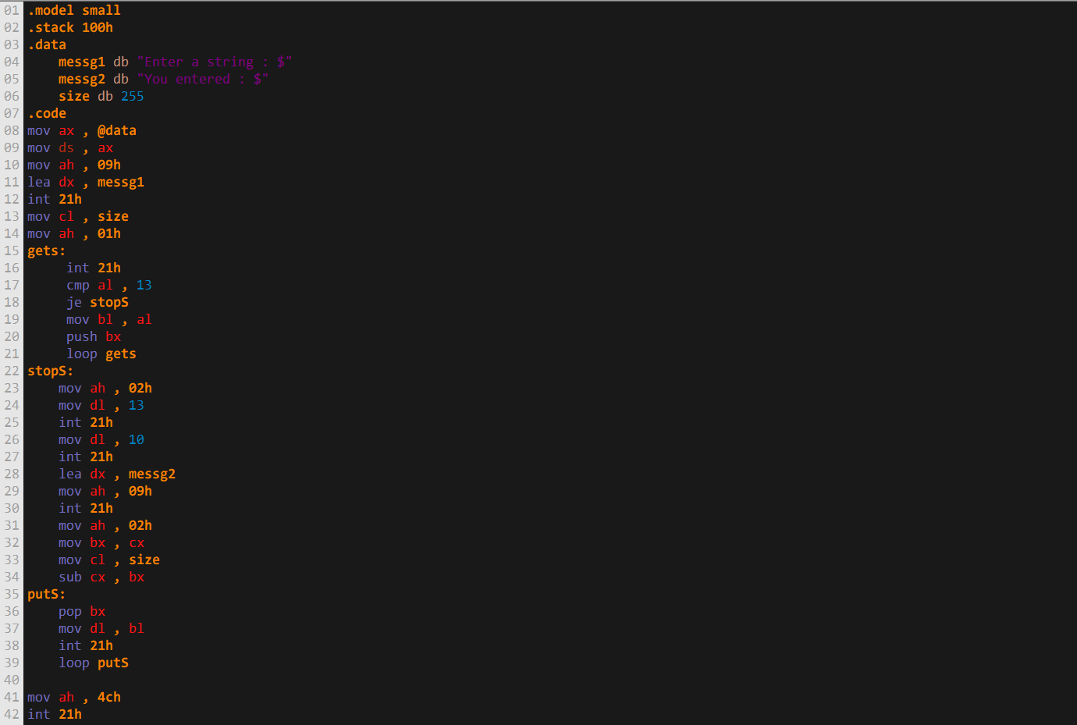

**Output:**

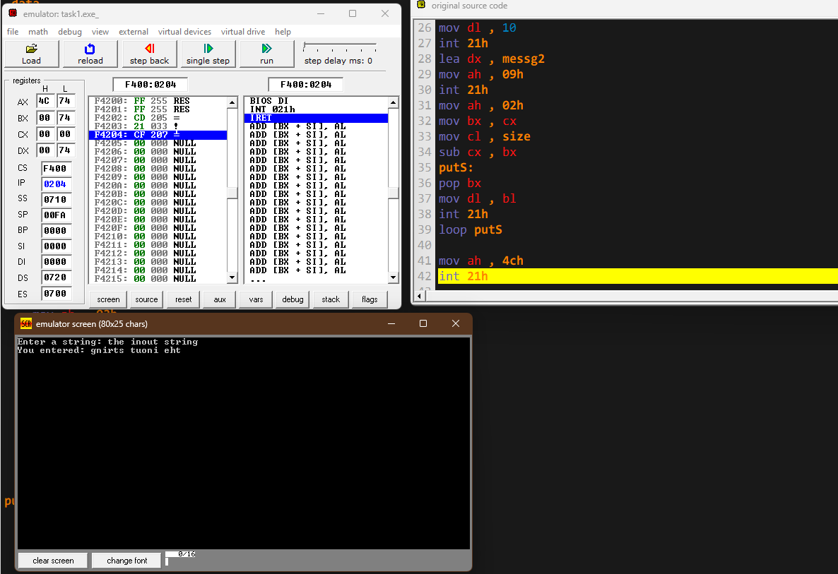

**Task 2:** Write a code that searches **“a”** in an input string

**Answer:** We use loop to get continuous input from the user until the user presses the Return/Enter key, while taking input we also compare if it is an “a” or not and adjust the counter as such

**Code:**

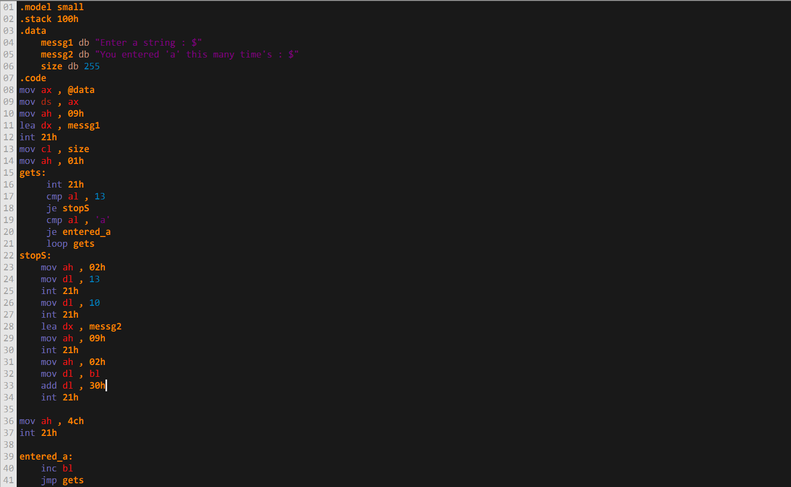

**Output:**

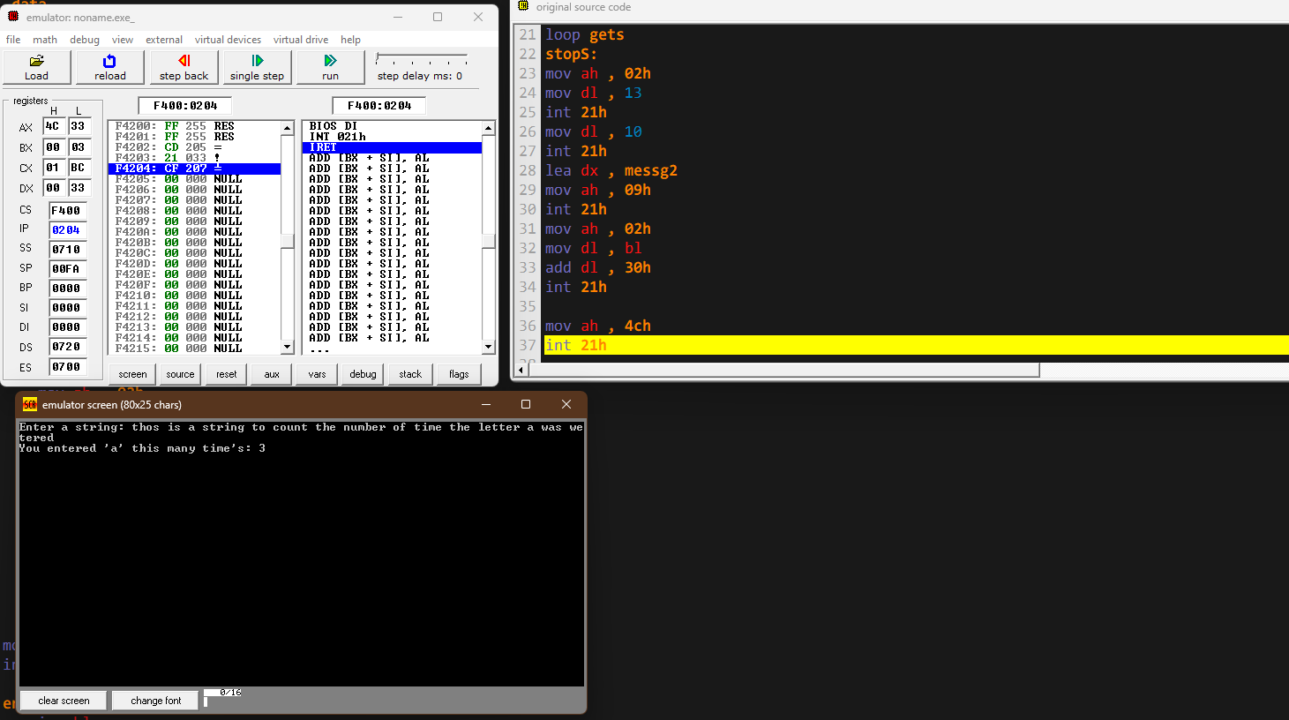

**Home Activity 1:** Perform the multiplication on two numbers. Display Proper messages to user.

**Code:**

**Output:**

**Home Activity 2:** Perform addition on two numbers. The result can either be of single digit or more.

**Code:**

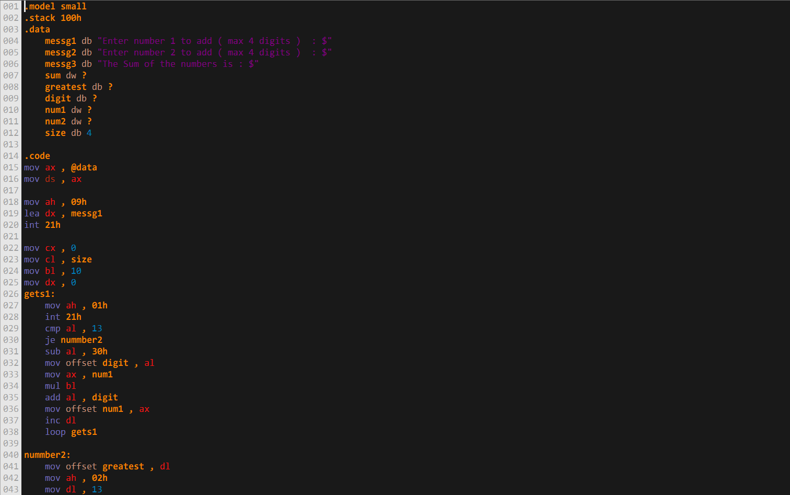

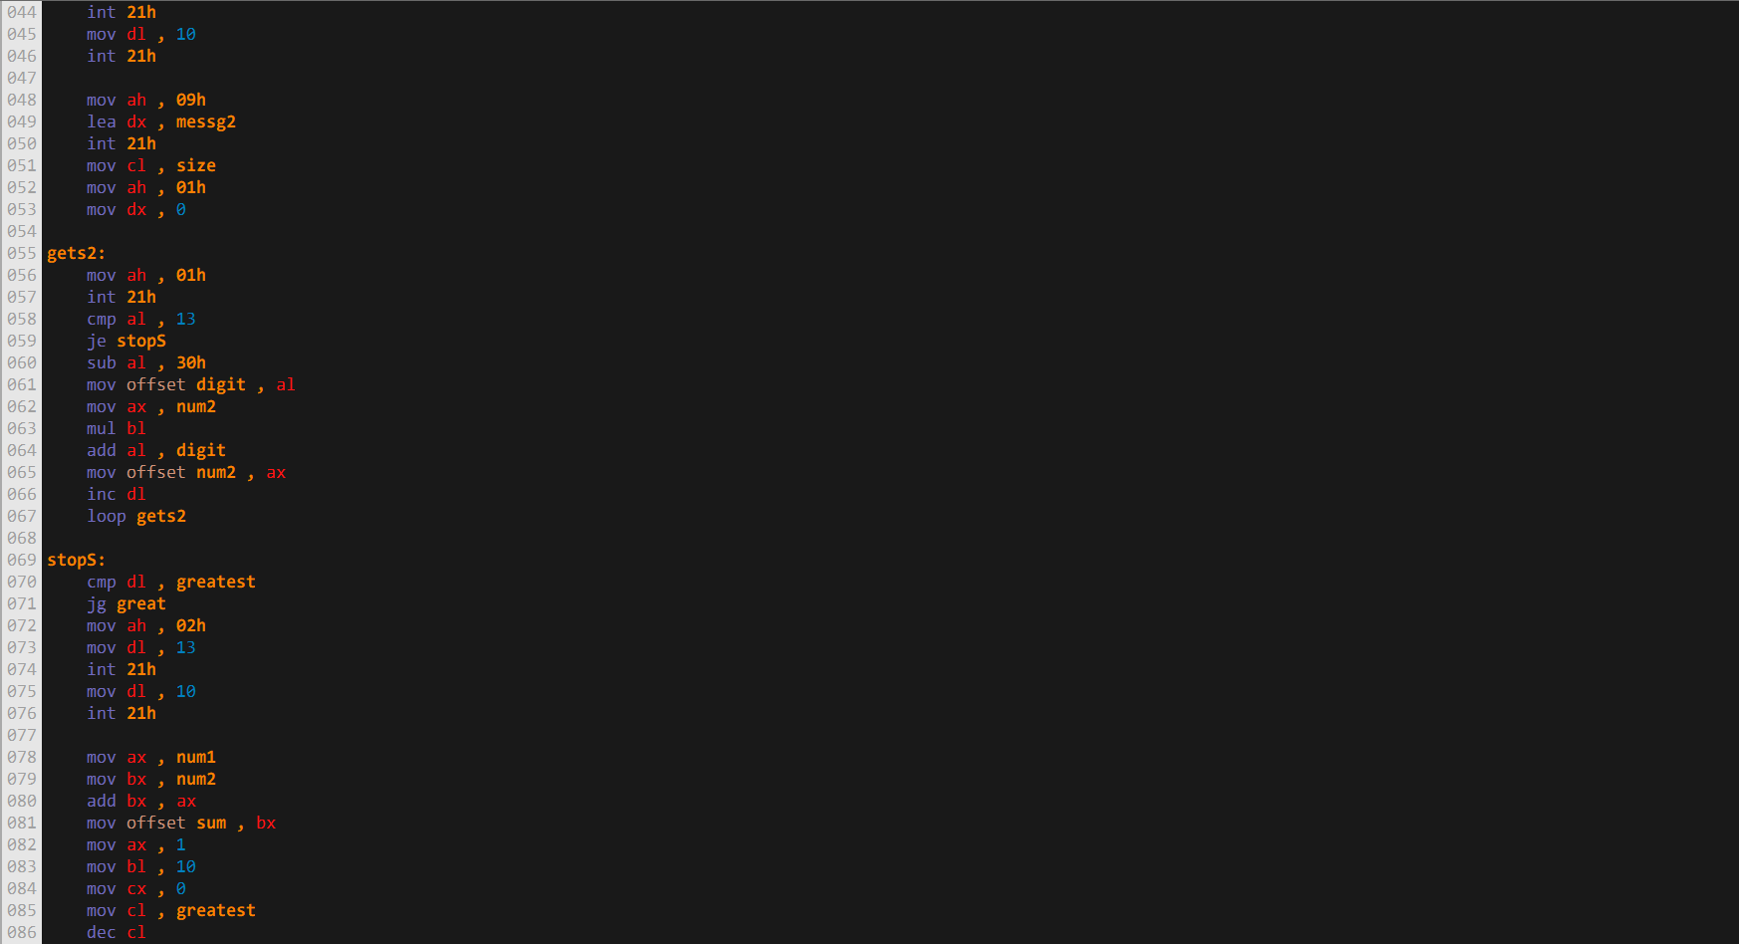

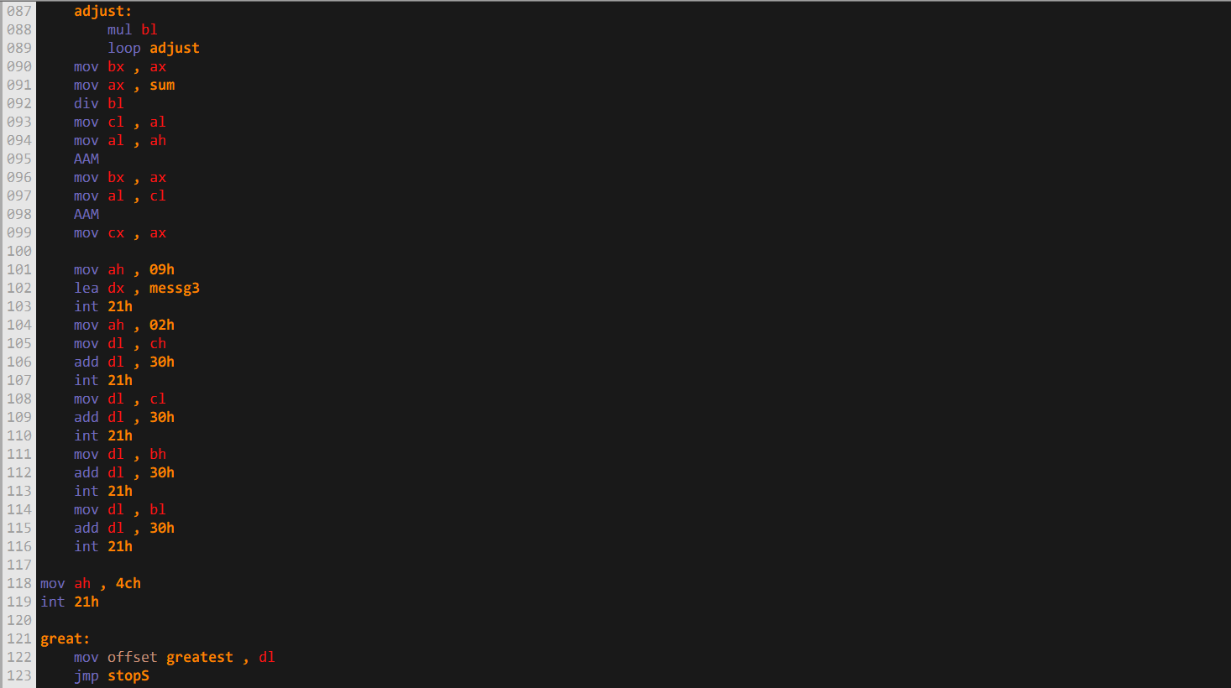

**Output:**

