

**Department of Computer Science**

**HITEC University, Taxila**

**BS Computer Science Program**

**(Batch 2022)**

**CS-206 Computer Organization & Assembly language 4(3+1)**

**Lab Folder**

**SPRING 2024**

**Instructor: Fatima Rauf**

**Submitted By:**

**Abdul Ahad (22-CS-071)**

**Lab Report # 9**

**Task 1:** Write a program that compares two strings to check if they are equal using assembly language instructions.

**Code:**

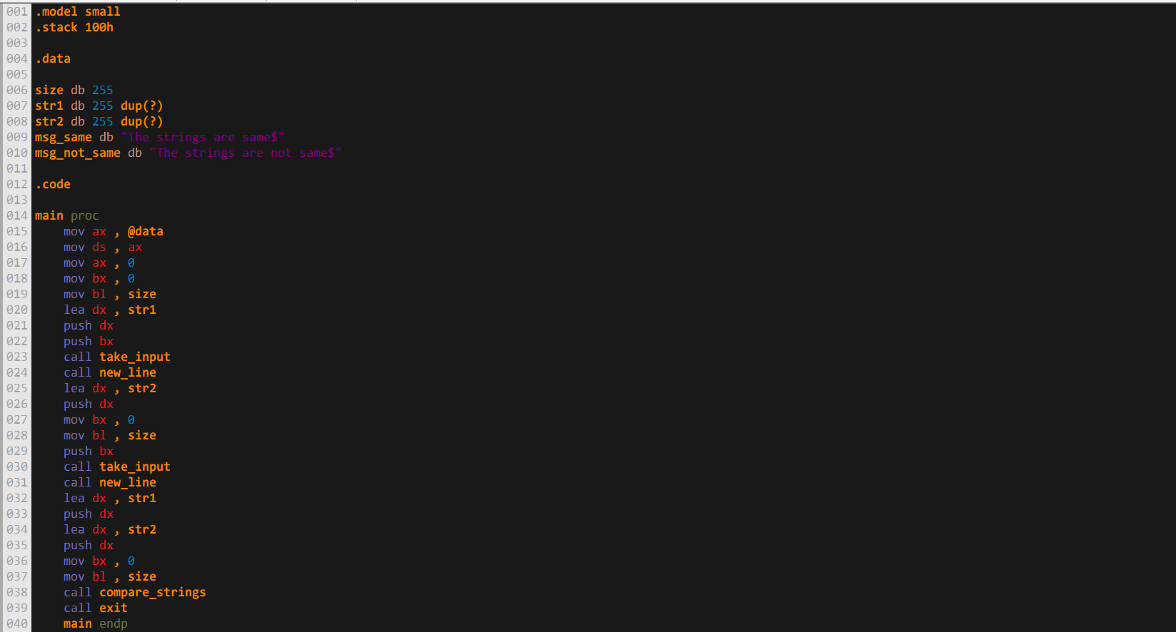

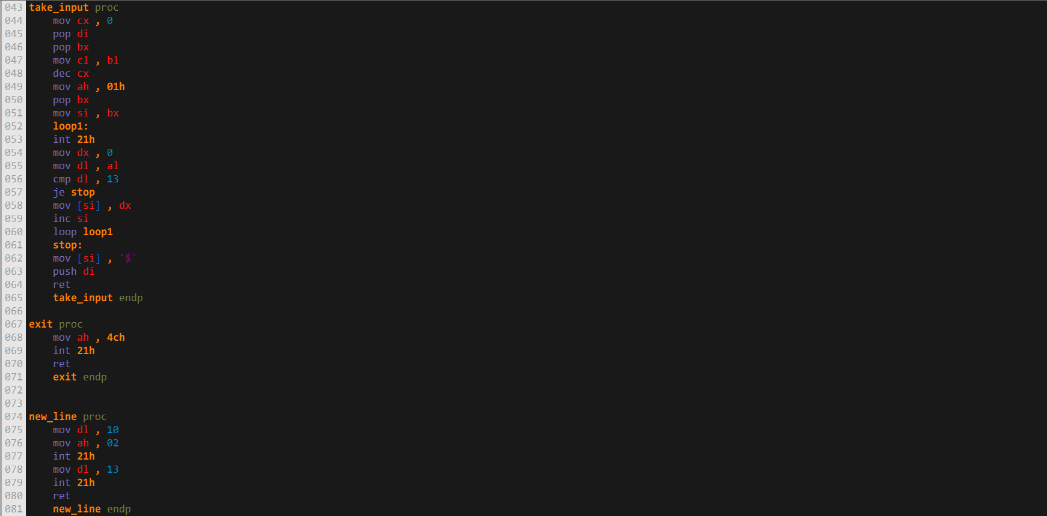

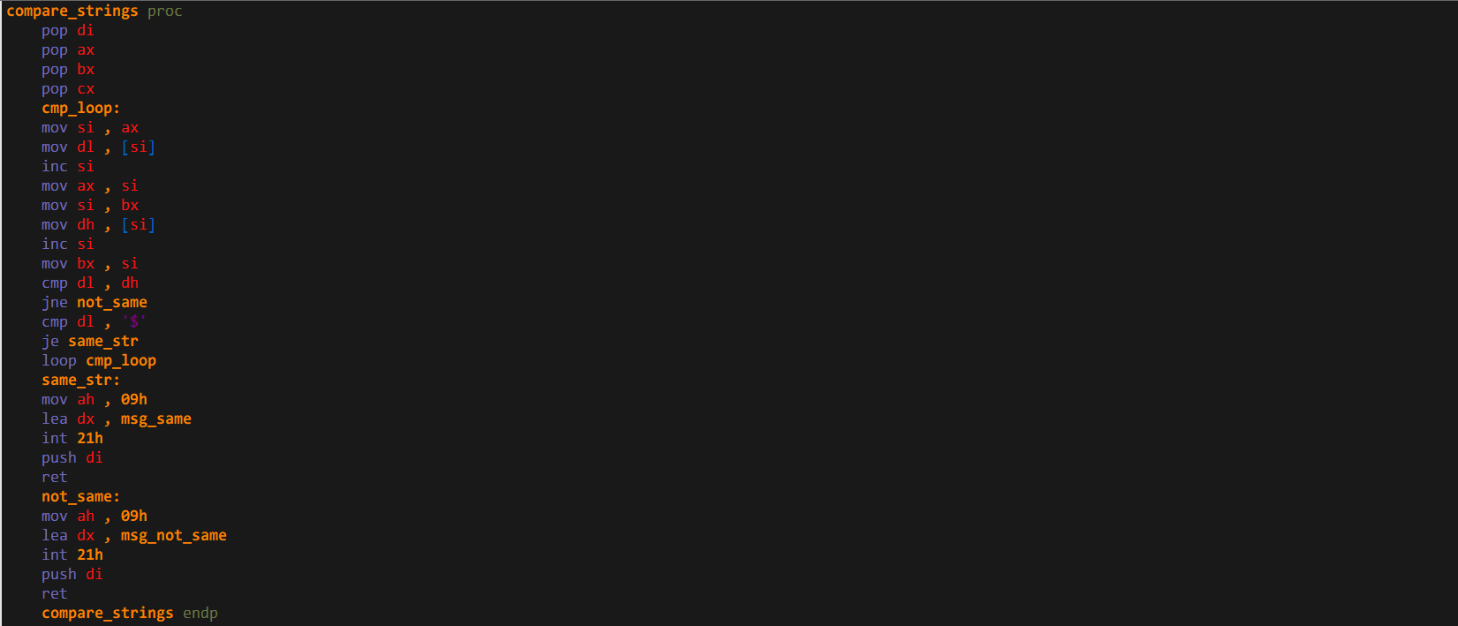

**Output:**

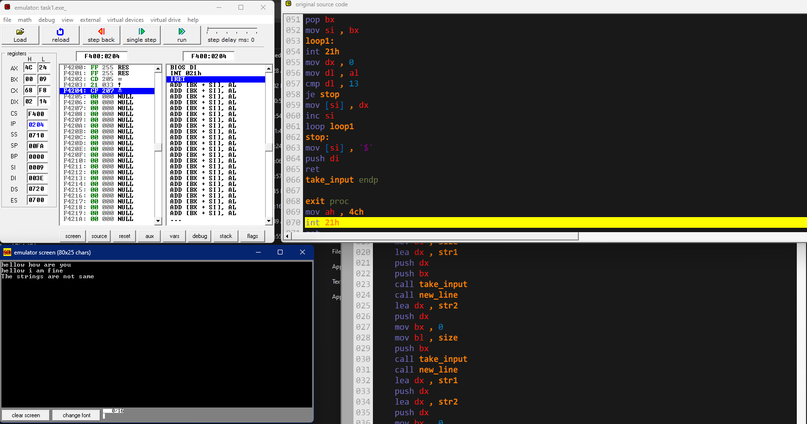

**Task 2:** Write a program that concatenates two strings (appends one string to another) using assembly language instructions.

**Code:**

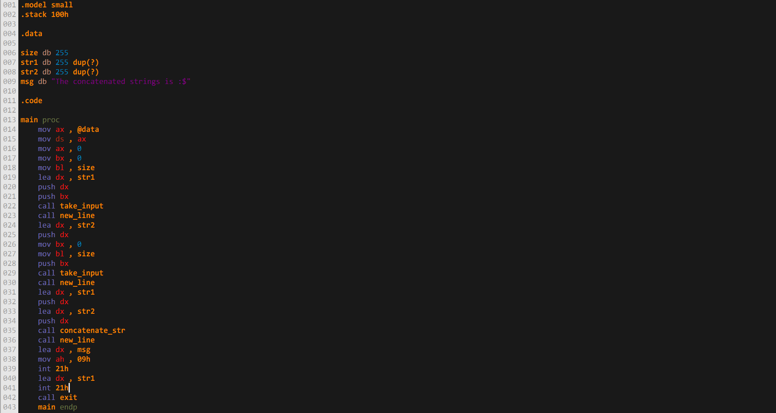

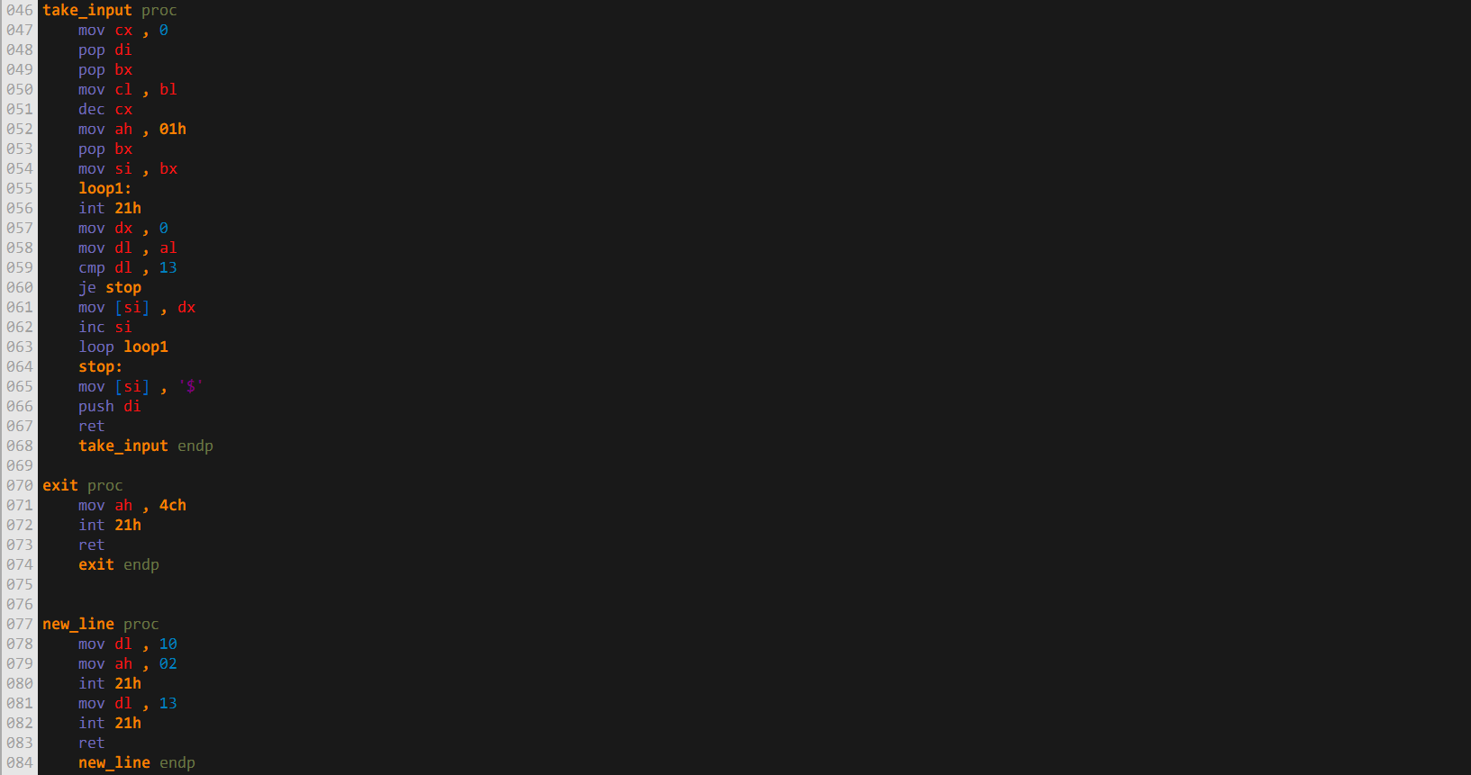

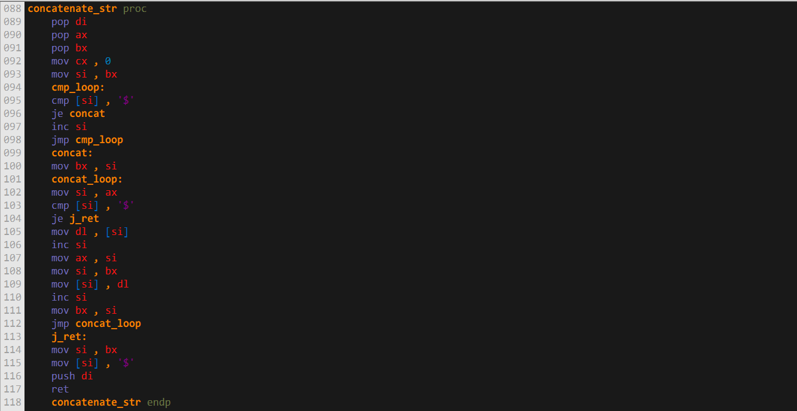

**Output:**

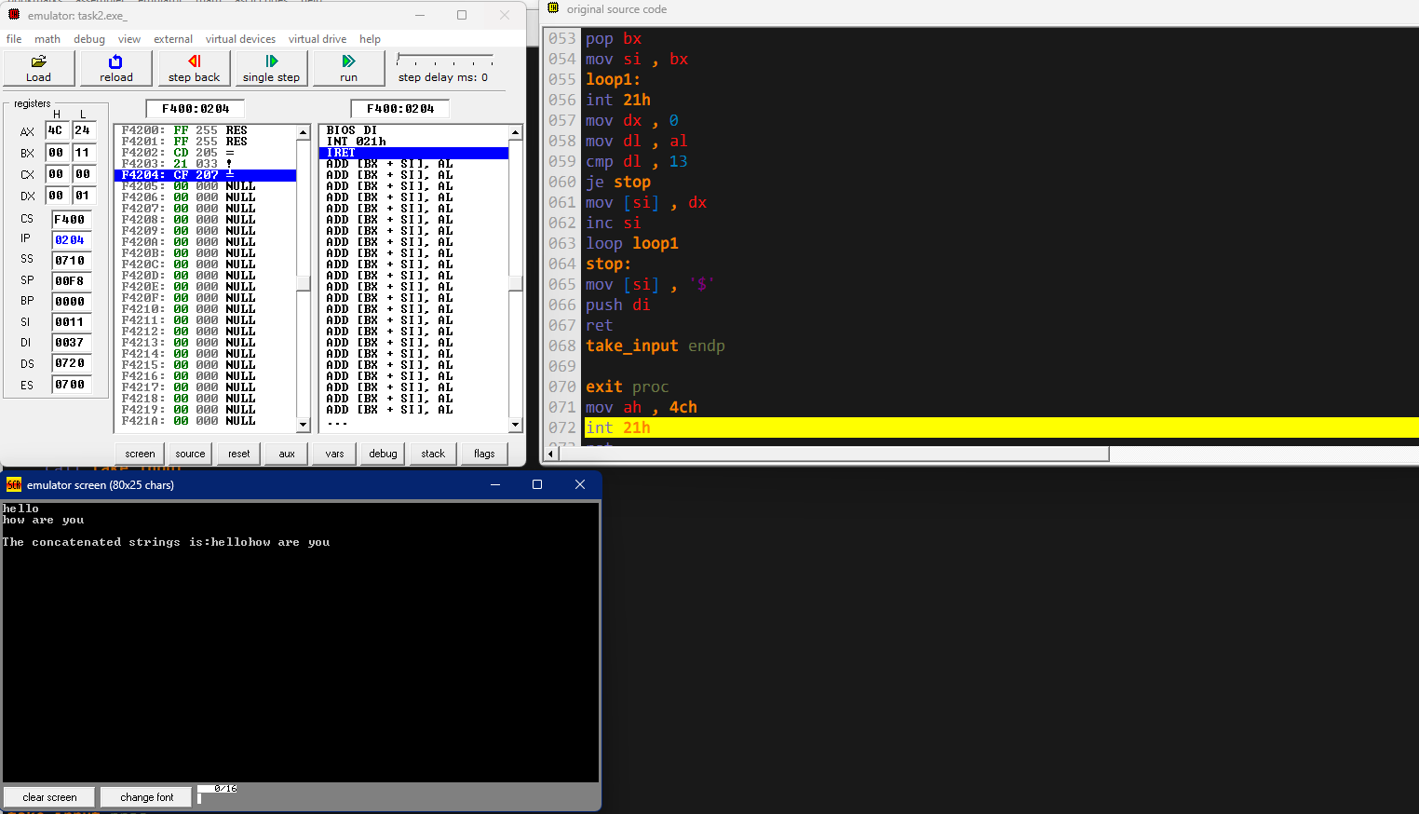

**Task 3:** Write a program that copies one string to another using assembly language

instructions.

**Code:**

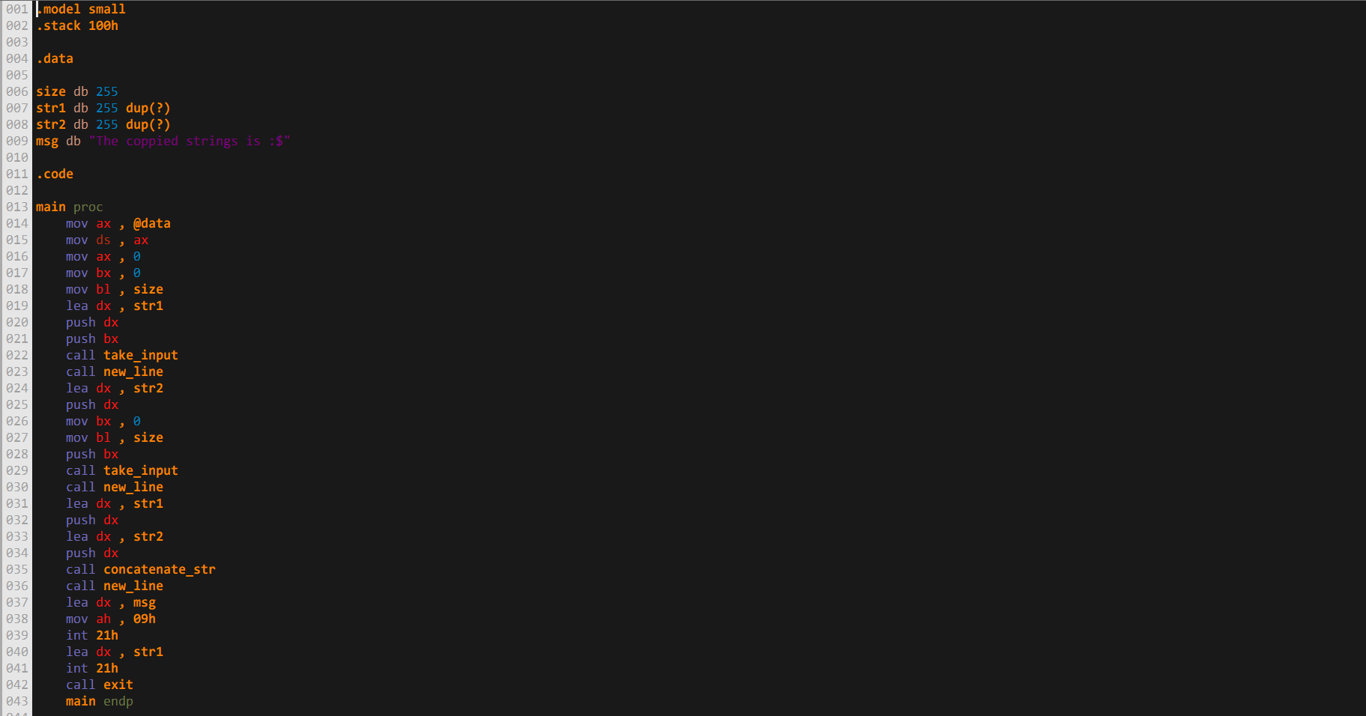

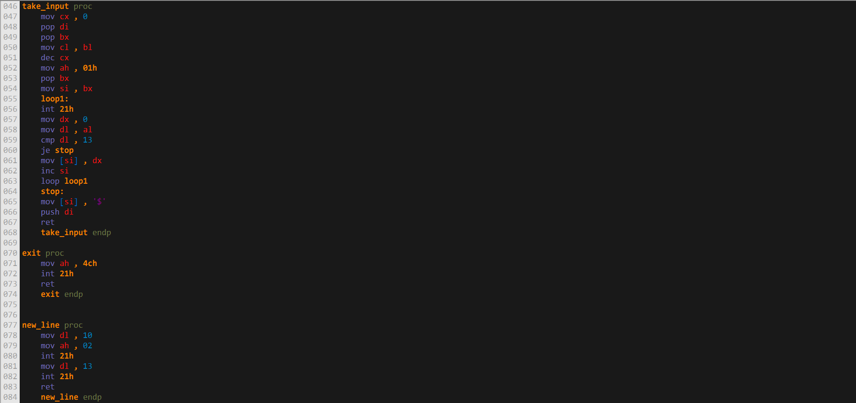

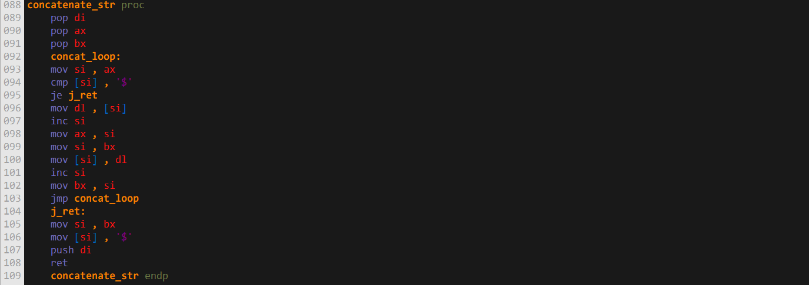

**Output:**

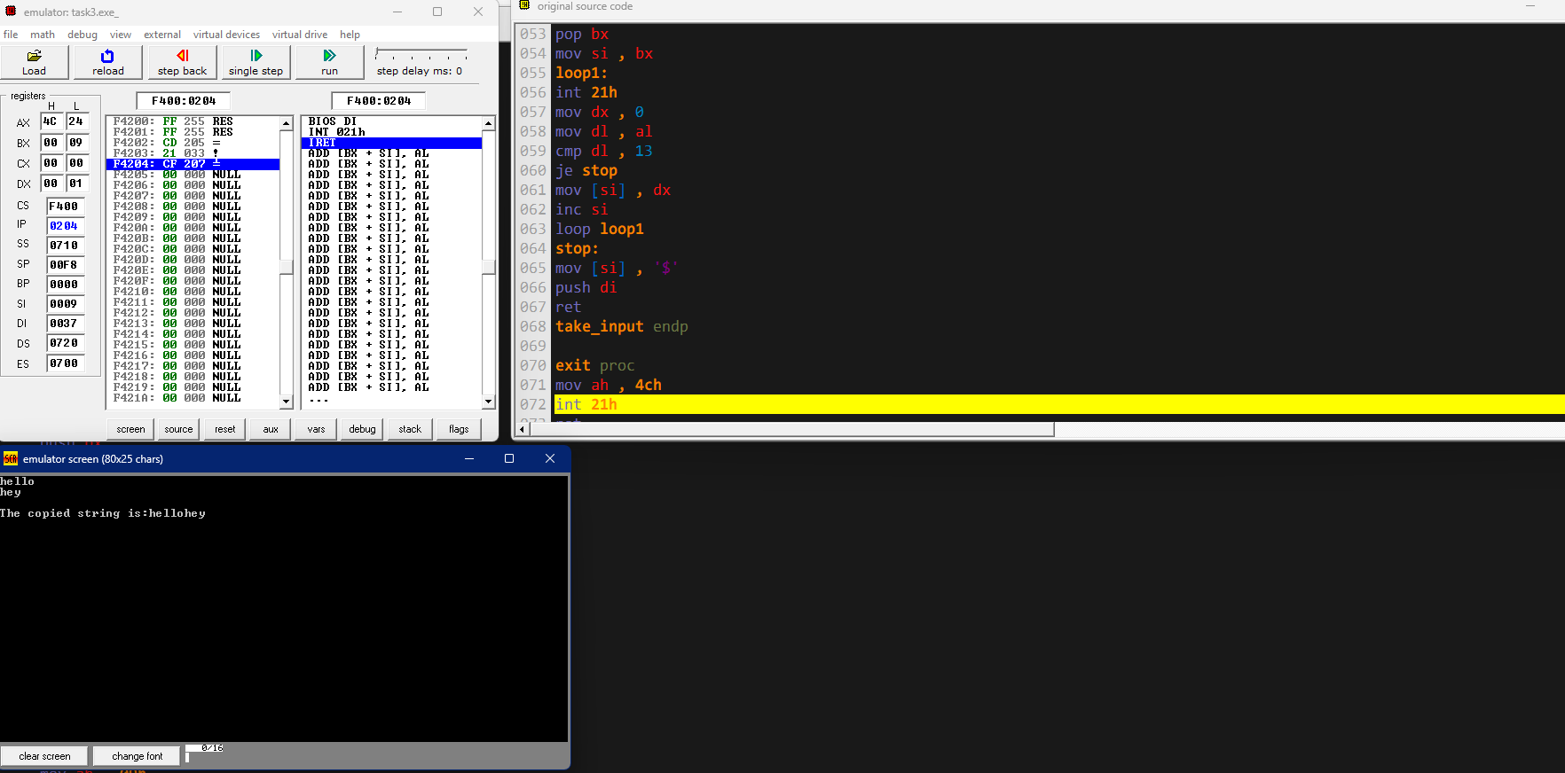

**Task 4:** Write a program that calculates the length of a string (number of characters) using assembly language instructions.

**Code:**

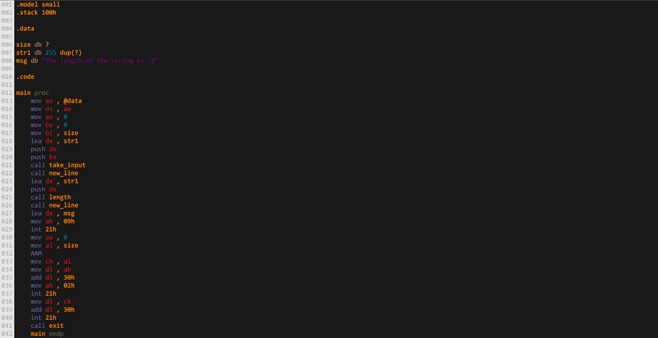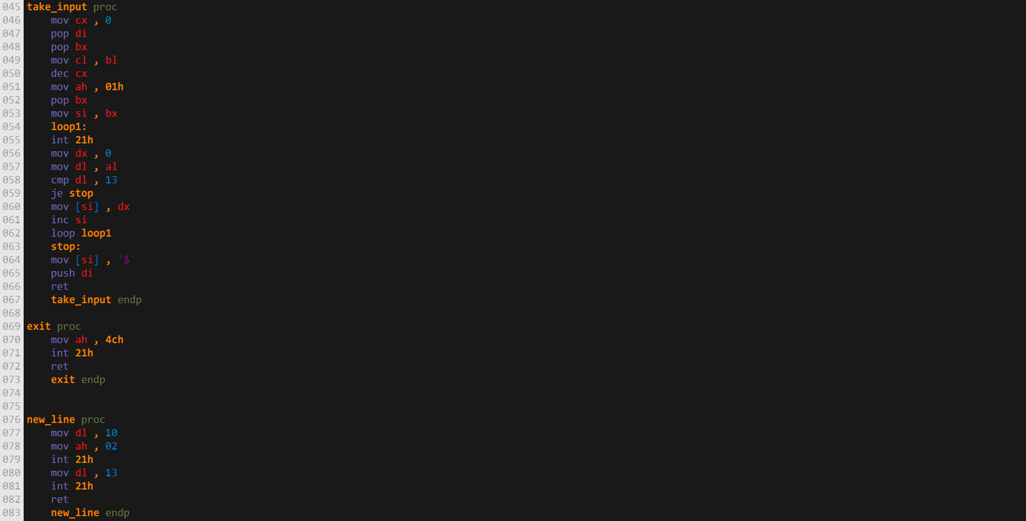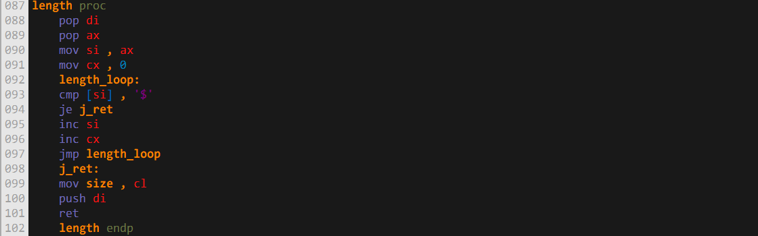

**Output:**

