

**Department of Computer Science**

**HITEC University, Taxila**

**BS Computer Science Program**

**(Batch 2022)**

**CS-206 Computer Organization & Assembly language 4(3+1)**

**Lab Folder**

**SPRING 2024**

**Instructor: Fatima Rauf**

**Submitted By:**

**Abdul Ahad (22-CS-071)**

**Lab Mids**

**Task 1:** Simulate an assembly language program to perform basic arithmetic operations, implement a procedure which takes 2 numbers as argument. Calculate

* Multiplication on two numbers.
* Subtraction of these two numbers.
* Addition
* Division

Display the output of operations in main procedure with proper messages. Make sure that you can display a double-digit number in result. Also define procedure that can move cursor to next line.

**Code:**

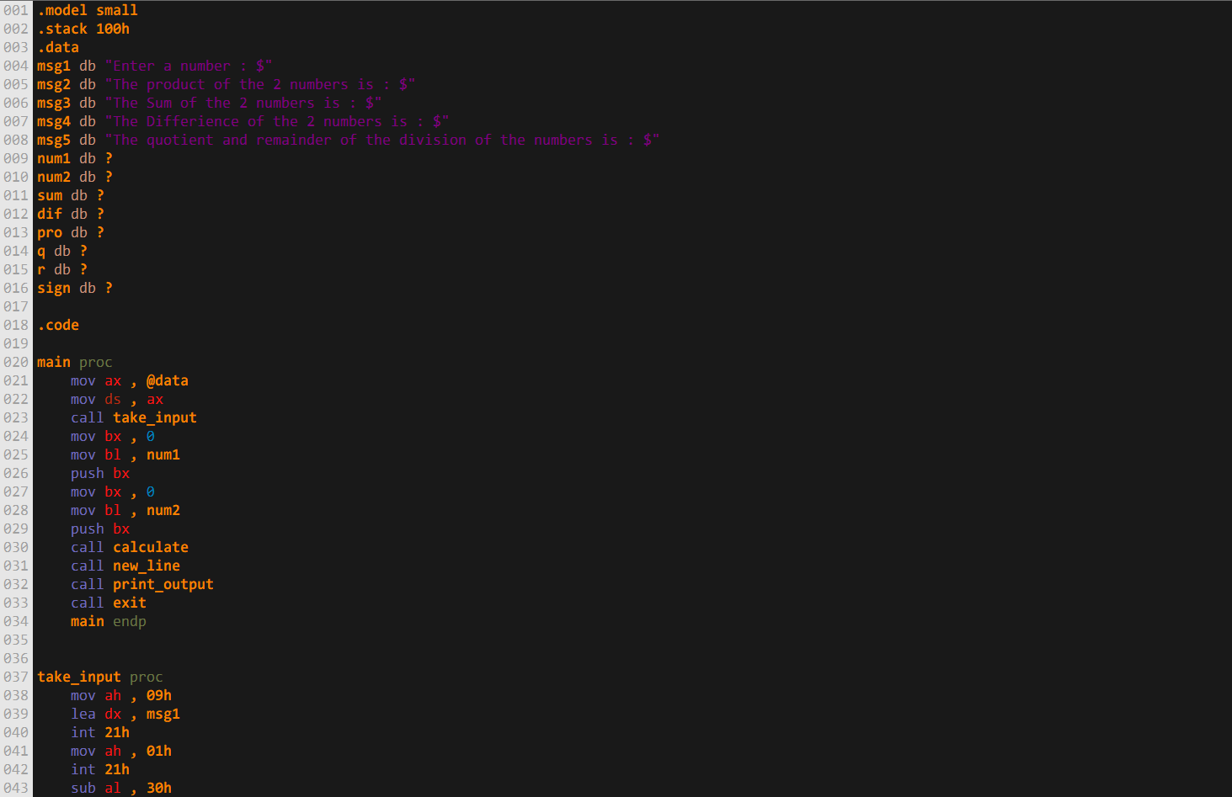

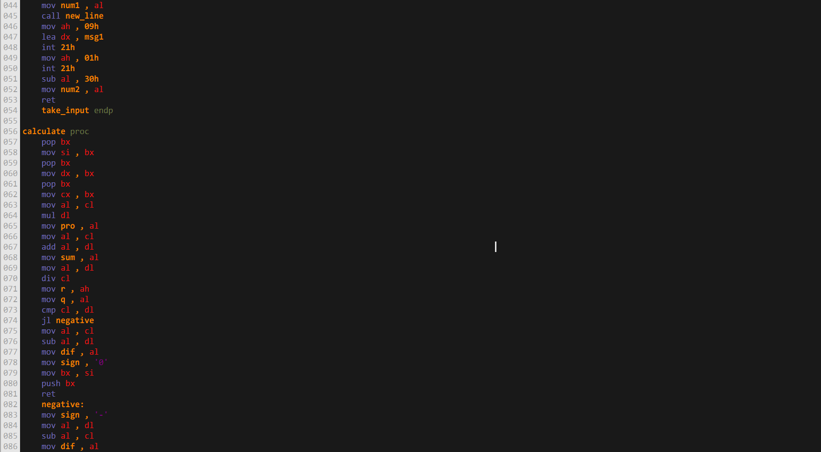

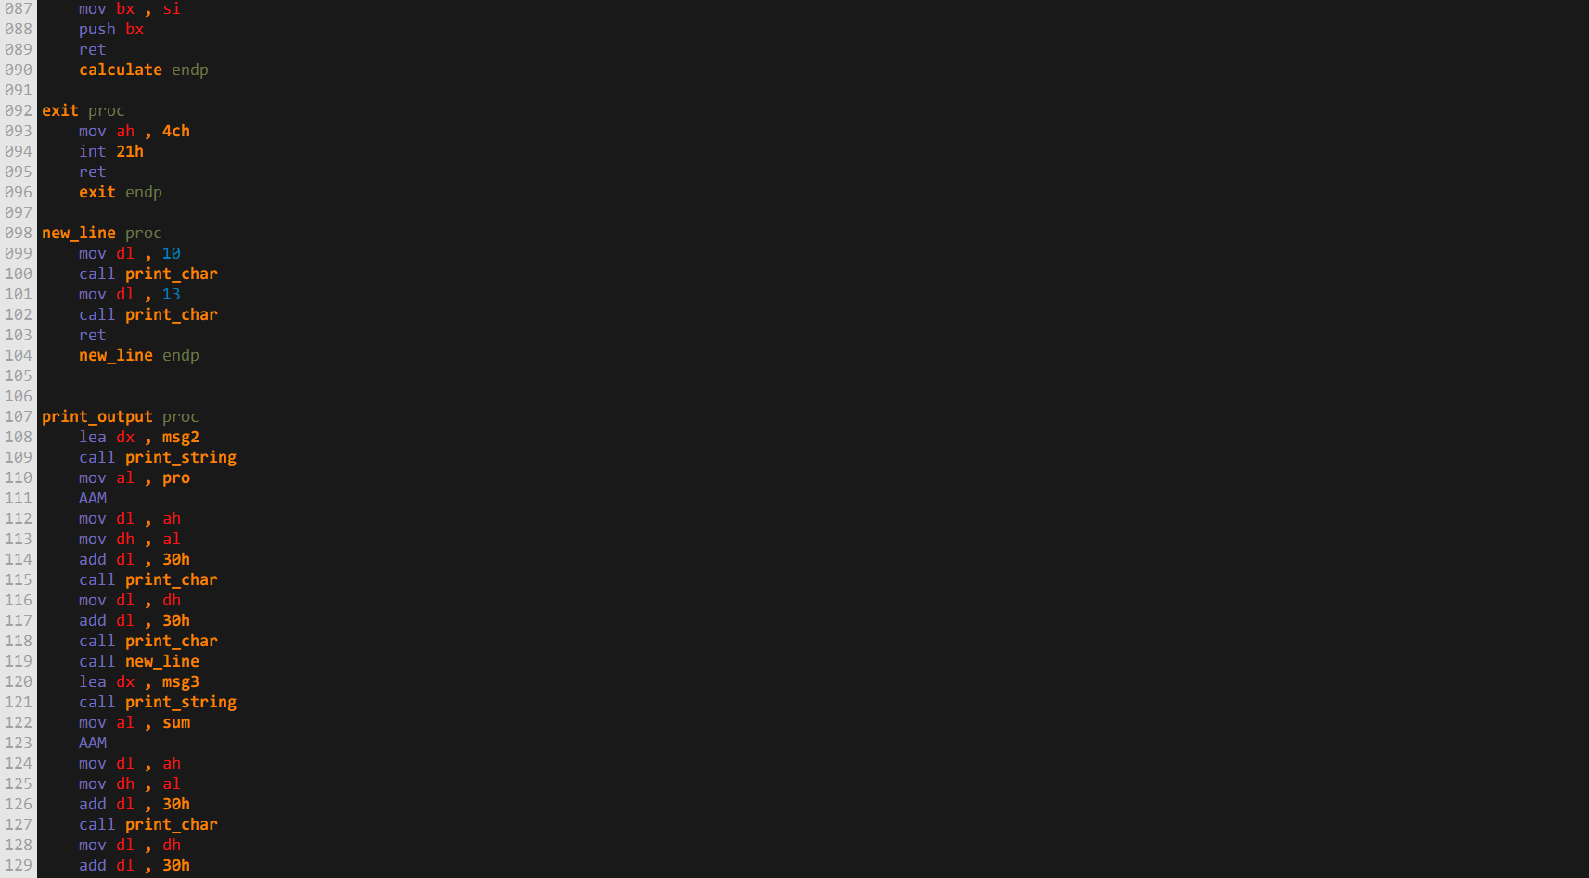

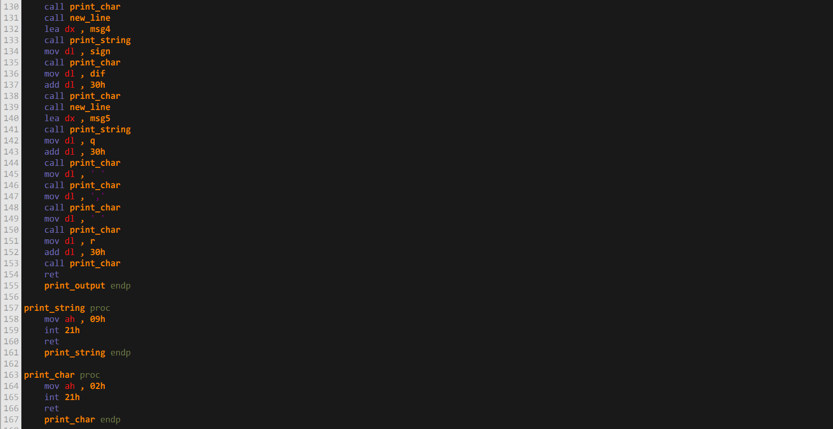

**Output:**

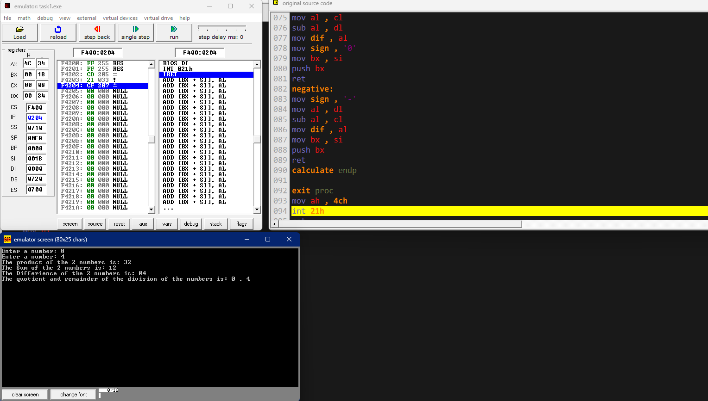

**Task 2a)** Implement a program in assembly language that takes inputs a string in array store and then print the stored string in reverse order on screen and check if string is palindrome or not.

**Code:**

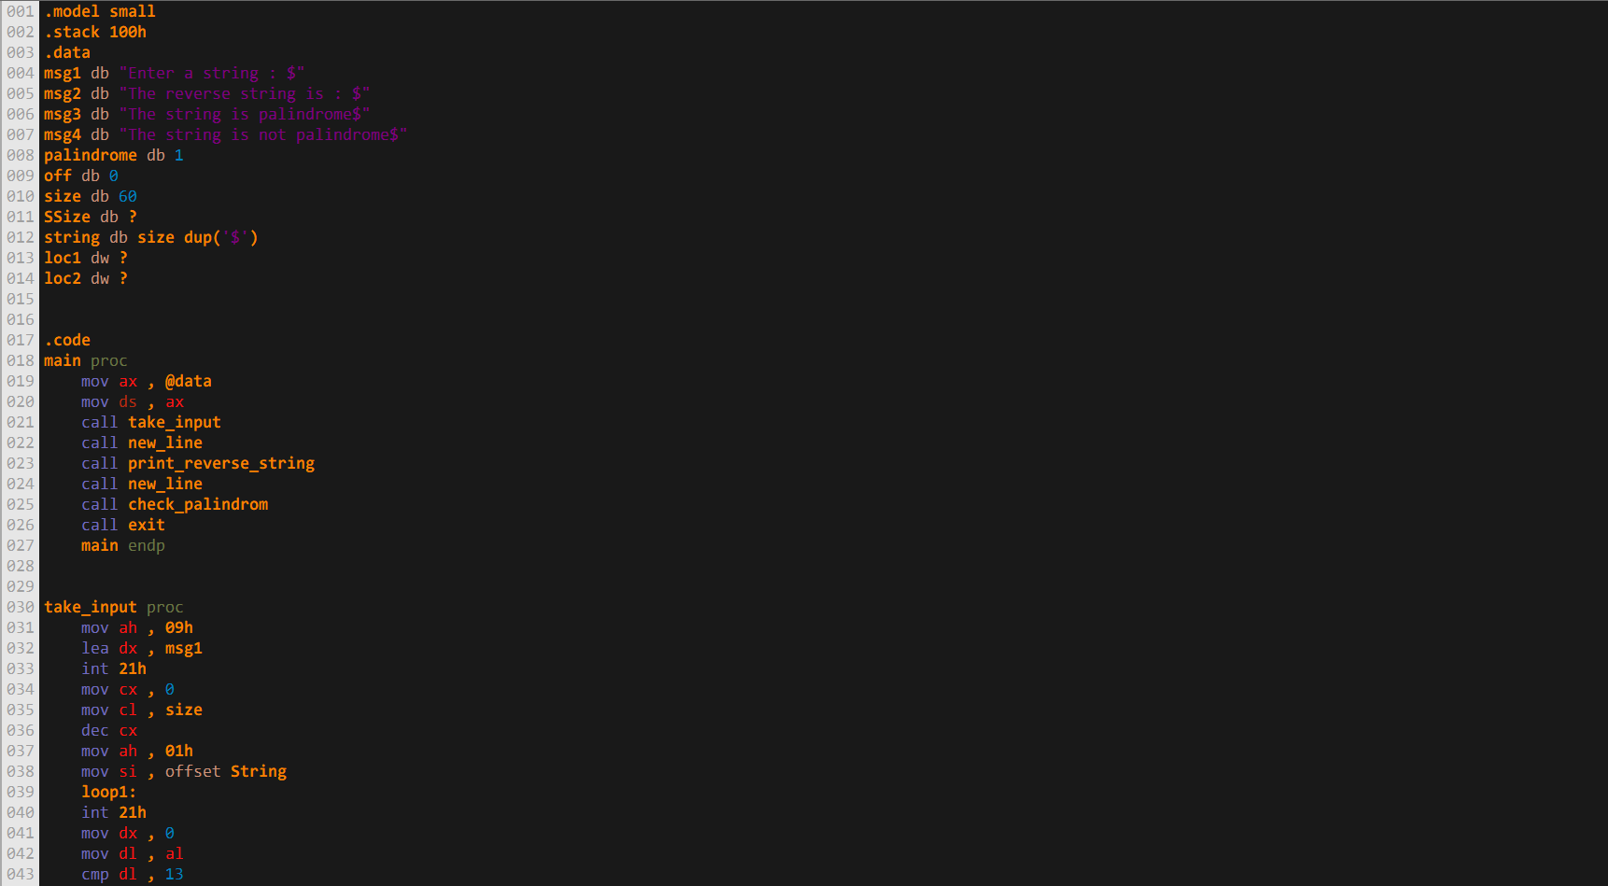

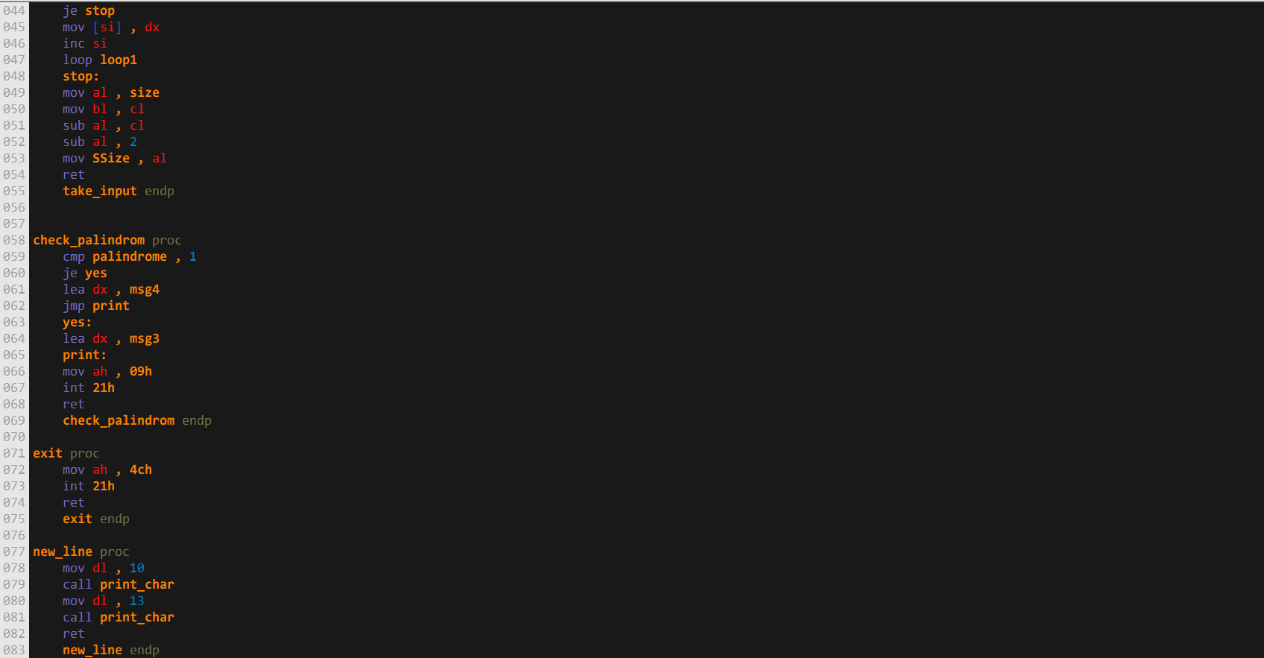

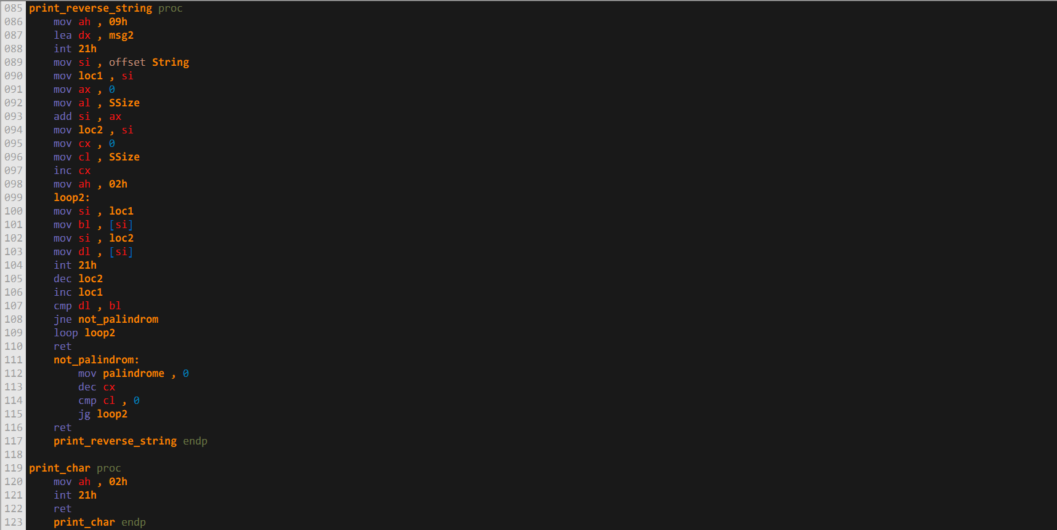

**Output:**

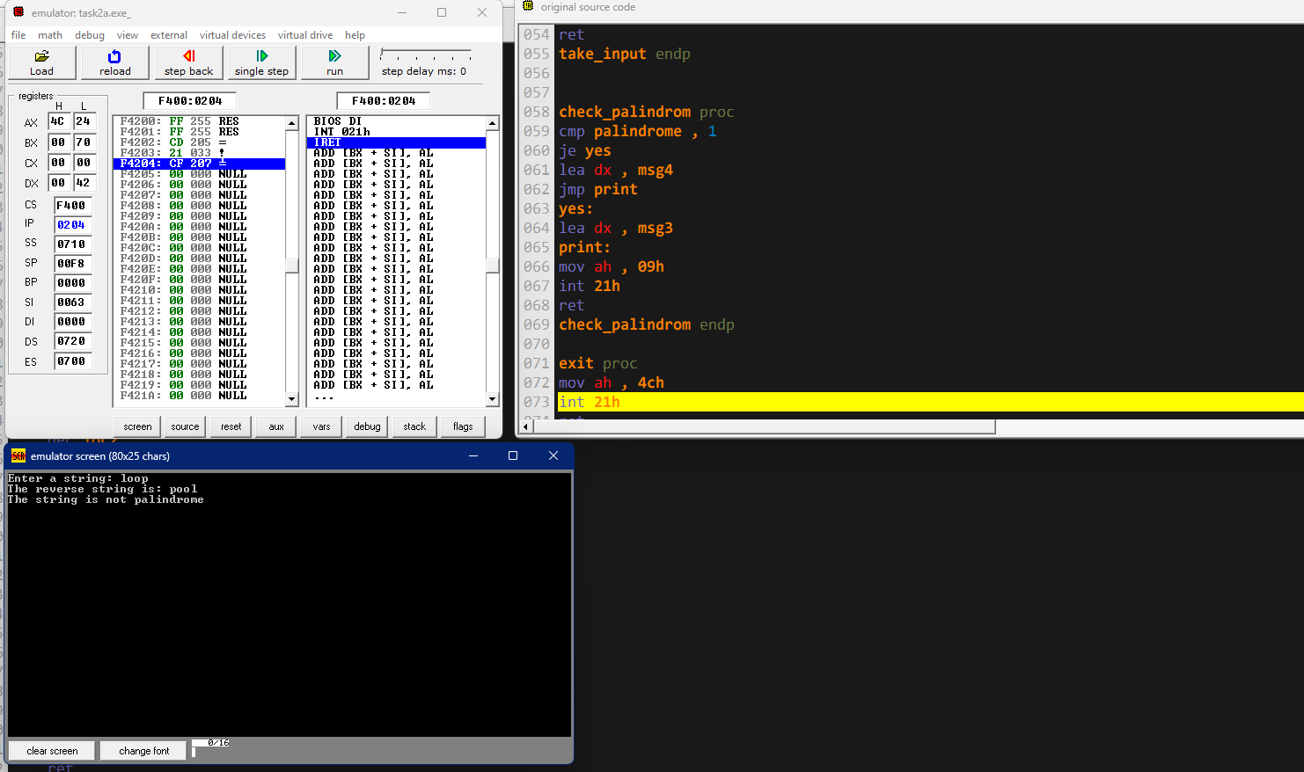

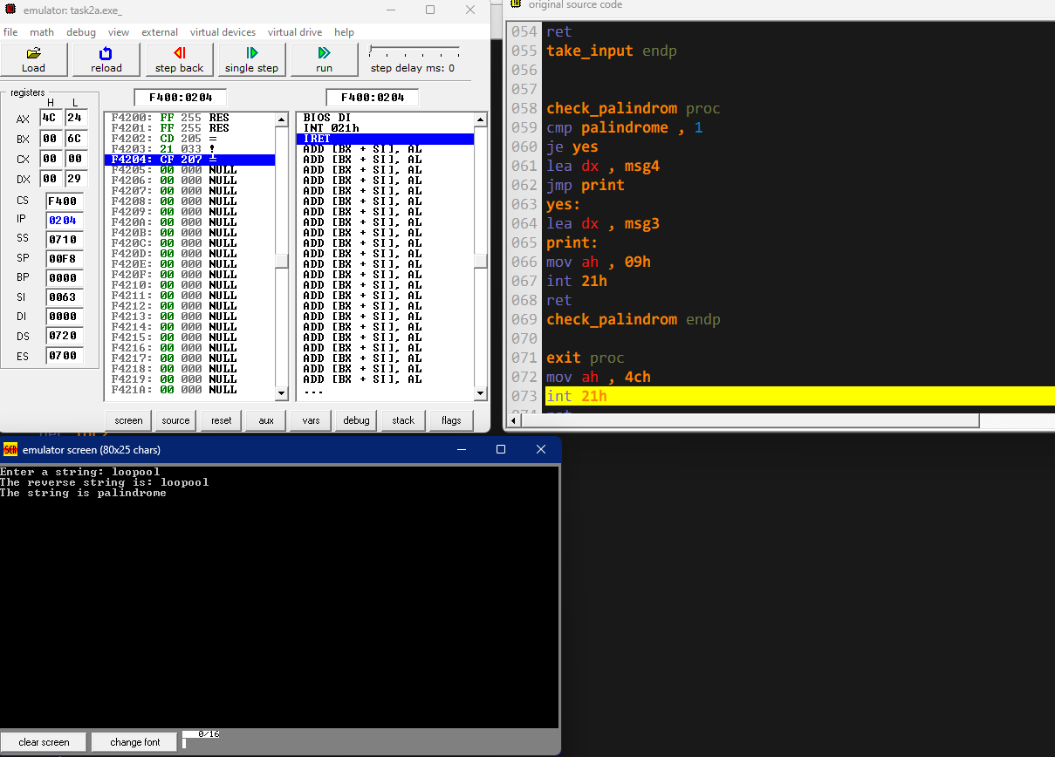

**Task 2b:** Implement a program in assembly language that take 3 numbers (X, Y, Z) from user as input. And Perform following Calculations

**Output = (X XOR Y) XOR Z**

Number and output must be in Decimal. Use following Registers for implementing above situation AL, BL and AH

**Code:**

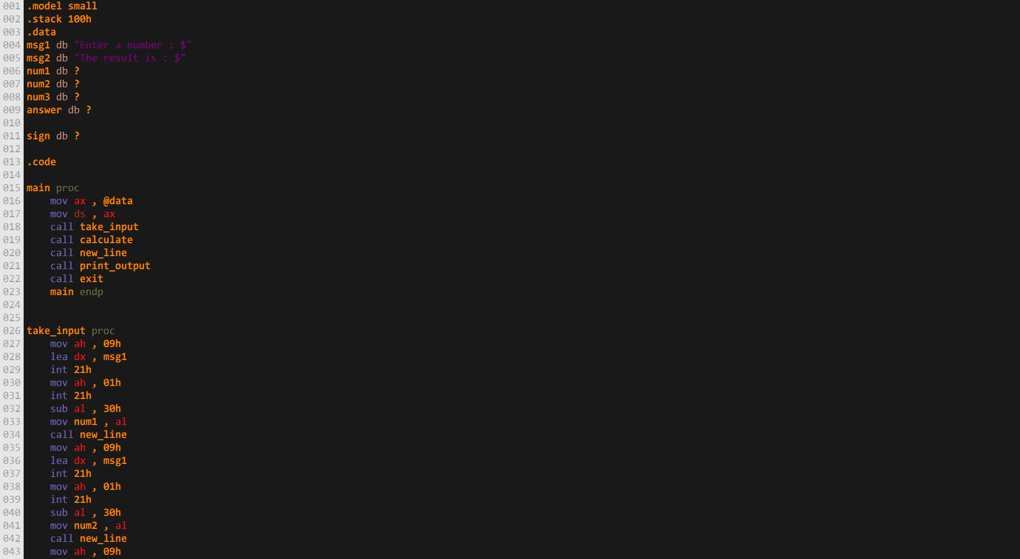

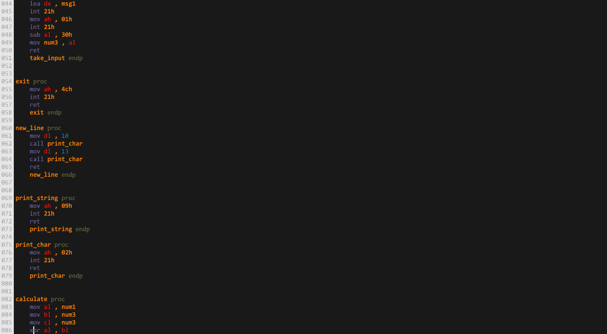

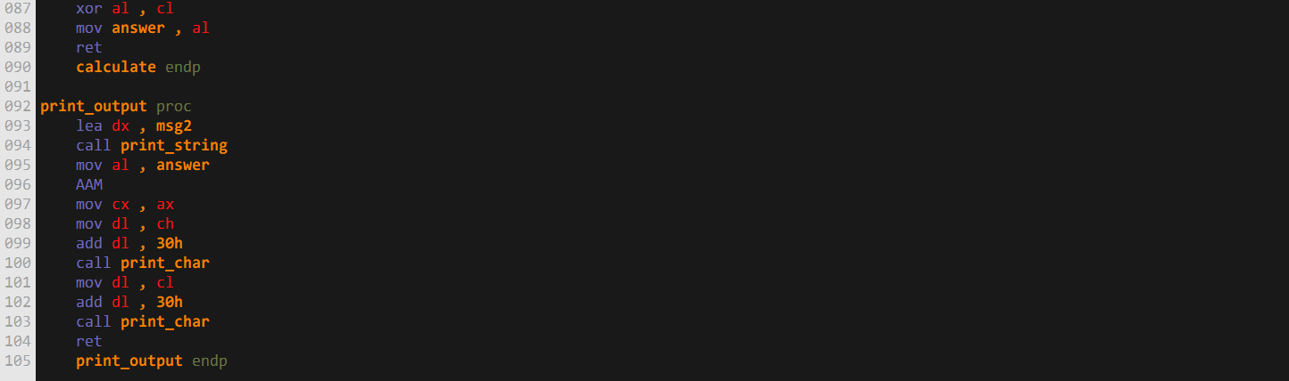

**Output:**

