

**Department of Computer Science**

**HITEC University, Taxila**

**BS Computer Science Program**

**(Batch 2022)**

**CS-206 Computer Organization & Assembly language 4(3+1)**

**Lab Folder**

**SPRING 2024**

**Instructor: Fatima Rauf**

**Submitted By:**

**Abdul Ahad (22-CS-071)**

**OEL**

**Task:**

**Code:**

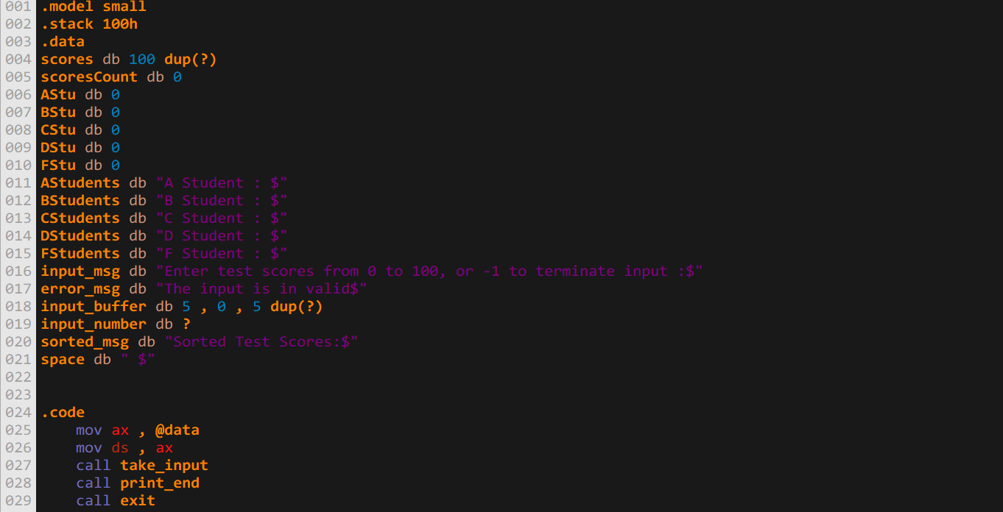

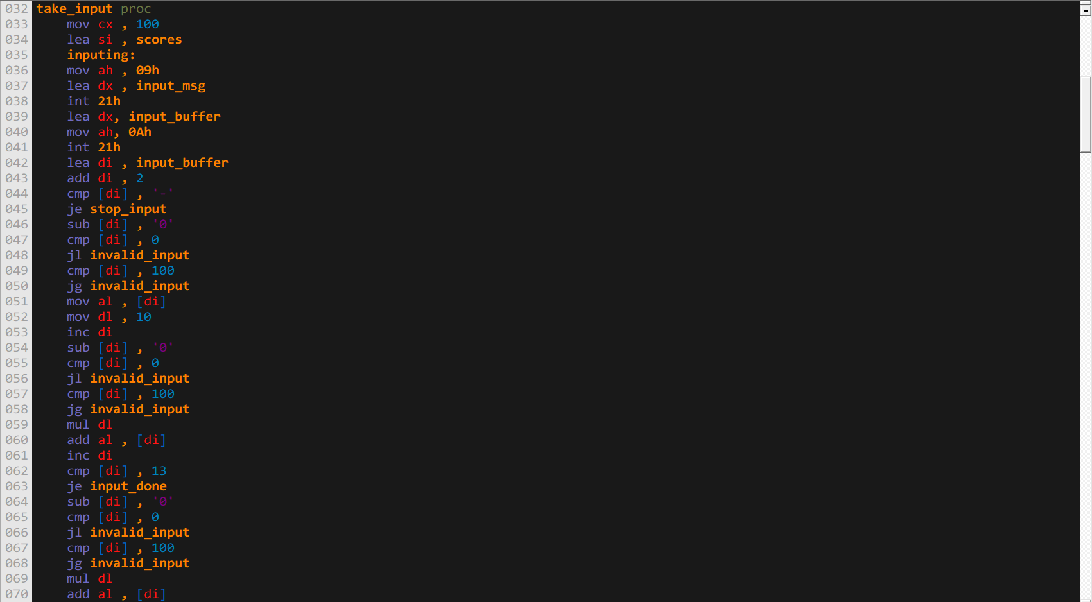

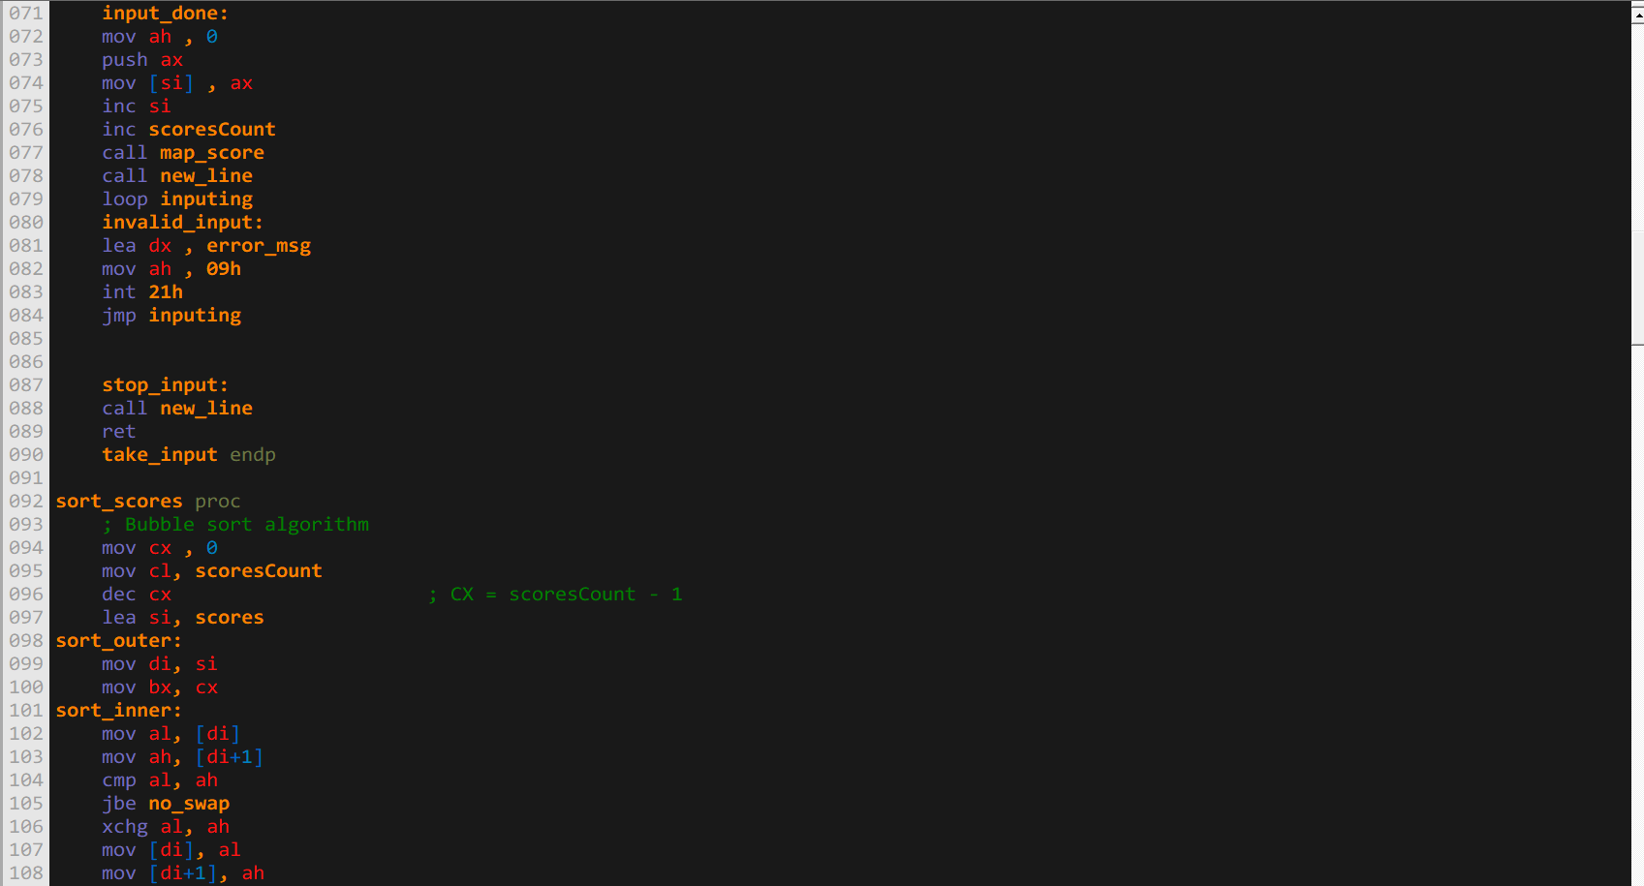

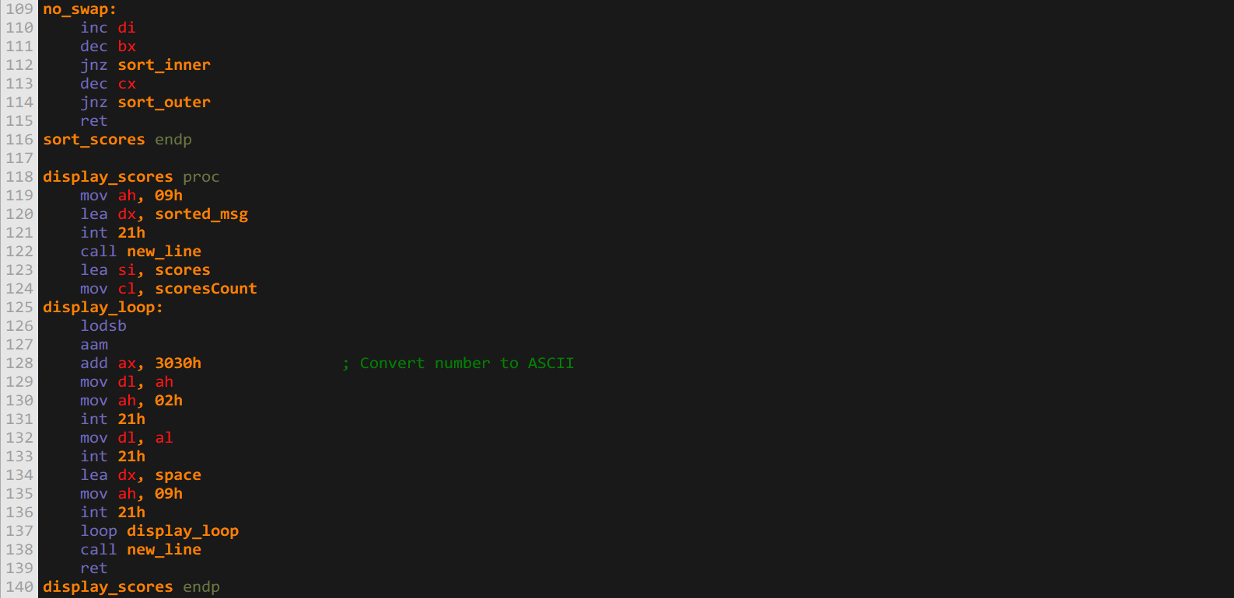

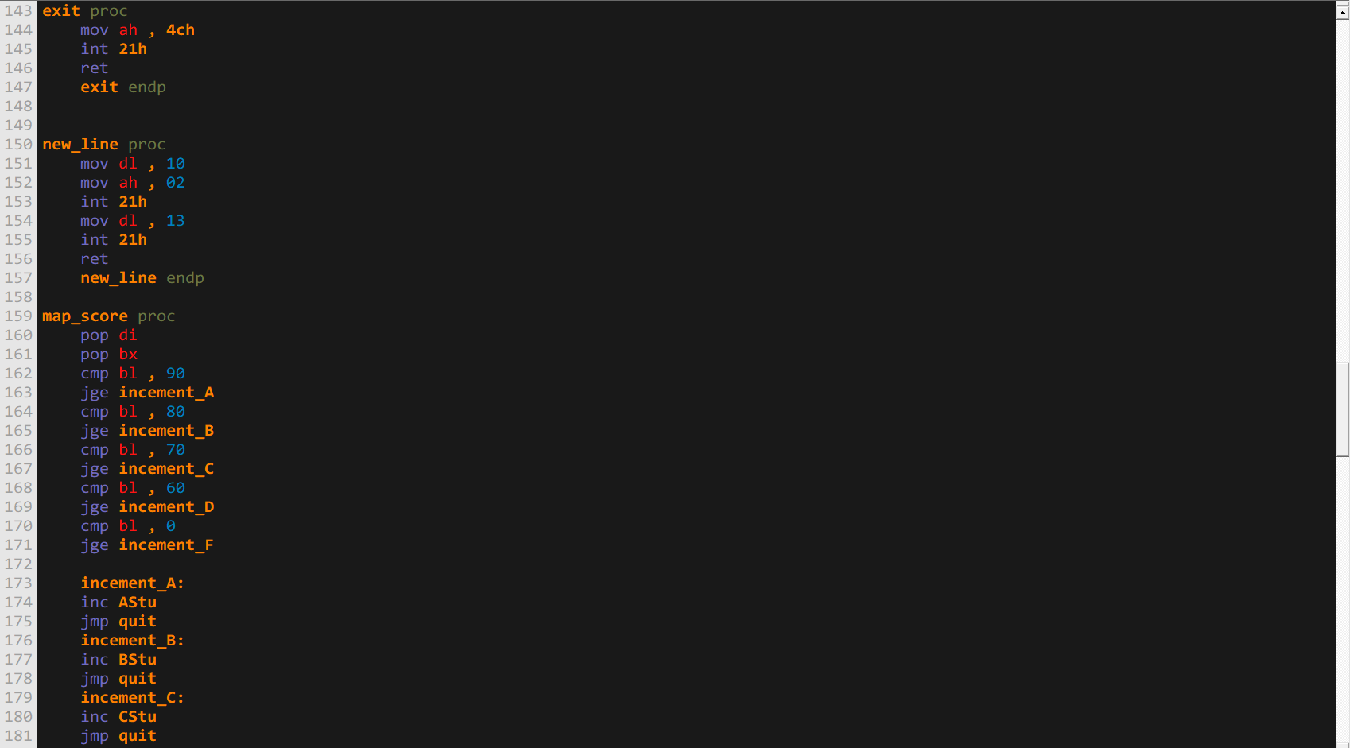

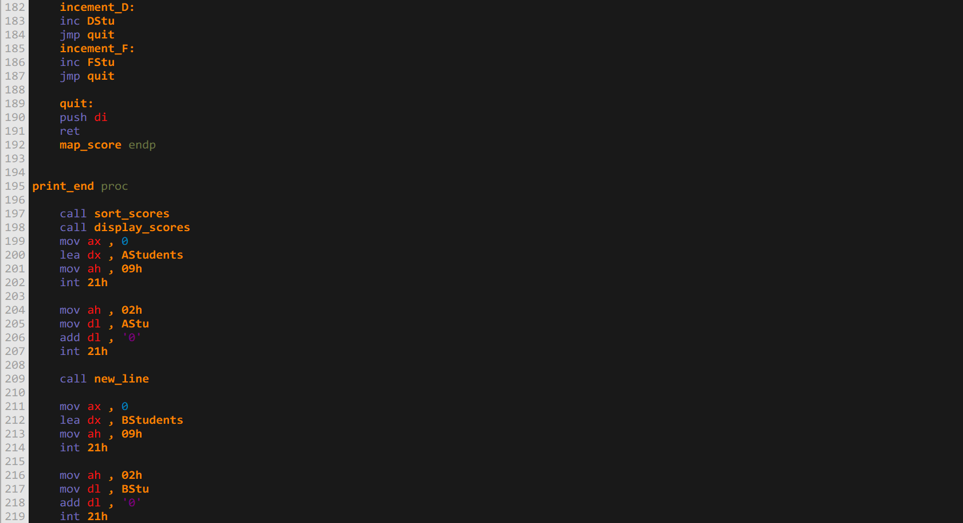

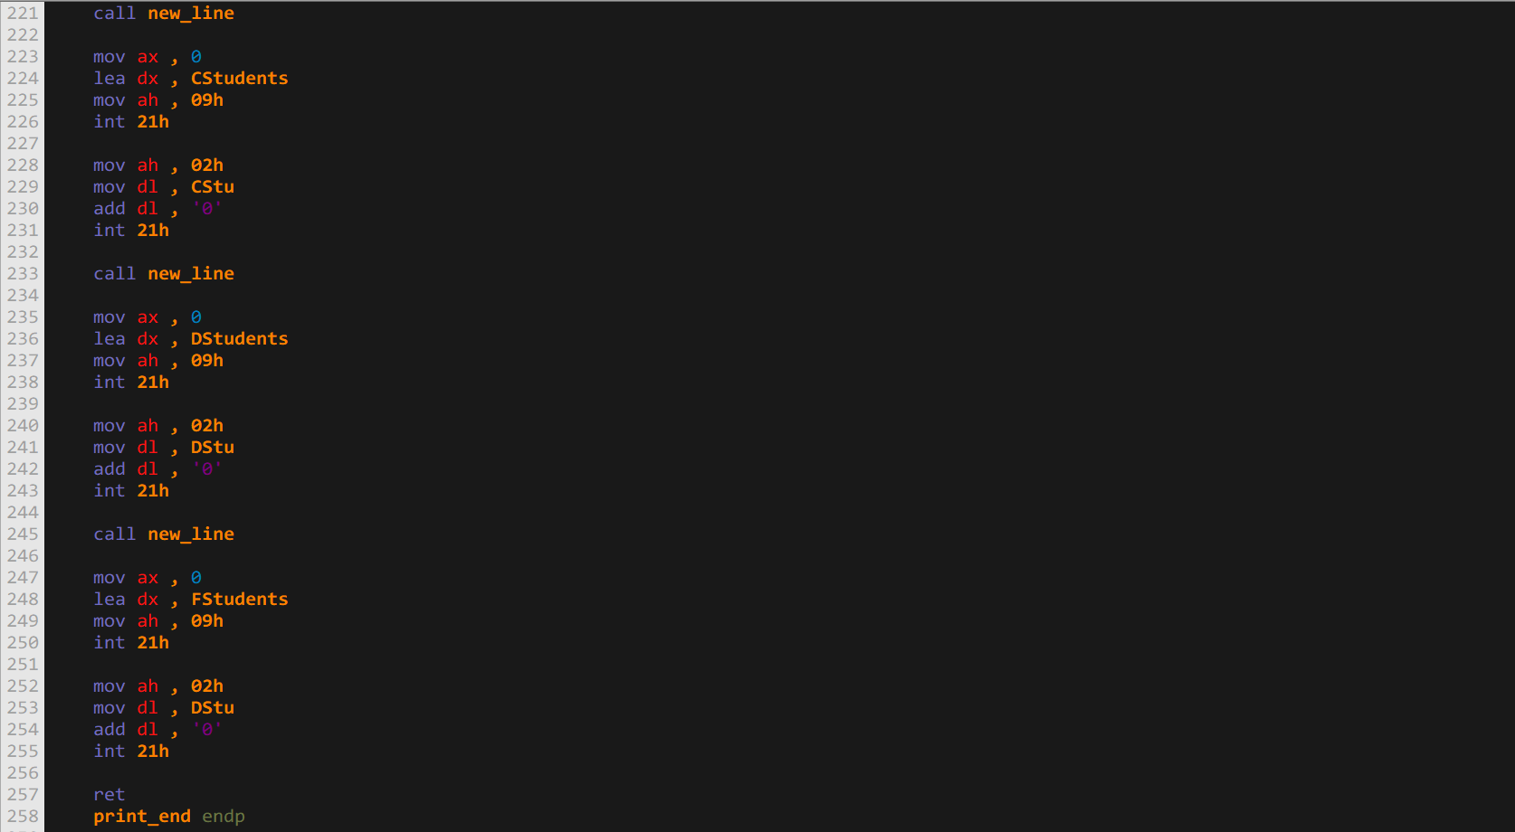

**Output:**

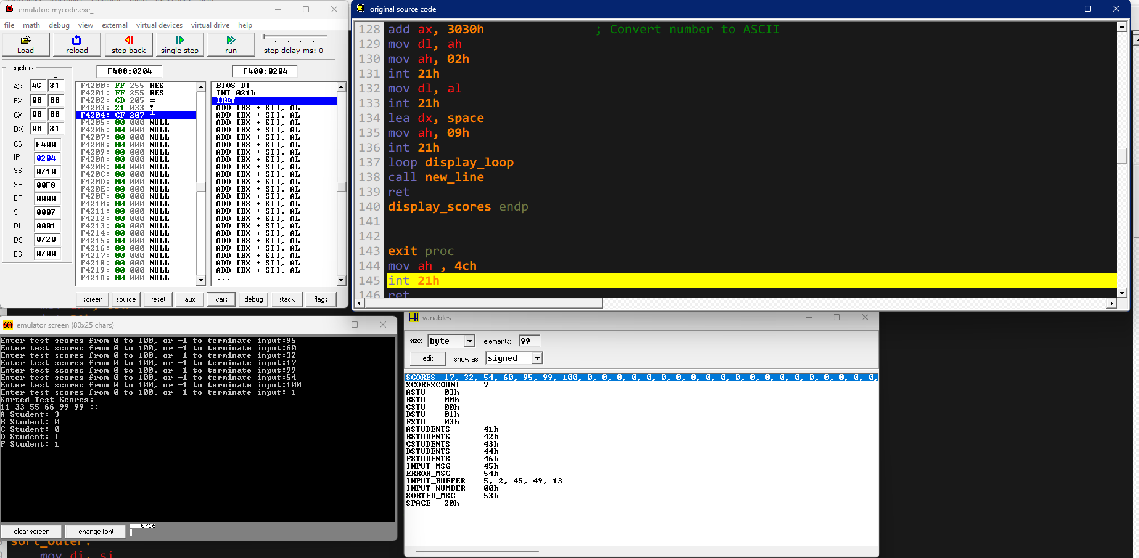

**Conclusion**

This x86 assembly program for DOS takes an array of integer test scores (0 to 100) from the user, stores them, sorts them, and maps them to letter grades (A, B, C, D, F). The program follows these steps:

1. **Initialization**:
   * Sets up the data segment and stack.
   * Displays a message asking the user to input test scores.
2. **Input Handling**:
   * Reads user input using DOS interrupt 21h, function 0Ah (buffered input).
   * Converts the input string to a number, validates it, and stores it in the scores array if valid.
   * Checks for the termination input (-1), and displays an error message for invalid inputs.
3. **Mapping Scores to Grades**:
   * The map_score procedure categorizes each score into letter grades (A, B, C, D, F) based on predefined ranges.
   * The count for each grade is updated accordingly.
4. **Sorting and Displaying Scores**:
   * Sorts the scores array using a bubble sort algorithm.
   * Displays the sorted scores.
5. **Displaying Grade Counts**:
   * After sorting and displaying the scores, it shows the number of students in each grade category (A, B, C, D, F).
6. **Exit**:
   * Properly exits the program using DOS interrupt 21h, function 4Ch.

**Key Procedures**

1. **take_input**:
   * Manages user input, validates it, and stores it in the scores array.
2. **sort_scores**:
   * Implements a bubble sort to sort the scores array.
3. **display_scores**:
   * Displays the sorted scores.
4. **map_score**:
   * Maps each score to a corresponding grade and updates the counts of students in each grade category.
5. **print_end**:
   * Calls the sorting and display functions, and then prints the number of students in each grade category.
6. **new_line**:
   * Prints a new line (carriage return and line feed).

This program ensures that only valid inputs are accepted, sorts the scores, and provides a detailed summary of the test results, including a breakdown of how many students achieved each letter grade.