

**Department of Computer Science**

**HITEC University, Taxila**

**BS Computer Science Program**

**(Batch 2022)**

**Design And Analysis of Algorithm**

**Project**

**Instructor: Dr. Muhammad Nazir**

**Submitted By:**

**Abdul Ahad (22-CS-071)**

**Muhammad Zain Ali (22-CS-015)**

**Junaid Jiya Khan (22-CS-182)**

**Muhammad Afzal (22-CS-071)**

### **Library Management System Implementation**

#### **Introduction**

The Library Management System is a software solution designed to efficiently manage the procedures of a library. This project utilizes various data structures and algorithms to organize and maintain library resources, manage member records, and facilitate seamless borrowing and returning of books. The system is implemented in C++ programming language, leveraging data structures such as **unordered_map**, vector, and custom hashing function to efficiently manage books and members.

#### **Key Features**

1. **Book Management**: Efficient storage and retrieval of book information using **unordered_map** with ISBN as the key. Each book record includes details like title, author, ISBN, category, availability status, and location in the library.
2. **Member Management**: Maintenance of member records using **unordered_map** with membership ID as the key. Member information includes name, contact details, membership ID, and borrowing history.
3. **Borrowing and Returning**: Implementation of functions to manage the borrowing and returning process, updating availability status and member borrowing history accordingly.
4. **Display All Books**: Ability to display all books in the library, providing detailed information about each book.
5. **User Interface**: A menu-driven interface allows users to interact with the system seamlessly, providing options to perform various operations.

#### **Implementation Details**

* **Data Structures**: The core data structures used in the implementation include **unordered_map** to store books and members efficiently. Custom hashing function (**ISBNHash**) is defined to hash book ISBNs.
* **Hashing Function**: The **ISBNHash** struct defines a custom hashing function for book ISBNs. This function overrides the **operator()** to compute the hash value of an ISBN string. The hashing function converts each character of the ISBN string into its ASCII value and accumulates them to calculate the hash value. While this hashing function is simplistic for demonstration purposes, in real-world scenarios, a more sophisticated hashing algorithm should be used for better distribution and reduced collision probability.

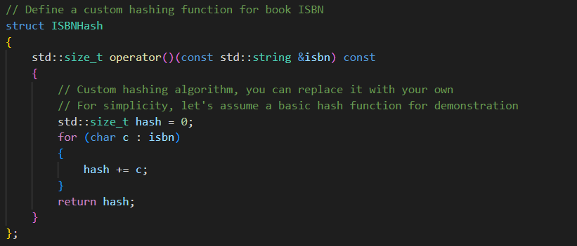

* **Functions**: Functions are implemented to add and remove books/members, borrow and return books, and display all books in the library. Error handling and input validation are included to ensure the robustness of the system.
* **Menu-Driven Interface**: The system provides a user-friendly menu-driven interface to facilitate user interaction. Users can select options from the menu to perform desired operations.

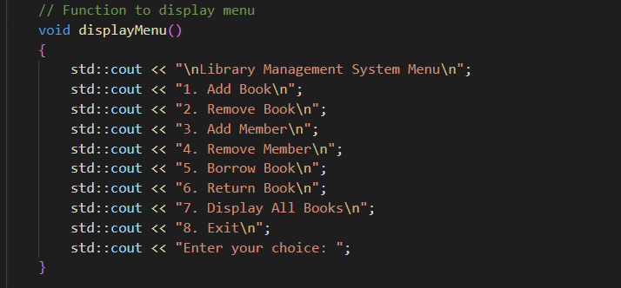

#### **Evaluation Criteria**

The implementation of the Library Management System is evaluated based on various criteria:

1. **Implementation of Data Structures**: Effective use of unordered_map and vector for book and member management.
2. **Efficiency of Operations**: Optimized algorithms and data structures to ensure efficient search, retrieval, borrowing, and returning of books.
3. **User Interface Design**: Intuitive menu-driven interface design for easy interaction.
4. **Correctness of Operations**: Correct implementation of functions to ensure accurate book and member management.
5. **Error Handling and Exception Management**: Proper error handling and exception management to handle invalid inputs and unexpected scenarios.
6. **Administrative Functions and Reports**: Implementation of administrative functions such as adding/removing books/members and generating reports on library usage.
7. **Comments and Documentation**: Adequate comments and documentation to enhance code readability and maintainability.

#### **Conclusion**

The implementation of the Library Management System demonstrates effective utilization of data structures and algorithms to manage library resources and member records efficiently. The system provides a user-friendly interface and ensures correctness, efficiency, and robustness in performing various library operations.

#### **Future Enhancements**

* Integration of advanced data structures and algorithms for further optimization.
* Implementation of additional functionalities such as book reservations and fine calculation.
* Enhancement of the user interface to provide more interactive features.
* Integration with a database system for persistent storage of library data.
* Implementation of a web-based interface to enable remote access to the library system.

Overall, the Library Management System serves as a foundational framework for managing library operations and can be further enhanced to meet evolving requirements and user needs. The custom hashing function demonstrates the core principle of hashing in data structures, providing efficient storage and retrieval of book records based on their ISBNs.