

**OS (OPERATING SYSTEM) Lab**

**LAB REPORT # 1**

**Semester**: 5ndSemester

**Section**: C

**Submitted To:**

**Mr. Muhammad Hasnain**

**Submitted By:**

**Name**: Abdul Ahad

**Roll No**: 22-CS-071

**Tasks**

1. **Repeat the above steps and install VMware on Your Pc**
2. **Also Install Ubuntu or any other flavor of LINUX in it**
3. **Write complete Description of each step**

Sir I have used a **better and more advance tool** that is provided in the latest versions of Windows by default. This is **provided by the Microsoft** as a part of Windows for **developer** that require the use of **Linux Operating System.**

**WSL** is the tool provided by Microsoft. So, for this provided I have decided to use **WSL.**

The steps are all that are officially available on the Microsoft WSL guide the Screenshot’s used were required from a third party (one of my fellow batch mates).

**Steps:**

1. **First installing the required features from the windows Settings:**
   1. Press Windows Key and search “Windows Features” Select the first match

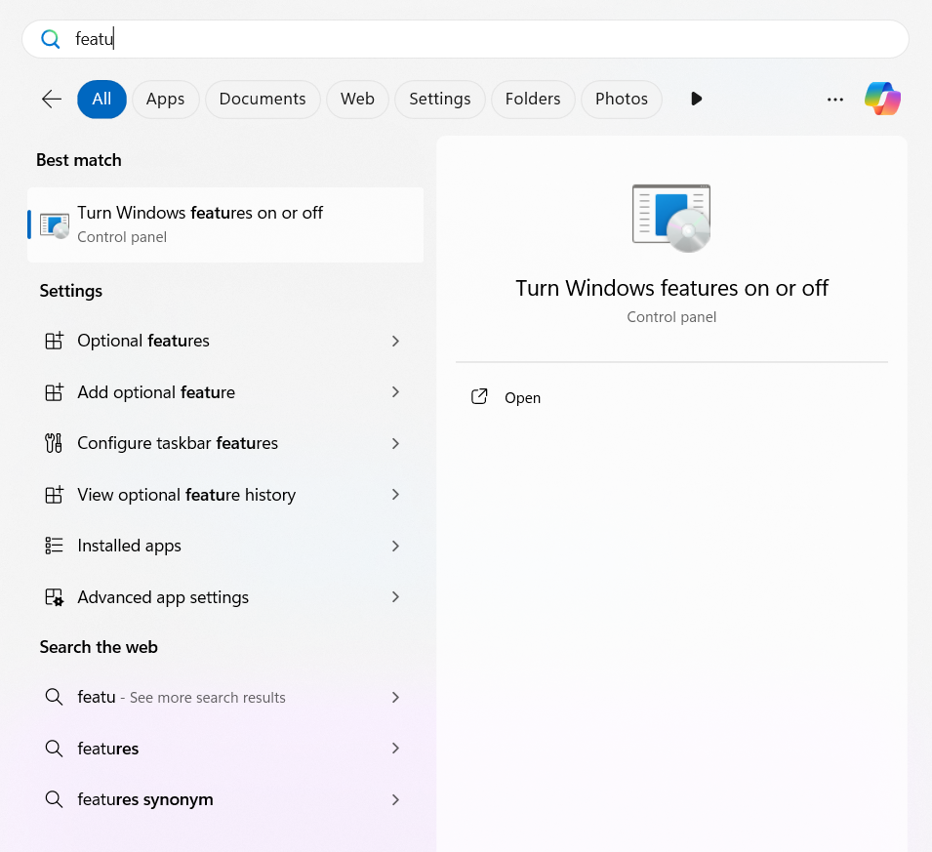

* 1. A new window will open from this Select 2 option and mark them tick ✅

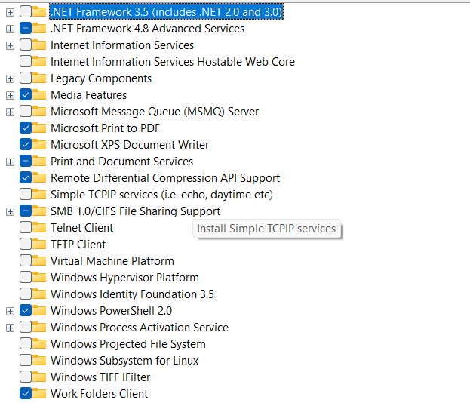

* + 1. Virtual Machine Platform



* + 1. Windows Subsystem for Linux



* 1. After this select Ok



* 1. Now a new window will pop up Select Restart

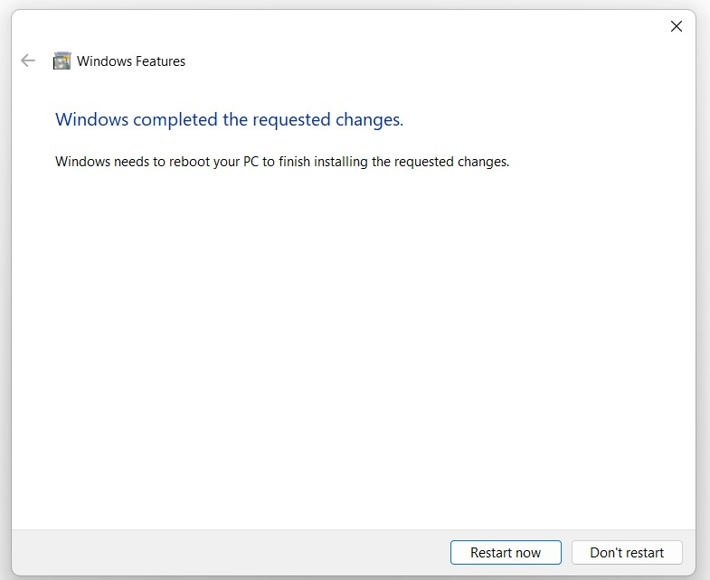

* 1. After Your System Restart
  2. Press Windows Key + X
  3. Then select Terminal or Terminal (Admin) or press “I” or “A” Keys respectively or you can also Search for terminal in the Windows Search options

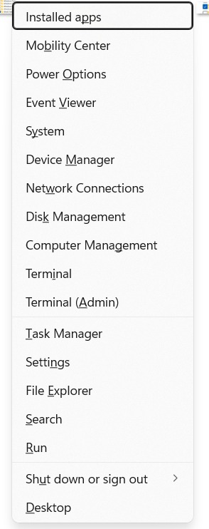

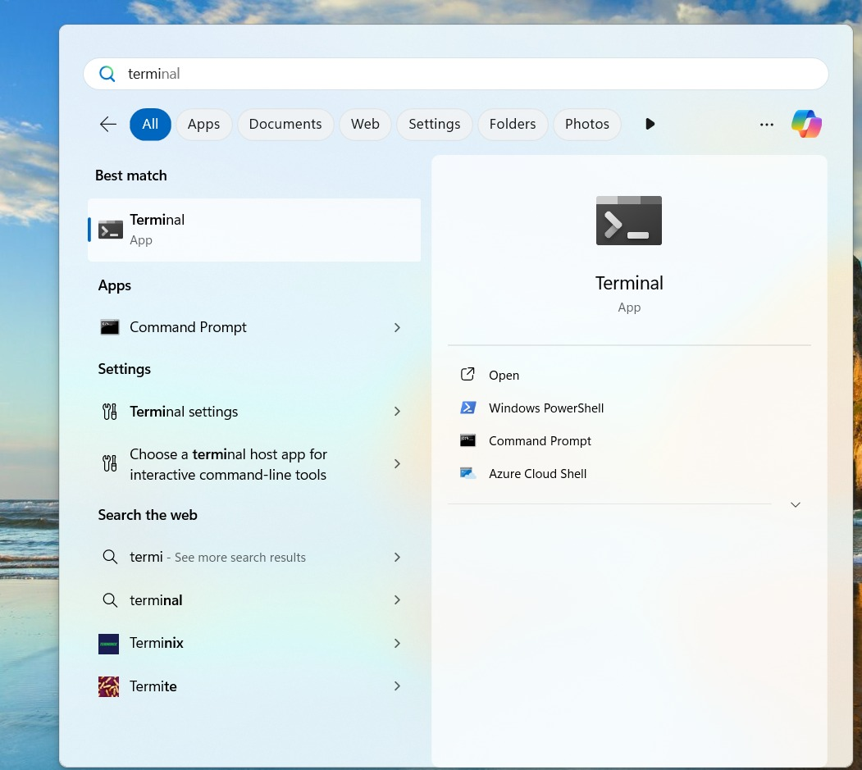

* 1. Now type in the Terminal **“wsl”** to see if wsl was installed correctly

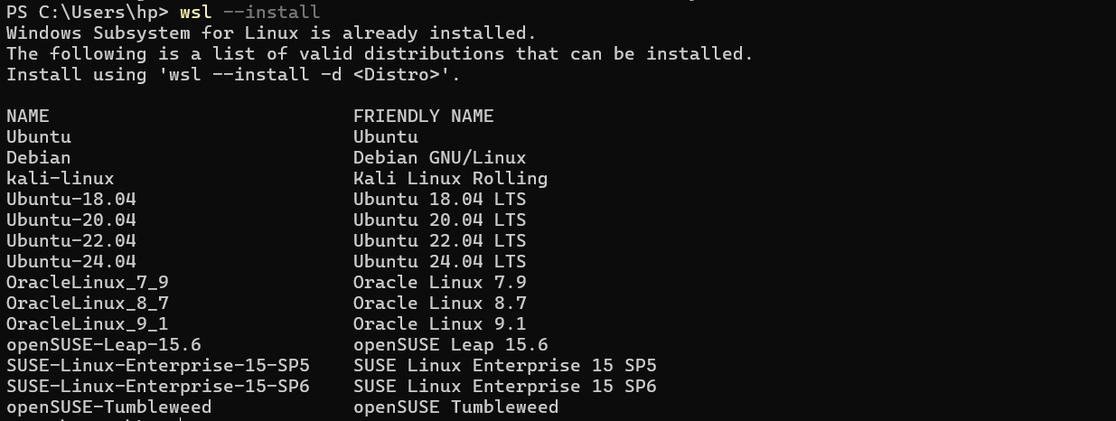

* 1. If installed Correctly follow
  2. Now in the Terminal type **“**wsl –install -d “Ubuntu-24.04”**”** this will install Ubuntu Version 24.04 in the system



* 1. After the installation is complete you will be prompted to prompted to provide a username and a password for the installed OS

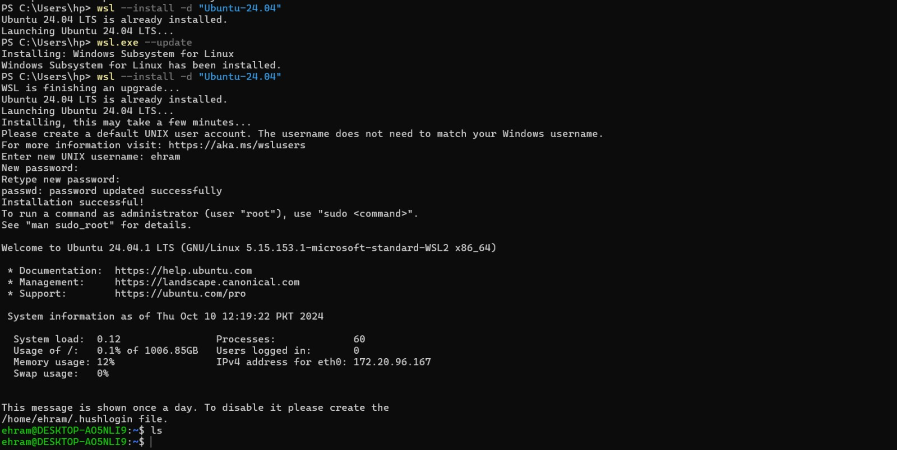

* 1. After providing a username and a password you will be logged in the Ubuntu Virtual Machine.

1. **Following the Very Same Steps I have also Installed Kali-Linux in my System**