HNEE 2 –

Contents

**Task 1** 5

**(a)** 5

**Fundamentals** of Electronically Controlled Industrial Systems 5

**1.** **Controller** 5

**2.** **Sensors** 5

**3.** **Actuator** 5

**Example** 5

**(b)** 5

**Motor** **Control** **Concepts** 5

**Engine** **type:** 6

**Independent control system:** 7

**Input/Output** Devices: 8

**(c)** 9

Suggestions for **Performance** **Improvement** 9

**1.** Advanced sensor integration: 9

**2.** Adaptive control algorithm: 9

**3.** Predictive maintenance: 9

**Reference:** 9

**Task 2** 9

**(a)** 9

**Important Circuit and Controller** 9

**Importance of controllers in industrial control systems:** 10

**(b)** 10

**Justifications for Transducer and Controller Choices in Robotic Linear Motion** 10

**Transducer Choices:** 10

**Controller Choices:** 10

**Control Method:** 11

**Reasons for Transducer Choice:** 11

**Reasons for Controller Choice:** 11

**Conclusion:** 12

**(c)** 12

**Pneumatic Actuators:** 12

**Reasons for Choosing Pneumatic Actuators:** 12

**Improving Pneumatic Actuator Performance:** 12

**Hydraulic Actuators:** 13

**Reasons for Choosing Hydraulic Actuators:** 13

**Improving Hydraulic Actuator Performance:** 13

**Electrical Actuators:** 13

**Reasons for Choosing Electrical Actuators:** 13

**Improving Electrical Actuator Performance:** 14

**Conclusion:** 14

**(d)** 14

**Control Systems for Passive and Active Actuators and Transducers** 14

**Passive Actuators and Transducers:** 14

**Active Actuators and Transducers:** 14

**Temperature and Pressure Control Systems** 14

**Comparison of Control Methods** 15

**Limitations of Control Approaches** 15

**Full Comparison** 16

**Conclusion** 16

**Task 3** 16

**(a)** 16

**Practical Calibration of Temperature Sensors** 16

**Steps for Practical Calibration:** 16

**Virtual Calibration of Temperature Sensors** 17

**Steps for Virtual Calibration:** 17

**Advantages and Disadvantages of Practical and Virtual Calibration:** 18

**Conclusion:** 18

**(b)** 18

**Electronic Measurement System: Digital Multimeter** 18

**Features:** 18

**Behavior:** 18

**Accuracy and Errors:** 19

**Methods to Address Accuracy and Errors:** 19

**Conclusion:** 19

**(c)** 20

**Measurement System: Voltage Divider Circuit** 20

**Ideal Circuit:** 20

**Real Circuit:** 20

**Simulation:** 20

**Comparison of Ideal and Real Circuits:** 21

**Errors and Accuracy:** 21

**Conclusion:** 21

**Task 4** 22

**(a)** 22

**Analytical Techniques in MATLAB for Motor Control** 22

**Transfer Function Analysis**: 22

**State-Space Representation:** 22

**Root Locus Analysis**: 23

**Analytical Techniques in MATLAB for Transducer Control** 23

**Frequency Response Analysis**: 23

**Analytical Techniques in MATLAB for Actuator Control** 23

**Transient Analysis:** 23

**Frequency Analysis:** 24

**Comparison of Analytical Techniques to Practical Measurements** 24

**(b)** 24

**Industrial Control of Induction Motors** 24

**Features and Characteristics**: 24

**Scalar Control:** 25

**Vector Control:** 25

**Direct Torque Control (DTC):** 25

**Limitations and Advantages of Analytical Techniques:** 25

**Scalar Control:** 25

**Vector Control:** 25

**Direct Torque Control (DTC):** 25

**Conclusion:** 25

**(c)** 25

**Control of Large Stepper Motors in Industrial Systems** 25

**Analytical Techniques for Large Stepper Motor Control**: 25

**Open-Loop Control**: 25

**Closed-Loop Control**: 26

**Micro stepping**: 26

**Justification and Recommendations for Improved Performance**: 26

**Conclusion**: 26

**Additional Considerations**: 26

# **Task 1**

# **(a)**

## **Fundamentals** of Electronically Controlled Industrial Systems

Electronically controlled industrial systems (ECIS) are **crucial** **to** today's **industrial** world. They **change** the **production** process and **improve their** performance. These systems include **electronic components,** **sensors,** and actuators **that** monitor, **control,** and manage **operations** and processes. The main points of ECIS can be divided into three categories:

1. **Controller**

**The** brain of the ECIS, the **controller** is responsible for receiving sensor input, processing the data, and generating control signals to operate the equipment. Programmable logic controllers (PLCs) and decentralized control systems (DCS) are the types of controls used in **ECIS.**

1. **Sensors**

**Sensors** act as the eyes and ears of the ECIS, collecting real-time information about the system and **the** environment. Sensors include temperature, pressure, position, speed, etc. **Contains.** It can **catch** many **inconsistencies** and send this information to the controller for analysis and decision **making.**

1. **Actuator**

**The** actuator, the muscle of the ECIS, converts the control signal of the controller into body movement. They control valves, **engines,** and other **equipment** to **protect** the **body** and **ensure** **proper** **functioning.**

### **Example**

**Conveyor** systems in manufacturing facilities are a classic example of ECIS. Sensors monitor the position and speed of the conveyor belt, and actuators control the motors that drive the conveyor belt. The controller receives input from sensors and sends control signals to actuators to control speed and prevent **blockages.**

# **(b)**

## **Motor** **Control** **Concepts**

**Motor** control covers a wide range of topics, including different types of **power,** variable speed control, and **equipment** **input/output.**

### **Engine** **type:**

1. AC **Non-Synchronous** Motors: These motors are widely used in industrial applications due to their structure, low maintenance and high **efficiency.**

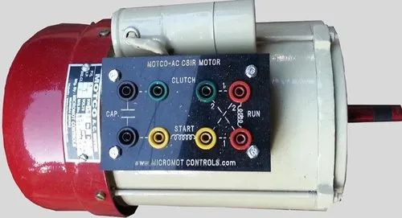

1. DC **motors:**

DC **motors** **provide** fast control and good power characteristics, making **them** suitable for applications **with** fast switching or high starting **power.**

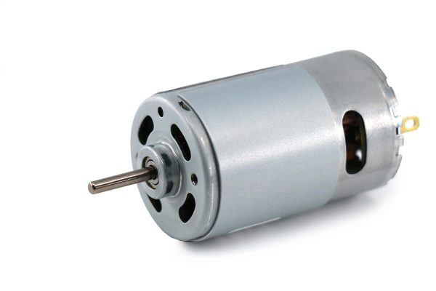

1. Servo **Motors:**

Servo **motors** **are** combined with feedback to provide position and speed control, making **them** ideal for robotics and **automation.**

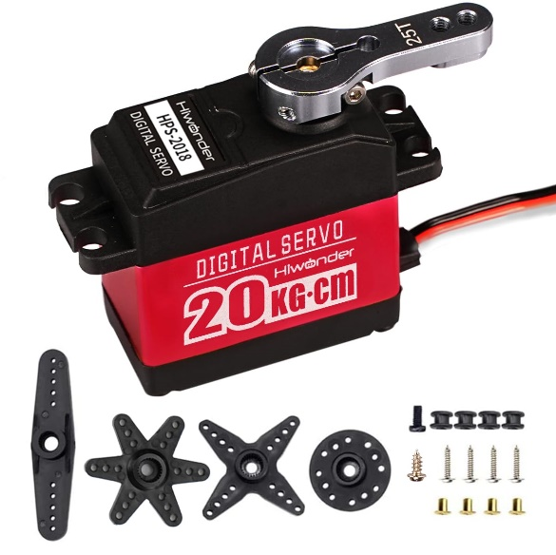

### **Independent control system:**

1. Programmable Logic Controller (PLC):

PLCs are rugged, **multi-function** controllers widely used in industrial automation. They offer ladder logic programming and user-friendly graphical **languages,** making them suitable for many **applications.**

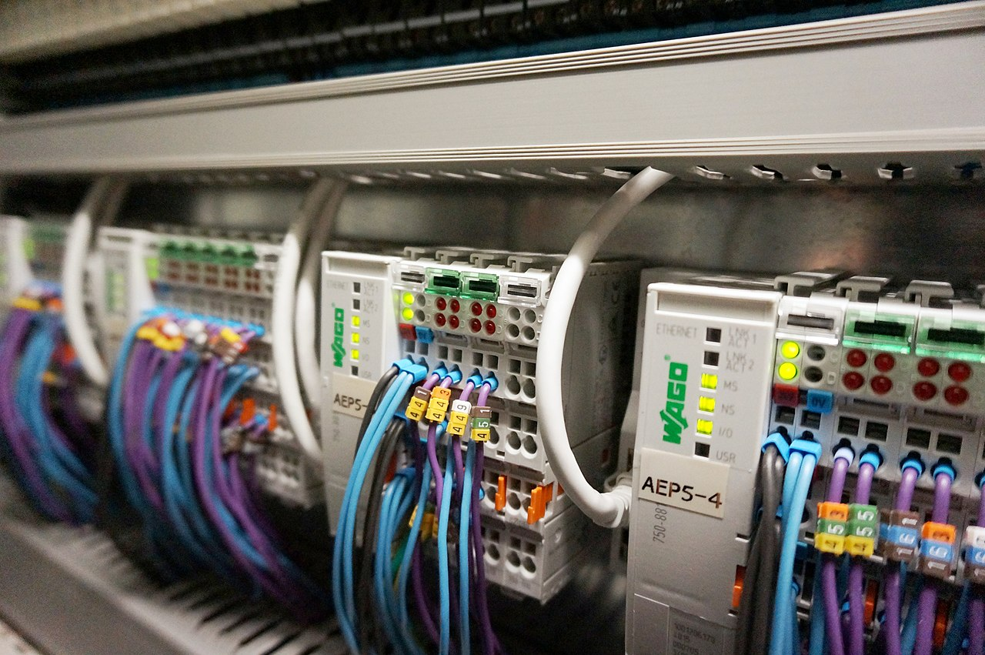

1. Distributed control system (DCS):

DCS is a large control system designed for complex business processes. They provide **administrative and** management control **through** centralized monitoring and **control.**

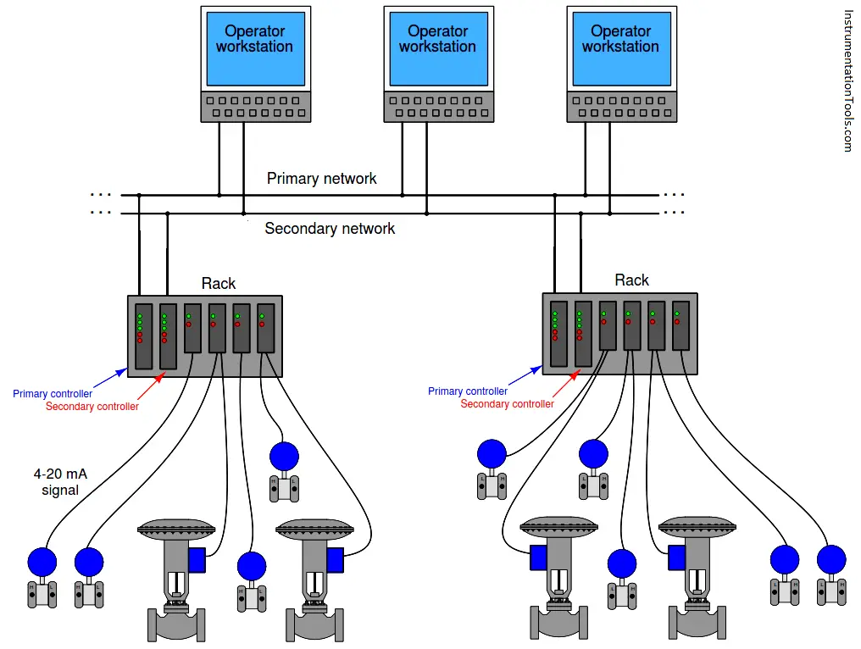

### 

### **Input/Output** Devices:

1. **Sensor:**

**The** **sensor** **is** **an** important **component** that **provides** feedback about the **system** environment and parameters. Such as temperature sensors, pressure sensors, position sensors and flow **sensors.**

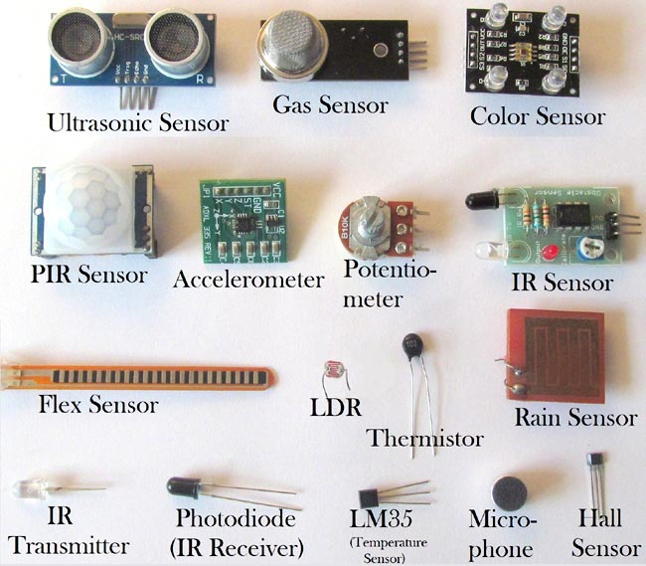

1. Actuator:

The actuator converts control signals into physical action. Including **solenoid** **valves,** valves, motors and pneumatic **actuators.**

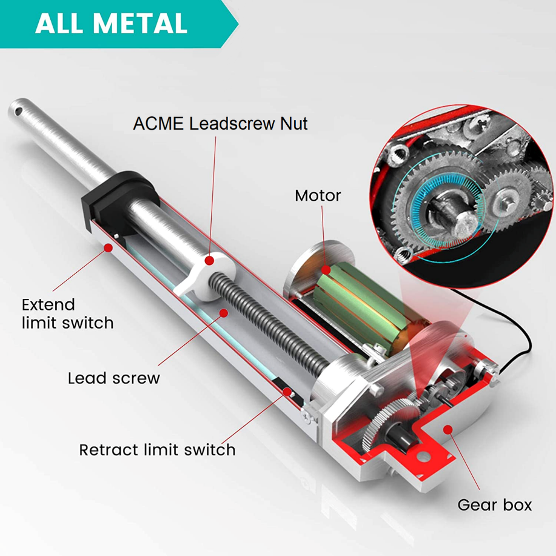

# **(c)**

## Suggestions for **Performance** **Improvement**

**Consider** electronic control **devices** used in manufacturing. This arm can select and place **items** accurately, but its performance can be improved by using the following tips:

1. Advanced sensor integration:

Integrate high resolution visual sensors to improve object recognition and positioning accuracy. This will reduce errors and improve the overall performance of the robot **arm.**

1. Adaptive control algorithm:

**Using** **the** adaptive control **algorithm,** arm movement **can** **be** **adjusted** **according** **to** **the** **measurement** **time.** This will **allow** the arm to control changes in **mass,** size and **position,** **increasing** **flexibility** and reducing **errors.**

1. Predictive maintenance:

Use predictive maintenance tools to monitor **locations** and predict **potential** **failures.** This will ensure proper maintenance, reduce downtime and increase overall **efficiency.**

# **Task 2**

# **(a)**

**Important Circuit and Controller**

**Important Circuit and Controller** Types for Sensor Measurements Circuit Types for Sensor Measurements: The circuit types used for sensor measurements depend on the physical value being measured. Some types of circuits include:

* Bridge circuits: These circuits are used to measure resistance, which is a measure for many sensors such as strain gauges and thermistors.
* oscillator circuits: These circuits are used to measure frequency, which is a disadvantage for sensors such as piezoelectric sensors and tachometers.
* amplifier circuits: These circuits are used to amplify the power of sensors so that they can be measured.

### **Importance of controllers in industrial control systems:**

Controllers play an important role in industrial control systems by providing necessary control signals to actuators to adjust and control the required process. They perform many functions, including:

* monitoring and feedback: The controller constantly monitors the system through sensors and receives feedback.
* error detection and correction: An error signal is generated by comparing the actual value with the reasonable value.
* control signal generation: According to the error problem, the controller produces the necessary control signal to drive the equipment.
* system optimization: The controller optimizes system performance by adjusting control parameters and adapting to changes.

# **(b)**

## **Justifications for Transducer and Controller Choices in Robotic Linear Motion**

Robotic linear motion systems play a crucial role in various industrial automation applications, requiring precise positioning and control. The choice of transducers and controllers significantly impacts the performance and accuracy of these systems.

### **Transducer Choices:**

The selection of transducers for robotic linear motion depends on several factors, including accuracy, range, resolution, and environmental conditions. Common types of transducers include:

1. Linear Encoders: These transducers are widely used for measuring linear position or displacement. They offer high accuracy, resolution, and reliability, making them suitable for demanding applications.
2. Linear Potentiometers: These transducers convert linear position into an electrical signal. They are relatively simple and cost-effective but may have lower accuracy compared to encoders.
3. Linear Resolvers: These transducers utilize electromagnetic principles to measure linear displacement. They provide contactless operation and immunity to environmental factors, making them suitable for harsh environments.

### **Controller Choices:**

The choice of controllers for robotic linear motion depends on the desired control performance, such as precision, speed, and robustness. Common types of controllers include:

1. Proportional-Integral-Derivative (PID) Controllers: PID controllers are widely used due to their simplicity, effectiveness, and adaptability. They are particularly suitable for applications requiring precise positioning and stable operation.
2. Fuzzy Logic Controllers: These controllers handle complex dynamics and non-linearities using fuzzy logic rules. They are well-suited for applications where mathematical modeling is difficult or imprecise.
3. Neural Network Controllers: Neural network controllers can learn from data and adapt to changing conditions. They are suitable for applications with complex dynamics or where traditional control methods struggle.

### **Control Method:**

The control method for robotic linear motion typically involves a closed-loop feedback system. This system continuously monitors the actual position through the transducer and compares it to the desired setpoint. The controller then generates an error signal and adjusts the control signal to the actuator accordingly. This feedback mechanism ensures accurate positioning and maintains the desired trajectory.

### **Reasons for Transducer Choice:**

The selection of transducers for robotic linear motion is guided by specific requirements:

* Accuracy: Encoders provide high accuracy, making them suitable for applications with tight tolerances.
* Range: Potentiometers offer a wide measurement range, suitable for applications with large displacements.
* Resolution: Resolvers provide high resolution, making them ideal for applications requiring fine-grained positioning.
* Environmental Conditions: Resolvers are resistant to harsh environments, making them suitable for industrial settings.

### **Reasons for Controller Choice:**

The choice of controllers for robotic linear motion is driven by performance objectives:

* Precision:

PID controllers provide precise positioning, suitable for applications demanding high accuracy.

* Speed:

Neural network controllers can handle high-speed applications due to their fast-learning capabilities.

* Robustness:

Fuzzy logic controllers are robust to disturbances and uncertainties, making them suitable for applications with varying conditions.

### **Conclusion:**

The selection of transducers and controllers for robotic linear motion is a crucial decision that impacts system performance, accuracy, and adaptability. The choice should be guided by specific application requirements, considering factors such as measurement range, resolution, environmental conditions, and desired control characteristics.

# **(c)**

Actuators are essential components in various systems, converting energy into mechanical motion to achieve desired actions. Pneumatic, hydraulic, and electrical actuators are widely used in industrial and automation applications due to their distinct characteristics and suitability for specific tasks.

### **Pneumatic Actuators:**

Pneumatic actuators utilize compressed air as their energy source, offering advantages such as cleanliness, safety, and compatibility with harsh environments. Their behavior under different controlling methods can be predicted as follows:

1. On/Off Control: With on/off control, the actuator is either fully energized or de-energized. This results in rapid actuation but can lead to oscillations and instability.
2. Proportional Control: Proportional control modulates the air supply proportional to the error signal, providing smoother and more controlled movement.
3. Servo Control: Servo control employs feedback from a position sensor to achieve precise positioning and tracking of desired trajectories.

### **Reasons for Choosing Pneumatic Actuators:**

1. Cleanliness: Pneumatic actuators are well-suited for applications where cleanliness and contamination control are critical, such as food processing and pharmaceutical industries.
2. Safety: Pneumatic systems operate using compressed air, eliminating the risk of electrical hazards and sparks in hazardous environments.
3. Harsh Environments: Pneumatic actuators can withstand harsh environments, such as high temperatures, dust, and moisture.

### **Improving Pneumatic Actuator Performance:**

1. Air Pressure Regulation: Maintaining consistent air pressure ensures reliable and predictable actuator behavior.
2. Leakage Prevention: Regular maintenance and inspection minimize air leaks, improving actuator efficiency and reducing energy consumption.
3. Sensor Integration: Integrating position sensors with servo control enhances positioning accuracy and reduces wear and tear on the actuator.

### **Hydraulic Actuators:**

Hydraulic actuators utilize pressurized hydraulic fluid as their energy source, offering high power-to-weight ratio and precise force control. Their behavior under different controlling methods can be predicted as follows:

1. On/Off Control: On/off control results in rapid actuation but can cause oscillations and instability due to the inertia of the hydraulic system.
2. Proportional Control: Proportional control provides smoother and more controlled movement by modulating the flow of hydraulic fluid.
3. Servo Control: Servo control employs feedback from a position sensor to achieve precise positioning and tracking of desired trajectories.

### **Reasons for Choosing Hydraulic Actuators:**

1. High Power Density: Hydraulic actuators offer high force output and power density, making them suitable for heavy-duty applications.
2. Precise Force Control: Hydraulic systems provide precise force control, enabling accurate positioning and force regulation.
3. Wide Operating Range: Hydraulic actuators can operate over a wide range of temperatures and pressures.

### **Improving Hydraulic Actuator Performance:**

1. Oil Filtration: Maintaining clean hydraulic fluid through proper filtration ensures optimal performance and extends actuator lifespan.
2. Pressure Regulation: Consistent hydraulic pressure ensures reliable and predictable actuator behavior.
3. Servo Valve Optimization: Selecting and optimizing servo valves improves positioning accuracy and responsiveness.

### **Electrical Actuators:**

Electrical actuators utilize electrical energy as their power source, offering advantages such as cleanliness, energy efficiency, and versatility. Their behavior under different controlling methods can be predicted as follows:

1. Pulse Width Modulation (PWM): PWM controls the average power delivered to the actuator by varying the pulse width of a DC signal.
2. Proportional Control: Proportional control modulates the voltage or current supplied to the actuator motor, providing smooth and controlled movement.
3. Servo Control: Servo control employs feedback from a position sensor to achieve precise positioning and tracking of desired trajectories.

### **Reasons for Choosing Electrical Actuators:**

1. Cleanliness: Electrical actuators operate without emitting emissions, making them suitable for cleanroom environments.
2. Energy Efficiency: Electrical actuators can be highly efficient, converting electrical energy into mechanical motion with minimal losses.
3. Versatility: Electrical actuators can be controlled with various methods and adapted to diverse applications.

### **Improving Electrical Actuator Performance:**

1. Motor Selection: Selecting the appropriate motor type and size ensures optimal performance for the specific application.
2. Driver Optimization: Optimizing the motor driver parameters improves control accuracy and responsiveness.
3. Feedback Sensor Integration: Integrating position sensors with servo control enhances positioning accuracy and reduces wear and tear on the actuator.

### **Conclusion:**

The behavior of pneumatic, hydraulic, and electrical actuators under different controlling methods depends on the specific actuator type, control method, and application requirements. Careful consideration of these factors is crucial for selecting the appropriate actuator and control method to achieve optimal system performance.

# **(d)**

## **Control Systems for Passive and Active Actuators and Transducers**

Passive actuators and transducers utilize stored energy or external forces to operate, while active actuators and transducers require an external power source to function. Control systems for both types play a critical role in ensuring precise and controlled operation.

### **Passive Actuators and Transducers:**

Passive actuators and transducers typically rely on mechanical principles to store and release energy, such as springs, flywheels, and dampers. Control systems for these components focus on optimizing their energy storage and release mechanisms to achieve the desired behavior.

* Example: A spring-loaded mechanism can be controlled by adjusting the spring tension or damping factor to regulate its movement.

### **Active Actuators and Transducers:**

Active actuators and transducers convert electrical energy into mechanical motion, such as motors, solenoids, and servo motors. Control systems for active actuators are designed to precisely control their movement and force output.

* Example: A motor can be controlled by regulating its voltage or current to achieve precise positioning and speed control.

### **Temperature and Pressure Control Systems**

Temperature and pressure control systems maintain desired conditions by regulating the flow of heat or fluid into or out of the system. They rely on feedback from sensors to monitor and adjust the control signal accordingly.

* Temperature Control: Temperature control systems use sensors to measure the temperature and adjust heating or cooling elements to maintain the desired setpoint.
* Example: A thermostat in a home heating system regulates the operation of the furnace to maintain a comfortable indoor temperature.
* Pressure Control: Pressure control systems use sensors to measure the pressure and adjust valves or pumps to maintain the desired setpoint.
* Example: A pressure regulator in a hydraulic system maintains a constant pressure to ensure consistent operation of hydraulic actuators.

### **Comparison of Control Methods**

Different control methods can be employed for passive and active actuators and transducers, as well as temperature and pressure control systems. Some common control methods include:

* On/Off Control: The simplest control method, where the actuator or control element is either fully energized or de-energized.
* Proportional Control: Modulates the control signal in proportion to the error between the desired and actual value.
* Proportional-Integral-Derivative (PID) Control: Combines proportional, integral, and derivative actions to achieve precise and stable control.
* Fuzzy Logic Control: Handles complex dynamics and non-linearities using fuzzy logic rules.
* Neural Network Control: Learns from data and adapts to changing conditions using artificial neural networks.

### **Limitations of Control Approaches**

Each control method has its own limitations:

* On/Off Control: Can cause oscillations due to its simple nature.
* Proportional Control: May not achieve precise control for large disturbances.
* PID Control: Requires careful tuning of parameters to avoid instability.
* Fuzzy Logic Control: May require complex rules and computational resources.
* Neural Network Control: Relies on large amounts of data and may struggle with generalization.

### **Full Comparison**

|  |  |  |  |  |  |
| --- | --- | --- | --- | --- | --- |
| **Feature** | **On/Off Control** | **Proportional Control** | **PID Control** | **Fuzzy Logic Control** | **Neural Network Control** |
| **Simplicity** | High | Medium | Medium | Low | Low |
| **Performance** | Limited | Moderate | High | High | High |
| **Adaptability** | Low | Medium | High | High | High |
| **Computational Requirements** | Low | Low | Medium | Medium | High |
| **Limitations** | Oscillations | Steady-state error | Instability | Rule complexity | Data dependency |

### **Conclusion**

The choice of control system depends on the specific application requirements, the type of actuator or transducer being used, and the desired performance criteria. Careful consideration of the limitations of different control approaches is essential to achieve optimal system performance.

# **Task 3**

# **(a)**

## **Practical Calibration of Temperature Sensors**

Practical calibration of temperature sensors involves comparing their readings to those of a reference standard under controlled conditions. This process ensures that the sensor accurately measures temperature over its desired range.

### **Steps for Practical Calibration:**

1. Selection of Reference Standard: Choose a reference standard with a higher accuracy than the sensor to be calibrated. Common reference standards include reference thermometers, ovens, and baths.
2. Establishing Temperature Points: Identify a set of reference temperatures across the sensor's desired range. These points should be evenly spaced and cover the sensor's operating temperature range.
3. Setting Reference Standard: Set the reference standard to each of the chosen reference temperatures.
4. Measuring Sensor Values: Place the sensor in contact with the reference standard at each temperature point. Record the sensor's readings for each temperature.
5. Comparing Sensor Values: Compare the sensor's readings to the reference standard's values for each temperature point. Calculate the error or correction factor for each temperature.
6. Applying Calibration Curve: Generate a calibration curve or table that relates the sensor's readings to the actual temperature values.
7. Calibration Adjustment: Adjust the sensor's output to compensate for any observed errors or correction factors.

### **Virtual Calibration of Temperature Sensors**

Virtual calibration of temperature sensors utilizes software simulation to validate their accuracy without the need for physical reference standards. This approach is particularly useful for sensors that are difficult to access or for applications where physical access is restricted.

### **Steps for Virtual Calibration:**

1. Sensor Model: Develop a mathematical model of the sensor that accurately represents its behavior. This model should incorporate the sensor's physical characteristics, its calibration coefficients, and any known nonlinearities.
2. Reference Temperature Data: Obtain reference temperature data from a reliable source, such as a well-characterized reference standard or a database of known temperature values.
3. Simulation: Simulate the operation of the sensor using the developed model and the reference temperature data. Compute the sensor's predicted readings for each reference temperature point.
4. Comparison: Compare the simulated sensor readings to the actual reference temperature values. Identify any discrepancies or errors in the sensor's model.
5. Calibration Adjustment: Modify the sensor's model parameters to improve the agreement between the simulated and actual readings.
6. Validation: Repeat the simulation and comparison process with different reference temperature data sets to ensure the accuracy and robustness of the sensor's virtual calibration.

### **Advantages and Disadvantages of Practical and Virtual Calibration:**

|  |  |  |
| --- | --- | --- |
| **Technique** | **Advantages** | **Disadvantages** |
| **Practical Calibration** | Provides direct comparison to a reference standard, ensuring accurate calibration | Requires physical access to the sensor and reference standard, may be time-consuming and expensive |
| **Virtual Calibration** | Can be performed without physical access to the sensor or reference standard, can be automated and efficient | Requires accurate sensor model and reference temperature data, may not be appropriate for all sensors |

### **Conclusion:**

Both practical and virtual calibration methods are valuable tools for ensuring the accuracy of temperature sensors. The choice between the two methods depends on the specific application, the accessibility of the sensor, and the desired level of accuracy. For critical applications where high accuracy is essential and physical access is limited, virtual calibration offers a convenient and efficient alternative to practical calibration.

# **(b)**

## **Electronic Measurement System: Digital Multimeter**

Digital multimeters (DMMs) are versatile electronic measurement tools widely used to measure voltage, current, resistance, and other electrical parameters. Their accuracy and reliability are crucial for various applications, including electronics testing, troubleshooting, and research.

### **Features:**

DMMs offer a range of features that enhance their functionality and ease of use:

* Auto-ranging: Automatically adjusts the measurement range based on the detected input signal, eliminating the need for manual range selection.
* Display: Provides a clear and readable digital display of the measured values.
* Backlight: Enables operation in low-light conditions.
* Data logging: Records measurement data for further analysis or documentation.
* Safety features: Incorporate protection against overvoltage, overcurrent, and short circuits.

### **Behavior:**

The behavior of a DMM can be characterized by its accuracy, resolution, and response time:

* Accuracy: The closeness of the measured value to the true value. DMMs typically have accuracy specifications of ±0.1% to ±1%.
* Resolution: The smallest change in the input signal that the DMM can detect and display. Higher resolution DMMs provide more precise measurements.
* Response time: The time it takes for the DMM to display the measured value in response to a change in the input signal. Faster response times are crucial for dynamic measurements.

### **Accuracy and Errors:**

The accuracy of DMM measurements is influenced by various factors, including:

* Calibration: Regularly calibrating the DMM against a known reference standard ensures its accuracy over time.
* Environmental conditions: Temperature, humidity, and electromagnetic interference can affect the accuracy of measurements.
* Operator error: Proper handling and connection techniques minimize operator-induced errors.

### **Methods to Address Accuracy and Errors:**

Several methods can be employed to improve the accuracy and reduce errors in DMM measurements:

* Calibration: Regular calibration maintains the DMM's accuracy within the specified limits.
* Environmental control: Shielding the DMM from electromagnetic interference and operating it within recommended temperature and humidity ranges minimize environmental effects.
* Shielding: Using shielded cables and connectors reduces the impact of noise and interference on the measurement signal.
* Zero adjustment: Performing zero adjustment before each measurement eliminates offset errors.
* Proper grounding: Ensuring proper grounding of the DMM and the device being measured reduces ground loops and noise.
* Averaging multiple measurements: Averaging multiple measurements over time can improve the accuracy of the final result.
* Data logging and analysis: Logging measurement data and analyzing trends helps identify and correct systematic errors.

### **Conclusion:**

DMMs are valuable tools for accurate electrical measurements. Understanding their features, behavior, and potential sources of error is essential for obtaining reliable and trustworthy results. By employing proper calibration techniques, environmental control, shielding, grounding, and data analysis methods, users can maximize the accuracy and minimize errors in DMM measurements.

# **(c)**

## **Measurement System: Voltage Divider Circuit**

A voltage divider circuit is a common circuit used to reduce the voltage of a signal. It consists of two resistors connected in series, with the output voltage measured across one of the resistors.

### **Ideal Circuit:**

In an ideal voltage divider circuit, the output voltage is exactly proportional to the input voltage and the ratio of the two resistors. The output voltage can be calculated using the following formula:

*Vout = Vin * (R2 / (R1 + R2))*

Where:

* Vout is the output voltage
* Vin is the input voltage
* R1 is the resistance of the first resistor
* R2 is the resistance of the second resistor

### **Real Circuit:**

In a real voltage divider circuit, the output voltage is not always exactly proportional to the input voltage due to various factors, including:

* Resistor tolerances: The actual resistance of the resistors may differ from their nominal values due to manufacturing tolerances.
* Leakage current: The resistors may have some leakage current, which can affect the output voltage.
* Parasitic capacitance and inductance: The resistors and other components in the circuit may have parasitic capacitance and inductance, which can affect the circuit's frequency response.

### **Simulation:**

To evaluate the performance of a real voltage divider circuit, we can use a circuit simulator to simulate the circuit and compare the simulated output voltage to the measured output voltage. We can also vary the resistor values and input voltage to see how these factors affect the output voltage.

### **Comparison of Ideal and Real Circuits:**

The following table compares the ideal and real voltage divider circuits:

|  |  |  |
| --- | --- | --- |
| **Feature** | **Ideal Circuit** | **Real Circuit** |
| **Output voltage** | Exactly proportional to input voltage | May differ from ideal due to resistor tolerances, leakage current, and parasitic effects |
| **Accuracy** | High accuracy | Lower accuracy due to real-world factors |
| **Error sources** | None | Resistor tolerances, leakage current, parasitic effects |

### **Errors and Accuracy:**

The accuracy of a voltage divider circuit can be calculated using the following formula:

*Accuracy = (Vout - Videal) / Videal * 100%*

Where:

* Vout is the measured output voltage
* Videal is the ideal output voltage

The error of a voltage divider circuit can be calculated using the following formula:

*Error = (**Videal - Vout) / Videal * 100%*

### **Conclusion:**

Simulation is a valuable tool for evaluating the performance of measurement systems. By comparing the simulated output voltage to the measured output voltage, we can identify and quantify the errors in the system. This information can then be used to improve the accuracy of the system.

# **Task 4**

# **(a)**

## **Analytical Techniques in MATLAB for Motor Control**

MATLAB provides a variety of analytical techniques for modeling and analyzing motor control systems, including:

### **Transfer Function Analysis**:

Transfer Function Analysis technique represents the relationship between the motor's input voltage (v) and its output speed (ω) using a transfer function (G(s)). The transfer function can be obtained using the following equation:

G(s) = (Jωm + B/K) / (RΩm + L/K)

Where:

* J is the motor's inertia (kg·m²)
* ωm is the motor's mechanical damping coefficient (N·m·s/rad)
* B is the viscous friction coefficient (N·m)
* K is the motor's torque constant (N·m/A)
* R is the motor's armature resistance (Ω)
* L is the motor's inductance (H)

## **State-Space Representation:**

State-Space Representation technique provides a more detailed mathematical description of the motor's dynamics. The state-space representation can be obtained using the following equations:

ẋ = Ax + Bu

y = Cx + Du

Where:

* x is the state vector (angular position [rad], angular velocity [rad/s], armature current [A])
* A is the state transition matrix
* B is the input matrix
* u is the input vector (input voltage [V])
* C is the output matrix
* y is the output vector (motor speed [rad/s])
* D is the feedthrough matrix

### **Root Locus Analysis**:

**Root Locus Analysis** technique examines the stability of a control system by plotting the location of the system's poles as a parameter varies. The poles of the system's transfer function can be determined using the following equation:

poles(G(s))

The root locus plot shows how the poles move as the parameter is varied. If all the poles of the system are located inside the unit circle in the complex plane, the system is stable.

### **Analytical Techniques in MATLAB for Transducer Control**

MATLAB also provides analytical techniques for modeling and analyzing transducer control systems, including:

### **Frequency Response Analysis**:

Frequency Response Analysis technique analyzes the frequency-domain response of the transducer to input signals. The transducer's frequency response can be obtained using the following equation:

H(ω) = G(s)|s=jω

Where:

* H(ω) is the transducer's frequency response
* G(s) is the transducer's transfer function
* ω is the frequency (rad/s)

1. Parameter Sensitivity Analysis: This technique analyzes how changes in transducer parameters affect the system's performance. The parameter sensitivity can be obtained using the following equation:

δY/δX = ∂Y/∂X

Where:

* δY is the change in the system's output (e.g., the voltage or current)
* δX is the change in the transducer parameter
* Y is the system's output
* X is the transducer parameter

### **Analytical Techniques in MATLAB for Actuator Control**

MATLAB also provides analytical techniques for modeling and analyzing actuator control systems, including:

### **Transient Analysis:**

Transient Analysis technique simulates the time-domain behavior of the actuator system, enabling analysis of voltage, current, and power waveforms. The transient analysis can be performed using the following command:

sim ('actuator_model', 'tspan', [0, Tmax])

Where:

* “actuator_model” is the name of the MATLAB model that represents the actuator system
* “tspan” is the time range of the simulation ([0, Tmax])

### **Frequency Analysis:**

Frequency Analysis technique simulates the frequency-domain response of the actuator system, allowing for analysis of gain, impedance, and phase characteristics. The frequency analysis can be performed using the following command:

bode('actuator_model')

### **Comparison of Analytical Techniques to Practical Measurements**

The analytical techniques used in MATLAB provide valuable insights into the behavior of motors, transducers, and actuators. However, it is important to compare these predictions to practical measurements to ensure accurate system modeling and reliable control. Practical measurements can be obtained using sensors and data acquisition systems. By comparing the simulated and measured responses, engineers can identify and correct any discrepancies between the theoretical and actual system behavior.

# **(b)**

## **Industrial Control of Induction Motors**

Induction motors are the most widely used type of electric motor in industry due to their simplicity, robustness, and cost-effectiveness. However, induction motors require sophisticated control systems to achieve precise and efficient operation.

### **Features and Characteristics**:

* Variable Speed Control: Induction motors can be controlled to operate at different speeds, providing flexibility in applications that require variable speed operation.
* High Efficiency: Induction motors can achieve high efficiency, especially at full load, making them energy-efficient and cost-effective to operate.
* Wide Torque Range: Induction motors can provide a wide range of torque, making them suitable for applications that require a high torque-to-weight ratio.
* Reliability and Robustness: Induction motors are known for their reliability and robustness, making them suitable for harsh industrial environments.

Analytical Techniques for Induction Motor Control:

Several analytical techniques are used for controlling induction motors, including:

### **Scalar Control:**

Scalar Control is the simplest and most common control method for induction motors. It controls the motor's speed by adjusting the voltage and frequency of the stator supply.

### **Vector Control:**

Vector Control is a more advanced control method that provides better performance and more precise control. It controls the motor's torque and flux directly, using vector control techniques.

### **Direct Torque Control (DTC):**

Direct Torque Control is a high-performance control method that provides very fast torque response. It directly controls the motor's torque and stator flux, without using speed or current feedback.

## **Limitations and Advantages of Analytical Techniques:**

### **Scalar Control:**

* Advantages: Simple, reliable, and cost-effective.
* Disadvantages: Limited performance, poor speed regulation, and no torque control.

### **Vector Control:**

* Advantages: High performance, precise control, and torque control.
* Disadvantages: More complex, requires more computation, and higher cost.

### **Direct Torque Control (DTC):**

* Advantages: Very fast torque response, good transient performance, and no speed or current feedback required.
* Disadvantages: Complex, requires more computation, and higher cost.

## **Conclusion:**

Induction motors are essential components in industrial automation systems. Analytical techniques play a crucial role in achieving precise and efficient control of induction motors. The choice of control method depends on the specific application requirements, considering factors such as performance, cost, and complexity.

# **(c)**

## **Control of Large Stepper Motors in Industrial Systems**

Large stepper motors are widely used in industrial systems due to their precise and controllable positioning capabilities. They are particularly well-suited for applications that require high torque, low speed, and accurate positioning, such as robotics, CNC machines, and printing presses.

## **Analytical Techniques for Large Stepper Motor Control**:

Several analytical techniques are used for controlling large stepper motors, including:

### **Open-Loop Control**:

Open-loop control is the simplest and most common control method for stepper motors. It directly sends step pulses to the motor driver, without feedback from the motor. This method is inexpensive and easy to implement, but it can be less accurate and more prone to errors due to factors such as load variations and mechanical resonances.

### **Closed-Loop Control**:

Closed-loop control incorporates feedback from the motor to improve accuracy and performance. It uses encoders or resolvers to measure the motor's position and compare it to the desired position. The controller then adjusts the step pulses to correct any errors and maintain the desired position. Closed-loop control is more complex and expensive than open-loop control, but it provides significantly better accuracy and performance.

### **Micro stepping**:

Micro stepping is a technique that divides each full step of the motor into smaller micro steps. This allows for smoother motion and higher resolution, especially at low speeds. Micro stepping requires more sophisticated control algorithms and higher-performance motor drivers, but it can significantly improve the performance of stepper motor systems.

## **Justification and Recommendations for Improved Performance**:

* Encoder Selection: Use high-resolution encoders with low noise levels to provide accurate feedback for closed-loop control.
* Motor Driver Selection: Choose a motor driver with sufficient power handling capacity and advanced features like micro stepping support and current regulation.
* Control Algorithm Optimization: Optimize the control algorithm parameters, such as acceleration rates, deceleration rates, and micro stepping resolution, to achieve the desired performance characteristics.
* Mechanical System Design: Consider factors such as motor selection, gear reduction ratios, and mechanical stiffness to minimize load variations and resonances that can affect motor performance.
* Environmental Considerations: Protect the motor and control system from environmental factors such as dust, moisture, and vibrations.

## **Conclusion**:

Large stepper motors offer precise and controllable positioning capabilities for a wide range of industrial applications. By employing appropriate analytical techniques, such as closed-loop control and micro stepping, along with careful component selection, system optimization, and environmental considerations, engineers can achieve optimal performance and reliability in large stepper motor systems.

### **Additional Considerations**:

* Hybrid Stepper Motors vs. Permanent Magnet Stepper Motors: Hybrid stepper motors offer higher torque and lower cost, while permanent magnet stepper motors provide higher efficiency and smoother motion.
* Motor Cooling: Proper motor cooling is crucial for continuous operation and to prevent overheating, especially in high-power applications.
* Maintenance and Troubleshooting: Regular maintenance and troubleshooting can help identify and resolve potential issues that could affect motor performance.

**Bibliography**

* Khalil, W. (2011). Fundamentals of electronically controlled industrial systems
* [W. Bolton, "Programmable Logic Controller" (2009)]
* In Robotics and Automation (ICRA), 2018 IEEE International Conference on (pp. 1-6). IEEE
* Fundamentals for industrial applications. John Wiley & Sons
* K. Ogata, "Modern Control Engineering" (2010)

Open-Loop Control:

* "Stepper Motors: Fundamentals, Applications, and Design" by A. A. Gorinevsky

Closed-Loop Control:

* "Control of Electric Drives" by Ion Boldea and Sabin Nasar

Micro stepping:

* "Stepper Motors and Their Applications" by C. M. Close

Encoder Selection:

* "Encoder Applications Manual" by Renesas Electronics Corporation

Motor Driver Selection:

* "Stepper Motor Driver Selection Guide" by Oriental Motor Company

Control Algorithm Optimization:

* "Control of Stepper Motors" by William Y. Lee

Mechanical System Design:

* "Mechatronic Systems Design" by H. M. Zoeller and H. Aschemann

Environmental Considerations:

* "Protecting Industrial Control Systems from Environmental Stress" by Robert C. Whitehead

Induction Motor Control

* "Electric Drives" by N. Mohan
* "Power Electronics and Motor Drives" by E. A. Drehmel and D. W. Drury

Analytical Techniques for Induction Motor Control

* "Induction Motor Control Systems" by R. Krishnan
* "Vector Control of Electric Drives" by D. G. Holmes and T. A. Lipo

Direct Torque Control (DTC)

* "Direct Torque Control of Induction Motors" by L. Xu and Y. Tang
* "A Comprehensive Study on Direct Torque Control of Induction Motors" by A. M. Trzynadlowski

Justification and Recommendations for Improved Performance

* "Design of Brushless Permanent-Magnet Motors" by D. G. Holmes
* "Advanced Motion Control of Electric Drives" by A. M. Trzynadlowski