STACKLENS
See Every Push and Pop
A stack-based expression evaluator with exact arithmetic,
positioned error messages and an animated stack visualizer

DCOMP320 Data Structures and Algorithms
Individual Assignment: Stacks Implementation

Name: Abdulai Bah
Course: DCOMP320 Data Structures and Algorithms
Institution: Limkokwing University of Creative Technology, Sierra Leone
Submission date: October 2026
GitHub repository: dcomp320-stacklens

CONTENTS
1. Introduction
2. Data Structures Used
3. Program Design
4. Testing and Results
5. Conclusion
6. References
Quick guide: the program is stacklens.py. Run it with python stacklens.py, then open stacklens.html in a web browser to watch the stacks work.
1. INTRODUCTION
A stack is easy to describe and surprisingly hard to see. Push, pop and peek happen in a fraction of a second, and the only evidence is the final answer. This project began with a simple question: what if the program could show every push and pop, so that anyone, including the person who wrote it, can watch exactly how 3 + 5 * 2 becomes 13?
The result is StackLens, a Python program that meets the assignment requirements and goes further. It reads expressions from input.txt, evaluates each one using stacks, and writes the results to output.txt in the same layout, with every separator line (-----) kept in place. It supports +, -, * and /, brackets and correct precedence, as required. In addition:
• It shows its working. After every step the program records the contents of both stacks. This feeds a plain-text trace (trace.txt) and an animated web page (stacklens.html) in which the person clicks through any expression one push or pop at a time.
• It calculates exactly. Numbers are stored as fractions, so 1 / 3 + 1 / 3 + 1 / 3 is exactly 1 and 0.1 + 0.2 is exactly 0.3.
• Every error says where the problem is. For example, 3 + * 4 gives: unexpected '*' at position 5.
• It supports powers and negative numbers. The ^ operator (also written **) works right to left, and -2 ^ 2 is -4, as in mathematics.
• It is tested thoroughly. There are 38 system tests, many of them real-life Sierra Leone examples in New Leones, and 27 automated unit tests, including a check of 400 random expressions against an independent calculator.
• It is built for demonstration. The --expr option evaluates one expression and prints its working, which suits a live demonstration to a lecturer.
Section 2 explains the stack data structure and how three stacks are used. Section 3 describes the design. Section 4 reports the testing and results, including a discussion of the input and output files. Section 5 concludes and Section 6 lists the references.
2. DATA STRUCTURES USED
2.1 What a stack is
A stack is a collection that follows the Last In, First Out (LIFO) rule: the item added most recently is the first item removed. A pile of plates is the usual picture. A new plate goes on the top and the next plate taken is the top one, so only the top of the stack can be reached. A stack is an abstract data type: it is defined by the operations it offers, not by how it is built.
Operation | Meaning | Time cost | Used in StackLens to
push(item) | Place an item on the top | O(1) | put a number, an operator or a bracket position on a stack
pop() | Remove and return the top item | O(1) | take numbers for a calculation; remove a finished bracket
peek() | Look at the top item without removing it | O(1) | decide whether the waiting operator must go first
is_empty() | True if there are no items | O(1) | stop loops safely
size() | Number of items | O(1) | check how many numbers are available
snapshot() | A copy of the contents, bottom first (added) | O(n) | record the stacks after every step
Table 1: Stack operations and where each is used
2.2 How the Stack class is built
The Stack class keeps its items in a Python list inside a private attribute, so other code can only use the stack through its operations. The end of the list is the top of the stack, because adding and removing at the end of a list takes constant time. pop and peek raise an IndexError on an empty stack, so a mistake in the logic stops at once and is never hidden. The class also provides __len__ and __repr__ for convenience when debugging.
2.3 Two stacks evaluate an expression
An expression such as 10 - (2 + 3) * 4 contains numbers that cannot be used yet and operators that must wait their turn. The program uses two stacks, following the two-stack method associated with Dijkstra. The value stack holds numbers and intermediate results. The operator stack holds operators and open brackets that are waiting. The rules for each token are:
1. A number is pushed on the value stack.
2. A negative sign or an open bracket is pushed on the operator stack.
3. A close bracket applies waiting operators until the open bracket is on top, then removes that bracket.
4. An operator (+ - * / ^) first applies every waiting operator that must go first, then is pushed. An operator must go first if it has higher precedence, or equal precedence and the new operator is worked left to right. Power is worked right to left, so a waiting ^ is not applied when another ^ arrives.
5. Applying an operator means popping its number or numbers, calculating, and pushing the answer back.
6. At the end, the remaining operators are applied. The single number left on the value stack is the answer.
Table 2 shows these rules on the handout example (8 / 4) + 7 * 2. The table was produced by running the program, not typed by hand: each row is one snapshot taken by the observer. It ends with 16.
Step | Token | What happens | Value stack | Operator stack
0 | start | start: both stacks are empty | [] | []
1 | ( | '(': push on the operator stack | [] | [(]
2 | 8 | number 8: push on the value stack | [8] | [(]
3 | / | operator /: push on the operator stack | [8] | [(, /]
4 | 4 | number 4: push on the value stack | [8, 4] | [(, /]
5 | ) | apply 8 / 4 = 2; ')': brackets done, remove '(' | [2] | []
6 | + | operator +: push on the operator stack | [2] | [+]
7 | 7 | number 7: push on the value stack | [2, 7] | [+]
8 | * | operator *: push on the operator stack | [2, 7] | [+, *]
9 | 2 | number 2: push on the value stack | [2, 7, 2] | [+, *]
10 | end | apply 7 * 2 = 14; apply 2 + 14 = 16 | [16] | []
Table 2: Evaluating (8 / 4) + 7 * 2, one step at a time
Power needs special care because it is worked right to left. Table 3 shows 2 ^ 3 ^ 2, which means 2 ^ (3 ^ 2) = 512 and not (2 ^ 3) ^ 2 = 64. Notice that the second ^ is pushed on top of the first without applying it, so the 3 ^ 2 is calculated first.
Step | Token | What happens | Value stack | Operator stack
0 | start | start: both stacks are empty | [] | []
1 | 2 | number 2: push on the value stack | [2] | []
2 | ^ | operator ^: push on the operator stack | [2] | [^]
3 | 3 | number 3: push on the value stack | [2, 3] | [^]
4 | ^ | operator ^: push on the operator stack | [2, 3] | [^, ^]
5 | 2 | number 2: push on the value stack | [2, 3, 2] | [^, ^]
6 | end | apply 3 ^ 2 = 9; apply 2 ^ 9 = 512 | [512] | []
Table 3: Power is worked right to left
2.4 A third stack: finding where brackets go wrong
Before any calculation, a third stack checks the brackets. Each open bracket pushes its position in the line. Each close bracket must pop a position. If a close bracket arrives and the stack is empty, there is an extra close bracket. If the stack is not empty at the end, the position on top is the open bracket that was never closed. Pushing positions instead of the bracket characters costs nothing extra, but it lets the program say exactly where the mistake is. Tables 4 and 5 show two faulty expressions.
Position | Char | Action | Stack of open positions
1 | ( | open bracket: push its position | [1]
2 | ( | open bracket: push its position | [1, 2]
8 | ) | close bracket: pop the matching position | [1]
end | - | stack still holds 1: that '(' is never closed: error | [1]
Table 4: Checking ((2 + 3): the '(' at position 1 is never closed
Position | Char | Action | Stack of open positions
1 | ( | open bracket: push its position | [1]
7 | ) | close bracket: pop the matching position | [ ]
8 | ) | close bracket, but the stack is EMPTY: error | [ ]
Table 5: Checking (2 + 3)): the ')' at position 8 has no partner
2.5 Exact arithmetic with fractions
Ordinary floating-point numbers are stored in binary, and many everyday decimals such as 0.1 cannot be stored exactly. Small errors then appear in results. StackLens stores every number as a fraction using Python's Fraction type: 0.1 becomes 1/10, and 1 / 3 stays 1/3, with nothing lost. The numbers are rounded only once, at the very end, when the result is printed with up to four decimal places. Table 6 compares the two approaches. The right-hand column was produced by the program.
Expression | Ordinary floating-point result | StackLens result (exact)
0.1 + 0.2 | 0.30000000000000004 | 0.3
0.1 * 3 | 0.30000000000000004 | 0.3
1000 * (1 + 0.05) ^ 3 | 1157.6250000000002 | 1157.625
(98.6 - 32) * 5 / 9 | 37.0 | 37
Table 6: Floating-point versus exact fractions
2.6 Why stacks matter in computing
• The call stack: each function call pushes a return address and each return pops it. This is how functions and recursion work.
• Undo and redo: editors push every change on a stack; undo pops the latest one.
• Browser history: the back button pops the most recently visited page.
• Compilers and code editors: stacks match brackets and evaluate expressions, which is exactly what this program does.
• Debugging: a crash report prints a stack trace, a picture of the call stack at the moment of failure. StackLens applies the same idea to its own work: its trace is a record of both stacks at every step.
• Search and backtracking: depth-first search, maze solving and puzzle solving keep a stack of places still to try.
3. PROGRAM DESIGN
3.1 Design goals
Goal | How the design achieves it
Correctness | Standard precedence and associativity; exact fractions; checked against an independent calculator
Explainability | An observer reports both stacks after every step, so any answer can be traced
Robustness | Every bad input raises one error type, StackLensError, with a clear message and position; no input can crash the program
Clarity | The program is one file in seven labelled parts; each function has a single job
Usability | Works from any folder; clear messages; a one-line demo mode (--expr)
Table 7: Design goals
3.2 Architecture
The program, stacklens.py, is organised into seven labelled parts. Figure 1 shows how they connect. Solid arrows mean 'calls'. Dashed arrows mean 'may raise an error'. The same evaluate function serves both the file run and the --expr demo.
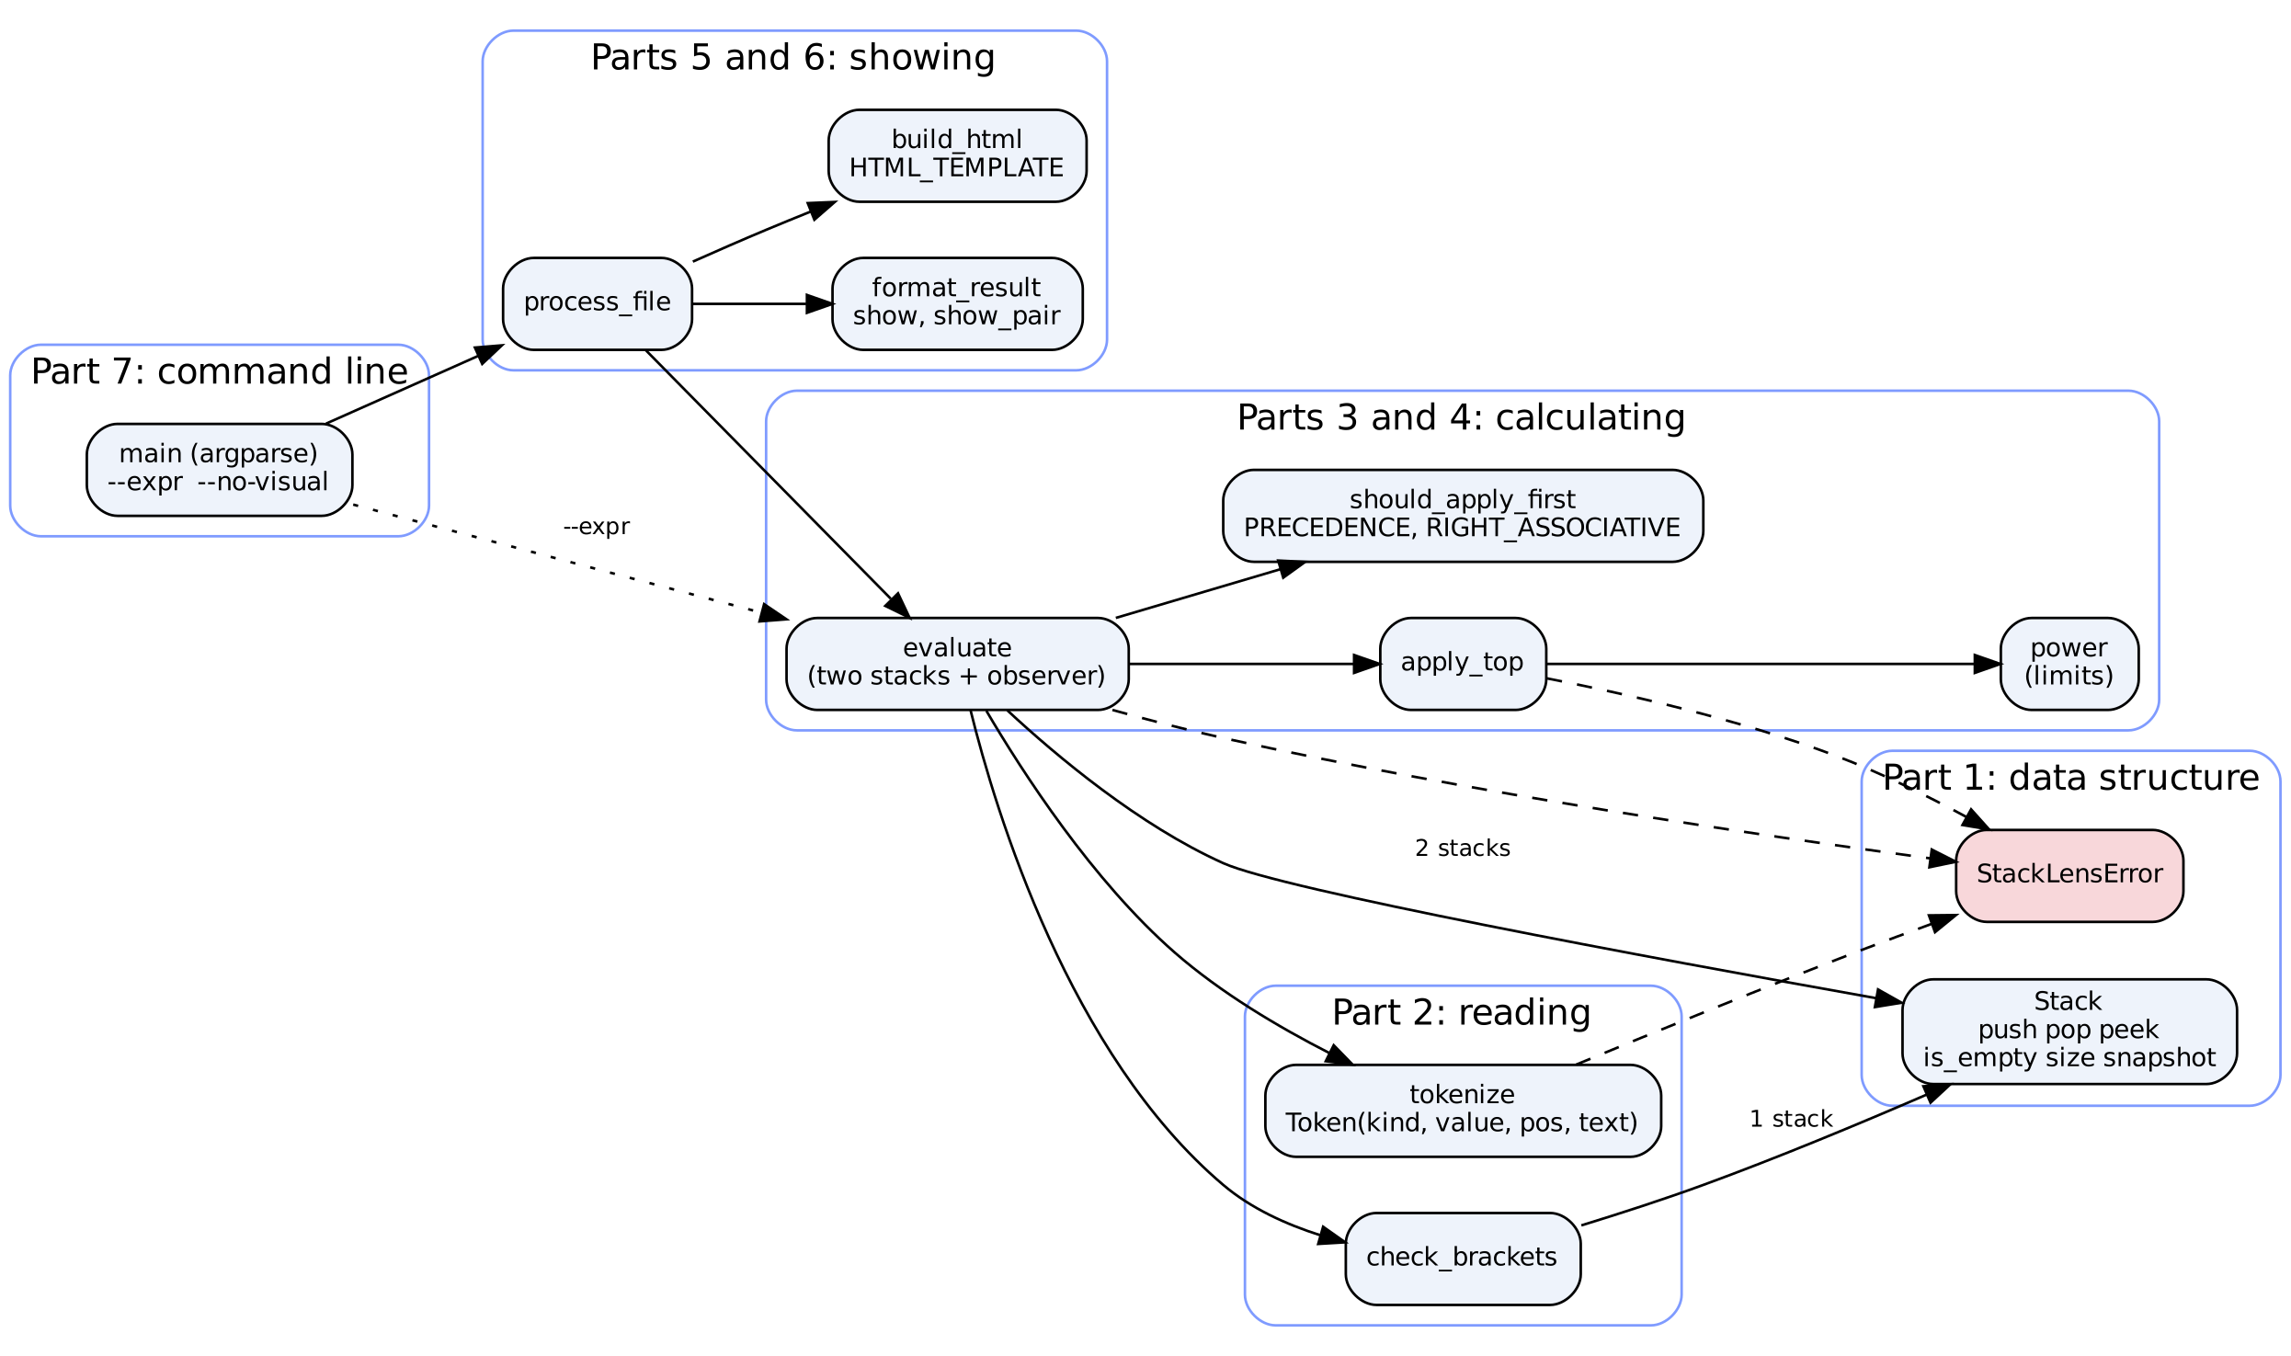
Figure 1: Architecture of stacklens.py
Component | Responsibility
Stack | The LIFO data structure (push, pop, peek, is_empty, size, snapshot)
StackLensError | The single error type for every problem with an expression
Token, tokenize | Splits a line into numbers, operators, brackets and negative signs; every token remembers its position
check_brackets | Uses a stack of positions to find missing or extra brackets
evaluate | The two-stack algorithm; calls the observer after every step
apply_top, power | Takes an operator and its numbers off the stacks, calculates exactly, pushes the answer; power enforces its limits
should_apply_first | Decides, from PRECEDENCE and RIGHT_ASSOCIATIVE, whether a waiting operator goes first
format_result, show, show_pair | Turn an exact fraction into text (no decimal point for whole numbers; up to four decimals otherwise)
process_file | Reads input.txt, copies separators, evaluates, writes output.txt, trace.txt and stacklens.html
build_html | Inserts the recorded steps into the visualizer page
main | The command line: file names, --expr and --no-visual
Table 8: Components
3.3 Program flow
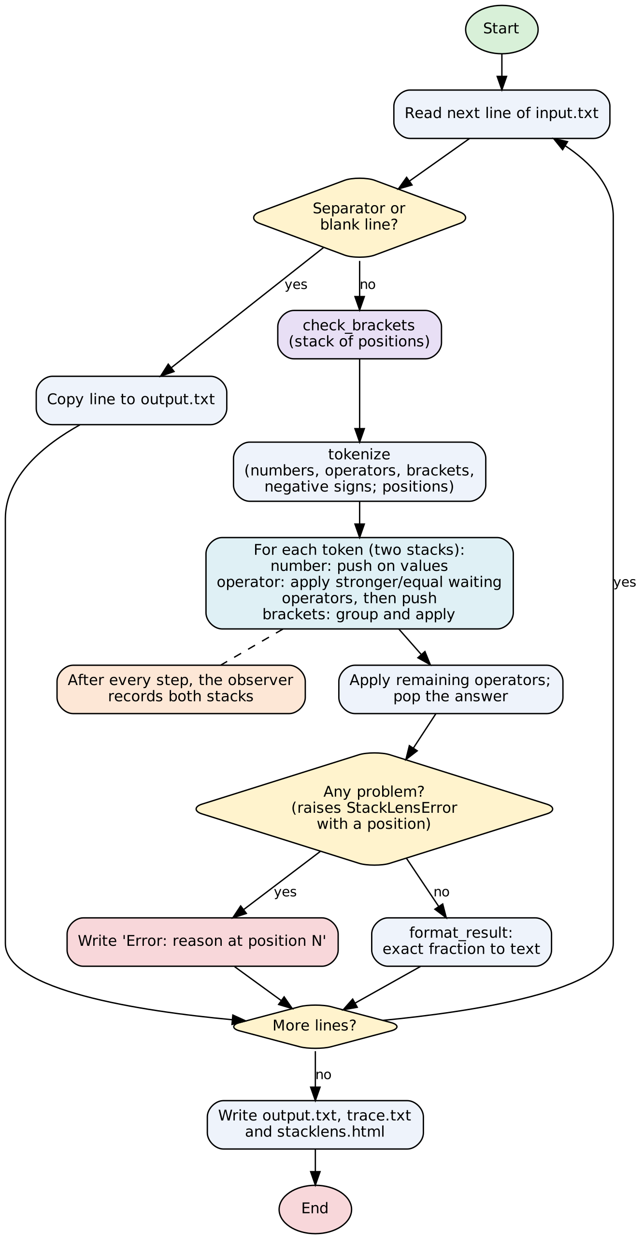
Figure 2: Flowchart of the program
3.4 Pseudocode
evaluate
check_brackets(text) // stops with a positioned error if wrong
tokens = tokenize(text)
values = new Stack; operators = new Stack; expect_number = true
report the empty stacks to the observer
for each token:
if token is a number:
if not expect_number: error "missing operator before number"
push it on values; expect_number = false
else if token is a negative sign:
push it on operators
else if token is "(":
if not expect_number: error "missing operator before ("
push it on operators
else if token is ")":
if expect_number: error "nothing to calculate before )"
while top of operators is not "(": apply_top
pop and discard "("
else: // + - * / ^
if expect_number: error "unexpected operator"
while operators is not empty and top is not "(" and should_apply_first(top, token):
apply_top
push token on operators; expect_number = true
report both stacks to the observer
if expect_number: error "expression ends unexpectedly"
while operators is not empty: apply_top
return the single number left on values

apply_top and should_apply_first
apply_top:
op = pop operators
if op is a negative sign: push -(pop values)
else:
b = pop values; a = pop values // the second number comes off first
if op is "/" and b = 0: error "division by zero"
push (a op b) on values // power checks exponent first

should_apply_first(top, incoming):
if precedence(top) is not equal to precedence(incoming):
return precedence(top) > precedence(incoming)
return incoming is left-to-right // equal precedence: only if not power

check_brackets
opened = new Stack
for position = 1 to length of text:
if character is "(": push position on opened
else if character is ")":
if opened is empty: error "unexpected ) at position"
pop opened
if opened is not empty: error "( at position <top of opened> is never closed"

3.5 Precedence and order
Operator | Precedence | Order of working | Example
^ or ** | 4 (highest) | right to left | 2 ^ 3 ^ 2 = 512
negative sign | 3 | applied after a power, before * and / | -2 ^ 2 = -4; -3 * 2 = -6
* / | 2 | left to right | 100 / 4 / 5 = 5
+ - | 1 | left to right | 10 - 4 - 3 = 3
Table 9: Operator precedence
3.6 Error handling
Every problem with an expression raises StackLensError. process_file catches it and writes the message on that expression's line, so one bad line never stops the run. Most messages include the position of the problem, counting from 1.
Problem | Example | Message written to output.txt
Division by zero | 8 / (4 - 4) | division by zero (the '/' at position 3)
Missing close bracket | (3 + 4 | mismatched parentheses: '(' at position 1 is never closed
Extra close bracket | 3 + 4) | mismatched parentheses: unexpected ')' at position 6
Operator with no number | 3 + * 4 | unexpected '*' at position 5
Expression ends too early | 5 - | expression ends unexpectedly: a number is missing after '-' at position 3
Empty brackets | () | nothing to calculate before ')' at position 2
Two numbers in a row | 3 4 | missing operator before number 4 at position 3
Number touching a bracket | 3(4) | missing operator before '(' at position 2
Unknown character | 7 $ 2 | invalid character '$' at position 3
Malformed number | 1.2.3 + 4 | invalid number '1.2.3' at position 1
Fractional exponent | 2 ^ 0.5 | exponent must be a whole number (the '^' at position 3)
Zero to a negative power | 0 ^ -1 | division by zero (0 raised to a negative power, the '^' at position 3)
Exponent over the limit | 2 ^ 5000 | exponent too large, the limit is 1000 (the '^' at position 3)
Table 10: Errors and their messages (each prefixed with 'Error: ' in the file)
3.7 The visualizer
The most visible extra is stacklens.html, written every time the program runs. It is one self-contained page with no internet connection and no libraries needed. The recorded steps are embedded in the page as data, and a small script draws them. The person chooses an expression from the list on the left and steps through it: the token being processed is highlighted, a sentence explains what happened, and the two stacks are drawn as columns of blocks, with newly pushed blocks sliding in.
• Controls: Next, Back, first, last, Play and Pause, with a speed slider.
• Keyboard: left and right arrows step, Space plays or pauses, Home and End jump, up and down change expression.
• Exact values: a result such as 10/3 is shown as 3.3333 with the exact fraction underneath.
• Accessibility: buttons have text labels, there is a visible focus outline, colours are not the only signal (stacks are labelled), and animations are switched off for people who prefer reduced motion.
• Light and dark themes: it follows the device setting and has a Theme button.
• Responsive: it works on a phone-width screen with no sideways scrolling. This was checked in a real browser.
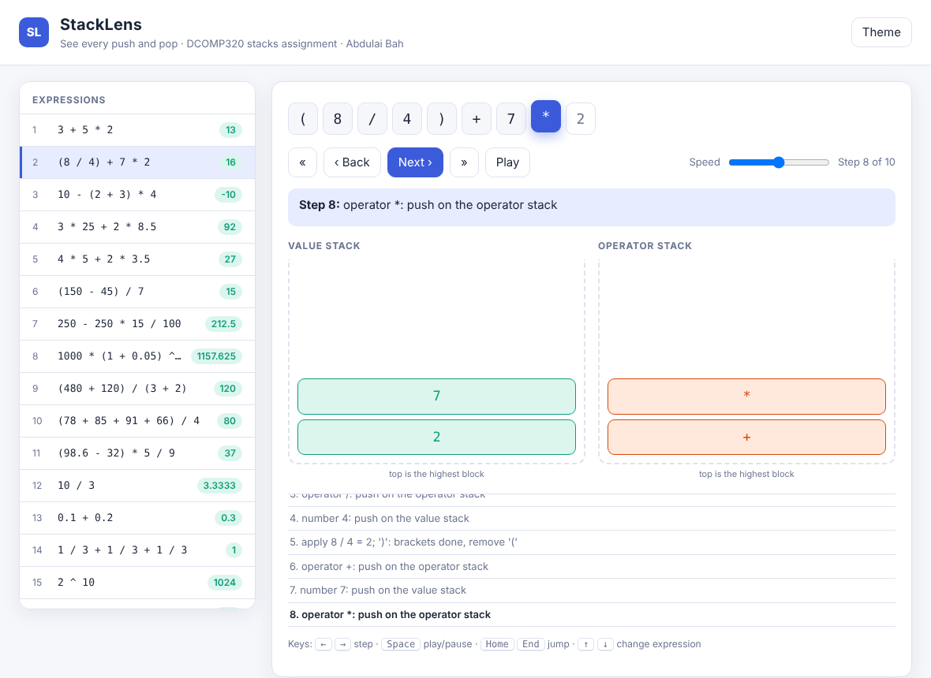
Figure 3: The visualizer, light theme, midway through (8 / 4) + 7 * 2
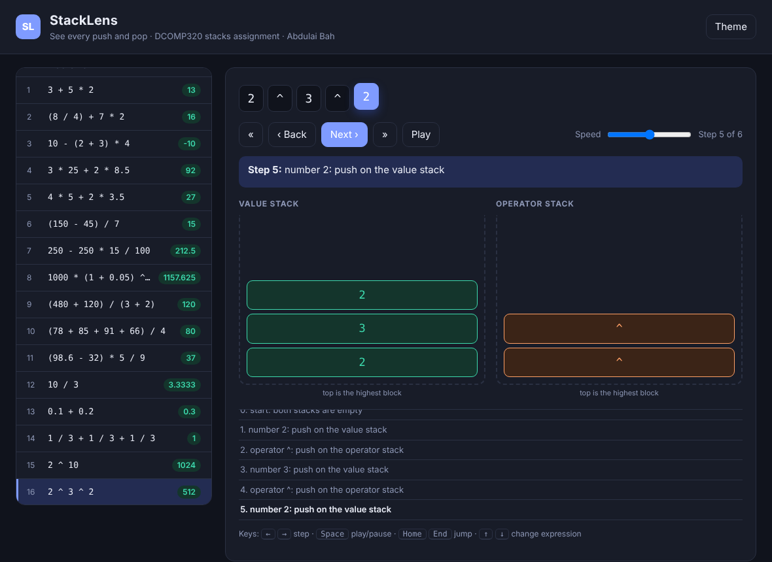
Figure 4: The visualizer, dark theme, evaluating 2 ^ 3 ^ 2
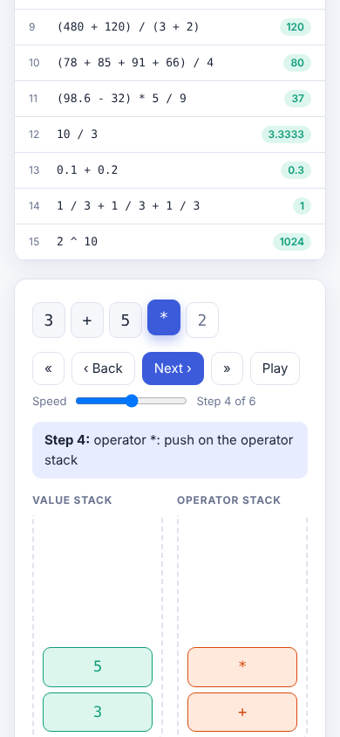
Figure 5: The visualizer on a phone-width screen
Because the page is static, it could also be published on GitHub Pages to give the project a live web link.
3.8 Requirements and extras at a glance
Handout requirement | How StackLens meets it | Extra beyond the requirement
Stack class with push, pop, peek | Stack class, with is_empty and size | snapshot(), __len__, __repr__
Evaluate + - * / with brackets and precedence | Two-stack algorithm | Power, negative numbers, decimals, exact fractions
Read input.txt | process_file | Custom file names; clear message if the file is missing
Write output.txt, separators kept | Same layout, line for line | Position in every error message
Testing and results | 38 system tests | 27 unit tests; 400 random expressions checked; 60,000 random inputs stress-tested
README with run, formats, assumptions | README.md | Screenshots; GitHub Pages instructions
GitHub | Repository with a commit history | Optional live visualizer link
Table 11: Requirements and extras
3.9 Efficiency and limits
Each token is pushed and popped at most once and every stack operation is O(1), so an expression of n tokens takes O(n) time and O(n) space, plus the cost of the arithmetic itself. The bracket check is also O(n). Recording the steps adds a constant amount of work per step. To stop absurd requests from freezing the computer, the program limits exponents to between -1000 and 1000 and refuses results that would be astronomically large.
4. TESTING AND RESULTS
4.1 Testing strategy
Testing was done in four layers, each catching a different kind of mistake:
1. System tests (38). The whole program is run on input.txt and the output file is checked line by line. Every expected value was calculated by an independent method: a short recursive-descent calculator that uses exact fractions and no stacks. Expected error messages were written by hand, including the positions.
2. Unit tests (27). Small pieces of the program are tested on their own with python -m unittest. They can be repeated after any change.
3. Random comparison (400 expressions). A generator builds 400 random valid expressions with brackets, negatives, decimals and powers. StackLens and the independent calculator must agree on every one.
4. Random garbage (600 inputs in the tests; 60,000 in a separate run). Random strings of digits, symbols and spaces are fed to the program. Any outcome is acceptable except a crash: it must give an answer or a clean StackLensError.
The last layer found a real bug. A line containing only a plus sign, such as +, produced no tokens at all, and the evaluator crashed with an IndexError when it tried to name the last token in its error message. The test failed, the evaluator was changed to report 'no numbers to calculate', a test for that exact input was added, and the 60,000-input run was repeated with no crashes. This is the kind of mistake that hand-chosen test cases rarely find.
4.2 System tests: valid expressions
The first 25 test cases are valid expressions. They include the three handout examples and nine real-life examples, with illustrative prices in New Leones (NLe), the currency of Sierra Leone. Table 12 lists them with the expected value from the independent calculator and the output of the program. All 25 matched.
# | Expression | Scenario | Expected | Output | Result
1 | 3 + 5 * 2 | Handout example 1 | 13 | 13 | Pass
2 | (8 / 4) + 7 * 2 | Handout example 2 (the handout's 17 is a typo; correct is 16) | 16 | 16 | Pass
3 | 10 - (2 + 3) * 4 | Handout example 3 | -10 | -10 | Pass
4 | 3 * 25 + 2 * 8.5 | Market: 3 kg of rice at 25 NLe plus 2 bundles at 8.5 NLe | 92 | 92 | Pass
5 | 4 * 5 + 2 * 3.5 | Shared taxi: 4 adults at 5 NLe plus 2 children at 3.5 NLe | 27 | 27 | Pass
6 | (150 - 45) / 7 | Data budget: 150 NLe less 45 NLe already spent, per day over 7 days | 15 | 15 | Pass
7 | 250 - 250 * 15 / 100 | A 15% discount on a 250 NLe item | 212.5 | 212.5 | Pass
8 | 1000 * (1 + 0.05) ^ 3 | Savings: 1,000 NLe at 5% a year for 3 years | 1157.625 | 1157.625 | Pass
9 | (480 + 120) / (3 + 2) | Sharing costs: 480 NLe plus 120 NLe among 5 people | 120 | 120 | Pass
10 | (78 + 85 + 91 + 66) / 4 | Average of four test scores | 80 | 80 | Pass
11 | (98.6 - 32) * 5 / 9 | Fahrenheit to Celsius | 37 | 37 | Pass
12 | 10 / 3 | Sharing 10 NLe among 3 people (needs rounding) | 3.3333 | 3.3333 | Pass
13 | 0.1 + 0.2 | Decimal exactness | 0.3 | 0.3 | Pass
14 | 1 / 3 + 1 / 3 + 1 / 3 | Exact fractions: three thirds make exactly 1 | 1 | 1 | Pass
15 | 2 ^ 10 | Power | 1024 | 1024 | Pass
16 | 2 ^ 3 ^ 2 | Power is right-to-left: 2 ^ (3 ^ 2) | 512 | 512 | Pass
17 | -2 ^ 2 | Negative sign applies after the power | -4 | -4 | Pass
18 | 2 ^ -2 | Negative exponent | 0.25 | 0.25 | Pass
19 | (2 + 3) ^ 2 * 2 | Brackets with power | 50 | 50 | Pass
20 | 2 ** 5 | Alternative power notation | 32 | 32 | Pass
21 | 100 / 4 / 5 | Equal precedence, left to right | 5 | 5 | Pass
22 | -5 + 12 | Leading negative number | 7 | 7 | Pass
23 | 2 - -3 | Minus then negative sign | 5 | 5 | Pass
24 | ((2 + 3) * (4 - 1)) / 5 | Nested brackets | 3 | 3 | Pass
25 | -(2 + 3) * 2 | Negative sign before a bracket | -10 | -10 | Pass
Table 12: System tests, valid expressions (25 of 25 passed)
4.3 System tests: invalid expressions
The last 13 test cases are invalid. For each, the program must write a clear message with the right position and carry on with the next line. All 13 matched exactly.
# | Expression | Expected message (after 'Error: ') | Result
26 | 8 / (4 - 4) | division by zero (the '/' at position 3) | Pass
27 | (3 + 4 | mismatched parentheses: '(' at position 1 is never closed | Pass
28 | 3 + 4) | mismatched parentheses: unexpected ')' at position 6 | Pass
29 | 3 + * 4 | unexpected '*' at position 5 | Pass
30 | 5 - | expression ends unexpectedly: a number is missing after '-' at position 3 | Pass
31 | () | nothing to calculate before ')' at position 2 | Pass
32 | 3 4 | missing operator before number 4 at position 3 | Pass
33 | 3(4) | missing operator before '(' at position 2 | Pass
34 | 7 $ 2 | invalid character '$' at position 3 | Pass
35 | 1.2.3 + 4 | invalid number '1.2.3' at position 1 | Pass
36 | 2 ^ 0.5 | exponent must be a whole number (the '^' at position 3) | Pass
37 | 0 ^ -1 | division by zero (0 raised to a negative power, the '^' at position 3) | Pass
38 | 2 ^ 5000 | exponent too large, the limit is 1000 (the '^' at position 3) | Pass
Table 13: System tests, invalid expressions (13 of 13 passed)
4.4 Discussion of the input and output files
The input file has 75 lines: 38 expressions with a separator line (-----) between each pair. The output file has exactly the same number of lines (75). Every expression line has been replaced by its result, and every separator is in exactly the same position. This was confirmed by comparing the line numbers of the separators in both files. Table 14 shows the start of both files side by side.
Line | input.txt | output.txt
1 | 3 + 5 * 2 | 13
2 | ----- | -----
3 | (8 / 4) + 7 * 2 | 16
4 | ----- | -----
5 | 10 - (2 + 3) * 4 | -10
6 | ----- | -----
7 | 3 * 25 + 2 * 8.5 | 92
8 | ----- | -----
9 | 4 * 5 + 2 * 3.5 | 27
10 | ----- | -----
11 | (150 - 45) / 7 | 15
12 | ----- | -----
13 | 250 - 250 * 15 / 100 | 212.5
14 | ----- | -----
15 | 1000 * (1 + 0.05) ^ 3 | 1157.625
16 | ----- | -----
17 | (480 + 120) / (3 + 2) | 120
18 | ----- | -----
19 | (78 + 85 + 91 + 66) / 4 | 80
20 | ----- | -----
21 | (98.6 - 32) * 5 / 9 | 37
Table 14: First 21 lines of input.txt and output.txt
Whole-number results appear without a decimal point (13, not 13.0). Results that need a fraction appear to at most four decimal places, so 10 / 3 gives 3.3333 and 1000 * (1 + 0.05) ^ 3 gives exactly 1157.625. The exact arithmetic is visible in the results: 1 / 3 + 1 / 3 + 1 / 3 gives 1 and (98.6 - 32) * 5 / 9 gives exactly 37, which floating-point arithmetic cannot guarantee. Error lines carry a message with a position on the same line as the expression, and the lines after them are still evaluated, which shows that one bad expression does not stop the run.
Besides output.txt, each run produces trace.txt. The next listing shows the start of it, taken directly from the file:
Expression: 3 + 5 * 2
step 0 | values=[] | operators=[] | start: both stacks are empty
step 1 | values=[3] | operators=[] | number 3: push on the value stack
step 2 | values=[3] | operators=[+] | operator +: push on the operator stack
step 3 | values=[3, 5] | operators=[+] | number 5: push on the value stack
step 4 | values=[3, 5] | operators=[+, *] | operator *: push on the operator stack
step 5 | values=[3, 5, 2] | operators=[+, *] | number 2: push on the value stack
step 6 | values=[13] | operators=[] | apply 5 * 2 = 10; apply 3 + 10 = 13
RESULT = 13

Expression: (8 / 4) + 7 * 2
step 0 | values=[] | operators=[] | start: both stacks are empty
step 1 | values=[] | operators=[(] | '(': push on the operator stack
step 2 | values=[8] | operators=[(] | number 8: push on the value stack
step 3 | values=[8] | operators=[(, /] | operator /: push on the operator stack
Figure 6: First lines of trace.txt (columns separated by | for printing)
The --expr option prints the same working for a single expression, which suits a live demonstration:
$ python stacklens.py --expr "2 ^ 3 ^ 2"
step 0 | values=[] | operators=[] | start: both stacks are empty
step 1 | values=[2] | operators=[] | number 2: push on the value stack
step 2 | values=[2] | operators=[^] | operator ^: push on the operator stack
step 3 | values=[2, 3] | operators=[^] | number 3: push on the value stack
step 4 | values=[2, 3] | operators=[^, ^] | operator ^: push on the operator stack
step 5 | values=[2, 3, 2] | operators=[^, ^] | number 2: push on the value stack
step 6 | values=[512] | operators=[] | apply 3 ^ 2 = 9; apply 2 ^ 9 = 512
RESULT = 512
Figure 7: A demonstration session (columns separated by | for printing)
4.5 Unit tests
Table 15 summarises the 27 unit tests by test class. Running python -m unittest test_stacklens -v gives: Ran 27 tests, OK.
Test class | Tests | What it checks
TestStack | 4 | Last-in-first-out order; peek leaves the stack unchanged; empty-stack errors; snapshot is a copy
TestTokenizer | 3 | Positions start at 1; negative sign versus minus; ** is accepted as power
TestEvaluation | 7 | Handout examples; left-to-right order; power right-to-left; negative sign with power; negative numbers; exact arithmetic; brackets and spaces
TestErrorMessagesGivePositions | 5 | Every error message and its position; power limits
TestFormatting | 3 | No decimal point for whole numbers; four decimal places; no minus-zero
TestObserverAndFiles | 3 | The observer sees every step; full file round trip keeps separators and writes the visualizer; command-line single expression
TestAgainstIndependentCalculator | 2 | 400 random expressions agree with an independent calculator; 600 random garbage inputs never crash
Table 15: Unit tests (27 of 27 passed)
4.6 A correction to the handout example
The handout gives the answer to (8 / 4) + 7 * 2 as 17. Working it by hand: 8 / 4 = 2, then 7 * 2 = 14, and 2 + 14 = 16. The correct answer is 16. The program gives 16 (see Table 2, which shows every step), the independent calculator gives 16, and a unit test fixes it at 16. The handout figure appears to be a typing error. The other two handout answers, 13 and -10, are correct.
4.7 Limitations
• Variables, functions and implicit multiplication such as 3(4) are not supported; 3(4) is reported as a missing operator.
• Scientific notation such as 1e3 is rejected as an invalid character.
• Exponents must be whole numbers from -1000 to 1000, so 2 ^ 0.5 (a square root) is refused.
• Results are rounded to four decimal places when printed.
• trace.txt and stacklens.html grow with the size of the input file. They can be switched off with --no-visual.
4.8 How to repeat the tests
Place the files in one folder. Run python stacklens.py to recreate output.txt, trace.txt and stacklens.html. Run python -m unittest test_stacklens -v to run the unit tests. Run python stacklens.py --expr "3 + 5 * 2" to try any single expression. Adding lines to input.txt, separated by ----- lines, runs further tests.
5. CONCLUSION
StackLens meets every requirement of the assignment. It provides a Stack class with push, pop and peek; evaluates expressions with correct precedence and brackets using stacks; reads input.txt; and writes output.txt in the same layout with every separator line kept. All 38 system tests and all 27 unit tests passed, and every expected result was confirmed by an independent calculator.
It also goes beyond the requirements. It calculates exactly with fractions, supports powers and negative numbers, reports the position of every error, and records its own working. Its animated visualizer turns the abstract idea of a stack into something that can be watched, which was the original aim. Three separate stacks are used (values, operators and bracket positions), which shows the data structure solving three different problems.
Building it taught three lessons. A single idea, last in first out, is enough to handle precedence, brackets and negative signs. Checking against an independent method is how mistakes are found, including the one in the handout example. And random testing finds failures that hand-written tests miss: it exposed a crash on a lone plus sign that no human test case had tried. Possible future work is support for variables and functions, square roots, and a version of the visualizer that lets the person type a new expression directly in the page.
GitHub. The project is hosted on GitHub in the repository dcomp320-stacklens, and the lecturer, Hawa Kallon, has been added as a collaborator, as required by the assignment.
Repository link: https://github.com/AbdulaiBah479/dcomp320-stacklens
6. REFERENCES
1. Cormen, T. H., Leiserson, C. E., Rivest, R. L. and Stein, C. (2009). Introduction to Algorithms, 3rd edition. Cambridge, MA: MIT Press. (Section 10.1, Stacks and queues.)
2. Dijkstra, E. W. (1961). Algol 60 Translation: An Algol 60 Translator for the X1 and Making a Translator for Algol 60. Report MR 34/61. Amsterdam: Mathematisch Centrum.
3. Goodrich, M. T., Tamassia, R. and Goldwasser, M. H. (2013). Data Structures and Algorithms in Python. Hoboken, NJ: Wiley.
4. Knuth, D. E. (1997). The Art of Computer Programming, Volume 1: Fundamental Algorithms, 3rd edition. Reading, MA: Addison-Wesley. (Section 2.2.1, Stacks, queues and deques.)
5. Sedgewick, R. and Wayne, K. (2011). Algorithms, 4th edition. Upper Saddle River, NJ: Addison-Wesley. (Section 1.3, Bags, queues and stacks.)
6. Python Software Foundation (2026). The Python Standard Library: fractions, Rational numbers. https://docs.python.org/3/library/fractions.html (accessed October 2026).
7. Python Software Foundation (2026). The Python Standard Library: unittest, Unit testing framework. https://docs.python.org/3/library/unittest.html (accessed October 2026).
8. Python Software Foundation (2026). The Python Standard Library: argparse, Parser for command-line options. https://docs.python.org/3/library/argparse.html (accessed October 2026).
9. W3C (2018). Web Content Accessibility Guidelines (WCAG) 2.1. https://www.w3.org/TR/WCAG21/ (accessed October 2026).

