TABLE OF CONTENTS

1. Introduction 3
2. Frequency Distribution Table 3
3. Bar Chart — Incidents by Cause 4
4. Histogram — Downtime Duration 5
5. Pie Chart — Downtime Minutes % 6
6. Analysis and Findings 7
7. Conclusion 8
8. References 9

1. Introduction
This report presents a statistical analysis of the server downtime data recorded on one of Africell's network servers during the month of April 2026. As a newly hired part-time researcher, the task was to study the downtime patterns, identify the most problematic causes, and present the findings to the company's management in a clear and professional manner.
A total of 23 downtime incidents were recorded across 5 distinct problem categories, accumulating 700 minutes of server unavailability over the month. This report includes a frequency distribution table, a bar chart, a histogram, and a pie chart, all derived from the raw data. A discussion of the key findings and actionable recommendations is provided in the analysis section.
2. Frequency Distribution Table
A frequency distribution organises raw data into a structured summary by grouping observations into categories and counting how many times each occurs. Table 1 below classifies all 23 downtime incidents by their cause, showing the frequency (number of occurrences), total downtime minutes, and relative frequency as a percentage of all incidents.
Downtime Cause | Tally | Frequency | Total Minutes | Relative Freq. (%)
Memory Errors | |||| |||| | | 10 | 215 | 43.5%
Lockups | |||| || | 7 | 180 | 30.4%
Weekly Virus Scan | |||| | 4 | 240 | 17.4%
Slow Startup | | | 1 | 45 | 4.3%
Manual Re-start | | | 1 | 20 | 4.3%
TOTAL |  | 23 | 700 | 100%
Table 1: Frequency Distribution of Server Downtime Incidents — April 2026
As shown in Table 1, memory errors were the most frequent cause of server downtime, occurring 10 times and representing 43.5% of all incidents. Lockups followed with 7 occurrences (30.4%). The weekly virus scan, slow startup, and manual re-start were comparatively rare in frequency, though their minute-impact tells a different story, as explored in the sections that follow.

3. Bar Chart — Incidents by Cause

A bar chart is used to visually compare the frequency of each downtime category. Each bar represents one cause; the height of the bar corresponds to the number of times that cause occurred during April 2026. The X-axis shows the cause categories and the Y-axis shows the number of incidents.
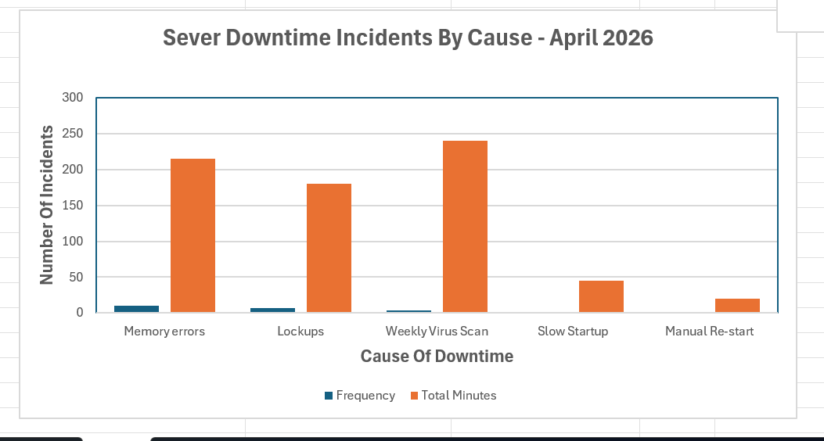
Figure 1: Bar Chart of Server Downtime Incidents by Cause — April 2026
Figure 1 clearly illustrates that memory errors were the dominant cause of server downtime, with 10 occurrences — more than any other single category. Lockups were the second most common problem with 7 incidents. The weekly virus scan, despite occurring only 4 times, is still notable compared to the single occurrences of slow startup and manual re-start. This chart makes it visually easy for management to identify where technical attention is most needed.

4. Histogram — Distribution of Downtime Duration
Unlike a bar chart, a histogram groups continuous numerical data into intervals (called bins or classes) and displays how many observations fall within each range. The bars in a histogram always touch each other, indicating that the data is continuous. In this analysis, the 23 downtime durations (measured in minutes) are grouped into 10-minute intervals to reveal the distribution pattern.
Class Interval (Min) | Downtime Values Included | Frequency
10 – 19 | 10, 10, 15 | 3
20 – 29 | 20, 20, 20, 20, 25, 25, 25 | 7
30 – 39 | 30, 30, 35, 35, 35, 35 | 6
40 – 49 | 40, 40, 45 | 3
50 – 59 | (none) | 0
60 – 69 | 60, 60, 60, 60 | 4
Table 2: Histogram Class Intervals and Frequencies — April 2026
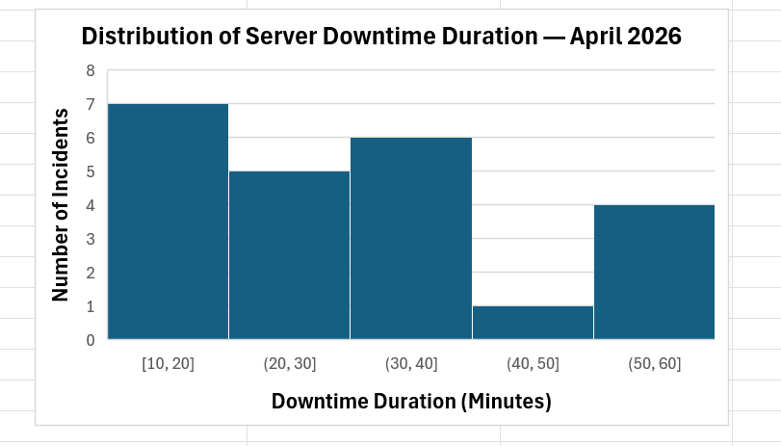
Figure 2: Histogram of Server Downtime Duration — April 2026
Figure 2 reveals an interesting bimodal distribution — meaning the data has two distinct peaks. The first peak appears in the 20–29 minute range, where most incidents were resolved relatively quickly. The second, smaller peak at 60–69 minutes corresponds exclusively to the weekly virus scan events, which consistently caused exactly 60 minutes of downtime per occurrence. The gap at 50–59 minutes further highlights that the 60-minute virus scan incidents form a distinct cluster separate from all other downtime events.

5. Pie Chart — Percentage of Total Downtime by Cause
A pie chart represents the proportional contribution of each category to a whole. In this analysis, the pie chart shows what percentage of the total 700 downtime minutes was caused by each problem type. The percentage for each cause is calculated as: (Total Minutes for Cause ÷ 700) × 100.
Cause | Total Minutes | Calculation | Percentage (%)
Weekly Virus Scan | 240 | 240 ÷ 700 × 100 | 34.3%
Memory Errors | 215 | 215 ÷ 700 × 100 | 30.7%
Lockups | 180 | 180 ÷ 700 × 100 | 25.7%
Slow Startup | 45 | 45 ÷ 700 × 100 | 6.4%
Manual Re-start | 20 | 20 ÷ 700 × 100 | 2.9%
TOTAL | 700 | — | 100%
Table 3: Percentage Breakdown of Total Downtime Minutes by Cause — April 2026
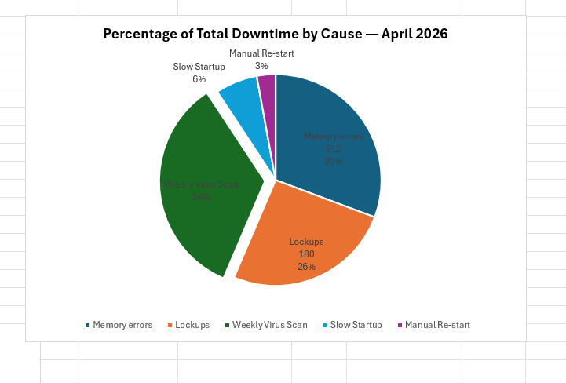

Figure 3: Pie Chart of Total Downtime Minutes by Cause — April 2026
Figure 3 presents a striking finding: despite the weekly virus scan occurring only 4 times during April, it consumed the largest single share of total downtime — 34.3%, equivalent to 240 minutes. Memory errors, while the most frequent problem, account for 30.7% of total downtime. Lockups contribute 25.7%. Slow startup and manual re-start together make up less than 10% of the total. This chart powerfully demonstrates that frequency alone does not reflect the full operational impact of each problem.

6. Analysis and Findings
The data for April 2026 reveals a clear and important distinction between the frequency of downtime causes and their actual operational impact. At first glance, memory errors appear to be the most critical problem, having triggered 10 out of 23 incidents — nearly half of all events. However, a deeper look at the total downtime minutes tells a different story. The weekly virus scan, occurring just 4 times, consumed 240 minutes of server time, the highest of any single cause, because each occurrence consistently caused exactly 60 minutes of unavailability.
This distinction between frequency and impact is precisely what statistical analysis is designed to uncover. Memory errors and lockups together accounted for 74% of all incidents but only 56.4% of total downtime minutes. The virus scan, by contrast, caused disproportionate downtime relative to its frequency. The histogram further supports this finding by revealing a bimodal distribution — most incidents clustered between 20 and 39 minutes, with a separate cluster at exactly 60 minutes, which belongs entirely to the virus scan category.
Based on these findings, two key recommendations are presented to Africell management. First, the weekly virus scan should be rescheduled to run during off-peak hours — such as late at night or on weekends — to minimise its impact on network availability during business operations. Second, the recurring nature of memory errors and lockups across multiple dates in April suggests possible hardware instability or software conflicts that warrant a thorough technical investigation by the IT department.

7. Conclusion
This report has analysed the server downtime data for Africell's network infrastructure during April 2026 using frequency distribution, bar chart, histogram, and pie chart visualisations. The analysis has demonstrated that while memory errors are the most frequently occurring problem, the weekly virus scan has the greatest overall impact on server availability, consuming 34.3% of all downtime minutes in the month.
Statistics is not merely about counting events — it is about understanding their true impact. This analysis empowers Africell's management to make data-driven decisions rather than relying on assumptions. By addressing the scheduling of virus scans and investigating the root causes of memory errors and lockups, the company stands to significantly improve its server reliability and deliver a more consistent network experience to its customers across Sierra Leone.

8. References

- Montgomery, D.C. and Runger, G.C. (2014). Applied Statistics and Probability for Engineers. 6th edn. New Jersey: John Wiley & Sons.
- Spiegel, M.R. and Stephens, L.J. (2008). Schaum's Outline of Statistics. 4th edn. New York: McGraw-Hill.
- Bluman, A.G. (2018). Elementary Statistics: A Step by Step Approach. 10th edn. New York: McGraw-Hill Education.
- Africell Sierra Leone (2026). Server Downtime Log — April 2026. [Internal data file]. Freetown: Africell.

