PROG209 - EVENT DRIVEN PROGRAMMING
Basic Interactive GUI - Individual Assignment 1
Project: Sunrise Studio (Java Swing)

Application icon designed for this project
Student: Abdulai Bah
Lecturer: Amandus Benjamin Coker
Issued: Week 2 | Due: Week 4 | Weight: 10% of the module
1. Introduction
Event driven programming is a style of programming in which the program waits for events, such as a mouse click or a key press, and reacts to each one through code called an event handler. Java Swing is the standard Java toolkit for building desktop windows that work this way. This document presents my solution to Individual Assignment 1: a Swing application named Sunrise Studio. The application opens a window titled "Java Swing Assignment", shows the welcome message "Welcome to Java Swing First Individual Assignment by Abdulai Bah" together with my own application icon, and reacts when the user clicks a button by changing the text of the label and the colour of the panel.
Beyond the minimum requirements, I made the window feel like a small finished product: an animated gradient sky with a floating sun and moving waves, four moods that fade smoothly into each other, a live clock, a menu bar, keyboard shortcuts and an About dialog. Every extra feature is built only from the Swing concepts taught in this module, so I can explain each line of code.
2. Requirements Checklist
The table below links each assignment requirement to the place in the code where it is satisfied.
Requirement | Marks | How it is met (in SwingAssignment.java)
Class SwingAssignment using inheritance and a constructor | - | public class SwingAssignment extends JFrame; the constructor SwingAssignment() calls super("Java Swing Assignment") and builds the window.
JFrame named frame; title; 800 x 800; closes on X | 20 | frame = this; setSize(800, 800); setDefaultCloseOperation(JFrame.EXIT_ON_CLOSE); title set through super(...).
JPanel named panel; added to the frame | 20 | panel = new JPanel(new GridBagLayout()) {...}; frame.add(panel);
JLabel named label with the required text; added to the panel | 20 | label = new JLabel("Welcome to Java Swing First Individual Assignment by Abdulai Bah"); panel.add(label, gbc);
Own application icon with ImageIcon | 10 | appIcon = loadIcon("icon.png") returns an ImageIcon, used on the label and with frame.setIconImage(...).
Addition: a button that changes label text and panel colour | (extra) | button.addActionListener(e -> nextMood()); nextMood() calls label.setText(...) and panel.setBackground(...).
Wireframe made in Figma | 20 | Section 4 and the file wireframe/wireframe.svg (importable into Figma).
Documentation and GitHub | 10 | This document, README.md, and the GitHub repository with every file committed.

3. Design Overview
The class SwingAssignment inherits from JFrame, so an object of my class is itself a window. Inside the constructor the field frame refers to this window. The window contains a menu bar and one JPanel. The panel uses a GridBagLayout that centres three components vertically: the JLabel (with the ImageIcon above the text), the JButton, and a status JLabel. The panel overrides paintComponent() so that it can draw the gradient sky, the sun and three animated waves behind the components; it is still a normal JPanel and its background colour is changed by the button.
A mood is a small object that stores a name, a message and four colours. There are four moods: Sunrise (shows the required welcome text), Ocean, Forest and Twilight. Each click moves to the next mood. A javax.swing.Timer running about 30 times per second blends the old colours into the new ones, which creates a smooth fade instead of a sudden jump. A second Timer updates the clock once per second.
4. Wireframe (Figma)
The wireframe was designed before coding. It shows the window frame with its title bar and close button, the menu bar, the gradient JPanel, the ImageIcon, the JLabel, the JButton, the status line and the animated scenery. The same wireframe is saved as wireframe.svg and can be imported into Figma by dragging the file into a Figma design file; every shape and text then becomes an editable layer.
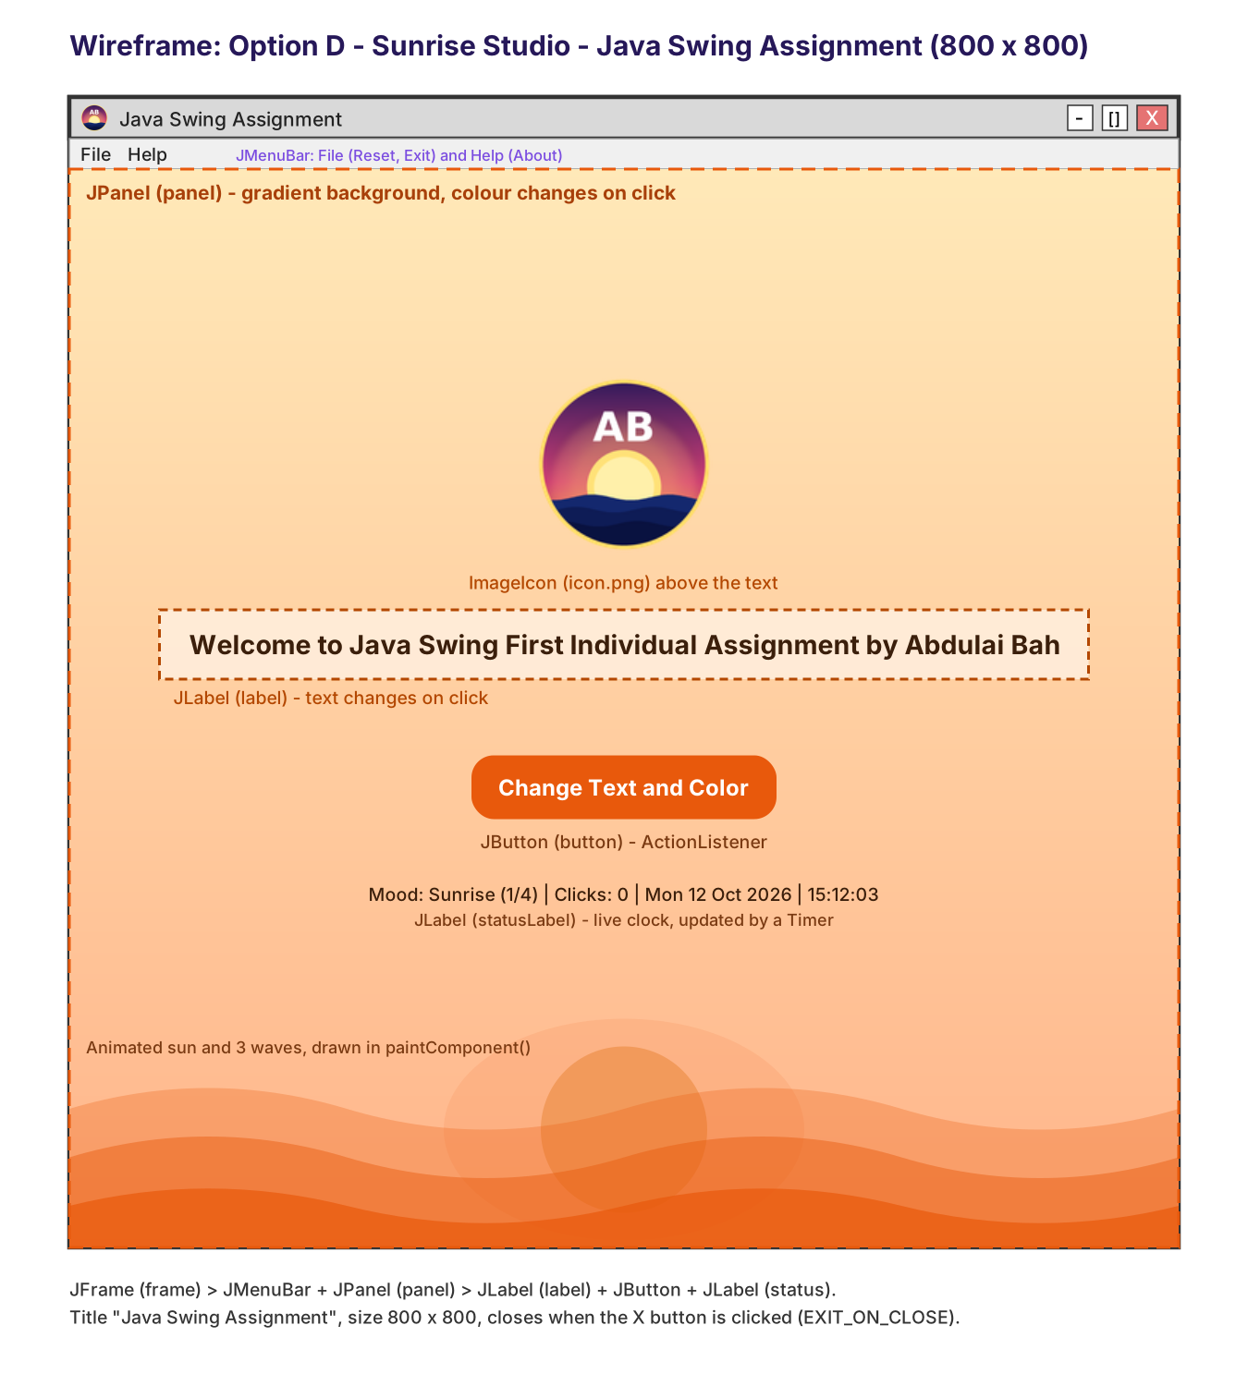
Figure 1: Wireframe of the Sunrise Studio window (800 x 800)
5. Source Code
File: SwingAssignment.java (all code in one file, so it is easy to compile and run)
import javax.swing.*;
import javax.swing.border.EmptyBorder;
import java.awt.*;
import java.awt.event.*;
import java.awt.geom.*;
import java.awt.image.BufferedImage;
import java.time.LocalDateTime;
import java.time.format.DateTimeFormatter;

/**
* PROG209 - Event Driven Programming
* Basic Interactive GUI - Individual Assignment 1
* Author : Abdulai Bah
* Theme : "Sunrise Studio" - an animated, mood-changing welcome window.
*
* KEY IDEAS (explained in simple words):
* 1. INHERITANCE : SwingAssignment "extends JFrame", so our class IS a window
* and inherits everything a JFrame can do.
* 2. CONSTRUCTOR : the SwingAssignment() constructor builds the whole window.
* 3. EVENTS : the button (ActionListener), a menu (ActionListener),
* and two Timers (ActionListener) are all "events".
*/
public class SwingAssignment extends JFrame {

private static final long serialVersionUID = 1L;

// ---- The three components the assignment asks for ----------------------
private JFrame frame; // the window (it refers to this very object)
private JPanel panel; // the container that holds everything
private JLabel label; // the welcome text

// ---- Extra components (the "Addition" and the "more") ------------------
private JButton button; // changes the label text and panel colour
private JLabel statusLabel; // shows mood, click count and a live clock
private ImageIcon appIcon; // my own application icon

// ---- A "Mood" = one text message + one colour theme --------------------
private static class Mood {
final String name, message;
final Color top, bottom, text, accent;
Mood(String name, String message, Color top, Color bottom, Color text, Color accent) {
this.name = name; this.message = message;
this.top = top; this.bottom = bottom; this.text = text; this.accent = accent;
}
}

private final Mood[] moods = {
new Mood("Sunrise",
"Welcome to Java Swing First Individual Assignment by Abdulai Bah",
new Color(0xFFE9B8), new Color(0xFFB48A), new Color(0x3B1F0B), new Color(0xE8590C)),
new Mood("Ocean",
"Smooth waves, smooth code: this text changed by an ActionListener!",
new Color(0xD6F1FF), new Color(0x7CC8E8), new Color(0x08324A), new Color(0x0B7BA7)),
new Mood("Forest",
"Event driven programming: the program reacts when you act.",
new Color(0xE0F5DC), new Color(0x8FD19E), new Color(0x0F3D1E), new Color(0x2E8B57)),
new Mood("Twilight",
"Built with Java Swing by Abdulai Bah. Thank you for visiting!",
new Color(0xE8DDFB), new Color(0xF5A9C8), new Color(0x2A1250), new Color(0x7B3FE4))
};

// ---- Animation state ---------------------------------------------------
private int current = 0; // which mood is showing
private int clicks = 0; // how many times the button was clicked
private double phase = 0; // moves the waves and the sun
private double progress = 1.0; // 0..1 smooth colour change between moods
private Mood from = moods[0]; // mood we are changing from
private Mood to = moods[0]; // mood we are changing to
private Color curTop = moods[0].top, curBottom = moods[0].bottom;
private Color curText = moods[0].text, curAccent = moods[0].accent;

// =======================================================================
// CONSTRUCTOR : builds the window
// =======================================================================
public SwingAssignment() {
super("Java Swing Assignment"); // call the JFrame (parent) constructor
frame = this; // "frame" is this JFrame
appIcon = loadIcon("icon.png"); // my own icon (ImageIcon)

// ---- JPanel: paints a soft gradient sky, a sun and animated waves ----
panel = new JPanel(new GridBagLayout()) {
@Override
protected void paintComponent(Graphics g) {
super.paintComponent(g);
paintScenery((Graphics2D) g.create(), getWidth(), getHeight());
}
};
panel.setBackground(curBottom);

// ---- JLabel: the required welcome text, with my icon above it --------
label = new JLabel(moods[0].message, SwingConstants.CENTER);
label.setFont(new Font("Tahoma", Font.BOLD, 20));
label.setForeground(curText);
label.setIcon(appIcon);
label.setVerticalTextPosition(SwingConstants.BOTTOM);
label.setHorizontalTextPosition(SwingConstants.CENTER);
label.setIconTextGap(18);

// ---- JButton: the "Addition" (changes label text + panel colour) -----
button = new JButton("Change Text and Color") {
@Override
protected void paintComponent(Graphics g) {
Graphics2D g2 = (Graphics2D) g.create();
g2.setRenderingHint(RenderingHints.KEY_ANTIALIASING, RenderingHints.VALUE_ANTIALIAS_ON);
Color c = curAccent;
if (getModel().isPressed()) c = c.darker();
else if (getModel().isRollover()) c = brighter(c, 0.18f);
g2.setColor(c);
g2.fill(new RoundRectangle2D.Double(0, 0, getWidth(), getHeight(), 30, 30));
g2.dispose();
super.paintComponent(g); // draws the button text
}
};
button.setFont(new Font("Tahoma", Font.BOLD, 16));
button.setForeground(Color.WHITE);
button.setContentAreaFilled(false);
button.setOpaque(false);
button.setFocusPainted(false);
button.setBorder(new EmptyBorder(12, 30, 12, 30));
button.setRolloverEnabled(true);
button.setCursor(Cursor.getPredefinedCursor(Cursor.HAND_CURSOR));
button.setMnemonic(KeyEvent.VK_C); // Alt+C also works
button.setToolTipText("Click, press Enter, or press Alt+C");
button.addActionListener(e -> nextMood()); // EVENT: runs on every click

// ---- Status line: mood, clicks and a live clock ------------------------
statusLabel = new JLabel(" ", SwingConstants.CENTER);
statusLabel.setFont(new Font("Tahoma", Font.PLAIN, 13));
statusLabel.setForeground(curText);
updateStatus();

// ---- Put the components inside the panel -------------------------------
GridBagConstraints gbc = new GridBagConstraints();
gbc.gridx = 0;
gbc.insets = new Insets(0, 20, 28, 20);
gbc.gridy = 0; panel.add(label, gbc); // label -> panel
gbc.gridy = 1; panel.add(button, gbc); // button -> panel
gbc.gridy = 2; gbc.insets = new Insets(0, 20, 0, 20);
panel.add(statusLabel, gbc); // status -> panel

// ---- Put the panel inside the frame ------------------------------------
frame.add(panel); // panel -> frame

// ---- Menu bar (File / Help) ---------------------------------------------
frame.setJMenuBar(buildMenuBar());

// ---- Frame settings required by the assignment -------------------------
frame.setSize(800, 800); // 800 x 800
frame.setDefaultCloseOperation(JFrame.EXIT_ON_CLOSE); // close button ends the app
frame.setIconImage(appIcon.getImage()); // window icon
frame.getRootPane().setDefaultButton(button); // Enter key = click
frame.setLocationRelativeTo(null); // centre on screen

// ---- Two Timers: animation (~30 fps) and live clock (every second) -----
new Timer(33, e -> animate()).start();
new Timer(1000, e -> updateStatus()).start();

frame.setVisible(true);
}

// =======================================================================
// EVENT HANDLERS
// =======================================================================

/** Runs when the button is clicked: moves to the next mood. */
private void nextMood() {
clicks++;
changeTo((current + 1) % moods.length);
}

private void changeTo(int index) {
from = new Mood("now", "", curTop, curBottom, curText, curAccent);
current = index;
to = moods[index];
progress = 0.0; // start the smooth colour change
label.setText(to.message); // change the LABEL text
updateStatus();
}

/** Called ~30 times per second by a Timer. */
private void animate() {
phase += 0.06;
if (progress < 1.0) {
progress = Math.min(1.0, progress + 0.06);
curTop = blend(from.top, to.top, progress);
curBottom = blend(from.bottom, to.bottom, progress);
curText = blend(from.text, to.text, progress);
curAccent = blend(from.accent, to.accent, progress);
panel.setBackground(curBottom); // change the PANEL background colour
label.setForeground(curText);
statusLabel.setForeground(curText);
}
panel.repaint();
}

private void updateStatus() {
String time = LocalDateTime.now().format(DateTimeFormatter.ofPattern("EEE d MMM yyyy | HH:mm:ss"));
statusLabel.setText("Mood: " + moods[current].name + " (" + (current + 1) + "/" + moods.length
+ ") | Clicks: " + clicks + " | " + time);
}

private JMenuBar buildMenuBar() {
JMenuBar bar = new JMenuBar();

JMenu file = new JMenu("File");
file.setMnemonic(KeyEvent.VK_F);
JMenuItem reset = new JMenuItem("Reset to Sunrise");
reset.addActionListener(e -> { clicks = 0; changeTo(0); });
JMenuItem exit = new JMenuItem("Exit");
exit.addActionListener(e -> frame.dispatchEvent(new WindowEvent(frame, WindowEvent.WINDOW_CLOSING)));
file.add(reset);
file.addSeparator();
file.add(exit);

JMenu help = new JMenu("Help");
help.setMnemonic(KeyEvent.VK_H);
JMenuItem about = new JMenuItem("About");
about.addActionListener(e -> JOptionPane.showMessageDialog(frame,
"Java Swing Assignment\nPROG209 Event Driven Programming\n\n"
+ "Created by Abdulai Bah\n"
+ "Press the button to change the label text and the panel colour.",
"About", JOptionPane.INFORMATION_MESSAGE, appIcon));
help.add(about);

bar.add(file);
bar.add(help);
return bar;
}

// =======================================================================
// DRAWING : gradient sky, glowing sun and three animated waves
// =======================================================================
private void paintScenery(Graphics2D g2, int w, int h) {
g2.setRenderingHint(RenderingHints.KEY_ANTIALIASING, RenderingHints.VALUE_ANTIALIAS_ON);

// sky gradient
g2.setPaint(new GradientPaint(0, 0, curTop, 0, h, curBottom));
g2.fillRect(0, 0, w, h);

// glowing sun that floats up and down gently
double bob = Math.sin(phase * 0.7) * 8;
double cx = w / 2.0, cy = h - 85 + bob;
for (int i = 4; i >= 1; i--) {
double r = 70 + i * 30;
g2.setColor(withAlpha(curAccent, 22));
g2.fill(new Ellipse2D.Double(cx - r, cy - r, 2 * r, 2 * r));
}
g2.setColor(withAlpha(brighter(curAccent, 0.35f), 235));
g2.fill(new Ellipse2D.Double(cx - 70, cy - 70, 140, 140));

// three layers of waves
for (int layer = 0; layer < 3; layer++) {
Path2D wave = new Path2D.Double();
wave.moveTo(0, h);
for (int x = 0; x <= w; x += 8) {
double y = h - 95 + layer * 30
+ Math.sin(x / 90.0 + phase * (1.0 + layer * 0.35) + layer) * (15 - layer * 2);
wave.lineTo(x, y);
}
wave.lineTo(w, h);
wave.closePath();
g2.setColor(withAlpha(curAccent, 70 + layer * 45));
g2.fill(wave);
}
g2.dispose();
}

// =======================================================================
// SMALL HELPERS
// =======================================================================
private static Color blend(Color a, Color b, double t) {
int r = (int) (a.getRed() + (b.getRed() - a.getRed()) * t);
int g = (int) (a.getGreen() + (b.getGreen() - a.getGreen()) * t);
int bl = (int) (a.getBlue() + (b.getBlue() - a.getBlue()) * t);
return new Color(r, g, bl);
}

private static Color brighter(Color c, float amount) {
return blend(c, Color.WHITE, amount);
}

private static Color withAlpha(Color c, int alpha) {
return new Color(c.getRed(), c.getGreen(), c.getBlue(), alpha);
}

/** Loads the icon file. Tries the folder first, then the class path,
* and finally draws a simple icon so the program never fails. */
private static ImageIcon loadIcon(String path) {
ImageIcon icon = new ImageIcon(path);
if (icon.getIconWidth() > 0) return icon;

java.net.URL url = SwingAssignment.class.getResource("/" + path);
if (url != null) return new ImageIcon(url);

BufferedImage img = new BufferedImage(128, 128, BufferedImage.TYPE_INT_ARGB);
Graphics2D g = img.createGraphics();
g.setRenderingHint(RenderingHints.KEY_ANTIALIASING, RenderingHints.VALUE_ANTIALIAS_ON);
g.setColor(new Color(0x261859));
g.fillOval(4, 4, 120, 120);
g.setColor(new Color(0xFFD264));
g.fillOval(34, 40, 60, 60);
g.dispose();
return new ImageIcon(img);
}

// =======================================================================
// The program starts here
// =======================================================================
public static void main(String[] args) {
SwingUtilities.invokeLater(SwingAssignment::new);
}
}

6. Explanation of the Code
- Inheritance and constructor: "extends JFrame" gives my class all the abilities of a window. The constructor runs once when the object is created, and it sets up every component, so main() only needs one line: new SwingAssignment().
- JFrame (frame): holds the menu bar and the panel. setSize(800, 800) sets the size and setDefaultCloseOperation(JFrame.EXIT_ON_CLOSE) makes the whole program end when the close button is clicked. setLocationRelativeTo(null) centres the window on the screen.
- JPanel (panel): the container for the label, button and status line. Overriding paintComponent() lets the panel draw its own gradient background, sun and waves. panel.setBackground(...) is called whenever the colour changes.
- JLabel (label): displays the required welcome text. label.setIcon(appIcon) places my icon above the text, and label.setText(...) changes the message when the button is clicked.
- ImageIcon: new ImageIcon("icon.png") loads my own icon. If the file cannot be found in the folder, the loader tries the class path, and finally draws a simple icon, so the program never crashes because of a missing image.
- Events: button.addActionListener(e -> nextMood()) registers an event handler. Every click runs nextMood(), which increases the click counter, picks the next mood and changes the label text and colours. The menu items and both Timers are also ActionListeners.
- Smooth colour change: blend(a, b, t) mixes two colours; t moves from 0 to 1 over about half a second, so the colours fade.
- Keyboard and usability: the Enter key (default button) and Alt+C both press the button; the button shows a tooltip, a hand cursor and changes shade when the mouse is over it.
7. Features Added Beyond the Requirements
- Four moods with different messages and colour themes, including the required welcome message as the first mood.
- Smooth animated colour transitions using javax.swing.Timer.
- Gradient sky, floating sun and three animated waves drawn with Java 2D (Graphics2D, GradientPaint, Path2D).
- Rounded custom button with hover and pressed effects.
- Live status line: current mood, number of clicks, date and a clock updated every second.
- Menu bar: File (Reset to Sunrise, Exit) and Help (About dialog showing my icon).
- Original icon designed by me: a sunrise over the sea with my initials, created with Python image code.
- Robust icon loading with two fall-backs, and keyboard shortcuts for accessibility.
8. Testing
Test | Expected result | Result
Start the program | Window titled "Java Swing Assignment", 800 x 800, welcome text and icon visible | Pass
Click the button once | Label text changes to the Ocean message; background fades to blue; Clicks: 1 | Pass
Click the button four times | Cycles Ocean, Forest, Twilight, then back to the welcome message | Pass
Press Enter or Alt+C | Same as clicking the button | Pass
File > Reset to Sunrise | Returns to the welcome message and the Sunrise colours; clicks reset to 0 | Pass
Help > About | Dialog with my name and icon appears | Pass
Click the window close button | Program ends (EXIT_ON_CLOSE) | Pass

The program was compiled with javac and run on Java 21. Screenshots were captured from the running window.
9. Screenshots
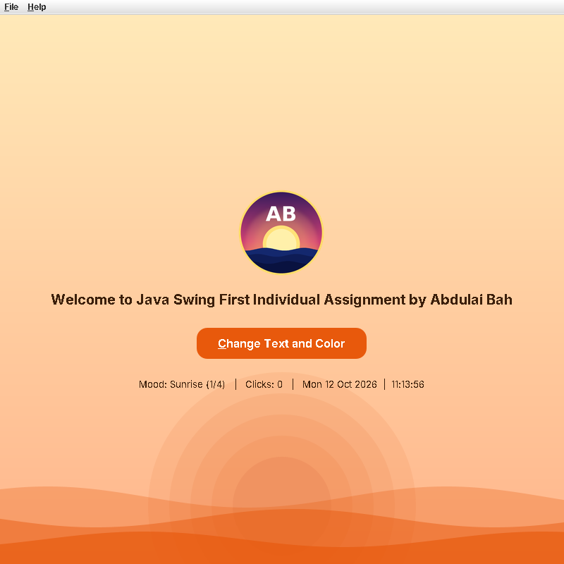
Figure 2: Application on start-up (Sunrise mood, required welcome text)
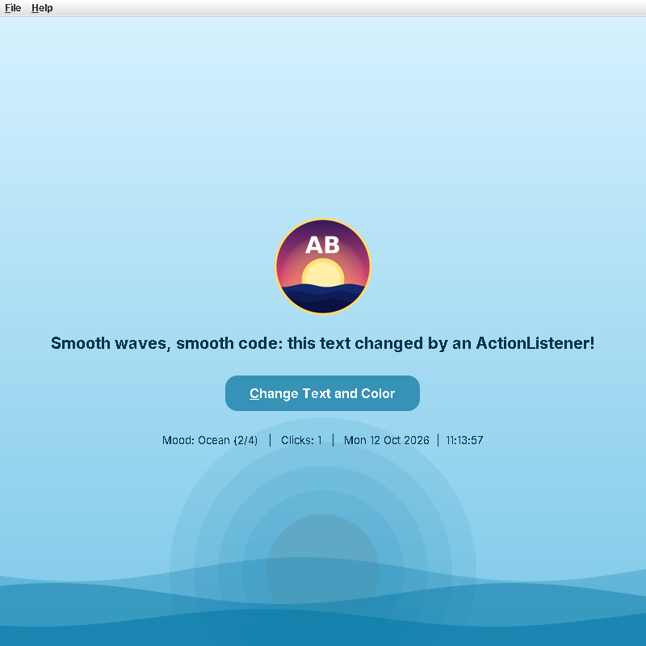
Figure 3: After one click - label text and panel colour changed (Ocean mood)
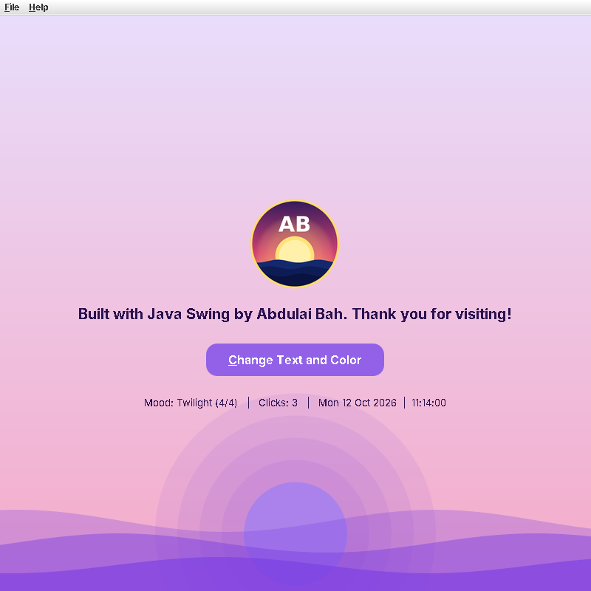
Figure 4: After three clicks - Twilight mood
10. How to Run
Put SwingAssignment.java and icon.png in the same folder. Open a terminal in that folder, compile with: javac SwingAssignment.java and run with: java SwingAssignment. In an IDE such as NetBeans, IntelliJ IDEA or Eclipse, create a new Java project, paste the file in, copy icon.png into the project's main folder and press Run.
11. GitHub Submission
All files (source code, icon, wireframe, screenshots, this documentation and README.md) are committed to the GitHub repository for this assignment, and the lecturer, Amandus Benjamin Coker, has been added as a collaborator. Repository link: https://github.com/AbdulaiBah479/prog209-swing-assignment-1
12. References and Academic Integrity
- Oracle. The Java Tutorials: Creating a GUI With Swing. https://docs.oracle.com/javase/tutorial/uiswing/
- Oracle. Java SE API documentation: javax.swing, java.awt and java.awt.geom packages.
- Figma Help Center: importing SVG files into a design file.
This project is my own work for PROG209. The design, icon, wording and code structure were produced for this assignment, I understand how every part works and I am able to explain it, and any tool or reference that helped me is listed above. I have followed the institution's academic integrity and plagiarism rules.

