Task #1

Syntax Error:

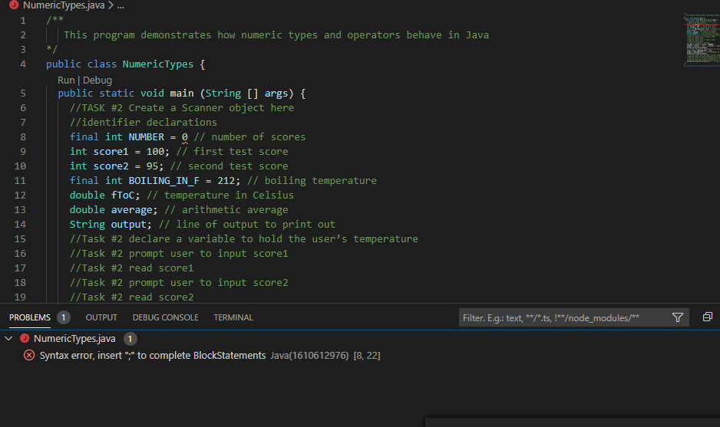

Runtime Error:

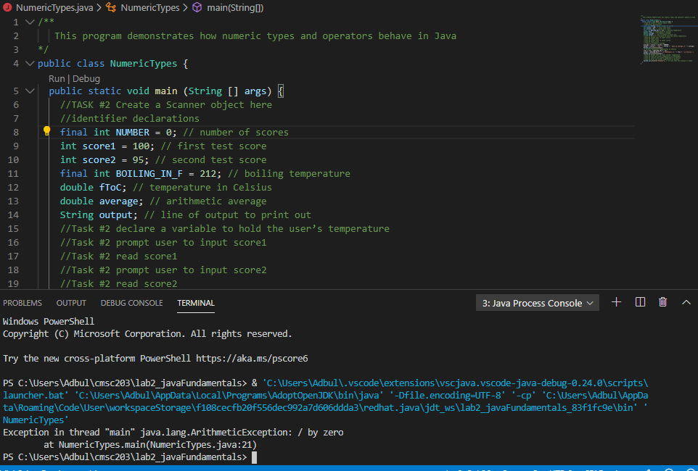

No Errors

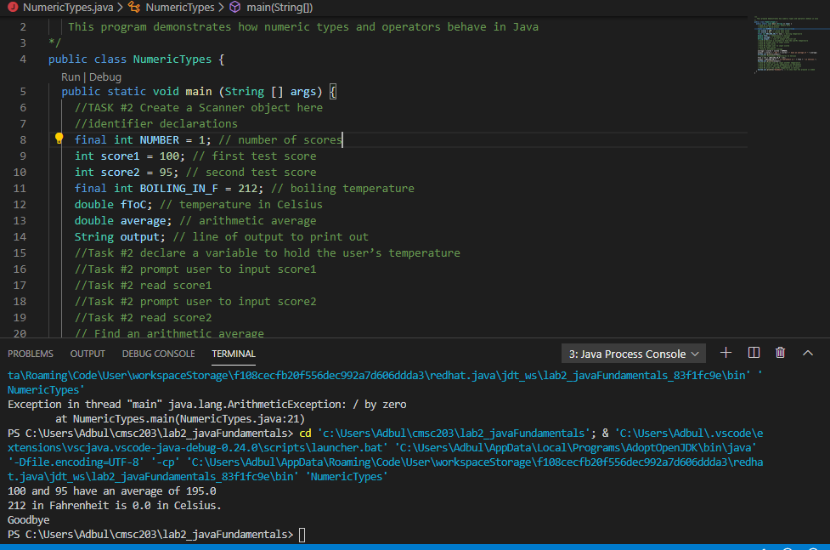

Task #2

Fix type casting

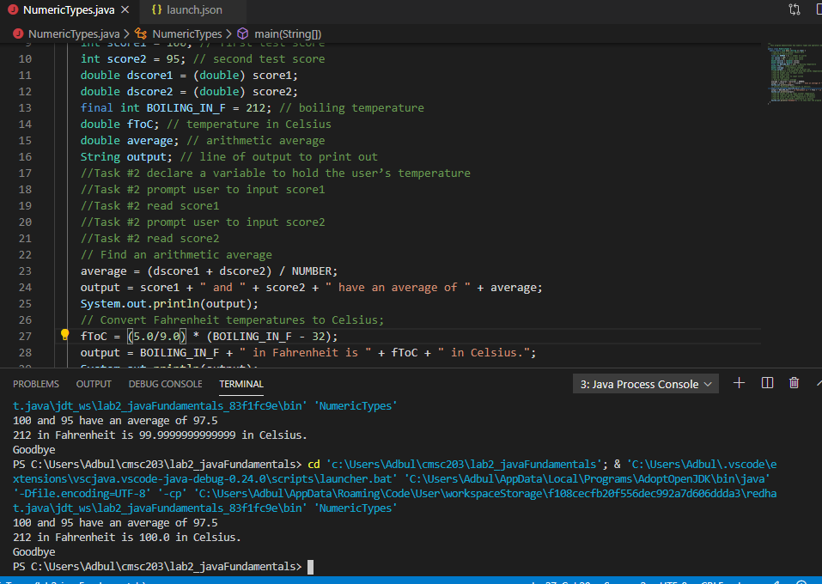

Task#3

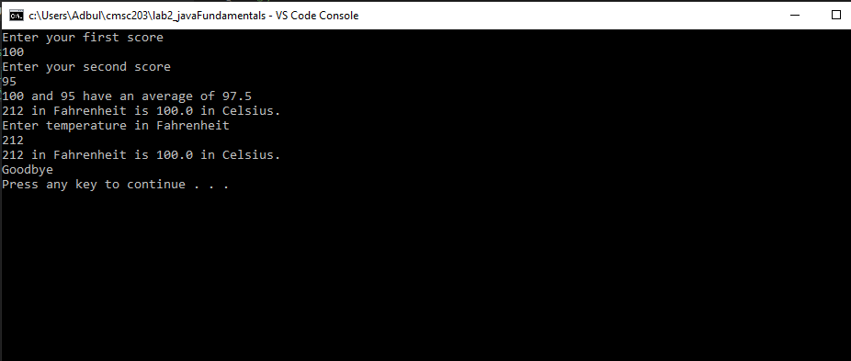

Task#4

|  |  |  |
| --- | --- | --- |
| Diameter | Volume (hand calculated) | Volume (resulting output) |
| 2 | 33.51032 | 33.510321638291124 |
| 25.4 | 8580.24665 | 8580.24664605096 |
| -5 | It has to be positive | -65.44984694978736 |

