1)To load the .JSON file into table:-

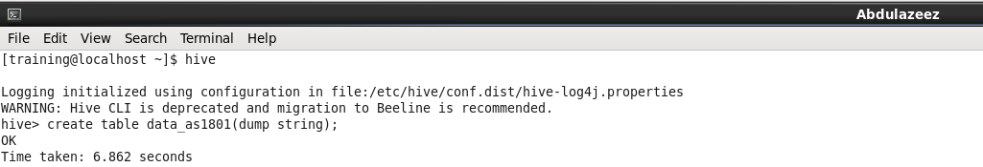

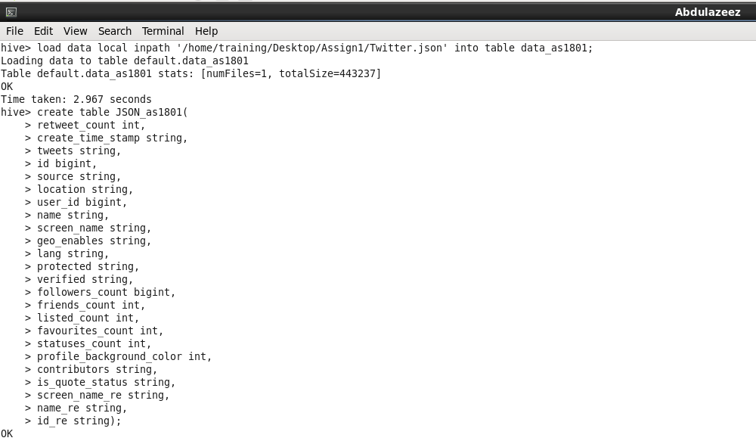

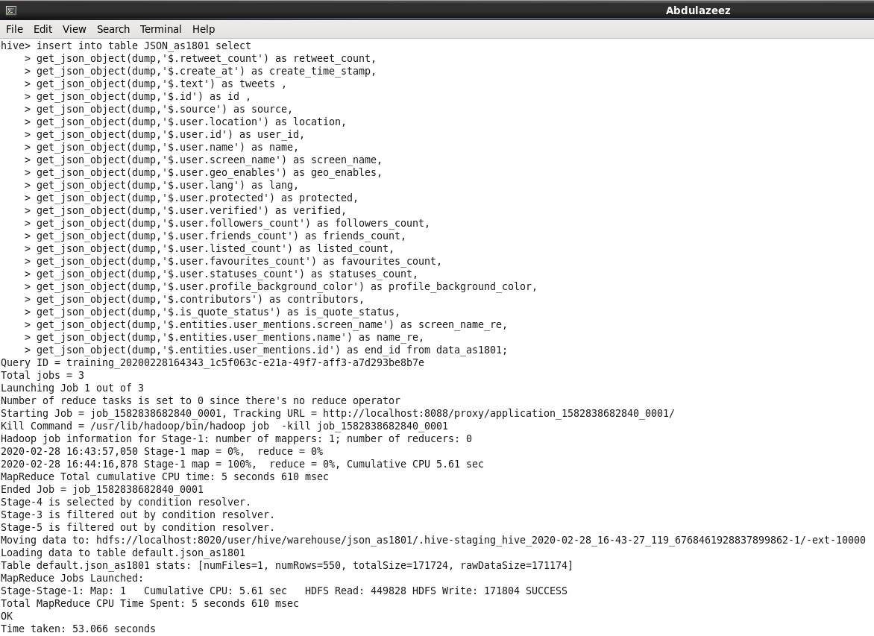

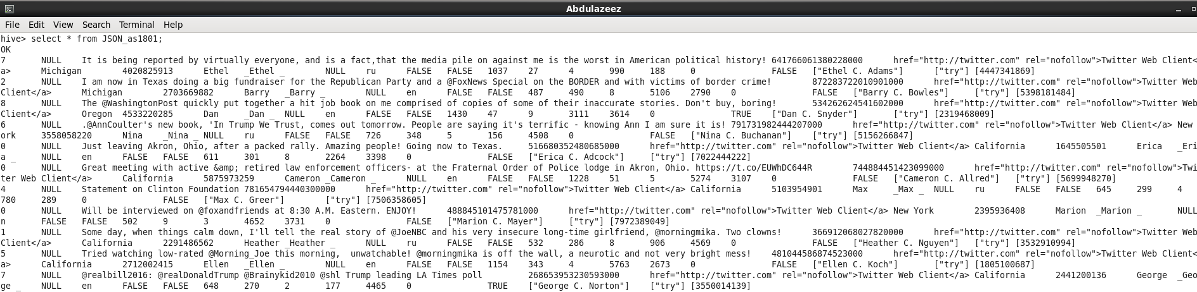

To load the Dictionary file into table:-

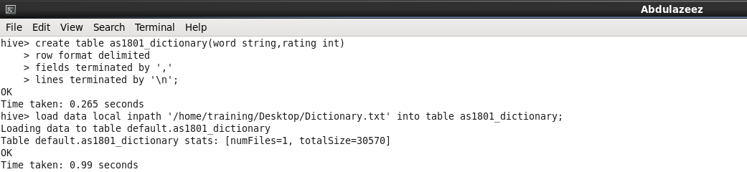

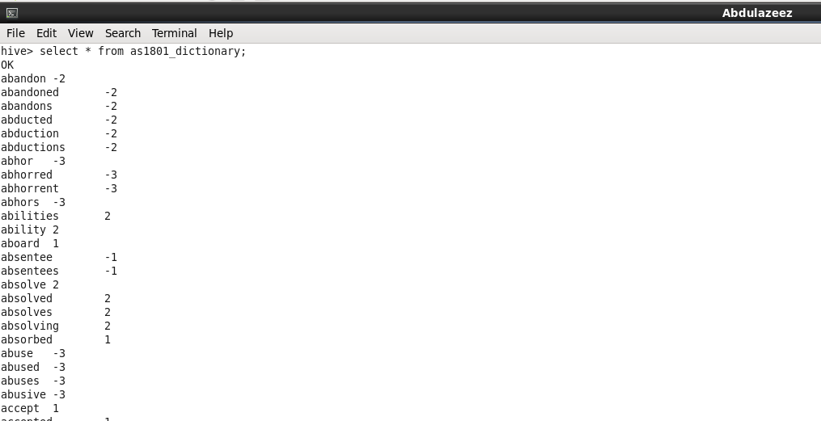

Extracting the Tweets:-

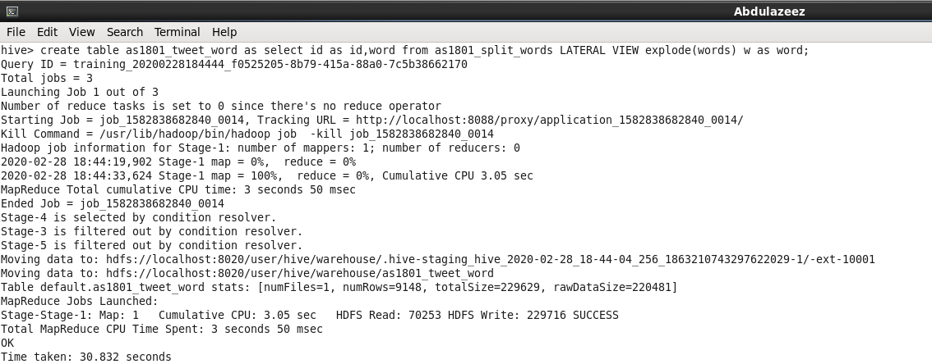

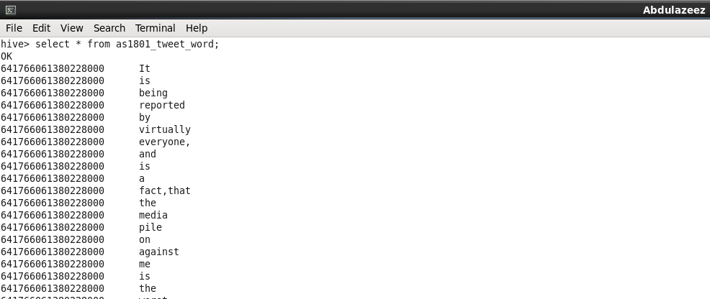

2a) hashtags used in the file, and how many times each hashtag was used:-

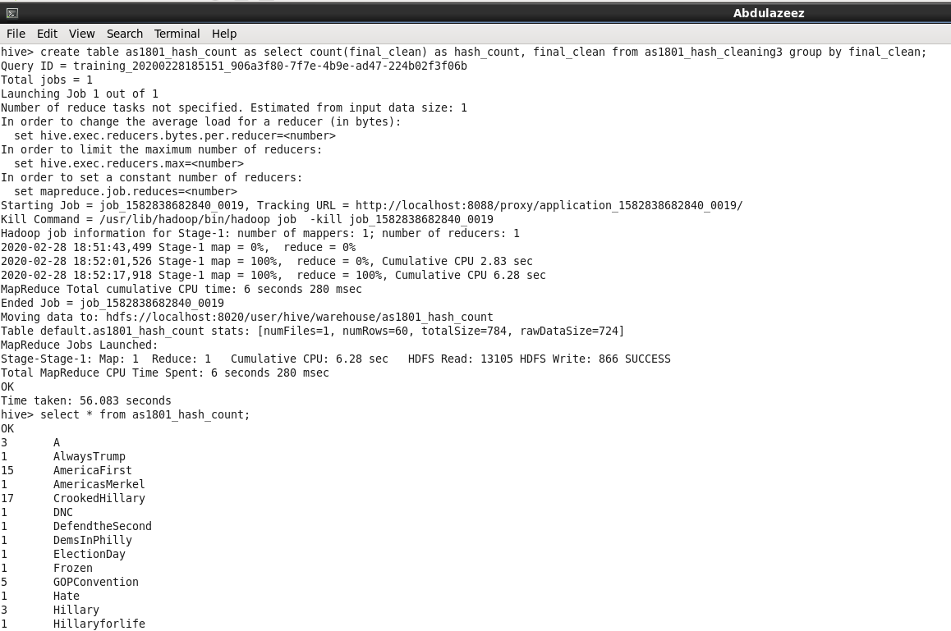

2b) most trending hashtag by the day. How many times the most trending hashtag was tweeted:-

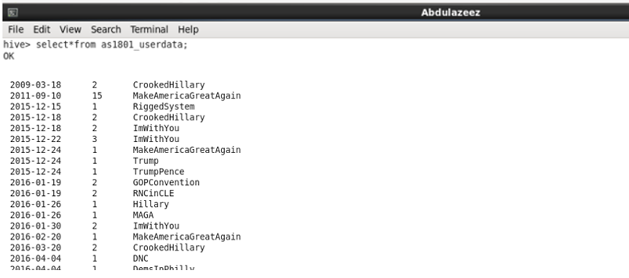

2c) Identifying whether the tweet had a positive or negative sentiment:-

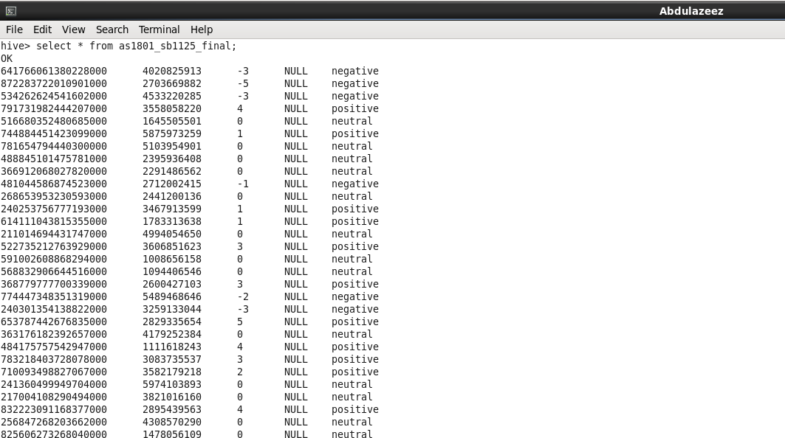

**Sentiment Analysis** is the most common text classification tool that analyses an incoming message and tells whether the underlying **sentiment** is positive, negative our neutral. We can perform sentimental Analysis by machine learning and by using dictionaries. The **machine learning method** uses supervised learning techniques to determine **sentiment** by training a known dataset. Application of classification techniques from data **mining** have also been employed in **sentiment analysis** and there is another approach which is through NLP. One of the most important fields of NLP is sentiment analysis. Sentiment analysis is the process of unearthing or mining meaningful patterns from text data. Sentiment analysis can help us attain the attitude and mood of the wider public which can then help us gather insightful information about the context. NLP is most widely uses approach for sentimental analysis . Here we have used dictionaries for this.