Task 1. Insert 200 random rows into the airport table
INSERT INTO airport (airport_id, airport_name, country, state, city, created_at, updated_at)
SELECT
100 + i,
'Airport' || i,
(ARRAY['Kazakhstan', 'France', 'Germany', 'Poland', 'Brazil'])[(random() * 4 + 1)::int],
'State' || i,
'City' || i,
now(),
now()
FROM generate_series(1, 200) AS i;

SELECT count(*) FROM airport;
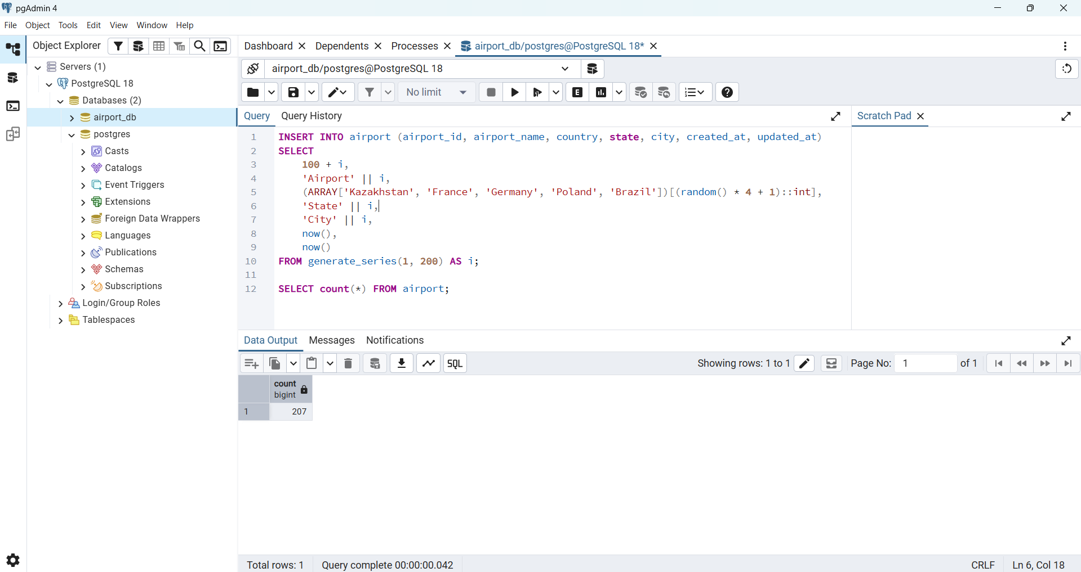
Task 2. Add the airline "KazAir" (Kazakhstan)
INSERT INTO airline (airline_id, airline_code, airline_name, airline_country, created_at, updated_at)
VALUES (6, 'KZA', 'KazAir', 'Kazakhstan', now(), now());

SELECT * FROM airline;
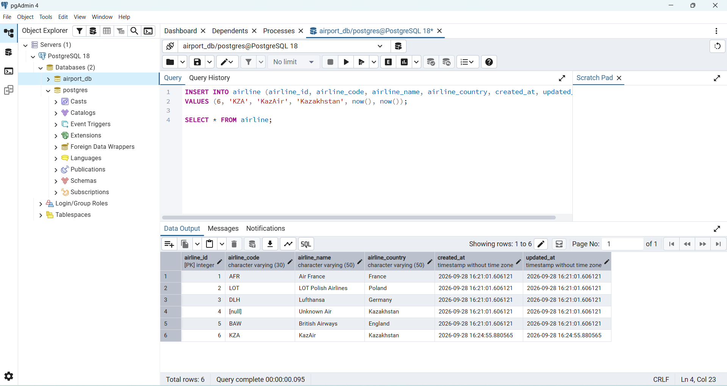
Task 3. Update the country of "KazAir" to "Turkey"
UPDATE airline
SET airline_country = 'Turkey'
WHERE airline_name = 'KazAir';

SELECT * FROM airline;
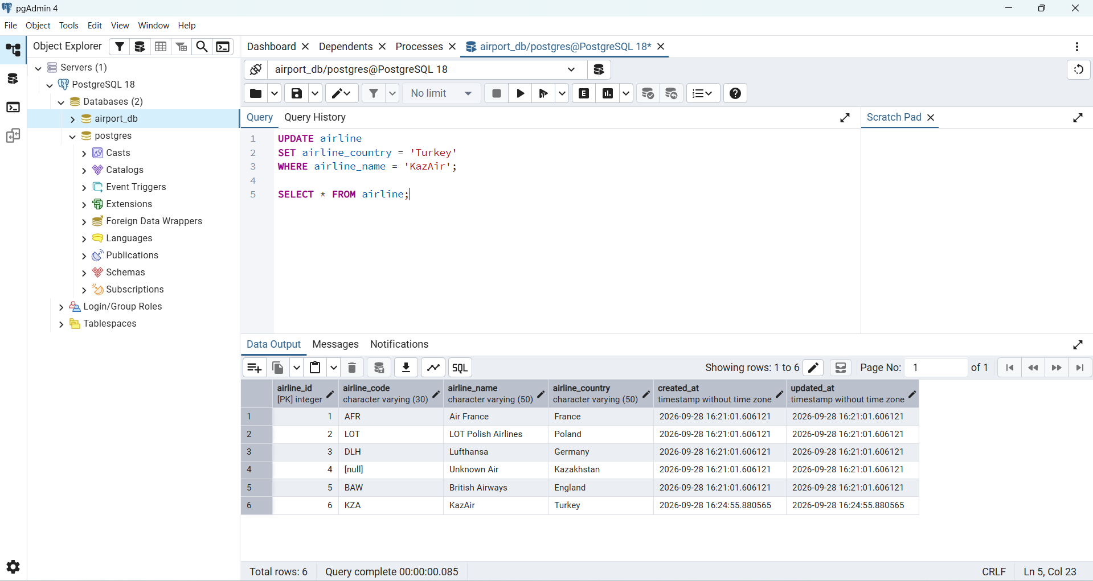
Task 4. Add three airlines at once
INSERT INTO airline (airline_id, airline_code, airline_name, airline_country, created_at, updated_at)
VALUES
(7, 'AER', 'AirEasy', 'France', now(), now()),
(8, 'FLH', 'FlyHigh', 'Brazil', now(), now()),
(9, 'FLF', 'FlyFly', 'Poland', now(), now());

SELECT * FROM airline;
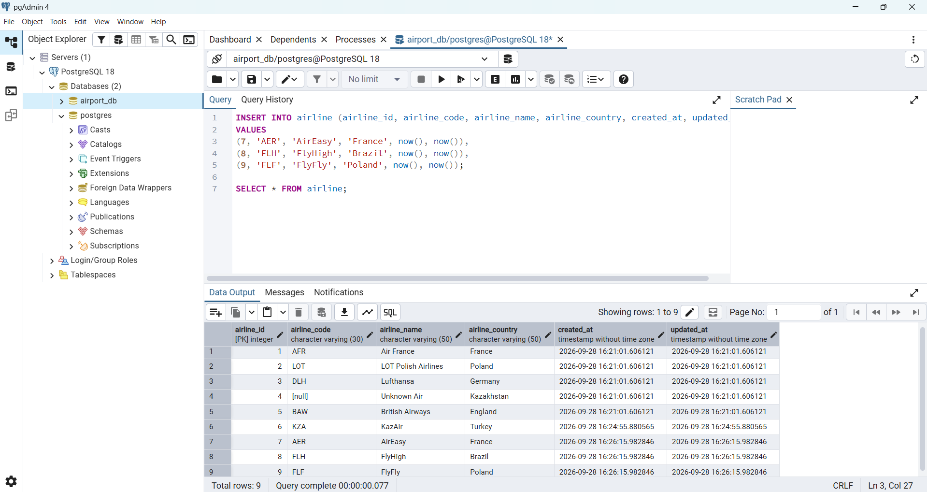
Task 5. Delete all flights arriving in 2024
DELETE FROM flights
WHERE EXTRACT(YEAR FROM sch_arrival_time) = 2024;

SELECT flight_id, sch_arrival_time FROM flights;
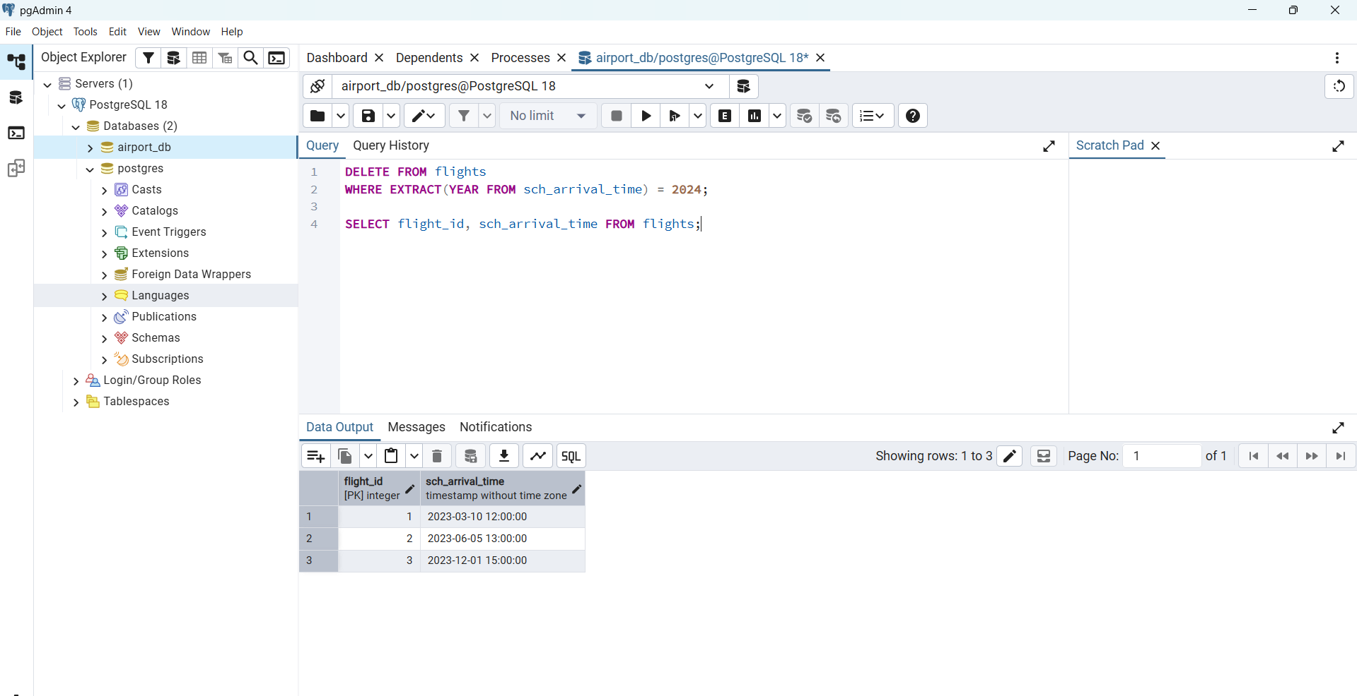
Task 6. Increase ticket prices by 15%
UPDATE booking
SET ticket_price = ticket_price * 1.15;

SELECT booking_id, ticket_price FROM booking;
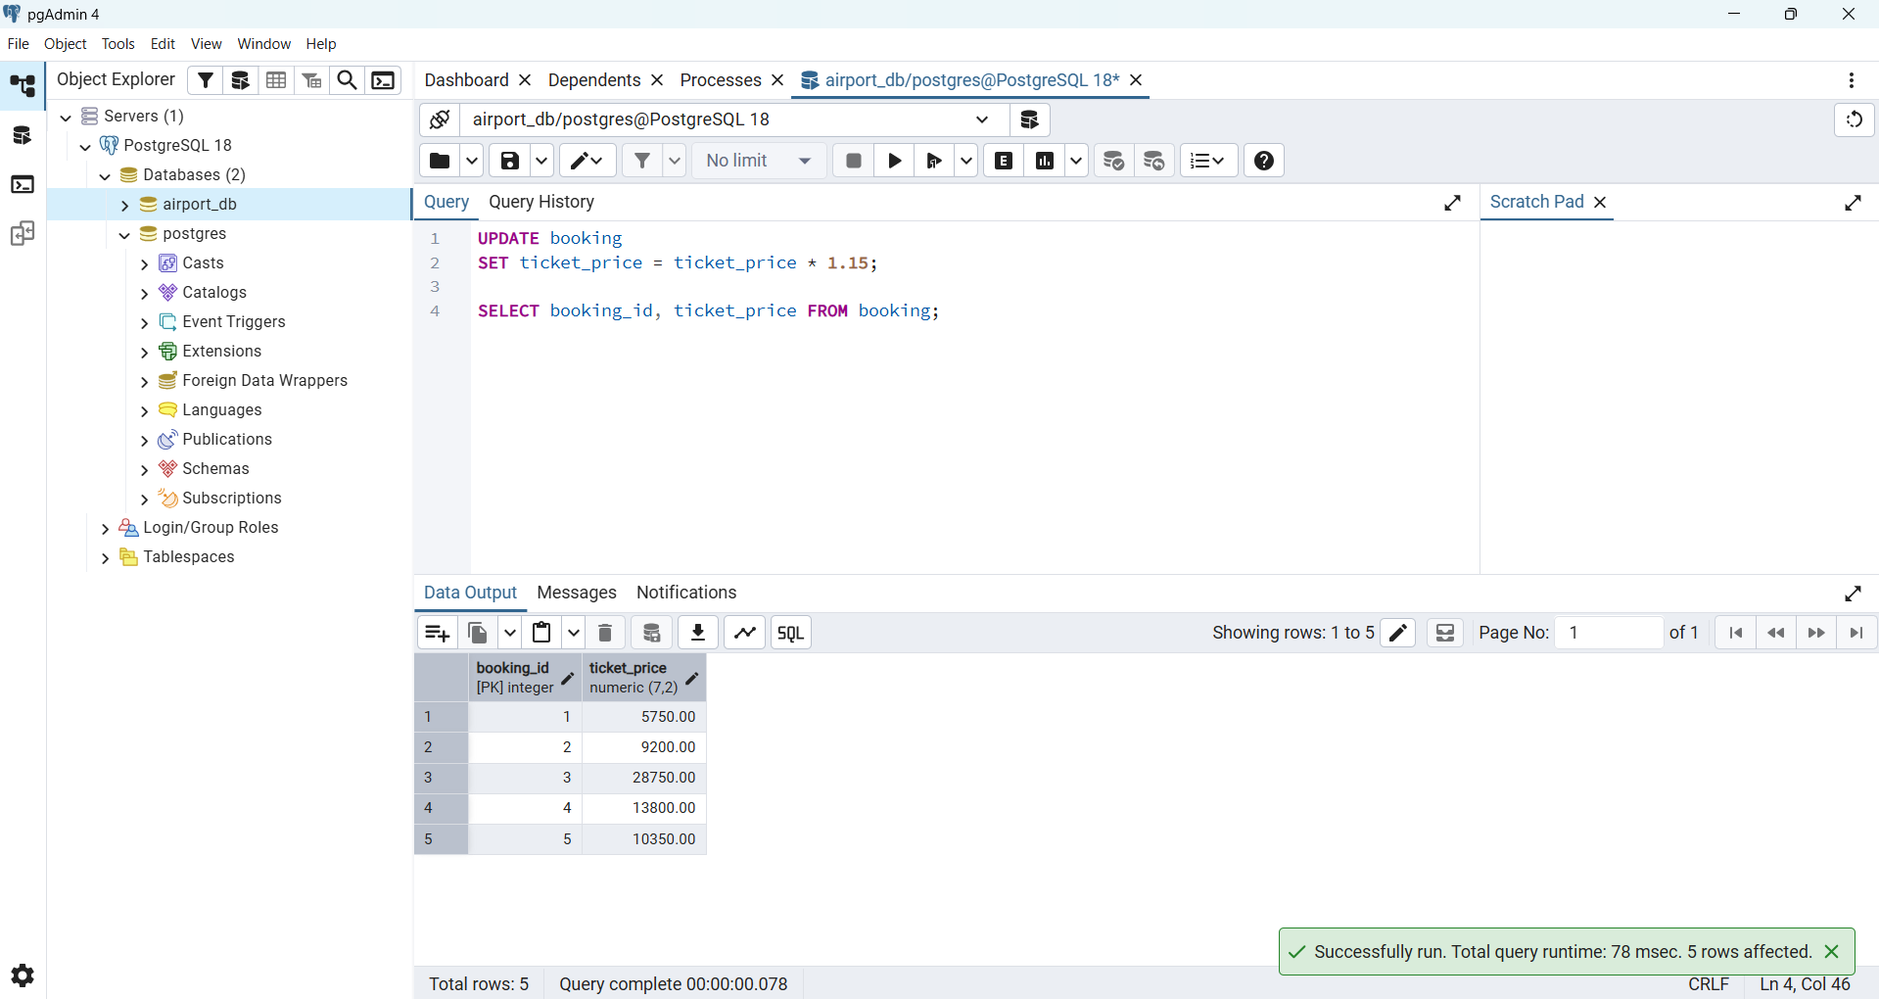
Task 7. Delete all tickets with price less than 10000
DELETE FROM booking
WHERE ticket_price < 10000;

SELECT booking_id, ticket_price FROM booking;
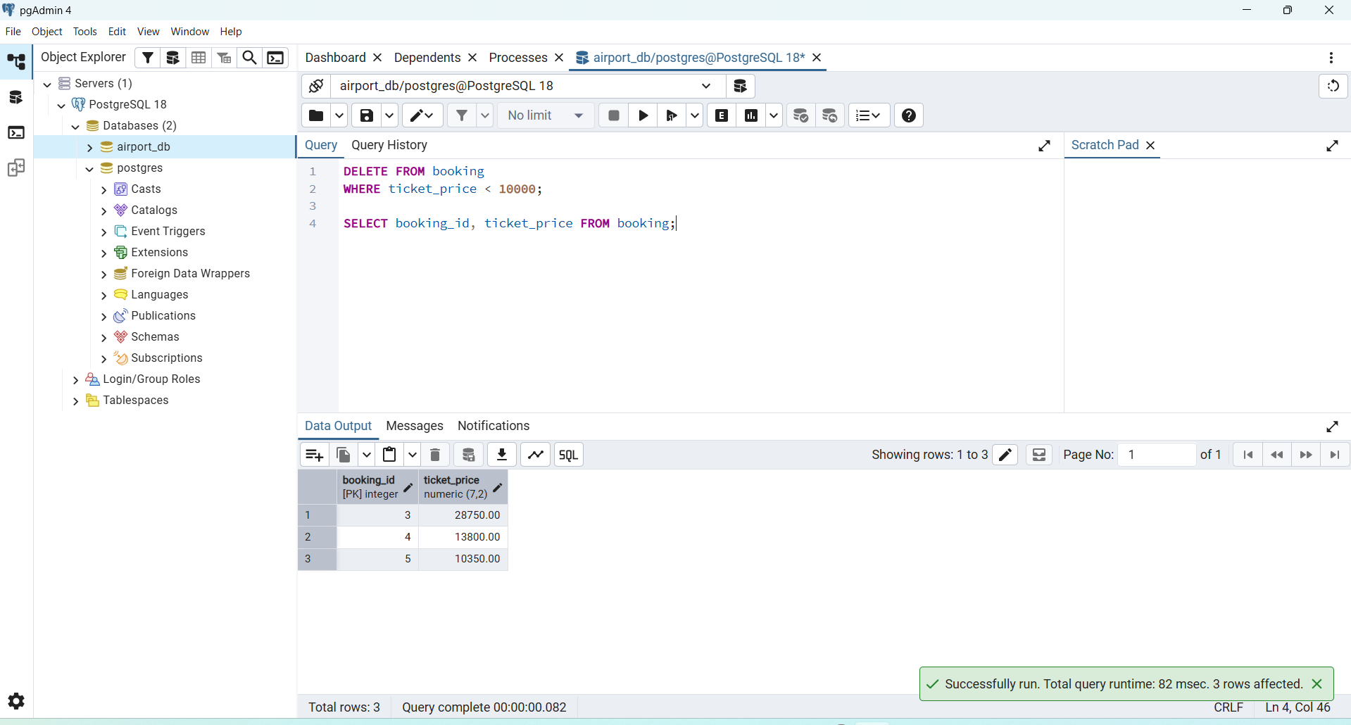
Task 8. Set default airline code 'UNK' where it is NULL
UPDATE airline
SET airline_code = 'UNK'
WHERE airline_code IS NULL;

SELECT * FROM airline;
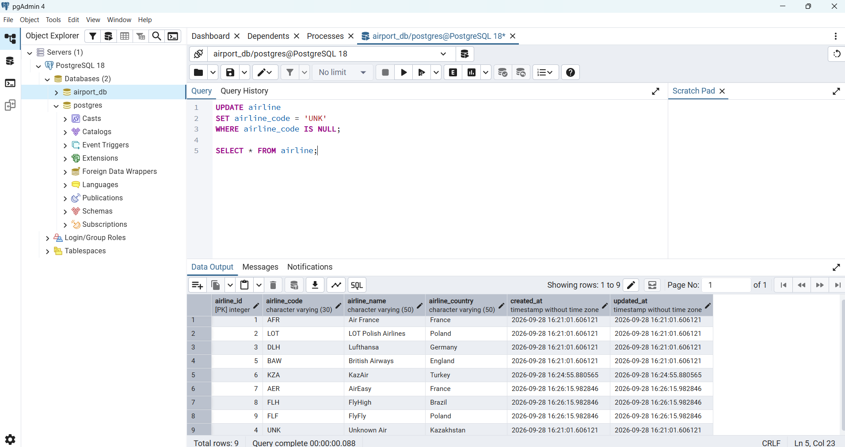
Task 9. Delete old baggage checks with result 'Not checked'
DELETE FROM baggage_check
WHERE created_at < '2023-06-01'
AND check_result = 'Not checked';

SELECT * FROM baggage_check;
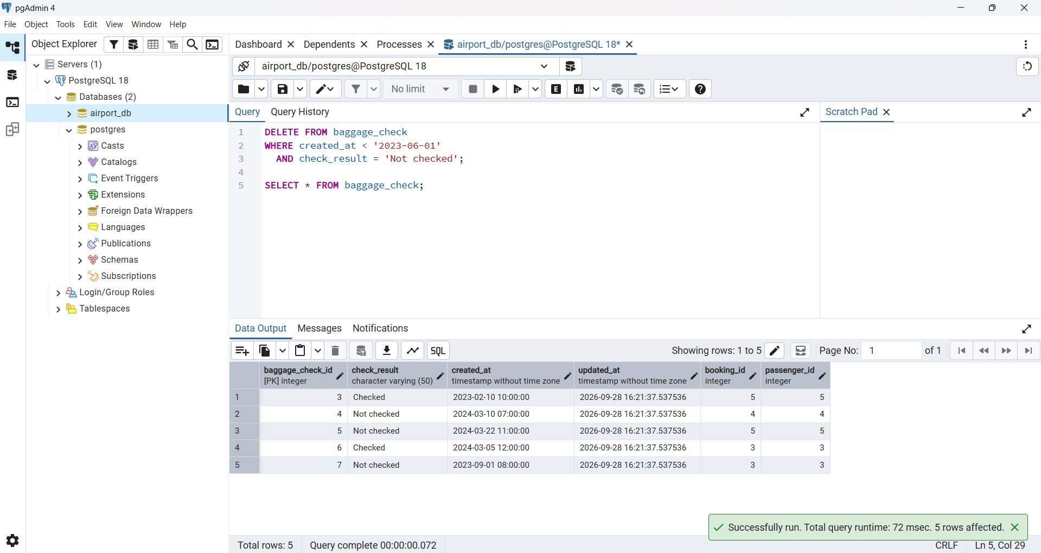
Task 10. Delete airports without state in Mlawe and Kepuh
DELETE FROM airport
WHERE state IS NULL
AND city IN ('Mlawe', 'Kepuh');

SELECT * FROM airport WHERE airport_id <= 7;
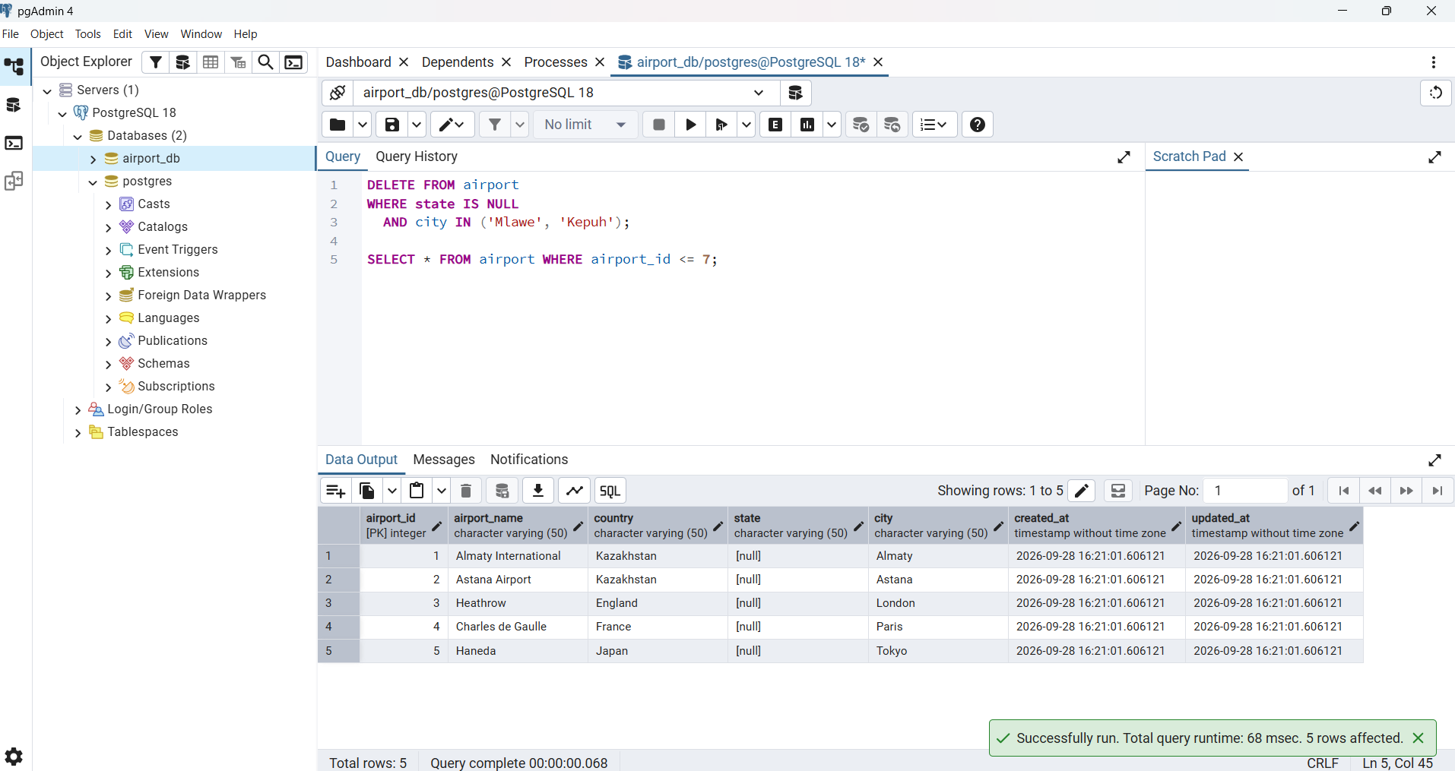
Task 11. Insert a baggage check and return its id and created_at
INSERT INTO baggage_check (check_result, created_at, updated_at, booking_id, passenger_id)
VALUES ('Not checked', now(), now(), 4, 4)
RETURNING baggage_check_id, created_at;
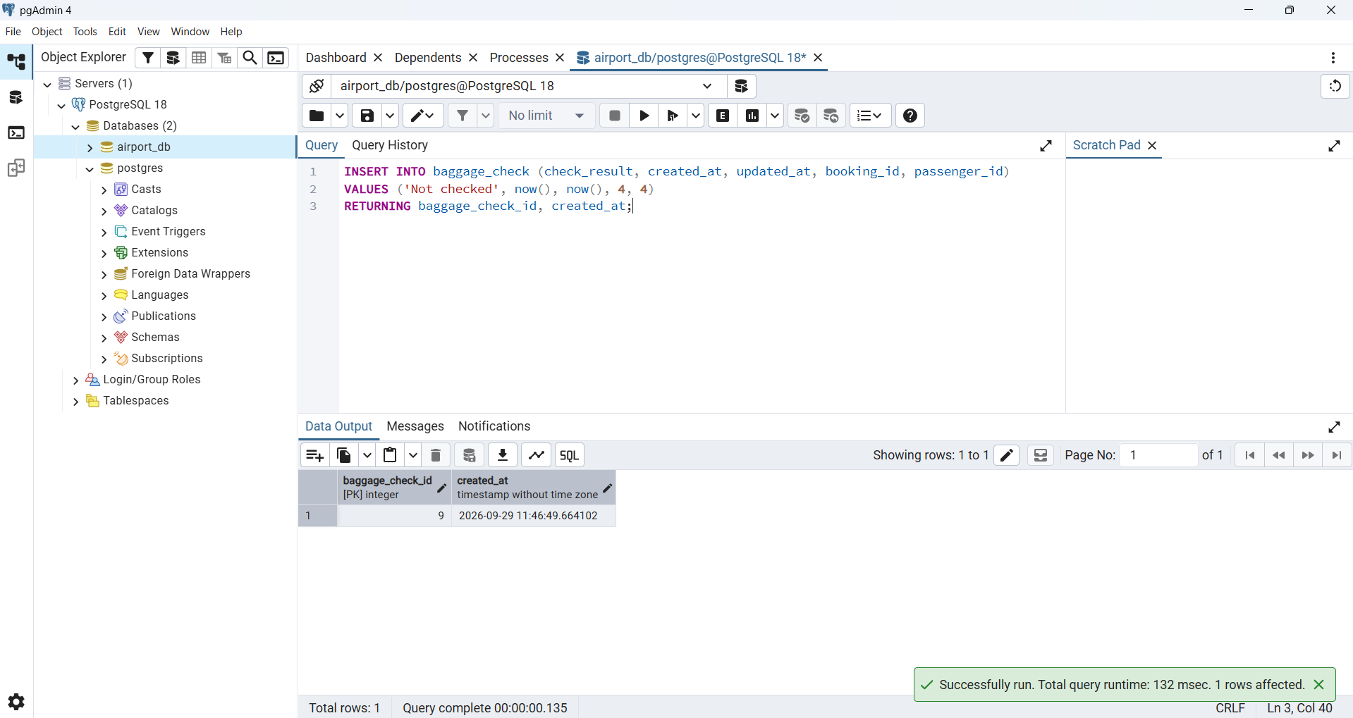
Task 12. Convert airline country names to uppercase
UPDATE airline
SET airline_country = UPPER(airline_country);

SELECT * FROM airline;
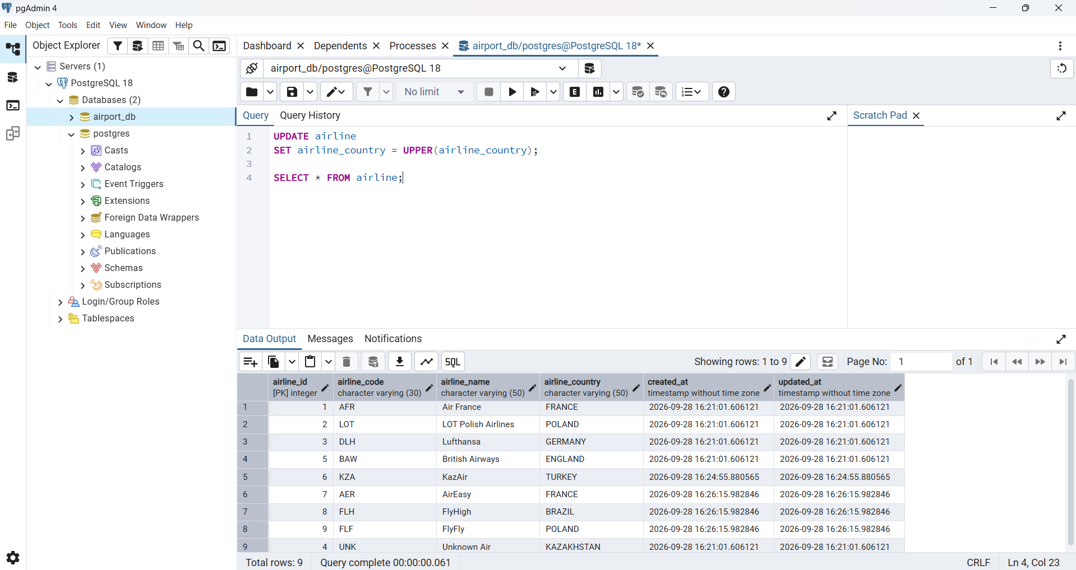
Task 13. Update name and country of the airline with airline_id = 5
UPDATE airline
SET airline_name = 'Global Airways',
airline_country = 'United Kingdom',
updated_at = CURRENT_DATE
WHERE airline_id = 5;

SELECT * FROM airline WHERE airline_id = 5;
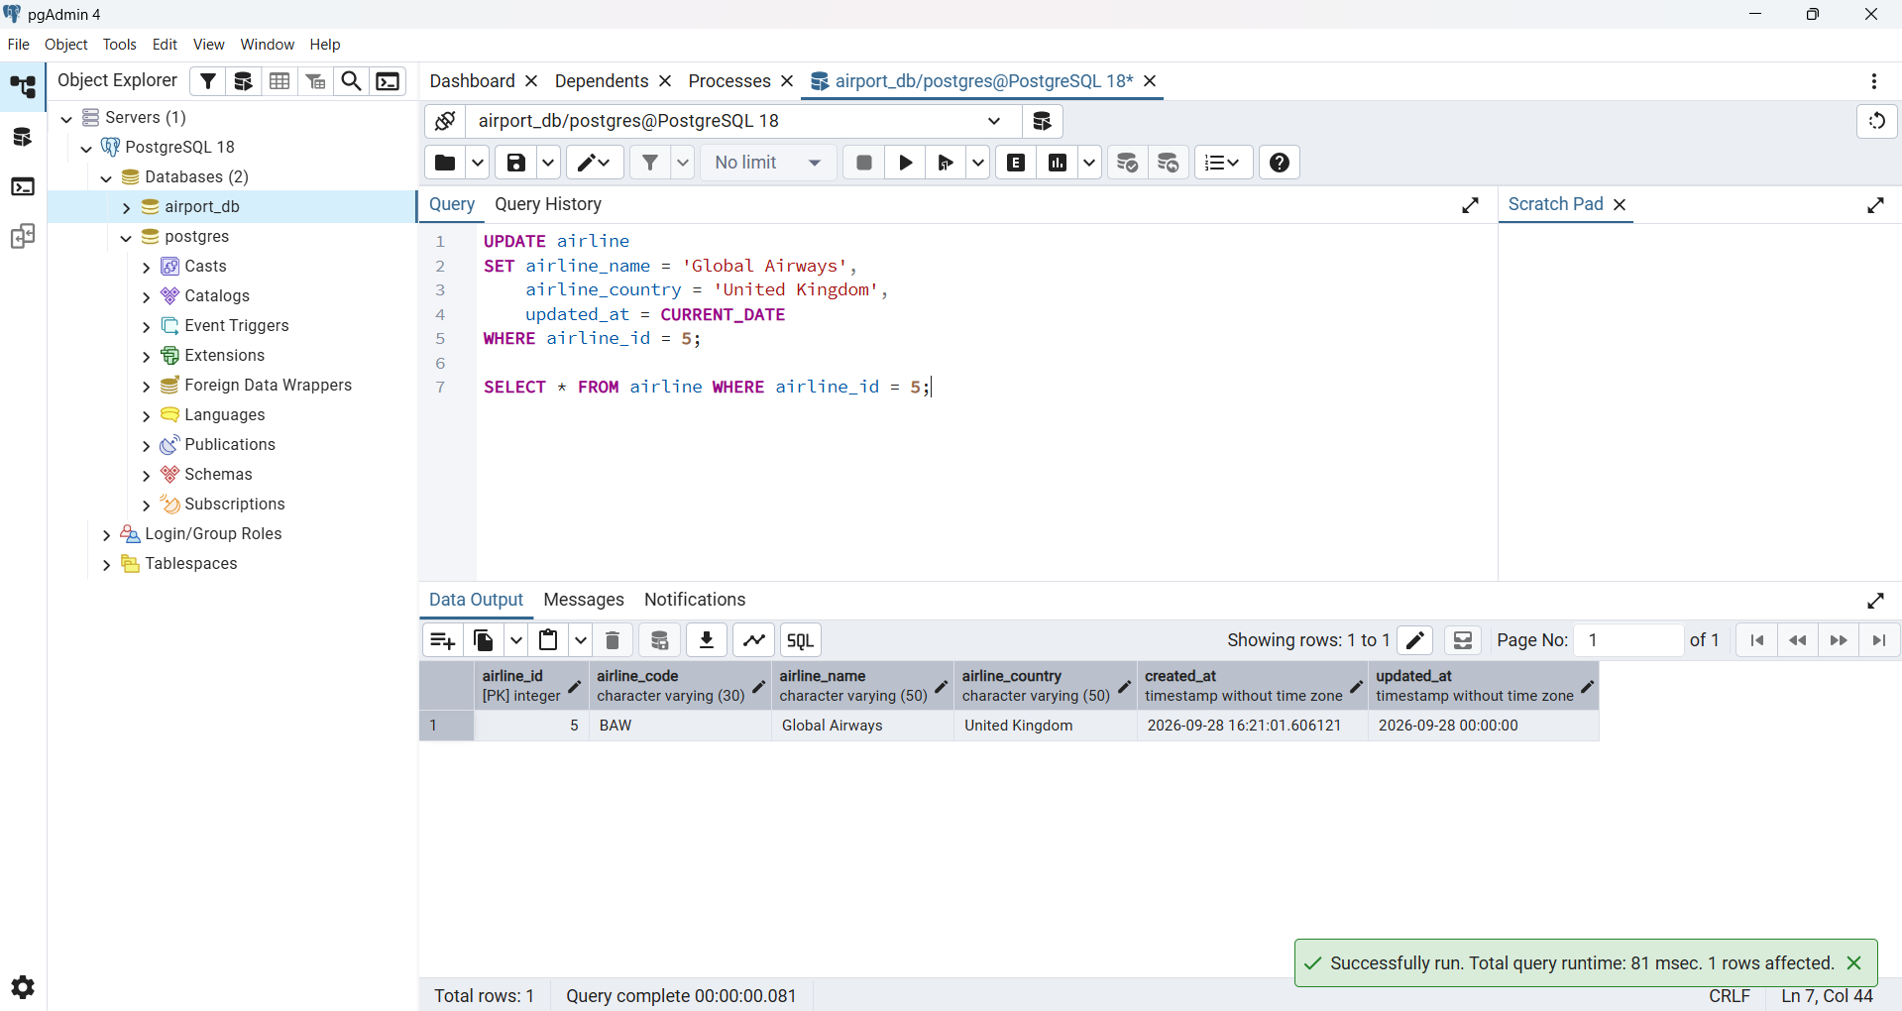
Task 14. Set state 'Capital District' for Astana, London, Tokyo
UPDATE airport
SET state = 'Capital District'
WHERE city IN ('Astana', 'London', 'Tokyo');

SELECT * FROM airport WHERE airport_id <= 7;
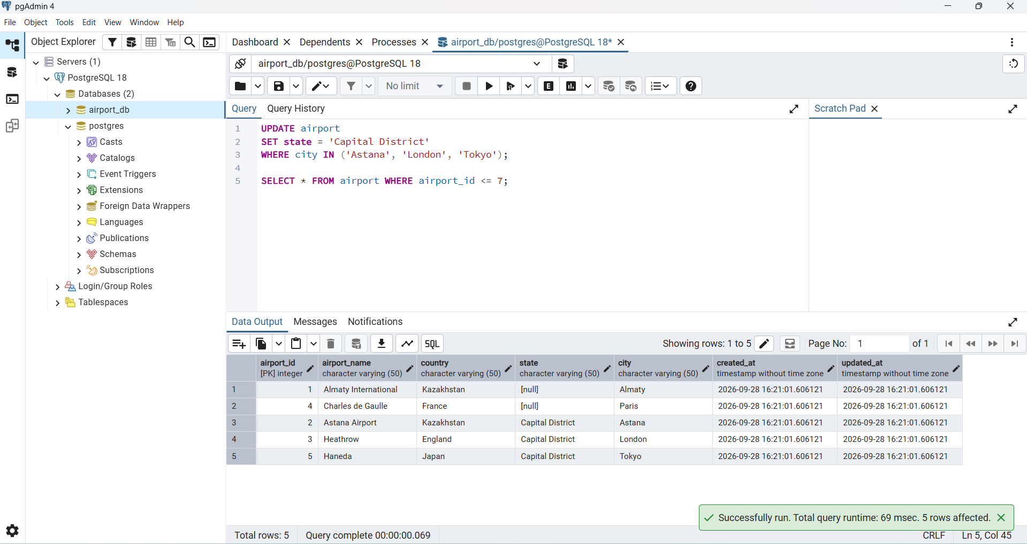
Task 15. Mark March 2024 baggage checks as 'Checked'
UPDATE baggage_check
SET check_result = 'Checked'
WHERE check_result = 'Not checked'
AND created_at >= '2024-03-01'
AND created_at < '2024-04-01';

SELECT * FROM baggage_check;
