Laboratory work 4
Tasks 1–2
1. Retrieve all airline names in uppercase.
2. Replace any occurrence of the word "Air" in airline names with "Aero".
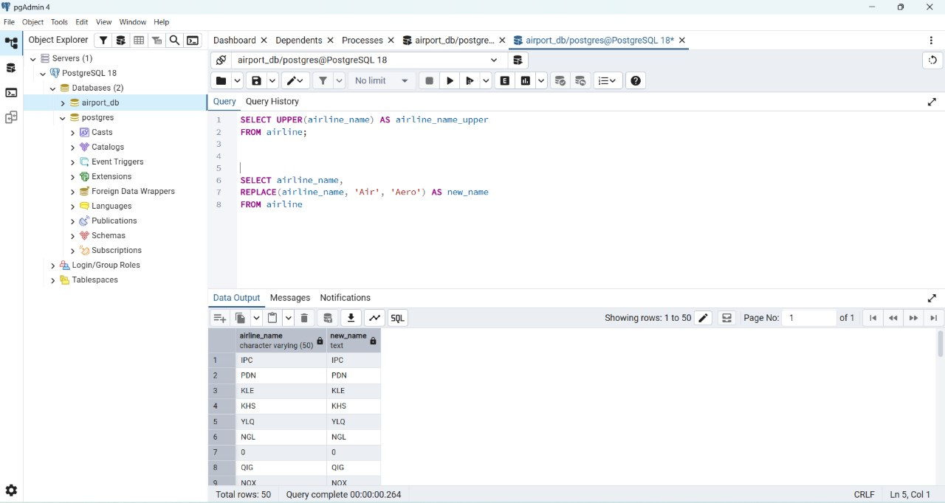
Task 3
Find all flight numbers that coincide with both airline 1 and airline 2.
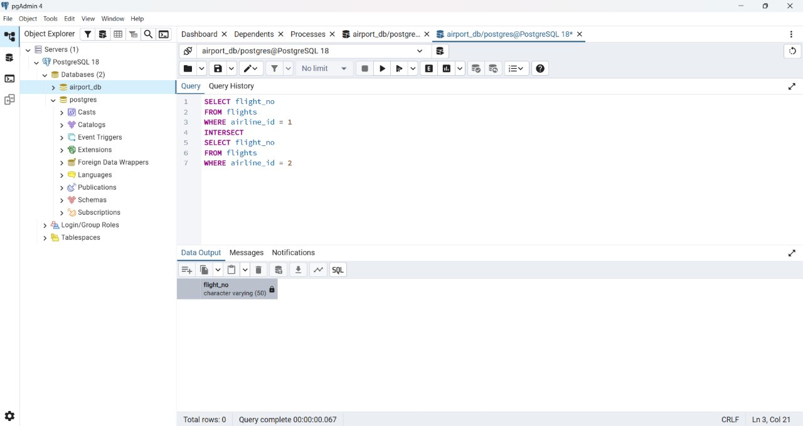
Task 4
Retrieve airports that contain the words "Regional" and "Air" in their names.
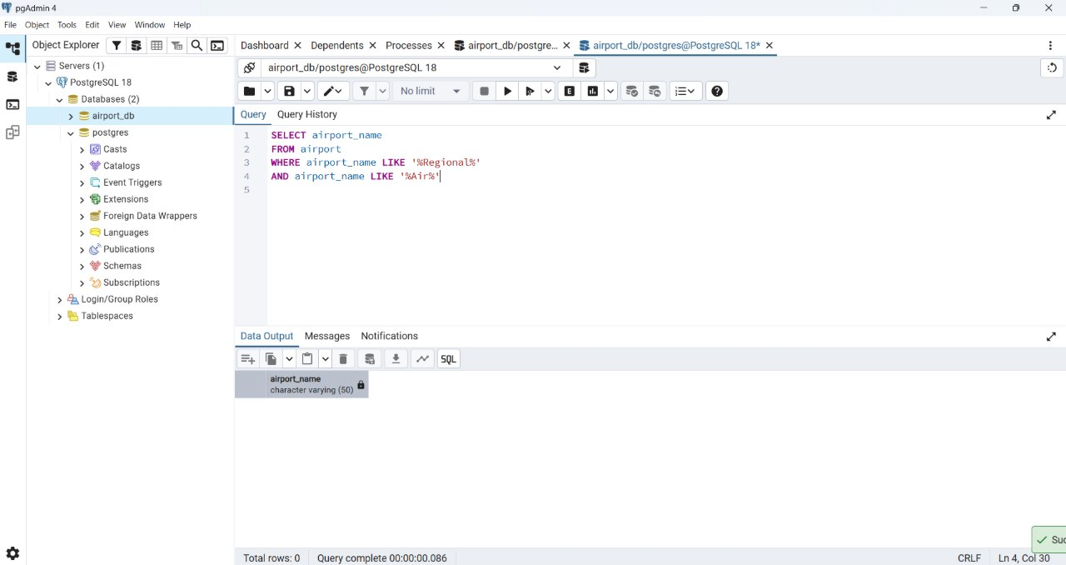
Task 5
Retrieve passenger names and format their birth dates as 'Month DD, YYYY'.
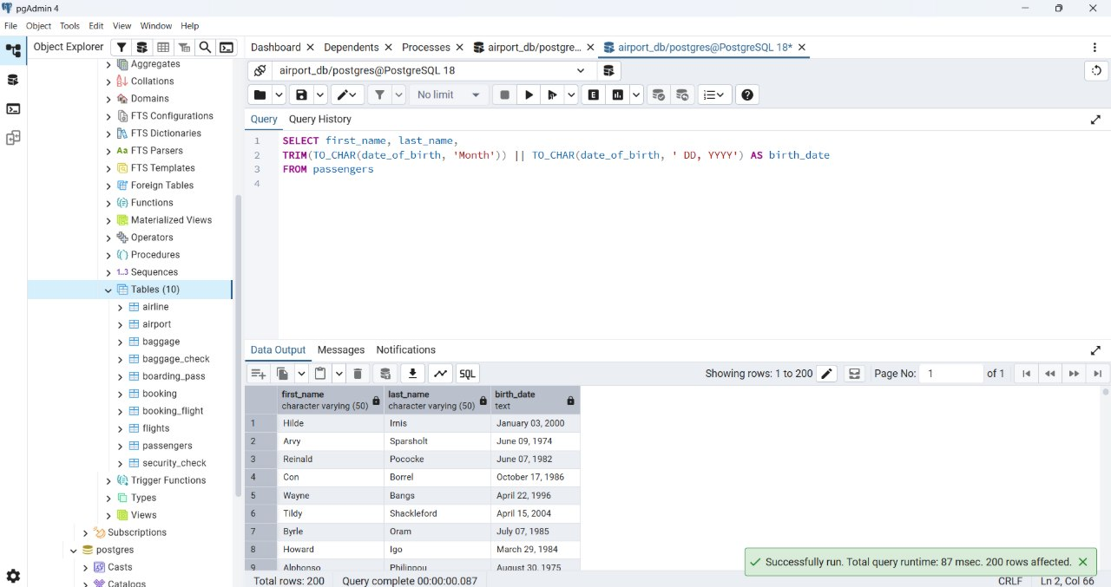
Task 6
Find flight numbers that have been delayed based on the actual arrival time.
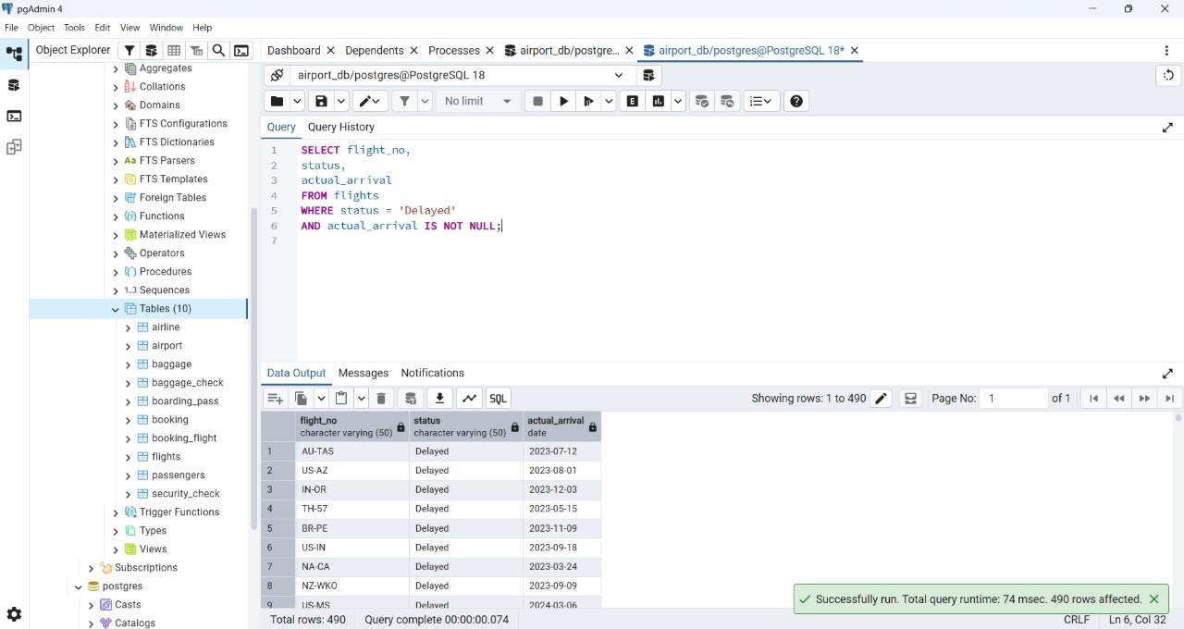
Task 7
Find flights that arrived late according to their actual arrival time compared to the scheduled arrival time.
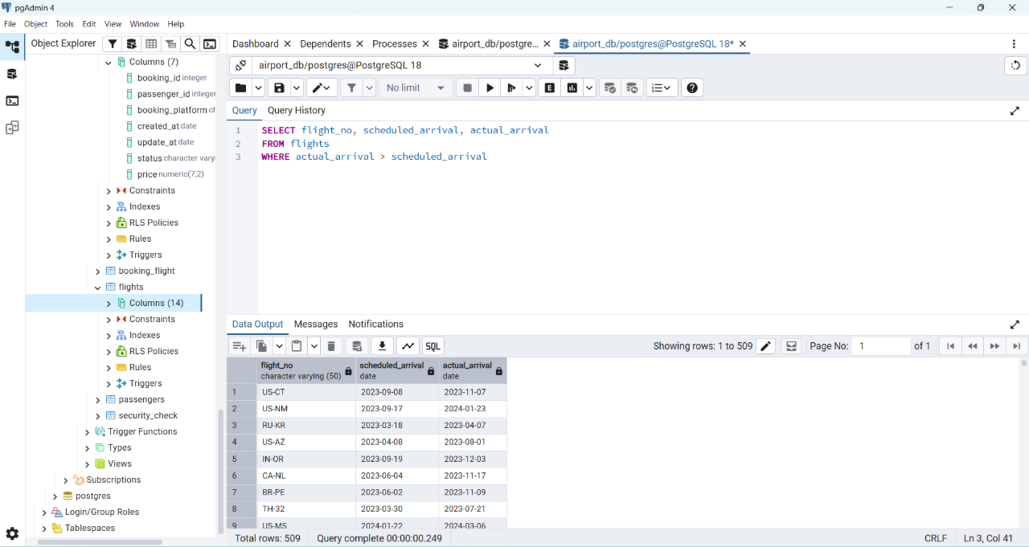
Task 8
Show airlines from any of: ('France','Portugal','Poland') created between '2023-11-01' and '2024-03-31'.
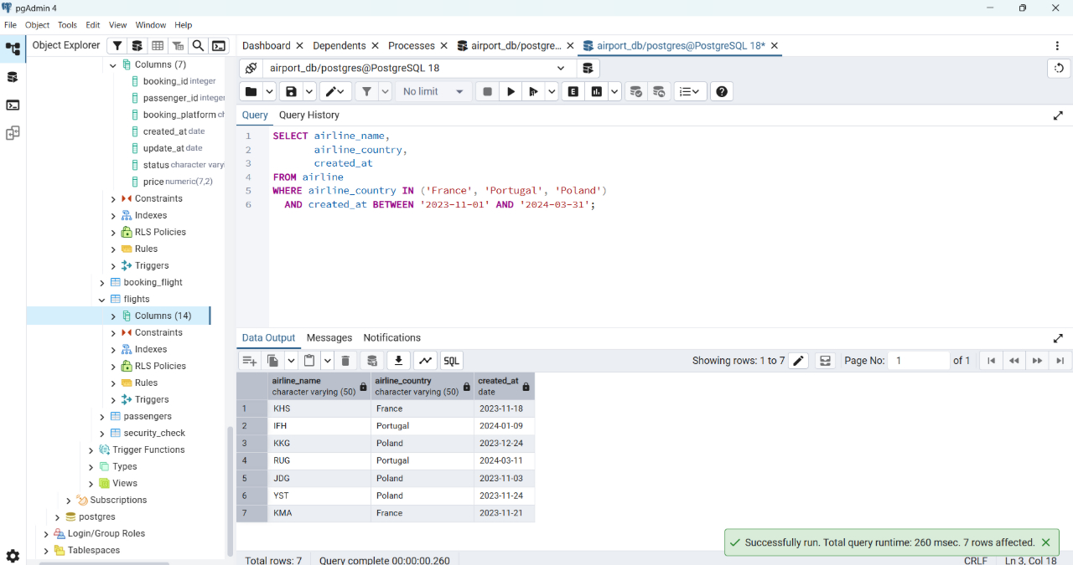
Task 9
Find top 3 overweighted baggage with more than 25 kg.
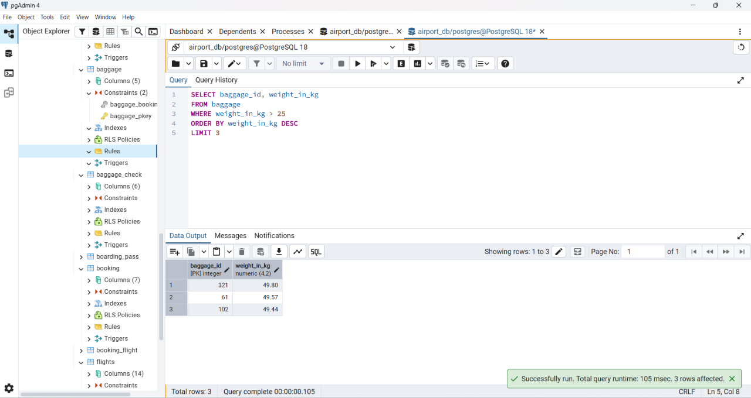
Task 10
Find the youngest passenger's full name.
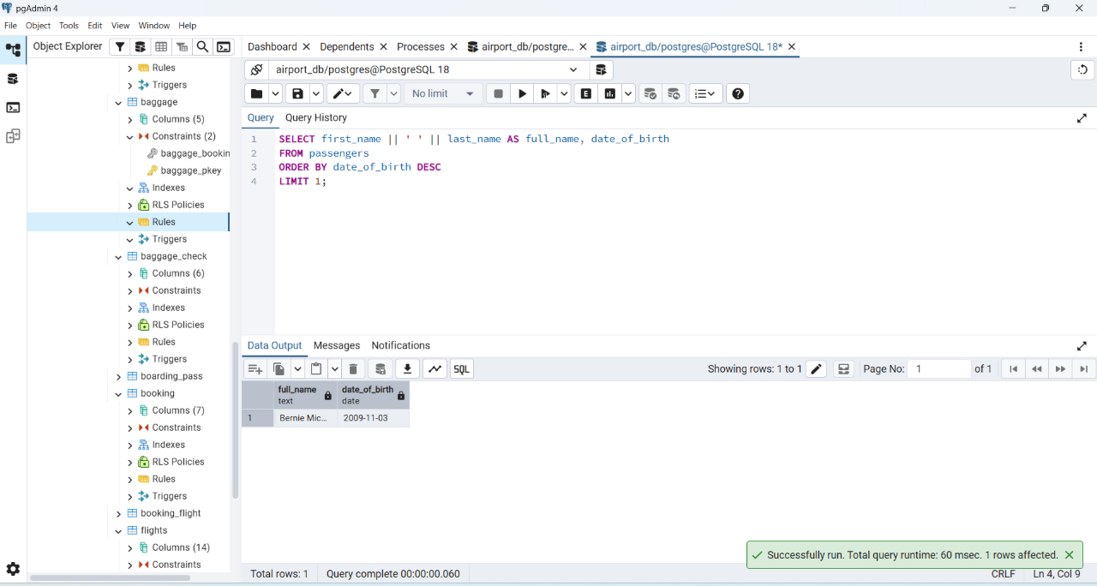
Task 11
Find the cheapest booking price on each booking platform.
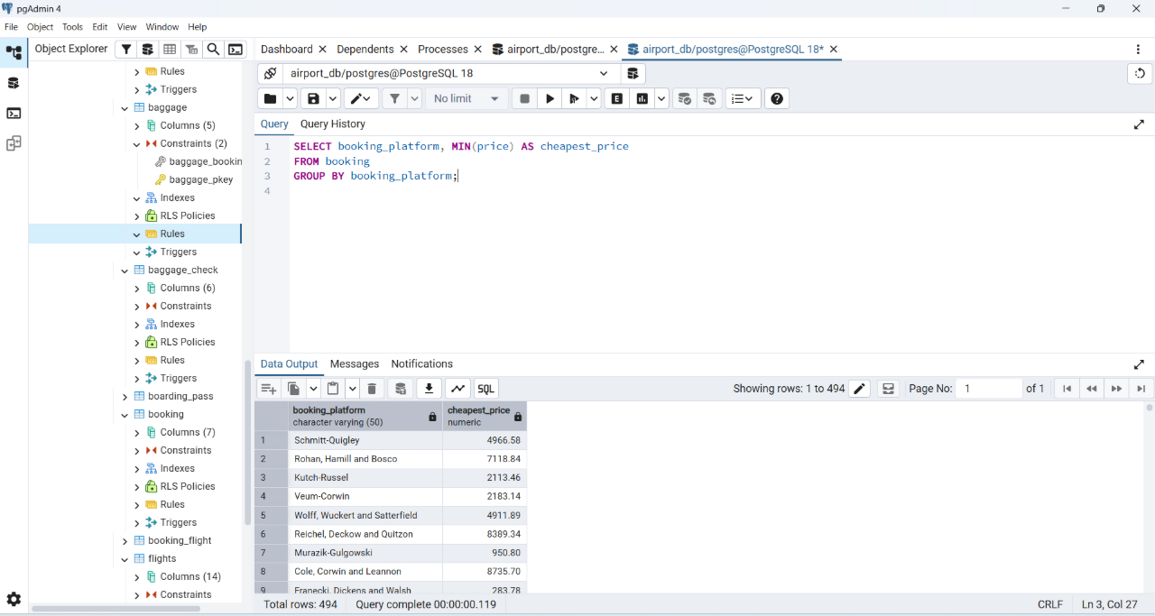
Task 12
Return airlines whose airline_code contains a digit.
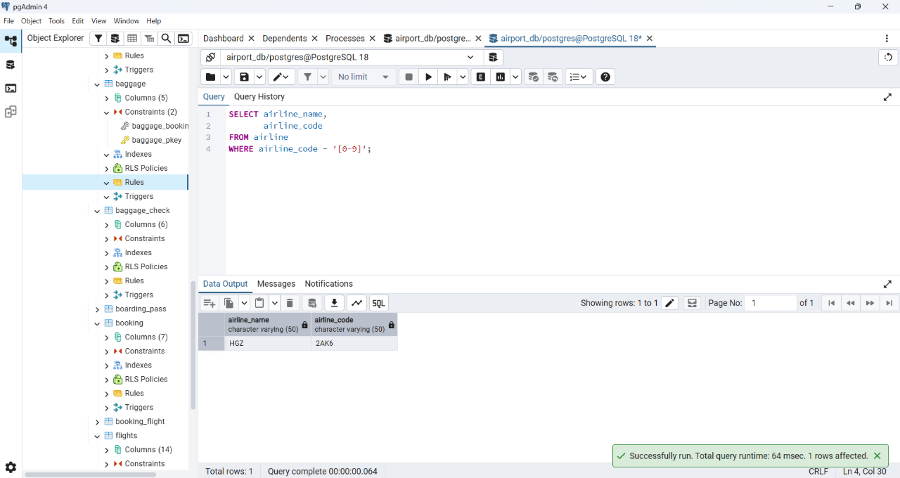
Task 13
List the top 5 most recently created airlines.
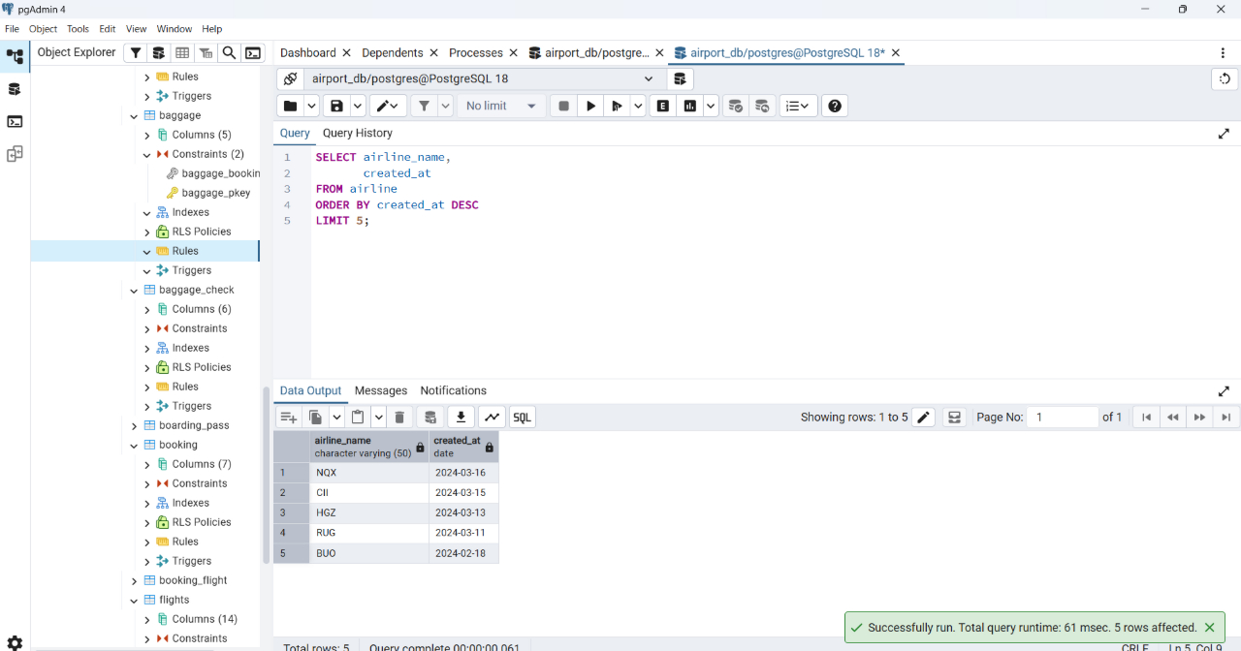
Task 14
Return all rows where booking_id is between 200 and 300 inclusive and check_result <> 'Checked'.
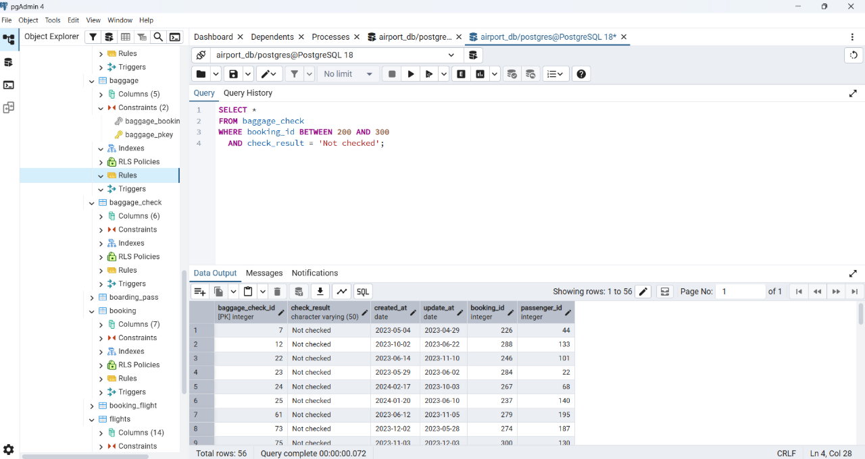
Task 15
Baggage checks where update_at is in the same month as created_at but occurs earlier than created_at.
