**Jenkins-Task-03**

1. Create one jenkins job using the below code and create three stages.

stage1: Git clone to download the source code.

URL: <https://github.com/betawins/VProfile-1.git>  
clone this repo and created a Job.

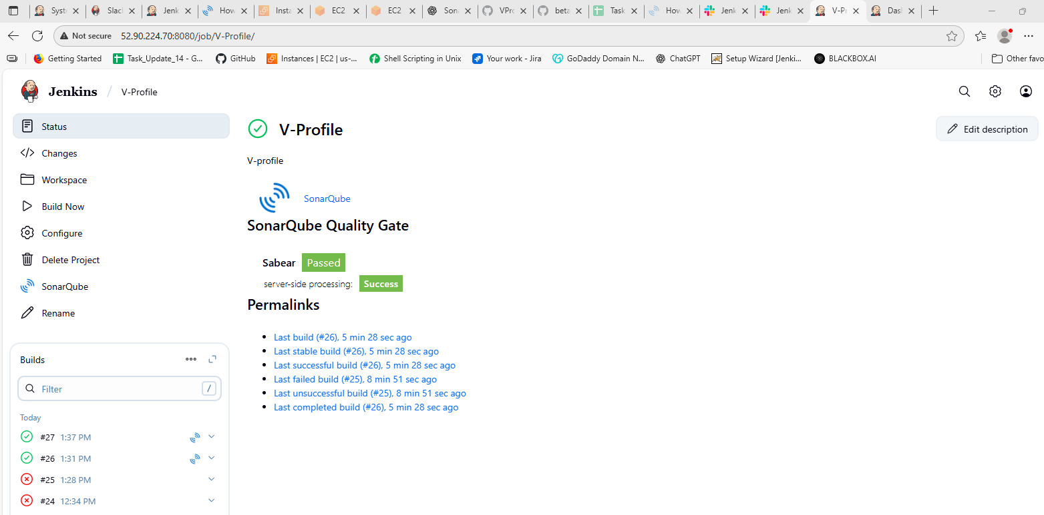

stage2: Sonarqube Integration to check the quality of code.

First we create Ec2-instance for sonar-qube

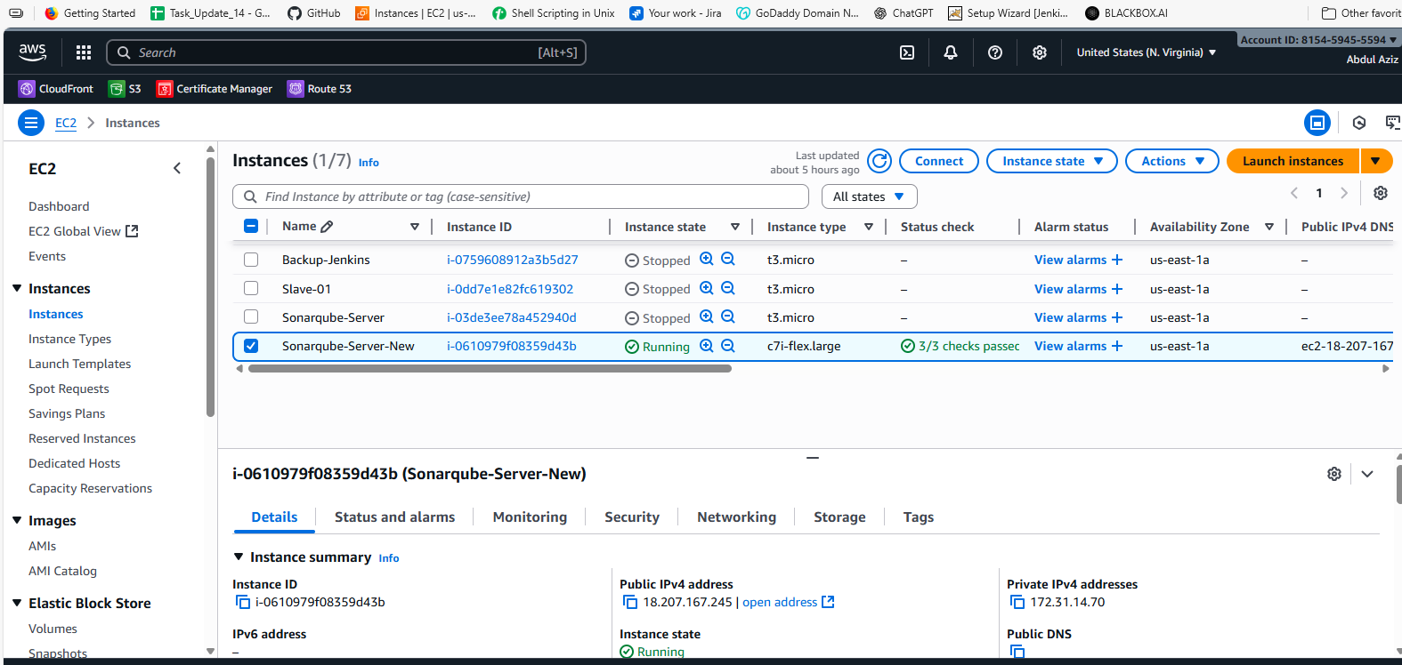

And then we install java 1.8 version.

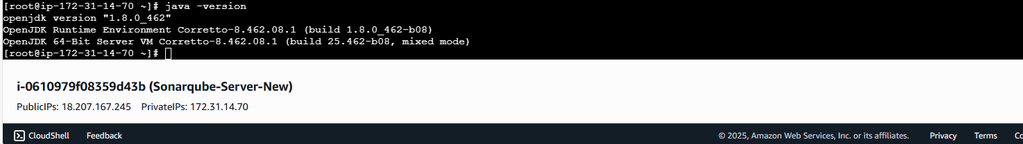

Than we install Docker on machine.

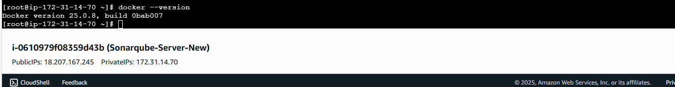

Than we run the command Docker pull sonarqube.

Than we use command to run the sonarqube on port 9002

docker run -itd -p 9002:9000 sonarqube

Than we configure in the master.

wget <https://binaries.sonarsource.com/Distribution/sonarqube/sonarqube-8.9.6.50800.zip>  
unzip sonarqube-8.9.6.50800.zip  
amazon-linux-extras install java-openjdk11 -y  
useradd sonar  
chown sonar:sonar sonarqube-8.9.6.50800 -R  
chmod 777 sonarqube-8.9.6.50800 -R

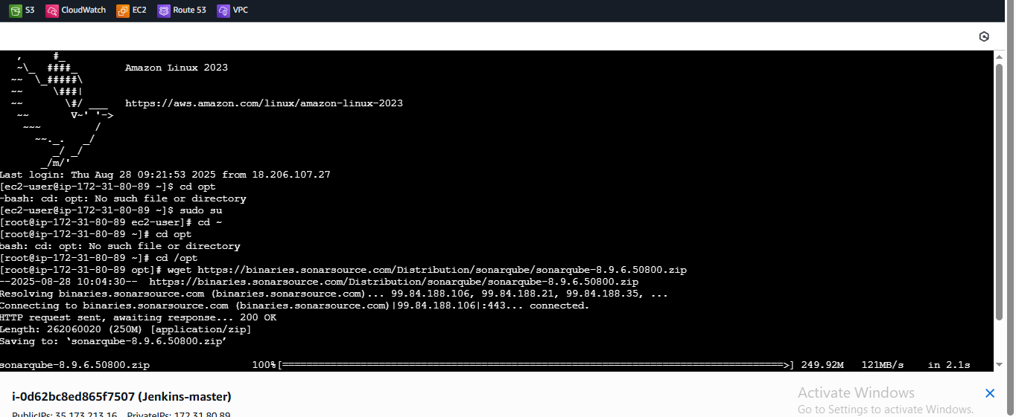

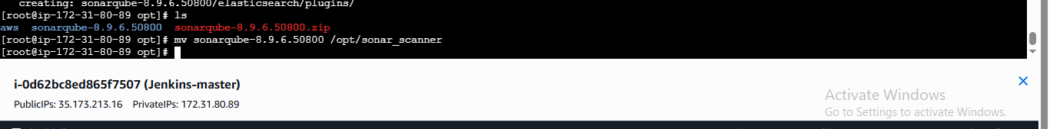

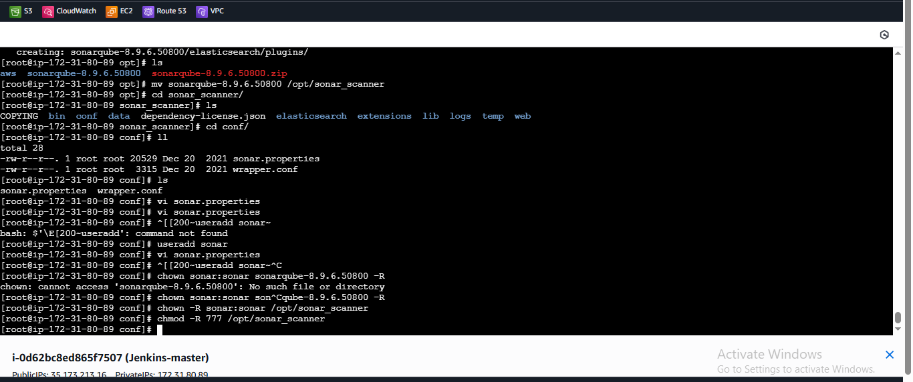

Than we install pulgins.

* Sonar scanner

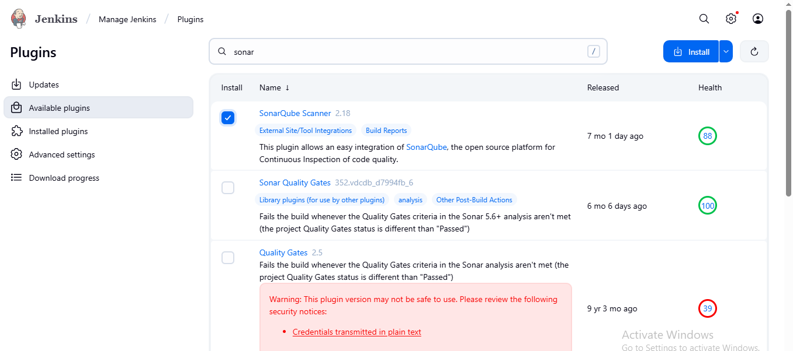

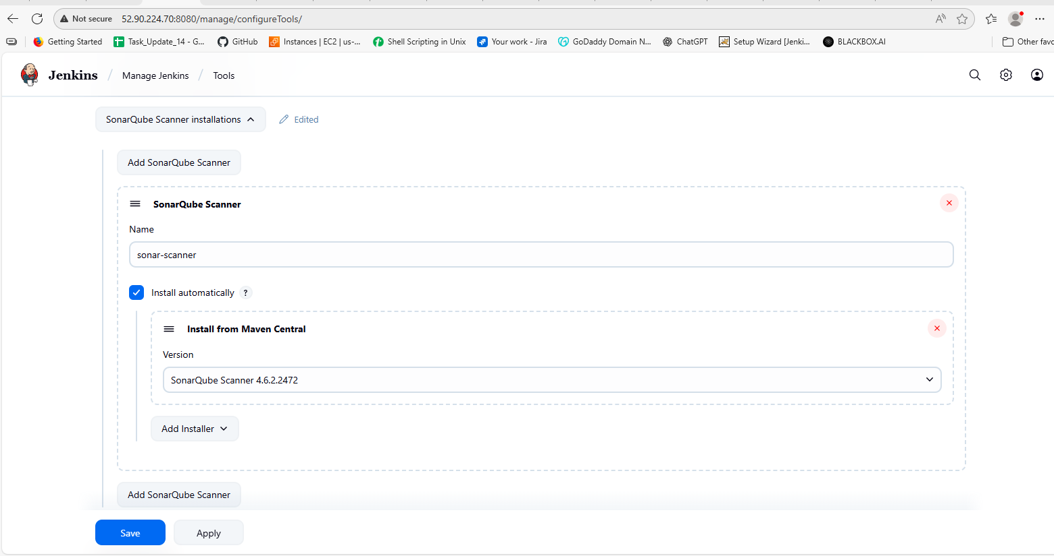

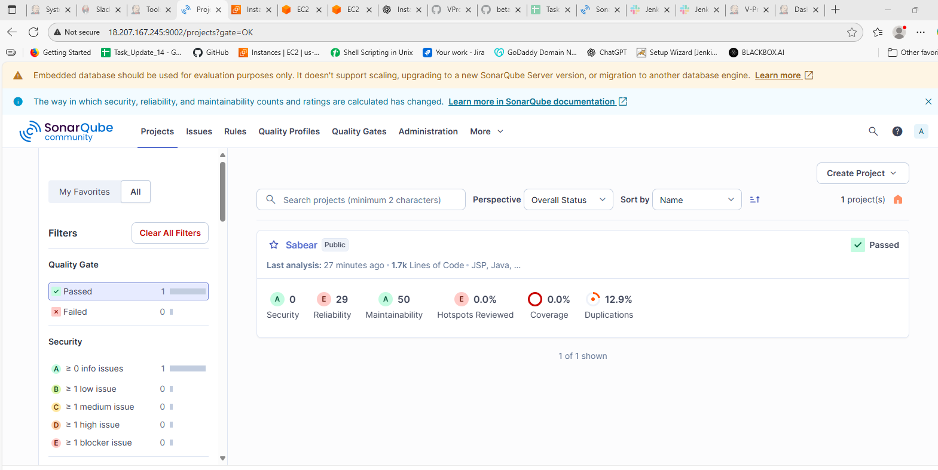

stage3: Slack Integration to send the alerts to slack.

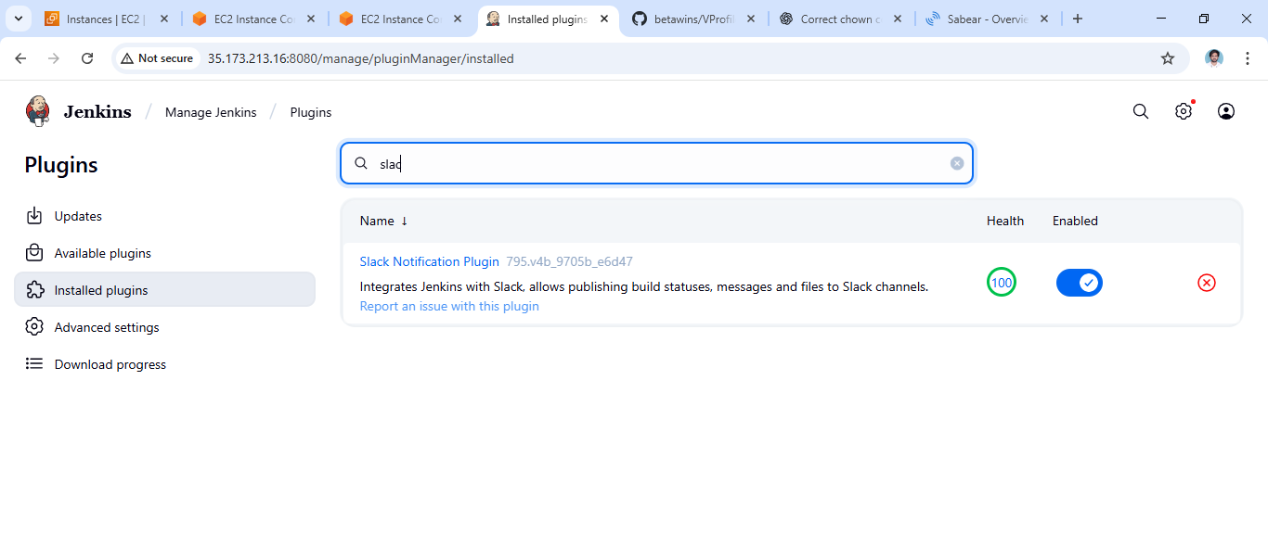

https://techiehorizon.slack.com/services/B09CB7A6V35?added=1

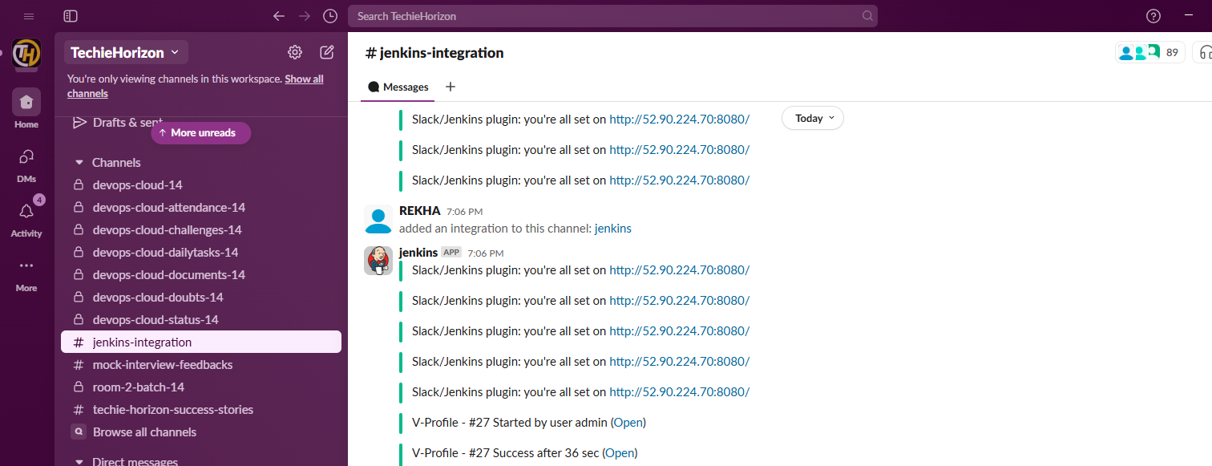

1. Create one jenkins job using the below code and create three stages. stage1: Git clone to download the source code. stage2: Sonarqube Integration to check the quality of code stage3: Slack Integration to send the alerts to slack. URL: <https://github.com/betawins/hiring-app.git>

I have done this task on same job the steps have given what we have to do

