**Jenkins-Task-04**

**1) Setup jenkins CICD pipeline using freestyle job using Docker containers using below code.**

https://github.com/betawins/hiring-app.git

Stages:

1. Git Clone

* First I have created the job name : Jenkins-04-task-1

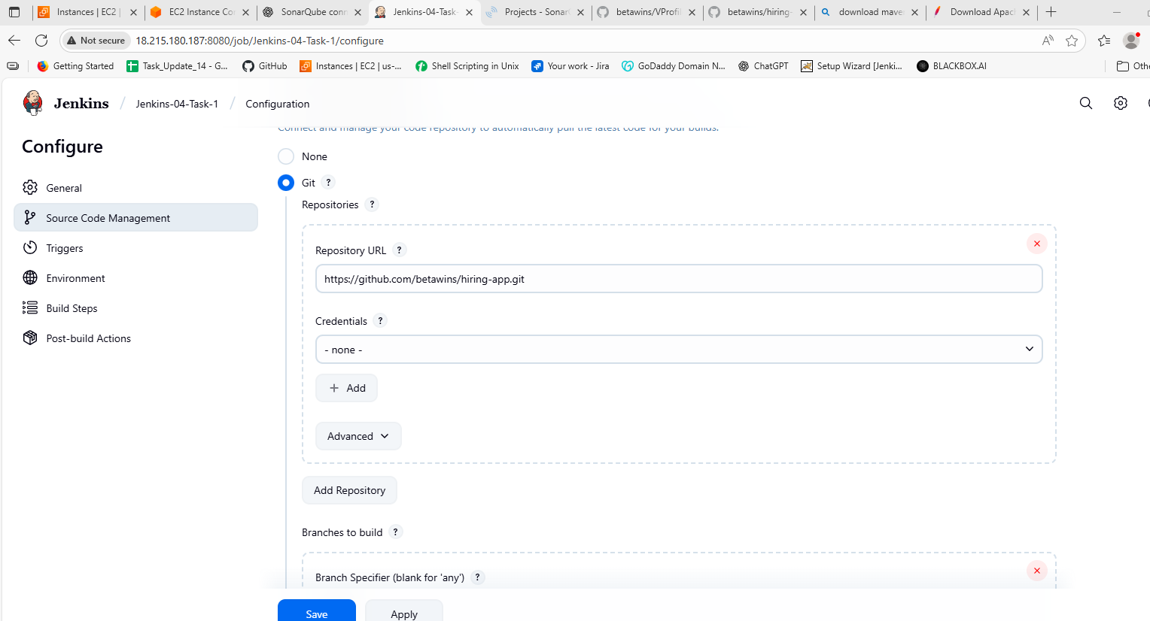

* Then attach the git repo url from the given link as I have attach in above pic.

* Click on save.

* Then **Build** the job

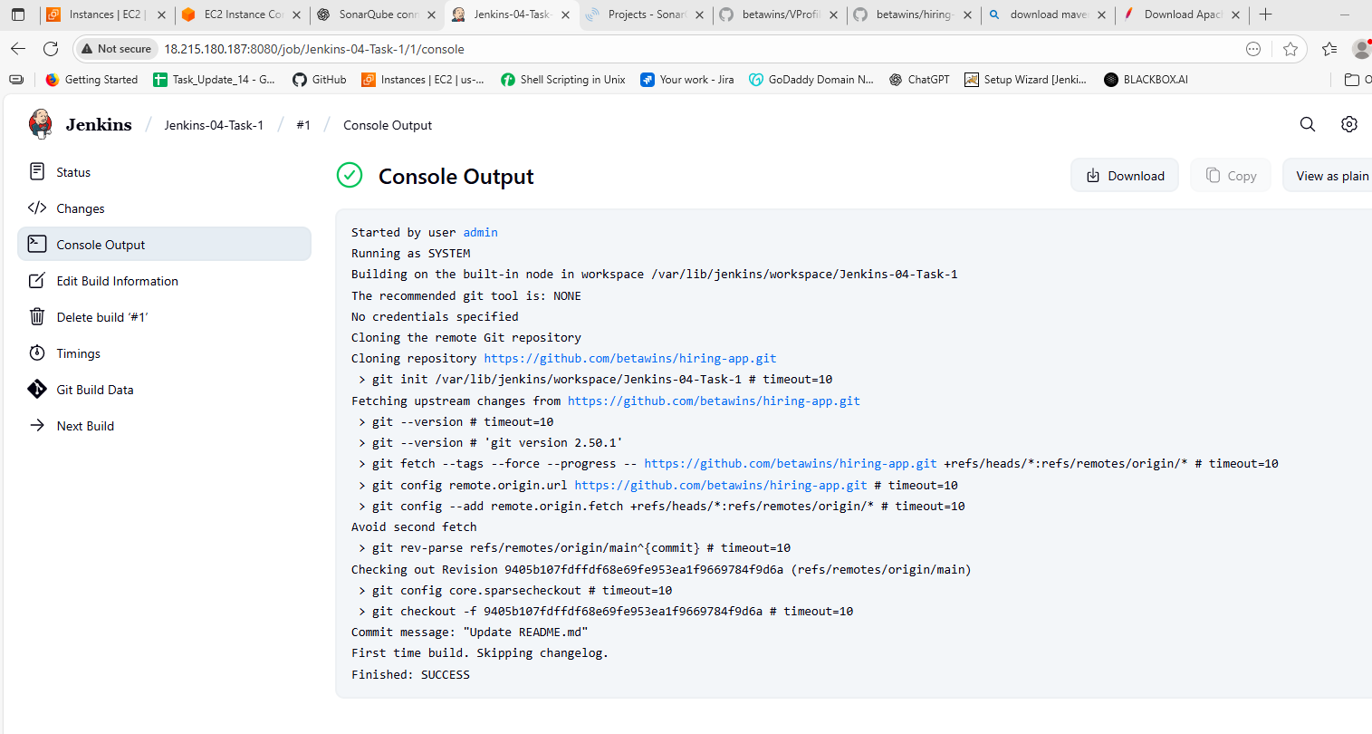

Now we have done with the first stage.

1. Sonarqube Integration

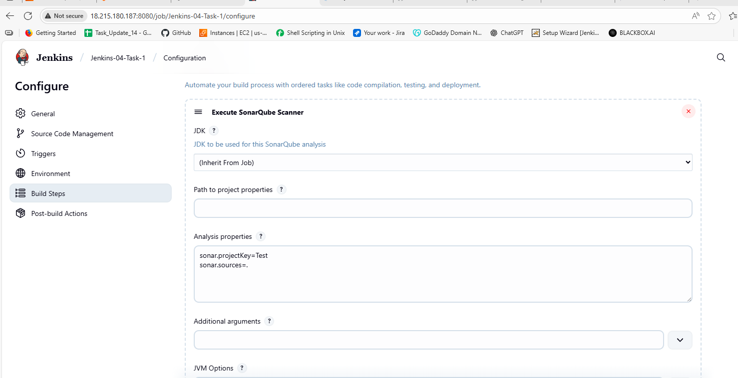

Here first we have to go to the **job** configuration and go to **Execute Sonarqube** **Scanner** then attach the **Analysis properties** in that which will be available in th given repo link at the end. As I have done in the above pic.

Before this we have to do some configurations in the Settings like

Go to Manage then System then in Sonarqube installation

* Name we have to give which is in the local machine
* Then paste thr server url of with the port number of sonarqube.
* Then we are attaching the Authentication Token
* This token we can create in the Sonarqube dashboard. Go to Account in left side.
* Then go to security click on generate token. You will get a token
* Then you have to paste that in the Jenkins Credentials.

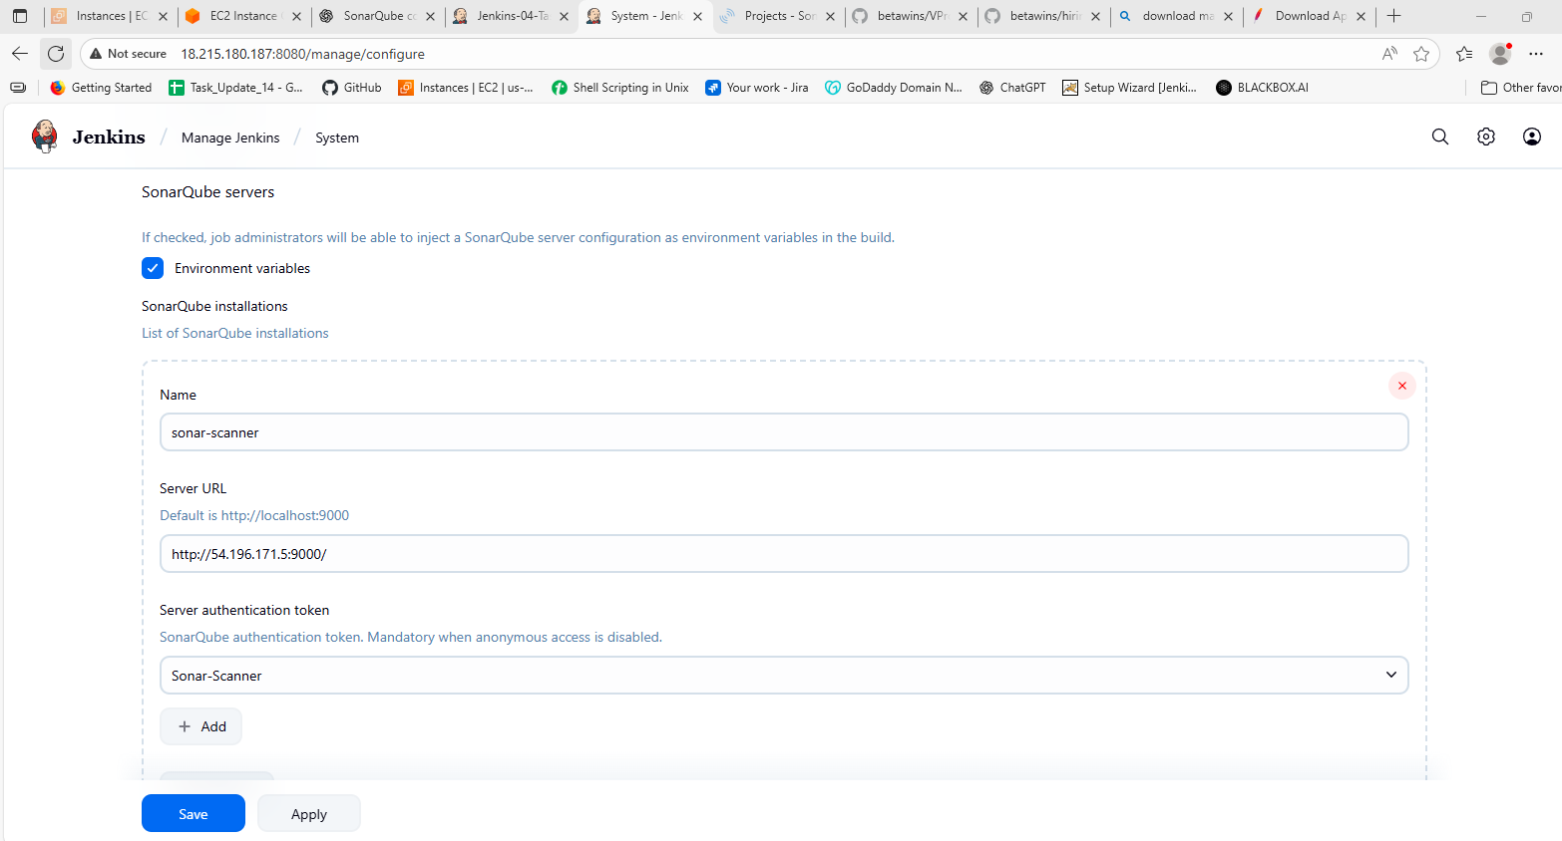

After adding everything just build the job and you should get the output like thiss

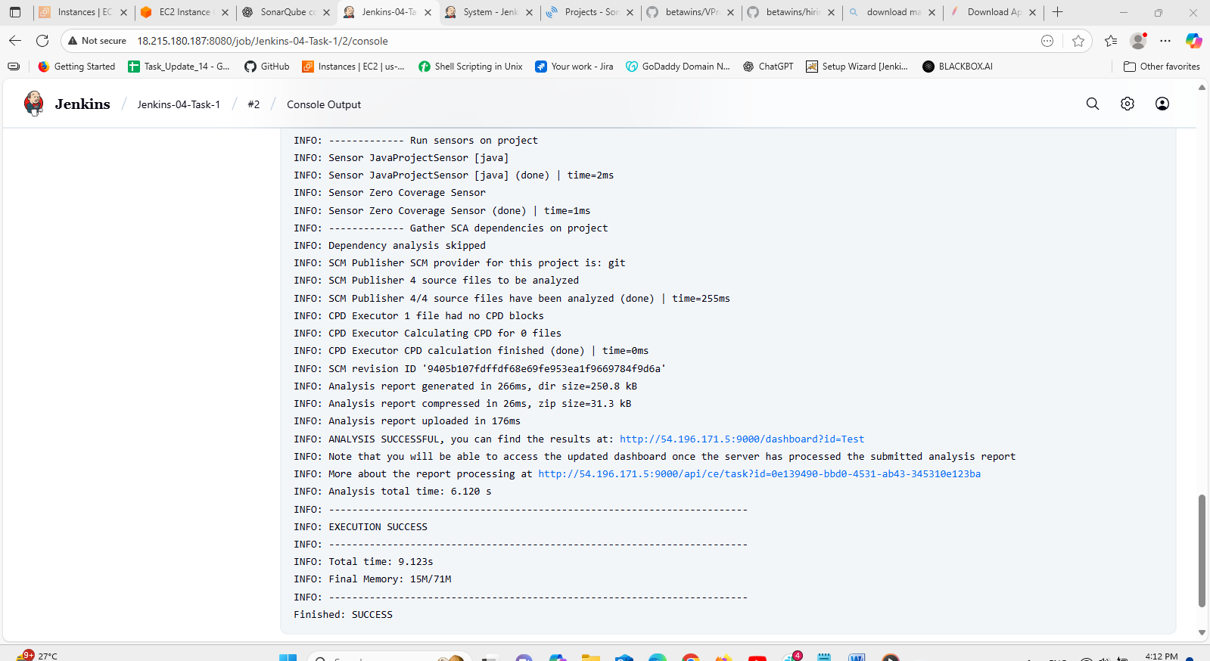

1. Maven Compilation

Here we have to install the Maven in the local machine first.

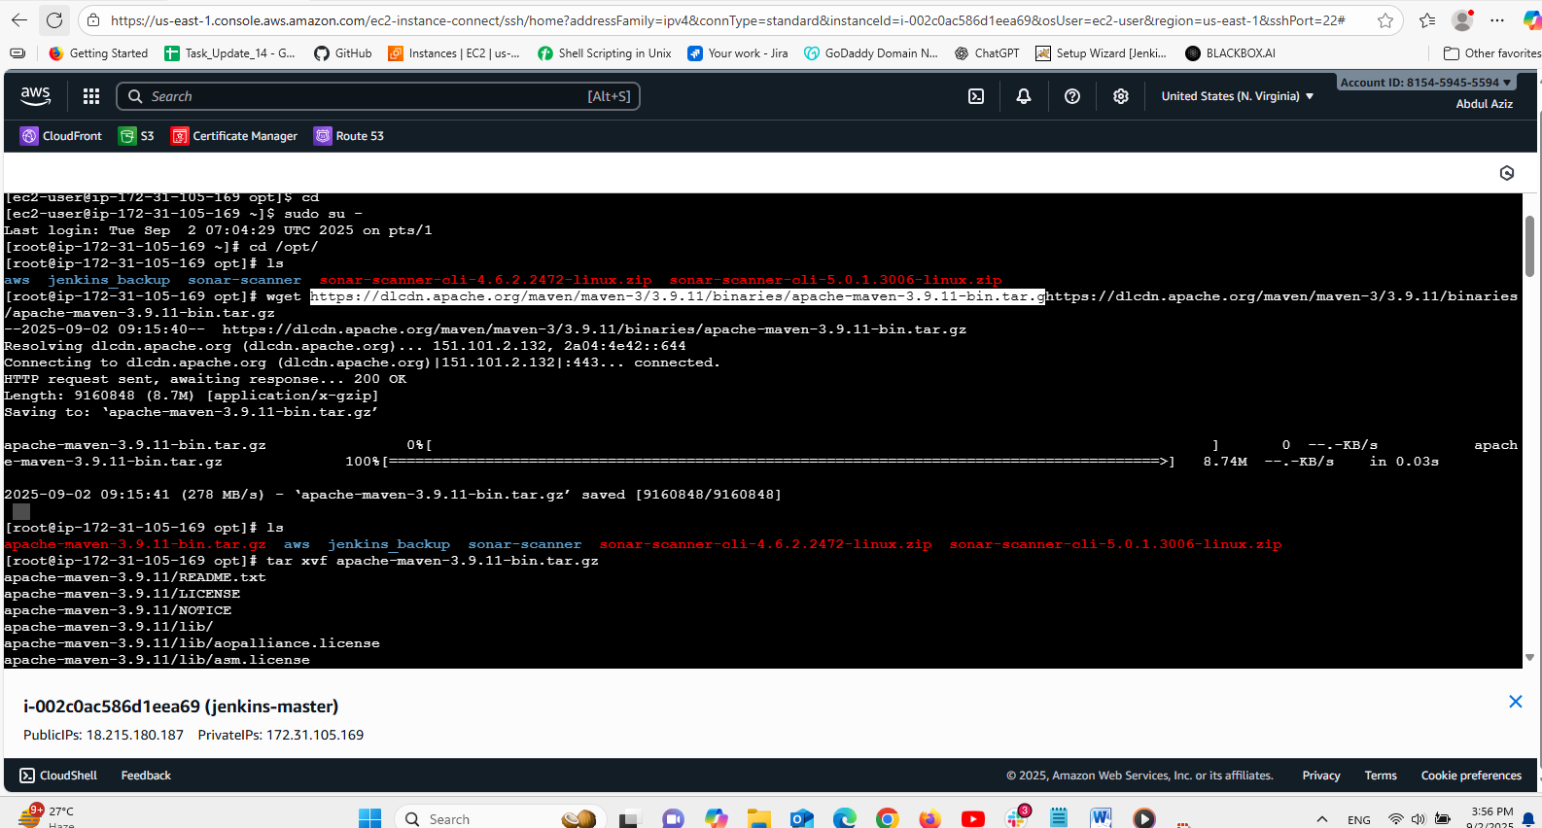

In the above picture we can see the installation

* First we should get into the opt then copy the link from the browser then paste it with **wget** command then the tar file will be created.

* extract that tar file

tar xvf “file-name”

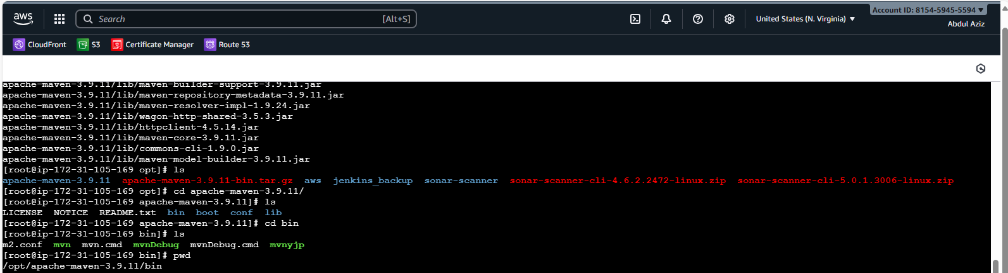

After that we have to go to the **.bash_profile** file then add some pathin this like

# Get the aliases and functions

if [ -f ~/.bashrc ]; then

. ~/.bashrc

fi

# User specific environment and startup programs

export MVN_HOME=/opt/apache-maven-3.9.11

export PATH=$PATH:$HOME/bin:$MVN_HOME/bin

Paste this script in that bash file then save it .

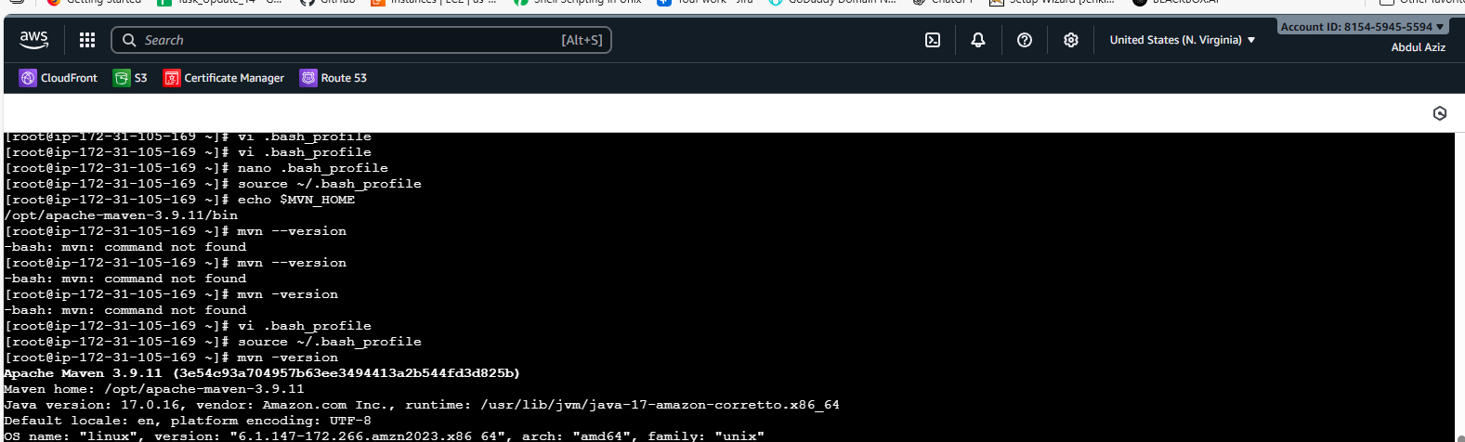

Then check the version of **mvn.**

Previous it is not showing the version we have edited it that’s why it is showing the version

We have given that path should be executed and been check from anywhere in the machine.

After this we have to attach to the Jenkins as given in the below pic.

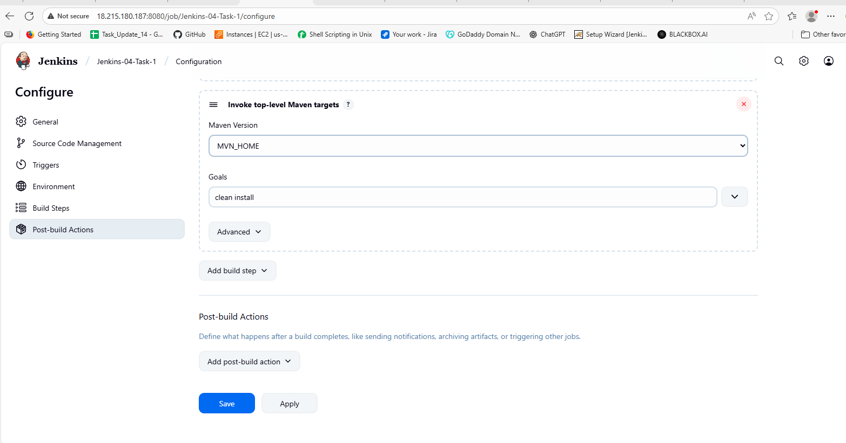

Here in goals we have to attach “clean install” this is a command that normally installs everything.

After attaching this click save. And build the job then the output will be.

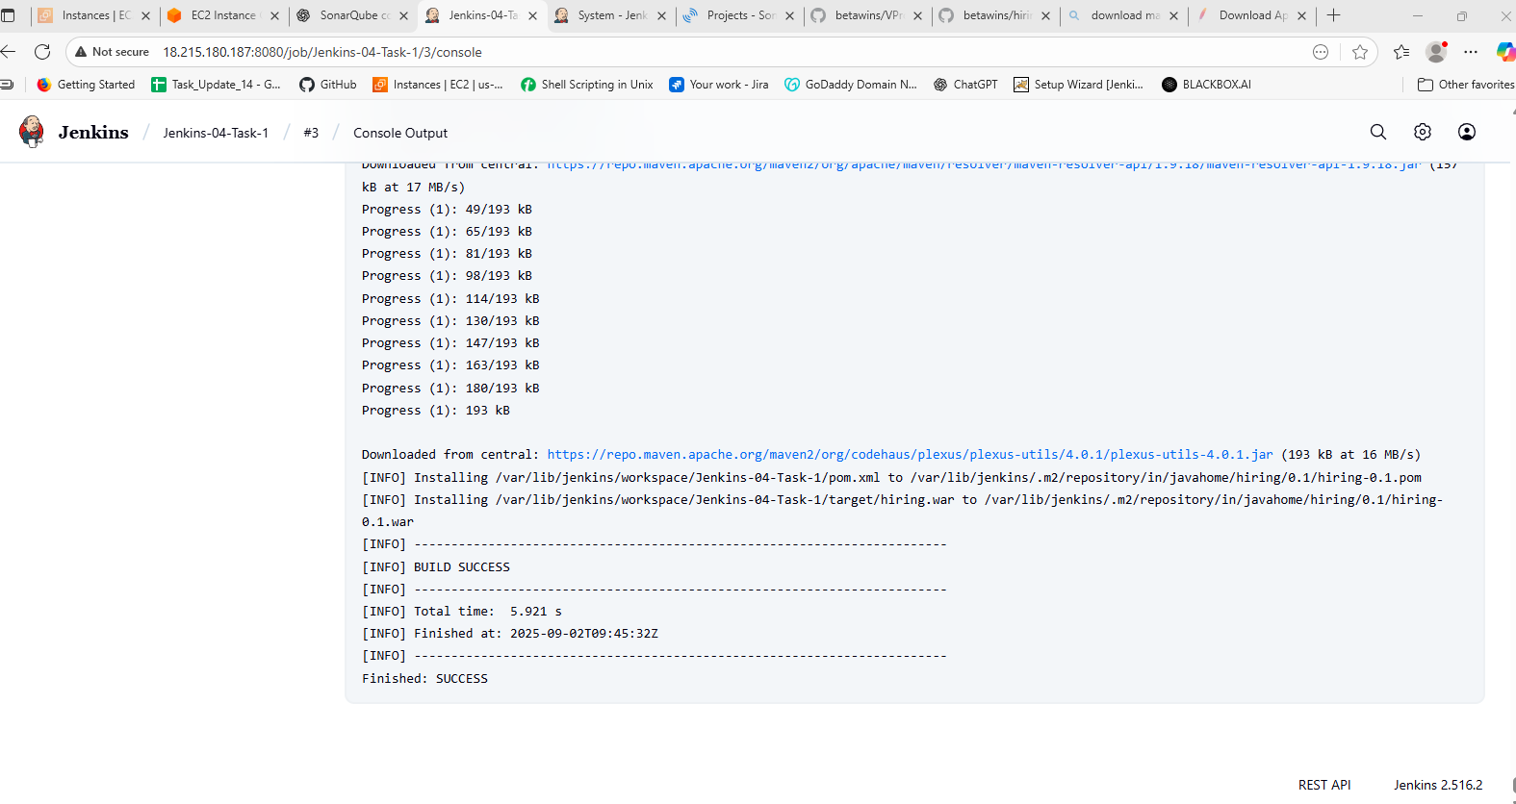

After this installed in our local machine we have see the file **target** has been created as we configure that.we can see below.

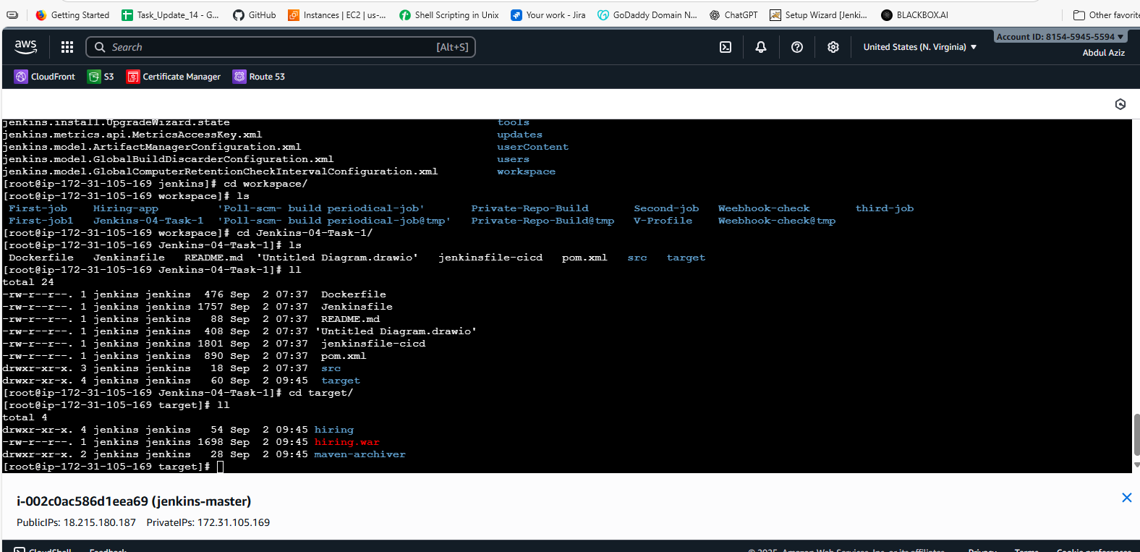

Then in target we can see the packages have created automatically after configuration in Jenkins.

1. Nexus Artifactory

First create one nexus server as given below.

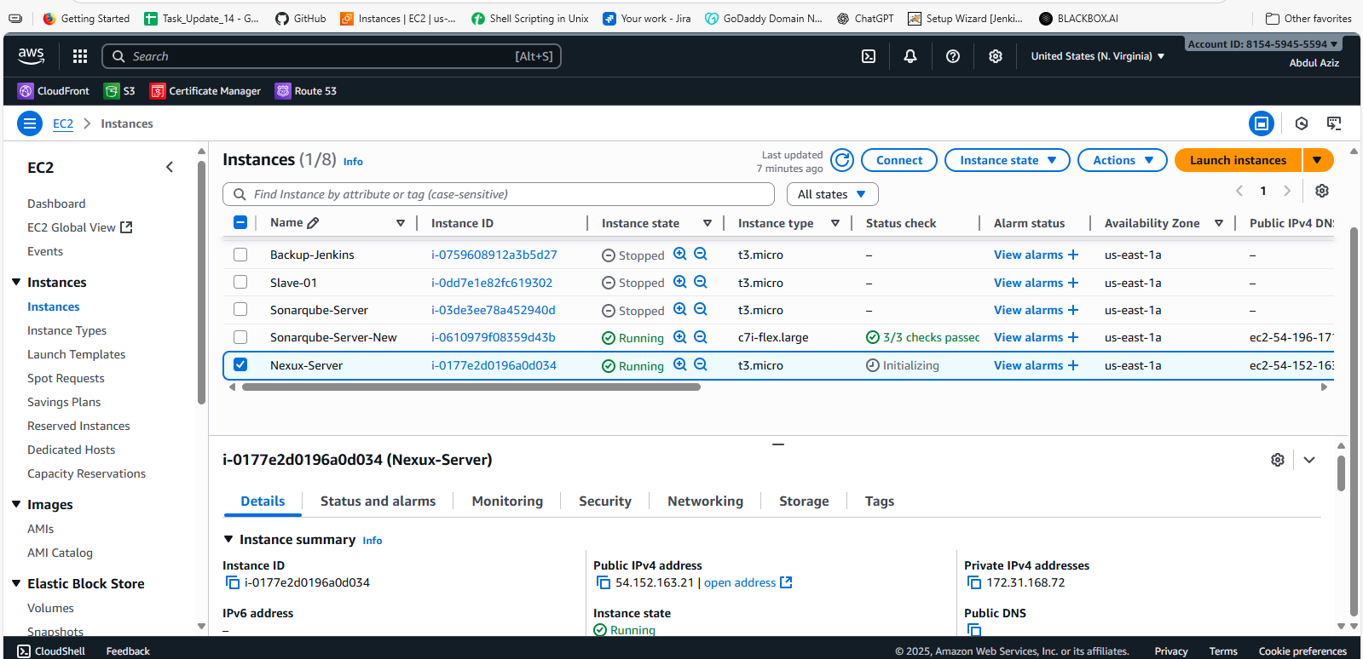

Now install the nexus in thiss follow the steps given below.

cd /opt

wget https://sonatype-download.global.ssl.fastly.net/nexus/3/nexus-3.0.2-02-unix.tar.gz

tar -zxvf  nexus-3.0.2-02-unix.tar.gz

mv /opt/nexus-3.0.2-02 /opt/nexus

vi /opt/nexus/bin/nexus.rc

Then exit from the root and enter to the ec2 and then cd /opt/nexus then change the ownership of the nexus with chown –R ec2-user:ec2-user nexus then run the command ./nexus start then check the status now it will work.

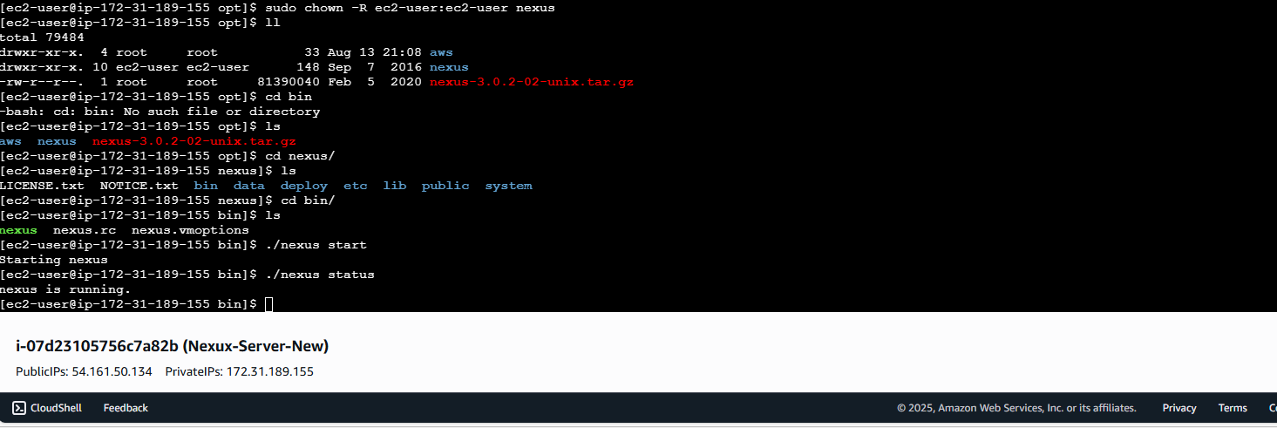

Then go to the browser and paste the public ip with the port number 8081 then the nexux page will come.

Now create repo in the nexus. As given below

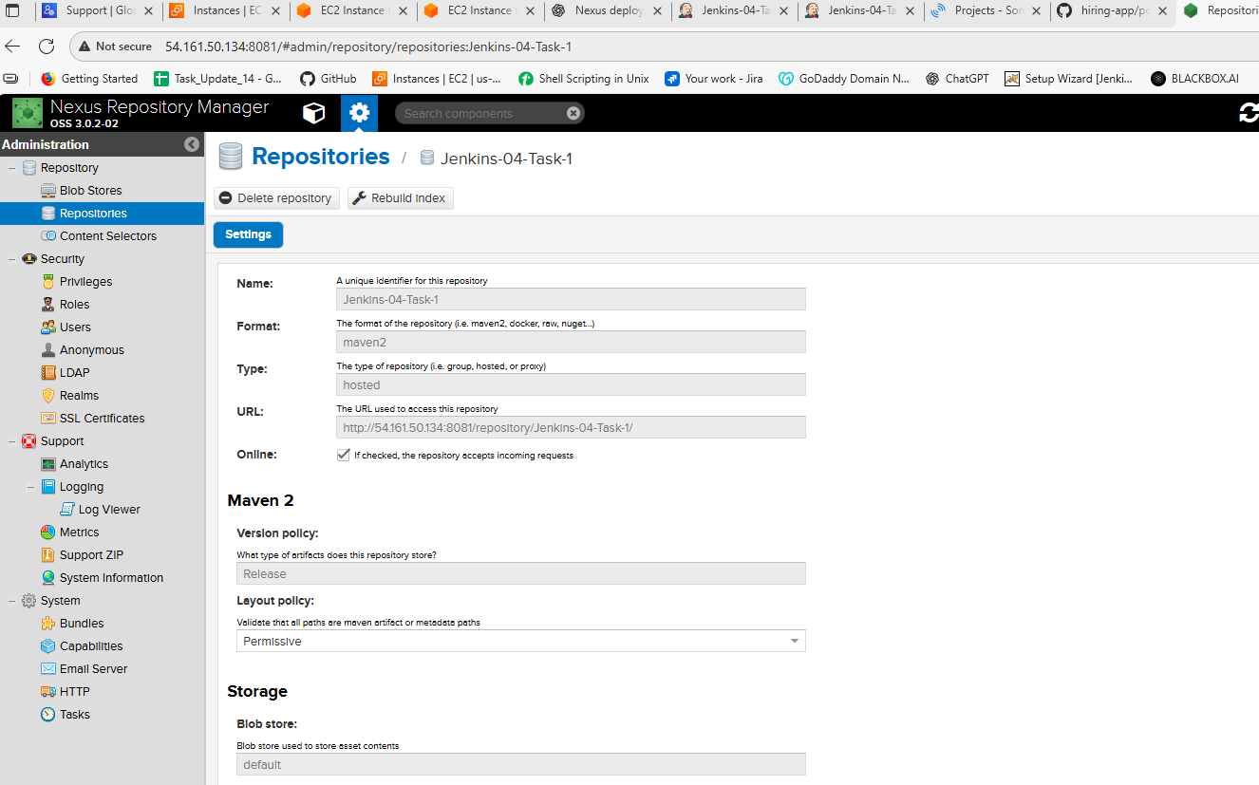

Then configure in Jenkins as given below.

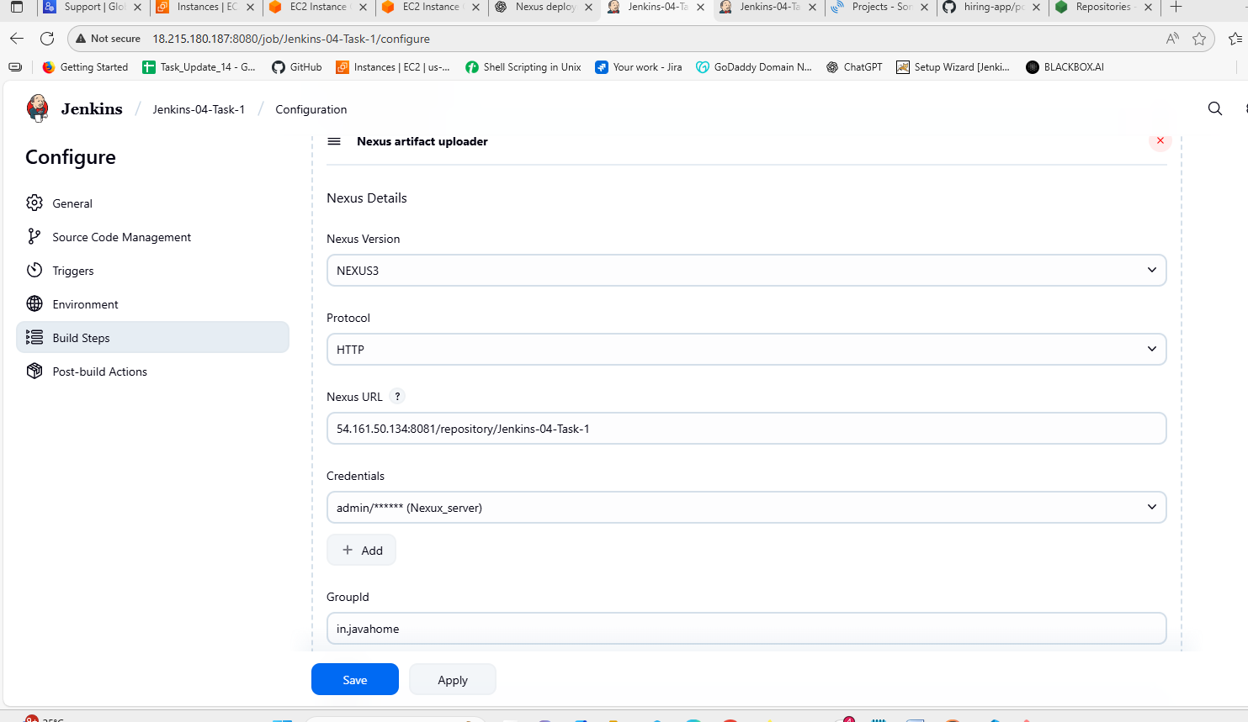

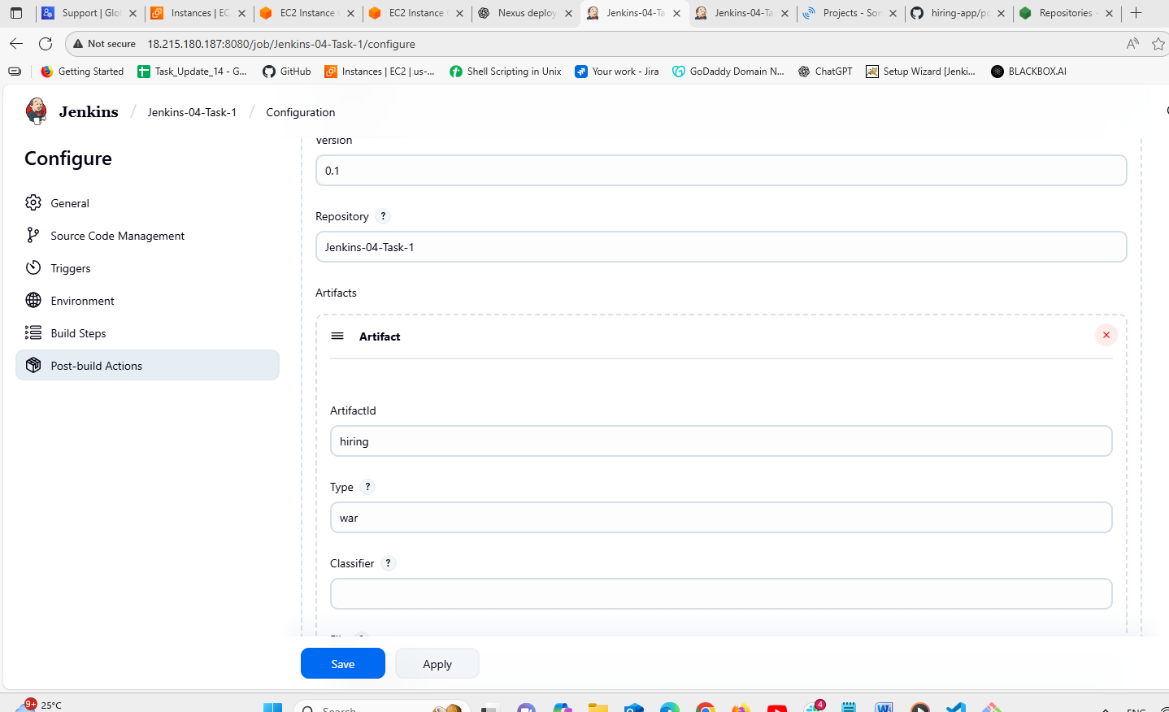

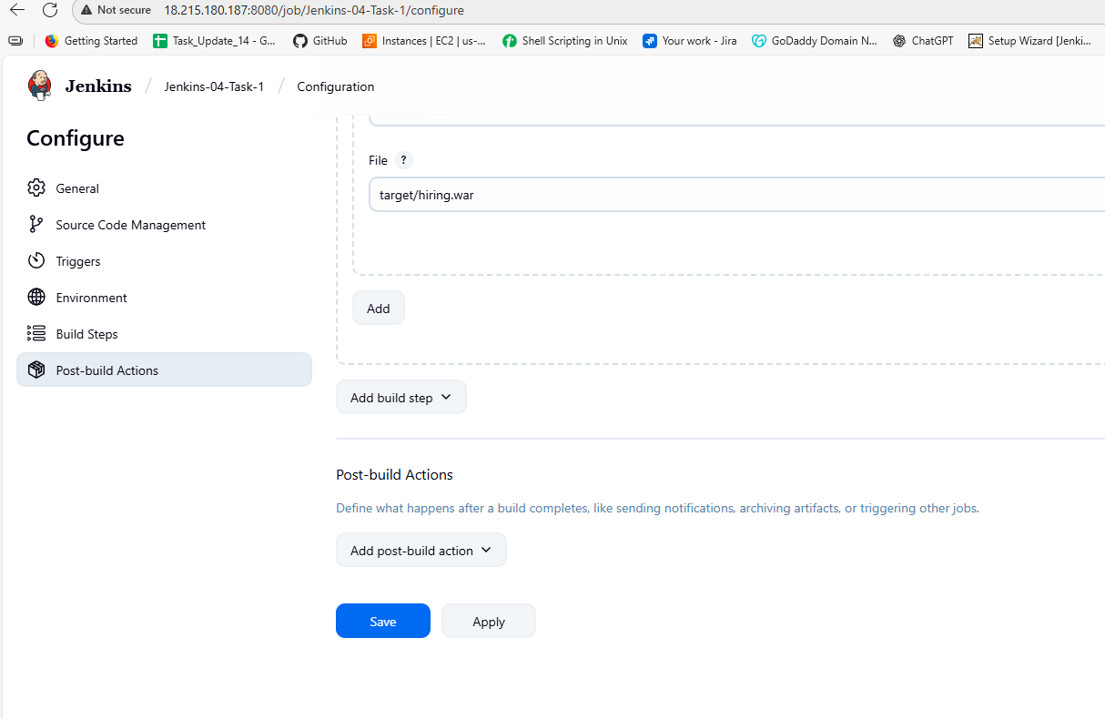

Then built the job see the output below.

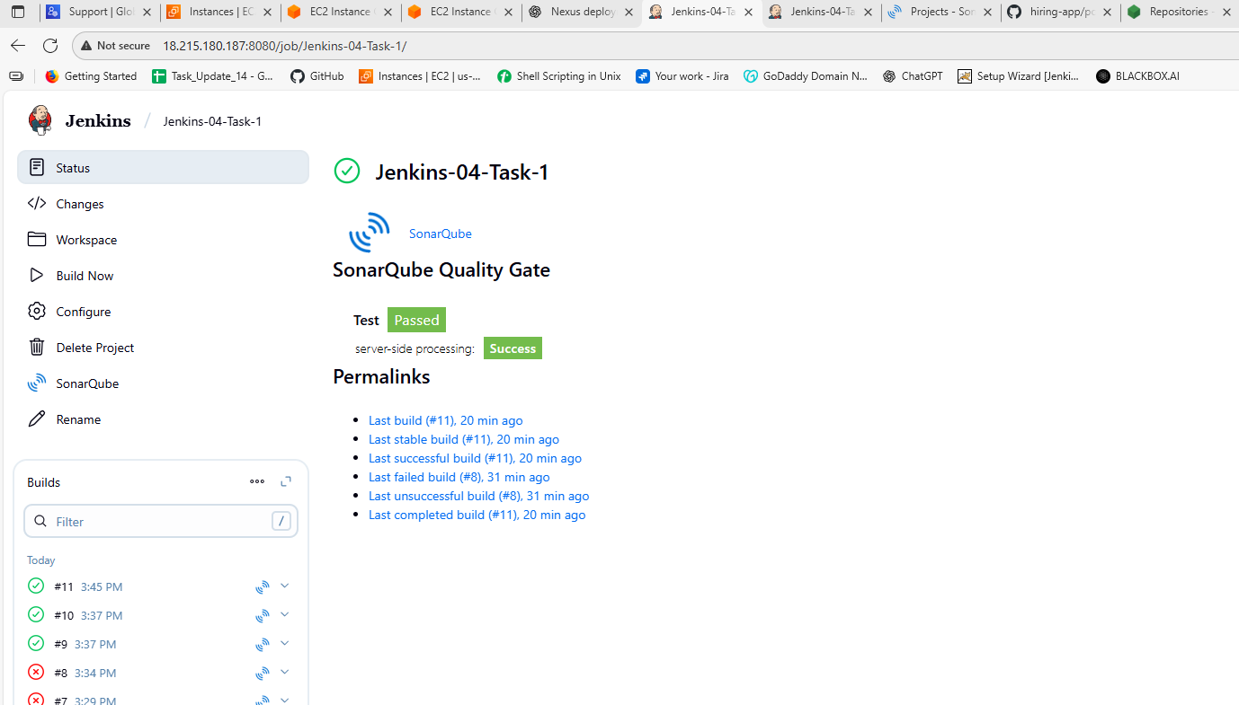

Done with the stage 4.

1. Slack Notification

First install the plugin slack

In this we have to configure Jenkins job like given below

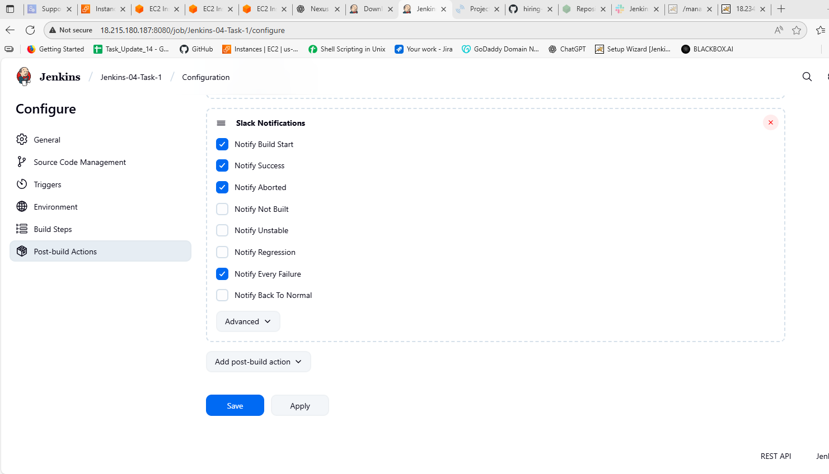

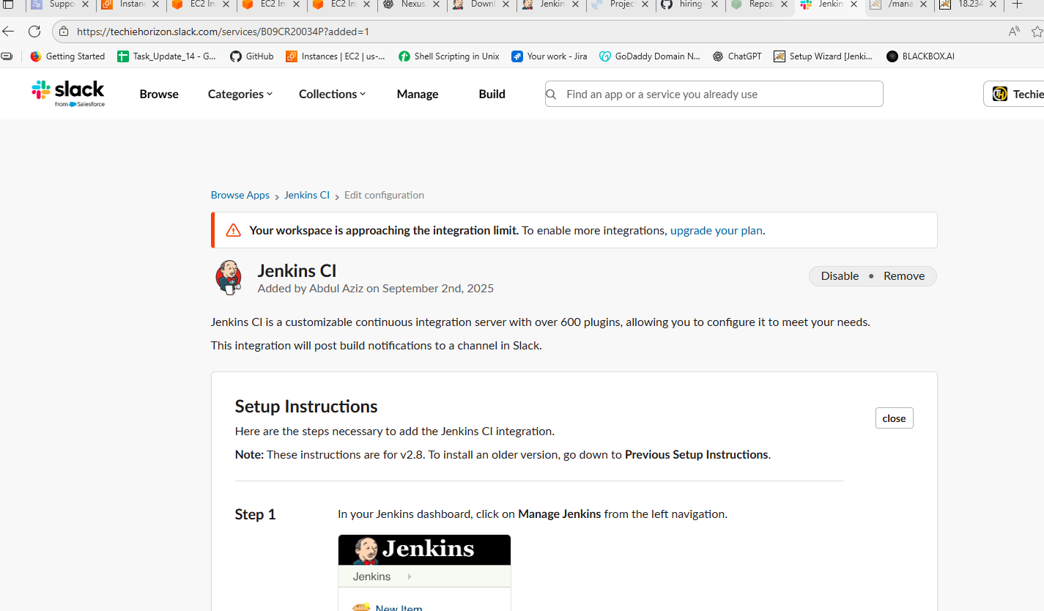

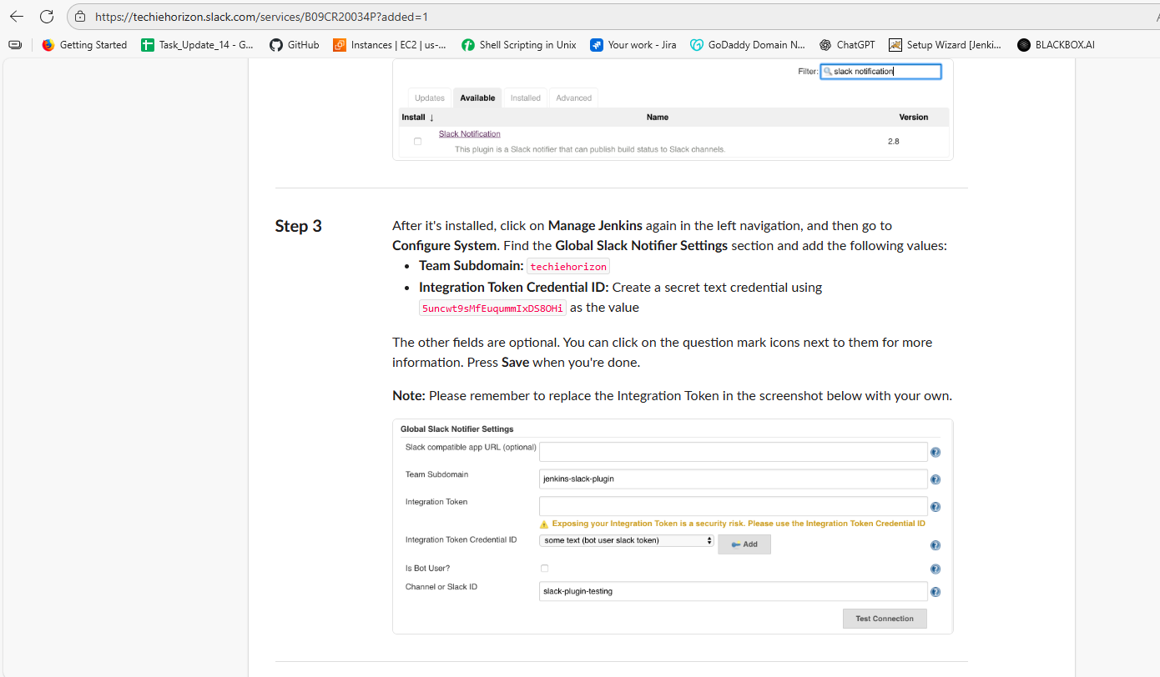

In the above picture we have the key that we have to paste in the credentials and the format should be the secret text. Id name should be the techiehorizon.

Then save it.

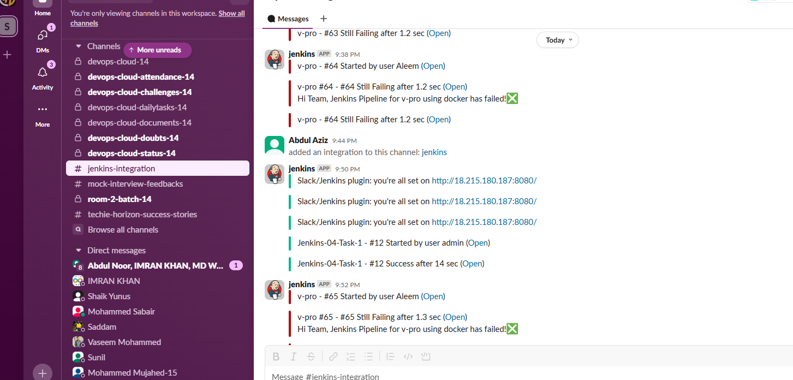

1. Deploy On tomcat

First install the plugin Deployer to..

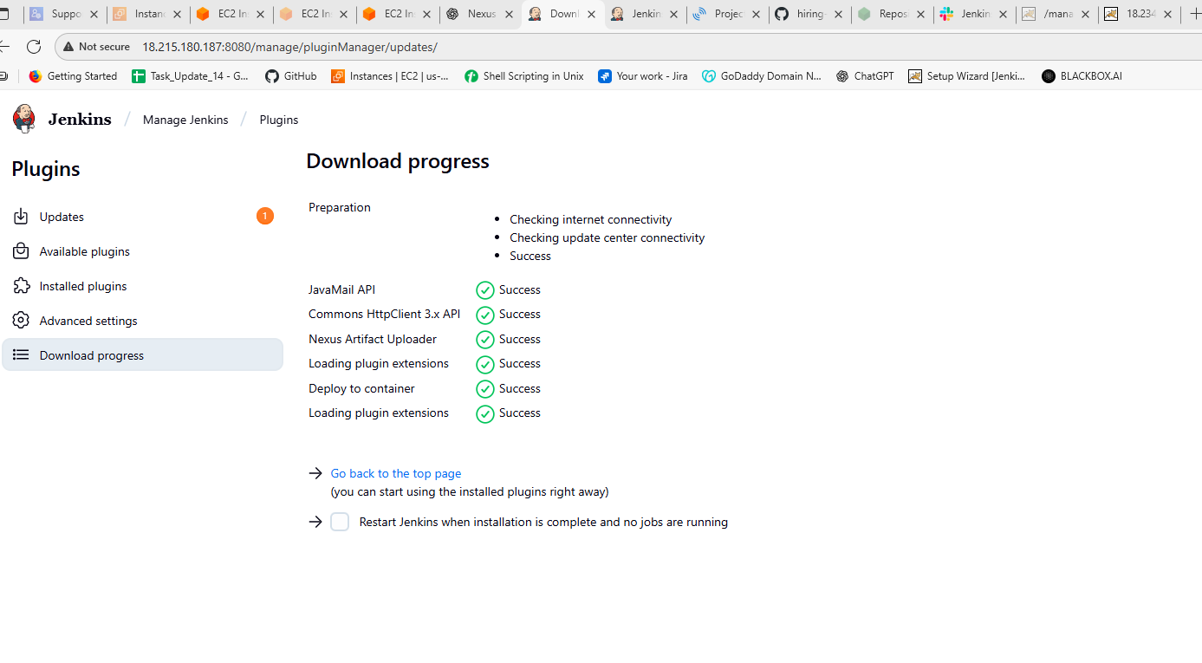

Then do the configurations in the job go to post-built action in that we can see the deploy option click it and configure as shown below.

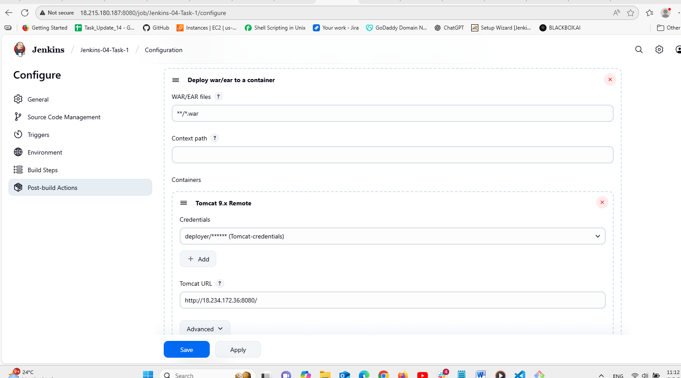

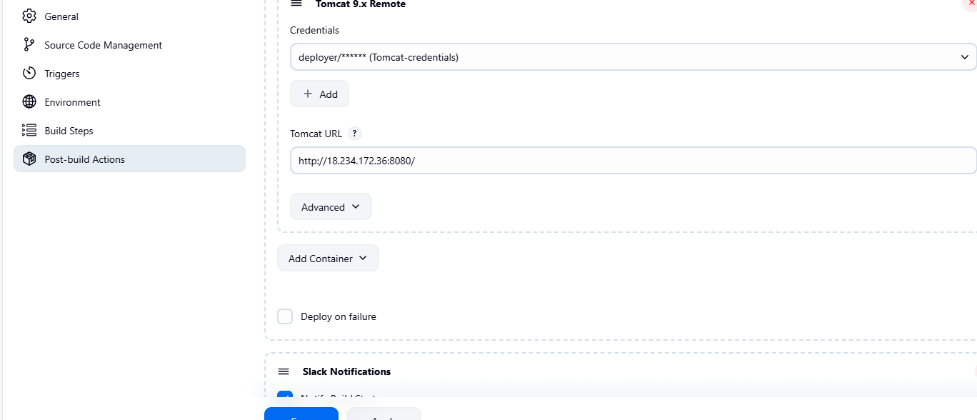

Then add container add as 9th version then save it .

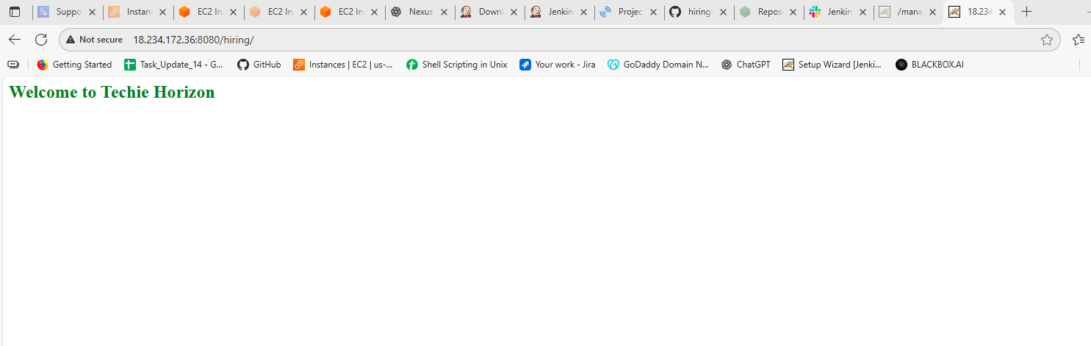

Then finally go to the new page and copy the public ip and tomcat port then /hiring then serach it it shows something like the above pic. We cant edit it because the repo that has only the read access to us see below code available according to that.

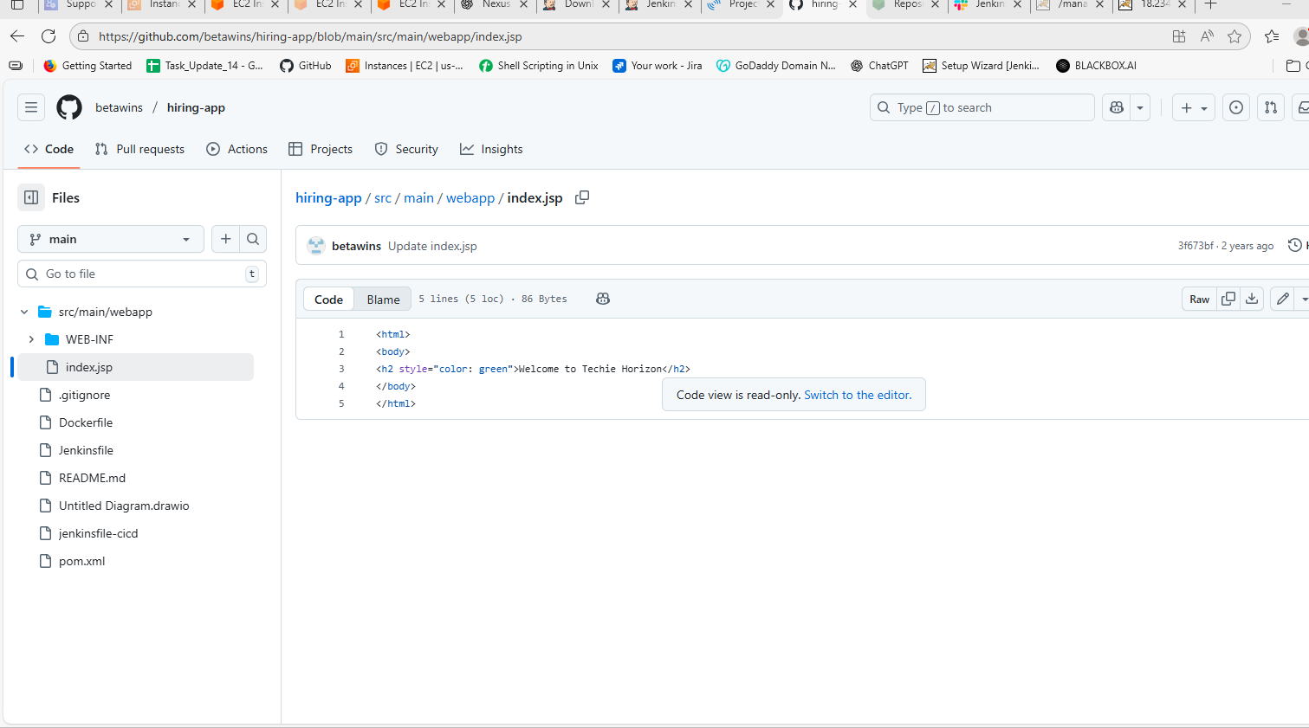

**2) Setup a jenkins CICD pipeline using Declarative pipeline using feature-1.1 branch.**

https://github.com/betawins/sabear_simplecutomerapp/tree/feature-1.1

stages:

1) Git Clone

2) Sonarqube Integration

3) Maven Compilation

4) Nexus Artifactory

5) Slack Notification

6) Deploy On tomcat

3) Setup a jenkins CICD pipeline using Scripted pipeline using feature-1.1 branch.

https://github.com/betawins/sabear_simplecutomerapp/tree/feature-1.1

stages:

1) Git Clone

2) Sonarqube Integration

3) Maven Compilation

4) Nexus Artifactory

5) Slack Notification

6) Deploy On tomcat

4) Write sample skeleton of pipelines.

5) Create a parametirized job in jenkins.

https://github.com/betawins/spring3-mvc-maven-xml-hello-world-1.git