Terraform-Task-03
- Watch the Terraform-03 video.
Yes Completed with the video.
- Execute the script shown in the video.

- Integrate Terraform in Jenkins using the Terraform plugin.

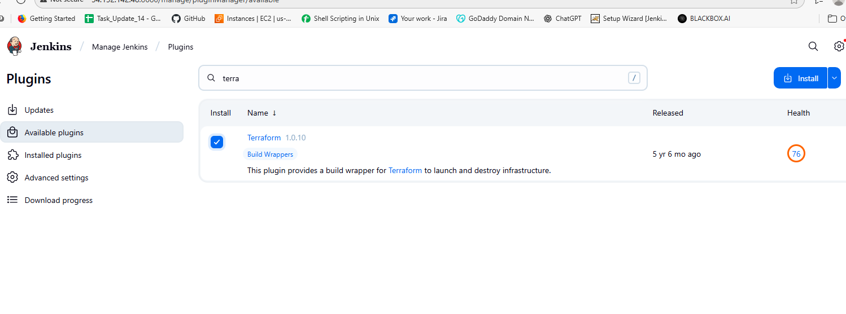

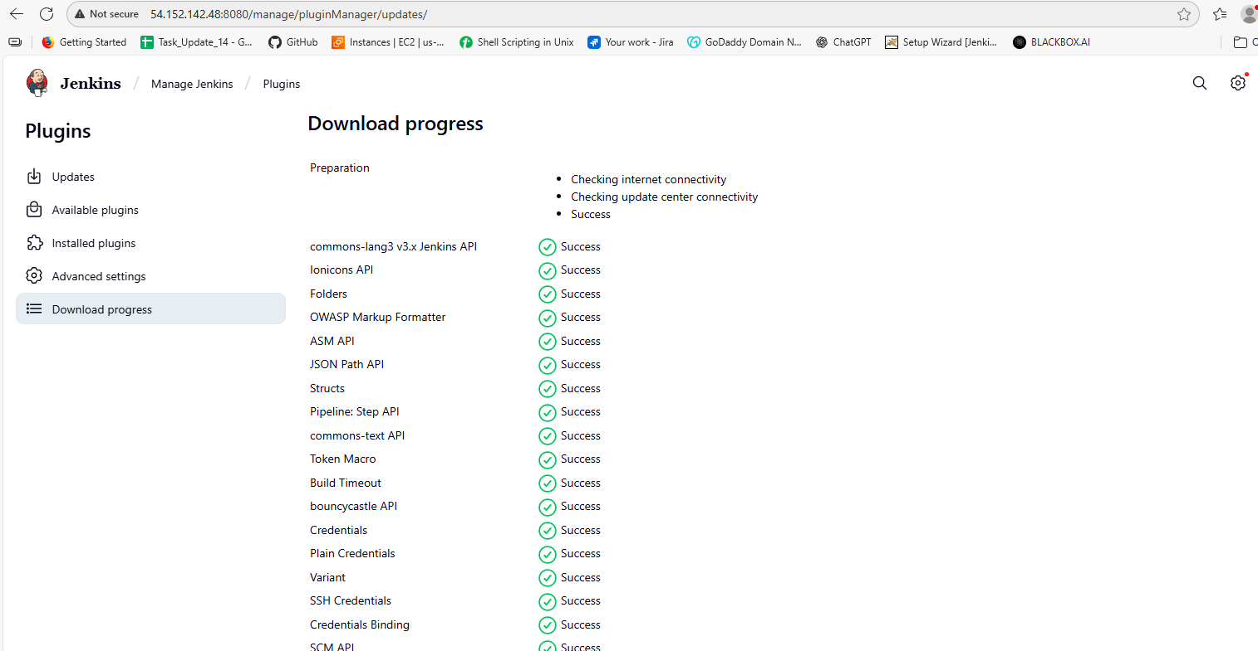
After installing the plugin then we have to create a free style jab and do the configurations as below.
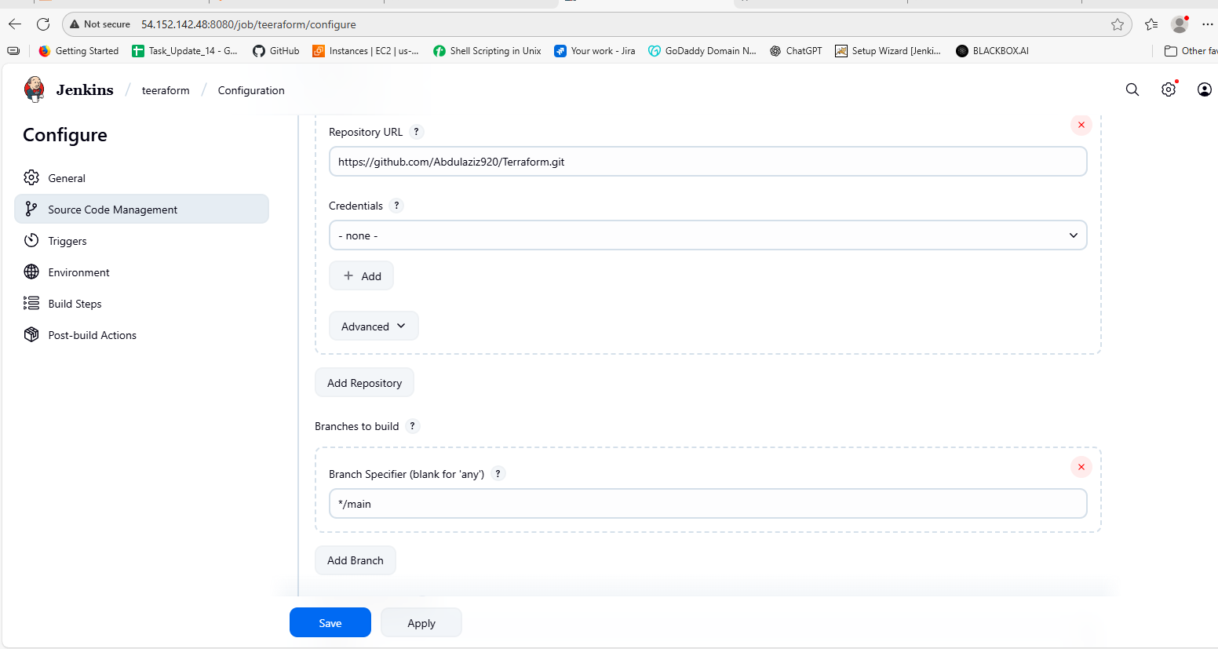
Then after if we check in the local machie we should see the var file in that as in the below.
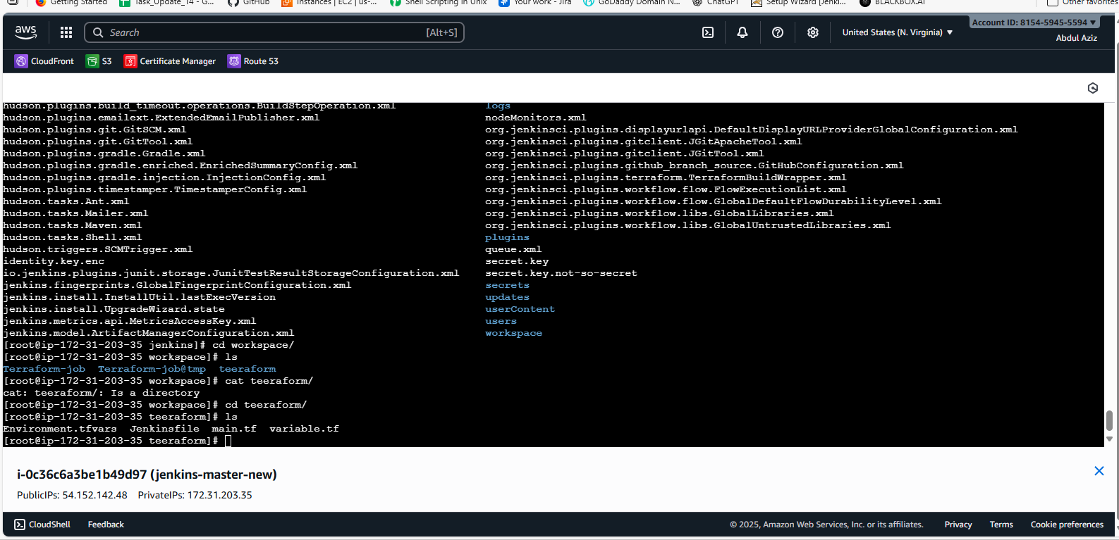

4. Create one Jenkins job using Maven Project for the code below with two stages:
Stage 1: Git clone
Stage 2: Maven Compilation Code: https://github.com/betawins/java-Working-app.git
Before creating we have to install some plugins like.
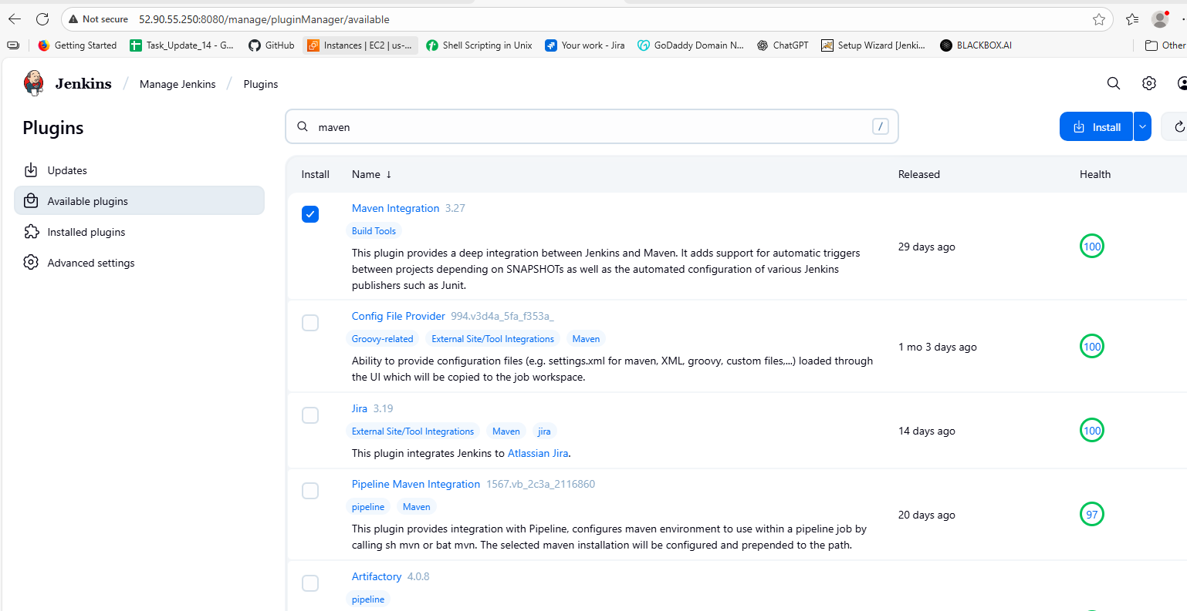
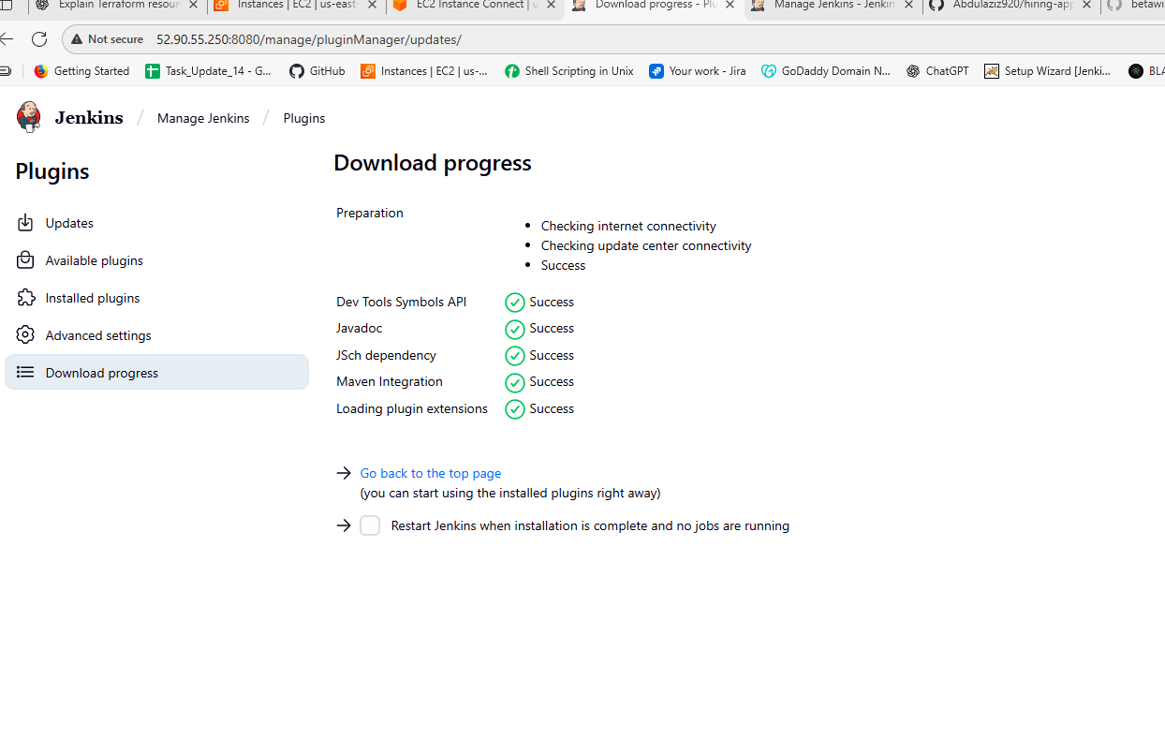
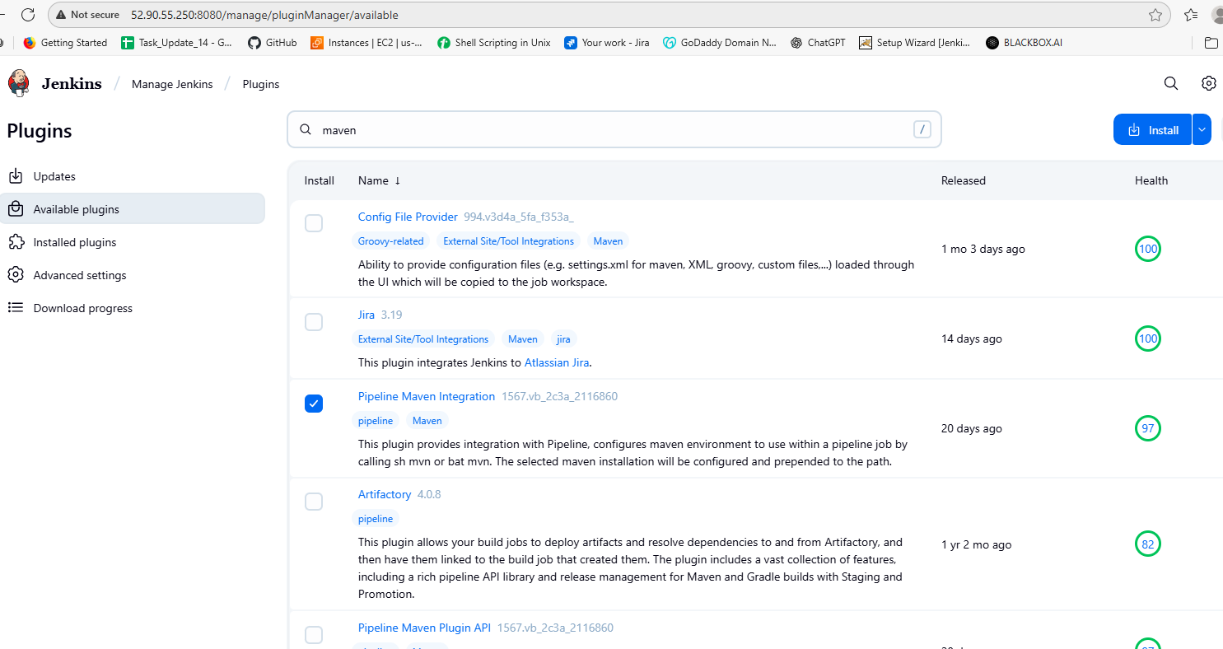
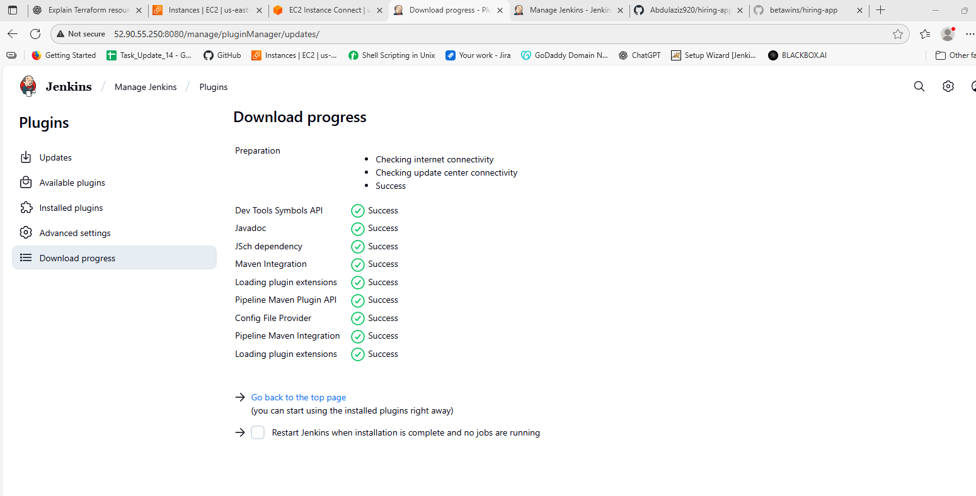
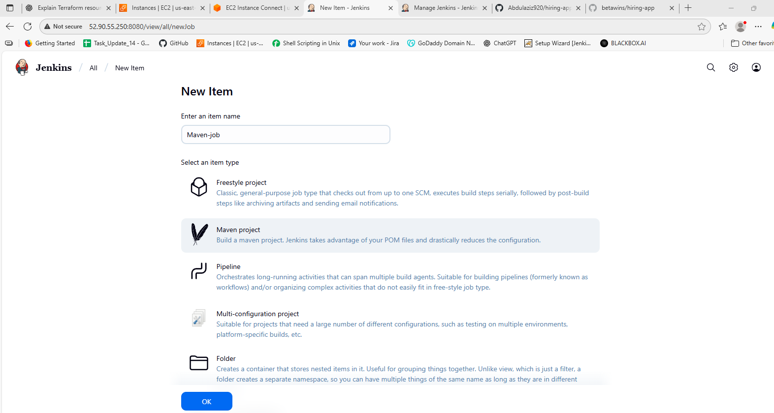
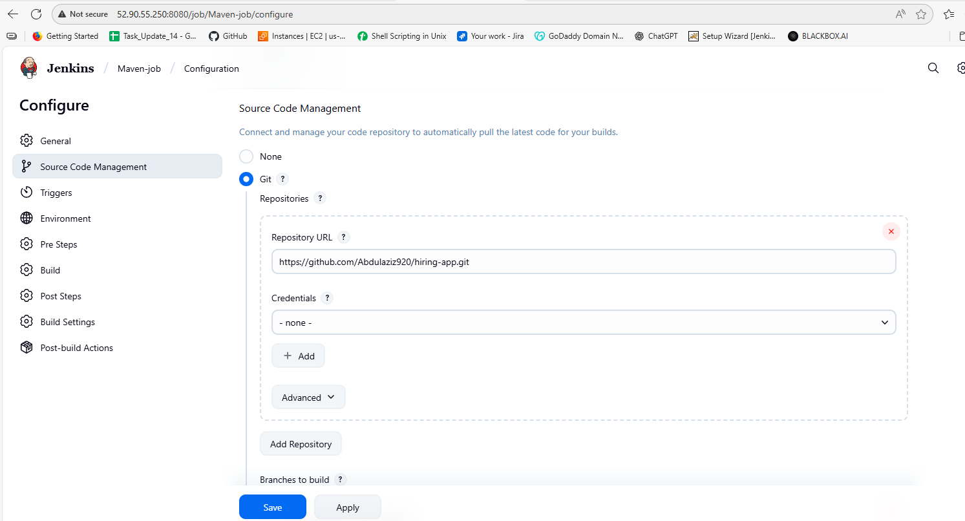

5. Use the same code and create a parameterized job in Jenkins with:
Stage 1: Git clone
Stage 2: Maven Compilation Code: https://github.com/betawins/java-Working-app.git
First create a Pipeline job in Jenkins
Then go to configure then select the script which you want then save it and make sure to input thiss data in the script given below.
properties([
parameters([
string(name: 'GIT_URL', defaultValue: 'https://github.com/Abdulaziz920/hiring-app.git', description: 'Git repository URL'),
string(name: 'BRANCH', defaultValue: 'main', description: 'Branch to build')
])
])

node {
// Use Maven tool configured in Jenkins (Name = MAVEN_HOME)
def mvnHome = tool name: 'MAVEN_HOME', type: 'maven'

stage('Git Clone') {
echo "Cloning from ${params.GIT_URL} (branch: ${params.BRANCH})"
git url: params.GIT_URL, branch: params.BRANCH
}

stage('Maven Compilation') {
echo "Running Maven compile with ${mvnHome}"
sh "${mvnHome}/bin/mvn clean compile"
}
}
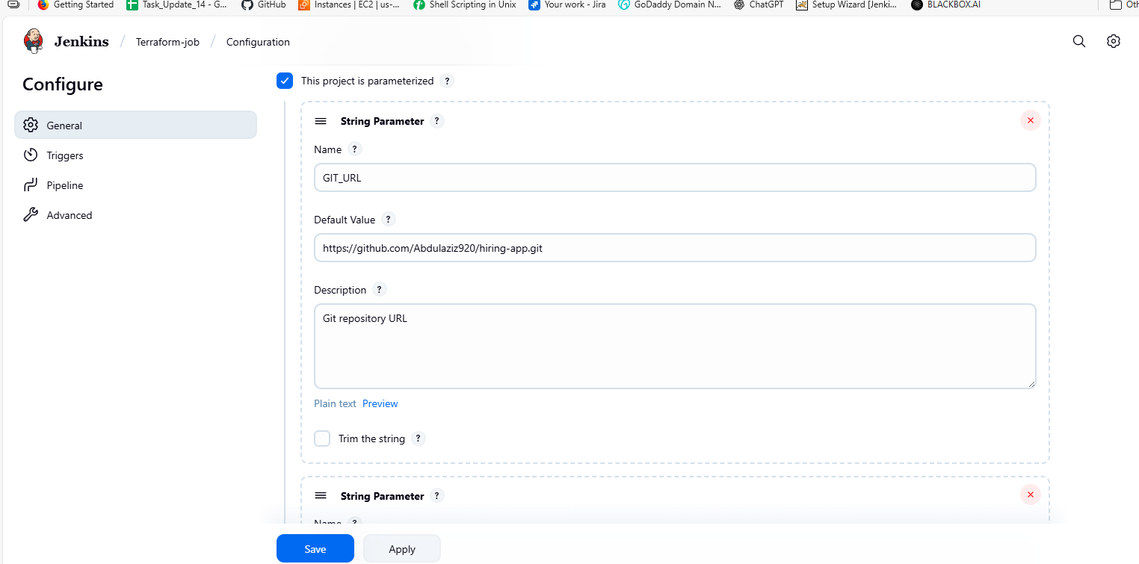
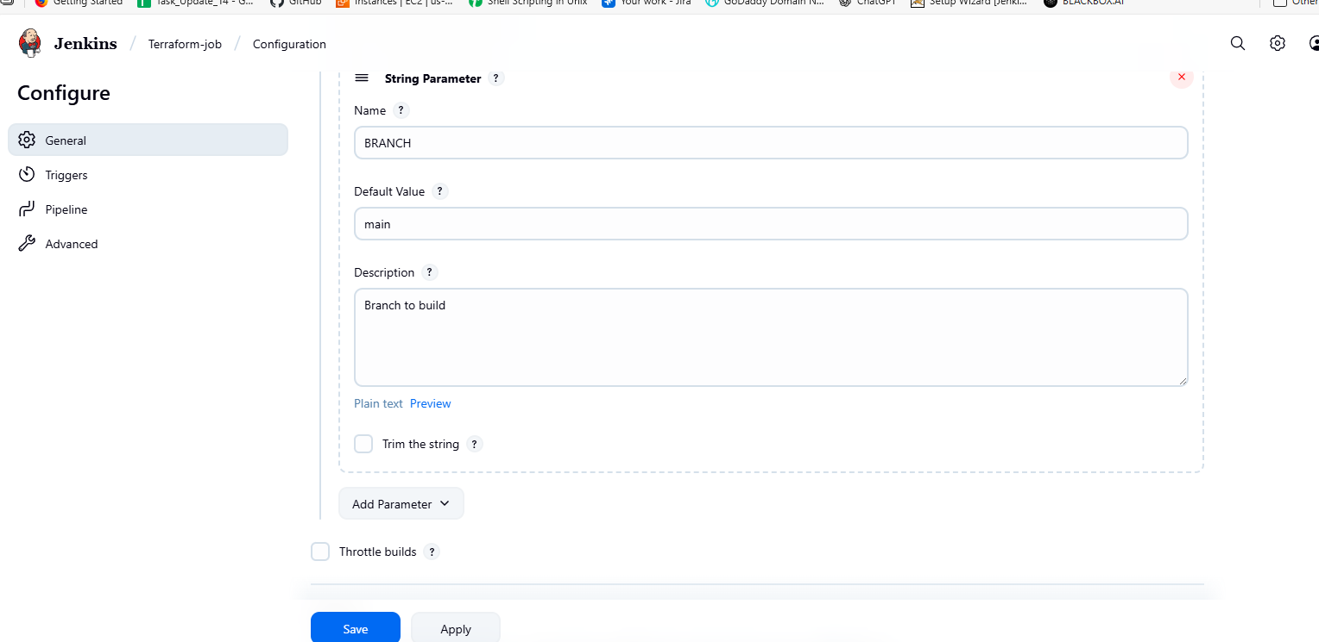
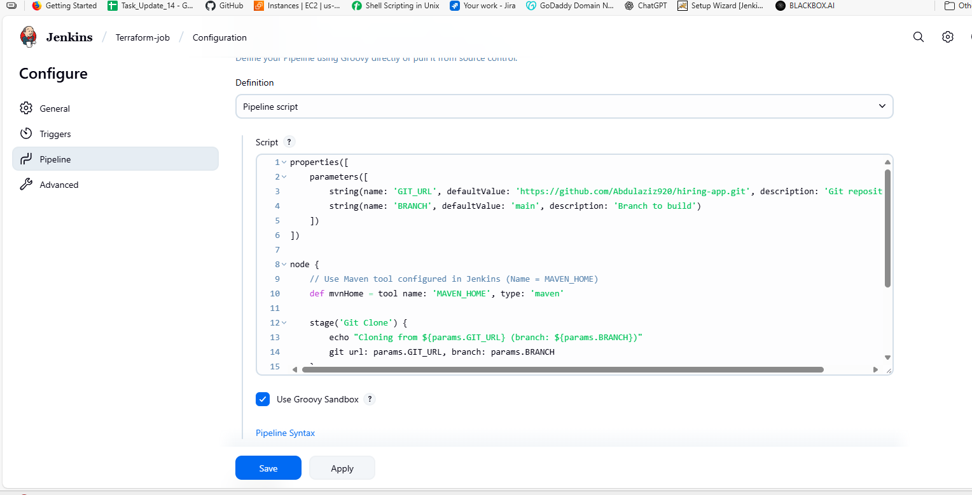
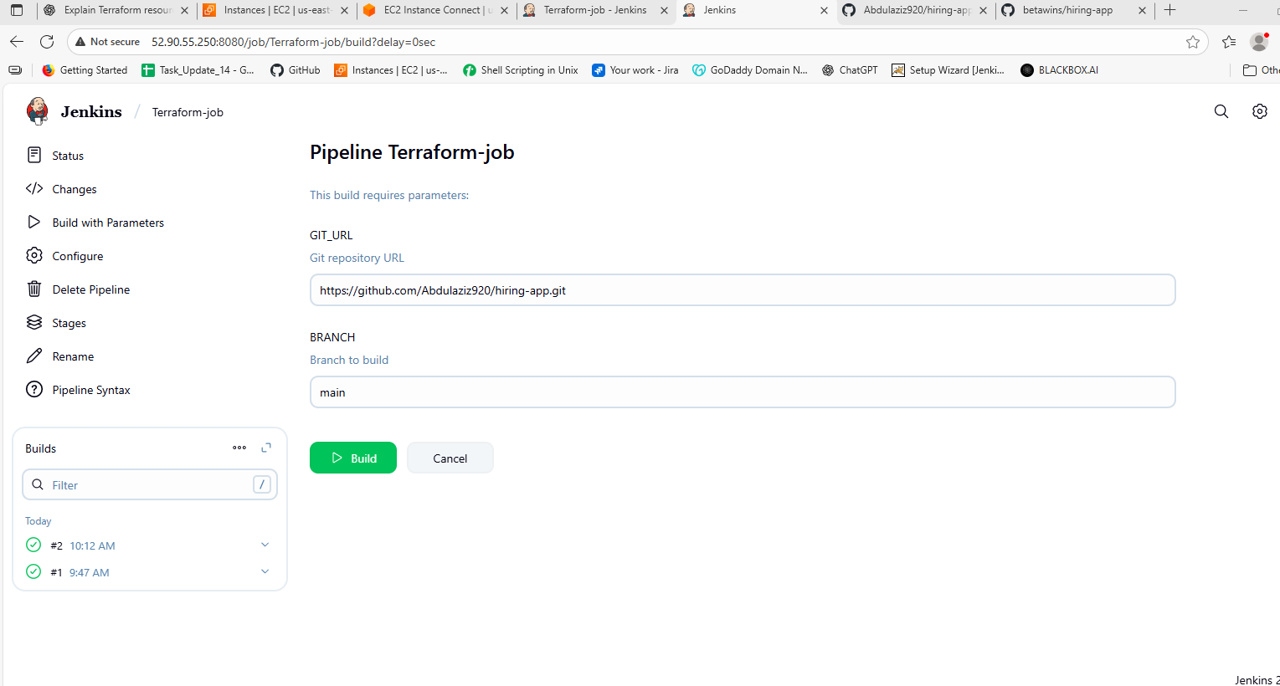
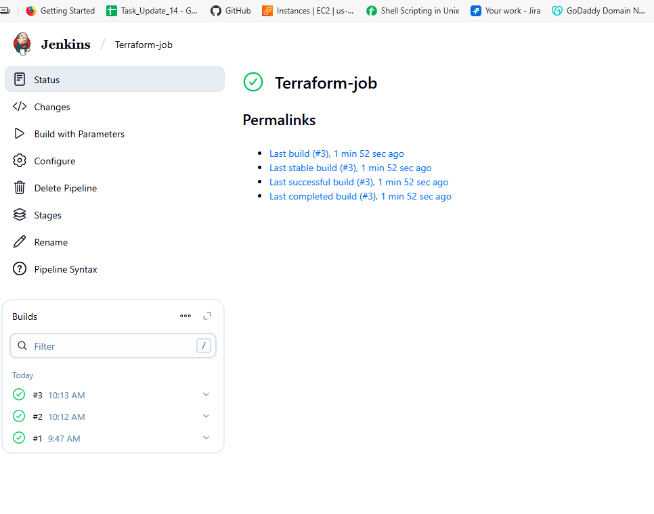
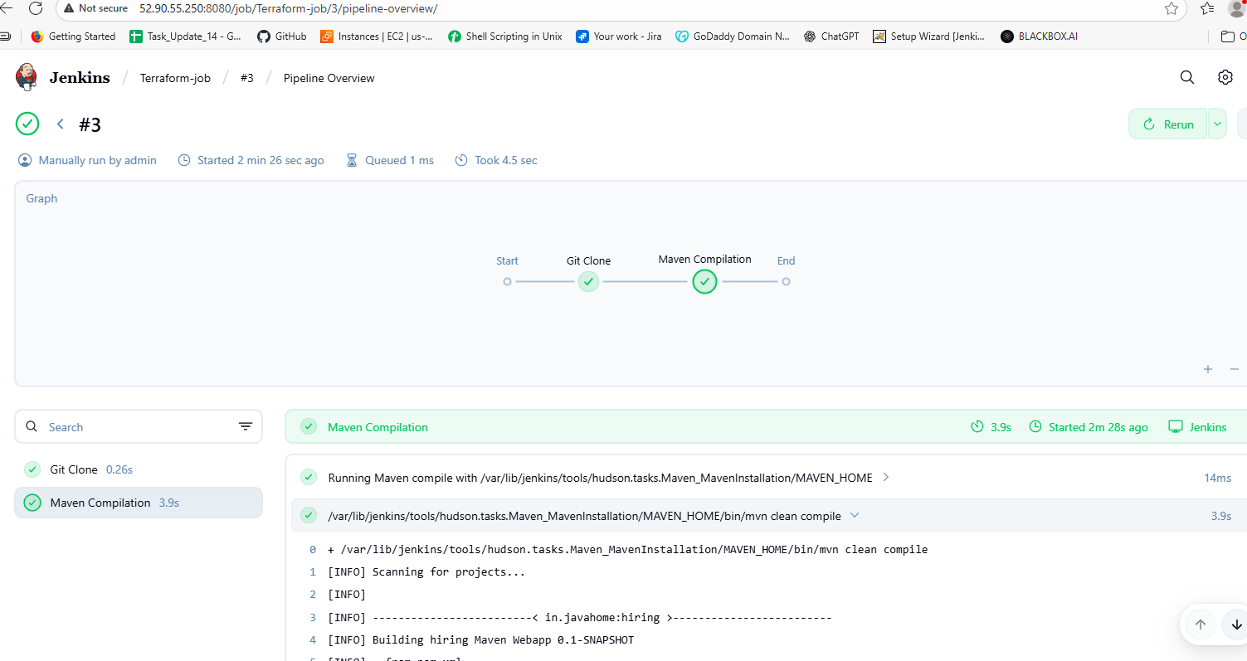

6. What are the global variables in Jenkins?
In Jenkins, global variables are predefined variables that are available in any pipeline without needing to be declared. They provide information about the build, environment, or pipeline itself, and are commonly used to simplify scripting in Jenkins pipelines.

1. Common Global Variables
Variable | Description
env | Access environment variables, e.g., env.BUILD_NUMBER, env.JOB_NAME, env.WORKSPACE
currentBuild | Provides information about the current build, e.g., currentBuild.result, currentBuild.fullDisplayName
params | Holds all pipeline parameters, e.g., params.BRANCH
scm | Represents the source control management configuration for the job
steps | Allows you to call pipeline steps programmatically, e.g., steps.echo("Hello")
pipeline (Declarative) | Provides access to declarative pipeline features like agent, stages, etc.
tools | Reference installed tools, e.g., tools { maven 'Maven-3' }
node | Represents the agent/node on which the pipeline runs

