Terraform-Task-06
- Watch the Terraform-06 video.
Yes Completed.
- Execute the script shown in the video.
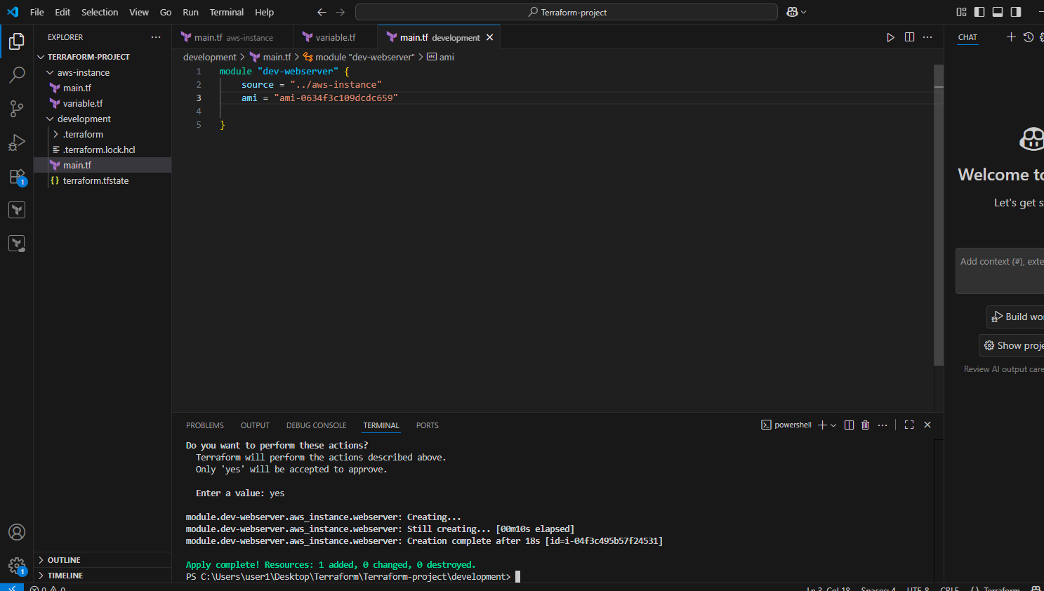
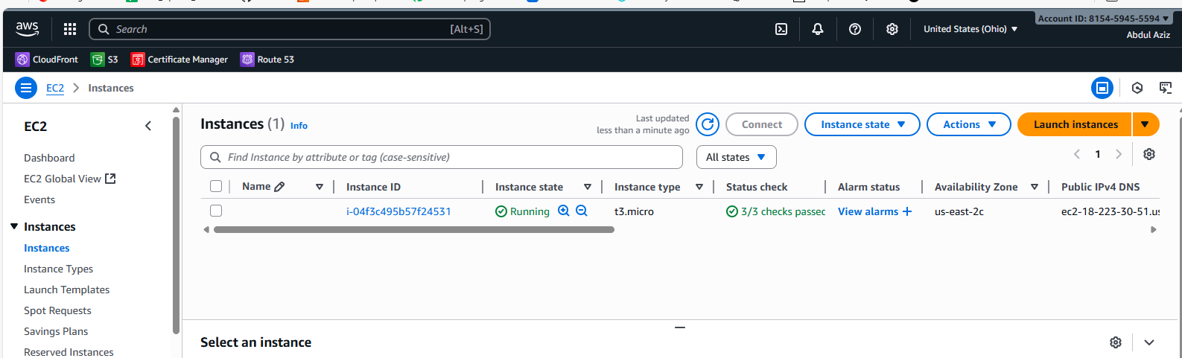
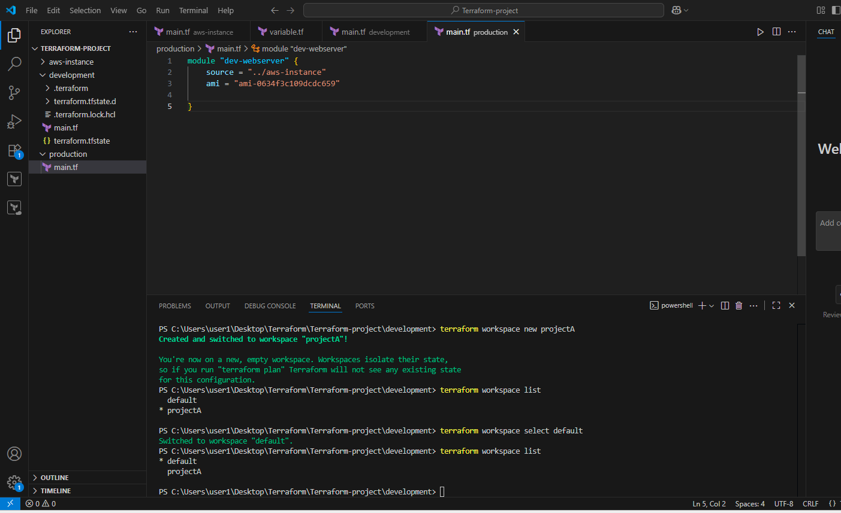
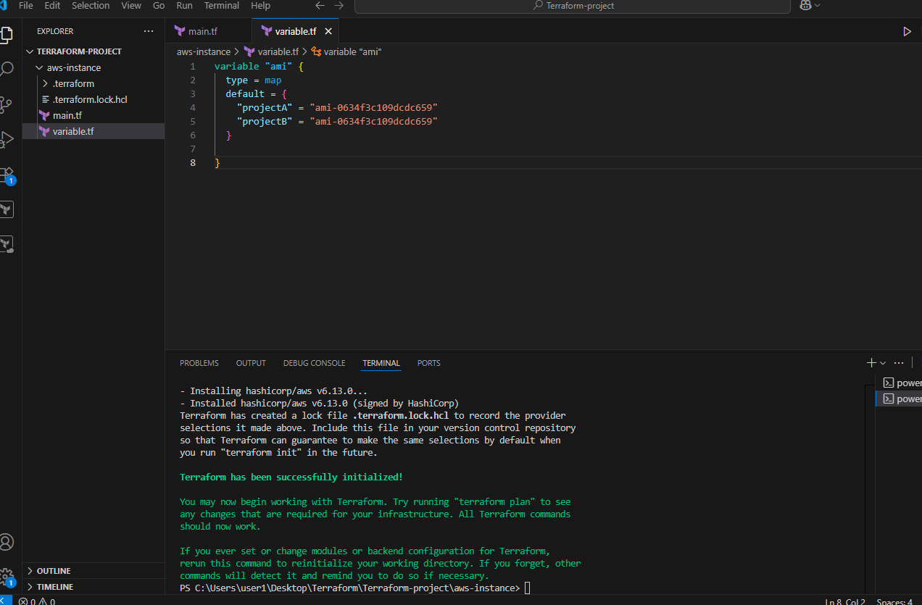
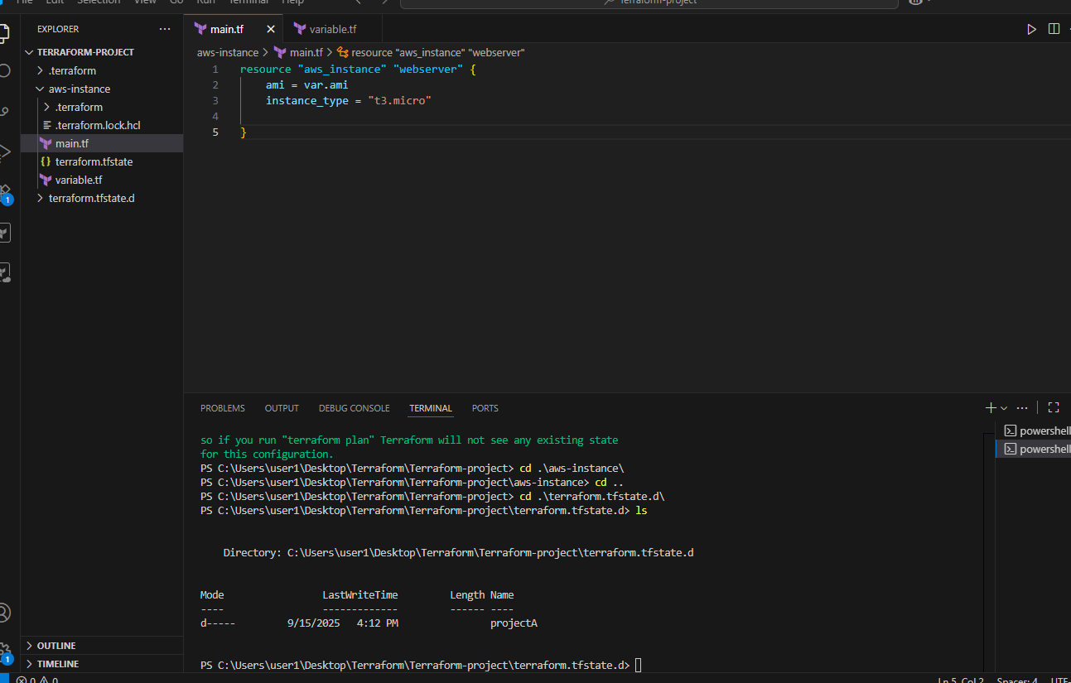

- Provision EC2, S3, and VPC using Terraform modules.

Step 1: Install Terraform
- Download and install Terraform on your machine.
- Verify installation:
terraform version

Step 2: Create Project Structure
Organize your project like this:
terraform-project/
│── main.tf
│── variables.tf
│── outputs.tf
│── modules/
│── vpc/
│── main.tf
│── variables.tf
│── outputs.tf
│── ec2/
│── main.tf
│── variables.tf
│── outputs.tf
│── s3/
│── main.tf
│── variables.tf
│── outputs.tf

Step 3: Create VPC Module
modules/vpc/main.tf
resource "aws_vpc" "main" {
cidr_block = var.cidr_block
tags = { Name = var.name }
}

resource "aws_subnet" "public" {
vpc_id = aws_vpc.main.id
cidr_block = var.public_subnet_cidr
map_public_ip_on_launch = true
tags = { Name = "${var.name}-public-subnet" }
}
modules/vpc/variables.tf
variable "cidr_block" {}
variable "public_subnet_cidr" {}
variable "name" {}

Step 4: Create S3 Module
modules/s3/main.tf
resource "aws_s3_bucket" "bucket" {
bucket = var.bucket_name
acl = "private"
}
modules/s3/variables.tf
variable "bucket_name" {}

Step 5: Create EC2 Module
modules/ec2/main.tf
resource "aws_instance" "web" {
ami = var.ami
instance_type = var.instance_type
subnet_id = var.subnet_id
tags = { Name = var.name }
}
modules/ec2/variables.tf
variable "ami" {}
variable "instance_type" {}
variable "subnet_id" {}
variable "name" {}

Step 6: Use Modules in Main Terraform File
main.tf
provider "aws" {
region = "us-east-1"
}

module "vpc" {
source = "./modules/vpc"
cidr_block = "10.0.0.0/16"
public_subnet_cidr = "10.0.1.0/24"
name = "my-vpc"
}

module "s3" {
source = "./modules/s3"
bucket_name = "my-example-bucket-2025"
}

module "ec2" {
source = "./modules/ec2"
ami = "ami-0d85d4f07a62e2969"
instance_type = "t2.micro"
subnet_id = module.vpc.public_subnet_id
name = "my-ec2-instance"
}

Step 7: Initialize and Apply Terraform
terraform init
terraform plan
terraform apply
After this we can see this as below….
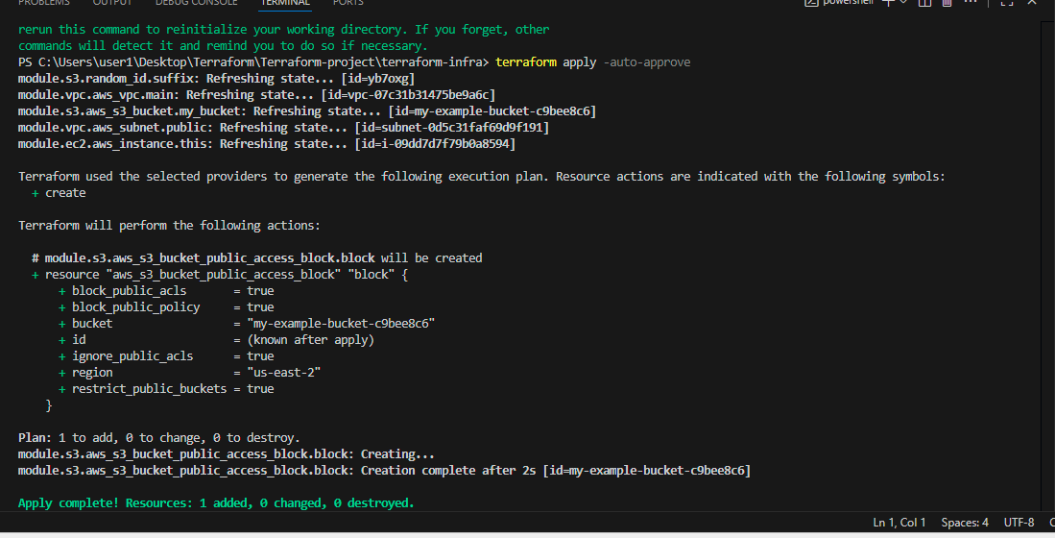
After this we can see all the created vpc,s3 Everything which is present in the code that will be crated in the AWS..See below..
VPC
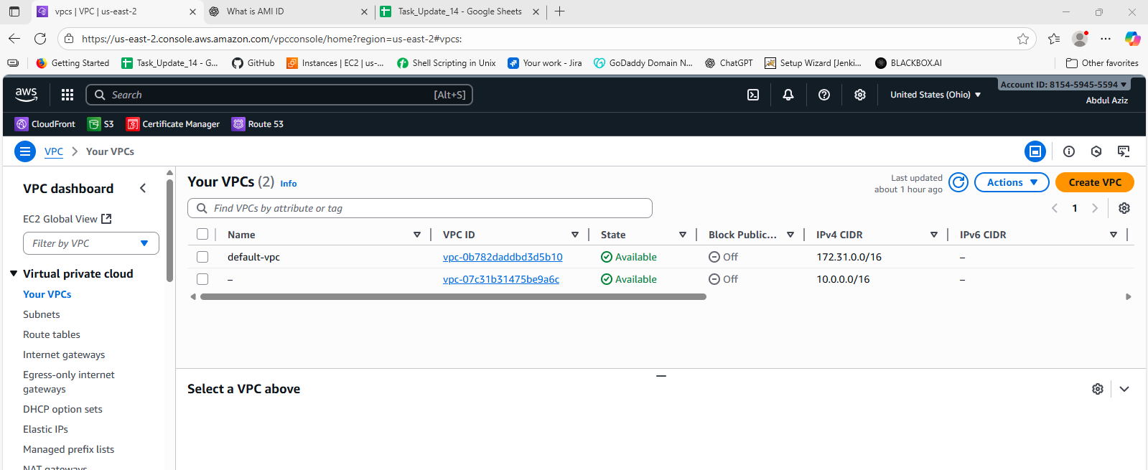
INSTANCE
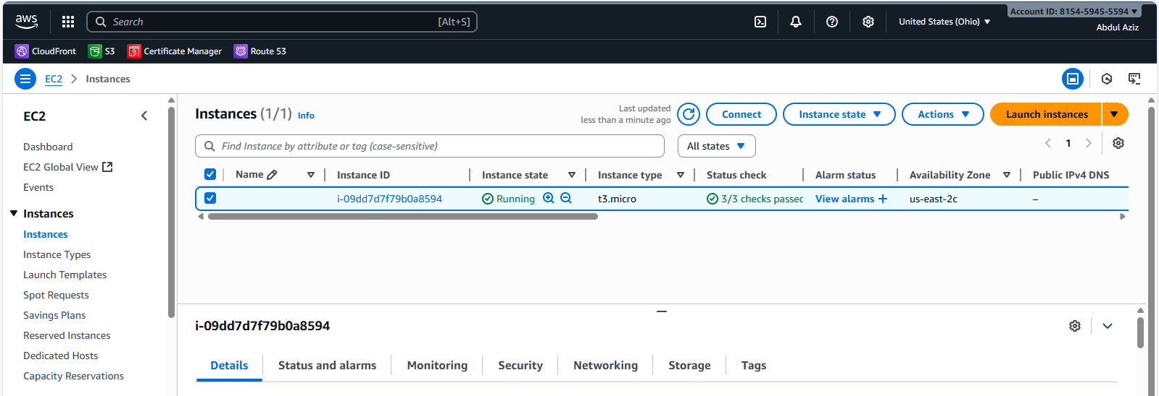
S3 BUCKET
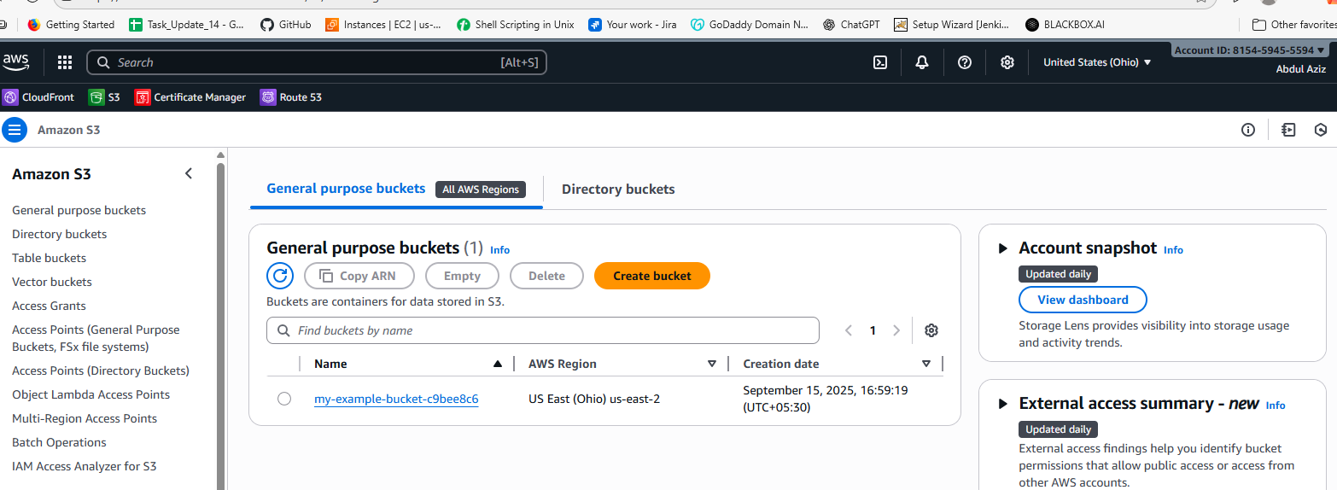
These all are created by the Terraform in the AWS.
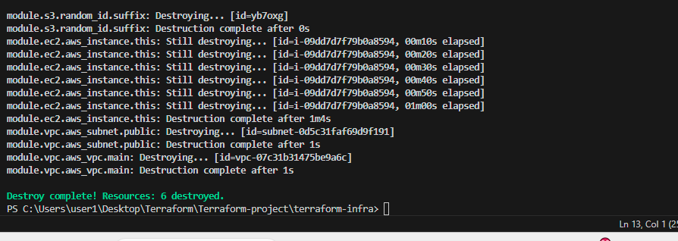
After everything has been done we are destring everthing..
- Provision EC2 for 3 different environments (Dev, Staging, and Prod) using Terraform workspaces.

Step 1: Create Terraform Project
Project structure:
terraform-workspaces/
│── main.tf
│── variables.tf
│── outputs.tf

Step 2: Write EC2 Configuration
main.tf
provider "aws" {
region = "us-east-1" # Change to your AWS region
}

resource "aws_instance" "app" {
ami = var.ami
instance_type = var.instance_type

tags = {
Name = "${terraform.workspace}-ec2-instance"
Environment = terraform.workspace
}
}
variables.tf
variable "ami" {
default = "ami-0d85d4f07a62e2969" # Replace with valid AMI
}

variable "instance_type" {
default = "t2.micro"
}
outputs.tf
output "instance_id" {
value = aws_instance.app.id
}

Step 3: Initialize Terraform
terraform init

Step 4: Create Workspaces
terraform workspace new dev
terraform workspace new staging
terraform workspace new prod
- Check workspaces:
terraform workspace list
- Active workspace marked with *.

Step 5: Deploy EC2 in Each Workspace
- Dev:
terraform workspace select dev
terraform plan
terraform apply -auto-approve
- Staging:
terraform workspace select staging
terraform plan
terraform apply -auto-approve
- Prod:
terraform workspace select prod
terraform plan
terraform apply -auto-approve

Step 6: Verify
- Each workspace has its own EC2 instance, independent of the others.
aws ec2 describe-instances --filters "Name=tag:Environment,Values=dev"
✅ Key Points
- Workspaces isolate state for each environment.
- Same Terraform code works for all environments.
- Tags use terraform.workspace to distinguish Dev, Staging, Prod.
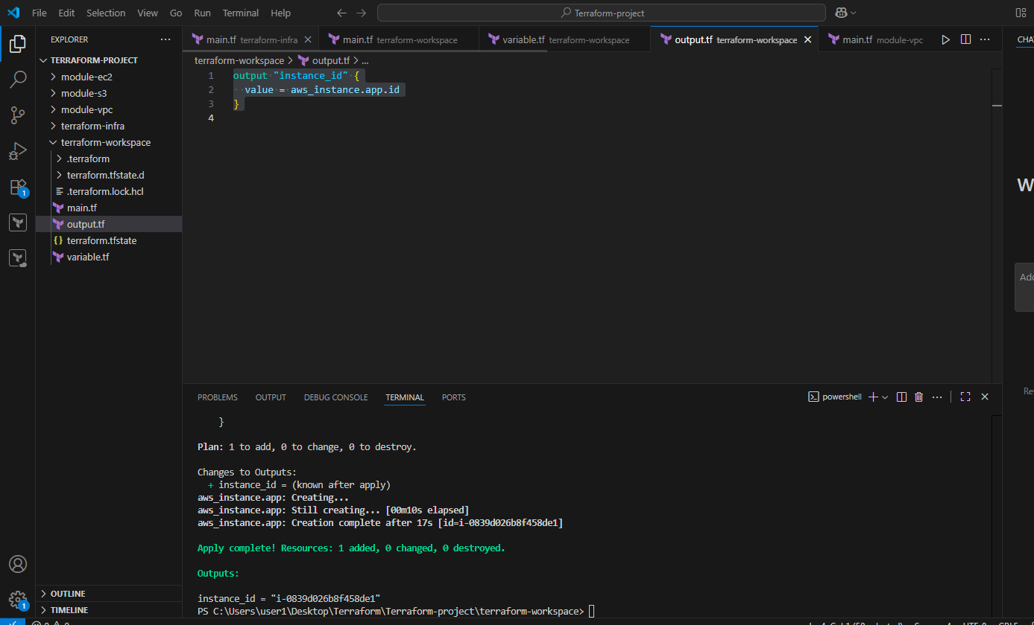
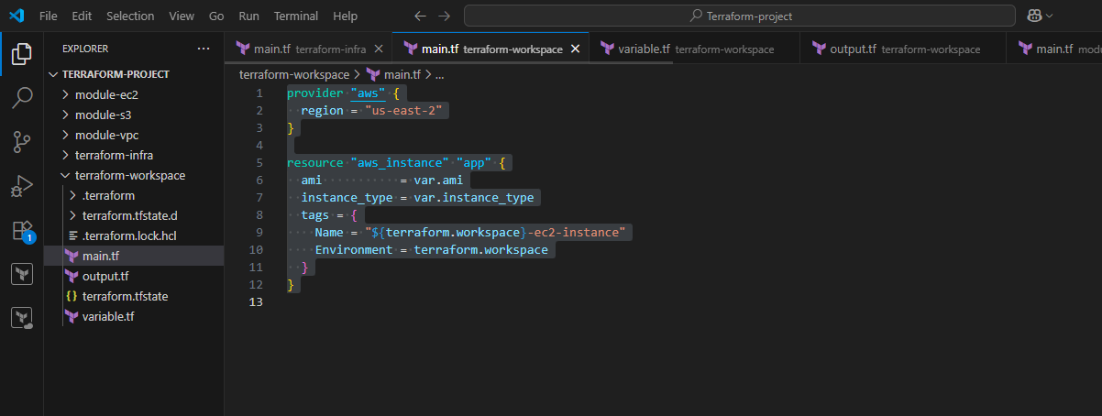
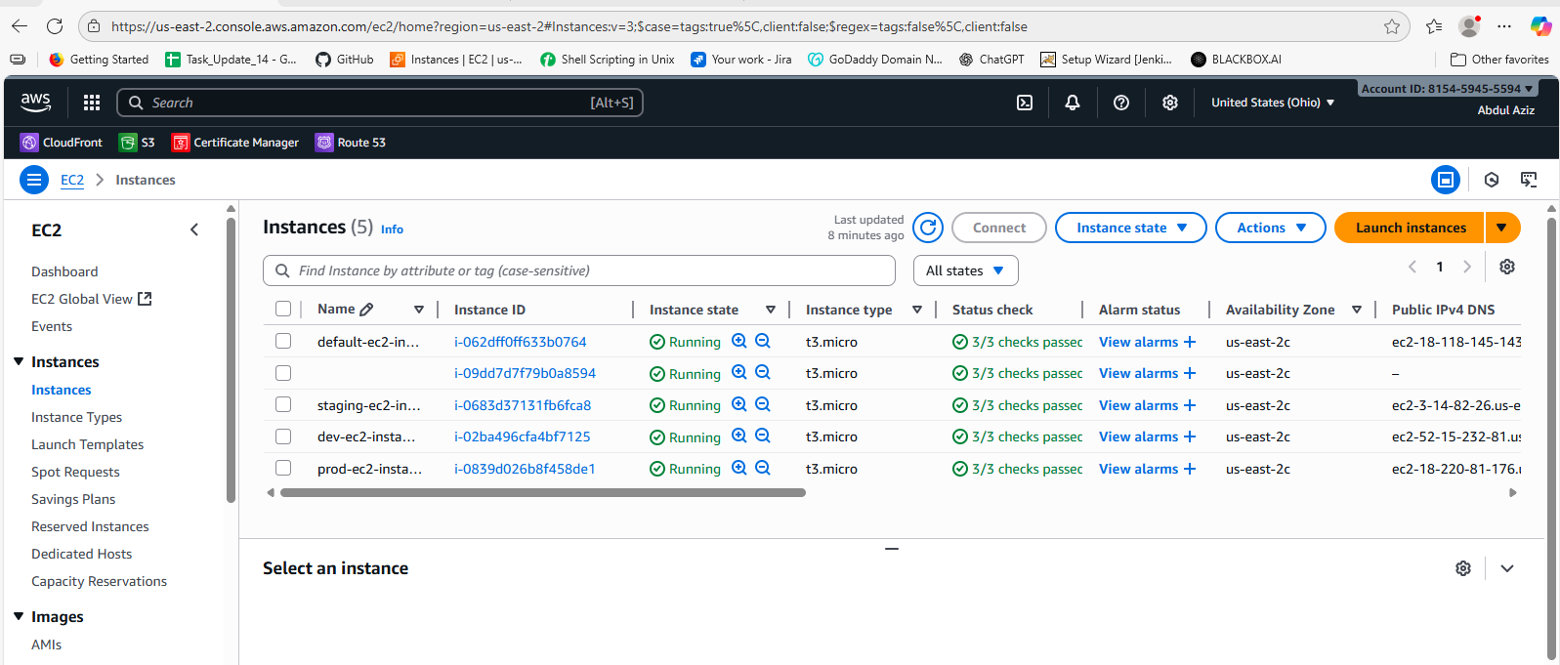
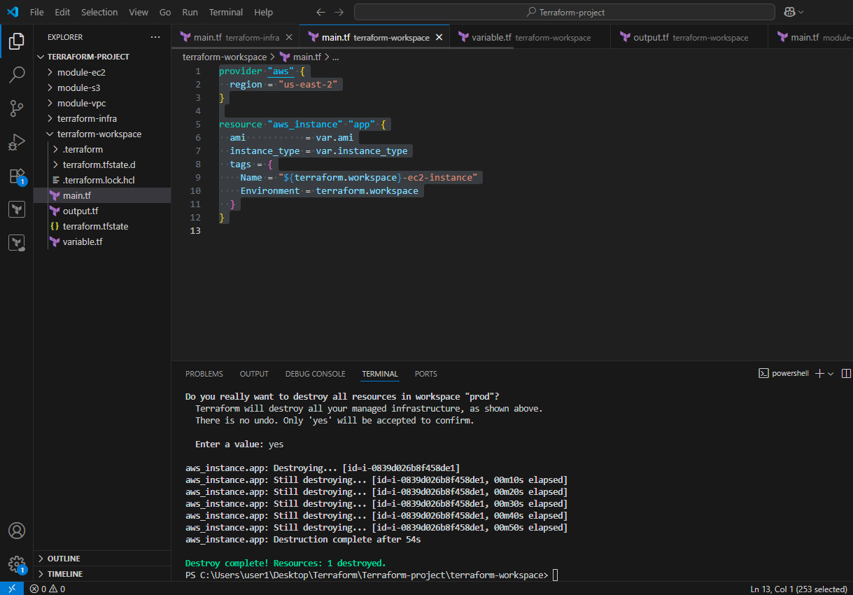
After everything has been done we are destring everthing..

