Terraform-Task-01
- Install Terraform on your PC

Step 1: Download Terraform
- Go to the official Terraform downloads page:
👉 https://developer.hashicorp.com/terraform/downloads
- Download the Windows 64-bit zip file.

Step 2: Extract Terraform
- Unzip the downloaded file (it contains a single terraform.exe file).
- Move terraform.exe to a folder (e.g., C:\terraform).

Step 3: Add to PATH
- Search for Environment Variables in Start menu.
- Click Environment Variables… → Select Path → Edit.
- Add the folder path where you placed terraform.exe (e.g., C:\terraform).
- Click OK.

Step 4: Verify Installation
Open Command Prompt / PowerShell and run:
terraform -version

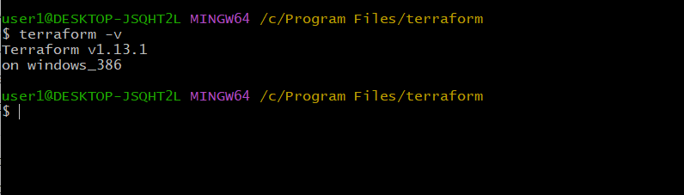
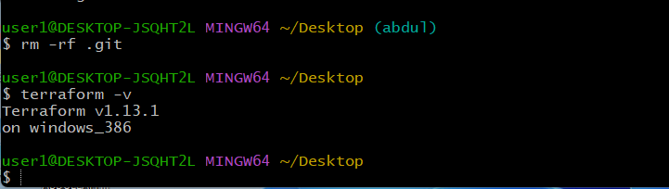

- Execute all the templates shown in video.
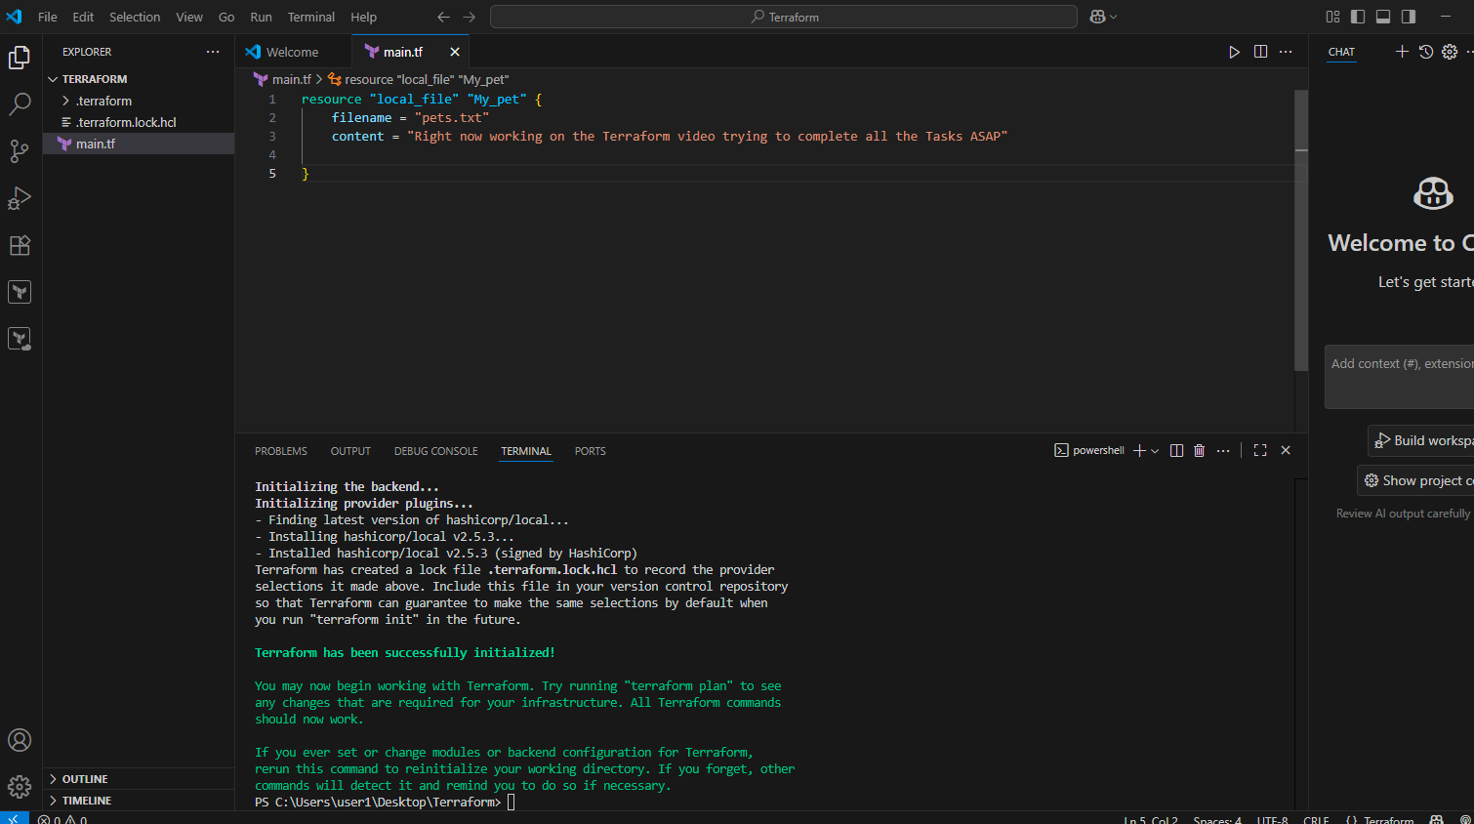
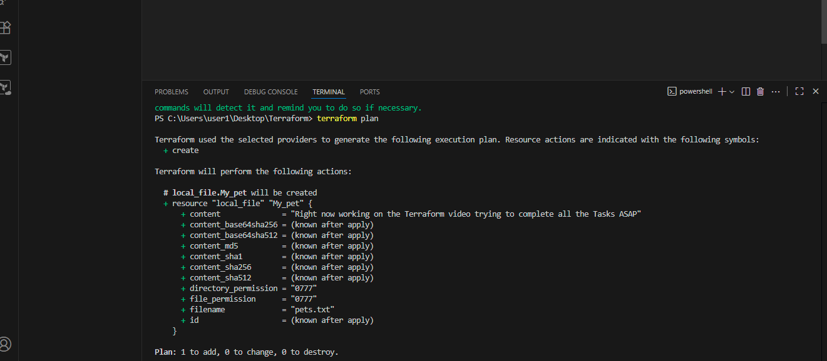
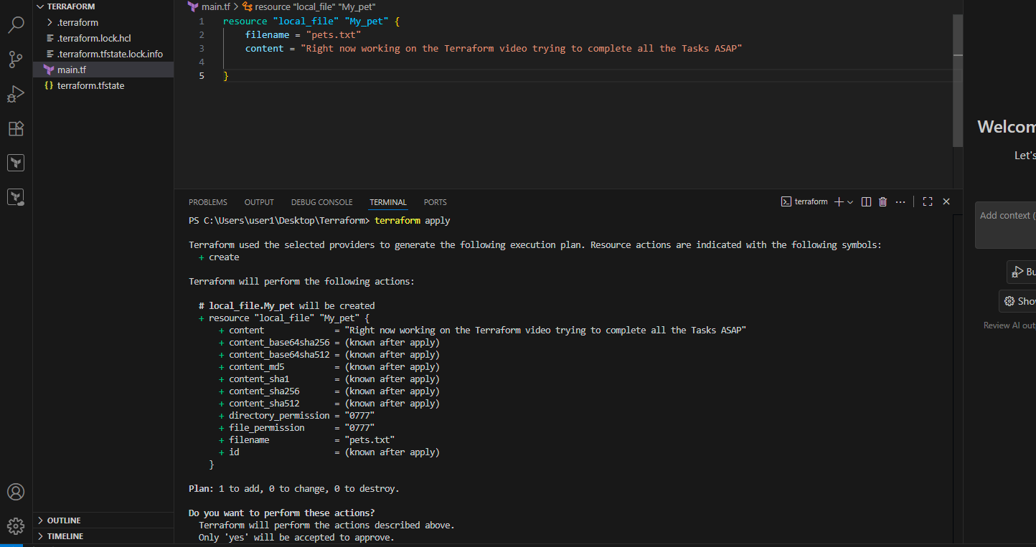
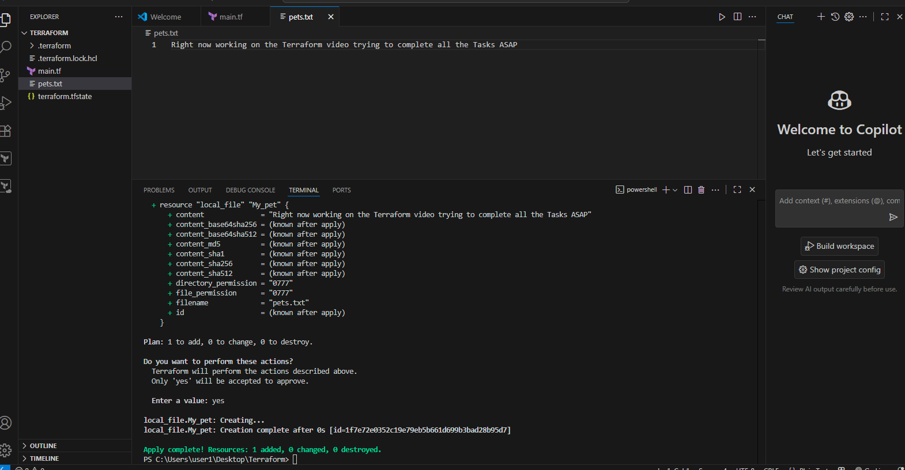
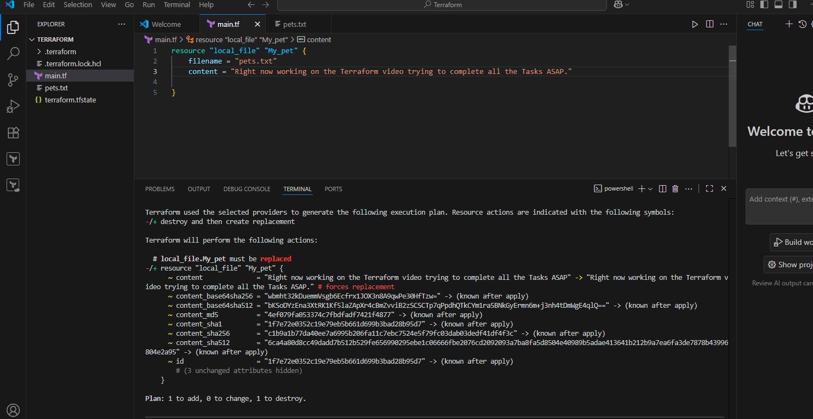
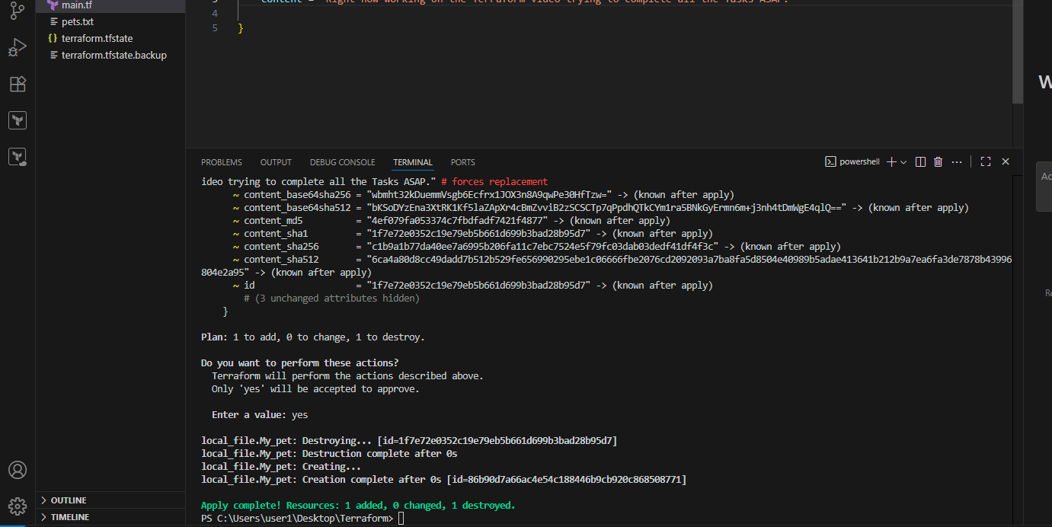
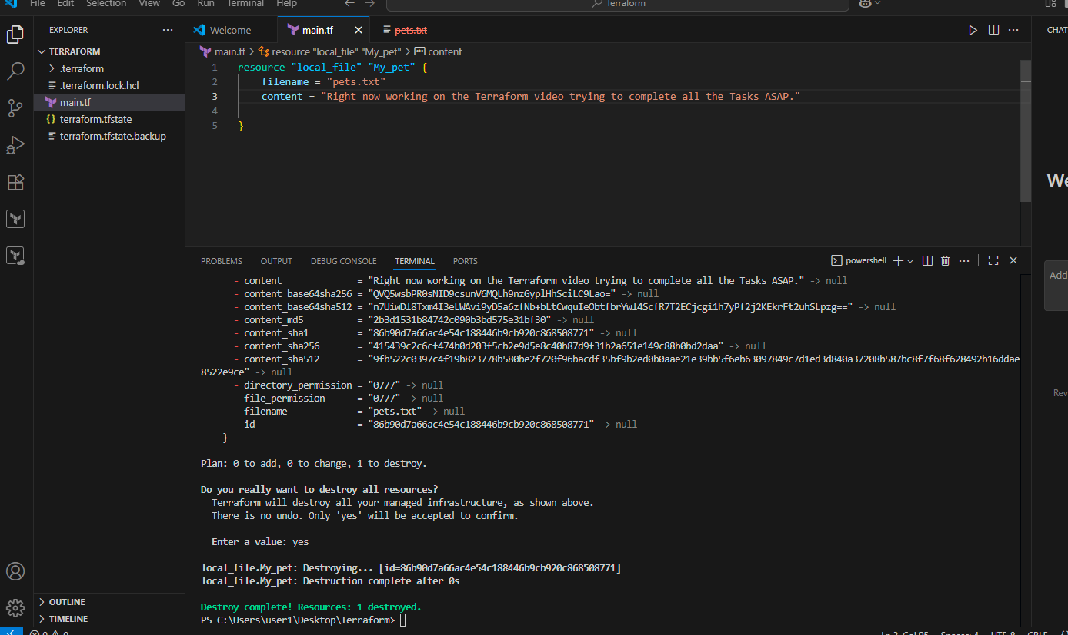
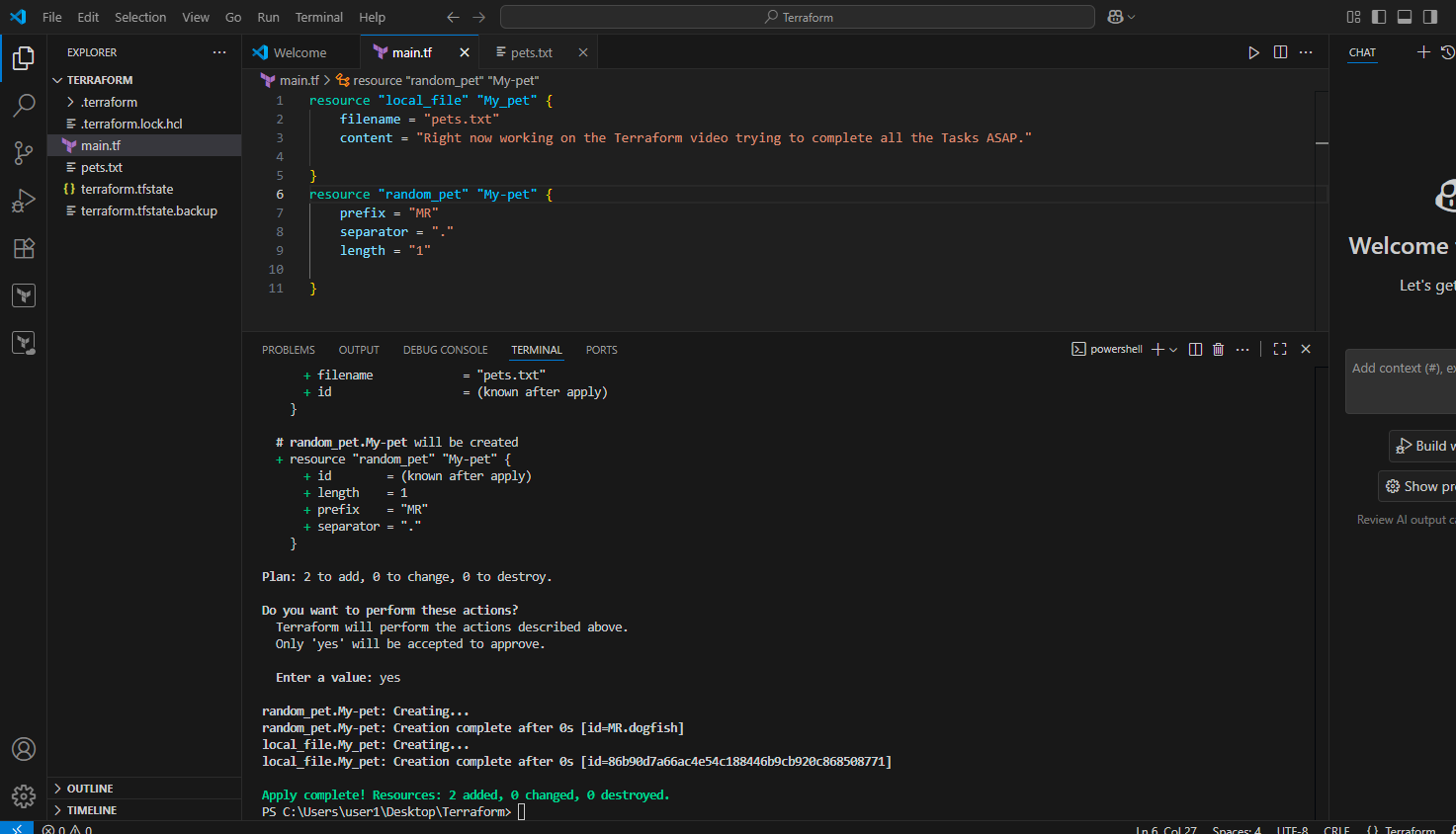
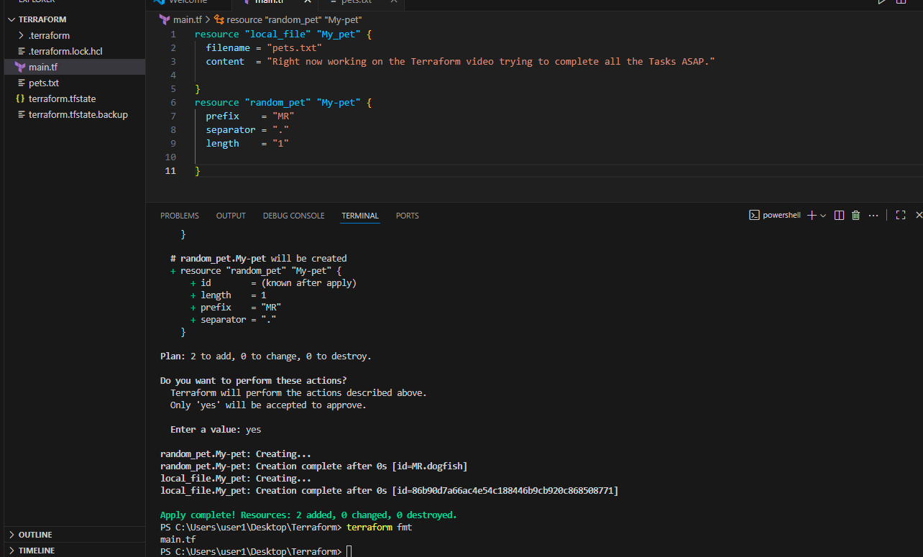
3) Note down below points,
Terraform Init

Common Notes:
- You only need to run terraform init once per project (or whenever you add new providers/modules or change backend).
- Safe to run multiple times; it won’t destroy anything.
- Must be run before plan or apply.


Terraform Plan

Why terraform plan is Important
- Acts as a preview before making changes.
- Helps catch mistakes before applying.
- Safe to run anytime.
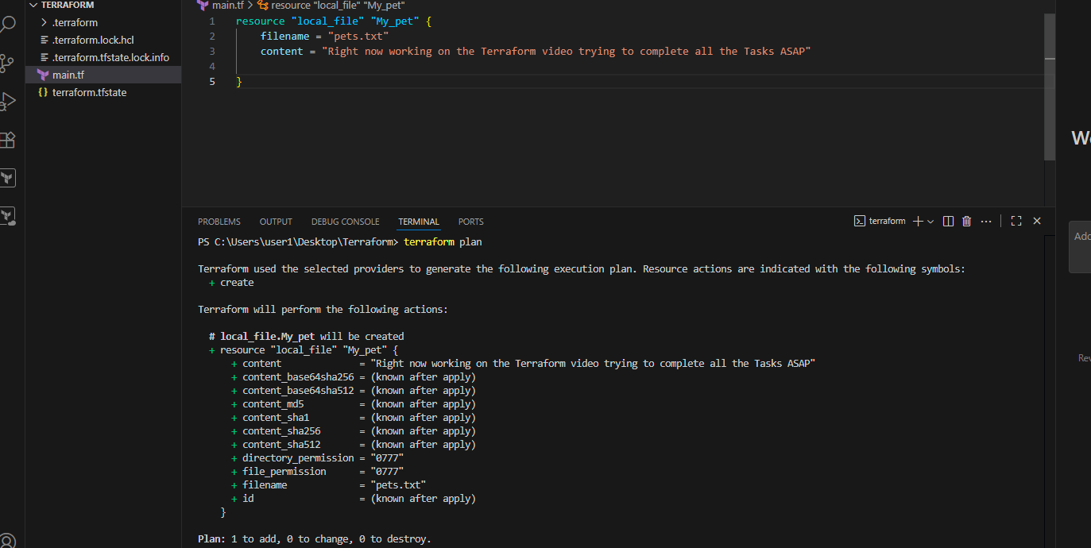
Terraform Apply

Why terraform apply is Important
- It’s the execution step → makes real changes to infrastructure.
- Should always be preceded by terraform plan to avoid mistakes.
- Safe but destructive changes (like deleting resources) require careful review.



Terraform Provider

Why Providers are Important
- Without providers, Terraform wouldn’t know what resources to create.
- They are the core building blocks that let Terraform manage any service.
It is a complete package of API calls to communicate with our resource.

4) Integrate a sample Terraform template in Jenkins.
First we have to install terraform in the Jenkins instance As given below.
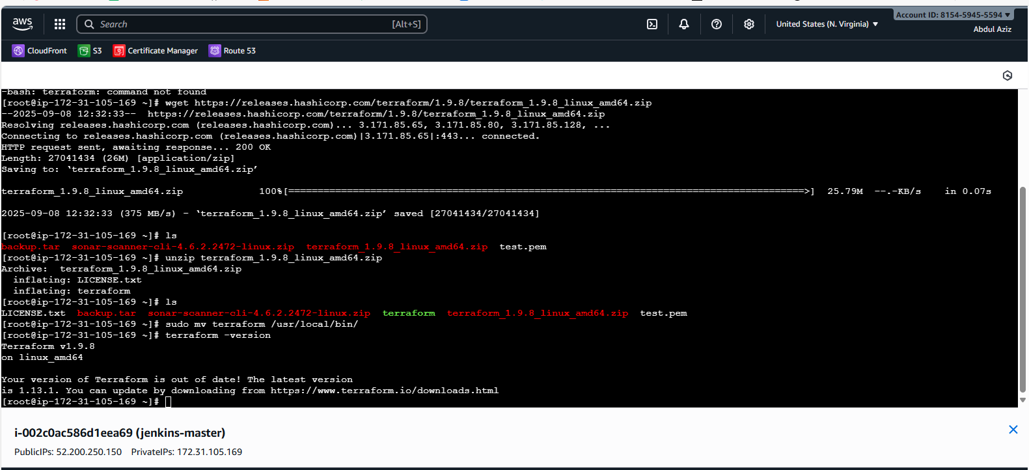
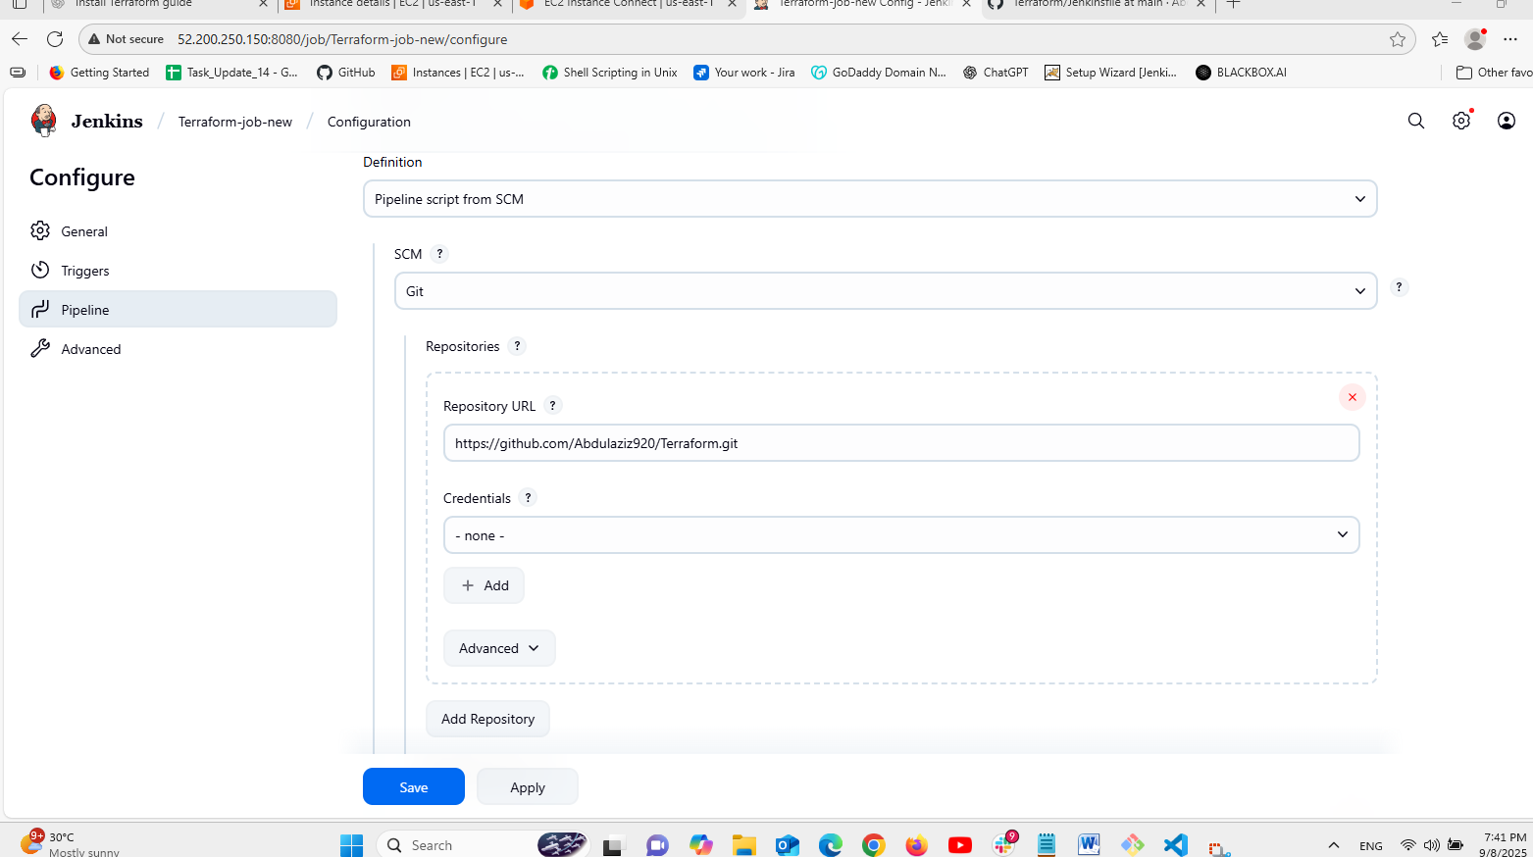
Create a pipeline job in Jenkins and configure as shown above.
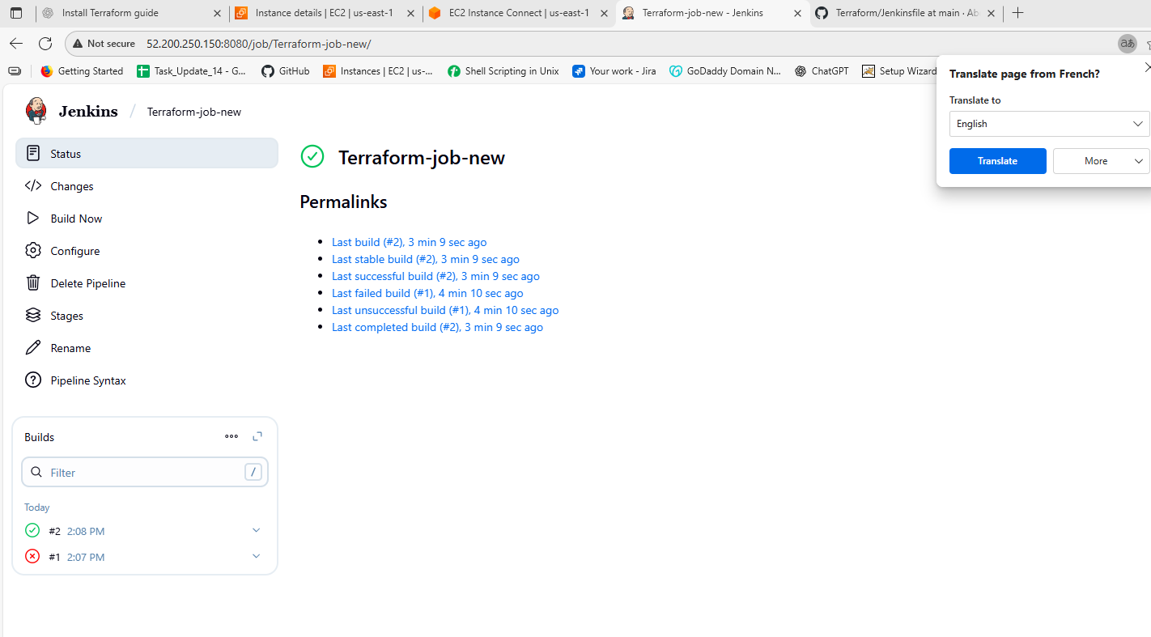
Run the job and then check the the files which has been created in the VS code as we have seen in the below picture.
