Terraform-Task-04
- Watch Terraform-04 video.
Yes the video has been Completed
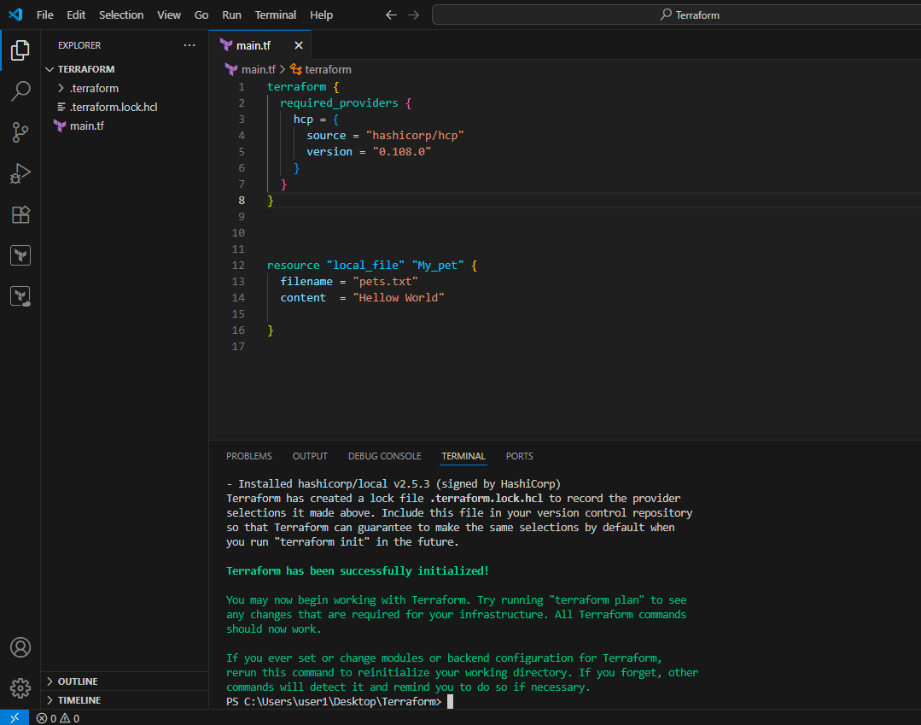
2) Execute the script shown in the video.
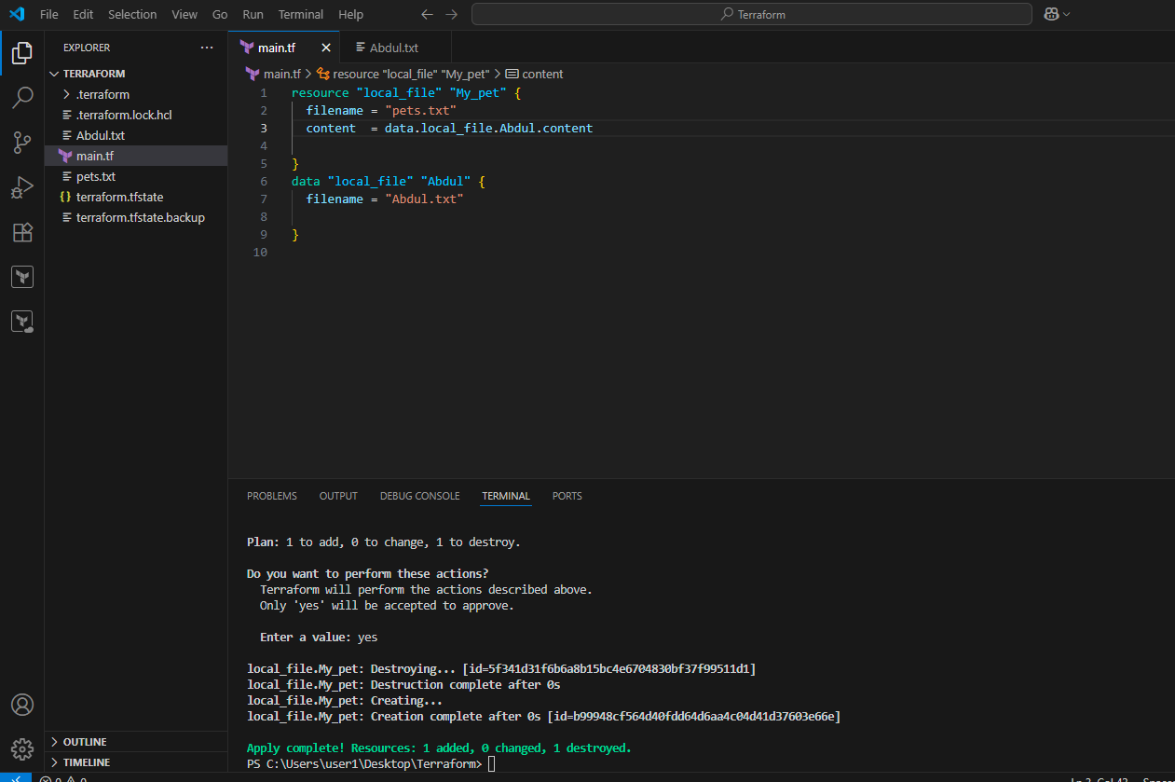
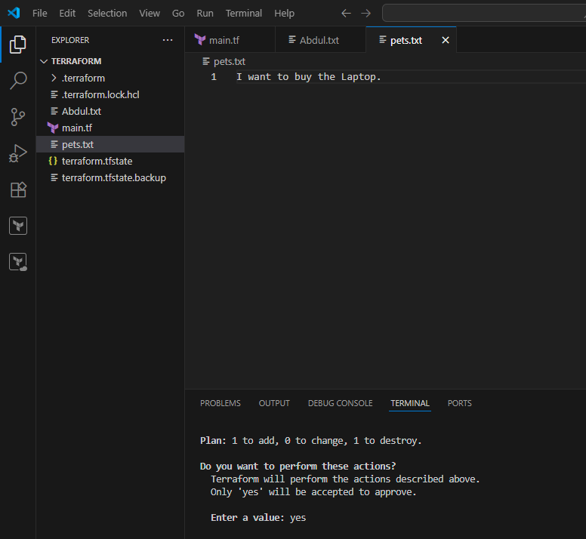
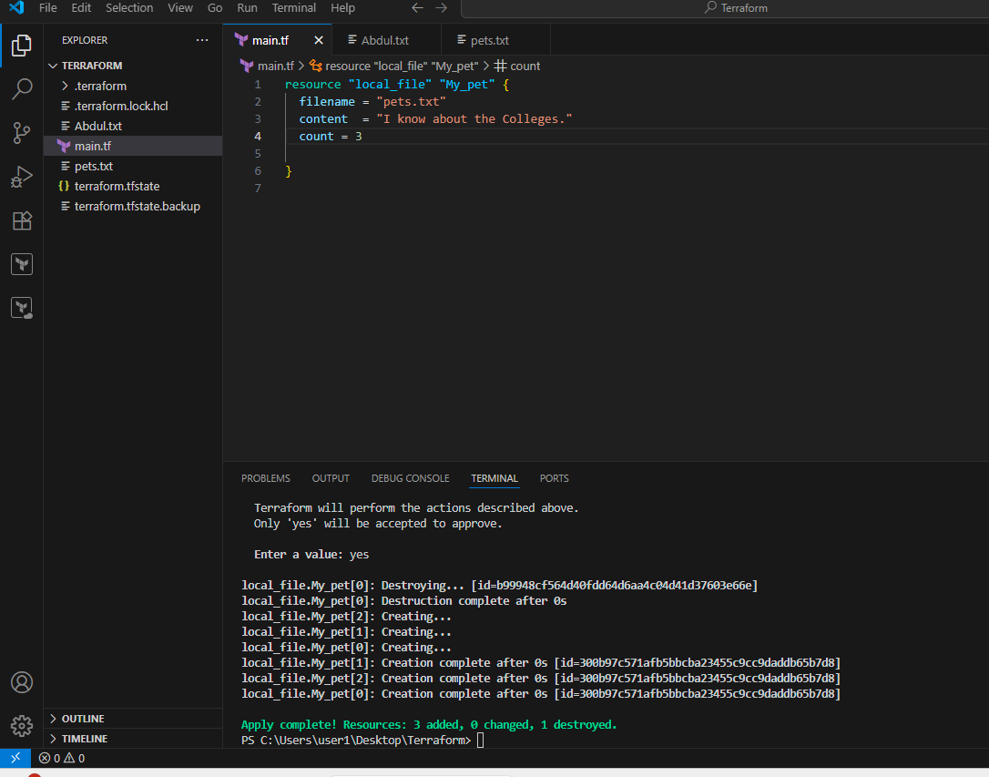
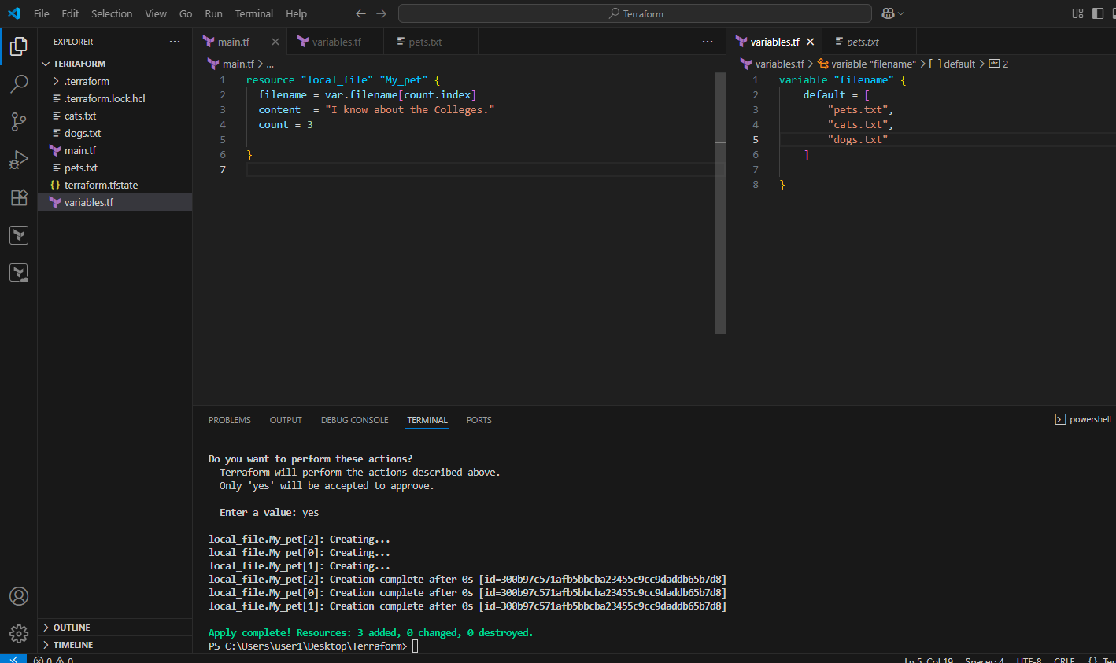
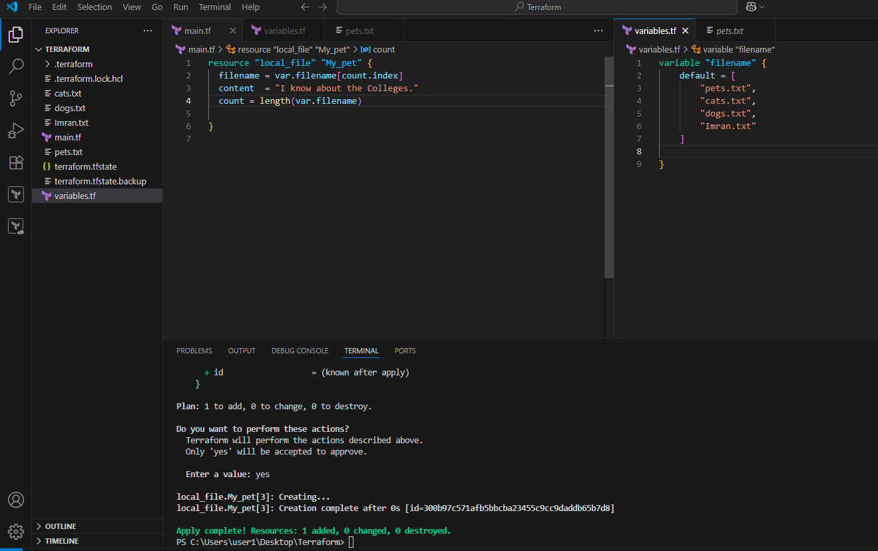
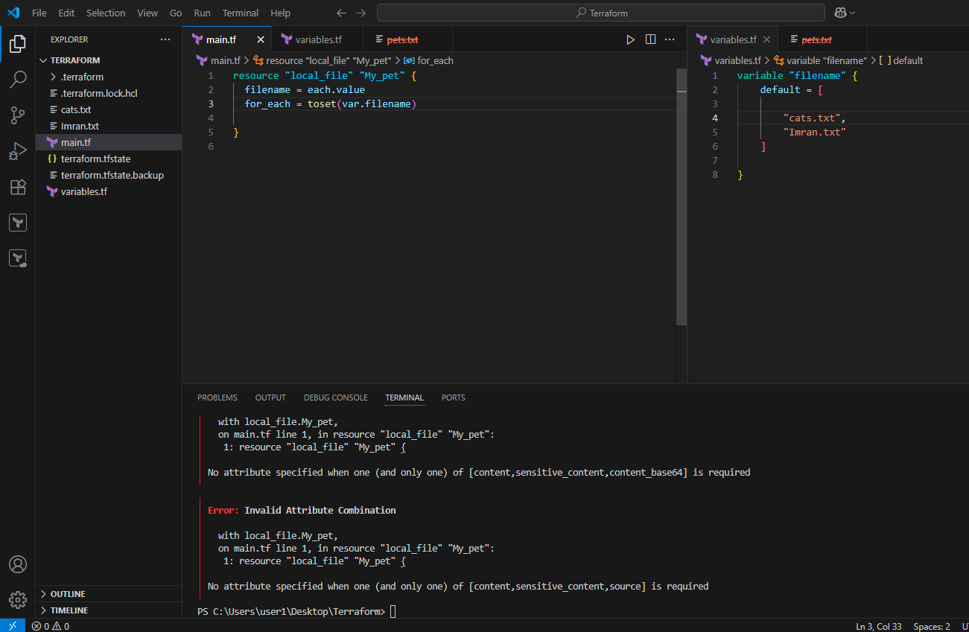
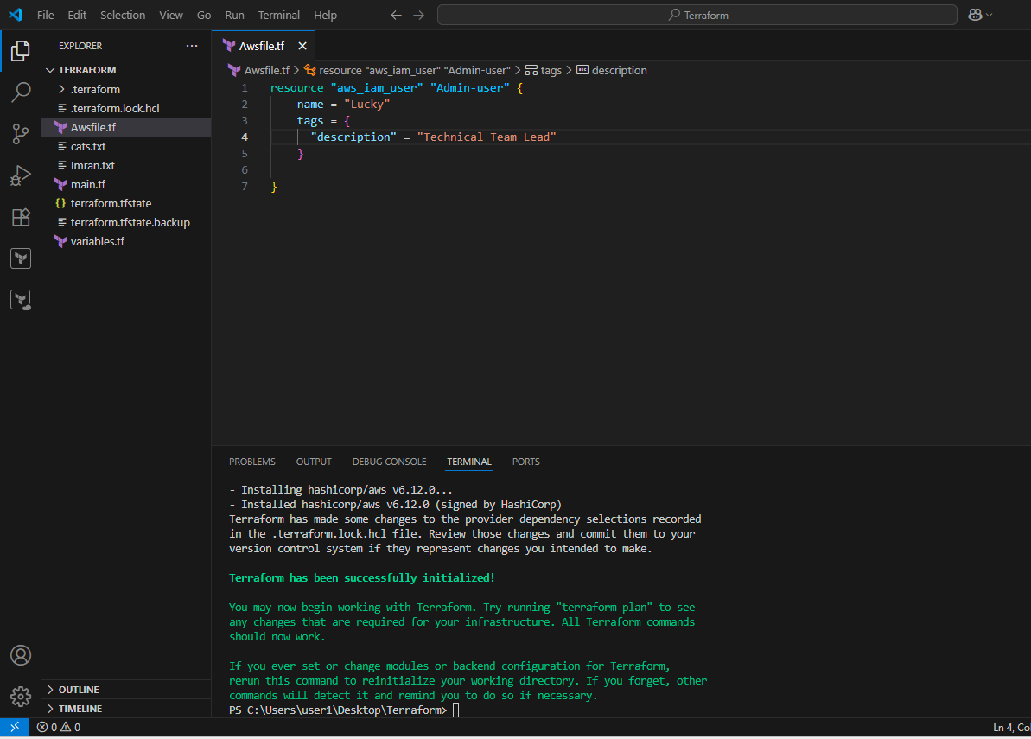
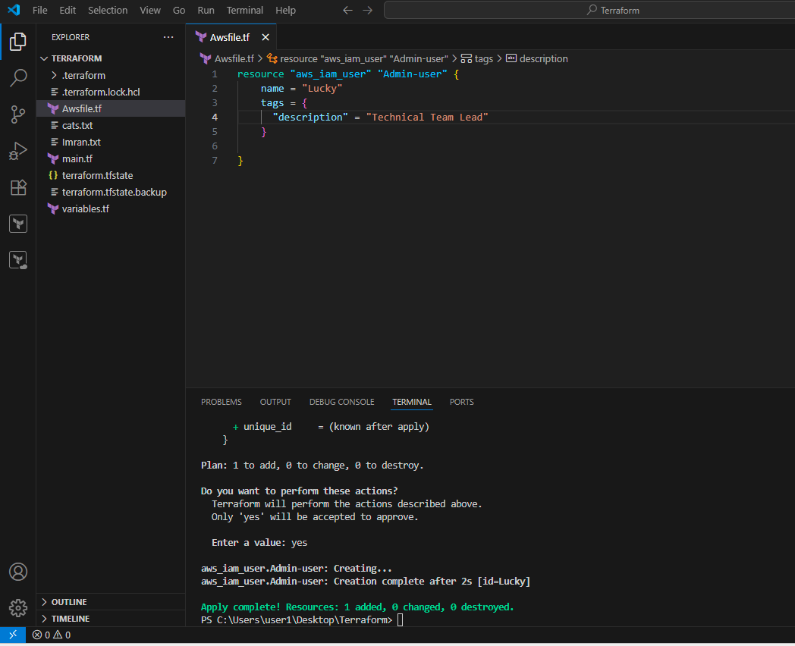
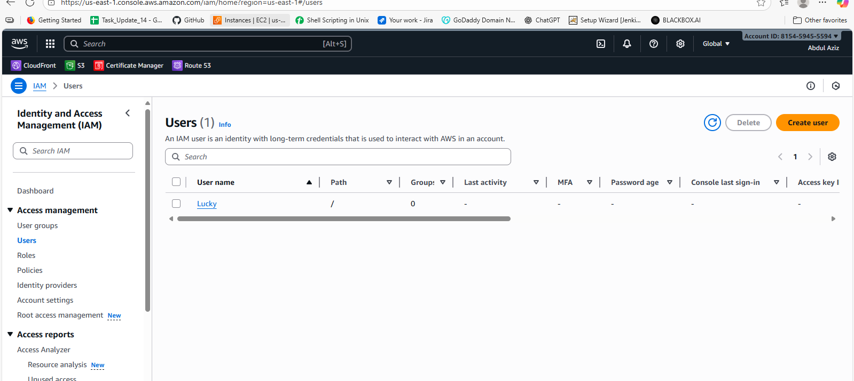
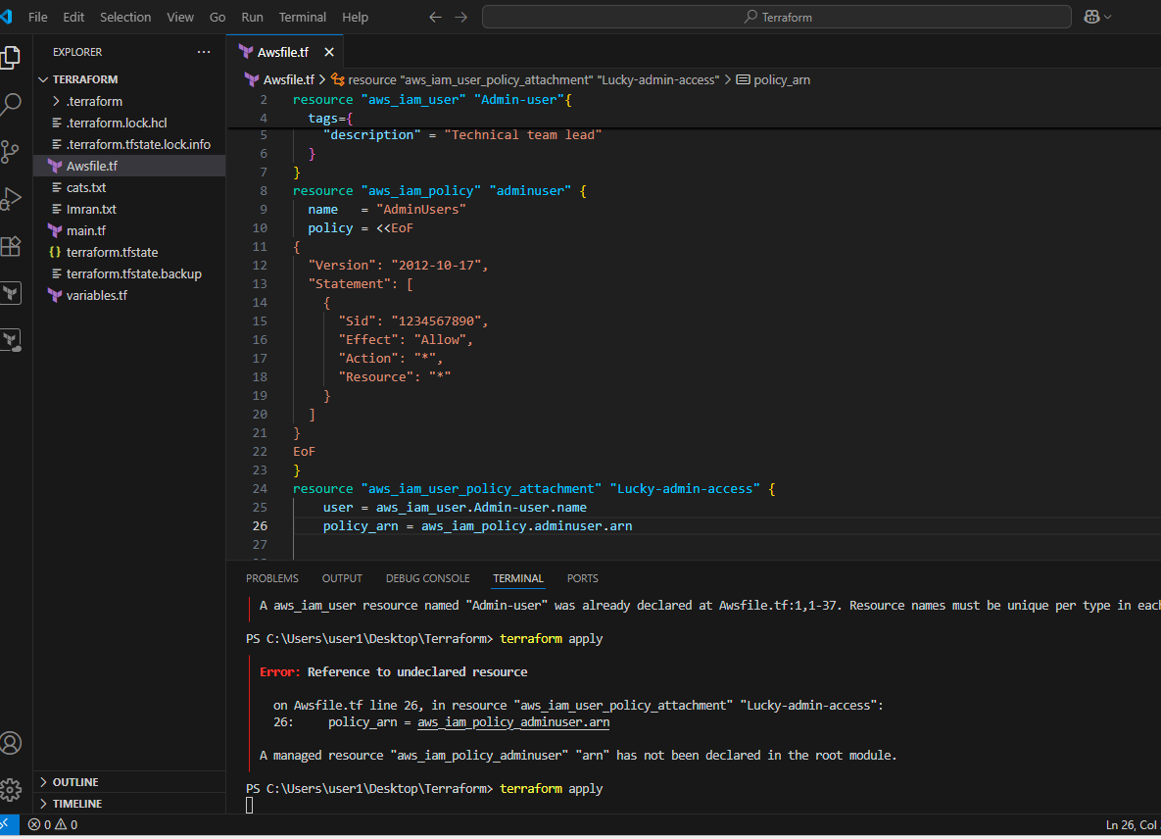
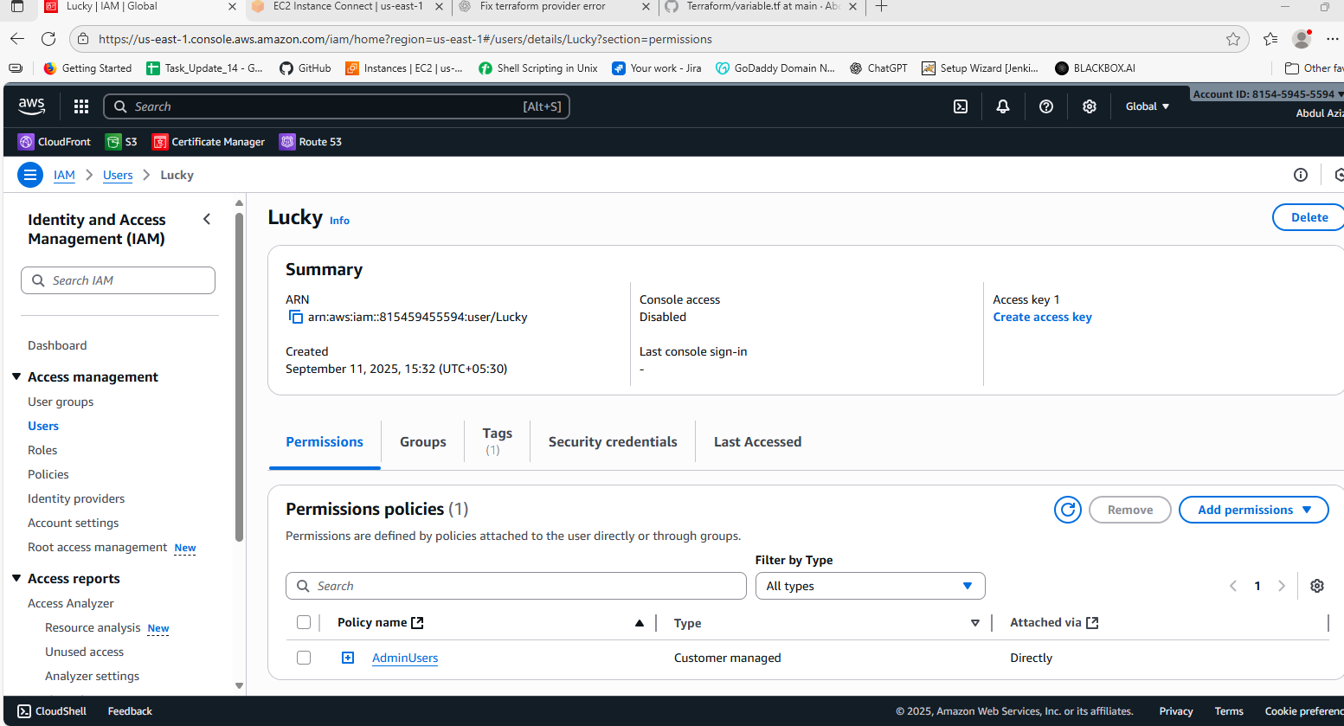
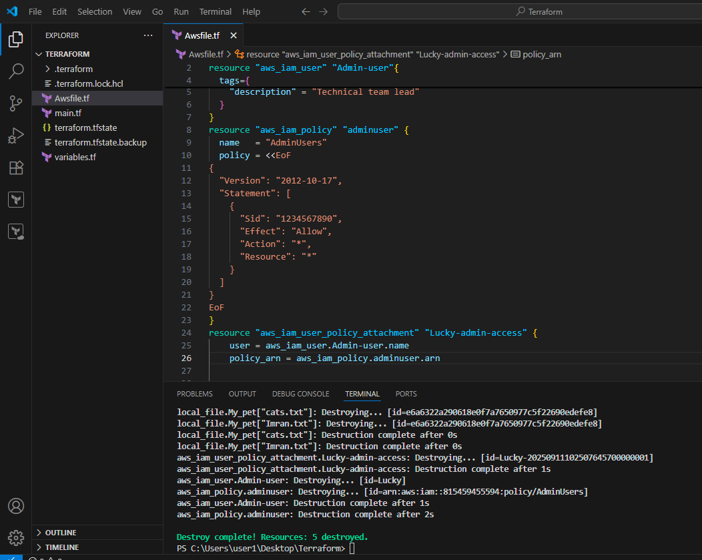
3) Integrate Terraform in Jenkins using the Terraform plugin.
First we have to create a pipeline job in Jenkins. But before this we have to create one repository in the github as given below
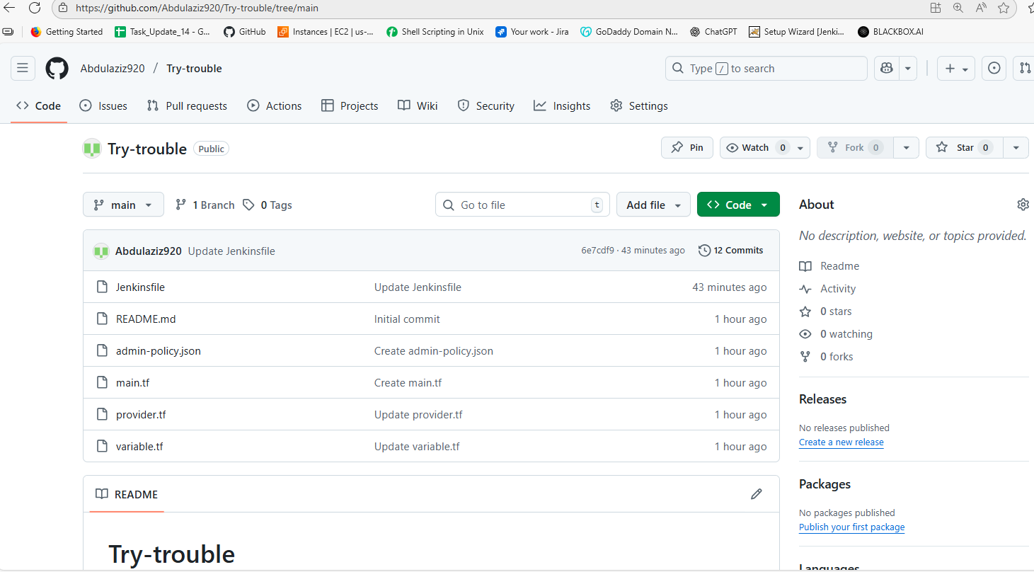
Add multiple files in that and the matter should be as given below
Jenkinsfile

pipeline {
agent any
parameters {
string(name: 'IAM_USERNAME', defaultValue: 'Abdul', description: 'IAM user name to create')
string(name: 'AWS_REGION', defaultValue: 'us-east-1', description: 'AWS region')
}
environment {
TF_IN_AUTOMATION = '1'
}
stages {
stage('Checkout') {
steps {
checkout scm
sh 'ls -la'
}
}
stage('Prepare Terraform') {
steps {
// optional: show terraform version
sh 'terraform -version || true'
}
}
stage('Terraform Init & Plan') {
steps {
// inject AWS credentials for the block
withCredentials([[$class: 'AmazonWebServicesCredentialsBinding', credentialsId: 'AWS_CRED']]) {
sh '''
export AWS_REGION=${AWS_REGION}
export AWS_DEFAULT_REGION=${AWS_REGION}
terraform init -input=false
terraform validate
terraform plan -out=tfplan -var "username=${IAM_USERNAME}"
'''
}
}
}
stage('Approve Apply') {
steps {
input message: "Apply terraform changes to create IAM user ${params.IAM_USERNAME}?"
}
}
stage('Terraform Apply') {
steps {
withCredentials([[$class: 'AmazonWebServicesCredentialsBinding', credentialsId: 'AWS_CRED']]) {
sh '''
export AWS_REGION=${AWS_REGION}
export AWS_DEFAULT_REGION=${AWS_REGION}
terraform apply -auto-approve tfplan || terraform apply -auto-approve -var "username=${IAM_USERNAME}"
'''
}
}
}
}
post {
success {
echo ':white_check_mark: Terraform completed — IAM user created (if permitted).'
}
failure {
echo ':x: Terraform failed — check logs and permissions.'
}
}
}
Main.tf
resource "aws_iam_user" "user" {
name = var.username
tags = {
Description = "Created by Jenkins/Terraform"
}
}
resource "aws_iam_policy" "admin_policy" {
name = "${var.username}-policy"
policy = file("${path.module}/admin-policy.json")
}
resource "aws_iam_user_policy_attachment" "user_attach" {
user = aws_iam_user.user.name
policy_arn = aws_iam_policy.admin_policy.arn
}
output "iam_username" {
value = aws_iam_user.user.name
}
Provider.tf
provider "aws" {
region = var.region
# Credentials are read from environment variables injected by Jenkins (AWS_ACCESS_KEY_ID / AWS_SECRET_ACCESS_KEY)
}
variable "region" {
default = "us-east-1"
}
Variable.tf
variable "username" {
description = "IAM username to create"
type = string
default = "Abdul"
}
admin-policy.json
{
"Version": "2012-10-17",
"Statement": [
{
"Sid": "1234567890",
"Effect": "Allow",
"Action": "*",
"Resource": "*"
}
]
}

After all these we have to create a jab and select pipeline SCM in that and create the creadentials first install the plugin aws creadentials then go to global creds then select aws cread then add the access and secret key in that

After that run the job
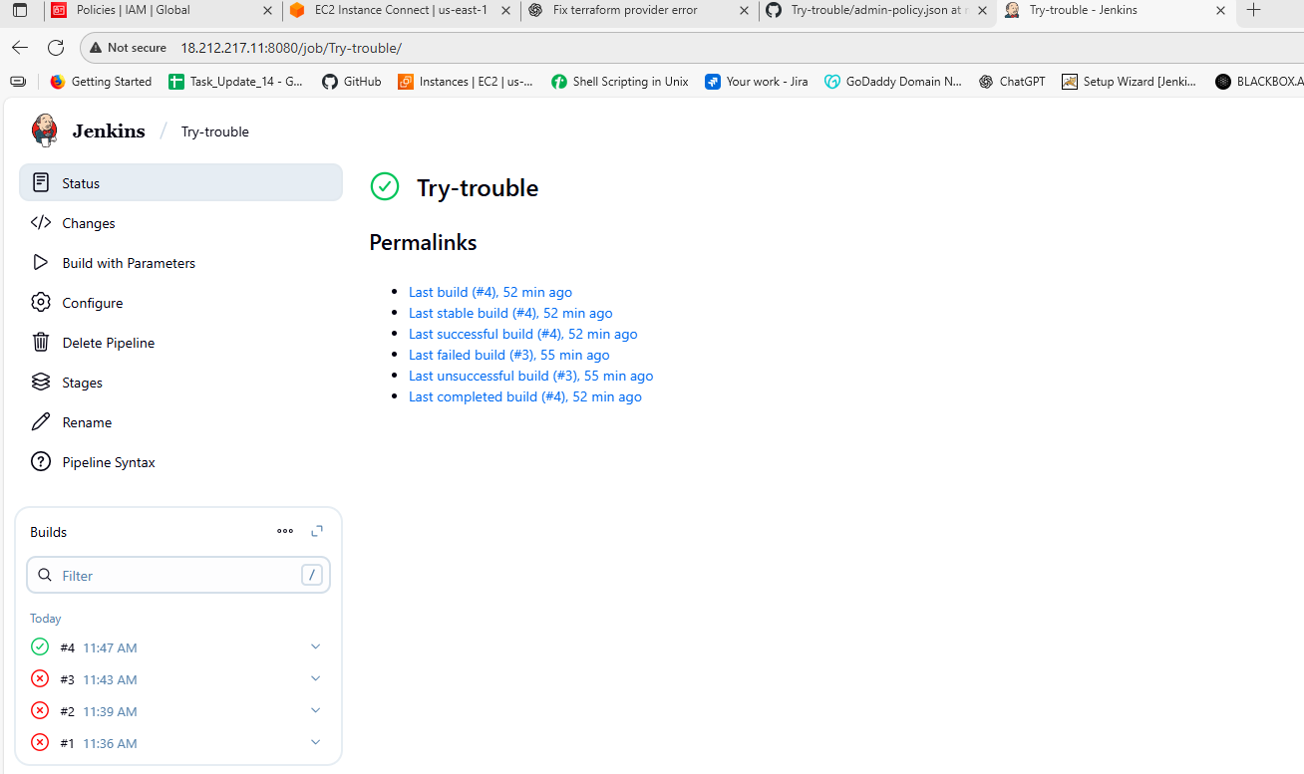
I have tried but in 4th attempd its success
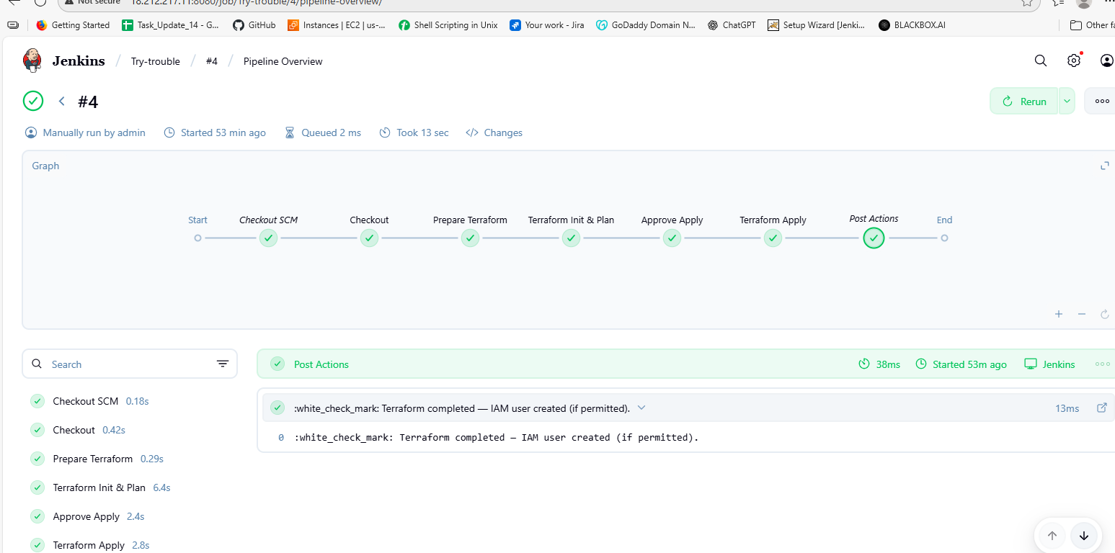
And here in appore apply we have to proceed or abort then it move on.
Then after this script runs automatically the user and the policy in aws se below.
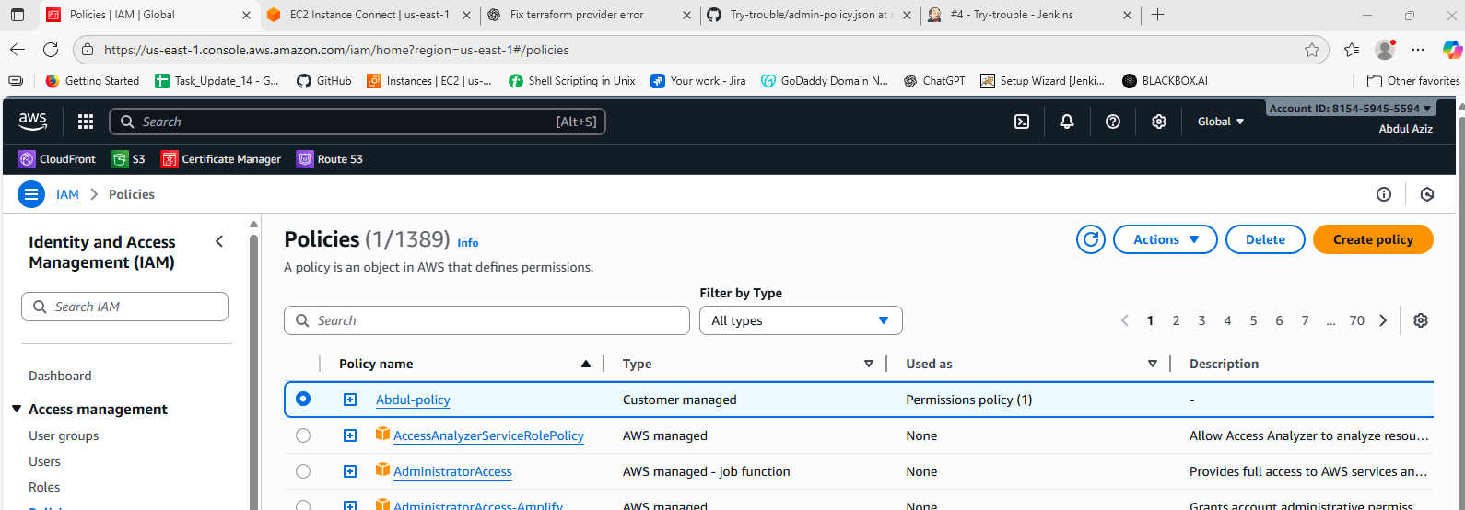
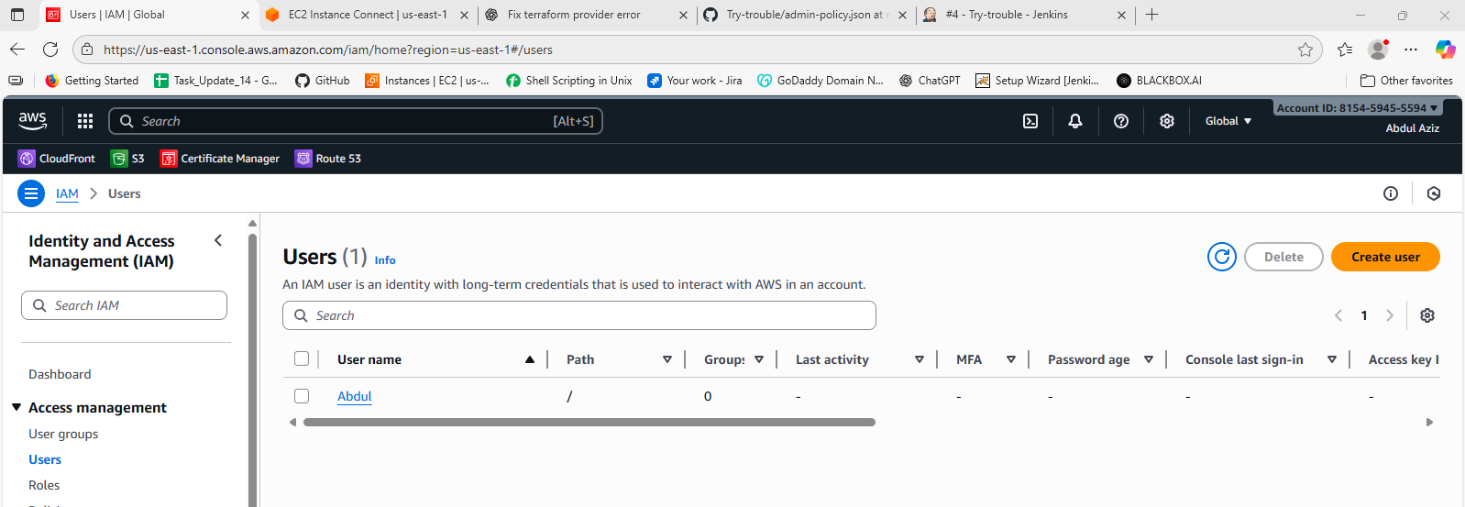
4) Create a CI/CD pipeline for a Nodejs Application: https://github.com/betawins/Trading-UI.git

First I have created a job and then configure the job as given below.
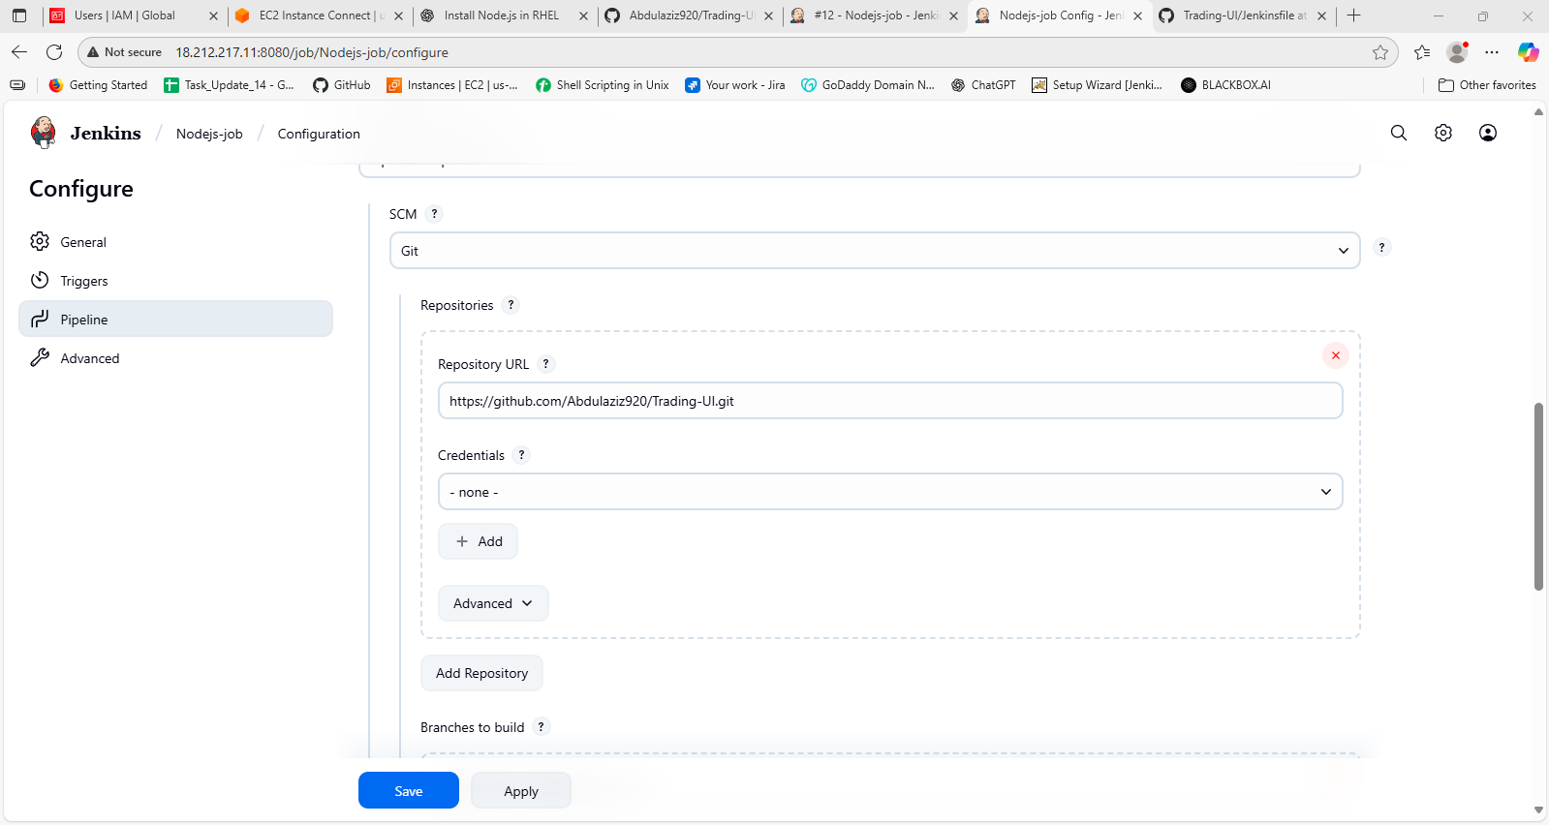
Then build this job.
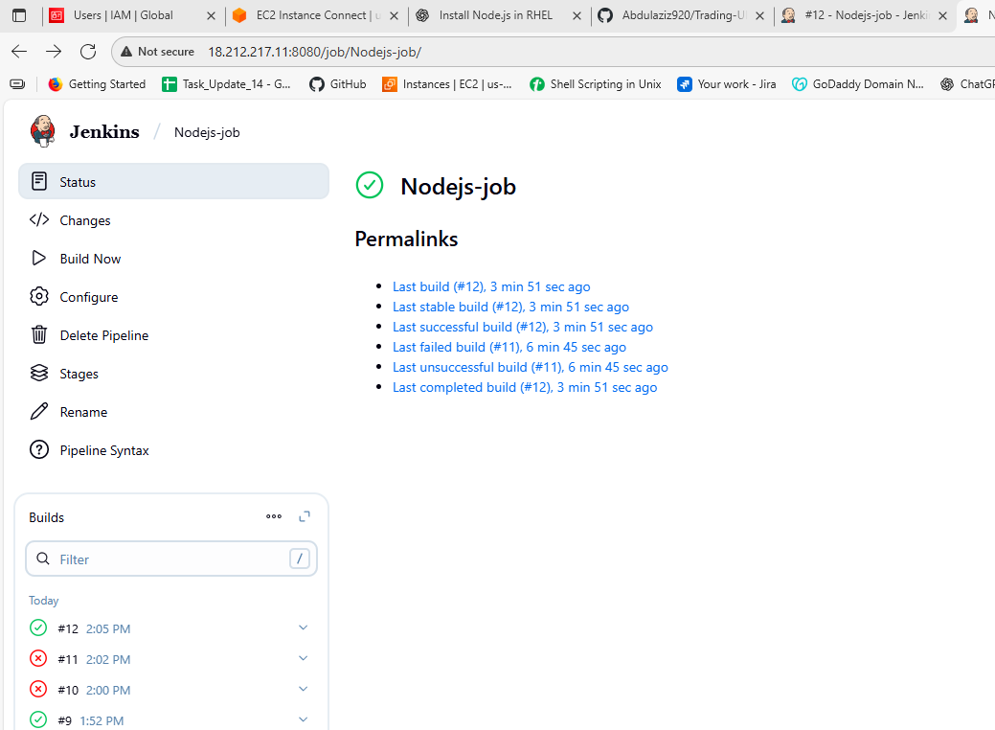
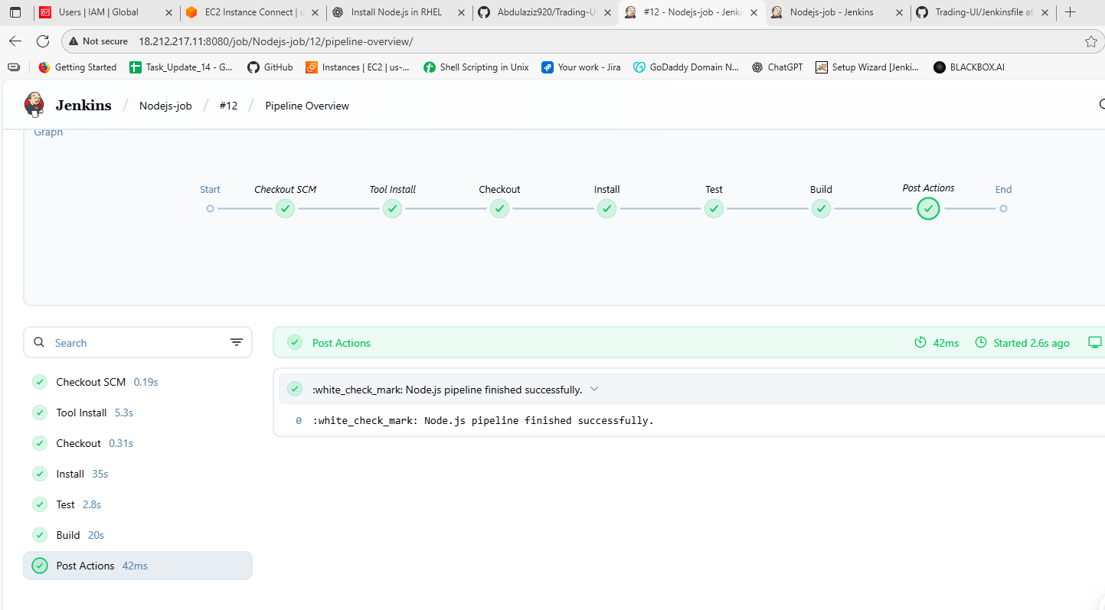
Then after every configurations done we have to run the job and this will be the output.
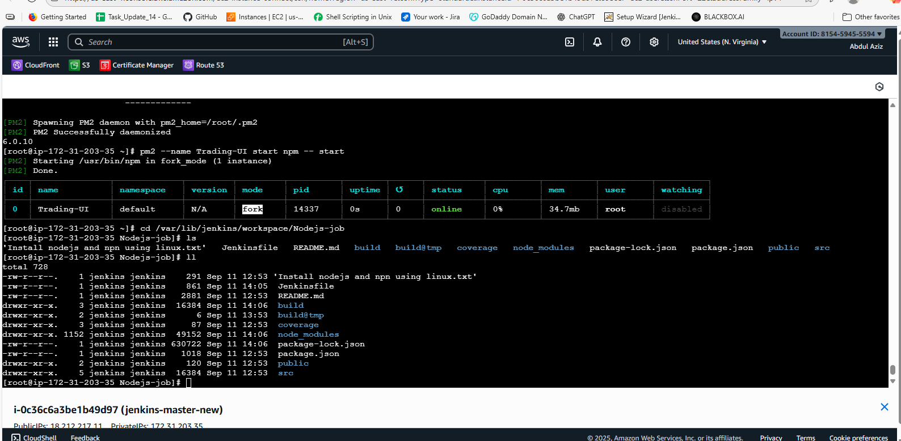
5) Explain 10 Maven commands.
a) mvn -v ---> shows the mvn version
b) mvn clean ---> Deletes the target/ directory (compiled .class files, JARs, WARs, temporary files)
c) mvn compile ---> Compiles Java source files in src/main/java and places class files into target/classes
d) mvn test --> Compiles and runs the tests in src/test/java using JUnit/TestNG. And Fails the build if tests fail
e) mvn package ---> It builds the project artifact and Compiles code, runs tests, and packages
f) mvn install --> It install into local repo and Installs the built artifact into your local Maven repository (~/.m2/repository) so it can be used by other projects
g) mvn deploy ---> It deploys to remote repo and Deploys the artifact to a remote repository (like Nexus or Artifactory) for use by other developers/teams
h) mvn site ---> It generates the documentation and Generates a project documentation website (reports, dependencies, plugins, test results) inside target/site
i) mvn dependency:tree ---> It shows the dependency tree and Displays the project’s dependencies in a tree structure and also Useful for troubleshooting version conflicts
j) mvn archetype:generate ---> It will generate new project and Creates a new Maven project from an archetype (template)

