Terraform-Task-02
- Watch the terraform-02 video.
Yes the video has been Completed.
- Execute all the templates shown in video.
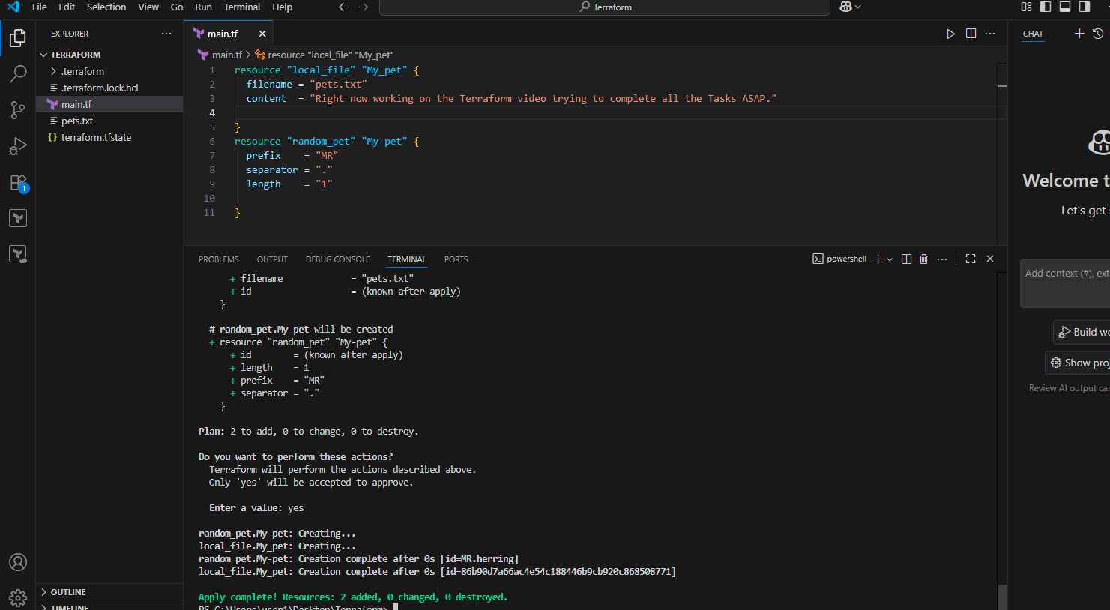
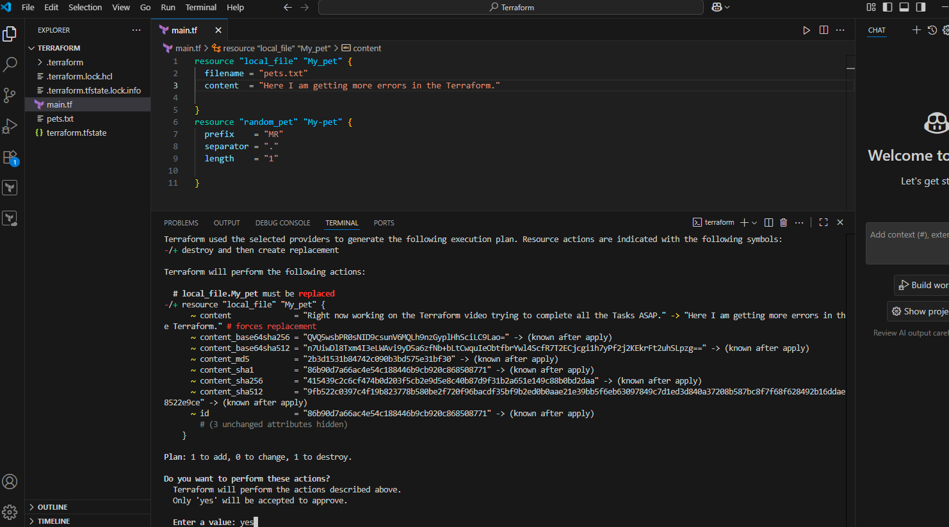
Here in the Terraform state also it gets changed in the below pic.
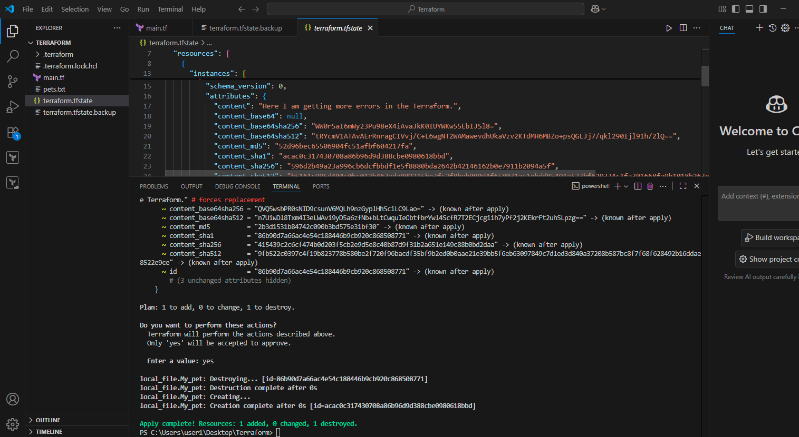
Here in the above picture we can see that first it is destroying then creating new so now we will change to create first then destroy Okayy..
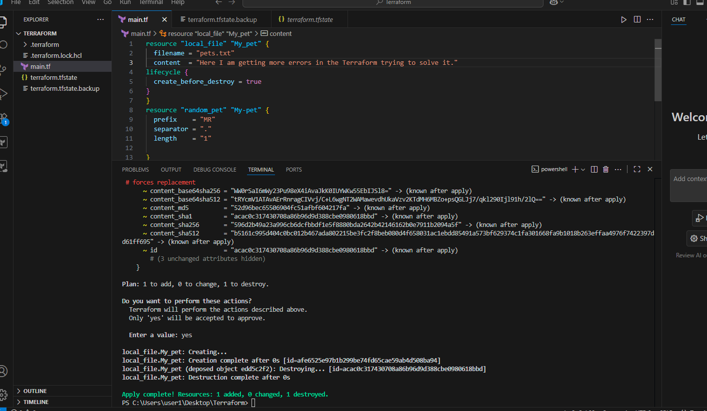
See above we have created first then destroyed in the above.
Now we will make the changes to not to destroysee below
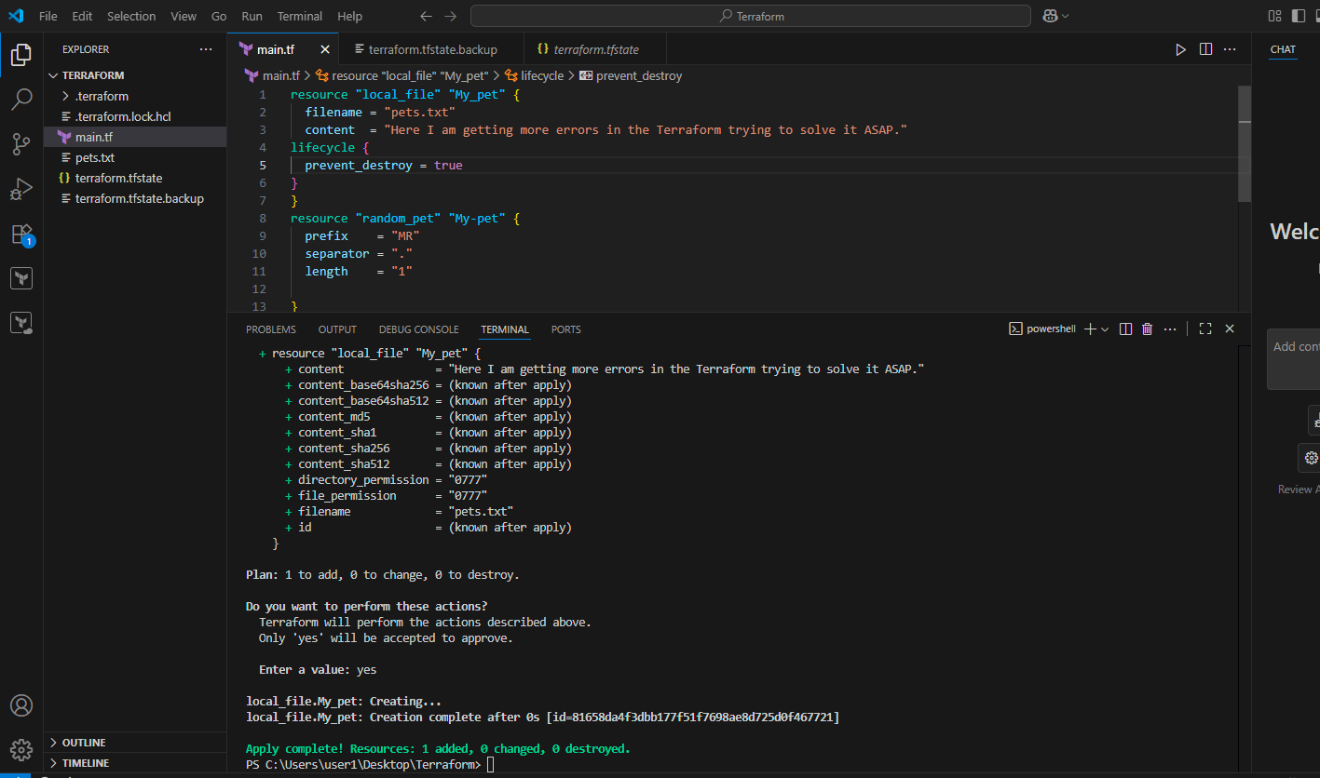
Now if edit and run Terraform apply then it will get the error lets see.
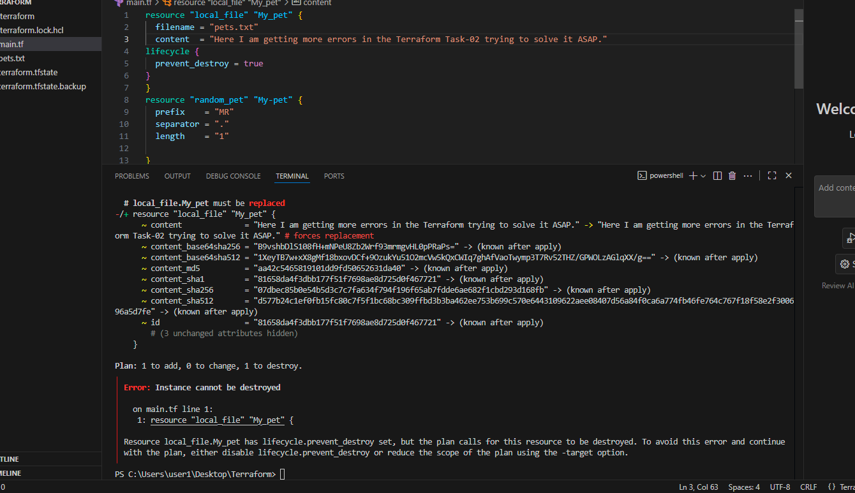
Likely we will try one more that is ignore_changes with this we ignore the changes.lets see
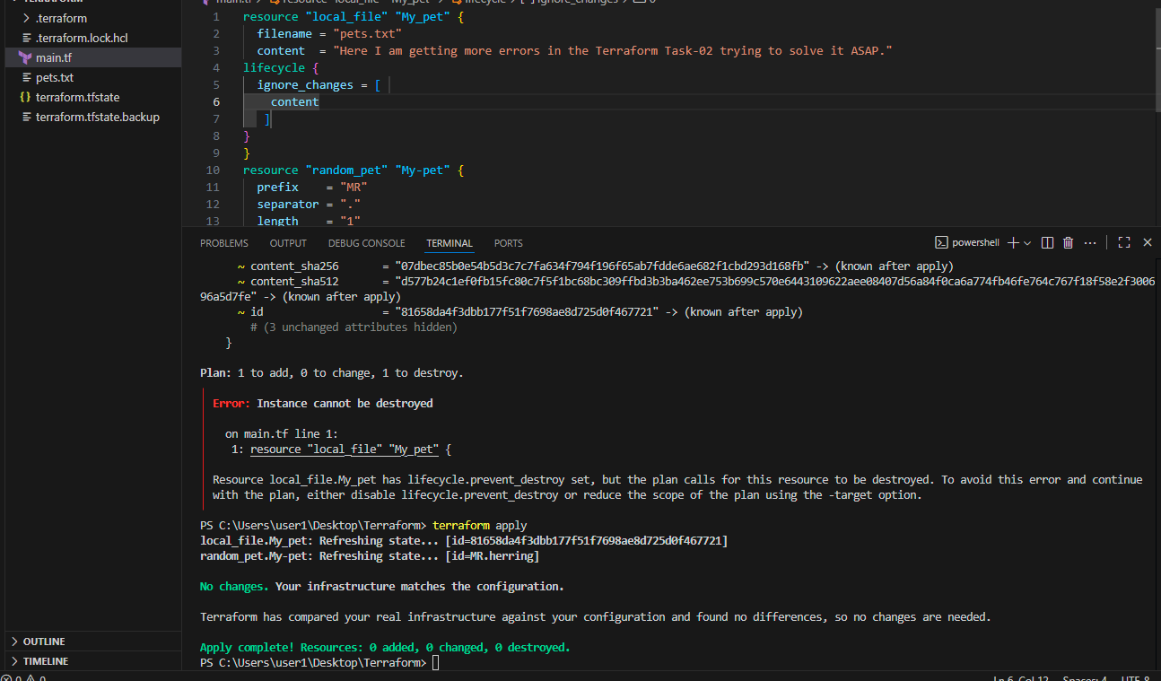
It ignore the changes what we are doing.
So now we will see the variables.
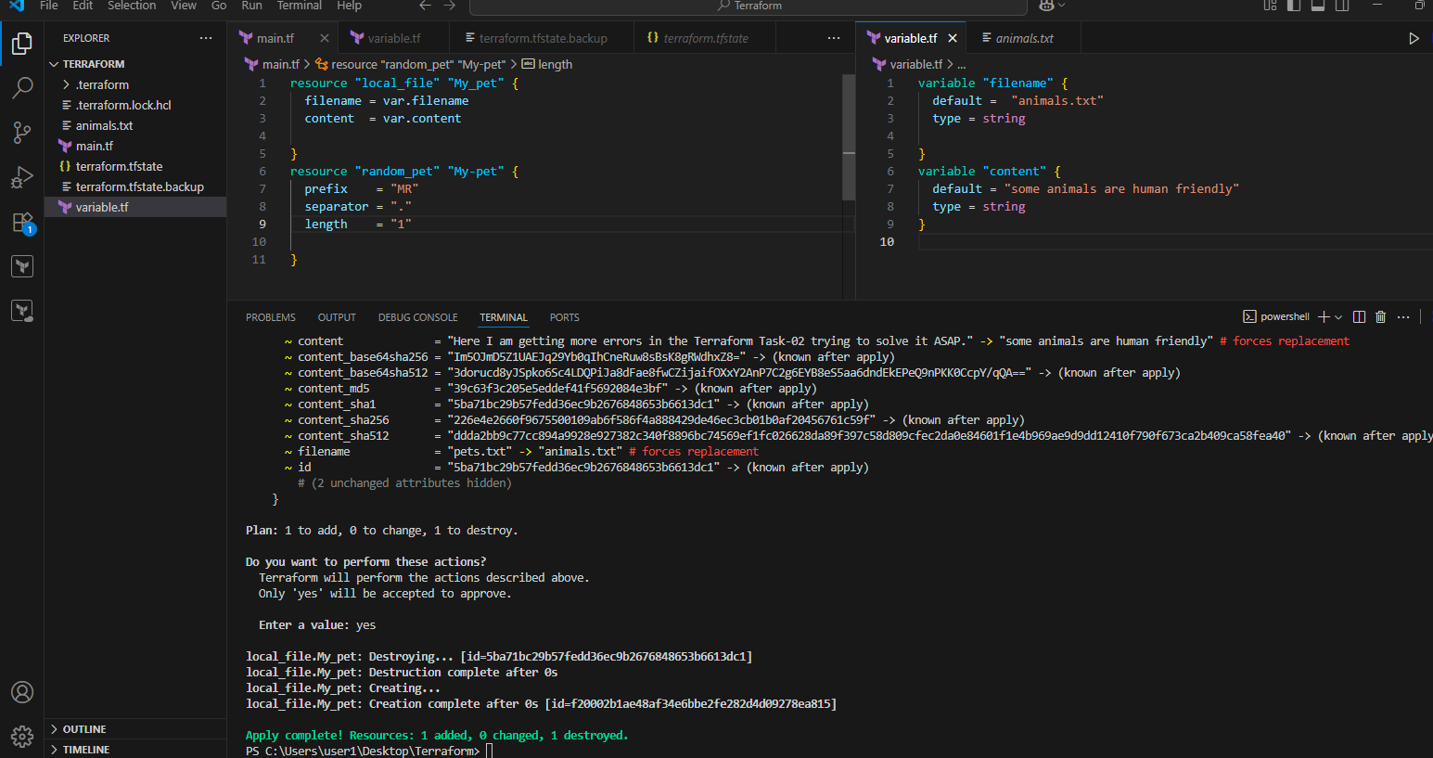
Now lets try with different variable. See below
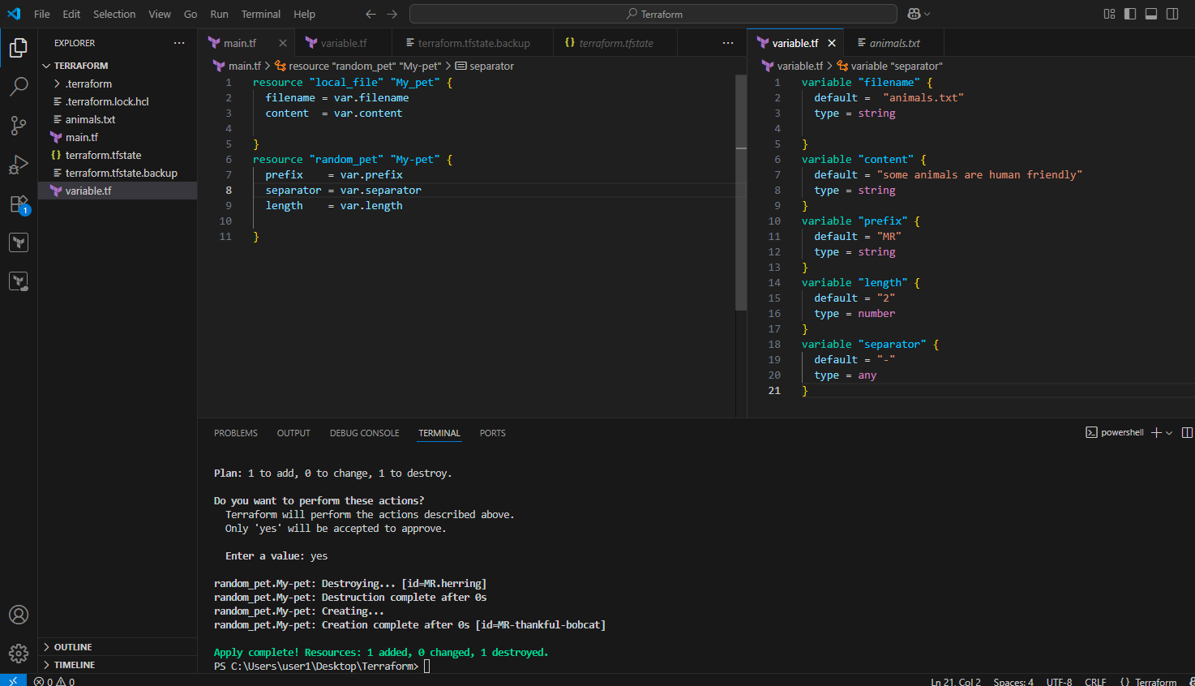
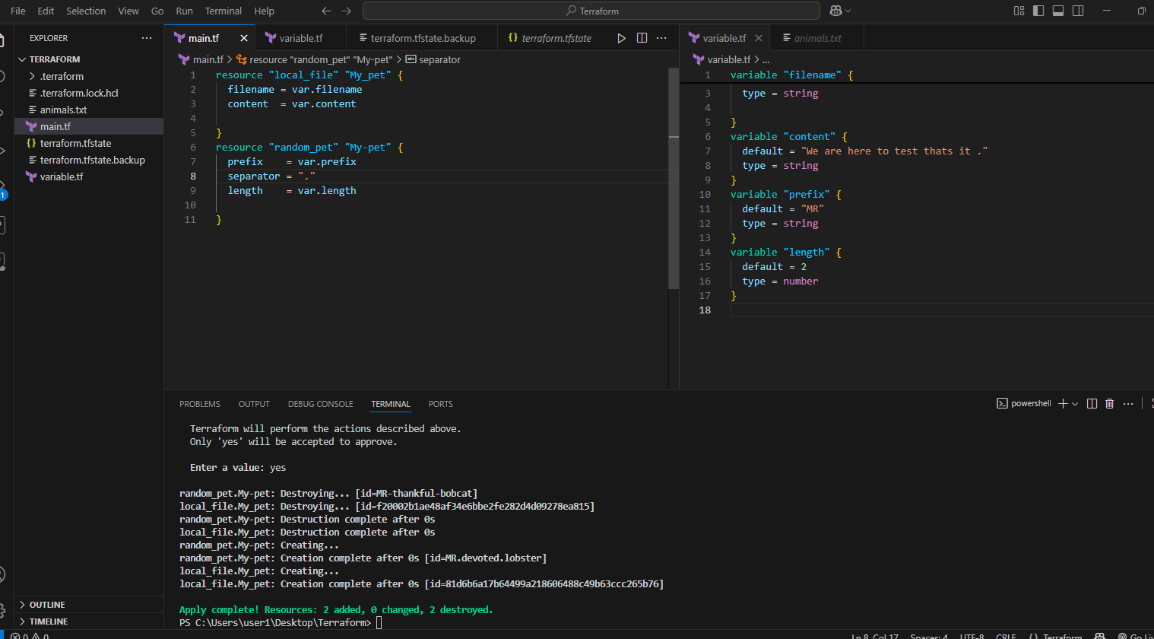
3) Integrate terraform in Jenkins using Terraform plugin.
First we have to install terraform in the Jenkins instance As given below.
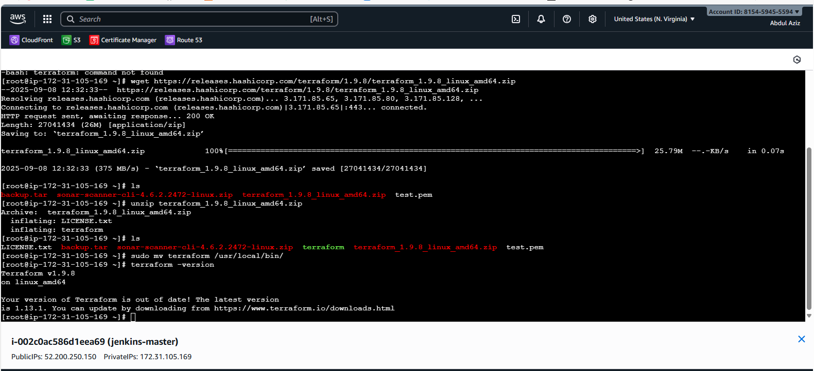
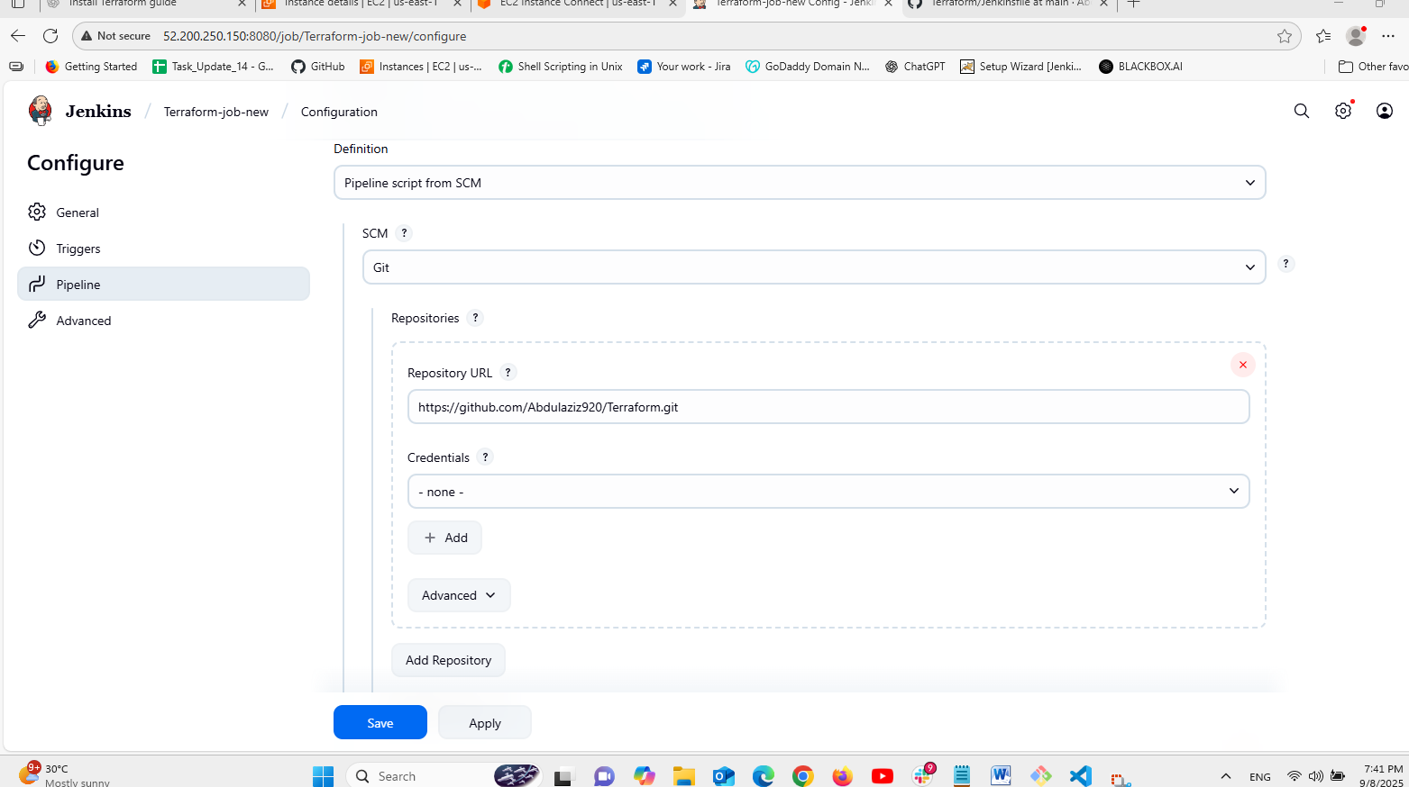
Create a pipeline job in Jenkins and configure as shown above.
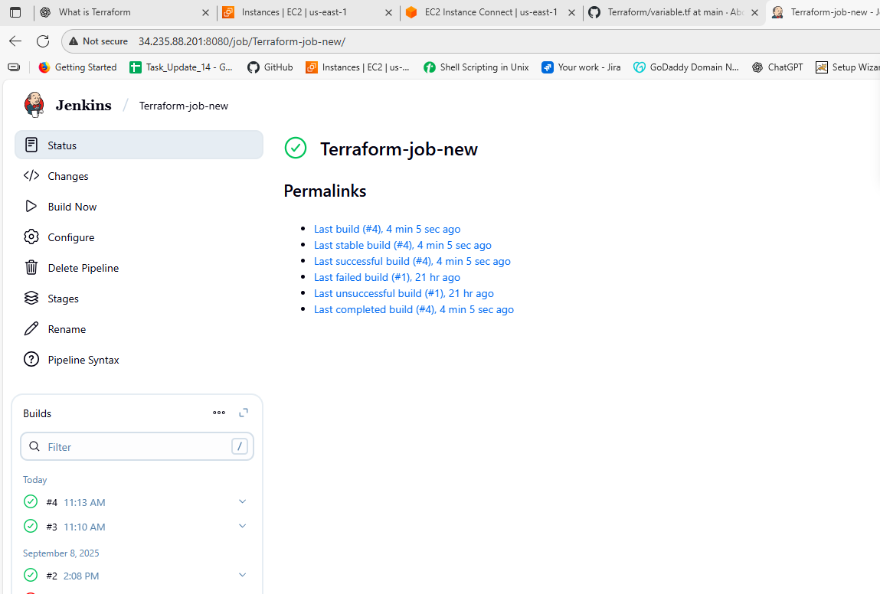
Run the job and then check the the files which has been created in the VS code as we have seen in the below picture.
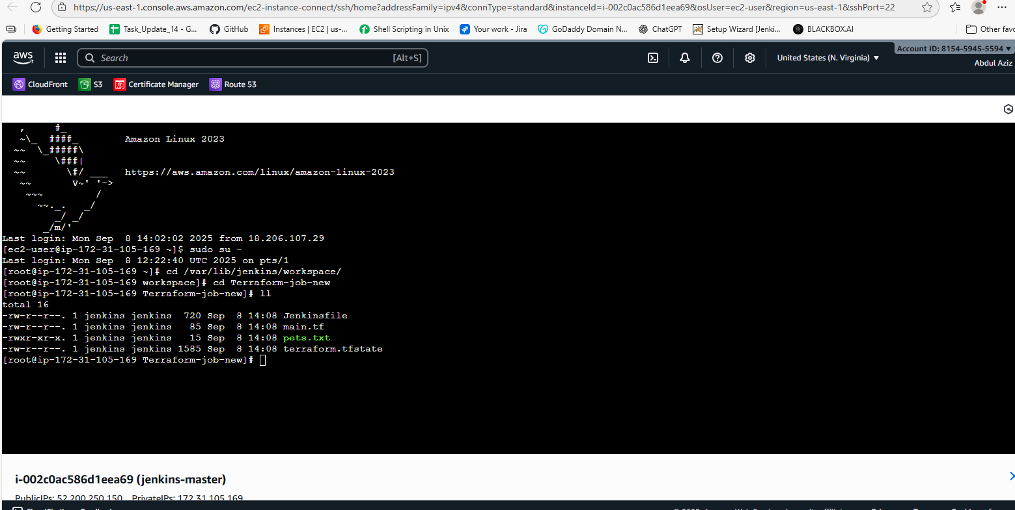
Previous it was not variable.tf in above then now it is visible below for that we have to the file in Jenkins and write that variables block…
