**Client-Server Architecture**

📌 **Requirement**: Server supports multiple clients using multithreading and TCP sockets.

🧠 **Where in code**:

* **File**: server.py
* **Function**: main()

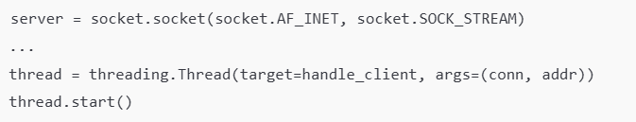

✔️ This sets up the TCP server and spawns a **thread per client**.

**✅ File Operations (Upload, Download, List)**

📌 **Requirement**: The system must allow upload, download, and list functionalities.

🧠 **Where in code**:

* **Upload**:
  + server.py: handle_upload(conn, parts, addr)
  + client.py: upload_file(sock, filepath)
* **Download**:
  + server.py: download_file_handler(conn, cmd_parts, addr)
  + client.py: download_file(sock, filename)
* **List**:
  + server.py: handle_list(conn)
  + client.py: list_available_files(sock)

✔️ All file operations are fully supported by dedicated functions in both the client and server.

**✅ Custom Protocol via TCP Sockets**

📌 **Requirement**: Use TCP sockets and define your own request-response protocol (not HTTP/FTP).

🧠 **Where in code**:

* **Client Commands**:
  + client.py → in main():

* **Server Handling**:
  + server.py → in handle_client(conn, addr):

✔️ You've defined a **custom command-based protocol** using simple strings like UPLOAD, DOWNLOAD, LIST over TCP.

**✅ Logging System**

📌 **Requirement**: Maintain logs with timestamps for all client and server events.

🧠 **Where in code**:

* **Client**:
  + client.py: log(message)
* A close-up of a computer screen

  AI-generated content may be incorrect.**Server**:
  + server.py: log(message)

✔️ Both client and server create logs in logs_client/ and logs_server/ respectively, with timestamps.

**✅ File Duplicates Handling**

📌 **Requirement**: If a file exists, automatically rename it (e.g., file_v2.txt).

🧠 **Where in code**:

* **File**: server.py
* **Function**: generate_versioned_filename(directory, filename)
* A computer code with red text

  AI-generated content may be incorrect.**Called inside**: handle_upload()

✔️ This ensures uploaded files are **not overwritten** but renamed safely with version numbers.