

SWE 363

Web App Project

**Requirements & Design**

*Phase 3*

**Group 12**

Date: 23/10/2023

*Table of Contents*

1. **Main Motivation** 3

2. **Users of the web app** 3

3. **Schedule** 4

4. **Requirements Modelling** 5

*a.* *Functional requirements* 5

*b.* *Non-functional requirements and constraints* 6

**i.** **Internal** 6

**ii.** **External** 7

*c.* *Use Case Diagram* 8

*d.* *Use Cases* 8

5. **Domain Modelling** 10

6. **Navigation Modelling** 11

7. **Low-Fi User Interface Design** 12

8. **References and definitions** 13

|  |  |
| --- | --- |
| **Name** | **ID** |
| Abdulaziz Binyabis | 201954390 |
| Luay Alluhaydan | 201954670 |
| Kaled Alqahtani | 201939890 |
| Ali Alrebdi | 202031700 |
| Ziyad Alghanam | 202035420 |

*Team members of* ***KFUPM CourseCraft***

# **Main Motivation**

1. KFUPM students think that the current system – Student Educational Planner (SEP) - for planning for the future terms is not usable, and not user friendly.

Solution:

Our website - KFUPM CourseCraft – will provide the user a smother user experience while planning.

1. KFUPM’s resources are scattered, and it is a hustle to navigate to it.

Solution:

Our website - KFUPM CourseCraft – will combine the most useful resources in one place.

# **Users of the web app**

**- Registered Students**

The main user of the website, they can create, design, edit, and save their plans. In addition to, view, download, and upload resources of the courses that the students take in the current semester, or the general resources. Furthermore, they can evaluate and see the evaluation of their instructors in the current term or the other instructors.

**-Admins**

Admins filter the uploaded resources and review them, review user behaviour, and take the appropriate actions if a user misbehaves.

Furthermore, maintaining the integrity of instructor evaluations, and maintain the overall safety of the website safeguarding the platform's integrity.

**-Guests**

Non-registered users are like registered students, but they have access to limited features, they cannot save their plans on the cloud, cannot upload resources, and do not have access to write a review about instructors. In addition, they don't get personalized resources that match their registered courses in a semester.

# **Schedule**

|  |  |  |  |  |  |
| --- | --- | --- | --- | --- | --- |
| **Task Name** | **Assigned To** | **Start Date** | **End Date** | **Duration (in days)** | **Status** |
| **Main motivation** | *Luay, Khaild, Ziyad* | 10/10/2023 | 10/10/2023 | *1* | **Finished** |
| **Users of the web app** | *Luay, Khaild, Ziyad* | 10/10/2023 | 10/10/2023 | *1* | **Finished** |
| **Schedule** | *All Members* | 11/10/2023 | 11/10/2023 | *1* | **Finished** |
| **Functional requirements** | *Abdulaziz* | 12/10/2023 | 12/10/2023 | *1* | **Finished** |
| **Non-functional requirements and constraints** | *Abdulaziz* | 12/10/2023 | 12/10/2023 | *1* | **Finished** |
| **Use Case Diagram** | *Luay* | 14/10/2023 | 14/10/2023 | *1* | **Finished** |
| **Use Cases** | *Abdulaziz* | 13/10/2023 | 15/10/2023 | *2* | **Finished** |
| **Domain Modeling** | *Luay* | 16/10/2023 | 18/10/2023 | *2* | **Finished** |
| **Navigation Modeling** | *Khalid, Ali* | 16/10/2023 | 20/10/2023 | *4* | **Finished** |
| **Low-Fi User Interface Design** | *Ziyad* | 19/10/2023 | 21/10/2023 | *3* | **Finished** |
| **References and Definitions** | *All Members* | 10/10/2023 | 22/10/2023 | *12* | **Finished** |
| **<1>1 Design and Planning Phase** | *All Members* | 10/10/2023 | 22/10/2023 | *12* | **In-Progress** |
| **<2>2 Front-End** | *All Members* | 1/11/2023 | 8/11/2023 | *7* | **Not Started** |
| **<3>3 Back-End** | *All Members* | 10/11/2023 | 18/11/2023 | *8* | **Not Started** |
| **Database** | *All Members* | 12/11/2023 | 15/11/2023 | *3* | **Not Started** |
| **<4>4 Testing** | *All Members* | 16/11/2023 | 18/11/2023 | *2* | **Not Started** |
| **Maintenance** | *All Members* | 20/11/2023 | 6/12/2023 | *16* | **Not Started** |

# **Requirements Modelling**

## *Functional requirements*

* + 1. **User Account Management:**
       1. Allow students to register, log in, and manage their accounts.
       2. Provide administrators with tools to manage user accounts.
    2. **Academic Planning:**
       1. Enable students to develop and modify their academic plans.
       2. Allow searching for courses by entering relevant keywords or browsing through different departments.
       3. Provide detailed information about courses, including descriptions, prerequisites, and available sections.
       4. Enable the addition of selected courses to the academic plan.
       5. Check for scheduling conflicts and prerequisite fulfilment.
    3. **Course Resource Access:**
       1. Centralize access to course resources.
       2. Ensure that students can easily find and access the necessary materials for their studies.
    4. **Instructor Evaluations:**
       1. Allow students to provide feedback and ratings for instructors.
       2. Enable searching for instructors or courses to review.
       3. Provide a rating system for various aspects of the instructor's performance.
       4. Offer a platform for textual feedback alongside ratings.
    5. **Administrative Features:**
       1. Grant administrators the capability to moderate content.
       2. Provide tools for handling technical issues and managing the platform.

## *Non-functional requirements and constraints*

### **Internal**

* + - 1. The platform should be user-friendly, ensuring that students can easily navigate and access its features.
      2. The website should load quickly and respond to user interactions without noticeable delays.
      3. User data, especially feedback and ratings, should be securely stored and protected from unauthorized access. Passwords and sensitive data should be encrypted.
      4. The platform should be able to handle many users as the student population grows.
      5. The platform should have high availability, ensuring that students can access it anytime they need.

### **External**

* + - 1. The website should be compatible with various devices, including desktops, tablets, and smartphones.
      2. If the platform integrates with other external tools or platforms, seamless integration should be ensured.
      3. The platform should adhere to educational and online platform regulations, ensuring that user data is handled appropriately.

## *Use Case Diagram*

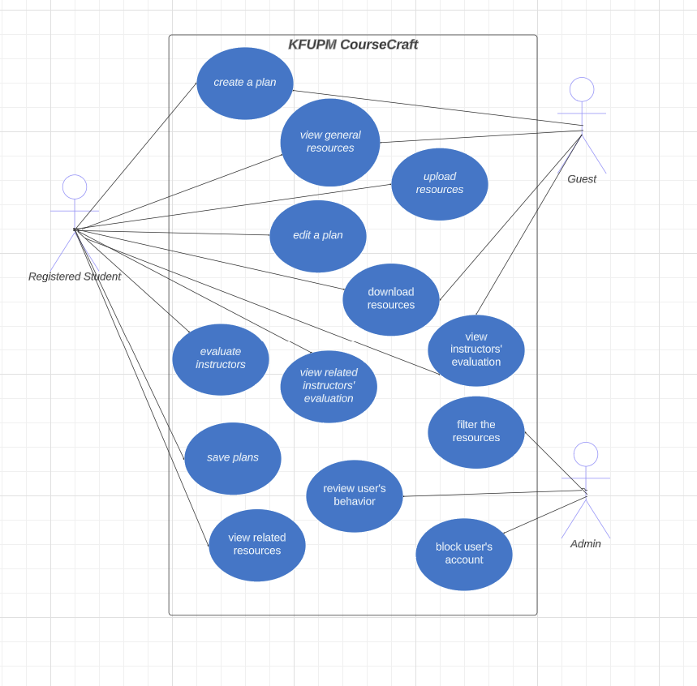

## *Use Cases*

Registered Students:

* + - 1. Create, Design, Edit, and Save Plans:

**Description**: Registered students are the primary users of the website. They have the capability to initiate, design, modify, and save their academic plans for future terms.

* + - 1. View, Download, and Upload Resources:

**Description**: Students can access, download, and contribute resources. These resources may be specific to the courses they are currently enrolled in or general educational materials relevant to their studies.

* + - 1. Evaluate and View Instructor Evaluations:

**Description**: Registered students have the privilege to assess their instructors based on their teaching performance. They can also view evaluations given by other students for their current or other instructors.

Admins:

1. Filter and Review Uploaded Resources:

**Description**: Admins have the responsibility to look over the resources uploaded by users. This ensures that only relevant and appropriate content is made available to the user community.

1. Review User Behaviour and Take Actions:

**Description**: Admins monitor the actions and behaviour of users on the platform. In cases where a user exhibits inappropriate behaviour, admins have the authority to take necessary actions, which might include warnings, suspensions, or other measures.

1. Maintain Integrity of Instructor Evaluations:

**Description**: Admins play a crucial role in ensuring that the evaluations provided for instructors are genuine and free from bias. This may involve reviewing evaluations, flagging suspicious activities, and taking corrective actions when needed.

Guests:

1. View Plans Without Saving:

**Description**: Guests, or non-registered users, can view and design academic plans, but they lack the capability to save these plans on the platform.

1. Limited Access to Resources:

**Description**: While guests can view certain educational resources, they cannot upload new resources to the platform.

1. No Instructor Review Privileges:

**Description**: Guests are not permitted to provide evaluations for instructors. They also do not have access to certain personalized resources that might be available to registered students based on their current courses.

# **Domain Modelling**

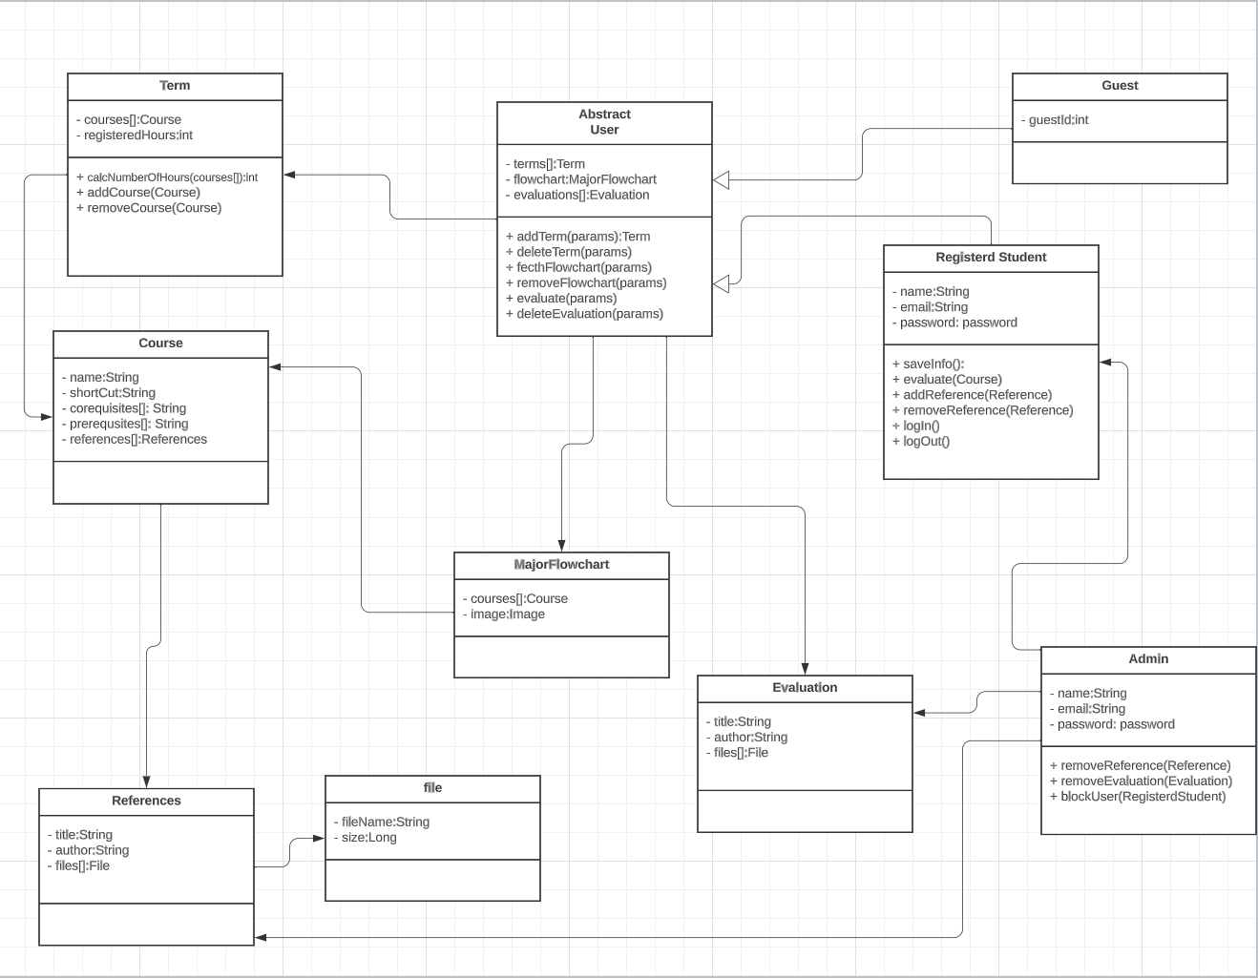

# **Navigation Modelling**

# **Low-Fi User Interface Design**

**Main Page:**

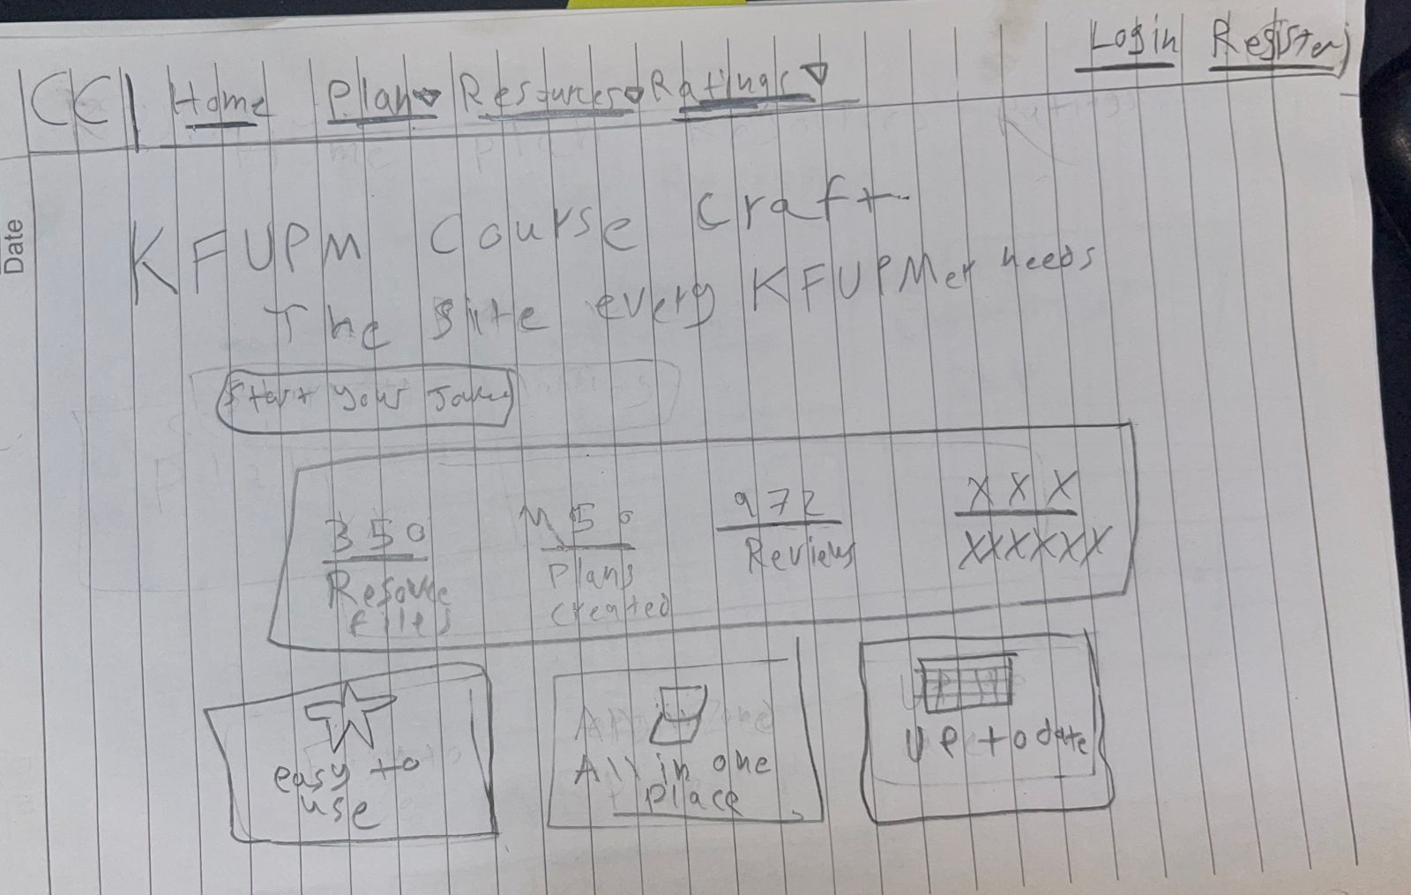

**Plan Page:**

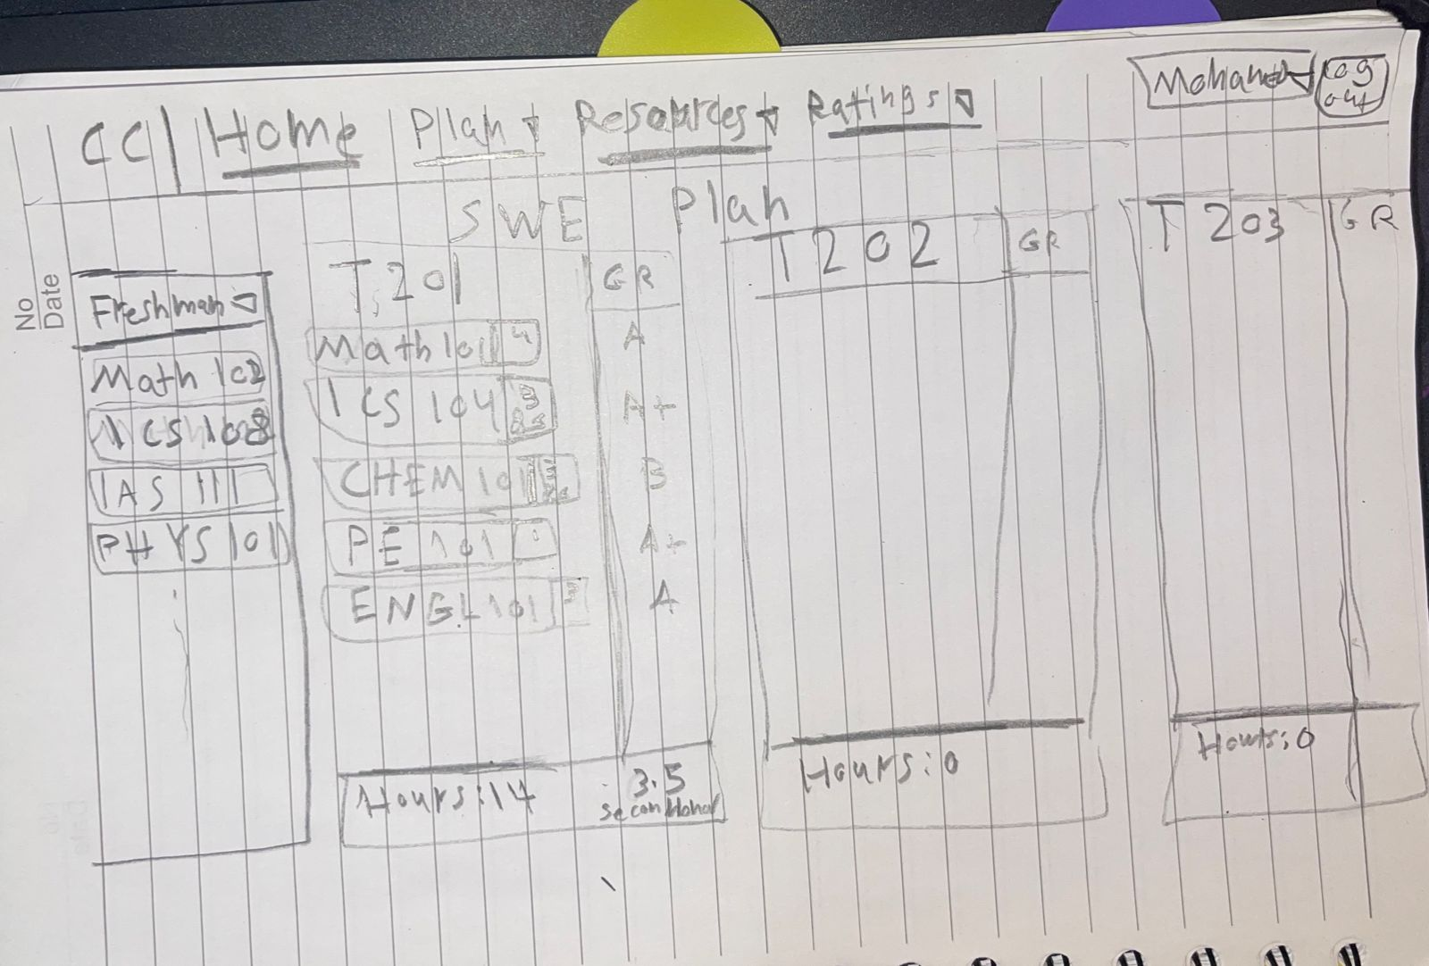

**Resources Page:**

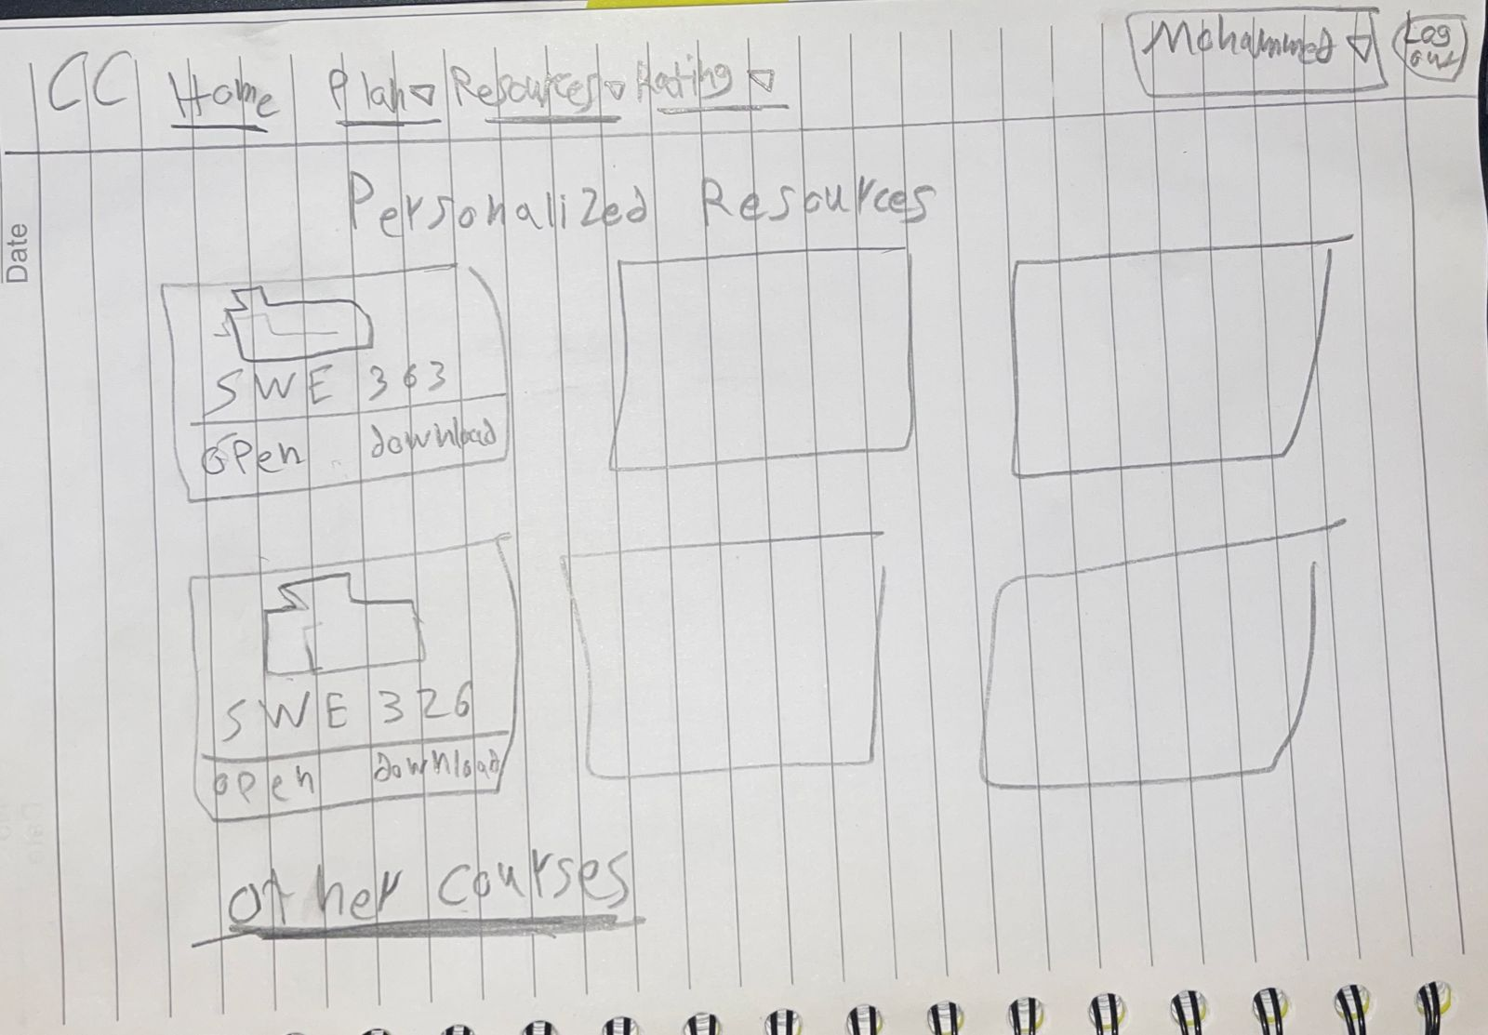

# **References and definitions**

This representing a milestone