

**CS383 Group Project**

**Software Design Document**

**) SDD )**

**A Text Chat messaging application**

**( Echo ) v1.0**

**Project for group 1 .**

*1 . Introduction*

1.1 Purpose --------------------------------------------------------------------------------------------------------------------------

1.2 Scope -----------------------------------------------------------------------------------------------------------------------------

1.3 Reference -----------------------------------------------------------------------------------------------------------------------

1.4 Document Structure --------------------------------------------------------------------------------------------------------

*2 . System Overview*

*3 . System Architecture and components*

3.1 Architecture Description --------------------------------------------------------------------------------------------------

3.2 Component Decomposition Description ------------------------------------------------------------------------------

3.3 Detail Component Description -------------------------------------------------------------------------------------------

3.4 Design Rationale -----------------------------------------------------------------------------------------------------------

*4 . Data Design*

4.1 Database Description --------------------------------------------------------------------------------------------------------

4.2 Data Structure -----------------------------------------------------------------------------------------------------------------

*5 . Design Details*

5.1 Class Diagram ------------------------------------------------------------------------------------------------------------------

5.2 Activity Diagram --------------------------------------------------------------------------------------------------------------

5.3 Sequence Diagram -----------------------------------------------------------------------------------------------------------

*6 . Human Interface Design*

6.1 Overview of the user interface *-----------------------------------------------------------------------------------------------------*

6.2 Detail Design of User Interface *-----------------------------------------------------------------------------------------------------*

*7 . Group Members Participation -----------------------------------------------------------------------*

**1 Introduction :**

This Software Design Document (SDD) outlines the design of Echo , a text-based chat application. Echo is designed to be a simple and user-friendly tool for people to communicate in real-time . The goal of Echo is to provide a fast and reliable messaging platform for users to connect with one another .

1.1 Purpose:

The purpose of this Software Design Document ( SDD ) is to provide a comprehensive and detailed description of the design of a specific software system , serving as a guide for implementation and testing .

1.2 Scope :

The scope of this Software Design Document ( SDD ) covers the design of a specific software system , including its architecture , component design , user interface design , interfaces, and data management design . This SDD serves as a comprehensive guide for implementation and testing, but does not include implementation details or low-level design decisions .

1.3 References :

SOFTWARE ENGINEERING by Ian Sommerville .

1.4 Document Structure :  
The structure of this Software Design Document ( SDD ) includes the following sections :

1- Introduction : Overview of the software system and purpose of the SDD .

2- SystemOverview: Description of the system's architecture and 3-high-level design decisions.

3-System Architecture Component design: Description of the high-level structure of the software system design of individual components.

4-Data Design : refers to the design of the data elements and data structures used in the software system

5- Design Details : detailed design specifications for the software system using diagrams and other methods , it helps to find all the requirements of the system .

6- Human Interface Design : provide a clear and detailed description of the user interface, including its look-and-feel, navigation structure, and functional elements .

7- Group Members Participation :work participations done by the group members

**2 System Overview :**

When the user enters Echo app , they will be presented with a login page where they can either log in with an existing account , or create a new account The main page will display a list of current conversations , sorted by the time of the most recent message .

Users can start a new conversation , view and participate in existing conversations , and delete any unwanted conversations . The design of the Echo app will be analyzed and explained, including the system architecture and data design , using diagrams such as sequence diagrams , class diagrams , and activity diagrams .

**3 System Architecture and components**

**3.1 Architecture Description :**

Echo's architectural description is as follows :  
1-User Interface : presenting the user with a clear and intuitive interface .

2-Media Handling : handling multimedia content such as images and videos and ensuring that content is handled correctly .

3-Data Storage : storing messages and user data .

4-Authentication and Authorization : authenticating users and controlling access to the system ( e.g . user registration ) .

5-Security: protecting the system and its users from potential security threats ( e.g . spam messages ) .

6-API : responsible for providing a programmatic interface for external applications .

**3.2 Component Decomposition Description :**

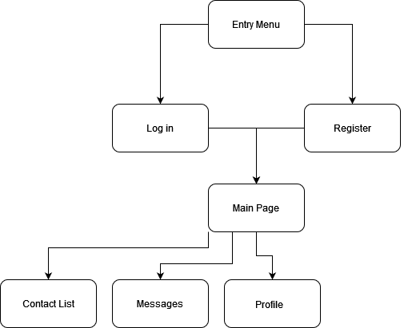

**3.3 Detail Component Description :**

Upon launching the software the entry menu will be the first thing a user will see . This menu is the starting point for the user , providing them with access to Logging into an existing account or Registring a new account . Login option would allow users to log in to their account , allowing them to send and receive messages . The login page would require the user to enter their E-mail and password, and would validate their credentials against the authentication and authorization component . Register option would allow users to create a new account , providing them with access to the messaging features of the software. The registration page would require the user to enter their E-mail and and password . The main page is the central hub for the user's interactions with the software , providing them with access to all key features, after logging in the user will be transferred to the main page where they have access to

1- Contact list .  
2- Messages .  
3- Settings .  
4- Personal profile .

Contact list : allows the user to manage their contacts, view their list of contacts and start conversations .

Messages : allows the user to send and receive messages with their contacts . the message view will display all of the user's conversation.

Settings : allows the user to configure the settings for the software , such as notifications , theme color and such .

Personal Porfile : allows the user to view and manage their personal profile such as their nickname , profile picture and such .

**3.4 Design Rationale :**

Echo was designed to address a specific problem , that problem is communicating things easily and quickly . by offering multi media messaging capabilities echo will provide users with a more versatile way to communicate with others . Echo is designed to be user-friendly and intuitive making it accessible to people accross all ages regardless of their technical abilities . the software is designed to work seamlessly accross multiple platforms and devices providing service to users accross all platforms and addressing the communication problem .

**4 Data Design**

**4.1 . Database Description**

Echo database will have five tables that contain information about user credentials , their conversation and contacts .

The user and conversation table share a unique ID which gives each user their own conversations , users can have multiple conversations , conversations can have one member ( private message ) or multiple members ( group message ) .

User table contains : user_id , name , password , email , phone number , profile_photo, status .

Conversation table contains : conversation_id, conversation_name.

Contact table contains : contact_id, name, email, phone number, profile_photo, status .

Message table contains : message_id, from_emailnumber, content, datetime, conversation_id .

Member table contains : contact_id, conversation_id, join_ datetime, leave_ datetime .

**4.2. Data Structure**

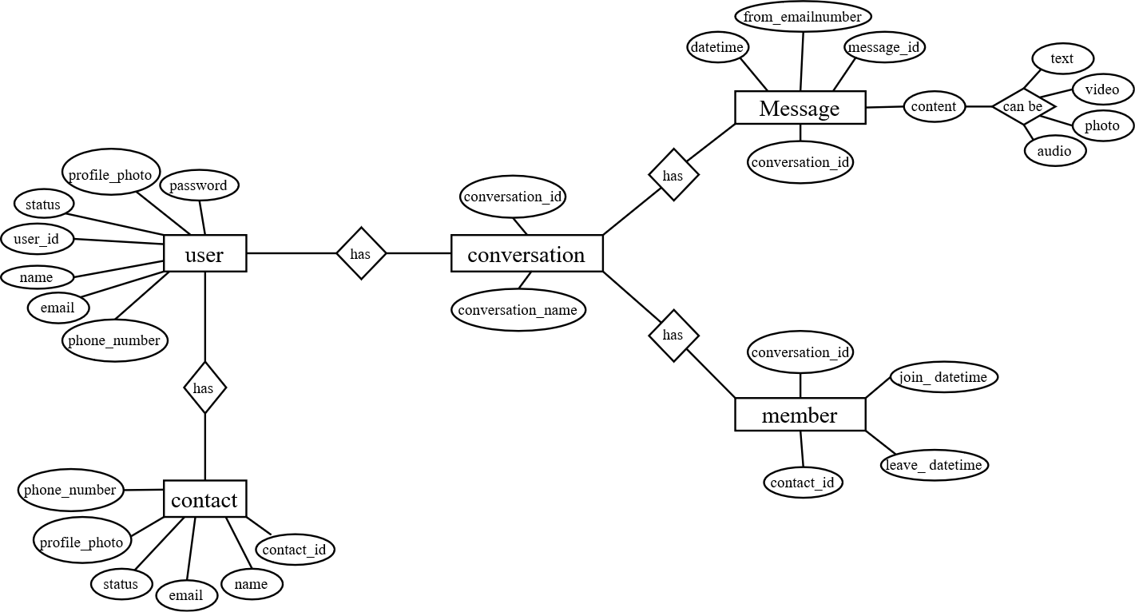

**5 Design Details**

**5.1 Class Diagram**

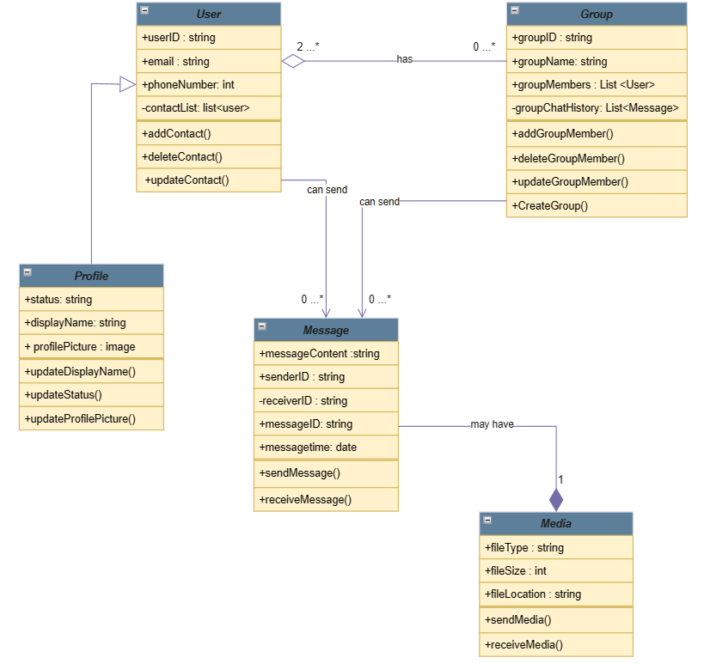

**5.2 Activity Diagram**

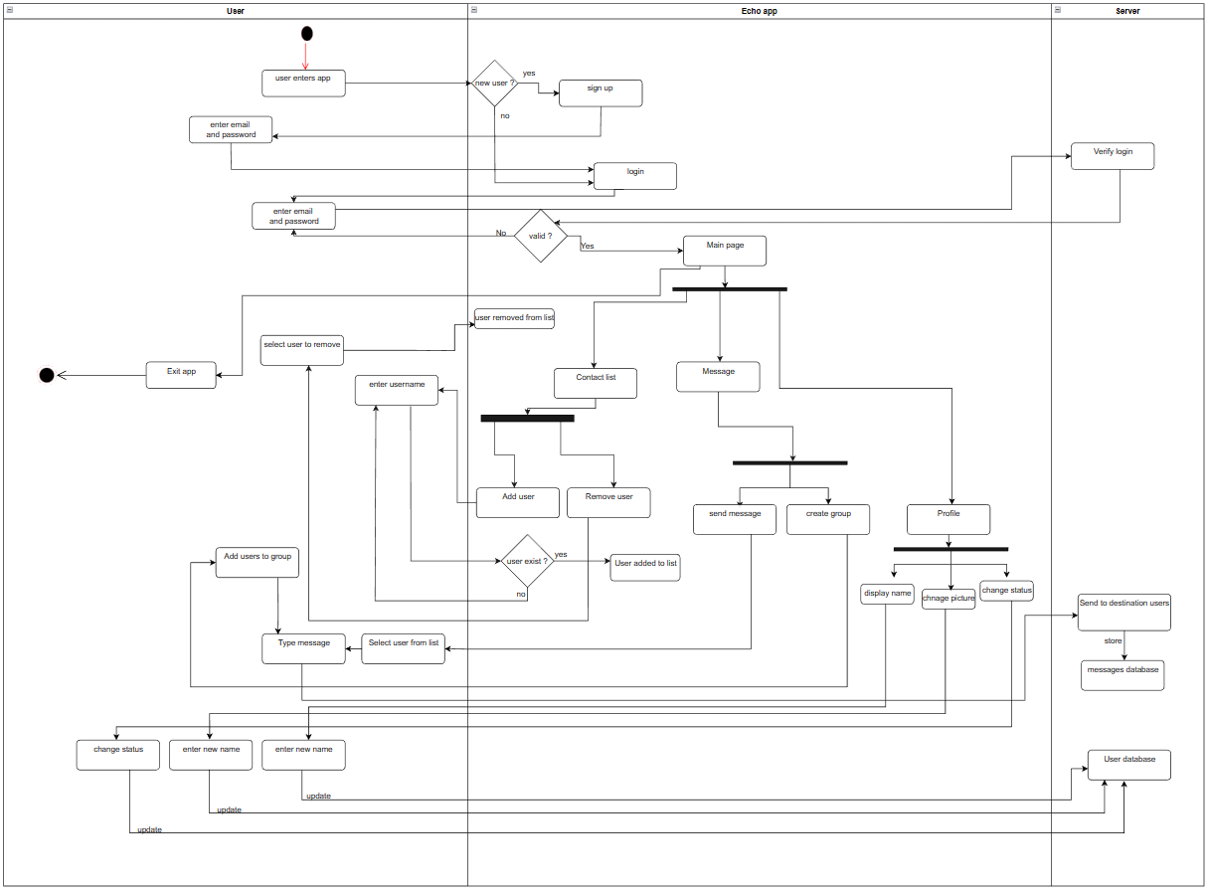

**5.3 Sequence Diagram**

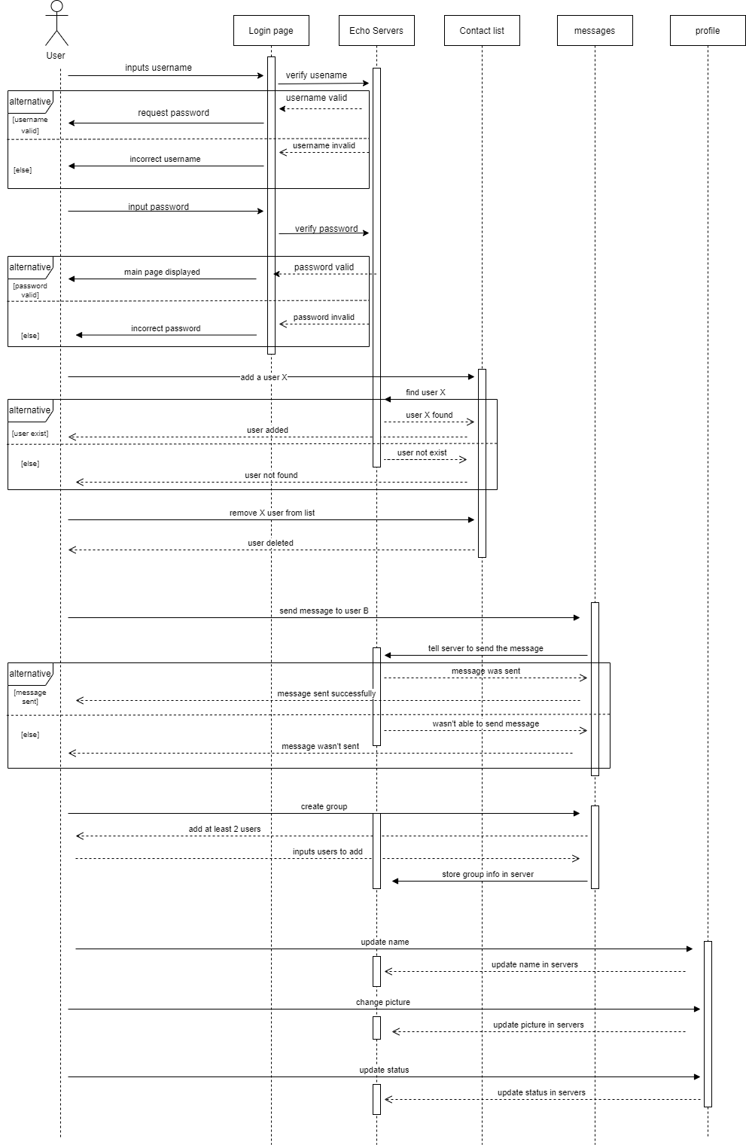

**6 Human Interface Design**

**6.1 . Overview of the User Interface**

In Echo , we provided 3 main functions :

One is to sign up for a new account and log in with an existing account . Login will provide a special verification code that the user should know it . The other is to send/receive messages from users/groups . Message type is either regular text or picture or video or audio . The last property is user profile . Echo user can customize its profile by Adding a nickname and a profile picture and a custom status .

## **6.2 . Detail design of the user interface**

## **6.2.1 . Login Screens**

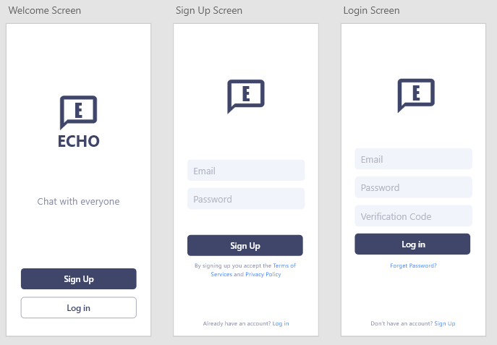

## **6.2.2 . Chat Screens**

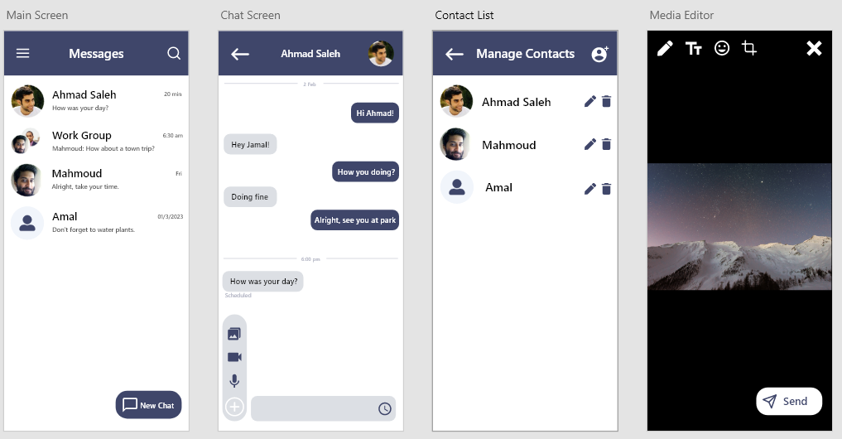

### **6.2.3 . Profile Screen**

### **6.2.4 . Screens Description**

In 6.2.1 , we see that we have login and sign-up screens . Users can either login or sign up . On Login Screen , the user must provide both Email Address , password , and verification code .

In 6.2.2 , we see that we have Main Screen , direct and group chats will be listed there . On Chat Screen , you can send a text or either image , video , or audio , also there is an option that you can schedule the message at any time . On Contact List Screen , you can manage your contacts ( or users ) by adding new contacts or editing current contacts or deleting any contact . On Media Editor Screen , you can edit any type of media and send it directly to the receiver .

In 6.2.3 , we see that we have Profile Screen , there you can change the nickname and set a profile picture and a custom status .

**7 .** **Group Members Participation**

|  |  |
| --- | --- |
| **Student Name** | **Work on document** |
| **ناصر العواجي** | **Introduction** |
| **ناصر العواجي** | **System Overview** |
| **حمد المعارك** | **System Architecture and components** |
| **عمار الزين** | **Data Design** |
| **محمد الرشود** | **Design Details** |
| **عبدالعزيز السحيباني** | **Human Interface Design** |