

**CS383 Group Project**

**Software Requirements Specification**

**) SRS )**

**A Text Chat messaging application**

**( Echo ) v1.0**

**Project for group 1 .**

*1 . Introduction*

1.1 Purpose --------------------------------------------------------------------------------------------------------------------------

1.2 Scope -----------------------------------------------------------------------------------------------------------------------------

1.3 Reference -----------------------------------------------------------------------------------------------------------------------

1.4 Document Structure --------------------------------------------------------------------------------------------------------

*2 . System Overview*

2.1 Product perspective ----------------------------------------------------------------------------------------------------------

2.2 Product Features --------------------------------------------------------------------------------------------------------------

2.3 User Classes and Characteristics ------------------------------------------------------------------------------------------

2.4 Design and Implementation Constraints --------------------------------------------------------------------------------

*3 . UML Use Case diagram*

*4 . System Features*

3.1 Main system features(functional) -----------------------------------------------------------------------------------------

*5 . External Interface Requirements*

4.1 User interface ------------------------------------------------------------------------------------------------------------------

4.2 Hardware interface -----------------------------------------------------------------------------------------------------------

4.3 Software interface ------------------------------------------------------------------------------------------------------------

4 .4 Communication interface --------------------------------------------------------------------------------------------------

*6 . Non Functional Requirements*

5.1 Performance Requirements *-------------------------------------------------------------------------------------------------*

5.2 Safety Requirements *----------------------------------------------------------------------------------------------------------*

5.3 Security Requirements *-------------------------------------------------------------------------------------------------------*

5.4 Software Quality Requirements *-------------------------------------------------------------------------------------------*

*7 . Group Members Participation -----------------------------------------------------------------------*

**1 Introduction :**

Echo is a software that allows its users to send and recieve multimedia messages, such as text , images , audio and video files , seamlessly and easily . It is designed to make messaging more interactive and fun by allowing users to express themselves through various forms of media .

1.1 Purpose:

This document describes the software requirements and specification ( SRS ) of Echo ,

An online messaging application that allows it’s user to send messages and chat with each other .

1.2 Scope :

The scope of Echo will cover the core functionality of sending and receiving text and multimedia messages, as well as additional features such as group messaging, integration with other communication platforms and services, and customizability options for the user interface .

1.3 References :

SOFTWARE ENGINEERING by Ian Sommerville

Learning PHP, MySQL & JavaScript , 5th Edition by O'Reilly

1.4 Document Structure :  
**Introduction** : This section provides an overview of the project and the purpose of the SRS document. It includes a brief summary of the system's objective

**System Overview** : This section provides a high-level description of the system, including its main components

**System Features** : This section describes the specific features and capabilities that the system should have. It includes detailed descriptions of the system's functionality , the system cannot function without them

**Use Case** : This section draws the Use case diagram of echo , Use-case diagrams helps in describing the requirements for our system by modeling its functionality in a graphical form .

**External Interface Requirements** : This section describes the system's interactions with other systems or external entities. It includes information about the system's , as well as any communication protocols or interfaces that it uses

**Non-functional Requirements :** This section describes the system's performance , quality , and reliability characteristics . It includes information about the system's behavior and characteristics such as response time , security and usability

**Group Members Participation :** work participations done by the group members

**2 System Overview :**

2.1 Product perspective :

The Text Chat messaging Application Echp enables real-time text-based communication between users . It is intended to offer a simple , intuitive interface that is simple to use and navigate . The Text Chat application “ Echo ” needs to be a dependable and effective communication tool for both personal and small business use .

2.2 Product Features :

The Text Chat application allows users to perform several key features to communicate efficiently :

Account creation and sign-in :

Echo users will need to sign up to the application using their personal information such as their password , and email address. They can log in to the application with their credentials after creating an account .

Sending and receiving messages :

After creating an account , users will be able to communicate with each other using text messages . This is the main and most important feature of our application

Creating and communicating in group chats :

Users can create and take part in group chats with a variety of other users . this feature will be helpful For group conversations or team and business related chatting .

Media file sharing :

Users can send to other contacts media items like photos and videos . Users can share visual content with others using this feature .

Managing contacts :

Users will have the ability to view and manage their contacts , including the ability to add and remove users . Additionally , users can see a contact's availability and status .

End-to-end encryption :

The application needs to provides end-to-end encryption for Private messaging , which guarantees that only the intended recipients can read the message .

2.3 User Classes and Characteristics :

The Text Chat application is meant for all ages and may be used for both personal and professional purposes . Users will consist of general public users and small enterprises .

2.4 Design and Implementation Constraints :

The application will be devolved for smart phone operating systems and browsers .

The application will be created with security in mind to make sure user information is protected and kept private .

The application should be able to perform even on end systems with poor internet connectivity

The application should support at least Arabic and English languages .

2.5 Assumptions and Dependencies :

assumptions and dependencies are necessary for the Echo application to function properly and provide a comprehensive messaging service :

1. Internet connection : Users of the application are assumed to have a reliable internet connection in order to use its features . The application will not be able to send or receive messages without an internet connection .
2. Device permissions : Users of the application will be required to give access for their device's camera and microphone and photo album for media sharing , also they will be required to give access for the contacts on their device for contacting and messaging said contacts .
3. Valid user account : Users of the echo application will be required to give a valid email , phone number and credentials to be able to use the application’s functionality and features .

**3 UML Use case diagram :**

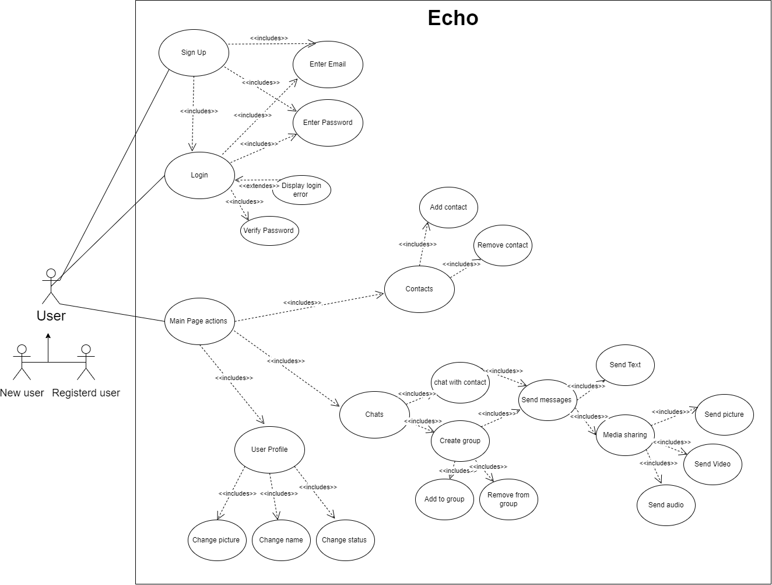

**4 System features (functional):**

3.1 Main system features :

1. **Sending and Receiving Messages:**

Echo will give users the ability to send and receive many types of messages , including texts, images , audio , and videos with many different extensions. Also, Echo users can schedule the time of sending their message to send it later .

1. **User Account:**

Echo will make people create their own accounts using their E-Mail addresses. An Echo account will have a password that makes account data private to the account owner . Echo will also include two-factor authentication to make the login process secure .

1. **Customized Profile:**

In Echo, users will be able to customize their profile with a nickname, profile picture, and custom status . Custom status can be any description or some existing status (like active , busy , offline… etc.)

1. **Group Chats:**

Echo will provide group channels to make many users communicate with each other in one place . The group will include an administrator role who can manage users and chats . Also, every group has an invite link that can be shared through any user .

1. **Media sharing**

Echo users can send and receive any type of media (audio, images, video) Also, Echo will be included with a media editor that gives users the ability to edit any media before sending it to other users .

1. **Reporting system**

Echo users can report other users for sending inappreciable content. The report will be sent to Echo developers and then the opposing user will get a permanent ban

1. **Security system**

Echo will be built with a compatible security system . It will encrypt user-sensitive content, and all messages will be encrypted using end-to-end encryption. Passwords will be stored in an advanced hash form to improve account protection .

**5 External Interface Requirements :**

4.1 User interface : About Graphical User Interface ( GUI ) we will focus in UX \ UI and try to make it easier to use and interact the software can be accessed vie mobile application or computer or browser . The GUI it will be use good programming tools that gives good resolution , good response , good consistent for all devices.

4 .2 Hardware interface : Mobile devices , computer, servers and internet connection to send and receive messages .

4 .3 Software interface: Operating systems ( OS ) the software will support all operating systems devices and versions of Windows and mac OS including 64-bit / 32-bit and apple and android OS for mobiles to make the application compatible with any software . Browser : in case using the software in a specific browser it must be keep it up to date . Database : well deal with MySQL since it is reliable and has some data security , high performance and flexibility of open source .

4.4 Communication interface : This software will be supporting any kind of update in OS . We will use some simple smarts tools that will help us to design and implementing app functionality . and we must deal with : 1 - communication standards and network server communication protocols like HTTP , HTTPS and FTP . 2 - electronic forms for example , HTML Forms to get feedback and data from the user . 3 - Message formatting for example , Audio , image , or video-based .

**6 Non-functional Requirements**

5.1 Performance Requirements:

The system must respond to user requests within a minimal and reasonable time .

The system must be able to handle at the very least 100,000 concurrent users .

The system must be available 99% of the time .

5.2 Safety Requirements:

If a user tries to send an email they will get warned about the potential risks of sharing sensitive information and will be prompted to verify that they understand and accept the risks before sending that email.

To be able to directly message other users you must either share a group with them or have them added to your contact list.

To add other users, you must input a newly generated string that consists of 10 characters given to you by the other user,minmizing the chance of being added randomly by an unknown user

To be able to directly message other users you must either share a group with them or have them added to your contacts.

Users that share a group are able to send an invite request to other users from the same group without the need to generate a new invite request.

The app has an anti-flooding feature that monitors the number of messages sent by a user within a certain time frame, and if it detects an excessive number of messages, it could take actions such as slowing down or blocking the user's ability to send messages for a set amount of time

5.3 Security Requirements :

Ensuring safe storage of user passwords :

the server will store the password in hashed form as opposed to plain text. Once the password is hashed, the plaintext password is discarded and the hashed password is stored in the server's database. When a user attempts to log in, the server takes the plaintext password entered by the user, hashes it, and compares the resulting hashed value to the one stored in the database. If the two hashed values match , the server grants the user access

5.4 Software Quality Attributes :

the ease with which users can learn, navigate and use the system. the app is intuitive and easy to navigate .

**7 .****Group Members Participation**

|  |  |
| --- | --- |
| **Student Name** | **Work on document** |
| **حمد المعارك** | **Introduction** |
| **محمد الرشود** | **System Overview** |
| **محمد الرشود** | **Use Case Diagram** |
| **عبدالعزيز السحيباني** | **System Features** |
| **وائل المقبل** | **External Interface Requirements** |
| **حمد المعارك** | **Non Functional Requirements** |