[

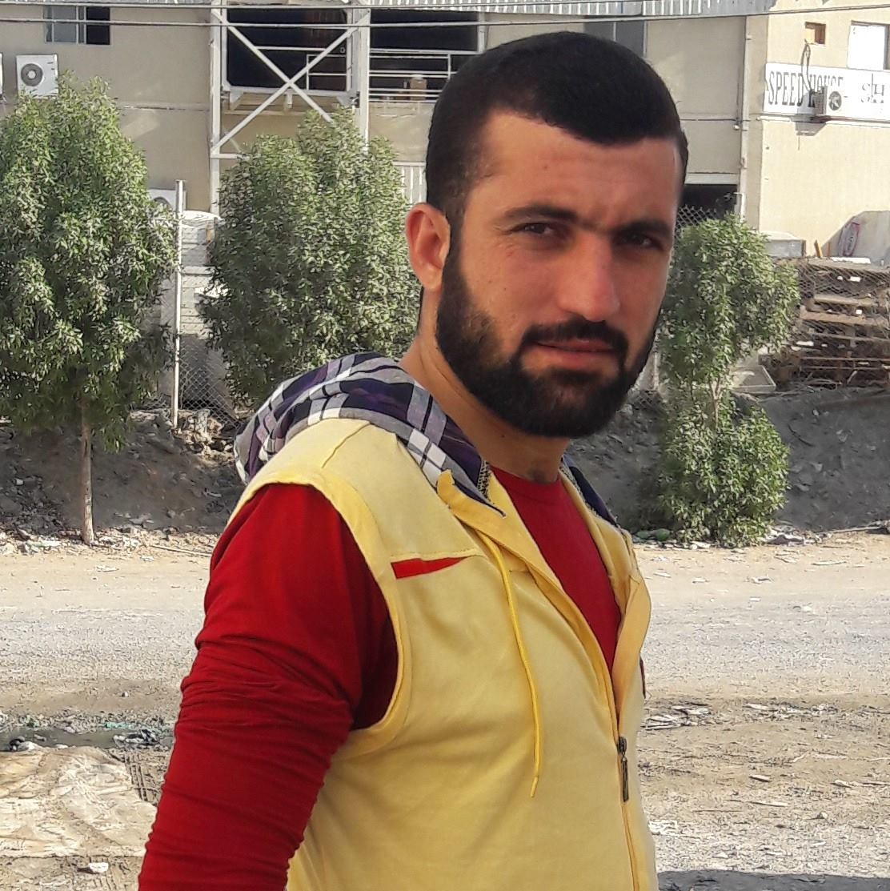

PERSONAL INFORMATION

Father Name:
Muhammad Zaman

Marital Status
Married

Date of Birth
14-04-1991

LANGUAGE

- English
- Arabic
- Urdu
- Pashto

REFERENCE
Hamayoun khan

Curriculum Vitae

Curriculum Vitae

Muhammad Usman
Contact # 0547902216
CNIC: 2490823388
License Cat: (Heavy Transport Saudi Arabia License no:2490823388)
License Cat: (LTV Dubai License No:3482556)

Summary
Qualified and experienced Bulldozer Operator, Dump Truck Driver, Mixture with a strong record of employer satisfaction. Mindful of safety punctuality and efficiency. Mechanical expert adept at troubleshooting minor truck operation problems
ACADEMIC QUALIFICATION

- Matric from Board of Secondary Education Kohat (2007).
- DAE(Diploama of Electrical & Engineering)-2010

COMPUTER SKILLS

- Basic Computer Knowledge
- Internet
.
WORKING EXPEREINCE
Bulldozer Operator (2011-2013 Kohat Cement Factory Pakistan).
Job Responsibilities
- Knowledge of uses, limitations and operations of a bulldozer.
- Ability to read maps, interpret manuals, catalogs, related to work.
- Capability of working independently under minimum supervision.
- Operate the bulldozer and work on-site to scrap land and clear grounds for construction.
- Load and unload construction materials and transport them to dumping areas.
- Perform other tasks as instructed by seniors from time to time.
Dump Truck Driver (2013-2015 Kohat Cement Factory Pakistan).
Job Responsibilities
- Drove truck equipped with dump body to transport and dump loose materials, such as sand, gravel, crushed rock
- Performed daily cleaning of vehicle and equipment.
- Shifting load material into the dump truck by handling a team of 5 laborers
- Transported several tons of waste to landfills; maneuvered trucks on uneven ground..
- Load and unload equipment or materials
- Managed steam cleaning and washed a wide range of parts and equipment.
- Loaded and unloads small and large parts and packages.
- performed routine cleaning and maintenance of facility.
- Locate and label parts and maintain inventory of stock.
- Routine maintenance, such as change oil, check batteries and repair defective equipment.
- Performs oil changes and lubes Trucks,heavy equipment(valvo,cutterpiller).
Transit Mixture Driver (2015-2017 Discon Company Pakistan).
Job Responsibilities
- Loaded and Unloaded
- Ensured concrete product quality to best of ability
- Maintained exterior and interior cleanliness of mixer truck.
- Handle the task of positioning the truck and driving it to the assigned destinations in a safe manner
- Perform the responsibility of coordinating with the plant manager in receiving and dispatching materials
- Handle the responsibility of verifying loaded materials and performing the unloading of materials
- Shouldered the responsibility of maintaining the truck in a clean and safe operating condition
Driver(heavy vechicle 2019- Till now in Soudi Arabia).
Loaded and Unloaded Raw Materials From Curie.

