Bug Report – API Test Failures
Project: REST API | Total Failures: 5 | Date: April 16, 2026

Bug #1: TC-UR-PATCH-007 — Update with Wrong Data Type for 'firstName' Field
Field | Details
Test Case ID | TC-UR-PATCH-007
Bug ID | BUG-UR-PATCH-007
Title | Update with Wrong Data Type for 'firstName' Field
Module | User Profile – PATCH /users/me
Severity | High
Priority | High
Preconditions | User is logged in. Valid Bearer Token is available.
Endpoint | PATCH /users/me
Method | PATCH
Request Body | { "firstName": 122 }
Expected Result | Status Code: 400 Bad Request Response body: { error: "invalid data type" }
Actual Result | Status Code: 200 OK Response body: { _id, firstName, lastName } — server accepted integer as firstName without validation.
Status | FAIL
Steps to Reproduce | 1. Authenticate and obtain a valid Bearer Token. 2. Send PATCH /users/me with body: { "firstName": 122 } 3. Observe the response.
Suggested Fix | Add input validation on the firstName field to reject non-string values and return 400 with a descriptive error message.
Screenshot 1 (Test Results) | 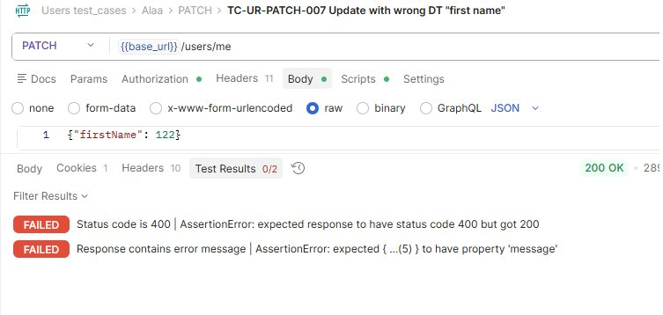
Screenshot 2 (Response Body) | 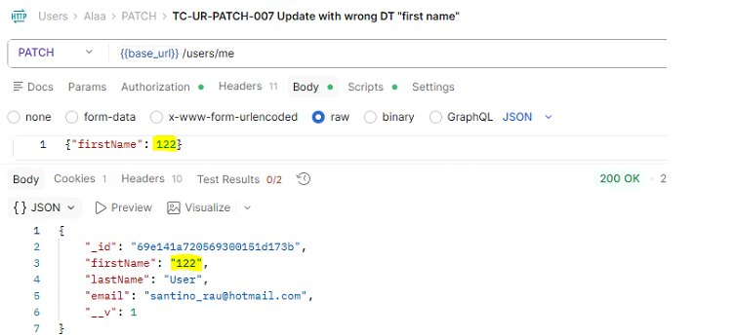

Bug #2: TC-UR-PATCH-008 — Update with Wrong Data Type for 'lastName' Field
Field | Details
Test Case ID | TC-UR-PATCH-008
Bug ID | BUG-UR-PATCH-008
Title | Update with Wrong Data Type for 'lastName' Field
Module | User Profile – PATCH /users/me
Severity | High
Priority | High
Preconditions | User is logged in. Valid Bearer Token is available.
Endpoint | PATCH /users/me
Method | PATCH
Request Body | { "lastName": 2.9 }
Expected Result | Status Code: 400 Bad Request Response body: { error: "invalid data type" }
Actual Result | Status Code: 200 OK Response body: { _id, firstName, lastName } — server accepted float as lastName without validation.
Status | FAIL
Steps to Reproduce | 1. Authenticate and obtain a valid Bearer Token. 2. Send PATCH /users/me with body: { "lastName": 2.9 } 3. Observe the response.
Suggested Fix | Add input validation on the lastName field to reject non-string values and return 400 with a descriptive error message.
Screenshot 1 (Test Results) | 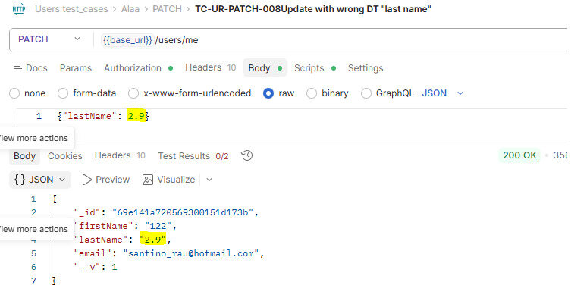
Screenshot 2 (Response Body) | 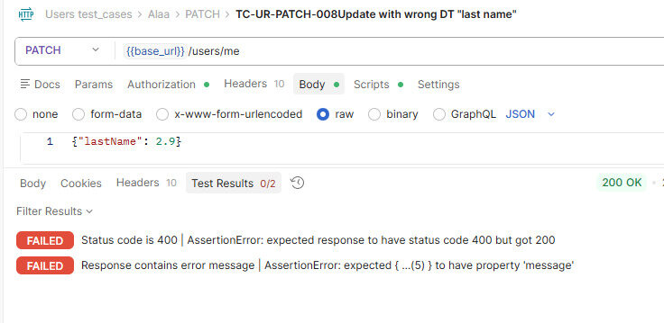

Bug #3: TC-CON-DEL-003 — Delete Contact with Oversized / Non-Existent Fake ID
Field | Details
Test Case ID | TC-CON-DEL-003
Bug ID | BUG-CON-DEL-003
Title | Delete Contact with Oversized / Non-Existent Fake ID
Module | Contacts – DELETE /contacts/:id
Severity | High
Priority | High
Preconditions | Valid Bearer Token is set. fakeId = "6085a221fcfc7240566700003432434234324234234" (too long to be a valid ObjectId).
Endpoint | DELETE /contacts/{{fakeId}}
Method | DELETE
Request Body | None
Expected Result | Status Code: 400 Bad Request Response body: Error message indicating the path value (ID) is not valid.
Actual Result | Status Code: 500 Internal Server Error Response body: error message pointing to path value being invalid — server crashes instead of gracefully rejecting the request.
Status | FAIL
Steps to Reproduce | 1. Set fakeId = "6085a221fcfc7240566700003432434234324234234". 2. Send DELETE /contacts/{{fakeId}} with a valid Bearer Token. 3. Observe the response.
Suggested Fix | Validate the contact ID format before hitting the database. Return 400 Bad Request for malformed or oversized IDs instead of propagating the error as a 500.
Screenshot 1 (Test Results) | 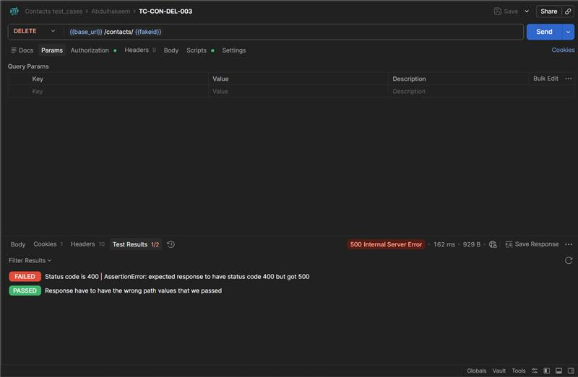
Screenshot 2 (Response Body) | 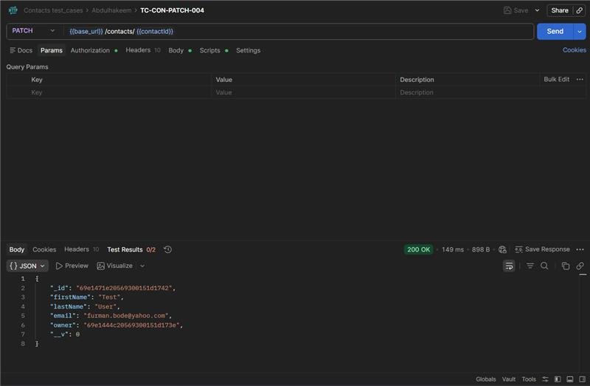

Bug #4: TC-CON-PATCH-004 — Patch Contact with Empty JSON Body
Field | Details
Test Case ID | TC-CON-PATCH - 004
Bug ID | BUG-CON-PATCH - 004
Title | Patch Contact with Empty JSON Body
Module | Contacts – PATCH /contacts/:id
Severity | Medium
Priority | Medium
Preconditions | Valid Bearer Token. A dummy contact exists; contactId is set via POST /contacts.
Endpoint | PATCH /contacts/{{contactId}}
Method | PATCH
Request Body | {}
Expected Result | Status Code: 400 Bad Request Response body: Error message indicating the request body is empty or contains no updateable fields.
Actual Result | Status Code: 200 OK Response body: Returns the unchanged contact — server accepts empty body as a valid update with no error.
Status | FAIL
Steps to Reproduce | 1. Create a dummy contact via POST /contacts; capture contactId. 2. Send PATCH /contacts/{{contactId}} with an empty JSON body {}. 3. Observe the response.
Suggested Fix | Add server-side validation to detect empty or no-op request bodies and return 400 with a message such as "Request body must contain at least one field to update."
Screenshot 1 (Test Results) | 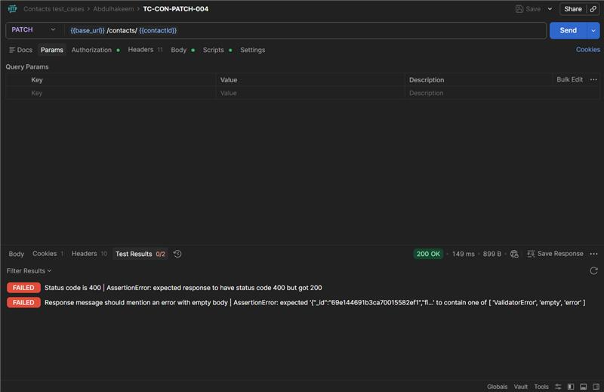
Screenshot 2 (Response Body) | 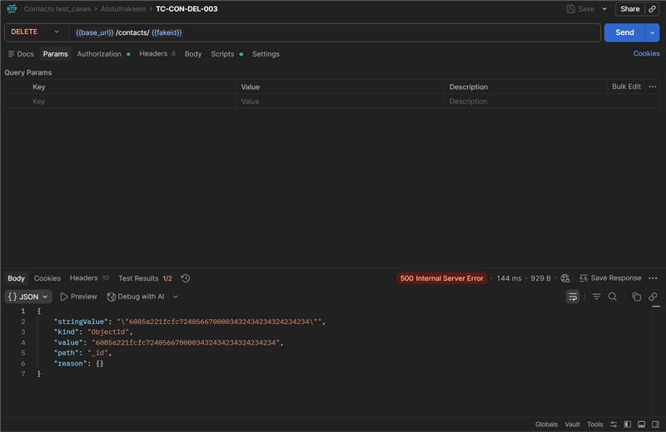

Bug #5: TC-CON-GET-005 — GET Contacts with Non-Existent / Malformed contactId
Field | Details
Test Case ID | TC-CON-GET-005
Bug ID | BUG-CON-05
Title | GET Contacts with Non-Existent / Malformed contactId
Module | Contacts – GET /contacts
Severity | High
Priority | High
Preconditions | User is authenticated. Token is set. contactId is set to an invalid value: 000000000000000000.
Endpoint | GET /contacts?{{contactId}}=000000000000000000
Method | GET
Request Body | None
Expected Result | Status Code: 404 Not Found Response body: Error message indicating the contact was not found.
Actual Result | Status Code: 200 OK Response body: Returns the full contacts list — API ignores the invalid ID and returns all contacts. Test scripts also failed.
Status | FAIL
Steps to Reproduce | 1. Set contactId = 000000000000000000 (invalid/non-existent value). 2. Send GET /contacts?{{contactId}}=000000000000000000 with a valid Bearer Token. 3. Observe the response.
Suggested Fix | Validate the contactId query parameter. If provided, verify it is a valid ObjectId and return 404 if the contact does not exist. Do not silently fall back to returning all contacts.
Screenshot 1 (Test Results) | 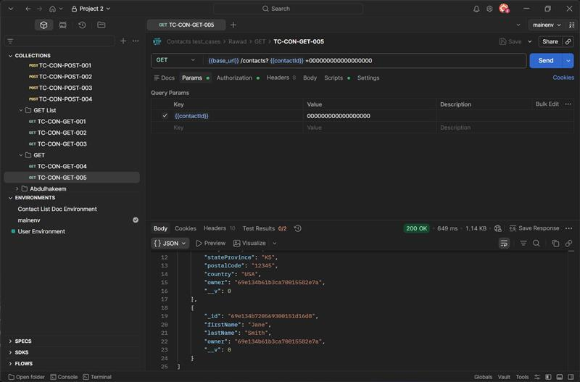
Screenshot 2 (Response Body) | 