Bug Report
Feature: Cryptocurrency Converter Calculator (Workflow WF2 — Converter)
Page under test: /converter
Date: 5 June 2026
Test suite reference: coinmarketcap_test_cases_WF2 — Converter

Summary
Three test cases failed during execution of the Converter test suite. Two of them (zero amount and negative amount) cause the converter to hang in a permanent loading-spinner state, so no result is ever returned. The third (a leading-plus input of “++5”) is accepted into the field but is neither sanitised nor rejected; the result silently stays on the default value instead of recalculating. The failures are summarised below and described in detail in the following sections.
Bug ID | Test Case | Title | Severity | Priority
BUG-001 | TC_CC_08 | Converter hangs on a loading spinner when amount is 0 | Minor | High
BUG-002 | TC_CC_09 | Converter hangs on a loading spinner when amount is negative (-1) | Minor | Medium
BUG-003 | TC_CC_12 | Leading “++” input is not sanitised; result stays on default value | Minor | Low

BUG-001 — Converter hangs on a loading spinner when the amount is 0
Related test case | TC_CC_08 — Enter zero amount
Severity | Minor
Priority | High
Status | FAIL
Environment | Converter page (/converter), default desktop browser
Preconditions | The Converter page is open and loaded.
Test data | From = BTC, To = USD, Amount = 0

Steps to reproduce
- Open the Converter page (/converter).
- Set the “From” currency to Bitcoin (BTC).
- Set the “To” currency to United States Dollar (USD).
- Enter 0 in the amount field.
- Observe the result area.

Expected result
The converted result is displayed as 0 (or the zero amount is otherwise handled gracefully) with no error and no hanging state.

Actual result
The converter does not return a value. The result area shows a loading spinner that never resolves; the converter is stuck in an infinite loading-animation loop.

Screenshot
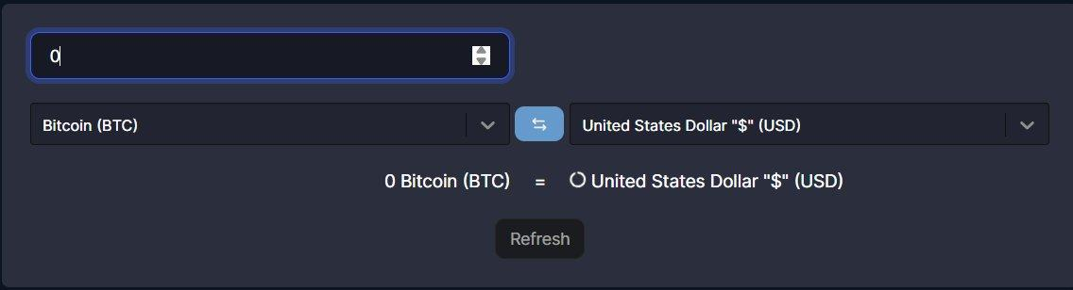

BUG-002 — Converter hangs on a loading spinner when the amount is negative
Related test case | TC_CC_09 — Enter a negative amount
Severity | Minor
Priority | Medium
Status | FAIL
Environment | Converter page (/converter), default desktop browser
Preconditions | The Converter page is open and loaded.
Test data | From = BTC, To = USD, Amount = -1

Steps to reproduce
- Open the Converter page (/converter).
- Set the “From” currency to Bitcoin (BTC).
- Set the “To” currency to United States Dollar (USD).
- Enter -1 in the amount field.
- Observe the result area.

Expected result
The negative value is rejected / not accepted, or no result is produced; handled gracefully with a clear state and no hang.

Actual result
The negative value is accepted into the field, but the converter does not return a result. The result area shows a loading spinner that never resolves; the converter is stuck in an infinite loading-animation loop.

Screenshot


BUG-003 — Leading “++” input is not handled; result stays on the default value
Related test case | TC_CC_12 — Enter two plus signs before the number
Severity | Minor
Priority | Low
Status | FAIL
Environment | Converter page (/converter), default desktop browser
Preconditions | The Converter page is open and loaded.
Test data | From = BTC, To = XAU (Gold Troy Ounce), Amount = ++5

Steps to reproduce
- Open the Converter page (/converter).
- Set the “From” currency to Bitcoin (BTC).
- Enter 1 in the amount field (default conversion is shown).
- Clear the amount field.
- Enter ++5 in the amount field.
- Observe the displayed result.

Expected result
The converter should ignore the extra leading plus sign(s) and calculate the conversion for an amount of 5 (i.e. treat “++5” as 5), or otherwise reject the malformed input.

Actual result
The field accepts the text “++5”, but the result does not update to reflect 5. The displayed conversion remains stuck on the default value of 1, so the input is neither parsed nor rejected.

Screenshot
