Project Documentation Report

* Project Title: Dockerized Python URL Parser
* Prepared by: Abdulharis Shaikh
* Technology Stack: Python, Docker
* Date: 27-06-2025

# 1. Introduction

This project demonstrates how to containerize a simple Python script using Docker. The script processes a hardcoded URL and prints its components such as scheme, domain, path, port number, and parameters. It is designed as a beginner-level DevOps exercise to strengthen core Docker concepts.

# 2. Objectives

The key objectives of this project are:

* Understand the structure and purpose of a Dockerfile.
* Learn how to build and run Python-based Docker containers.
* Apply containerization to basic Python automation tasks.
* Develop foundational skills for DevOps and cloud environments.

# 3. Tools and Technologies Used

Below are the tools and technologies used in this project:

|  |  |
| --- | --- |
| Tool/Technology | Purpose |
| Python 3.12 | Core scripting language |
| Docker | Containerization |
| Docker CLI | Build and run containers |
| VS Code / Notepad | Code and Dockerfile editing |
| Command Prompt | Running Docker commands |

# 4. Project Flow

Step-by-step workflow:

1. Create a Python script named 'url.py' to parse URLs using urllib.
2. Write a Dockerfile using Python 3.12 slim image.

3. Build the Docker image using:



4. Run the container using:



5. The container prints the components of the URL in the terminal.

# 5. Output

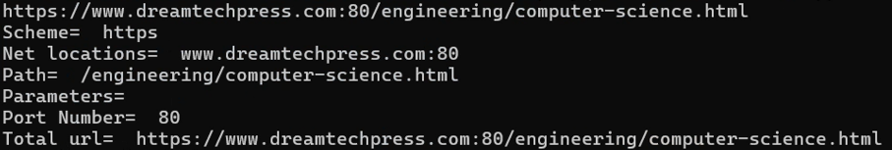

# 6. Learning Outcomes

Through this project, the following learning goals were achieved:

* Hands-on experience with Docker CLI and image building.
* Clear understanding of Dockerfile structure.
* Troubleshooting common issues inside containers.
* Practice of Python script execution in a containerized environment.

# 7. Future Scope

Potential future enhancements for this project:

* Accept dynamic URLs as user input.
* Extend to multiple URL parsing scripts.
* Push the Docker image to Docker Hub.
* Integrate into CI/CD pipeline using Jenkins.

# 8. Author & Acknowledgments

Author: Abdulharis Shaikh

DevOps Enthusiast & Cloud Learner

India | Python | Docker | Engineering Student

# 9. License

This project is licensed under the MIT License. Feel free to use and contribute.