**Face recognition Attendance system With Anti-spoofing Detection**

**By**

**Shaikh Fatima  
Qureshi Abdul Kader  
Morkas Ebrahim  
Shaikh Mohammed Ibrahim**

**M.H. Saboo Siddik College of Engineering**  
**Affiliated with Mumbai University**

**Bachelor of Engineering in Information Technology**

**Abstract**

In this project, we are developing a Face Recognition Attendance System that utilizes advanced computer vision techniques to automate the process of taking attendance in educational and corporate settings. The system captures and recognizes the faces of individuals to mark their presence, ensuring accuracy and efficiency.

To enhance security and prevent fraudulent attendance, we are implementing anti-spoofing detection measures. This feature distinguishes between real faces and spoofing attempts, such as photos or videos, thereby ensuring the integrity of the attendance records.

The system aims to provide a reliable and user-friendly solution for attendance management, integrating face recognition technology with robust anti-spoofing capabilities. The final product promises to enhance the efficiency of attendance management, reduce administrative workload, and provide accurate records while maintaining user privacy.

**Acknowledgement**

**List of Figures**

|  |  |  |
| --- | --- | --- |
| **Sr no** | **Title** | **Page no** |
| 1 |  | 1 |
| 2 |  |  |
| 3 |  |  |
| 4 |  |  |
| 5 |  |  |
| 6 |  |  |
| 7 |  |  |
| 8 |  |  |
| 9 |  |  |
| 10 |  |  |
| 11 |  |  |
| 12 |  |  |
| 13 |  |  |
| 14 |  |  |

**List of Table**

|  |  |  |
| --- | --- | --- |
| **Sr no** | **Title** | **Page no** |
| 1 | Literature Review |  |
| 2 |  |  |
| 3 |  |  |
| 4 |  |  |

**TIMELINE / GANTT CHART**

|  |  |  |  |
| --- | --- | --- | --- |
| **Task Name** | **Start Date** | **Duration (Days)** | **End Date** |
| Project Selection | 01/08/2024 | 1 | 06/08/2024 |
| Requirement Analysis | 05/08/2024 | 7 | 15/08/2024 |
| Technical Feasibility Study | 12/08/2024 | 7 | 23/08/2024 |
| Approval of System Design | 19/08/2024 | 7 | 30/08/2024 |
| Preliminary System Design | 26/08/2024 | 7 | 05/09/2024 |
| Approval of Modules and Components | 02/09/2024 | 7 | 12/09/2024 |
| System Architecture Discussion | 09/09/2024 | 7 | 19/09/2024 |
| Dataset Collection and Preprocessing | 16/09/2024 | 10 | 29/09/2024 |
| Study of Existing Anti-Spoofing Techniques | 23/09/2024 | 10 | 06/10/2024 |
| Initial Model Training and Evaluation | 30/09/2024 | 10 | 13/10/2024 |
| Report and Feedback to Guide | 14/08/2024 | 10 | 22/10/2024 |

**Table of Contents**

|  |  |  |
| --- | --- | --- |
| **Chapter No.** | **Topic** | **Page Number** |
|  | Title Page  Declaration of Student  Certificate of the Guide Project  Report Approval  Abstract  Acknowledgement  List of Figures  List of Tables  Timeline/Gantt Chart |  |
| 1 | Introduction:  1.1 Face Detection  1.1.1 Features  1.2 Face Recognition  1.2.1 Features  1.3 Anti spoofing  1.3.2 Features |  |
| 2 | Literature Review-1 |  |
| 3 | Literature Review-2 |  |
| 4 | Proposed System  4.1 Problem Statement  4.2 Objectives  4.3 Methodology  4.4 Block Diagram  4.5 Flow Chart |  |
| 5 | Implementation |  |
| 6 | Result |  |
| 7 | Conclusion |  |
| 8 | References |  |

**Chapter1: Introduction**

The traditional methods of attendance tracking, such as roll calls or paper-based registers, are often time-consuming and prone to errors. With the rapid advancement of technology, there is a growing need for automated systems that can streamline the attendance process. Face Recognition Attendance Systems have emerged as an innovative solution to this challenge, leveraging the capabilities of artificial intelligence (AI) and machine learning (ML) to accurately identify individuals in real-time.

Face recognition technology involves capturing an image of a person’s face and comparing it against a database of stored images to verify their identity. This biometric method is not only efficient but also minimizes human intervention, thereby reducing the chances of errors associated with manual attendance system. The widespread availability of cameras and the increasing affordability of computing devices have further accelerated the adoption of this technology in various sectors, including education, corporate environments, and public services.

* 1. **Face Detection**

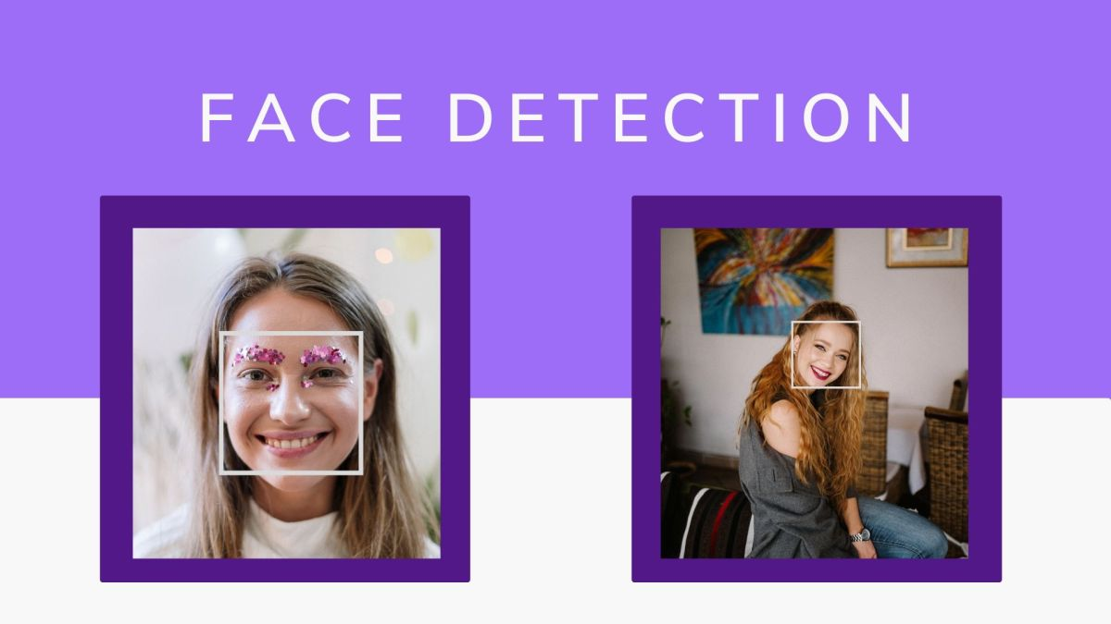Face detection is a technology that enables computers to recognize and locate human faces within images and videos. This process is essential for various applications, including security systems, social media, and even our smartphones, which use it to unlock devices. Unlike face recognition, which identifies specific individuals, face detection simply finds where faces are in an image.

There are several techniques used in face detection. One of the earlier methods is Haar Cascades, which uses machine learning to create a series of classifiers that can detect faces based on specific features.

Face detection is a vital technology that helps computers understand human faces, enabling countless applications that enhance our daily lives. As technology continues to evolve, face detection methods are becoming more sophisticated, paving the way for even more innovative uses in the future.

* + 1. **Features**

**Real-Time Processing**: Face detection systems are designed to operate in real time, making them suitable for applications like video surveillance and live streaming.

**Multi-Face Detection**: Advanced algorithms can detect multiple faces in a single image or frame, which is essential for group photos.

**Integration with Other Technologies**: Face detection can be combined with other technologies, such as face recognition and emotion detection, to enhance functionality in applications like security systems.

**Scalability**: Face detection systems can be scaled to handle large datasets, making them effective for use in various scenarios, from personal devices to large surveillance networks.

**Facial Feature Detection**: Face detection systems can identify key facial landmarks, such as eyes, nose, and mouth, which can be useful for applications like emotion recognition or facial analysis.

**Cross-Domain Application**: Face detection can be applied across various domains, including security, healthcare (e.g., monitoring patients), marketing (e.g., analyzing customer reactions), and human-computer interaction (e.g., gesture recognition).