Learn the following interpolation methods:

Cubic spline interpolation
We will be using the Scipy to perform the linear spline interpolation. We will be using Cubic Spline and interp1d function of scipy to perform interpolation of function f(x) =1/(1+x^2).
#imports
import matplotlib.pyplot as plt
import numpy as np
from scipy.interpolate import CubicSpline, interp1d
plt.rcParams['figure.figsize'] =(12,8)
x = np.arange(-10,10)
y = 1/(1+x**2)
# apply cubic spline interpolation
cs = CubicSpline(x, y)
# Apply Linear interpolation
linear_int = interp1d(x,y)
xs = np.arange(-10, 10)
ys = linear_int(xs)
# plot linear interpolation
plt.plot(x, y, 'o', label='data')
plt.plot(xs,ys, label="S", color='green')
plt.legend(loc='upper right', ncol=2)
plt.title('Linear Interpolation')
plt.show()
# plot cubic spline interpolation
plt.plot(x, y, 'o', label='data')
plt.plot(xs, 1/(1+(xs**2)), label='true')
plt.plot(xs, cs(xs), label="S")
plt.plot(xs, cs(xs, 1), label="S'")
plt.plot(xs, cs(xs, 2), label="S''")
plt.plot(xs, cs(xs, 3), label="S'''")
plt.ylim(-1.5, 1.5)
plt.legend(loc='upper right', ncol=2)
plt.title('Cubic Spline Interpolation')
plt.show()

Output

Cubic Spline Interpolation
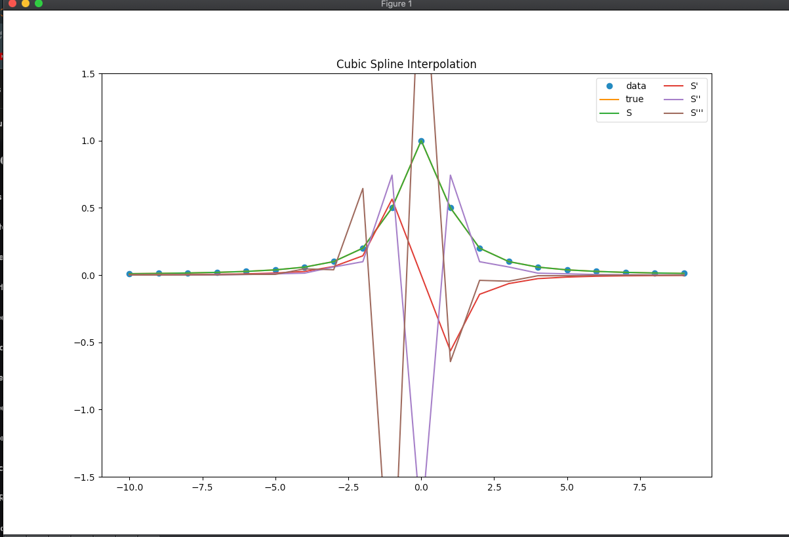
Linear Interpolation
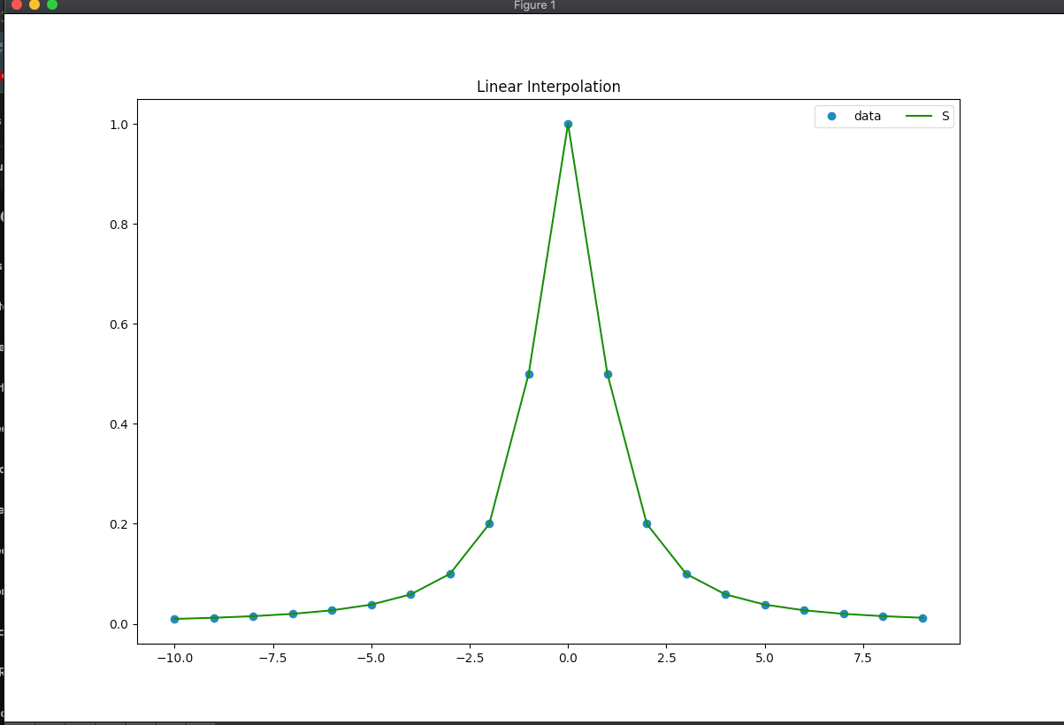

Quadratic spline interpolation
import numpy as np
import matplotlib.pyplot as plt
N = 4
x = np.array([3, 4.5, 7, 9])
# y=1/(1+np.exp(-x))
y = np.array([2.5, 1, 2.5, 0.5])
f = plt.figure()
plt.plot(x, y)
plt.show()
X = np.zeros([3 * (N - 1) - 1, 3 * (N - 1)])
Y = np.zeros([3 * (N - 1) - 1, 1])
j = 0
for i in range(N - 2):
# print(y[i+1])
# print(x[i+1])
Y[2 * i] = y[i + 1]
Y[i * 2 + 1] = y[i + 1]
for _ in range(2):
X[2 * i + _, 3 * j] = x[i + 1] ** 2
X[2 * i + _, 3 * j + 1] = x[i + 1]
X[2 * i + _, 3 * j + 2] = 1
if _ == 0:
j = (j + 1) % (N - 1)
pass
j = 2 * (N - 1) - 2
X[j, 0] = x[0] ** 2
X[j, 1] = x[0]
X[j, 2] = 1
Y[j] = y[0]
X[j + 1, -3] = x[-1] ** 2
X[j + 1, -2] = x[-1]
X[j + 1, -1] = 1
Y[j + 1] = y[-1]
h = 2 * (N - 1)
j = 0
for i in range(N - 2):
X[i + h, 3 * j + 0] = x[i + 1] * 2
X[i + h, 3 * j + 1] = 1
X[i + h, 3 * j + 2] = 0
X[i + h, 3 * j + 3] = -x[i + 1] * 2
X[i + h, 3 * j + 4] = -1
j += 1
X = np.mat(X[:, 1:])
Y = np.mat(Y)
a0 = 0
w = X.I * Y
def pre(xx):
for i in range(N - 1):
if x[i] <= xx and xx <= x[i + 1]:
if i == 0:
return a0 * xx ** 2 + w[0] * xx + w[1]
else:
return w[i * 3 - 1] * xx ** 2 + w[i * 3] * xx + w[i * 3 + 1]
break
else:
pass
xx = np.arange(3, 9, 0.2)
yy = np.apply_along_axis(pre, 1, xx)

Output
