**Boosting Algorithm**

**AdaBoostRegressor:**

An AdaBoost regressor is a meta-estimator that begins by fitting a regressor on the original dataset and then fits additional copies of the regressor on the same dataset but where the weights of instances are adjusted according to the error of the current prediction.

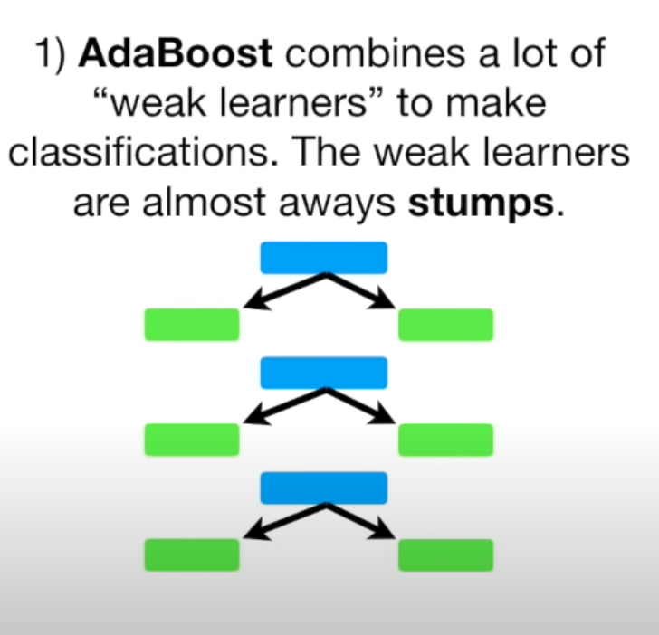

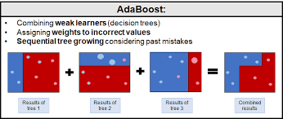

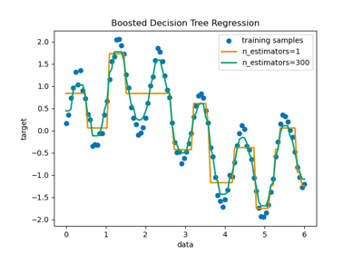

**XG BOOST: (Level wise tree growth)**

XGBoost (eXtreme Gradient Boosting) is a popular supervised-learning algorithm used for **regression and classification** on large datasets. It uses sequentially-built shallow decision trees to provide accurate results and a highly-scalable training method that avoids overfitting.

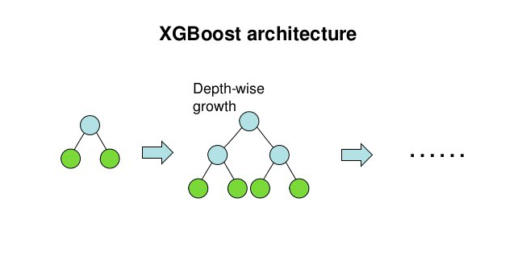

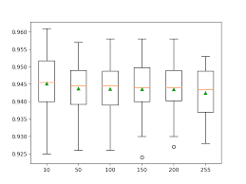

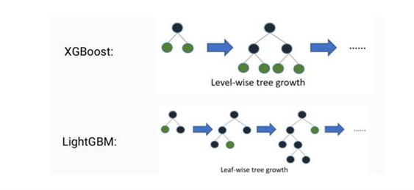

**LG Boost – (Leaf wise tree growth)**

**LightGBM is a gradient boosting ensemble method that is used by the Train Using AutoML tool and is based on decision trees**. As with other decision tree-based methods, LightGBM can be used for both classification and regression. LightGBM is optimized for high performance with distributed systems.

