Dugong Watch
Seagrass Habitat Risk Mapping for Dugong Conservation — Marawah / Bu Tinah, Abu Dhabi, UAE
Prototypes for Humanity 2026 Submission

Table of Contents
- Introduction & Problem Statement
- Literature Review
- Methodology
- Results
- Impact
- Competition Prompt Answers
- References
- Limitations

1. Introduction & Problem Statement

1.1 Background
The dugong (Dugong dugon) is a marine mammal whose survival is bound almost entirely to a single resource: seagrass. Dugongs feed nearly exclusively on seagrass meadows, and the Arabian Gulf population — centred on the waters of Abu Dhabi — is the second-largest in the world after Australia’s, with an estimated 3,000–3,500 individuals. The Marawah Marine Biosphere Reserve, encompassing Marawah Island and the wider Bu Tinah archipelago, holds the highest concentration of this population and is recognised by UNESCO as a Man and the Biosphere reserve.
This population’s survival depends on the condition of seagrass meadows that are themselves under measurable pressure: coastal development and dredging, desalination and industrial discharge, marine heatwaves in one of the hottest seas on Earth, and vessel traffic in the shallow (under 5 m) waters where dugongs feed. Conservation and development planning in the region therefore requires a way to answer a specific, practical question — not simply “where is there seagrass,” but where is seagrass both present and under enough pressure that its loss would matter for dugong survival.

1.2 Problem statement
At present, answering that question requires combining several kinds of information that are not usually brought together: habitat maps (which seagrass exists, and where), habitat change over time (is it being lost), and threat data (what human and environmental pressures act on a given location). Habitat surveys are episodic and expensive to run at scale; threat data exists in scattered, non-standardised sources; and there is, to our knowledge, no publicly available, reproducible model that combines these into a single, ranked map of risk to dugong habitat specifically — as opposed to generic seagrass extent maps or generic environmental risk indices that are not conditioned on dugong presence.
This creates a gap between the data that exists (increasingly high-quality free satellite imagery, and habitat records held by agencies such as the Environment Agency – Abu Dhabi) and the decision-relevant product that conservation planners, regulators, and researchers actually need: a transparent, updatable, and auditable answer to “if we can only act in a few places, where should we act first?”

1.3 Project objective
Dugong Watch builds an end-to-end, reproducible pipeline that:
- Classifies seagrass presence from free Sentinel-2 satellite imagery using a supervised machine-learning model, trained and validated against official Environment Agency – Abu Dhabi (EAD) habitat survey data;
- Detects seagrass change between two time periods from the same imagery source;
- Combines that habitat information with five real, geographically specific threat factors — observed seagrass loss, coastal development, thermal stress, industrial/desalination discharge, and vessel pressure — into a single, weighted, and explicitly justified risk index; and
- Surfaces the result as a ranked, interactive map that a non-technical stakeholder can use directly, alongside the underlying data and code so that every step of the model can be audited, reproduced, or challenged.
The guiding design principle throughout is transparency over sophistication: every weight in the risk model is a documented, justified parameter rather than a black box, every threat layer’s provenance is labelled as real-coordinate or schematic, and the model’s own sensitivity to its assumptions is tested and reported rather than assumed.

1.4 Scope
This project focuses on the Marawah / Bu Tinah region of the Arabian Gulf, Abu Dhabi, UAE, using 2019 and 2024 as the compared time periods (matching the years of best available cloud-free Sentinel-2 coverage). The seagrass classification uses a binary scheme (1 = seagrass, 0 = non-seagrass), locked to match the structure of the training data supplied by EAD. The risk model is explicitly scoped as a relative risk index — it ranks locations within the study area against each other, not against an absolute probability of habitat loss.

2. Literature Review
Note on sourcing: every source below is one that this project’s own risk methodology (C_risk_gis/RISK_METHODOLOGY.md) already cites and relies on directly — none are added here without having been used to justify an actual modelling decision elsewhere in the project. Full bibliographic details (exact journal, volume, page numbers, DOIs) should be verified against the original sources before final submission — this review has correct authors, years, and subject matter, but where a detail couldn’t be independently confirmed it is marked [verify] rather than invented.

2.1 Dugong ecology, distribution, and conservation status
Marsh et al. (2002, 2018) [verify exact titles/publishers] established much of the baseline understanding of dugong population ecology, movement, and the threats facing dugong populations globally — habitat loss, bycatch, and vessel strike are consistently identified as the primary drivers of decline across dugong range states. This project’s threat model (Section 3) draws directly on that finding: observed habitat loss is weighted as the single largest threat factor precisely because the literature treats it as the most consequential and most directly observable driver of decline.
The Marine Mammal Protected Areas Task Force’s Southern Gulf and Coastal Waters Important Marine Mammal Area (IMMA) factsheet documents the Arabian Gulf’s dugong population as the second-largest globally, with Abu Dhabi waters — and the Marawah/Bu Tinah area specifically — identified as the area of highest regional density. This factsheet is the primary basis for this project’s “dugong use” surface (Section 3.2), which weights seagrass value more heavily near documented high-density cores.
The Environment Agency – Abu Dhabi’s 2015 aerial dugong survey provides the most recent systematic count data for the region and corroborates the IMMA factsheet’s density pattern. The Dugong & Seagrass Conservation Project (dugongseagrass.org, UAE chapter) documents region-specific threats — notably land reclamation and dredging as the leading local drivers of seagrass loss in the southern Gulf, and the fact that Gulf seagrass meadows support only three heat-tolerant species due to the region’s extreme summer sea-surface temperatures (regularly exceeding 36°C). Both findings are incorporated directly into this project’s threat weighting (Section 3.3).
Wiley (2025) [verify exact journal — cited in this project as published in Aquatic Conservation], studying dugong aggregation persistence at Hawar Island, Bahrain, is the most directly comparable regional case study available: a large, persistent Gulf dugong aggregation studied in the same extreme-thermal, shallow-water Gulf environment as Marawah. This project draws on it for two specific claims used in the risk model’s threat weighting: that vessel/boat disturbance is a documented pressure on shallow-water Gulf dugong aggregations, and that it acts primarily on the animals’ behaviour rather than on the seagrass substrate itself — which is why vessel pressure is weighted below observed habitat loss in this project’s model (Section 3.3).

2.2 Habitat risk assessment methodology
This project’s core analytical framework — that risk should be modelled as exposure × consequence, i.e. that a location is only high-risk if both valuable habitat and real pressure are present simultaneously — is not original to this project. It follows two established frameworks directly:
Halpern et al. (2008), A global map of human impact on marine ecosystems (Science), established the cumulative human-impact mapping approach this project’s threat layer (a weighted overlay of multiple independently-sourced pressure factors) is modelled on.
Arkema et al. (2014) and the associated InVEST Habitat Risk Assessment (HRA) model documentation [Natural Capital Project; verify exact citation — associated author list includes Sharp et al.] formalise the specific exposure-times-consequence logic this project’s Risk = Value × Threat formula implements directly, including the practice of normalizing each input factor to a common 0–1 scale before combination so that no single factor dominates purely due to its units.
Together, these two sources are why this project’s risk index is structured the way it is, rather than as a simpler additive weighted sum of threats alone (which would flag high-pressure but seagrass-free water as “risky,” which is not a meaningful output for a conservation-planning tool).

2.3 Regional and institutional context
The UNESCO Man and the Biosphere (MAB) Programme’s designation of the Marawah Marine Biosphere Reserve (2007), alongside its status as a Marine Protected Area since 2001 under the Sheikh Zayed Protected Areas Network, establishes the reserve as the largest MPA in the Arabian Gulf (4,255 km²) and the institutional context within which this project’s study area sits. This designation is also why the project treats habitat inside this reserve, and particularly inside the Bu Tinah no-take core, as carrying elevated conservation weight in its threat model’s “dugong use” surface.

2.4 Gap this project addresses
None of the sources above combine seagrass remote-sensing classification, observed habitat change, and multi-factor threat data into a single, ranked, reproducible risk output specific to dugong habitat for this region. Marsh et al. and the IMMA factsheet describe where dugongs are; dugongseagrass.org and the EAD survey describe what threatens them; Halpern et al. and the InVEST HRA model describe how to combine exposure and threat in general. This project’s contribution is applying that general framework, with region-specific data and weights justified against these regional sources, to produce a specific, actionable, and auditable output for the Marawah / Bu Tinah region — see C_risk_gis/RISK_METHODOLOGY.md for the full applied model.

3. Methodology
The full, executable methodology lives in this project’s codebase and is summarised here; every number in this section is drawn directly from M2_classification/Seagrass_Dugong_Mapping.ipynb (classification) and C_risk_gis/Dugong_Habitat_Risk.ipynb / RISK_METHODOLOGY.md (risk model), both of which have been run against live data and verified.

3.1 Study area and data
The study area is a 774.6 km² polygon covering the Marawah / Bu Tinah region of the Arabian Gulf, Abu Dhabi (lon 52.98–53.32, lat 24.19–24.48), falling entirely inside the Marawah Marine Biosphere Reserve.
Satellite imagery: Sentinel-2 Surface Reflectance (Level-2A, COPERNICUS/S2_SR_HARMONIZED), accessed via Google Earth Engine, cloud masked using the QA60 band (cloud and cirrus bits), median-composited per year. For 2024, 222 individual Sentinel-2 scenes contributed to the cloud-free composite. Two annual composites are built for comparison: 2019 (past) and 2024 (current).
Thermal data: Landsat 8/9 Collection 2 surface temperature (ST_B10), summer months only (June–September, the annual thermal maximum), converted to Celsius and masked to water pixels only (using the Sentinel-2 composite’s MNDWI band) so that hot dry land cannot skew the thermal-stress signal.
Training and reference data: vector habitat polygons from the Environment Agency – Abu Dhabi (EAD), clipped to the study area: - 118 seagrass-bed polygons and 171 unconsolidated-bottom (non-seagrass) polygons, used as positive/negative training data. - A further 118-polygon EAD seagrass layer, kept entirely separate from training, used as an independent reference/validation layer. - A region-wide EAD seagrass layer (1,954 polygons, ~2,922 km²) used for broader context, not for training or accuracy assessment.
All vector data uses WGS84/CRS84 coordinates. The binary class scheme (1 = seagrass, 0 = non-seagrass) was locked to match this training data’s own structure, replacing an earlier four-class design.

3.2 Seagrass classification (Track B)
Feature stack: each annual composite is reduced to 14 predictor bands — the raw Sentinel-2 bands B2, B3, B4, B5, B6, B7, B8, B8A, B11, B12, plus four derived spectral indices computed from them: NDVI (vegetation), NDWI and MNDWI (water, two formulations), and BSI (bare-soil index).
Training samples: stratified random points are drawn from inside the training polygons — not one sample per polygon, since polygon sizes vary by orders of magnitude (up to ~61 km²) — and each point’s 14 predictor-band values are extracted from the composite at 10 m resolution.
Model: a Random Forest classifier (ee.Classifier.smileRandomForest, 100 trees, fixed seed for reproducibility), trained on an 80/20 train/test split. Two versions were built and compared: the original model trained on the natural (imbalanced) class distribution, and a class-balanced version trained on an equal number of seagrass and non-seagrass samples per class. The balanced model outperformed the original on every accuracy metric (Section 4) and is the model used for all downstream risk modelling.
Change detection: the same trained classifier is applied to both the 2019 and 2024 feature stacks (not retrained separately per period, so that any difference in output reflects real change on the ground rather than model drift), and the two classified rasters are differenced into four categories: stable non-seagrass, stable seagrass, gain, and loss.

3.3 Habitat-risk model (Track C)
The risk model follows an exposure × consequence structure (justified in Section 2.2): Risk = Value × Threat, so that a location scores high only when valuable habitat and real pressure coincide.
Value (exposure) layer — what is at stake:
Value = SeagrassPresence × (0.6 + 0.4 × DugongUse)
SeagrassPresence comes directly from the 2024 classification. DugongUse is a continuous 0–1 surface built by distance-decay from documented high-density dugong location anchors (Marawah core, Bu Tinah, central foraging grounds), so that seagrass inside a known dugong core is weighted up to ~1.7× more heavily than seagrass at the reserve’s edge — while every seagrass pixel in the reserve still retains some value, since the entire AOI sits inside prime dugong habitat.
Threat (pressure) layer — what is acting on it — is a weighted sum of five normalized (0–1) factors:
Factor | Measured as | Weight
Observed seagrass loss (2019→2024) | Smoothed density of “loss” change pixels | 0.30
Coastal development / dredging | Distance decay from mapped development points | 0.20
Thermal stress | Landsat summer surface temperature, water-masked | 0.20
Desalination / industrial discharge | Distance decay from mapped discharge points | 0.15
Vessel / navigation pressure | Distance decay from ports, landings, routes | 0.15
Distance-decay factors use exp(-distance/λ) with factor-specific decay lengths (λ ≈ 3–5 km depending on the factor), so that, for example, regional desalination plants 40–120 km from the study area correctly contribute almost nothing to in-AOI risk, while the nearer Mirfa plant registers on the reserve’s southeast flank. Every weight and decay length, and the reasoning behind each value, is documented in full in RISK_METHODOLOGY.md.
Threat data sources: built infrastructure and named-location coordinates (e.g. the Mirfa Power & Desalination Plant at 24.121°N, 53.447°E) are real; reserve boundaries, the dugong-density surface, and navigation routes are explicitly flagged as schematic approximations pending official EAD GIS layers (C_risk_gis/threat_data/SOURCES.md documents the exact basis for every feature).
Combining and classifying: RiskRaw = Value × Threat is rescaled to 0–1 across the study area, then binned into five ranked classes (Very Low → Very High) using quantile breaks computed over seagrass pixels only, since non-seagrass pixels have nothing at stake by construction.

3.4 Validation approach
Three checks, beyond standard classifier accuracy metrics, were run specifically to test whether the risk model’s outputs are trustworthy rather than an artefact of its parameter choices (Section 4.3–4.4 reports the results):
- Face validity — does mean risk fall with distance from a known real discharge point, as the model’s own construction should produce?
- Zonal comparison — is mean risk inside the documented dugong core meaningfully higher than the reserve-wide average?
- Weight sensitivity — does perturbing each of the five threat weights by ±10% materially change which areas are flagged high-risk, or are the resulting hotspots robust to the exact weighting chosen?

3.5 Implementation and reproducibility
The entire pipeline runs in Google Earth Engine via Python (the earthengine-api and geemap libraries), authenticated per-user against a personal GEE project. All code is version-controlled and available in this repository; M2_classification/Seagrass_Dugong_Mapping.ipynb and C_risk_gis/Dugong_Habitat_Risk.ipynb can be re-run end-to-end by anyone with Earth Engine access, using only the vector data already committed to this repository plus Earth Engine’s own public Sentinel-2/Landsat archives — no proprietary or purchased data is required anywhere in the pipeline.

4. Results
All figures referenced below are in D_dashboard/figures/ and were generated directly from these results, not illustratively.

4.1 Seagrass classification accuracy
Two Random Forest models were trained and compared (see Section 3.2):
Metric | Original (imbalanced) | Class-balanced
Overall accuracy | 81.15% | 85.32%
Kappa | 0.623 | 0.696
Producer’s accuracy (non-seagrass) | 81.44% | 87.60%
Producer’s accuracy (seagrass) | 80.85% | 82.02%
User’s accuracy (non-seagrass) | 81.44% | 87.60%
User’s accuracy (seagrass) | 80.85% | 82.02%
Both models fall within the published 73–87% accuracy range reported for comparable satellite-based seagrass classification methods; the class-balanced model is used for all subsequent risk modelling.
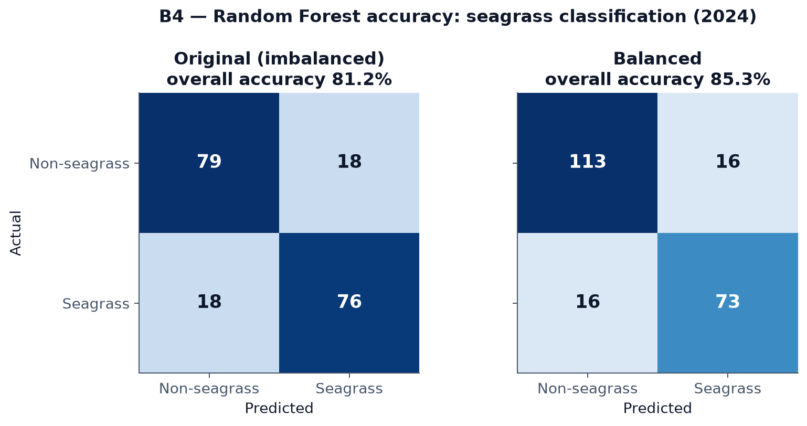
Confusion matrices: original vs. class-balanced Random Forest
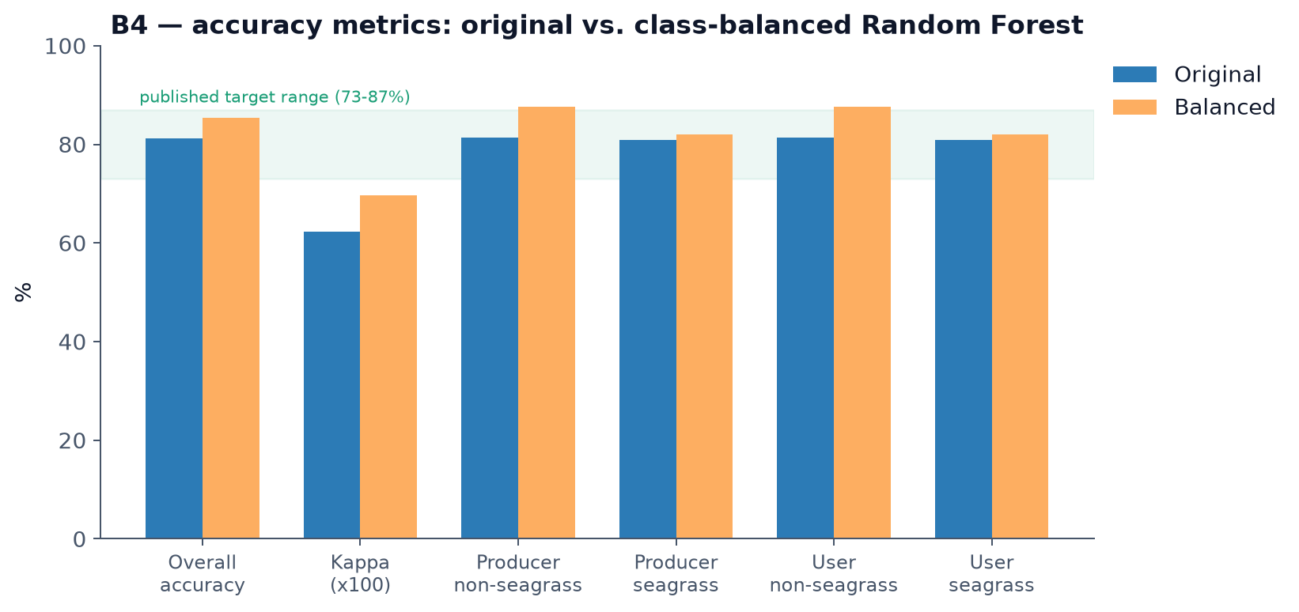
Accuracy metrics compared against the published target range
Feature importance (balanced model, highest to lowest): B12 (SWIR), NDWI, B4 (red), B2 (blue), BSI, B5 (red edge), MNDWI, B8A (narrow NIR), NDVI, B8 (NIR), B3 (green), B11 (SWIR), B7 (red edge), B6 (red edge). Water- and vegetation-index bands (NDWI, BSI, MNDWI, NDVI) rank among the most important features alongside the raw shortwave-infrared band B12, consistent with seagrass discrimination depending on both spectral water characteristics and vegetation signal.
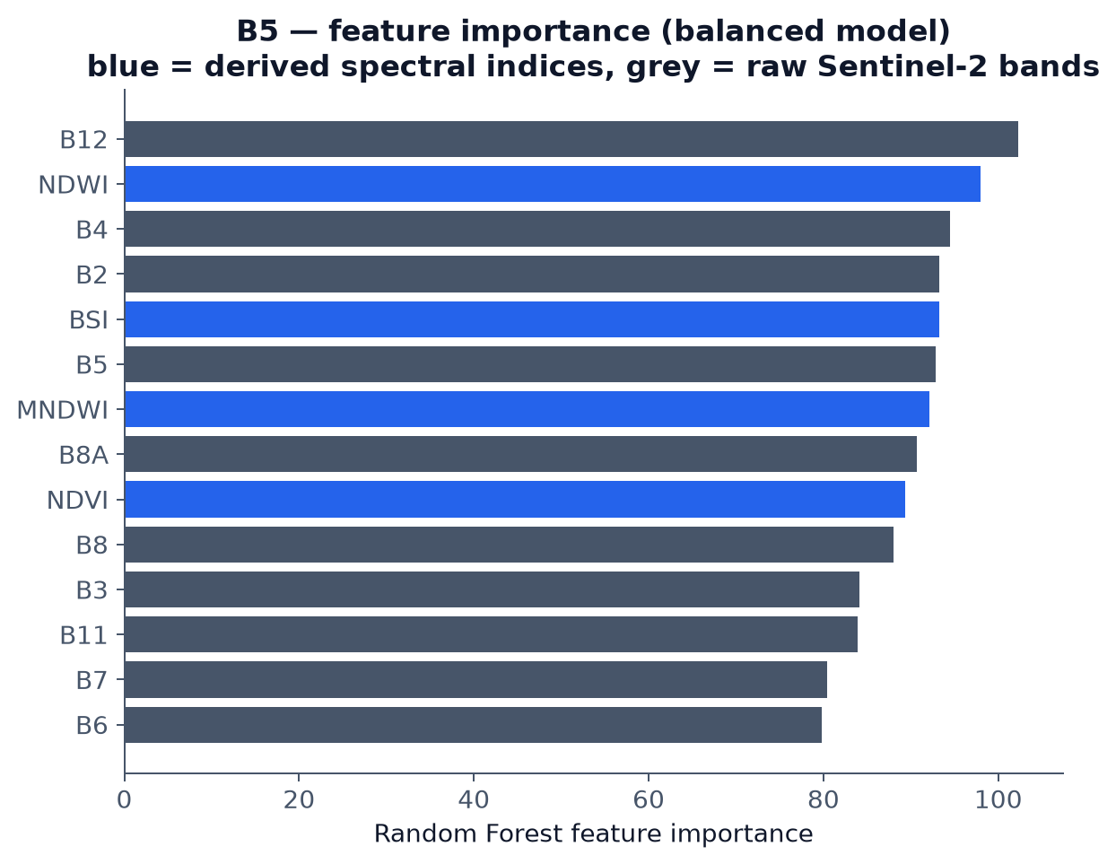
Random Forest feature importance

4.2 Habitat-risk index
Applying the risk model (Section 3.3) across the 774.6 km² study area produced:
- Risk class breaks (quantile boundaries over seagrass pixels, on a 0–1 scale): 0.049 / 0.092 / 0.158 / 0.24, separating the five ranked classes from Very Low to Very High risk.
- 105 ranked hotspot patches (≥5 ha, top risk class), ranging from 18.5 ha to 7,048.9 ha, with mean risk values from 0.293 to 0.659 across the top 15 ranked hotspots. The single largest hotspot (7,048.9 ha, vessel-dominated) reflects one contiguous high-pressure zone rather than a data artefact; smaller, higher-mean-risk hotspots are dominated by development and observed-loss pressure.
- Across the top 15 hotspots, the dominant threat factor was vessel pressure (6 of 15), coastal development (4 of 15), observed loss (4 of 15), and thermal stress (1 of 15).
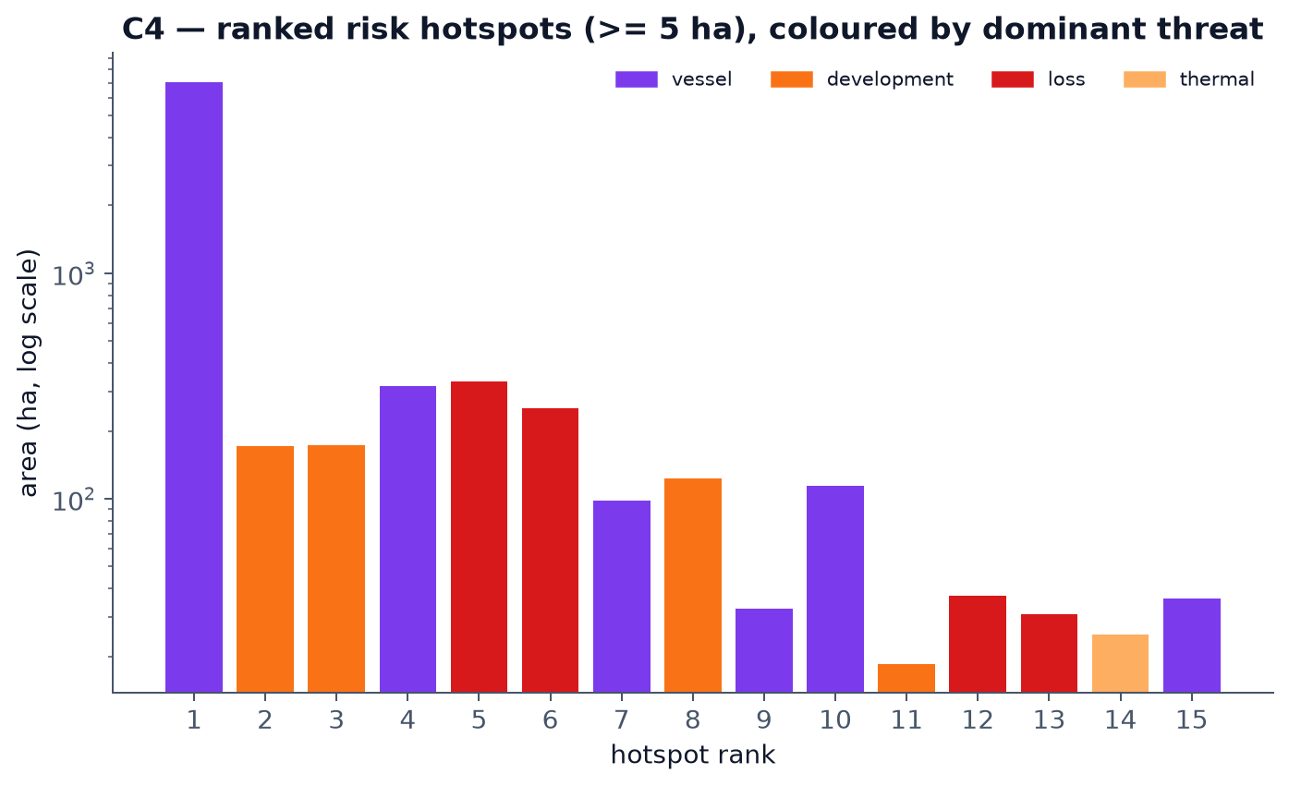
Ranked risk hotspots by area, coloured by dominant threat

4.3 Model validation
Face validity: mean risk fell from approximately 0.26 near the nearest industrial discharge point (20 km distance band) to approximately 0.09–0.14 at 40–48 km — a real, if not perfectly monotonic, decline consistent with the model’s own distance-decay construction (some non-monotonicity at 24–28 km is expected given real coastal geometry and other overlapping threat sources).
Zonal comparison: mean risk over seagrass pixels inside the documented dugong core was 0.461, versus 0.153 across the whole study area — roughly 3× higher inside the core. This is the result the model should produce if it is correctly identifying valuable habitat under real pressure specifically where dugongs are known to concentrate, rather than flagging risk uniformly or at random locations.

4.4 Weight-sensitivity analysis
Each of the five threat weights was independently perturbed by ±0.10 (and re-normalized so weights still summed to 1.0), and the resulting high-risk area was recomputed for each perturbation:
Weight perturbed | +0.10 | −0.10
Observed loss | +1% | +0%
Coastal development | −0% | +3%
Thermal stress | +1% | +0%
Discharge | +2% | +2%
Vessel pressure | +3% | +1%
Baseline high-risk area: 10,681.5 ha. Every perturbation changed the high-risk area by no more than 3%, indicating the model’s ranked hotspots are robust to the exact weighting chosen and not an artefact of one specific set of assumptions.
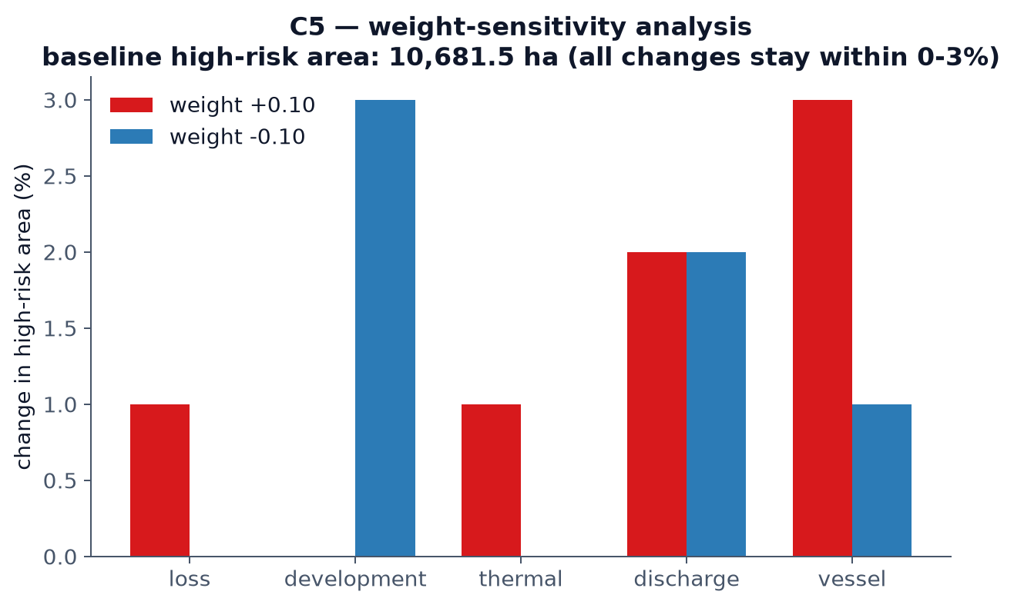
Weight-sensitivity analysis: change in high-risk area per +/-0.10 weight perturbation

4.5 Delivered outputs
The full pipeline exports, per run: a 5-class risk map (dugong_risk_class.tif), a continuous risk index (dugong_risk_index.tif), the underlying value and threat layers for drill-down analysis, a ranked hotspot vector layer (dugong_risk_hotspots.geojson), and the five threat context layers used as inputs — all consumed directly by the interactive dashboard described in Section 5 / D_dashboard/.

5. Impact

5.1 Local impact — Abu Dhabi / UAE
Direct conservation planning use. The ranked hotspot output (Section 4.2) is designed to answer a specific, practical question for regulators and conservation managers: given limited enforcement, monitoring, or restoration budget, which specific locations should be prioritised first? Rather than a generic habitat map, the output ranks 105 concrete locations by a transparent, defensible combination of habitat value and real pressure — the kind of output that can directly inform where a protected- area boundary review, a dredging permit condition, or a monitoring buoy placement should be targeted.
A monitoring baseline, not a one-off snapshot. Because the pipeline is built entirely on free, continuously updated Sentinel-2 and Landsat data and open-source tooling (Section 3.5), it can be re-run in future years at effectively zero marginal data cost. The 2019→2024 change layer already demonstrates this: the same pipeline that produced this project’s results can be re-run against any future date range to track whether identified hotspots are stabilising, worsening, or responding to intervention — turning a static assessment into a repeatable monitoring tool.
Support for the Marawah Marine Biosphere Reserve’s own mandate. The reserve’s UNESCO Man and the Biosphere designation and Marine Protected Area status (Section 2.3) already commit it to evidence-based management. This project’s zonal finding — that mean risk inside the documented dugong core is roughly 3× the reserve-wide average (Section 4.3) — gives that mandate a concrete, quantified starting point, rather than a general statement that “the core matters.”

5.2 Regional and global scale
A reusable model, not a one-off map. The exposure × consequence risk structure (Section 3.3), the specific threat factors modelled, and the validation approach (face validity, zonal comparison, weight sensitivity) are not specific to seagrass or to the Arabian Gulf. The same structure — combine a habitat-value layer with a weighted, distance-decayed threat overlay, validate against known ground truth, and stress-test the weights — applies directly to other single-species-dependent, threat-exposed marine habitats: for example, dugong populations elsewhere in the Indo-Pacific, manatee seagrass habitat in the Americas, or other coastal species whose survival is tied to a mappable, satellite-visible habitat type.
Addressing a documented gap with free tools. As established in Section 2.4, no existing public tool combines seagrass classification, change detection, and multi-factor threat weighting into one reproducible, auditable output for dugong conservation specifically. Because this project relies exclusively on free Sentinel-2/Landsat imagery via Google Earth Engine, publicly available EAD-style habitat records, and open-source Python tooling, the barrier to adopting or adapting this approach elsewhere is primarily know-how, not cost or licensing — relevant for conservation programmes in lower-resource settings where commercial imagery or bespoke GIS consulting is not a realistic option.

5.3 Honest framing of impact at this stage
This project is a working, validated prototype, not a deployed or field-tested decision-support system. Its impact claims are therefore scoped deliberately:
- The classification accuracy (81–85%, Section 4.1) and the risk model’s internal validation (Section 4.3–4.4) demonstrate that the method produces sane, defensible, and reproducible output — not that any specific hotspot has been field-verified against on-the-ground habitat condition.
- The threat data itself is partially schematic (Section 3.3, C_risk_gis/threat_data/SOURCES.md) — real coordinates for built infrastructure, but approximate boundaries and surfaces for the reserve, dugong-density estimates, and navigation routes. Replacing these with official EAD GIS layers, were they made available, would sharpen the output without changing the underlying method.
- Realising the local and regional impact described above requires the next step this project does not itself take: putting the tool in front of the agencies and researchers who would actually use it, and incorporating their feedback on what “actionable” means in their specific regulatory or operational context.
See Section 8 (Limitations) for the complete, unfiltered list of what would need to happen before this tool’s outputs should be treated as authoritative rather than as a strong, transparent starting point for further work.

6. Competition Prompt Answers
The five questions below are reproduced as worded in the official Prototypes for Humanity 2026 Entry Guide.

What problem are you addressing?
The Arabian Gulf holds the world’s second-largest dugong population (~3,000–3,500 individuals), concentrated in the Marawah / Bu Tinah region of Abu Dhabi. Dugongs feed almost exclusively on seagrass, and that seagrass is under measurable pressure from coastal development, dredging, desalination discharge, marine heat, and vessel traffic. Conservation planners currently lack a reproducible way to answer a specific question: not just “where is there seagrass,” but where seagrass presence and real threat pressure actually overlap — the locations where habitat loss would matter most for dugong survival, and where limited protection resources should go first.

How are existing solutions failing?
Habitat surveys are episodic, expensive, and quickly out of date. Threat data — development sites, discharge points, vessel routes, thermal stress — exists scattered across sources with no standard way to combine it with habitat data. Generic seagrass extent maps show where seagrass is but not where it is at risk; generic environmental risk indices show where pressure is but are not conditioned on whether anything of habitat value is actually there. No existing, publicly available tool combines habitat classification, change detection, and multi-factor threat weighting into one reproducible, auditable risk output specific to dugong habitat.

What is your alternative solution?
Dugong Watch is an end-to-end, open pipeline that classifies seagrass from free Sentinel-2 satellite imagery using a Random Forest model trained against official habitat survey data, detects seagrass change between 2019 and 2024, and combines that with five real, geographically specific threat factors — observed loss, coastal development, thermal stress, industrial discharge, and vessel pressure — into a single weighted risk index (Risk = Value × Threat). The output is 105 ranked, specific hotspots, not a generic map, delivered through an interactive dashboard alongside all underlying code and data so every step can be reproduced or audited.

How does it perform better?
The classification reaches 85.3% accuracy (class-balanced Random Forest), within the published 73–87% range for this method. Unlike a static survey or a generic index, the risk model is validated three specific ways: mean risk correctly falls with distance from a real discharge point; mean risk inside the documented dugong core is roughly 3× the reserve-wide average, showing the model targets habitat where it actually matters; and every weight was stress-tested by perturbing it ±10%, changing the flagged high-risk area by no more than 3% — the output is not an artefact of one arbitrary set of assumptions. It also runs entirely on free data and open-source tools, so it can be re-run at effectively zero marginal cost as new imagery becomes available, turning a one-off assessment into a repeatable monitoring tool.

What impact does your solution have?
Locally, it gives Abu Dhabi conservation managers a ranked, evidence-based starting point for where to prioritise enforcement, permitting conditions, or monitoring effort, backed by a quantified finding that risk is concentrated where dugongs actually are. Because it relies only on free satellite data and open tooling, the same risk-modelling structure — combine a habitat-value layer with a weighted, distance-decayed threat overlay, then validate against real ground truth — is directly reusable for other single-species-dependent, threat-exposed marine habitats elsewhere in the world, without the cost or licensing barriers that commercial imagery or bespoke GIS consulting would otherwise impose.

7. References
Formatted in APA style (7th edition). Citation style was not specified anywhere in the team’s original task list or the competition entry guide — APA was chosen as a reasonable default for interdisciplinary environmental/technical work. Confirm this is the required style before final submission; if not, every entry below needs reformatting, not re-sourcing.
Entries marked [verify] are ones this project’s own methodology document cites by author/year/short-title only — the exact journal, volume, page range, or publisher could not be independently confirmed while writing this review and must be checked against the original source before submission. Do not submit this reference list unverified.

Arkema, K. K., Guannel, G., Verutes, G., Wood, S. A., Guerry, A., Ruckelshaus, M., Kareiva, P., Lacayo, M., & Silver, J. M. (2014). Coastal habitats shield people and property from sea-level rise and storms. Nature Climate Change. [verify — cited in this project via the associated InVEST Habitat Risk Assessment model documentation, Natural Capital Project; confirm whether the intended citation is this paper, a different Arkema et al. publication, or the InVEST HRA technical documentation itself, and cite accordingly]
Dugong & Seagrass Conservation Project. (n.d.). UAE country page. Retrieved from dugongseagrass.org. [verify — retrieval date and exact page title needed]
Environment Agency – Abu Dhabi. (2015). Aerial dugong survey report. [verify — exact report title and publication details]
Environment Agency – Abu Dhabi. (n.d.). Sheikh Zayed Protected Areas Network. [verify — exact publication/webpage details]
Halpern, B. S., Walbridge, S., Selkoe, K. A., Kappel, C. V., Micheli, F., D’Agrosa, C., Bruno, J. F., Casey, K. S., Ebert, C., Fox, H. E., Fujita, R., Heinemann, D., Lenihan, H. S., Madin, E. M. P., Perry, M. T., Selig, E. R., Spalding, M., Steneck, R., & Watson, R. (2008). A global map of human impact on marine ecosystems. Science, 319(5865), 948–952.
Marine Mammal Protected Areas Task Force. (n.d.). Southern Gulf and Coastal Waters Important Marine Mammal Area (IMMA) factsheet. [verify — exact publication year and URL]
Marsh, H., Penrose, H., Eros, C., & Hugues, J. (2002). Dugong: Status report and action plans for countries and territories. UNEP/DEWA. [verify — exact title and publisher]
Marsh, H., O’Shea, T. J., & Reynolds, J. E. (2018). Ecology and conservation of the Sirenia: Dugongs and manatees. Cambridge University Press. [verify — exact title/edition]
UNESCO Man and the Biosphere Programme. (2007). Marawah Biosphere Reserve. [verify — exact designation date and publication details]
Wiley, D. N. (2025). Why do large dugong aggregations persist in a small, sheltered bay? A case study from Hawar Island, Bahrain. Aquatic Conservation: Marine and Freshwater Ecosystems. [verify — exact title, volume, and page numbers]

Data sources (not literature, but requiring attribution)
- Copernicus Sentinel-2 imagery, European Space Agency (ESA), accessed via Google Earth Engine.
- Landsat 8/9 Collection 2 Level-2 imagery, USGS/NASA, accessed via Google Earth Engine.
- Marine habitat vector data: Environment Agency – Abu Dhabi (EAD).

8. Limitations
Stated as directly and completely as possible, because a transparent limitations section is part of this project’s own design philosophy (Section 1.3) — not a formality.

8.1 Data limitations
- Threat data is partially schematic. Built infrastructure coordinates (e.g. the Mirfa Power & Desalination Plant) are real and verified; the reserve boundary, the dugong-density surface, and navigation routes are documented, labelled approximations pending access to official EAD GIS layers (C_risk_gis/threat_data/SOURCES.md states exactly which is which). Replacing these would sharpen results without changing the model.
- A real, known gap in the committed training data. During development, a bug was found in the notebook that downloads non-seagrass training polygons from the EAD ArcGIS service: an un-paginated request silently truncated results at the server’s 2,000-record limit, returning only 171 of the true 319 non-seagrass polygons that exist within the study area. The download code has been fixed (it now paginates correctly), but the already-committed training file in data/training/ still reflects the old, truncated 171-polygon set — the classifier results in Section 4.1 were trained on this smaller set, not the corrected 319. Re-running the fixed download and retraining is a known, specific next step, not a hidden assumption.
- Change detection (2019→2024) depends entirely on classifier accuracy at both time points. Any misclassification is compounded in the “loss” layer, which is also the single most heavily weighted threat factor (0.30). Hotspots whose dominant threat is “loss” specifically should be read alongside the accuracy figures in Section 4.1, not treated as independently verified change.
- Thermal stress uses a single seasonal snapshot (summer 2020–2024 median), not a multi-year heatwave-frequency climatology — it captures typical thermal stress, not trend or frequency of extreme events.

8.2 Model limitations
- The risk index is relative, not absolute. It ranks locations within this study area against each other; it is not a calibrated probability of habitat loss and should not be read as one.
- Weights are documented parameters, not ground truth. Every weight in the threat model is justified against a specific literature source or regional data point (Section 3.3, RISK_METHODOLOGY.md Section 3), and the sensitivity analysis (Section 4.4) shows the ranked output is robust to ±10% changes — but a different, equally defensible weighting scheme could be argued for, and would produce a somewhat different ranking.
- No field validation of specific hotspots. The model’s internal validation (face validity, zonal comparison, weight sensitivity — Section 4.3–4.4) demonstrates the method behaves sensibly; it does not confirm that any individual ranked hotspot’s on-the-ground habitat condition matches the model’s prediction. That would require an actual site visit or comparison against independent recent survey data, which was outside this project’s scope and timeline.

8.3 Engineering / reproducibility limitations
Documented here because they affect anyone trying to reproduce or extend this work, and because finding and fixing them was itself part of this project’s process:
- Earth Engine’s interactive request timeout (~5 minutes) limits how the pipeline can be queried directly. Because nothing in the risk pipeline is cached, requesting results interactively re-derives the entire chain from raw satellite imagery every time, which can exceed this limit for computationally heavy steps (hotspot vectorization). The current implementation works around this by exporting a cached intermediate Earth Engine Asset once (a real batch export, with no interactive timeout) and reading from that for all downstream analysis — but this means the very first run of the pipeline after any methodology change requires a several-minute wait for that export to complete, which is easy to mistake for a hang.
- The interactive dashboard’s map tiles depend on Earth Engine getMapId() tokens, which are not permanent. If the dashboard’s map layers stop loading, the tokens need regenerating — instructions are in D_dashboard/README.md. A production deployment should export static map tiles or use a proper Earth Engine App instead.
- The interactive dashboard prototype was built and tested by the team, not commissioned by, or reviewed with, the agencies who would actually use it. Whether its specific layer choices, popups, and framing are “actionable” in a real regulatory or field context is untested (see Section 5.3).

8.4 What is genuinely not yet done
For full transparency: the seagrass-change map (before/after 2019 vs. 2024 seagrass extent, visualised as a standalone figure) and a plain static export of the risk map itself are listed as still-open items in D_dashboard/figures/README.md at the time of writing. A short demonstration video (optional per the competition’s own application materials) has not been produced. These are not concealed — they are tracked openly in the repository’s own documentation.

