

**DAFFODIL IBTERNATIONAL UNIVERSITY**

BACHELOR PROJECT

**PROJECT TITLE**

Medical Store Management System

Student Name : Abdulla Al Saimun

ID : 171-35-1921

Supervisor Name : Mrs. Nusrat Jahan

Department : Software Engineering

Faculty of Science & Information Technology

December 2017

Final Approval

**Committee:**

**External Examiner:**

**Internal Examiner:**

**Supervisor:**

**Abstract**

In medicine store we face many problems in manually. We can do same thing by Medical Store Management System(MSMS). We can purchase medicine and sell that medicine. We can store medicine supplier and customer’s data. We can also manage stock. When we need to search any medicine than we have to press medicine name or id. In bill option we create bill receipt for customer and see the net amount of all sold medicine.

**Table of Contents**

**Chapter 1**

1. **Introduction-------------------------------------------------------------------------------5**
   1. **About the system----------------------------------------------------------------5**
   2. **Purpose----------------------------------------------------------------------------5**
   3. **Scope-------------------------------------------------------------------------------5**
   4. **Vision------------------------------------------------------------------------------6**
   5. **Why this system is necessary? -----------------------------------------------6**
   6. **Proposed Solution---------------------------------------------------------------6**

**Chapter 2**

**System Analysis --------------------------------------------------------------------------**

* 1. **Use Case diagram---------------------------------------------------------------7**
  2. **Use Case description------------------------------------------------------------8**

**Chapter 3**

* 1. **System Design-------------------------------------------------------------------------9**

**Chapter 4**

**Implementation-------------------------------------------------------------------------**

**4.1 Tools & Technology-------------------------------------------------------------10**

**Chapter 5**

**System Testing--------------------------------------------------------------------------**

**5.1 Black Box Testing -------------------------------------------------------------11-22**

**Chapter 6**

**6.1Conclusion--------------------------------------------------------------------------------23**

**Good features -----------------------------------------------------------------------23**

**Limitation of the system ----------------------------------------------------------23**

**Future Enhancement -------------------------------------------------------------------------23**

**Chapter 7: User Manual----------------------------------------------------------------------------23**

**Chapter 8: Reference--------------------------------------------------------------------------------24**

**Chapter 1. Introduction**

* 1. **About**

This C Programming project is about Medical Store. In medical store there are many work that we can easily done by this project. We can sell and purchase medicine. We can store all data easily. It is helpful for future purpose.

* 1. **Purpose**

The purpose of this project is to describe the Medical Store Management system(MSMS). There are many purpose in this project. The main purpose of the system is reduced time of working and work smoothly. This document contains the functional and non-functional requirements of the project. The system is so easy that user can easily use it. It is very helpful for medical store owner. We can also use this system in other department like grocery shop, super shop etc.

* 1. **Scope**

MSMS product is basically updating the manual system into a digital-based system so that the users can know the details of their stock, sell medicine, purchase medicine, availability of medicine and remaining time for expire date of medicine. The system can calculate the selling or purchasing medicine’s total amount immediately. The project is specifically

designed for the use of medical store seller. The product will work as a complete user interface for medical store management. We can save more time, money, energy by this system.

* 1. **Vision**

In future update of this project I will try to add a feature like user can see all the report at a glance search by date, month and daily. The system will be online system in future. Than owner of the store can easily manage his store at any place.

* 1. **Necessary of the system**

The necessity of the system can’t be ignored. In manually we lost our important time and need more human resources. So, the cost of the store rising high and owner of the store can’t get proper profit. Maintenance cost of the store always rising high in manually. So, this system is important for get more profit and using less time and less worker and maintain the store easily. The system saves all importation like sell, purchase etc. The stock will update every time. When we purchase medicine than it will add in stock. When sell to the customer than quantity of medicine reduces from stock. It will keep owner up to date to take proper decision. User of the system can make bill receipts for customer easily. It will helpful for save many times and get more profit.

* 1. **Proposed Solution**

In future I will make this project with other programming language like java or c sharp. I will add database system. Database is very important for maintain the system. We can use this system for online medicine selling. Customer will purchase medicine from home any time. We will get real time situation of store instantly. We will set reminder for expired medicine. When medicine date expired then will show alert and show the medicine.

**Chapter 2 System Analysis**

2.1 **Use Case Diagram** 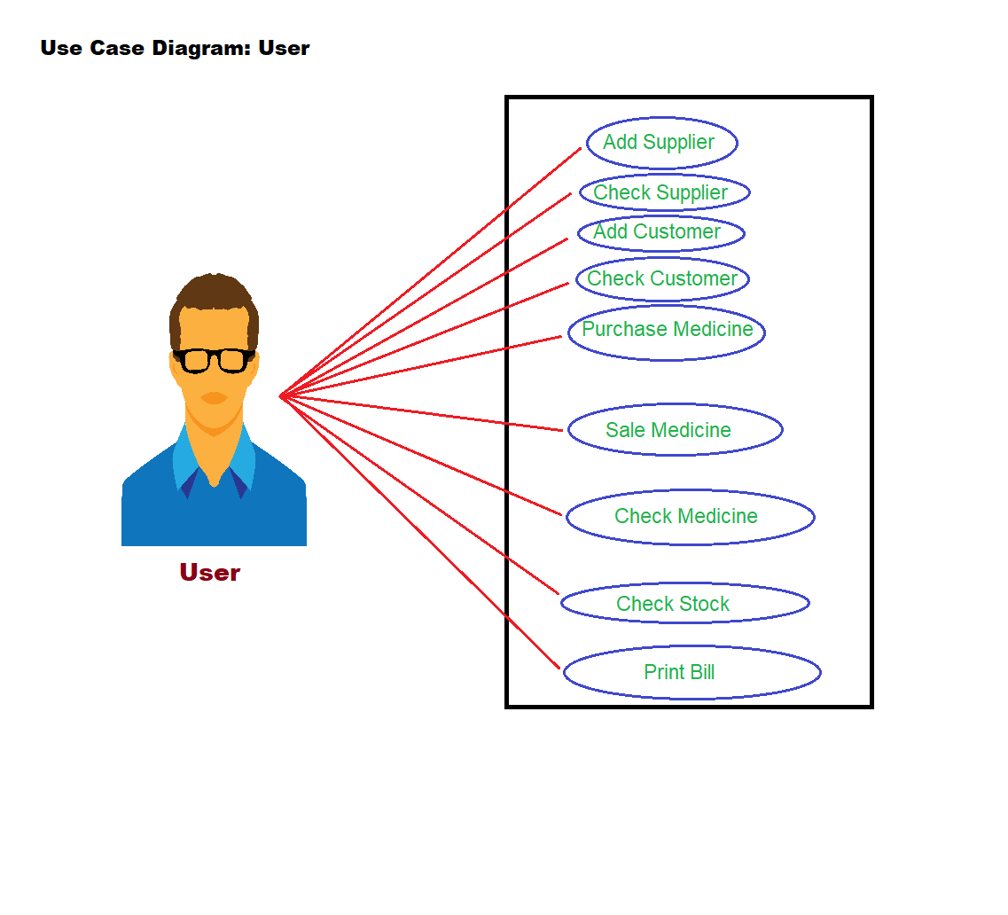

**2.1 Use Case Description**

|  |  |  |
| --- | --- | --- |
| **User** | Case | Purpose |
| **Add Supplier** | User can add supplier |
| **Check Supplier** | User can check the list of customers |
| **Add Customer** | User can add supplier |
| **Check customer** | User can check the list of customers |
| **Purchase Medicine** | User can purchase medicine from supplier |
| **Sell Medicine** | User can sell medicine to the customer |
| **Search Medicine** | User can search medicine in the stock |
| **Check Stock** | User can check the list of all medicines in the list. |
| **Print Bill** | User can print bill for customer and see the net amount of the medicine. |

Chapter 3 **System Design**

3.1 **Entity link**

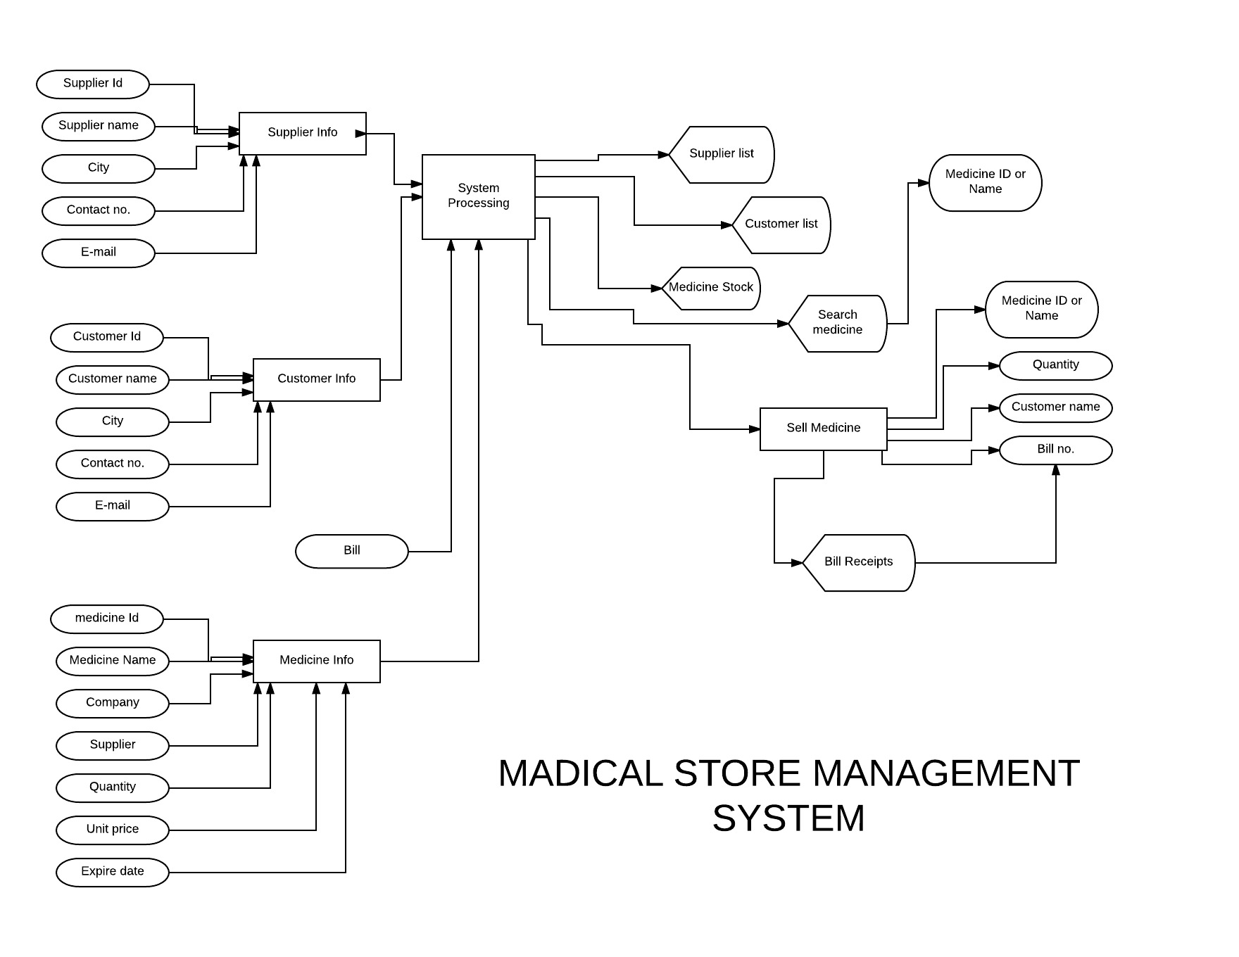

Chapter 4: **Implementation**

**4.1 Tools and Technology**

1. Laptops.

2. Code blocks 16.1

3. C programming Language

**Chapter 5: testing**

**5.1 Test cases**

**Log in page**

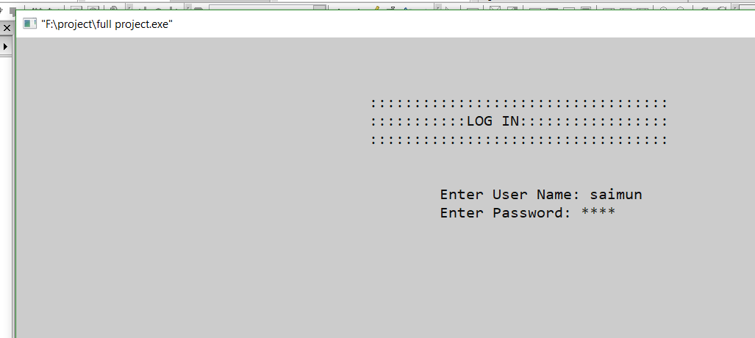

Main Menu Page:

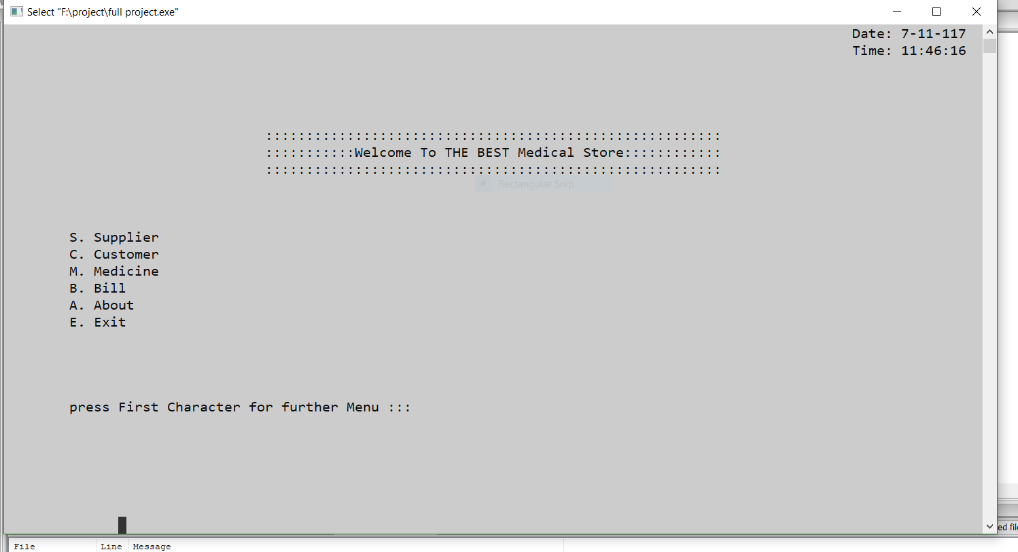

Supplier Entry page:

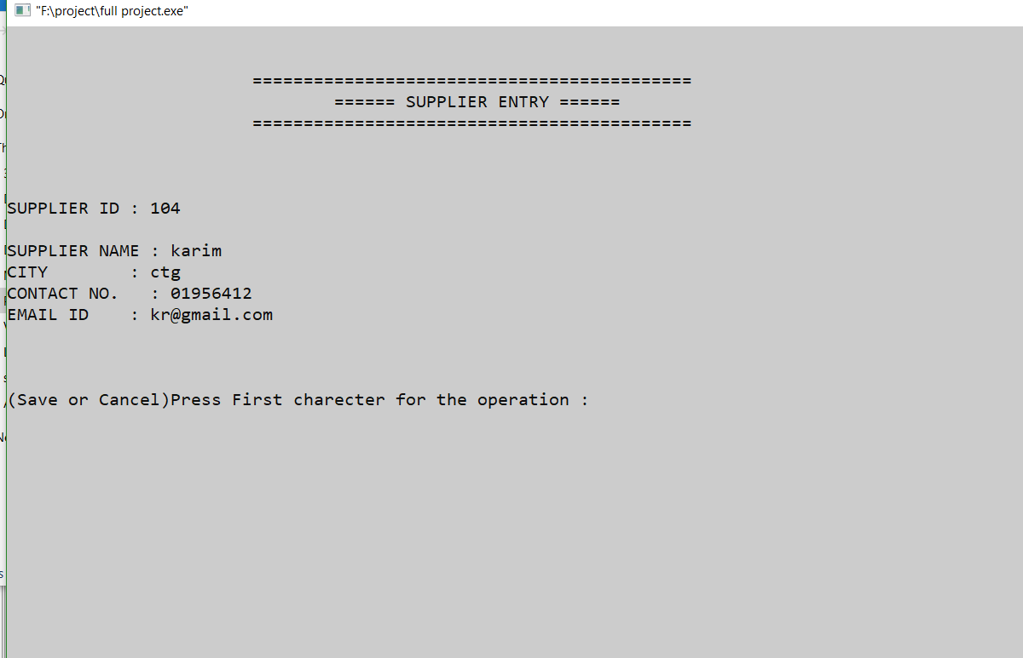

Supplier List page:

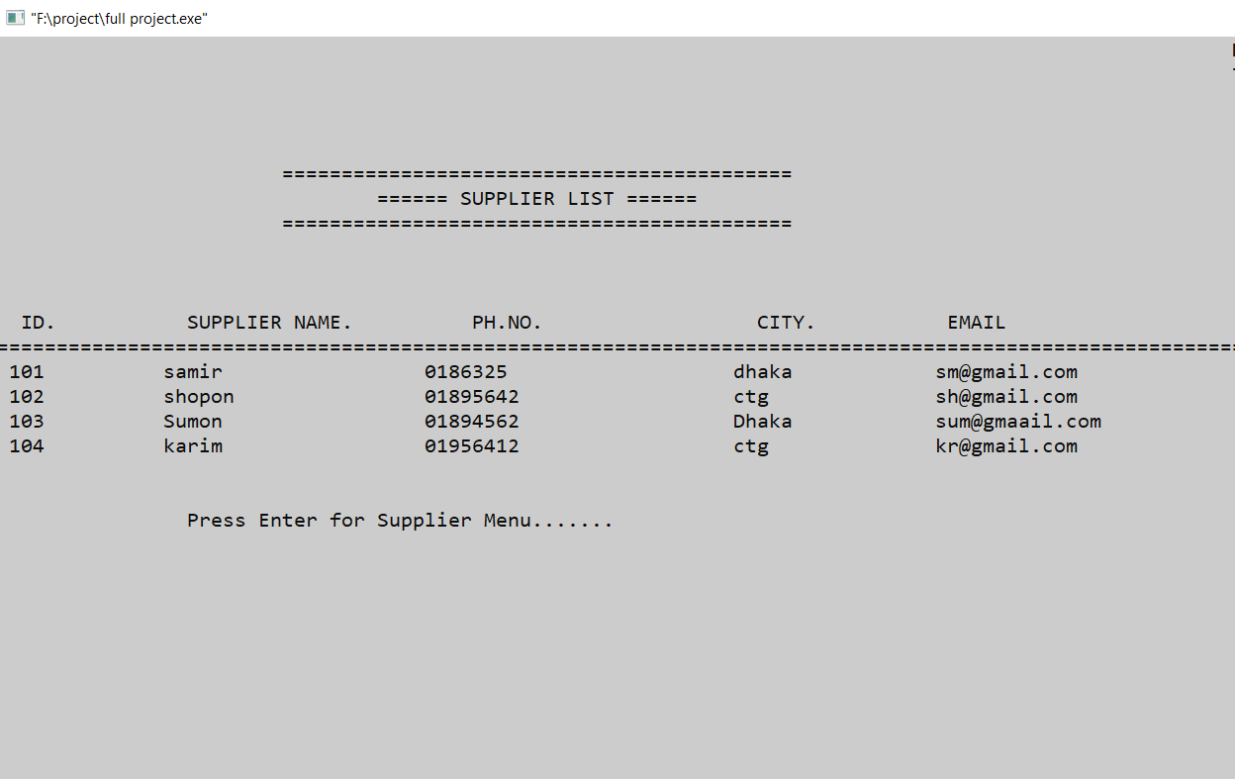

Customer Entry page:

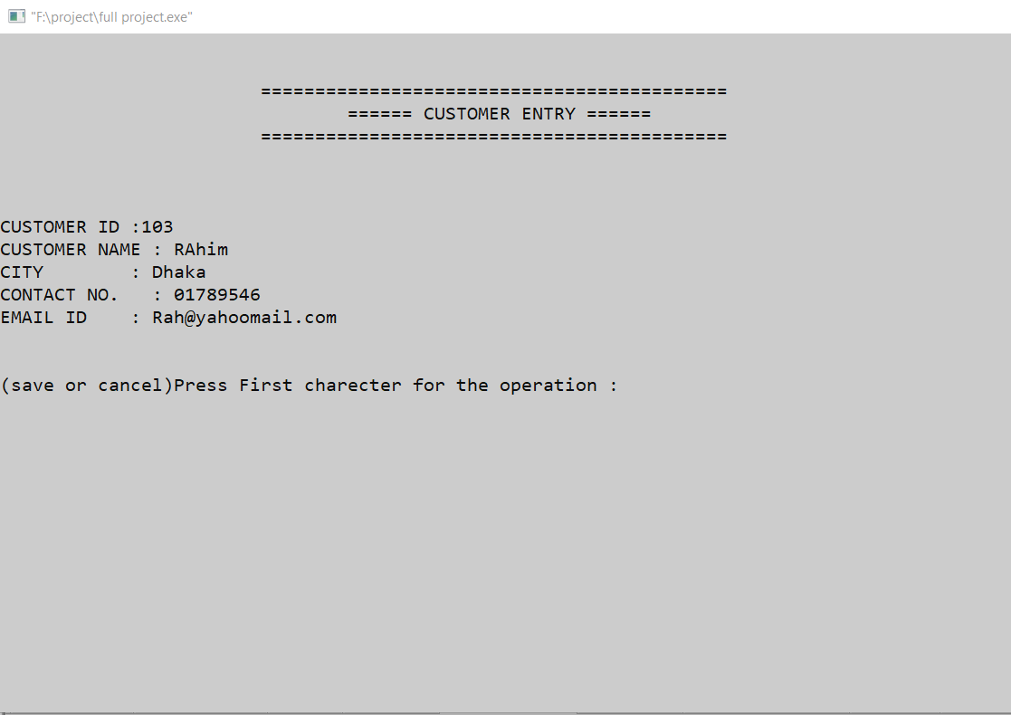

Customer list page:

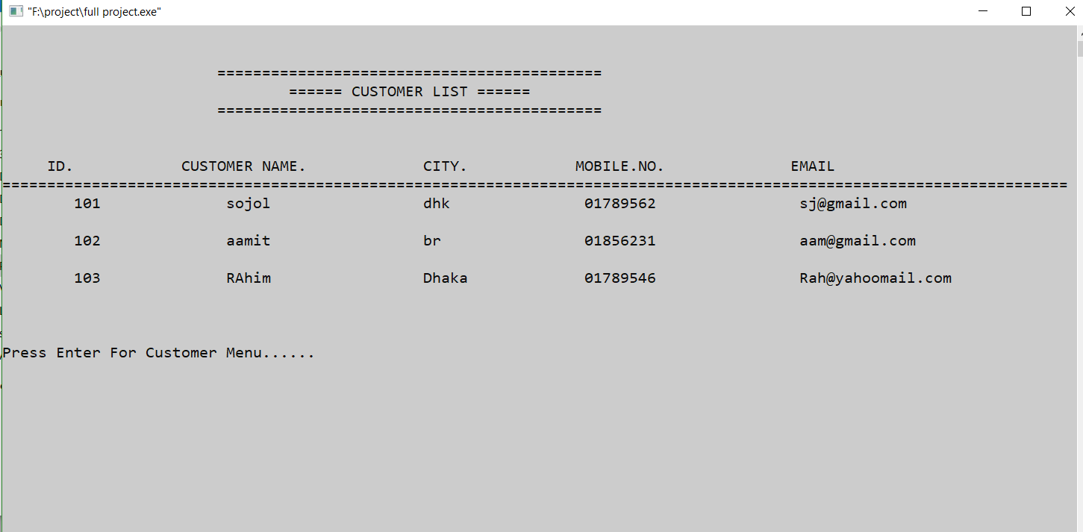

Purchase Medicine page:

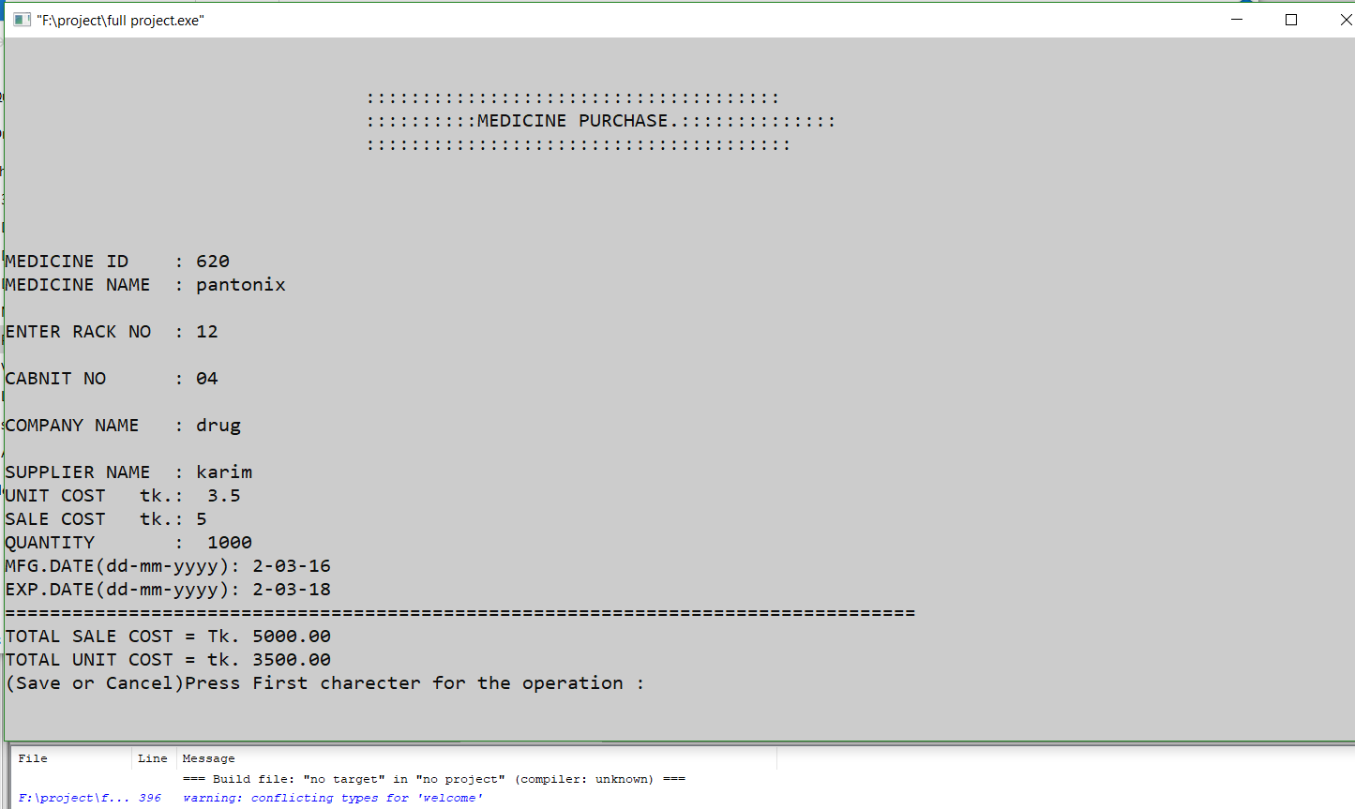

Sale medicine page:

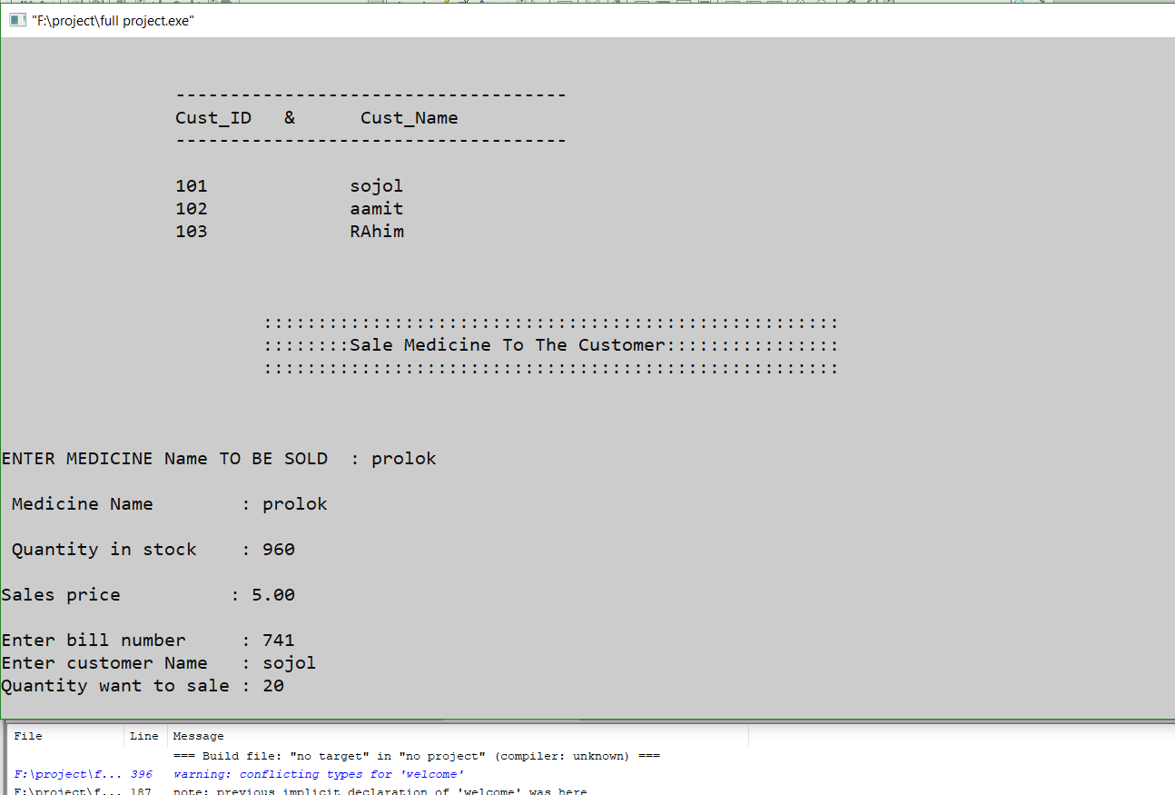

Check Medicine stock page:

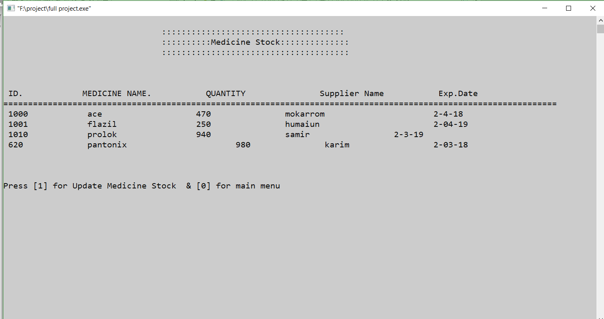

Search medicine page:

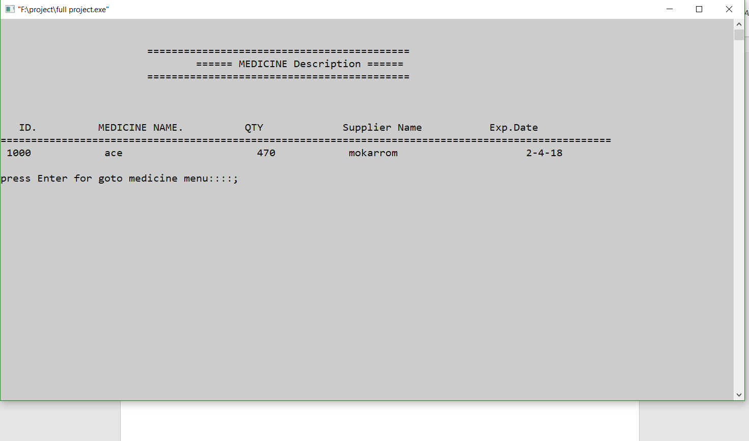

Bill Receipts page:

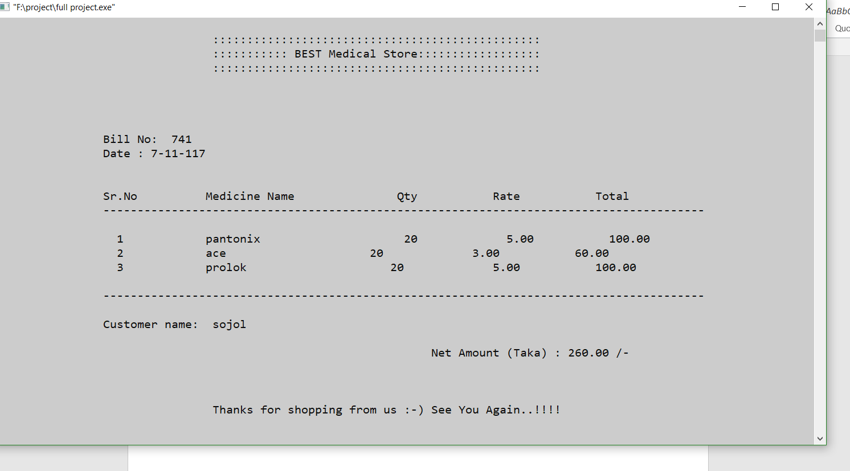

About The system page:

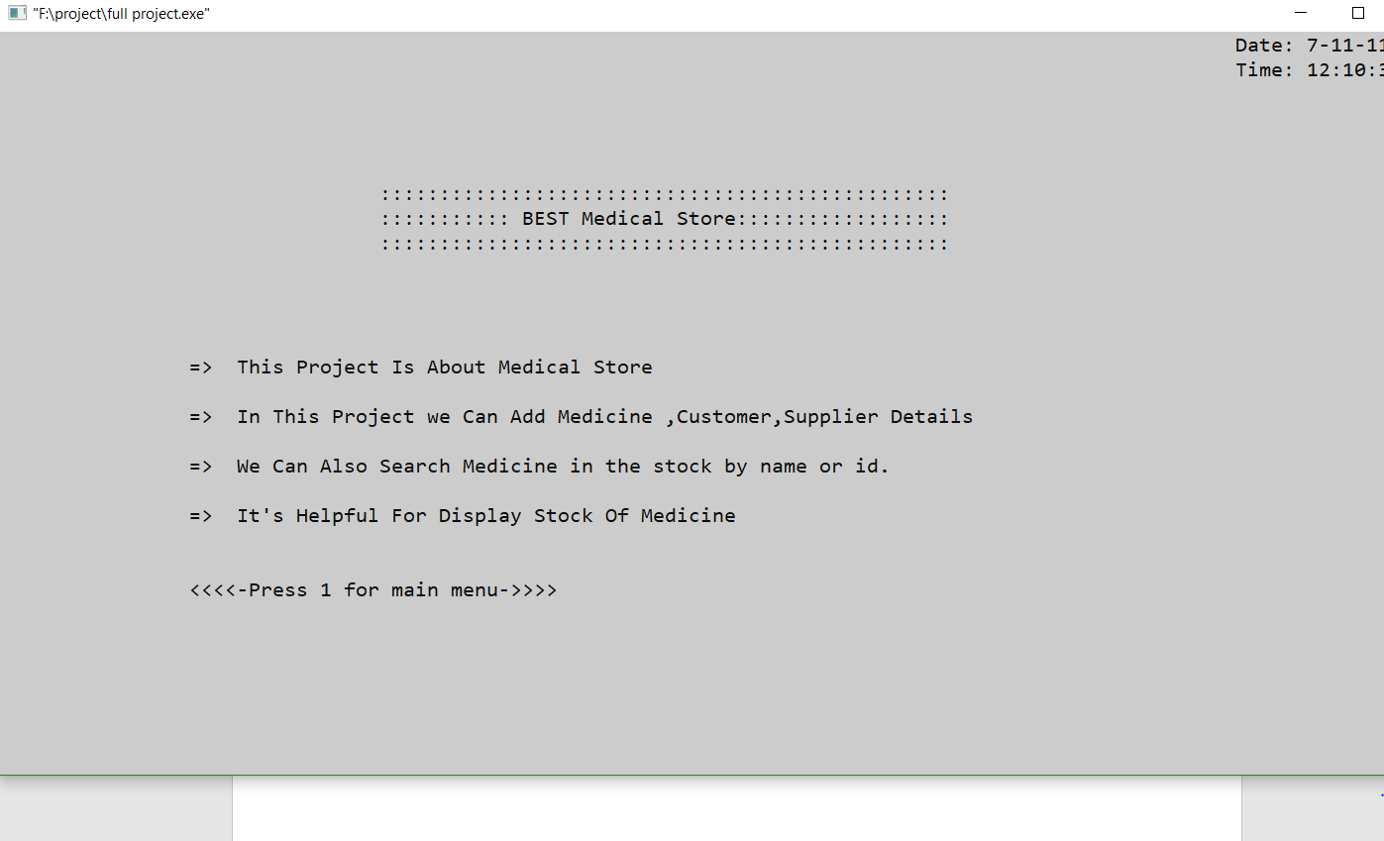

**Chapter 6: Conclusion**

**6.1 Good Feature**

* Save customer and supplier information for future operations.
* purchase easily and save them to the stock.
* Sell medicine to the customer and reduce quantity from stock.
* Search medicine.
* Check stock.
* Create bill for customer and show total amount.
  1. **Limitation of the project**
* In c program we can’t use many features like graphics, database system etc.
* In c data is not secured.
* C doesn't support the concept of constructors and destructors.
* Difficult to relate with real world objects.
  1. **Future Enhancement**
* Add report for daily sell, purchase, profit etc.
* Create two portals for store owner and user.
* In future I will make full system in other programming language.

**Chapter 7: User Manual**

**7.1 Instruction**

At first, we add all supplier who supplied the medicine in the store. Then We have seen the all existing supplier in the supplier list. We have some regular customer that need their information’s. So, we can add customer and see the list of customers in database.

For selling medicine we need purchase medicine first. We purchase medicine from company by supplier. Purchased medicine will go to stock. Then we sell medicine to the customer from stock. In stock we will see all medicine information. We also search medicine in the stock and find the information of the medicine. In bill option we create bill receipts for the customer and total amount of the medicine show there.

**CHAPTER 8: REFERENCES**

[1] DATA STRUCTURE WITH C by Seymour Lipschutz

[2] COMPUTER PROGRAMMING – 1st part by Tamim Sharier

[3] DATA STRUCTURE & ALGORITHM by Seymour Lipschutz

[4] https://www.youtube.com/watch?v=Bacf3wTY2EQ