A Survey of ZigBee Wireless Sensor Network Technology: Topology, Applications and Challenges

Abstract:
ZigBee technology is one of the most popularly deployed wireless technologies in recent years. It is used basically in wireless sensors and control networks. This is because ZigBee is an open standard, low-cost and low-power protocol that allows true operability between systems. It is built on existing IEEE802.15.4 protocol and therefore combines the IEEE 802.15.4 features and newly added features to meet required functionalities. Although the ZigBee design specification includes security features to protect data communication confidentiality, however, when simplicity and low-cost are the major goals, security suffers

Introduction:
Recent advances in Microelectromechanical Systems, tiny microprocessors and low power radio technologies have created low-cost, low-power, multi-functional sensor devices, so that we need another communication technology that suits these needs.
Wireless sensor networking is one of the most popular and active research areas in networking and communication field in recent years. Consequently, many workshops and conferences are being arranged annually on this emerging technology. This attraction resulted from the fact that the technology is exciting with unlimited potential for numerous applications based on wireless sensor networks (WSNs). Application areas include environmental, military, telecommunication, transportation, entertainment, crisis management, health, retail services and smart homes. Wireless sensor network (WSN) is many nodes with sensing capabilities which gather information from physical processes/events (e.g., temperature, sound, vibration, pressure, motion, or pollutants) and communicate the processed data to the base station.
ZigBee is a new open-standard wireless protocol developed by ZigBee Alliance (consisting of over 270 companies). The history of ZigBee started back in 1998 when it was first conceived and supported. ZigBee is particularly targeted at low-power, low-cost and low data rate wireless sensor and control networks, aimed at interoperability, it is easy to implement and can support up to 65,000 nodes depending on the type of topologies used.
ZigBee has a transmission range of 10 – 100 meters. Comparing ZigBee with Wi-Fi and Bluetooth, ZigBee has a maximum throughput of 250Kbps while Bluetooth (except 802.11n) and Wi-Fi transmit at 3Mbps and 54Mbps respectively. While Wi-Fi devices (e.g., Wi-Fi VoIP phones) are reported to have 8 – 12hours of battery life and Bluetooth devices with a battery life of a few days, many ZigBee devices can boast of a battery life of up to 5years. The huge power saving resulted from relatively short-range of transmission, low data transfer rates and simple protocol

ZigBee technology:

- Device types
1- Zigbee physical device types
1-Full function device (FFD)
can function in any topology, is capable of being the network coordinator and can talk to any other device. FFD can operate in three modes, personal area network coordinator, a coordinator or an end device.
2- Reduced function device (RFD)
is limited to star topology, can’t become a network coordinator, talks only to a network coordinator has very simple implementation. RFD can only operate as an end device.
The IEEE Zigbee standard requires at least one FFD to work as network coordinator, but endpoints can be FFD or RFD.
2-Zigbee logical device types
- Coordinator:
Forms the root of the network tree and might bridge to other networks. There is exactly one coordinator in each network. It is responsible for initiating the network and selecting the network parameters such as radio frequency channel, unique network identifier and setting other operational parameters. It can also store information about networks and security keys.
- Router:
Router acts as intermediate nodes, relaying data from other devices. Routers can connect to an already existent network, also able to accept connections from other devices and be some kind of re- transmitters to the network. Network may be extended through the use of ZigBee routers.
- End device:
End Device can be low power/ battery powered devices. They can collect various information from sensors and switches. They have sufficient functionality to talk to their parents (either the coordinator or a router) and cannot relay data from other devices. This reduced functionality allows for the potential to reduce their costs. They support better low
power models. These devices do not have to stay awake the whole time, while the devices belonging to the other two categories have to. Each end device can have up to 240 end nodes which are separate applications sharing the same radio.

- Network topologies
- Star Topology:
Star topology consists of one coordinator and any number of end devices. In star
Topology, a master slave network model is adopted where master is the ZigBee coordinator, which is FFD, and slave will be either FFD or RFD. ZigBee end devices are
physically and electrically separated from each other end devices and pass information through coordinator. Devices can only communicate with the coordinator.
This does not provide multi-hop networking and mesh networking.
- Cluster topology:
The cluster tree topology is like the star topology. The difference is that other
Nodes can communicate with each other so that more RFD/FFDs can be connected to non-coordinator FFDs. The advantage of this topology is the possible geographical expansion of the network.
- Mesh topology:
In mesh topology, each node can communicate with any other node within its range. Mesh
topology is complex to maintain, and beaconing is not allowed here. But it is more robust and tolerant to fault.
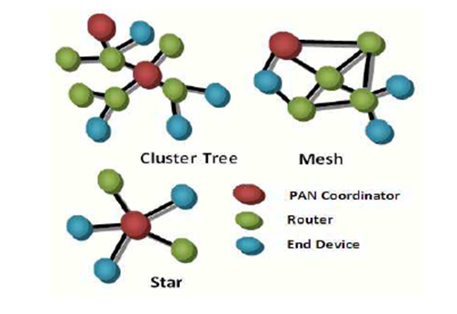

- Zigbee protocol
The IEEE 802.15.4 protocol specifies the Medium Access Control (MAC) sub-layer and physical layer for Low-Rate Wireless Private Area Networks (LR-WPAN). Even though this standard was not specifically developed for wireless sensor networks, it is intended to be suitable for them since sensor networks can be built up from LRWPANs. In fact, the IEEE 802.15.4 protocol targets low-data rate, low power consumption, low-cost wireless networking, with typically fits the requirements of sensor networks.

- Mac layer:
The MAC layer defines two types of nodes: Reduced Function Devices (RFDs) and Full Function Devices (FFDs). FFDs can act as a network coordinator or an end device. While RFDs can only act as an end device. The network coordinator may operate its PAN with a super frame or without it. When operating with super frame it starts the super frame with a beacon serving for synchronization purposes as well as to describe the super frame structure and send control information to the network. The super frame as shown in the next figure is divided into an active and an inactive portion (where the network coordinator may go to sleep and save energy).
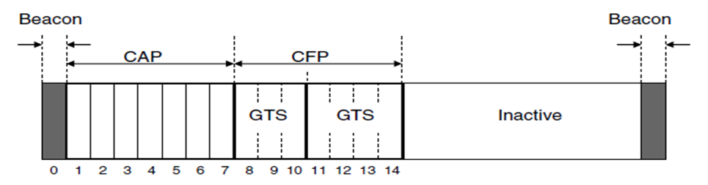
The active portion is divided into fixed size slots and contains a Contention Access Period (CAP), where nodes compete for channel access using a slotted CSMA-CA protocol, and a Contention Free Period (CFP), where nodes transmit without contending for the channel in Guaranteed Time Slots (GTS) assigned and administered by the network coordinator. When the end device needs to send data to coordinator, it needs to wait for a beacon to synchronize and later contend for channel access. The communication between coordinator and end device is not direct as end devices sleep most of time and wake up periodically and check if there any messages to receive.
When communicating without super frame, the network coordinator never sends beacons and communication happens based on unslotted CSMACA. The coordinator is always on and ready to receive data from an end-device while data transfer in the opposite direction is poll-based: the end device periodically wakes up and polls the coordinator for pending messages.
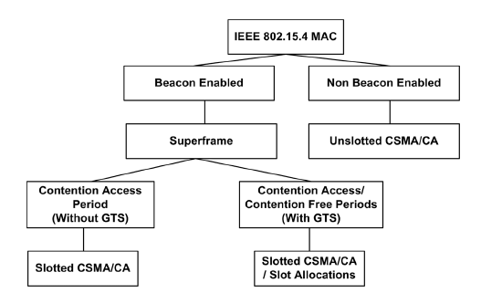
- Physical layer
Zigbee physical layer supports 3 bands of frequencies, a 2450 MHz band with 16 channels, a 915 MHz band with 10 channels and an 868MHz band with only one channel. All these channels use direct sequence spread spectrum access mode, at 2450 MHz band we use offset quadrature phase shift keying (O-QPSK) for modulation, While the 868MHz and 915MHz we use binary phase shift keying (BPSK).
- Zigbee applications
ZigBee Applications:
- Medical Care Applications
medical care application called Code Blue based on wireless sensor networks it is a remote medical care system. Patients can be well monitored no matter if they are in hospital or at home. It is used to detect patients’ physiological statuses. These sensors can be used to collect heart rates and oxygen saturation information.
- Fire Emergency Applications
A project called Fire Information and Rescue Equipment to improve fire-fighting equipment. It can protect fire fighters and help to relieve victims. Fire fighters are equipped with a Telos mote, a wearable computer, and a fireproof mask called FireEye. Wireless smoke and temperature sensors are deployed in a building to monitor the environment. When a fire emergency occurs, wireless sensor can provide real-time emergency-related information, which can be shown on FireEye. FireEye mask can also show other fire fighters’ locations. The Telos sensor monitors fire fighter’s heart rate and air tank level and propagates the information to other fire fighters.
- Future Data Communication System applications
It is likely that ZigBee will increasingly play an important role in the future of computer and communication technology as the IEEE 802.15.4–based ZigBee is designed for remote controls and sensors, which are very many in number, but need only small data packets and, mainly, extremely low power consumption for (long) life.
- Home Automation applications
ZigBee can be used to remotely control doors, lighting, security alarm, heating, cooling, and other residential applications.
- Smart Energy applications
ZigBee enables wireless communication between home area networks (HAN) and advanced metering infrastructure thereby enhancing quick reading of water, gas, and electrical meters. It also helps utility companies to effectively manage services provided to their customers, especially during peak demands.

5. Challenges
Despite of the huge number of practical applications of Zigbee sensor network, there are many challenges that face these technology
- Energy Limitation
Wireless sensor nodes are usually powered with batteries and replacing batteries in the field is often not practicable. Since a WSN must operate for a given network operation time or as long as possible, meeting the energy requirement with batteries becomes a challenge. Energy limitation can be improved by the use of solar cells, which can be charged as the battery is being in use. However, this is only applicable to applications in light exposed environments. Also, sensor nodes have now been designed with improved energy efficiency and balanced energy harvesting techniques to enable them to operate for several years without battery replacement
- Self-Management
WSNs are usually deployed in remote and harsh environments (which may not be predetermined or engineered) and often without infrastructural support, repair and maintenance. Consequently, sensor nodes are exposed to system and environmental dynamics thus posing a significant challenge for building reliable sensor networks [11]. Therefore, the need to build a self-managed WSN network in terms of self-organization, self-optimization, self-protection and self- healing becomes a necessity.
- connectivity Challenge
The fact that WSNs use wireless communication system also poses a number of challenges to their design especially when maintaining a balance between signal strength, power (transmitted and received) and distance. Increasing the distance between a sensor node and a base station increases the required transmission power and decreases signal strength. For energy and connectivity efficiency, the need to split large distances into several shorter distances using multi hop communication and routing becomes essential. Moreover, to conserve energy, some sensor nodes do switch off their radios when they are not in use thereby preventing them from receiving messages from Neighbours during down time and creating synchronization and connectivity problems. Arbitrary long sleep periods can also reduce the responsiveness and effectiveness of a sensor. However, sensor nodes now use wake up on demand strategies and adaptive duty cycling to conserve power and still maintain connectivity in WSNs. In adaptive duty cycling, some nodes sleep while others are active to form network backbone.

6. latest researches
- Accurate Phase Detection for ZigBee Using Artificial Neural Network
The IEEE802.15.4 standard uses a physical layer of binary phase-shift keying (BPSK) modulation and can be operated with two frequency bands, 868 and 915 MHz, and Offset Quadrature Phase Shift
Keying (O-QPSK) operates with frequency band 2.4 GHz.
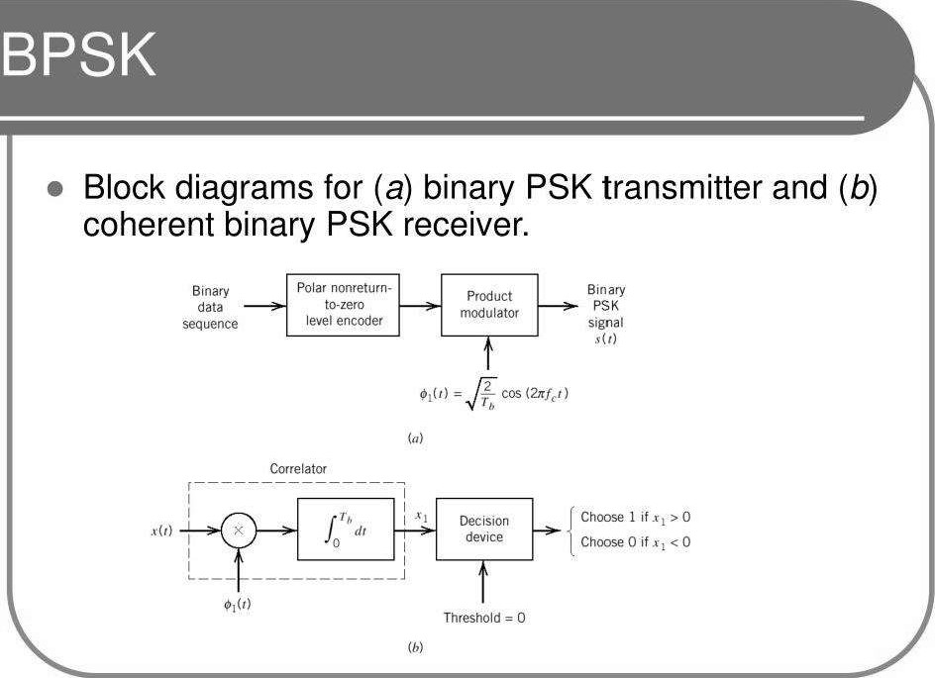
The frequency noise could interfere with the modulated signal (the BPSK signal), which causes distortion to the signal before its arrival at receiver. Therefore, filtering the modulated signal (the BPSK signal) from noise is essential to ensure carrying the signal from the sender to the receiver with less error.
This paper develops a neural network predictive detection method to enhance the performance of BPSK modulation.
By enhancing the BPSK phase signals at the receiver side by:
- Reducing the noise interfered with the BPSK signal at the receiver side of ZigBee.
- To do that, we implemented the RNN model to detect the noisy signal of the BPSK system via predicting the phase.

Architecture of RNN
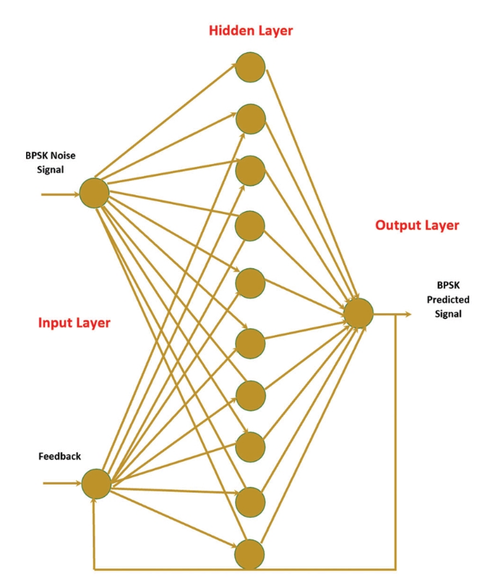
We briefly showed Recurrent Neural Network (RNN) in architecture, It consists of three layers: input, hidden, and output layer. The input layer is fed with the input signal x(t), which is the noisy phase signal of the BPSK system. The hidden layer has ten nodes to perform the required calculation to predict the actual signals of BPSK. After that, the estimated value is delivered to the output layer y(t). The feedback node is an essential part of the RNN because it feeds the input layer with the previous prediction y(t - 1), which leads to an increase in the accuracy of the prediction procedure.

- LigBee: Symbol-Level Cross-Technology Communication from LoRa to ZigBee

Low-power wide-area networks (LPWAN) evolve rapidly with advanced communication primitives (e.g., coding, modulation) being continuously invented. This rapid iteration on LPWAN, however, forms a communication barrier between legacy wireless sensor nodes deployed years ago (e.g., ZigBee-based sensor node) with their latest competitor running a different communication protocol (e.g., LoRa-based IoT node): they work on the same frequency band but share different MAC- and PHY-layer regulations and thus cannot talk to each other directly. To break this barrier, we propose LigBee, a cross-technology communication (CTC) solution that enables symbol-level communication from the latest LPWAN LoRa node to legacy ZIGBEE node. The experimental results show that i) LigBee achieves a bit error rate (BER) in the order of 10 ⁻³ with 70 ∼ 80% frame reception ratio (FRR), ii) the range of LigBee link is over 300m, which is 6 ∼ 7.5× the typical range of legacy ZigBee and iii) the throughput of LigBee link is maintained on the order of kbps, which is close to the LoRa’s throughput.

A Design for a Lithium-Ion Battery Pack Monitoring System

Based on NB-IoT-ZigBee.

This study proposes a battery monitoring system based on NB-IoT-ZigBee technology. The system operates in a master-slave mode, with the subordinate module collecting parameters such as the temperature, voltage, current, and strain of the battery pack and performing preliminary fault detection. The data are then transmitted to the master control module via ZigBee. The master control module uploads the collected data to a local upper computer via a serial port, and the local upper computer uploads the data to a local monitoring center via a TCP connection for staff inspection. The master control module also uploads the data to a cloud platform via NB-IoT, enabling the remote monitoring of the energy storage station when the local monitoring center is unattended. Finally, the test results demonstrate that the designed monitoring system effectively monitors and protects energy storage station batteries and has potential applications in energy storage stations.

7.References
- "IEEE Standard for Telecommunications and Information Exchange Between Systems - LAN/MAN Specific Requirements - Part 15: Wireless Medium Access Control (MAC) and Physical Layer (PHY) Specifications for Low Rate Wireless Personal Area Networks (WPAN)," in IEEE Std 802.15.4-2003 , vol., no., pp.1-680, 1 Oct. 2003, doi: 10.1109/IEEESTD.2003.94389.
- Wireless sensor networks: A survey on the state of the art and the 802.15.4 and ZigBee standards
- AJU, Omojokun G. A survey of zigbee wireless sensor network technology: Topology, applications and challenges. International Journal of Computer Applications, 2015, 130.9: 47-55.‏
- Wang, Lijun, Chengguang Wang, Xu Lu, Dongzhi Ping, Shitong Jiang, Xinxin Wang, and Jianyong Zhang. 2023. "A Design for a Lithium-Ion Battery Pack Monitoring System Based on NB-IoT-ZigBee" Electronics 12, no. 17: 3561. https://doi.org/10.3390/electronics12173561
- Z. Wang et al., "LigBee: Symbol-Level Cross-Technology Communication from LoRa to ZigBee," IEEE INFOCOM 2023 - IEEE Conference on Computer Communications, New York City, NY, USA, 2023, pp. 1-10, doi: 10.1109/INFOCOM53939.2023.10229005.

