Report

physical layer :
- IEEE 802.15.4 Physical Layer Specifications
the physical layer protocol functions and interacts with MAC layer which defines the hardware level requirement such as jamming resistance, receiver sensitivity and transmitter output power etc.
Physical layer of ZigBee networking protocol layer performs following tasks:
• Activation and deactivation of the radio transceiver.
• Energy detection (ED) with in the current channel.
• Link quality indicator for received packets.
• Clear channel assessment (CCA) for carrier sense multiple access with collision avoidance (CSMA-CA).
• Channel frequency selection.
• Data transmission and reception.
• Energy detection
• Carrier sense (CS)
• Link Quality Indicator (LQI)
• Clear channel assessment (CCA)
- Data rate and frequency of operation
There are three bands of operating frequency for ZigBee. They are 868 MHz, 915 MHz, and 2.4 GHz band. Since 2.4 GHz frequency band is available worldwide, the 2.4 GHz band is widely used for short range wireless communication 868 and 915 MHz band are respectively used in Europe and North America
- PHY Layer Services
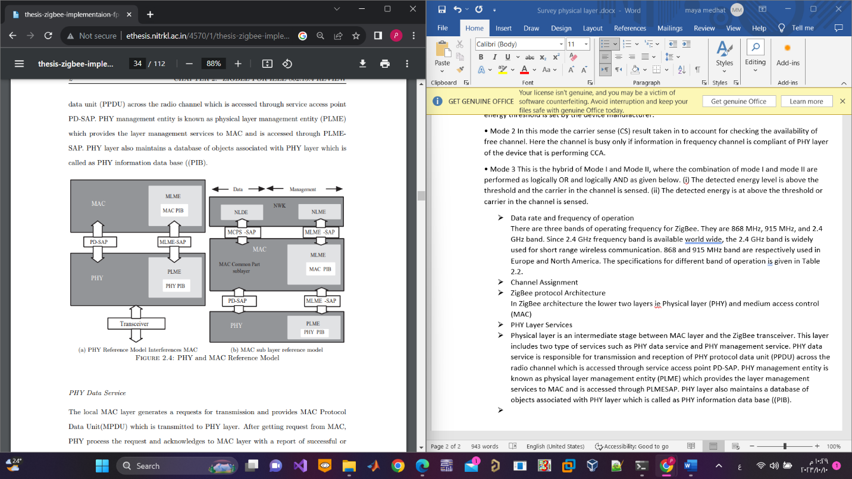
Physical layer is an intermediate stage between MAC layer and the ZigBee transceiver this layer includes two type of services such as
- PHY data service
It is responsible for transmission and reception of PHY protocol data unit (PPDU) across the radio channel which is accessed through service access point PD-SAP.
- PHY management service
It’s known as physical layer management entity (PLME) which provides the layer management services to MAC and is accessed through PLMESAP performs following tasks
  - Clear channel assessment
  - Signal Energy detection
  - Enabling and disabling the radio transceiver
  - Obtaining information from PHY-PIB
  - Setting the value of PHY layer information base attribute
PHY layer also maintains a database of objects associated with PHY layer which is called as PHY information data base ((PIB).
- Data transfer between devices
When data is received by radio transceiver, the PHY layer notifies MAC layer for reception of MAC PDU (MPDU) PHY layer not only provides the MPDU to the MAC layer, it also delivers the Link Quality
Indicator (LQI) information.
- the MAC and PHY layer frame formats
The preamble field is used by the transceiver to obtain chip and symbol synchronization with an incoming message The length of the preamble is 4 bytes The start of the frame delimiter (SFD) field indicates the end of the synchronization header (SHR) and the start of the PHY header (PHR). The length of SFD is 1 byte .The frame length field is 7 bits in length and specifies the total number of octets contained in the PHY service data unit (PSDU). The PSDU field carries the data of the PHY packet. The maximum size of this field is 127 bytes . Together, the SHR, PHR, and PSDU form the PHY protocol data unit (PPDU).
- acknowledgment frame
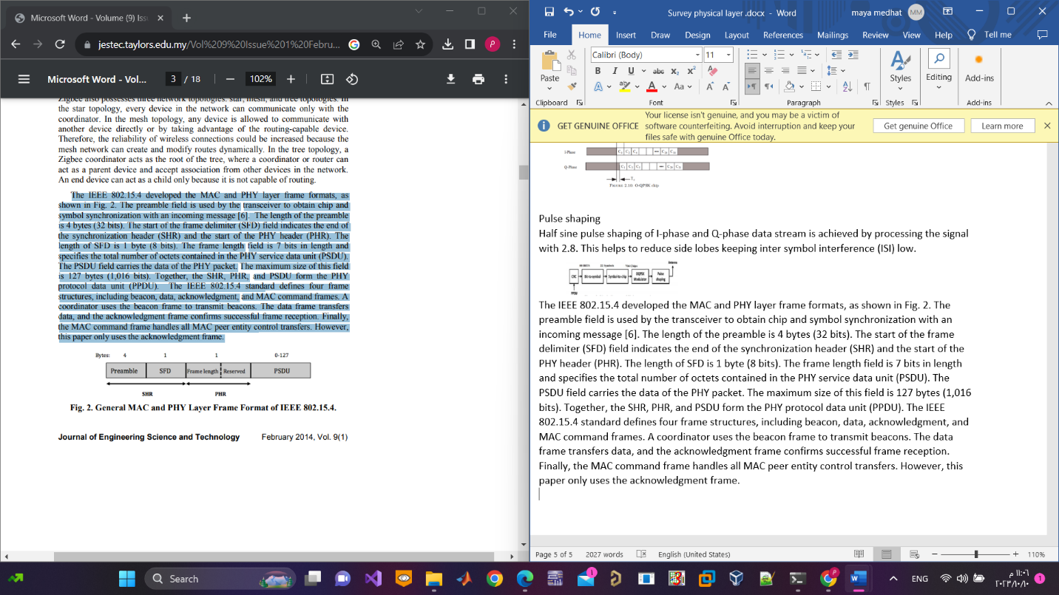

Zigbee transceiver:
- Design of ZigBee Transmitter
- The Modulation and Spreading Methods for 2.4GHz Operation:

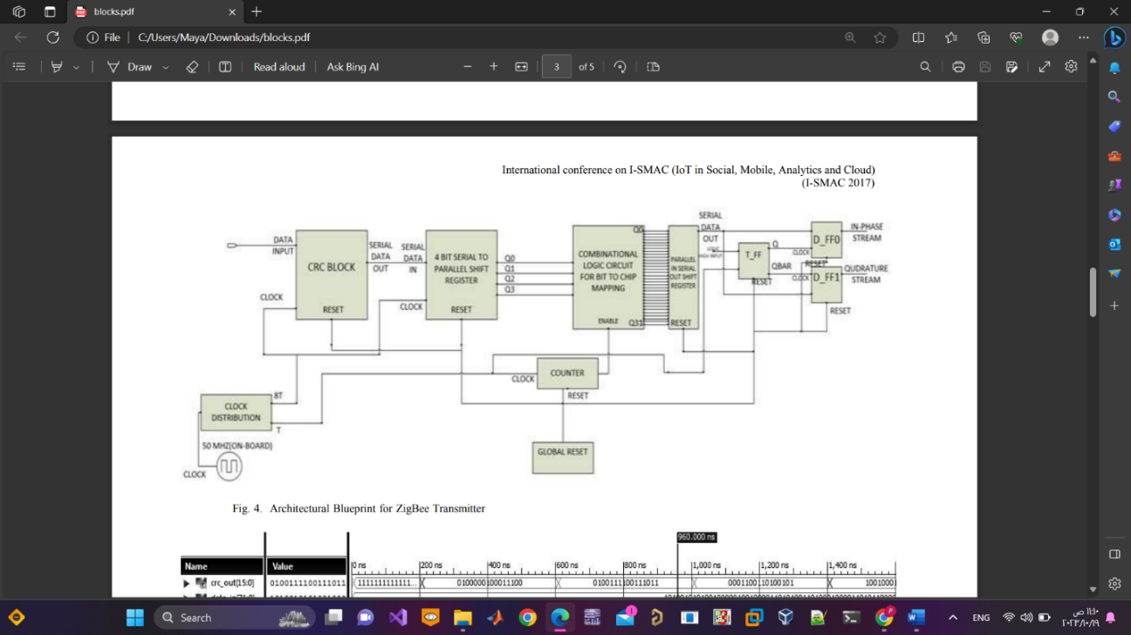
ZigBee transmitter comprises of five blocks such as
- CRC
CRC stands for Cyclic Redundancy Check Codes. Error detecting is a technique of detecting bit errors occurring due to noise or attenuation during data transmission. The CRC calculation is based on the polynomial arithmetic. The bits of the binary data represent the coefficients of the polynomial. For example, the message 11001001 represents a polynomial of $x^{7}+x^{6}+x^{3}+1$The sender and receiver, both have the generator polynomial.
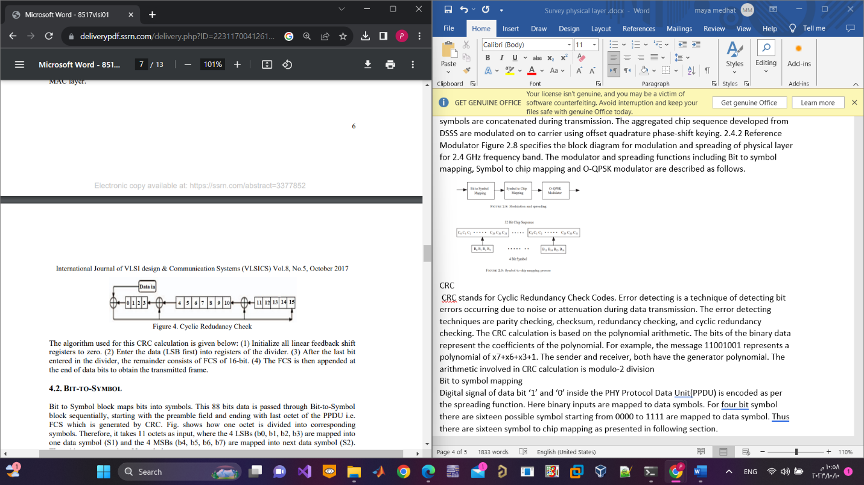
- Bit to symbol mapping
Bit to Symbol block maps bits into symbols bits of data is passed through this block sequentially, starting with the preamble field and ending with last octet (8 bit value ) of the PPDU each one octet LSBs (b0, b1, b2, b3) are mapped into one data symbol (S1) and the 4 MSBs (b4, b5, b6, b7) are mapped into next data symbol (S2)
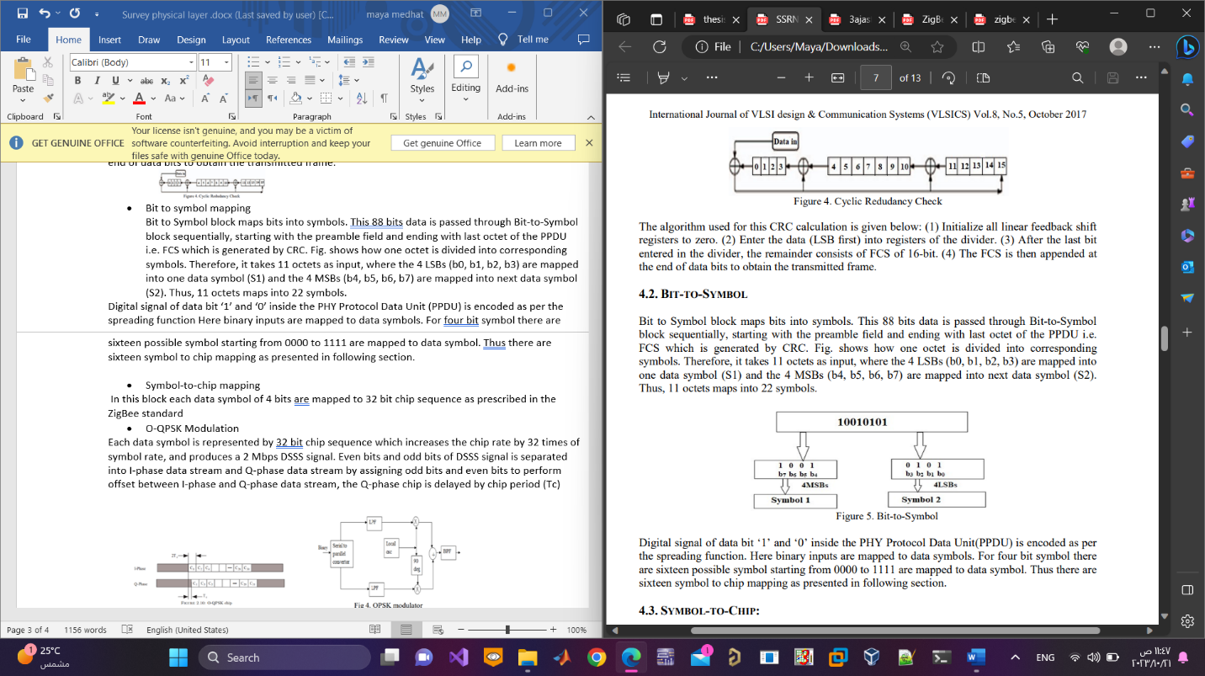
- Symbol-to-chip mapping
In this block each data symbol of 4 bits are mapped to 32 bit chip sequence as prescribed in the ZigBee standard, The output which has come from bit-to-symbol as taken input of symbol-to chip.
- O-QPSK Modulation
OQPSK modulator is the improved version of QPSK. The Chip sequences representing each data symbol are modulated on to the carrier using OQPSK with half sine pulse shaping. The fundamental OQPSK method is to sum the in-phase signal delayed by half a cycle is order to avoid the sudden phase shift change Each data symbol is represented by 32 bit chip sequence which increases the chip rate by 32 times of symbol rate, and produces a 2 Mbps DSSS signal. Even bits and odd bits of DSSS signal is separated into I-phase data stream and Q-phase data stream by assigning odd bits and even bits to perform offset between I-phase and Q-phase data stream

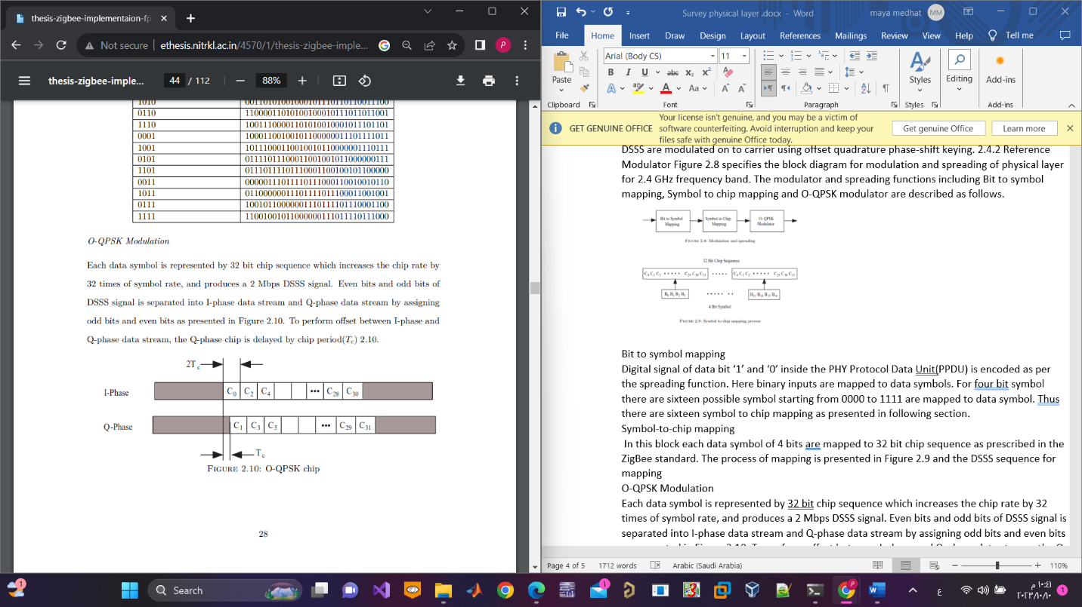

- Pulse shaping
Half sine pulse shaping of I-phase and Q-phase data stream is achieved by processing the signal this helps to reduce side lobes keeping inter symbol interference (ISI) low.

- Design of ZigBee receiver:
Zigbee receiver mainly consist of three blocks:
- Demodulator 2- despreading block 3- data decoder

As shown in the next figure:
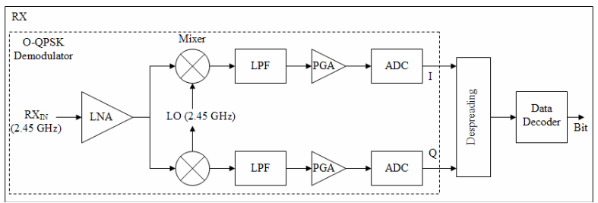

- Demodulator

That block demodulates the received signal as it was modulated using OQPSK modulator and the demodulator block is shown in the next figure
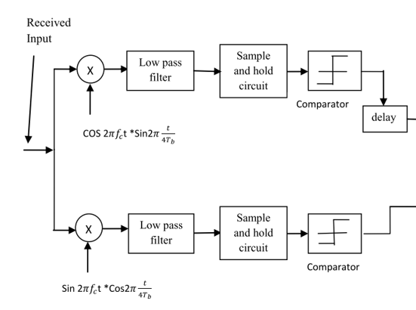

- Dispreading Block
This block returns the data from chip sequence to original data
One of the techniques which is used to despread is xnor input data with the PN sequences as shown
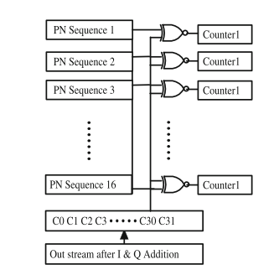
- Decoder which decodes data into stream of bits

Reference
- https://papers.ssrn.com/sol3/papers.cfm?abstract_id=3377852
- https://ajast.net/data/uploads/3ajast-39.pdf
- https://ieeexplore.ieee.org/abstract/document/8058369/
- Oh, Nam-Jin, and Sang-Gug Lee. "Building a 2.4-GHz radio transceiver using IEEE 802.15. 4." IEEE Circuits and Devices Magazine 21.6 (2006): 43-51.
- Supare, Vivek, and Mahendra Dhadwe. "Design & Implementation of MQAM based zigbee Transceiver using HDL." International Journal of Engineering Research and General Science 3.1 (2015).
- Rao, Pasala Raja Prakasha, and B. Rajendra Naik. "Verilog Based Design and Simulation of MAC and PHY Layers for Zigbee Digital Transmitter."
- El Oualkadi, Ahmed, and Denis Flandre. "Notice of Violation of IEEE Publication Principles: HDL system-level design of O-QPSK receiver for 2.4-GHz band IEEE 802.15. 4." 2007 International Conference on Design & Technology of Integrated Systems in Nanoscale Era. IEEE, 2007.
Recurrent Neural Network:
The traditional receiver of the Zigbee wireless device mainly consists of the demodulator circuit and the decision-making elements, the traditional demodulator circuit suffers from some effects that increase the probability of errors taking place and degrade the performance of the system, these effects are mainly the frequency offset phenomena that exists due to the difference between the transmitter and the receiver oscillators, some complex circuits or solutions were used to mitigate that effect. The second effect is the phase offset which is added to the signal in its way to the receiver.
The Recurrent Neural Network is the best neural network to deal with sequential data and generate output. To make these networks efficient they must be exposed to suitable training.
By deciding the form of the data that will be transmitted by the transmitter and the symbols with their frequency we can make an excellent training set which the neural network will be trained with to generate the binary data that was originally transmitted.
In addition to that, we got from the standards of the Zigbee the maximum effects that would be added to the system signals by the environment behaviors, and by adding these effects to the training sets and retrain the network again to make our system immune to the frequency and phase effects and hence the total performance of the system and improve the bit error rate.
For now, we have some problems that must be solved. Now the Zigbee signal frequency is around 2.4GHz band and we need to sample these signals and quantify them to process these data by the neural network.
If the signal frequency is 2.4GHz the sampling frequency value will be what, 4.8GHz? it does not make sense at all. To overcome this problem before the sampling the analog received signal will be multiplied by an oscillation signal of high frequency for example 2.41GHz and pass the result by a Low Pass Filter now we have our signal on 10MHz we can sample it by 20MHz and this value makes sense and can be implemented.
AES :

Enhancing Security in ZigBee Wireless Sensor Networks
Introduction:
Zigbee technology suffers from a wide range of security weaknesses, ZigBee uses the Advanced Encryption Standard (AES), and this is symmetric key block cipher for securing data of sensitive networks and applications is expected to be vulnerable to some attacks in the near future. The National Institute of Standards and Technology (NIST) has published a report stating that all versions of the AES are expected to remain secure beyond 2030. In a previous report by the National Security Agency (NSA) in the IETF, symmetric ciphers with a key size of 256 bits or more were projected to remain secure until 2245. Therefore, the current version of AES requires alternative solutions to strengthen its security. Asymmetric cryptography cannot be used in wireless sensor network devices because it is resource-intensive and unsuitable for wireless sensor networks, so we need to improve the encryption process of a regular AES without the need for asymmetric cryptography.
To achieve that, we will use
- A secure one-way hash function operation when D2TC (device to trust center communication) and D2D (device to device communication) mutually authenticate each other
- Dynamic identity.
- Mutual authentication, where both parties are authenticated before transmission

Network model:
Before we introduce the solution, we will make a quick review about the ZigBee network model.
The ZigBee network topology consists of three main types: star topology, tree topology, and mesh topology. Star or mesh topologies are commonly used as the primary architecture in ZigBee networks. In mesh networks, as shown in the Figure, TC assumes the role of both routing traffic and managing devices on the network. End devices can communicate with the network through the TC.
The TC is responsible for managing information about each device and initiating and maintaining the network, since it is aware of all devices within its network. During initialization, authentication through the TC is required for each ZigBee device, and all communication between devices must go through the TC to establish a session encryption key and for authentication purposes. Consequently, every ZigBee network must have a TC. 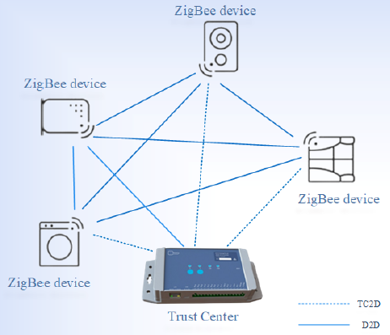

Proposed solution:
The proposed solution consists of two primary stages. The first stage is the device authentication and key agreement phase, which includes three sub-phases: (i) offline phase, (ii) authentication phase, and (iii) communication phase.
The second stage involves strengthening the cryptography based on AES by utilizing a secure value exchanged in the first stage to enhance the cryptography of exchanged data in the ZigBee network

The first stage:
- Offline phase
To establish secure D2TC and D2D communication in ZigBee networks, every device (Di) is required to register its master key and identity ID with the relevant TC during an offline phase to prevent unauthorized devices from gaining access.
- Authentication phase
In this section, D2TC authentication process is described. During the offline phase, if a device (Di) has participated, its ID address should be available in the authenticated devices list that is stored in the TC’s memory. If the ID matches one from the stored list, the requesting device (Di) will receive an encrypted message to begin the communication process. In our proposed solution, we prioritize the security and protection of ZigBee devices’ real identities (IDs) by ensuring that they are never transmitted in plain text. This is achieved by exclusively utilizing dynamic IDs during both the authentication and communication phases.
Step1: Device to trust center
The device D1 generates three parameters, namely, KD1, CTRD1, and RAD1. KD1 is the key that will be used for encrypting the exchanged data with D1. The counter CTRD1 is incremented with each message. RAD1 is a random array of bytes equal to the block size used in AES. The device D1 creates a dynamic identity DIDD1 = h(IDD1, CTRD1) that changes for every session. This method ensures that the DIDD1 is unique in every session and can only be traced by the TC. Then D1 concatenates IDD1, KD1, CTRD1, and RAD1 and calculates the hash value HD1 = h(CTRD1, (IDD1||KD1||CTRD1||RAD1)). This ensures that HD1 is computed based on two dynamic values, enabling the detection of attacks even if one of the values is compromised. Finally, D1 encrypts (IDD1, KD1, CTRD1, RAD1) using the KTC and sends the message {IDTC, DIDD1, HD1, (IDD1, KD1, CTRD1, RAD1)_KTC } to the TC.
Step 2: Trust center to device
After receiving the message, the TC decrypts it using KTC, looks up IDD1, and subsequently carries out a validation process. Then, TC calculates the hash value of *HD1 and DIDD1 and proceeds to compare them against the received HD1 and DIDD1 for verification. The TC stores D1 information, KD1, CTRD1, DIDD1, and RAD1 in its database. Then, the TC increments CTRD1 by 1. Next, it concatenates the (DIDD1||IDTC). After that, the TC computes the hash value, HTC1 = h(CTRD1, (DIDD1||IDTC)). Then, the TC sends the message to D1. Finally, the TC increments CTRD1 again by 1 and computes for the upcoming session DIDD1 = h(IDD1, CTRD1). On the other side, D1 computes both the hash value and dynamic identity of D1. Then, it verifies whether these values match those received from the TC. When a match is identified, it signifies the accurate validation of the message’s integrity. Finally, D1 updates the CTRD1 value and the new dynamic identity for the upcoming session. At the end of this stage, as explained in steps 1 and 2, both D1 and the TC authenticate each other, and the parameters (IDD1, CTRD1, DIDD1, and RAD1) are securely sent between D1 and TC. The second stage describes the communication among devices. We assume that the ZigBee device D1 wants to communicate as a sender with the ZigBee device D2 as a receiver.
- communication phase
In this section, we discuss the D2D communication phase, during which a device verifies the identity of one or more devices. Once verified, the devices establish a shared key and a secure array of bits that can be employed later to establish an encrypted communication channel. The following steps discuss the communication process in this phase.
Step 1: Device (D1) to device (D2)
Device D1 sends a request to establish communication with an authenticated device D2. The message contains the device’s dynamic identity DIDD1, the identity of trust center IDTC, and the identity of the second device IDD2 encrypted using KD1. Then, the D1 computes the hash value of those parameters and CTRD1, HD1 = h (CTRD1, (IDTC||DIDD1||(IDD2)_kTC).
Step 2: Device (D2) to trust center
After constructing its message using the same method, device D2 forwards both the information it received from D1 and its own information to the trust center, requesting a temporary session key.

Step 3: Trust center authentication
The messages received by TC from D2 are validated by reconstructing HD1 and HD2 with KD1, KD2, CTRD1, and CTRD2 for the corresponding stored DIDD1 and DIDD2. The comparison of the hash value computed at TC, HTC for both D1 and D2, and matching with HD1 and HD2 confirms the message is authentic, as only D1 and D2 have access to KD1, KD2, CTRD1, and CTRD2. In addition, they can construct a valid message.

Step 4: Trust center to device (1) and trust center to device (D2)
TC creates the session key KSD12 and random array of bits RAD12, and subsequently sends them to D1 and D2 in an encrypted form using KD1 and KD2, respectively.
Step 5: Devices (D1 and D2) authentication
After receiving the encrypted information, D1 and D2 retrieve the secret session key using their respective private keys KD1 and KD2. The presence of CTRD1 and CTRD2 in the received message assures both devices that the message is new. At this stage, both devices can communicate securely utilizing the session key KSD12.
Remark: We assume that the generated random array of bytes that will be used to strength the cryptography of AES will be used in the encryption process at the point that The devices need to send sensed data to the TC or other devices in the ZigBee network.
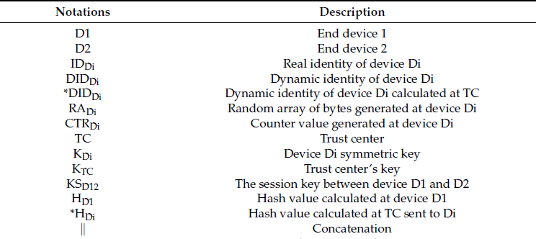

Drawbacks of these enhancements:
As we noticed we will need more computational power to calculate the hash functions and we need more storage space and counters.
There is overhead because of the hash function bits and the dynamic ID bits.

References
Allakany, Alaa, et al. "Enhancing Security in ZigBee Wireless Sensor Networks: A New Approach and Mutual Authentication Scheme for D2D Communication." Sensors 23.12 (2023): 5703.

