**CMPS 312 – Mobile Application Development**

**Final Practical Exam – 18 November 2020**

|  |  |  |  |
| --- | --- | --- | --- |
| **Student name:** | **Abdulla Khedr** | **Student Id:** | **201702167** |

**Grading Rubrics**

|  |  |  |  |
| --- | --- | --- | --- |
| Criteria | % | Functionality* | Quality of the implementation |
| 1. Display Visits | 30 | Working 100% |  |
| 2. Add Visit | 35 | Working 100% |  |
| 3. Update Visit | 15 | Working 100% |  |
| 4. Delete Visit | 10 | Working 100% |  |
| 5. Init continents and countries tables | 10 | Working 100% |  |
| **Total** | **100** |  |  |
| Provide screenshots in *testing.docx* | - |  | *[-10pts if missing]* |

**\* Possible grading for functionality**: ***Complete and*** ***Working*** (get 70% of the assigned grade), ***Complete and*** ***Not*** ***working*** (lose 60% of assigned grade) and ***Not done*** get 0. The remaining grade is assigned to the quality of the implementation. Must submit screenshots in **Testing-GradingSheet.docx** (otherwise -10pts).

**Testing screenshots**

**1. Display Visits**

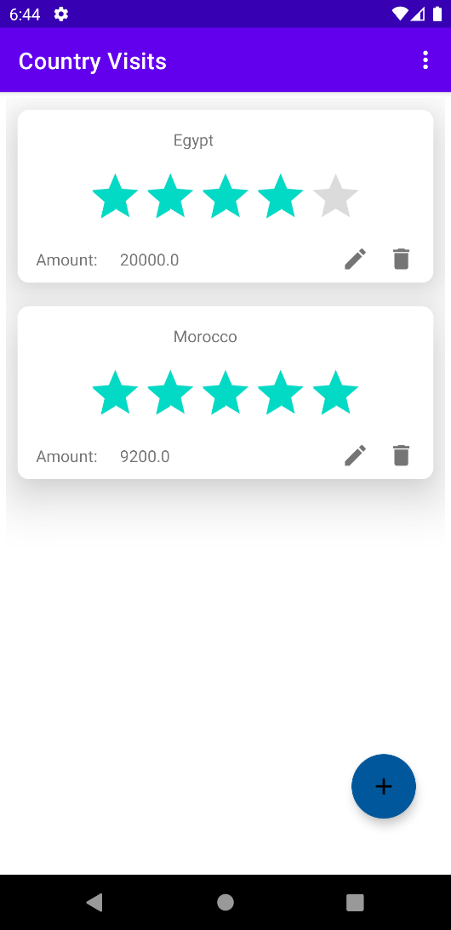

**2. Add Visit**

**3. Update Visit**

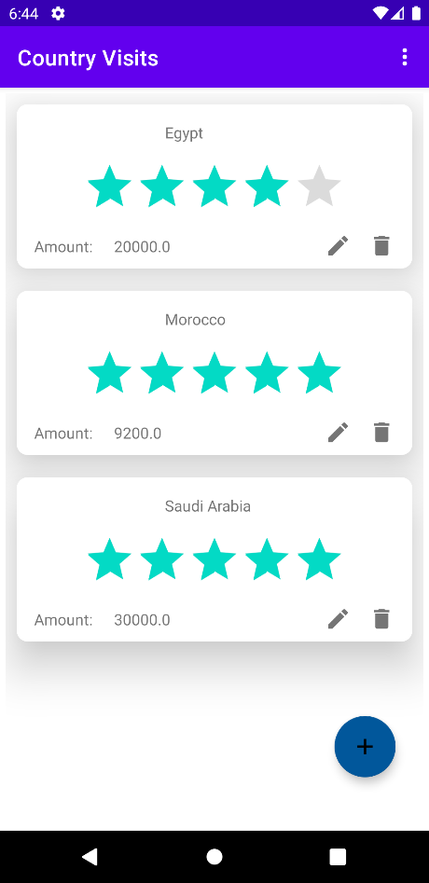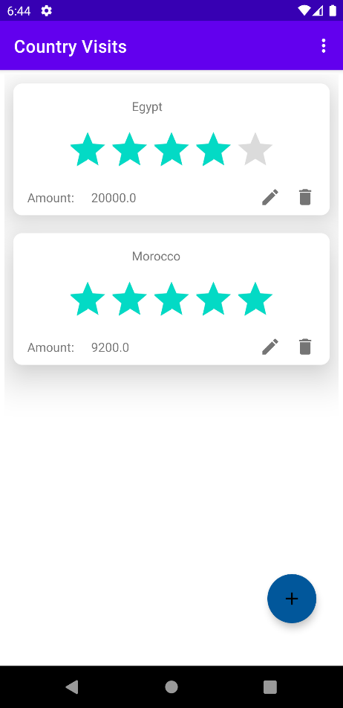

**4. Delete Visit**

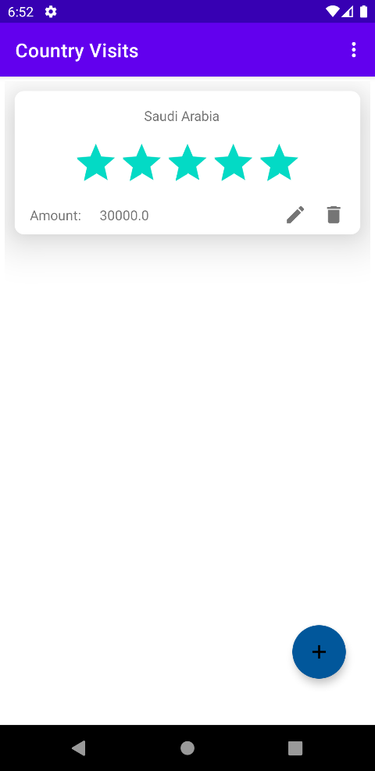

**5. Init continents and countries tables**

(you can include a screenshot of the tables filled with continent and country data)

