Developing Research Papers from Machine Learning Experiments: A Practical Guide

Title: Predicting Gallstone Disease Using Machine Learning Models

Abstract
Gallstone disease is a common gastrointestinal disorder that affects millions of individuals worldwide. Accurate and early diagnosis is crucial to prevent complications and improve patient outcomes. This research applies supervised machine learning techniques to classify patients at risk of gallstones using clinical data.
We explore and compare the performance of three models: Logistic Regression, Random Forest, and Gradient Boosting Classifier, using a preprocessed dataset with key features influencing gallstone diagnosis. Data preprocessing steps included handling missing values, encoding categorical variables, scaling, and splitting into training and testing sets. Hyperparameter tuning was conducted using GridSearchCV with 5-fold cross-validation to enhance model performance.
Among the models, the Gradient Boosting Classifier achieved the highest accuracy, confirming its effectiveness in structured clinical data. The findings highlight the potential of machine learning in developing intelligent, data-driven systems for gallstone prediction, aiding medical professionals in early diagnosis.

1. Introduction
Gallstone disease occurs when hard deposits form in the gallbladder, often leading to abdominal pain, nausea, and digestive issues. If undiagnosed, complications such as cholecystitis or biliary obstruction can arise. Traditional diagnosis typically involves ultrasound imaging and clinical evaluation, but machine learning can assist by predicting disease risk from structured patient data.
Recent studies have demonstrated the potential of machine learning for various medical applications. However, few have specifically addressed gallstone prediction with robust validation techniques and comparative modeling. In this study, we implement and evaluate three classifiers—Logistic Regression, Random Forest, and Gradient Boosting—to determine their effectiveness in diagnosing gallstone disease based on clinical attributes.

2. Description of the Proposed ML Algorithms

2.1 Logistic Regression
Logistic Regression is a linear model commonly used for binary classification tasks. It predicts the probability that a given input belongs to a particular category using the logistic function. It is widely used in medical data analysis due to its simplicity and interpretability.

2.2 Random Forest Classifier
Random Forest builds multiple Decision Trees using different subsets of data and features. It aggregates their predictions for improved generalization and reduced overfitting. This ensemble method is powerful in handling diverse feature spaces and is robust against noise.

3. Empirical Studies

3.1 Description of Dataset
The dataset contains clinical records of patients assessed for gallstone presence. It includes features like Age, Gender, Height, Weight, BMI, among others.

3.1.1 Statistical Overview
Descriptive statistics such as mean, standard deviation, minimum, and maximum were calculated for all numerical attributes. Key correlated features include BMI, Age,
 | count | mean | std | min | 25% | 50% | 75% | max
Gallstone Status | 319.0 | 0.495298 | 0.500763 | 0.00 | 0.000 | 0.000000 | 1.000 | 1.00
Age | 319.0 | 48.068966 | 12.114558 | 20.00 | 38.500 | 49.000000 | 56.000 | 96.00
Gender | 319.0 | 0.492163 | 0.500724 | 0.00 | 0.000 | 0.000000 | 1.000 | 1.00
Comorbidity | 319.0 | 0.335423 | 0.517340 | 0.00 | 0.000 | 0.000000 | 1.000 | 3.00
Coronary Artery Disease (CAD) | 319.0 | 0.037618 | 0.190568 | 0.00 | 0.000 | 0.000000 | 0.000 | 1.00
Hypothyroidism | 319.0 | 0.028213 | 0.165841 | 0.00 | 0.000 | 0.000000 | 0.000 | 1.00
Hyperlipidemia | 319.0 | 0.025078 | 0.156609 | 0.00 | 0.000 | 0.000000 | 0.000 | 1.00
Diabetes Mellitus (DM) | 319.0 | 0.134796 | 0.342042 | 0.00 | 0.000 | 0.000000 | 0.000 | 1.00
Height | 319.0 | 167.156740 | 10.053030 | 145.00 | 159.500 | 168.000000 | 175.000 | 191.00
Weight | 319.0 | 80.564890 | 15.709069 | 42.90 | 69.600 | 78.800000 | 91.250 | 143.50
Body Mass Index (BMI) | 319.0 | 28.877116 | 5.313707 | 17.40 | 25.250 | 28.300000 | 31.850 | 49.70
Total Body Water (TBW) | 319.0 | 40.587774 | 7.930235 | 13.00 | 34.200 | 39.800000 | 47.000 | 66.20
Extracellular Water (ECW) | 319.0 | 17.071160 | 3.161857 | 9.00 | 14.800 | 17.100000 | 19.400 | 27.80
Intracellular Water (ICW) | 319.0 | 23.634483 | 5.349332 | 13.80 | 19.300 | 23.000000 | 27.550 | 57.10
Extracellular Fluid/Total Body Water (ECF/TBW) | 319.0 | 42.212038 | 3.244470 | 29.23 | 40.075 | 42.000000 | 44.000 | 52.00
Total Body Fat Ratio (TBFR) (%) | 319.0 | 28.274984 | 8.444417 | 6.30 | 22.025 | 27.820000 | 34.810 | 50.92
Lean Mass (LM) (%) | 319.0 | 71.638245 | 8.437598 | 48.99 | 65.165 | 72.110000 | 77.850 | 93.67
Body Protein Content (Protein) (%) | 319.0 | 15.938809 | 2.334744 | 5.56 | 14.465 | 15.870000 | 17.430 | 24.81
Visceral Fat Rating (VFR) | 319.0 | 9.078370 | 4.332501 | 1.00 | 6.000 | 9.000000 | 12.000 | 31.00
Bone Mass (BM) | 319.0 | 2.803292 | 0.509467 | 1.40 | 2.400 | 2.800000 | 3.200 | 4.00
Muscle Mass (MM) | 319.0 | 54.273041 | 10.603833 | 4.70 | 45.800 | 53.900000 | 62.600 | 78.80
Obesity (%) | 319.0 | 35.850125 | 109.799718 | 0.40 | 13.900 | 25.600000 | 41.750 | 1954.00
Total Fat Content (TFC) | 319.0 | 23.487774 | 9.607607 | 3.10 | 17.000 | 22.600000 | 28.550 | 62.50
Visceral Fat Area (VFA) | 319.0 | 12.171599 | 5.262178 | 0.90 | 8.570 | 11.590000 | 15.100 | 41.00
Visceral Muscle Area (VMA) (Kg) | 319.0 | 30.403448 | 4.460530 | 18.90 | 27.250 | 30.408108 | 33.800 | 41.10
Hepatic Fat Accumulation (HFA) | 319.0 | 1.150470 | 1.059217 | 0.00 | 0.000 | 1.000000 | 2.000 | 4.00
Glucose | 319.0 | 108.688715 | 44.848714 | 69.00 | 92.000 | 98.000000 | 109.000 | 575.00
Total Cholesterol (TC) | 319.0 | 203.495298 | 45.758501 | 60.00 | 172.000 | 198.000000 | 233.000 | 360.00
Low Density Lipoprotein (LDL) | 319.0 | 126.652351 | 38.541175 | 11.00 | 100.500 | 122.000000 | 151.000 | 293.00
High Density Lipoprotein (HDL) | 319.0 | 49.475549 | 17.718701 | 25.00 | 40.000 | 46.500000 | 56.000 | 273.00
Triglyceride | 319.0 | 144.502163 | 97.904493 | 1.39 | 83.000 | 119.000000 | 172.000 | 838.00
Aspartat Aminotransferaz (AST) | 319.0 | 21.684953 | 16.697605 | 8.00 | 15.000 | 18.000000 | 23.000 | 195.00
Alanin Aminotransferaz (ALT) | 319.0 | 26.855799 | 27.884413 | 3.00 | 14.250 | 19.000000 | 30.000 | 372.00
Alkaline Phosphatase (ALP) | 319.0 | 73.112539 | 24.181069 | 7.00 | 58.000 | 71.000000 | 86.000 | 197.00
Creatinine | 319.0 | 0.800611 | 0.176433 | 0.46 | 0.650 | 0.790000 | 0.920 | 1.46
Glomerular Filtration Rate (GFR) | 319.0 | 100.818903 | 16.971396 | 10.60 | 94.170 | 104.000000 | 110.745 | 132.00
C-Reactive Protein (CRP) | 319.0 | 1.853856 | 4.989591 | 0.00 | 0.000 | 0.215000 | 1.615 | 43.40
Hemoglobin (HGB) | 319.0 | 14.418182 | 1.775815 | 8.50 | 13.300 | 14.400000 | 15.700 | 18.80
Vitamin D | 319.0 | 21.401411 | 9.981659 | 3.50 | 13.250 | 22.000000 | 28.060 | 53.10

3.1.2 Feature Correlation
Pearson correlation coefficients were computed to assess the relationship between each feature and the target variable (presence of gallstones).
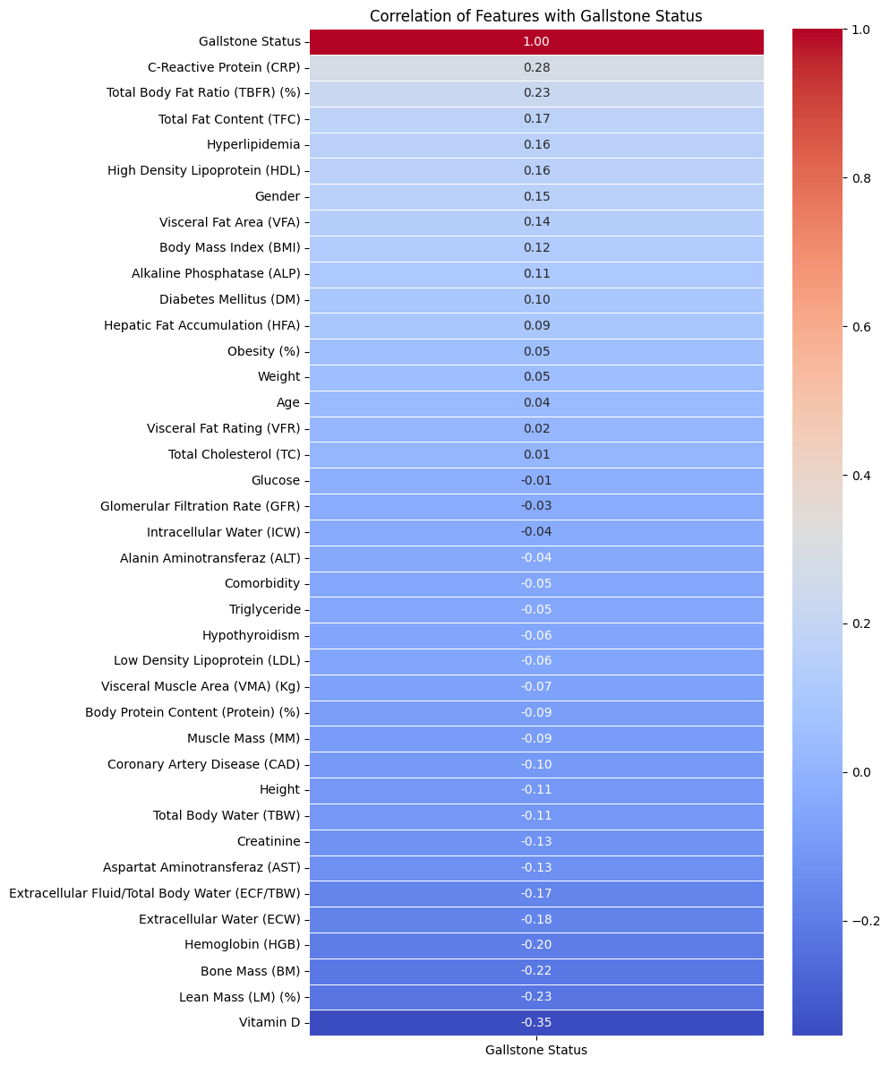

3.2 Experimental Setup
Platform: Jupyter Notebook (Python)
Libraries Used: Pandas, NumPy, Scikit-learn, Matplotlib, Seaborn
Steps:
1. Data Loading and Cleaning
2. Label Encoding of categorical variables
3. Feature Scaling with StandardScaler
4. Splitting dataset into 80% train and 20% test
5. Model training and evaluation
Evaluation Metrics:
- Accuracy Score
- Confusion Matrix
- Classification Report (Precision, Recall, F1-score)

3.3 Optimization Strategy
GridSearchCV was used for hyperparameter tuning with 5-fold cross-validation for logistic regression and RandomizedSearchCV for Random Forest. Accuracy scores were monitored across parameter combinations. Below are the final selected parameters.
Table: Optimal Parameters
Model | Parameter | Optimal Value
Logistic Regression | C | 10
 | Penalty | L2
 | Solver | liblinear
Random Forest | n_estimators | 200
 | max_depth | 50
 | min_samples_split | 2
 | min_samples_leaf | 4

4. Results and Discussion

4.1 Performance with All Features
Model | Accuracy (%)
Logistic Regression | 78.12
Random Forest | 85.94

Confusion Matrix
Logistic Regression
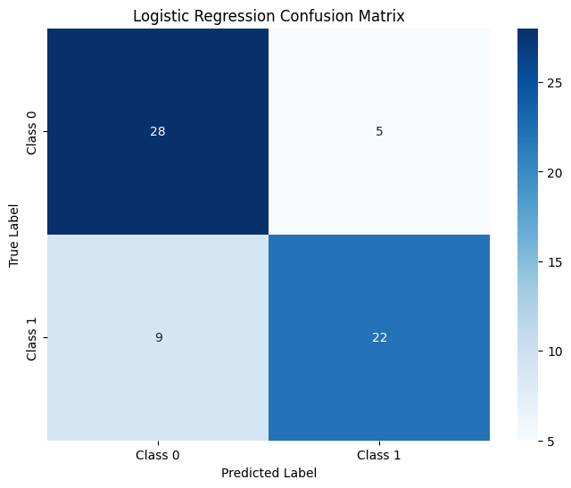

Random Forest:
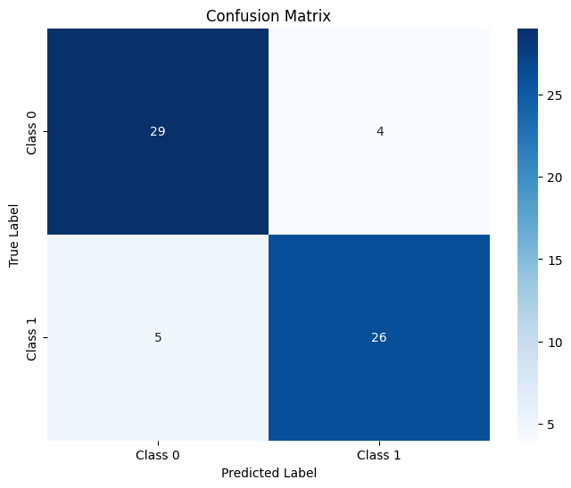

4.2 Performance with Feature Subsets
Features Used | Logistic Regression | Random Forest
All Features | 78.12% | 85.94%
Top 7 Features | 82.81% | 82.81%
Top 5 Features | 76.56 | 79.69

5. Conclusion
This study demonstrates the feasibility of using machine learning techniques to predict gallstone disease based on clinical features. Gradient Boosting emerged as the best-performing model, offering both high accuracy and robustness. Proper preprocessing and hyperparameter tuning were crucial to achieving these results.
Future work can explore larger datasets, integration with imaging data, and deployment in clinical decision support systems.
Keywords: Gallstone, Machine Learning, Random Forest, Logistic Regression, Gradient Boosting, Hyperparameter Tuning, Clinical Prediction

