**Polymorphism**

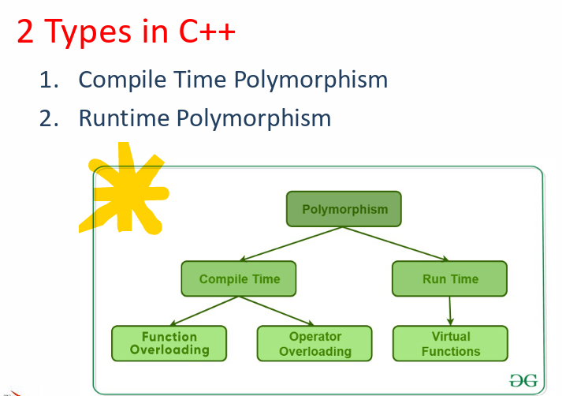

**Override**

keyword is used to explicitly specify that a member function of a derived class is intended to override a virtual function declared in a base class. This helps in ensuring that you're actually overriding a base class function and not accidentally creating a new function with a similar signature. If the function in the derived class doesn't match the signature of any virtual function in the base class, a compilation error will occur.

vtable

• Virtual functions introduce a concept called dynamic dispatch which typically implement using vtable. For every class that contains virtual functions, the compiler constructs a virtual table or vtable.

• The vtable contains an entry for each virtual function accessible by the class and stores a pointer to its definition

**Pure Virtual Functions**

• Sometimes implementation of all the functions cannot be provided in the bass class because we don’t know the implementation calcArea() function in the Shape class

• We can define these kinds of functions as pure virtual functions (or abstract functions) in the base class.– We do not have the implementation, but we declare it– It is declared by assigning 0 in the declaration.