**Chapter 1:**

**Introduction:**

* 1. **History**
  2. **Objective**
  3. **Motivation and Significance**
  4. **How to play**
  5. **History:**

The name Sudoku  comes from Japan and consists of the Japanese characters Su (meaning 'number') and Doku (meaning 'single') but it was not invented in Japan. Sudoku originated in Switzerland and then traveled to Japan by way of America.

On July 6, 1895, *Le Siècle*'s rival, La Franch refined the puzzle so that it was almost a modern Sudoku. It simplified the 9×9 magic square puzzle so that each row, column, and broken diagonal contained only the numbers 1–9, but did not mark the subsquares. Although they are unmarked, each 3×3 subsquare does indeed comprise the numbers 1–9 and the additional constraint on the broken diagonals leads to only one solution.

Sudoku has its deep roots in ancient number puzzles. For many centuries people have been interested in creating and solving them. Puzzles continue to stimulate new development in mathematics.

Magic Square puzzles which involve the ordering of consecutive numbers into a square, comes to us from the mists of history.The magic square is first documented in China two thousand years ago. The puzzle is both a numerical and positional problem, as all the rows, columns and diagonal lines through the grid must add up to the same number. Just as in Sudoku a number can only be used once in the grid. The aim of the puzzle is to try to devise a new ordering of the numbers to complete the puzzle starting from scratch. Solutions were considered to have mystical properties and became part of the Chinese method of telling the future.

The 3x3 solution shown is called the Lo shu diagram. It was regarded as the gift of the turtle from the river lo . This image was first printed in the first or second century CE. The magic square reached Europe from China by way of the Arabs who brought news of many of the Chinese inventions with them along the silk road.

* 1. **Objective:**

The main objective of our project is to design and fabricate Sudoku game by using c ++ programming language.

* 1. **Motivation and significance:**

Sudoku is one of the logical game and mostly popular in Asia. It contains different levels(easy, beginners, medium, hard). But now-a-days this type of games are not created. But these type of logical games are useful for users especially for students. The reason behind that is : Sudoku requires logical option which increases brain power and thinking capacity.we’ve always wanted to develop something that would be useful for the society through our field. This project turned out to be a bliss to our thoughts from the very first day.

This project is a challenging project. Though solving Sudoku puzzles would be easier for smaller dimensions but becomes increasingly difficult for more larger dimensions of n. ordinary methods of brute forces would become completely inefficient for solving. So it is essential to optimize methods for solving this problem in order to save on time and space.

**Rules(How to play)**

* 1. **:**
* Default numbers cannot be changed
* Each horizontal row  contains each digit exactly once
* Each vertical column  contains each digit exactly once
* Each subgrid or region contains each digit exactly once

A Sudoku puzzle begins with a grid in which some of the numbers are already in place, depending on game difficulty. In this puzzle number from 1-9 only appears once in each of the row or column and blocks .Study the grids to find the numbers that might fit into each cell.

* 1. Sudoku contain 9x9 grid table and within it another 3x3 semi-grid table also included as shown below:

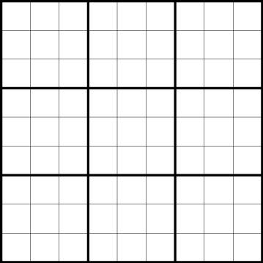

* 1. At the beginning user have to select difficulty level which are :
     1. Easy:

In this level user will be provided with 33-38 default numbers and other grid will remain blank.

* + 1. Medium:

In this level there will be 25-29 default numbers will be provided.

* + 1. Hard:

In this level there will be 20-24 default numbers will be provided.

* 1. After selecting the difficulty level user can proceed the game.