**Chapter 2: Related Works**

**Classic Sudoku-:**

Classic Sudoku is IOS game developed and designed by Easybrain LLC. . The objective is to fill a 9×9 grid with digits so that each column, each row, and each of the nine 3×3 subgrids that compose the grid contains all of the digits from 1 to 9.

**Information:**

Seller: Easybrain LTD

Category: Games

Updated:May 30,2017

Version: 1.0.4

Size: 31.9MB

Rating: 4.3 out of 5

Compatibility: Require IOS 8.0 or later.

Languages: English, Arabic, French, German, Japanese.

**What’s new?**

Improvisation of the game to make it better. This update includes:

-Dark borders of the blocks.

-Bug fixes and performances improvements.

**How to play?**

The classic Sudoku begins with a grid in which some of the numbers are already in place, depending on the game difficulty. A completed puzzle is one where each number from 1-9 appears only once in each of the 9 rows, columns and blocks. Study the grid to find the numbers that might fit into each cell.

1. Tap on New Game to choose the level.

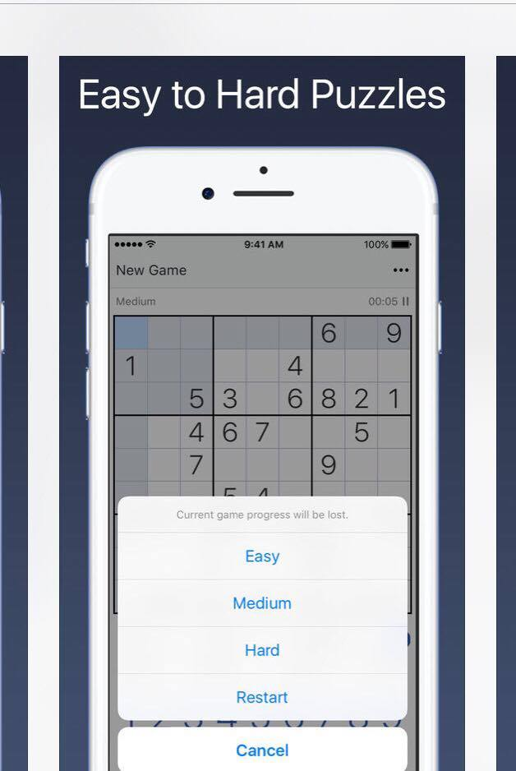

1. Select a cell then tap a number to fill in the cell.

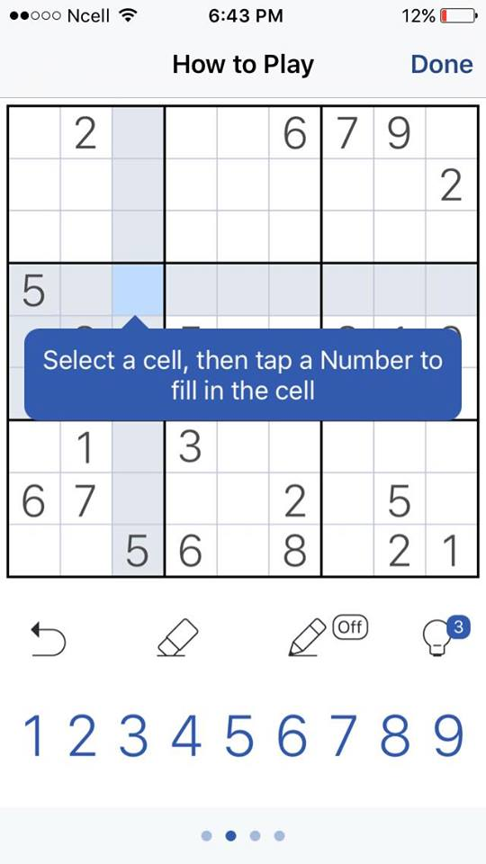

1. Turn on pencil mode to add and remove notes.

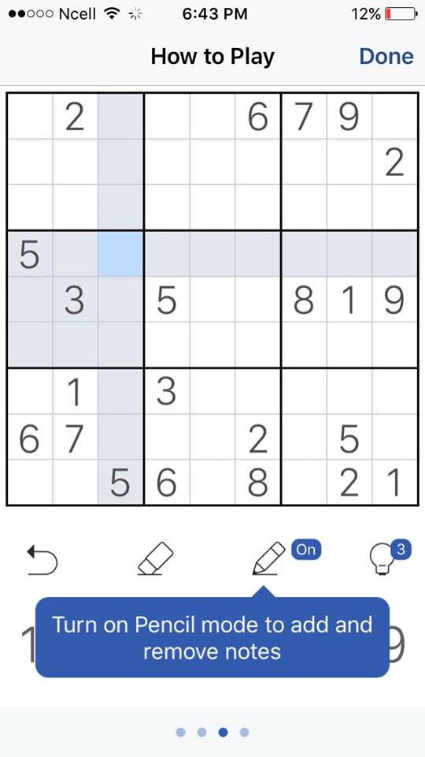

1. Tap and hold a cell to zoom it in.

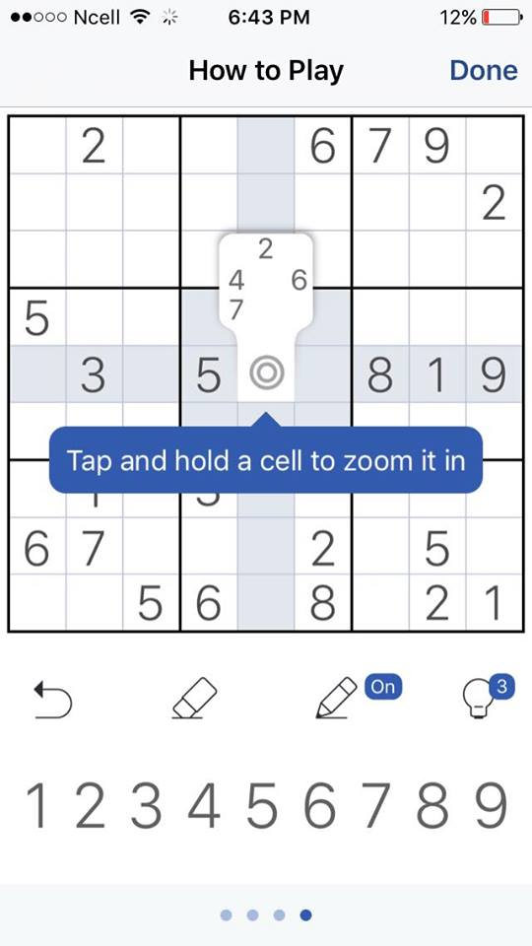

1. Tap on undo to cancel the move.

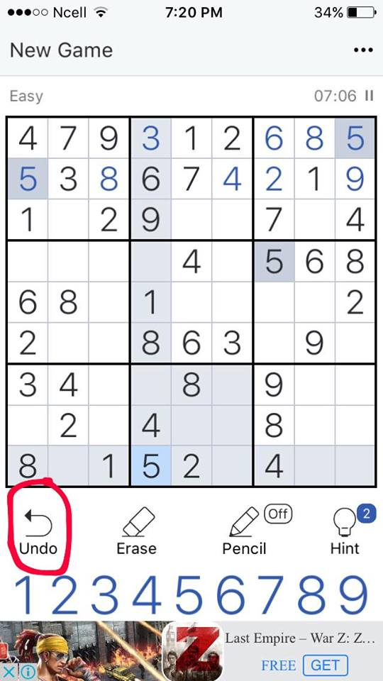

1. Select hint option to get help.

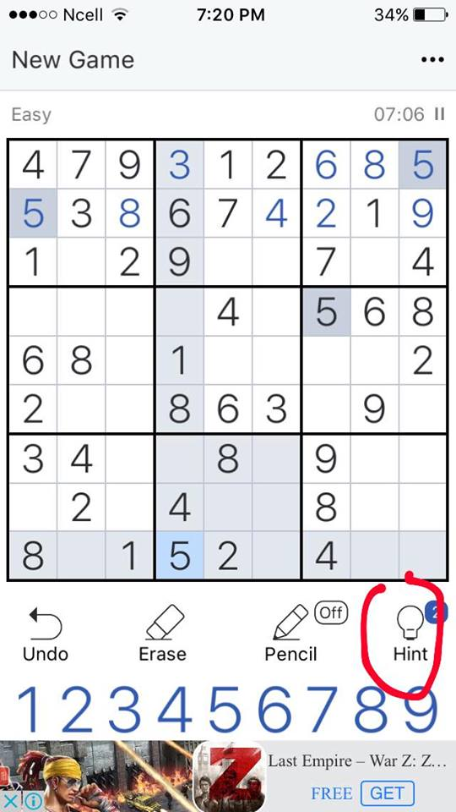

**Sudoku :**

Sudoku is the most popular logic based numbers game. This is simple easy-to-use Sudoku game, with fresh and cool interface, very acceptable difficult levels, suitable for Sudoku beginners to Sudoku expert. It is easy to use and has varities of level. It is user friendly, challenging and addictive.

**Information:**

Offered by : Brainium studios

Rating: 4.7 out of 5

Version: 2.3.94.106

Updated : May 16, 2017

Downloads: Above 5 million

Developer email: [support@BrainiumStudios.com](mailto:support@BrainiumStudios.com)

**Features:**

* 5 levels:beginner, easy, medium, difficult and expert.
* Two beautiful grid style
* Hints to help you complete hard ones.
* 5 gorgeous themes
* Endless collection of masterfully crafted puzzles
* Useful statistics to keep track of your progress
* Portrait and landscape play option

**Whats new?**

* General bug fixes
* Fix crash issues on android 7.0+
* Support for 2.1 aspect ratio devices

**How to play?**

The aim of the game is to place 1-9 into each grid cell so that each number can only appear in each row, each column, and each mini grid.

1. When the games starts user have to select difficulty level and tap play button.



1. Fill all squares so that each row, column and block contains 1 through 9.

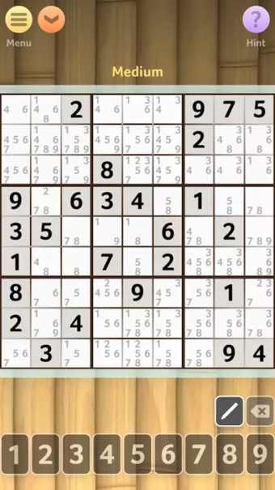

1. Given numbers cannot be changed.
2. Enter number by tapping.

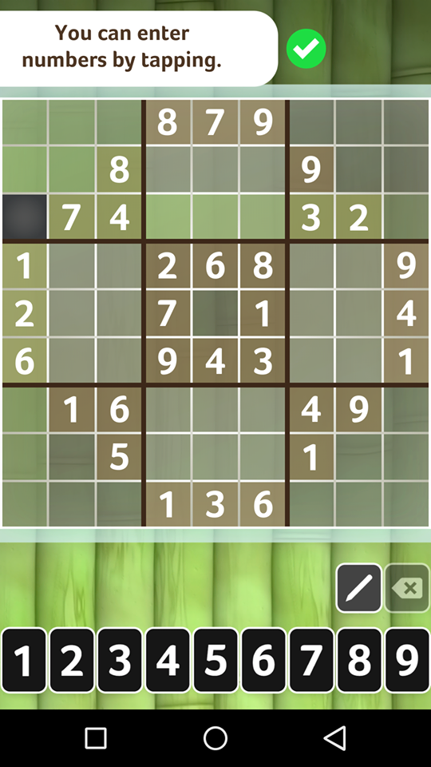

1. You can make notes by tapping.

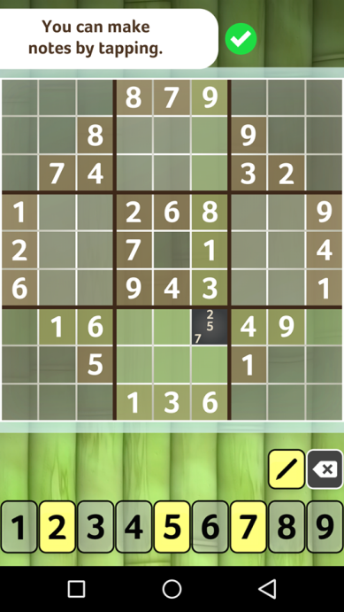

**Sudoku:**

Sudoku is one of the most popular puzzle game. It's simple and effective game with great gameplay options,helpful color highlighting and intuitive interface. This game is easy to use and pretty challanging. User can choose the difficulty level in which they can play. There are four difficulty level in this game. Internet premission is required for compititions and game results upload. This application is ad-supported but the ads aren't distracting and they don't disrupt the game.

**Information**

Offered By: genina.com

Versiong: 10.2.2

Updated On: 10 October 2016

Rating: 4.4/5

Features Rating

* Controls: 4.5/5
* Gameplay: 4.6/5
* Graphics: 4.4/5

Downloads: 10,000,000+ downloads

## Developer email: sudokugenina.com

**Features**

1. One of the worlds most advanced Sudoku learning tool.
2. 4 Difficulty Levels
3. 3 input modes:”Digit first','Cell first”, popup
4. Intelligent hints that use only logic
5. Unlimited Undo/Redo
6. Two levels of automatic error checking option
7. Optimized for Smartphones and Tablets
8. Auto save
9. Top Scores And History
10. Submits results and track progress online

1

**What's New?**

* Bugs and display related issues are fixed.
* Timer display problem is fixed.
* Addtion of translations for Hindi and Mandarin Chinese

**How To Play?**

The main objective of this game is to fill a 9x9 grid so that each column, each row, and each of the nine 3x3 boxes (also called blocks or regions) contains the digits from 1 to 9. A cell is the smallest block in the game. A row, column and region consits of 9 cells and the whole game consists of 81 cells.

Steps involved are:

1. When you open the app, you are allowed to choose the difficulty level. User are even allowed to continue they game that they had left.

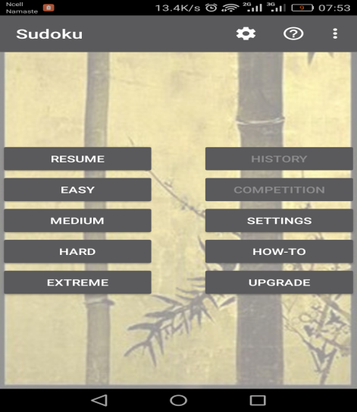

1. Then all the sqaures are filled so that each row, column and block contains numbers from 1 to 9. The number that are provided to the user cannot be changed.

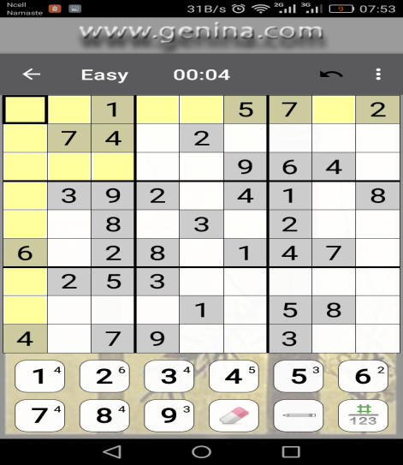

1. The numbers can be filled in the boxes by tapping.

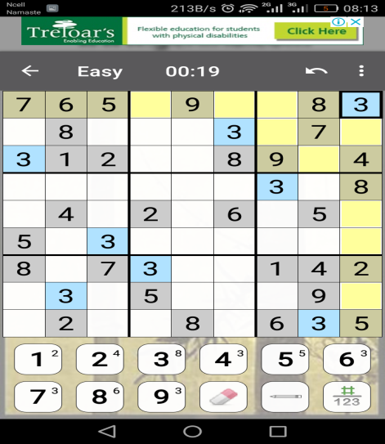

4.At last, each row and column is filled with numbers from 1 to 9. If all the numbers are kept in correct boxes then time will end and game will be stoped.

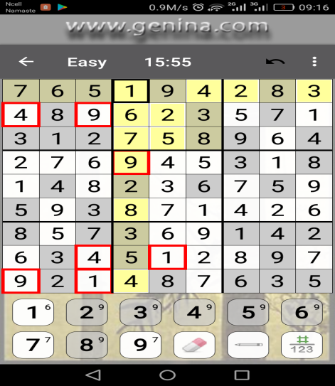

**Windows Sudoku puzzle game :**

Windows version of the popular Sudoku logic game. Single/Multiplayer sudoku - max 7 players. Create random sudoku grids at 5 difficulty levels or design your own to play/solve. Publish your best sudoku times to the web as a challenge for other players.

**Information:**

Offered by : phantasm4489

Rating: 4.5 out of 5

Version: windows 32/64 bit

Updated : April 07, 2014

Downloads: Above 2 million

Developer email: http://twitter.com/sfnet_ops

**Features:**

* 5 different levels
* Support multiplayer
* Can generate random numbers
* Useful statistics to keep track of your progress
* Contaims description and notes for beginners

**Whats new?**

* General bug fixes
* Fix crash issues on windows

**How to play?**

The aim of the game is to place 1-9 into each grid cell so that each number can only appear in each row, each column, and each mini grid.

1. When the games starts user have to select difficulty level and tap play button.

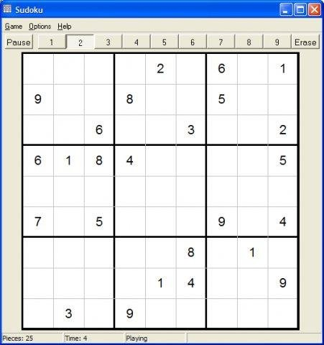

1. Fill all squares so that each row, column and block contains 1 through 9.

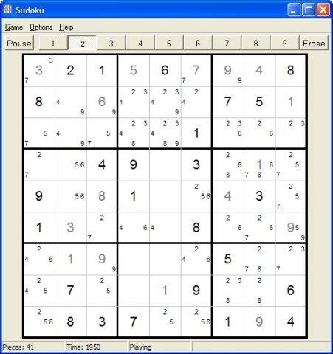

1. Given numbers cannot be changed.
2. Enter number by tapping or by using mouse.
3. Completing the level is followed by dialog box as shown:

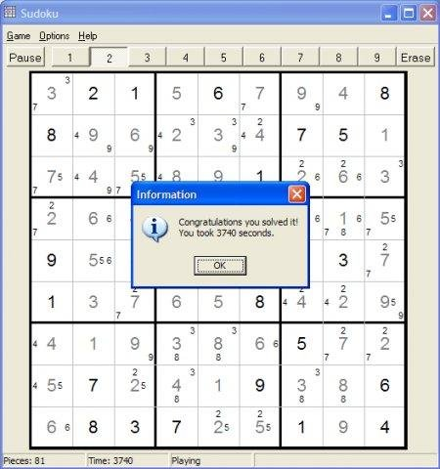

TO DO:

1. What is the difficulty level that we are implementing?
2. Understand how numbers are generated?