KarobarAI
SLM-Driven Agentic and Generative E-Commerce Platform for Small-Scale Sellers in Pakistan

Submitted by
Rafia Akbar (BSCS-Sp23-007)
Abdullah Afzal (BSCS-Sp23-012)

Session 2023-2027

Supervised by
Miss Anila Amjad



Department of Computer Science
Lahore Garrison University
Lahore

KarobarAI: SLM-Driven Agentic and Generative E-Commerce Platform for Small-Scale Sellers in Pakistan

A project submitted to the
Department of Computer Science
In
Partial Fulfillment of the Requirements for the
Bachelor’s Degree in Computer Science
By
Rafia Akbar, Abdullah Afzal

Internal Supervisor
Miss Anila Amjad _______________________
Designation
Department of Computer Science

External Examiner _______________________

Chairperson
Dr. Erum Mehmood _______________________
Assistant Professor
Department of Computer Science

COPYRIGHTS
This is to certify that the project titled “KarobarAI: SLM-Driven Agentic and Generative E-Commerce Platform for Small-Scale Sellers in Pakistan” is the genuine work carried out by Rafia Akbar and Abdullah Afzal, students of BSCS of Computer Science Department, Lahore Garrison University, Lahore during the academic year 2023-27, in partial fulfilment of the requirements for the award of the degree of Bachelor of Computer Science and that the project has not formed the basis for the award previously of any other degree, diploma, fellowship or any other similar title.

Rafia Akbar ____________

Abdullah Afzal ____________

DECLARATION
This is to declare that the project entitled “KarobarAI: SLM-Driven Agentic and Generative E-Commerce Platform for Small-Scale Sellers in Pakistan” is an original work done by undersigned, in partial fulfilment of the requirements for the degree “Bachelor of Science in Computer Science” at Computer Science Department, Lahore Garrison University, Lahore.
All the analysis, design and system development have been accomplished by the undersigned. Moreover, this project has not been submitted to any other college or university.

Group Members
Rafia Akbar ________________
Abdullah Afzal ________________
Supervisor

Miss Anila Amjad ________________

Date: ________________

DEDICATION
We dedicate this work to our parents, whose prayers and support carried us through every stage of this project, and to the small sellers of Pakistan who run their businesses from a single phone.

ACKNOWLEDGEMENTS
First of all, we are thankful to Allah Almighty for giving us the strength to complete this project. We are deeply grateful to our supervisor, Miss Anila Amjad, for her guidance, honest feedback and encouragement at every stage. We also thank the faculty of the Department of Computer Science, Lahore Garrison University, for the knowledge they shared with us during our degree.
Finally, we thank our families and friends for their constant support, and the sellers who shared the problems they face when selling online.

Table of Contents
Chapter 1 1
INTRODUCTION 1
1.1 Overview 1
1.2 Aim and Objectives 1
1.3 Gantt Chart 2
1.4 Report Organization 3
Chapter 2 5
LITERATURE REVIEW 5
2.1 Current Approaches 5
2.2 Research on AI and E-Commerce 6
2.3 Market Gap 7
Chapter 3 8
PROBLEM DEFINITION 8
3.1 Domain 8
3.2 Existing Problems and Solutions 8
3.3 Unaddressed Gaps 8
3.4 How KarobarAI Covers the Gaps 8
Chapter 4 9
SOFTWARE REQUIREMENT SPECIFICATION 9
4.1 Introduction 9
4.1.1 Purpose 9
4.1.2 Document Conventions 9
4.1.3 Intended Audience and Reading Suggestions 9
4.1.4 Product Scope 10
4.2 Overall Description 10
4.2.1 Product Perspective 10
4.2.2 Product Functions 10
4.2.3 User Classes and Characteristics 11
4.2.4 Operating Environment 11
4.2.5 Design and Implementation Constraints 12
4.2.6 Assumptions and Dependencies 12
4.3 External Interface Requirements 13
4.3.1 User Interfaces 13
4.3.2 Hardware Interfaces 13
4.3.3 Software Interfaces 13
4.3.4 Communications Interfaces 13
4.4 System Features 14
4.4.1 User Authentication and Account Management 14
4.4.2 Store Setup and Profile Management 15
4.4.3 AI Store Builder 15
4.4.4 Product Search and Browse 16
4.4.5 Cart and Checkout 17
4.4.6 Payment Processing and Settlement 18
4.4.7 Order Management 19
4.4.8 Intelligent Logistics Management 19
4.4.9 Live Order Tracking 20
4.4.10 Notification Center 21
4.4.11 ReturnsAI System 22
4.4.12 Seller Analytics Dashboard 23
4.4.13 Buyer Storefront Agent 23
4.4.14 Seller Business Agent 24
4.4.15 Admin Panel 25
4.5 Other Nonfunctional Requirements 26
4.5.1 Performance Requirements 26
4.5.2 Security Requirements 26
4.5.3 Software Quality Attributes 27
Chapter 5 28
METHODOLOGY 28
5.1 Research and Analysis 29
5.2 Requirements Gathering 29
5.3 System Design 29
5.4 Sprint Development 29
5.5 AI Integration 29
5.6 Testing and Refinement 30
5.7 Deployment 30
5.8 Documentation and Reporting 30
5.9 Tools and Technologies 30
Chapter 6 32
DETAILED DESIGN AND ARCHITECTURE 32
6.1 System Architecture 32
6.1.1 Architecture Design Approach 32
6.1.2 Architecture Design 32
6.1.3 Subsystem Architecture 33
6.2 Detailed System Design 33
6.2.1 Classification 33
6.2.2 Definition 34
6.2.3 Responsibilities 34
6.2.4 Constraints 34
6.2.5 Composition 34
6.2.6 Uses/Interactions 34
6.2.7 Resources 34
6.2.8 Processing 35
6.2.9 Interface/Exports 35
6.2.10 Detailed Subsystem Design 35
Chapter 7 43
IMPLEMENTATION AND TESTING 43
7.1 Implementation Phase 43
7.2 Testing Methodologies 43
7.2.1 Test Case for Register and Login 43
7.2.2 Test Case for Store Setup 44
7.2.3 Test Case for Create AI Listing 45
7.2.4 Test Case for Search Products 45
7.2.5 Test Case for Cart and Checkout 46
7.2.6 Test Case for Make Payment 47
7.2.7 Test Case for Manage Orders 47
7.2.8 Test Case for Book Courier 48
7.2.9 Test Case for Track Order 48
7.2.10 Test Case for View Notifications 49
7.2.11 Test Case for Request Return 50
7.2.12 Test Case for View Analytics 50
7.2.13 Test Case for Chat with Store Assistant 51
7.2.14 Test Case for Chat with Business Assistant 51
7.2.15 Test Case for Manage Platform 52
Chapter 8 54
RESULTS AND DISCUSSION 54
8.1 Buyer Storefront 54
8.1.1 Home Screen 54
8.1.2 Register and OTP Verification Screen 54
8.1.3 Login Screen 55
8.1.4 Search and Category Screen 55
8.1.5 Product Detail Screen 55
8.1.6 Store Page with Assistant 56
8.1.7 Cart and Checkout Screen 56
8.1.8 Orders and Tracking Screen 56
8.1.9 Return Request Screen 57
8.1.10 Notifications Screen 57
8.2 Seller Center 57
8.2.1 Store Setup Wizard 57
8.2.2 Seller Dashboard 58
8.2.3 AI Store Builder Screen 58
8.2.4 Seller Orders Screen 58
8.2.5 Seller Returns Screen 59
8.2.6 Analytics Dashboard 59
8.2.7 Seller Assistant Screen 59
8.3 Admin Panel 60
8.3.1 Admin Dashboard and Reports 60
8.3.2 User Management Screen 60
8.3.3 Listing Moderation Screen 60
8.3.4 Return Disputes Screen 61
8.3.5 Platform Configuration Screen 61
Chapter 9 62
CONCLUSION AND FUTURE WORK 62
9.1 Conclusion 62
9.2 Future Work 62
9.2.1 Real Courier and Wallet Integration 62
9.2.2 Faster and More Accurate AI 62
9.2.3 Native Mobile Applications 62
REFERENCES 63

List of Tables
Table 1: Limitations of Existing Solutions 5
Table 2: User Classes and Characteristics 11
Table 3: Minimum Hardware and Software Requirements 11
Table 4: User Authentication Functional Requirements 14
Table 5: Store Setup Functional Requirements 15
Table 6: AI Store Builder Functional Requirements 16
Table 7: Product Search and Browse Functional Requirements 17
Table 8: Cart and Checkout Functional Requirements 17
Table 9: Payment Processing and Settlement Functional Requirements 18
Table 10: Order Management Functional Requirements 19
Table 11: Intelligent Logistics Functional Requirements 20
Table 12: Live Order Tracking Functional Requirements 21
Table 13: Notification Center Functional Requirements 21
Table 14: ReturnsAI Functional Requirements 22
Table 15: Seller Analytics Functional Requirements 23
Table 16: Buyer Storefront Agent Functional Requirements 24
Table 17: Seller Business Agent Functional Requirements 24
Table 18: Admin Panel Functional Requirements 25
Table 19: Performance Requirements 26
Table 20: Security Requirements 26
Table 21: Tools and Technologies 30
Table 22: Subsystems and Responsibilities 33
Table 23: Use Case Descriptions 35
Table 24: Validate Register and Login Functionality 43
Table 25: Validate Store Setup Functionality 44
Table 26: Validate Create AI Listing Functionality 45
Table 27: Validate Search Products Functionality 45
Table 28: Validate Cart and Checkout Functionality 46
Table 29: Validate Make Payment Functionality 47
Table 30: Validate Manage Orders Functionality 47
Table 31: Validate Book Courier Functionality 48
Table 32: Validate Track Order Functionality 48
Table 33: Validate View Notifications Functionality 49
Table 34: Validate Request Return Functionality 50
Table 35: Validate View Analytics Functionality 50
Table 36: Validate Store Assistant Functionality 51
Table 37: Validate Business Assistant Functionality 51
Table 38: Validate Manage Platform Functionality 52

List of Figures
Fig 1: Gantt Chart 3
Fig 2: Agile Development Process of KarobarAI 28
Fig 3: Methodology Diagram of KarobarAI 28
Fig 4: Architecture Diagram 33
Fig 5: Use Case Diagram 35
Fig 6: Entity Relationship Diagram 37
Fig 7: Database Diagram 37
Fig 8: Architectural Diagram 37
Fig 9: Activity Diagram for Registration and OTP Verification 38
Fig 10: Activity Diagram for Login 38
Fig 11: Activity Diagram for Store Setup 38
Fig 12: Activity Diagram for AI Listing Generation 38
Fig 13: Activity Diagram for Product Search 38
Fig 14: Activity Diagram for Cart and Checkout 39
Fig 15: Activity Diagram for Payment 39
Fig 16: Activity Diagram for Courier Selection and Booking 39
Fig 17: Activity Diagram for Order Tracking 39
Fig 18: Activity Diagram for Return Request and AI Check 39
Fig 19: Activity Diagram for Store Assistant Chat 40
Fig 20: Activity Diagram for Admin Dispute Resolution 40
Fig 21: Sequence Diagram for AI Listing Generation 40
Fig 22: Sequence Diagram for Checkout and Payment 40
Fig 23: Sequence Diagram for Return Verification 41
Fig 24: Component Diagram 41
Fig 25: State Machine Diagram for Order 41
Fig 26: State Machine Diagram for Return 42
Fig 27: Class Diagram 42
Fig 28: Data Flow Diagram Level 0 42
Fig 29: Data Flow Diagram Level 1 42
Fig 30: Home Screen 54
Fig 31: Register and OTP Verification Screen 55
Fig 32: Login Screen 55
Fig 33: Search and Category Screen 55
Fig 34: Product Detail Screen 56
Fig 35: Store Page with Assistant 56
Fig 36: Cart and Checkout Screen 56
Fig 37: Orders and Tracking Screen 57
Fig 38: Return Request Screen 57
Fig 39: Notifications Screen 57
Fig 40: Store Setup Wizard 57
Fig 41: Seller Dashboard 58
Fig 42: AI Store Builder Screen 58
Fig 43: Seller Orders Screen 58
Fig 44: Seller Returns Screen 59
Fig 45: Analytics Dashboard 59
Fig 46: Seller Assistant Screen 59
Fig 47: Admin Dashboard and Reports 60
Fig 48: User Management Screen 60
Fig 49: Listing Moderation Screen 60
Fig 50: Return Disputes Screen 61
Fig 51: Platform Configuration Screen 61

List of Abbreviation
Short Form | Stands For
AI | Artificial Intelligence
API | Application Programming Interface
COD | Cash on Delivery
CPU | Central Processing Unit
DB | Database
DFD | Data Flow Diagram
ERD | Entity Relationship Diagram
FIG | Figure
FR | Functional Requirement
GMV | Gross Merchandise Value
HTTPS | Hypertext Transfer Protocol Secure
JSON | JavaScript Object Notation
JWT | JSON Web Token
LLM | Large Language Model
NFR | Non-Functional Requirement
ORM | Object Relational Mapping
OTP | One-Time Password
PKR | Pakistani Rupee
PWA | Progressive Web App
RAG | Retrieval-Augmented Generation
REST | Representational State Transfer
RTL | Right-to-Left
SLM | Small Language Model
SME | Small and Medium Enterprise
SMS | Short Message Service
SRS | Software Requirement Specification
TC | Test Case
UC | Use Case
UI | User Interface
UML | Unified Modeling Language

ABSTRACT
Pakistan has a large number of small sellers, including family businesses and home-based shops, who run their businesses on WhatsApp and Instagram and handle every order, courier booking and return dispute manually. Existing platforms such as Daraz and Shopify are costly, complex or not localized, and none of them combines AI-generated listings, local courier selection, return fraud checks and simple analytics for non-technical sellers. To fill this gap, we developed KarobarAI, an AI-powered e-commerce platform for small sellers. A seller can set up a store within minutes and create bilingual Urdu and English product listings from a single photo. The system scores and books couriers automatically, tracks every order in real time with notifications, compares return photos with dispatch photos to detect anomalies, settles payments after commission and provides analytics with recommendations. Two AI assistants answer buyer questions about a store's products and explain business data to sellers.

Chapter 1

INTRODUCTION

1.1 Overview
Online shopping in Pakistan has grown quickly, and platforms such as Daraz, Instagram and WhatsApp let small traders reach customers directly. However, most small sellers still work by hand: orders arrive in chats, photos are shared on Instagram and every delivery is booked by calling a courier.
KarobarAI closes this gap. It is a web-based, mobile-friendly platform where a seller opens a store, uploads a product photo and gets a ready Urdu and English listing. The platform then suggests and books couriers, keeps buyers updated, records payments, settles earnings and checks returns against dispatch photos. Sellers also get analytics and an AI assistant, while buyers can ask a store assistant about products.

1.2 Aim and Objectives
The aim of KarobarAI is to give small sellers in Pakistan a complete, AI-assisted platform to start and run an online business without any technical skill. A seller signs up, uploads product pictures and has a working store in minutes, while AI handles tedious tasks such as writing descriptions, choosing couriers, checking returns and reading sales data.
The main objectives of the project, as set out in the proposal, are:
• AI Store Builder: generate the title, description, tags and category of a product in both Urdu and English from a single uploaded picture.
• Intelligent Logistics Management: compare the available couriers (TCS, Leopards, Trax) on price, delivery time, reliability and coverage, and book the best one with a single click.
• Live Order Tracking: let both seller and buyer follow every order in real time and send notifications at every step, from confirmation to delivery.
• ReturnsAI System: analyse the photos uploaded with a return request, decide whether the item matches what was sent, and protect sellers from return fraud.
• Seller Analytics Dashboard: show best-selling products, return causes and sales trends, and recommend actions to the seller.
During development, the following features were added beyond the original proposal:
• Buyer Storefront Agent: an AI chat assistant on every store page that answers buyer questions using only that store's products.
• Seller Business Agent: an AI assistant inside the Seller Center that answers questions about the seller's own orders, stock, returns and earnings.
• Card payments through Stripe in test mode, alongside Cash on Delivery, with payment gateway interfaces ready for JazzCash and Easypaisa.
• Automatic settlement of seller earnings after deducting the platform commission, with cash on delivery remittance tracking.
• A complete Admin Panel for user management, listing moderation, return dispute resolution and platform configuration, with an audit log of every privileged action.
• An in-app notification centre and a public, login-free tracking link for every order.

1.3 Gantt Chart
The project was planned over a 20-week timeline divided into eight phases. The Gantt chart below shows these phases and their milestones.
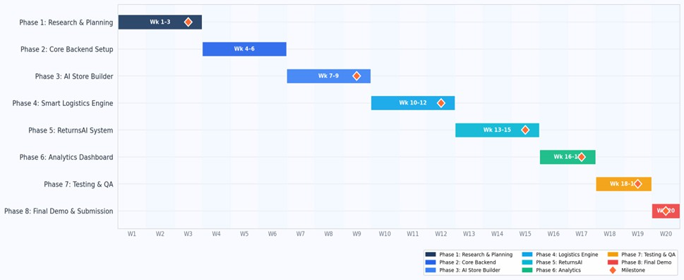
Fig 1: Gantt Chart

1.4 Report Organization
This report is organized into nine chapters, each covering one part of the project and its development.
• Chapter 1 introduces the project, its aim and objectives, the project timeline and the structure of this report.
• Chapter 2 reviews the existing literature and platforms related to e-commerce for small sellers and the use of AI in e-commerce.
• Chapter 3 defines the problem, the existing solutions, the gaps they leave and how KarobarAI covers them.
• Chapter 4 presents the Software Requirement Specification, including system features and functional and non-functional requirements.
• Chapter 5 describes the development methodology, the phases followed and the tools and technologies used.
• Chapter 6 explains the architecture and detailed design of the system with the help of UML diagrams.
• Chapter 7 discusses the implementation and the testing process, along with the test cases of each use case.
• Chapter 8 presents the results of the final product with screenshots of each panel.
• Chapter 9 concludes the project and highlights the future work.

Chapter 2

LITERATURE REVIEW

2.1 Current Approaches
The advent of e-commerce has revolutionized business practices around the world, but the change has been uneven, especially in developing economies such as Pakistan.
The International Finance Corporation notes that small firms in emerging nations struggle to adopt digital commerce because of cost, usability and poor infrastructure [7], and the OECD reports that SMEs lag behind because current solutions do not fit their needs [8]. Daraz, Shopify and WooCommerce allow users to create online stores, but they are expensive, technically complex or not localized for Pakistani sellers [9]. Table 1 summarizes these limitations.
Table 1: Limitations of Existing Solutions
Feature | KarobarAI | Others (Shopify, Daraz, etc.)
Language Support | Urdu and English | English only or limited
Local Courier Integration | TCS, Leopards, Trax (automatic) | Manual or not available
Local Payments | Cash on Delivery and gateway adapters | Limited or not available in Pakistan
AI Product Listing | Automatic from a photo | Manual entry required
Return Fraud Detection | AI image verification | Not available
AI Assistants | Store and seller chat assistants | Not available
Target User | Non-technical small sellers | Medium to large businesses
Pricing | Affordable | Expensive subscriptions

Research shows that AI-generated content can match human writing in quality with much less effort [1], AI-based logistics decisions reduce last-mile delivery cost [3], and image recognition can detect fraudulent returns with high precision [5]. These findings form the basis of the AI Store Builder, Intelligent Logistics and ReturnsAI components.
However, an integrated, localized solution for micro-sellers in developing markets is still missing. The World Bank stresses that digital tools must adapt to local payments, logistics and language to be adopted [10]. KarobarAI combines AI automation with Urdu support, local couriers (TCS, Leopards, Trax) and Cash on Delivery.

2.2 Research on AI and E-Commerce
Research in AI and e-commerce shows several trends that support the concept of this project:
• Generative AI, including large language models such as GPT-4, can create product descriptions quickly, with human-like quality at a much lower cost [1], [2].
• Agentic AI solutions that can make decisions and complete tasks are already used in logistics to improve efficiency, lower costs and reduce errors [3], [4].
• Machine learning methods for image analysis and anomaly detection have proved successful in detecting suspicious activity and preventing fraud in e-commerce [5], [6].
• Studies of emerging markets show that the main barrier to e-commerce growth in developing countries is the lack of affordable and easy-to-use solutions for micro-sellers [7], [8].
• Retrieval-augmented generation, where relevant records are retrieved first and given to the language model as context, reduces made-up answers and keeps responses grounded in real data [13].
• Self-supervised vision models such as DINOv2 produce image features that can compare two photos of the same object without task-specific training [14].

2.3 Market Gap
Current platforms do not meet all the needs of a small Pakistani seller who wants to start an online store: support for the Urdu language, integration with local couriers such as TCS, Leopards and Trax, local payment options, and AI that does not require any technical knowledge from the user. KarobarAI was developed to fill exactly this gap.

Chapter 3

PROBLEM DEFINITION

3.1 Domain
The project belongs to the e-commerce domain, specifically to tools for small and micro-sellers in Pakistan who sell from home or small shops and mostly rely on WhatsApp, Facebook and Instagram to reach buyers.

3.2 Existing Problems and Solutions
Small sellers face five recurring problems: writing bilingual listings, comparing couriers by hand, giving buyers no order updates, losing money on fake returns and having no clear view of sales. Daraz offers logistics but charges high fees and gives no listing help, Shopify is costly and not localized, and social media shops offer no tracking, returns or analytics.

3.3 Unaddressed Gaps
No existing platform combines AI-generated bilingual listings, automatic local courier selection, live tracking, evidence-based return checks and plain-language analytics in one place for a non-technical seller. Existing tools also do not let buyers ask questions about a store's products at any hour, and they leave sellers to read raw reports on their own.

3.4 How KarobarAI Covers the Gaps
KarobarAI generates listings from a photo, scores and books couriers, pushes live tracking updates, compares return photos with dispatch photos, escalates unclear cases to an admin and settles payments after commission. Two AI assistants answer buyer questions from the store catalogue and explain seller data in Urdu or English.

Chapter 4

SOFTWARE REQUIREMENT SPECIFICATION

4.1 Introduction
This chapter is the Software Requirement Specification (SRS) of KarobarAI, written following IEEE 830 [11] and ISO/IEC/IEEE 29148 [12] and adapted to the university template. It updates the earlier SRS to match the final system.

4.1.1 Purpose
The purpose of this document is to describe the functional and non-functional requirements of KarobarAI in one place. It serves as the reference for development, testing and evaluation, and helps the supervisor and examiners check whether the delivered system meets what was planned.

4.1.2 Document Conventions
The text uses Times New Roman: 14 pt bold main headings, 12 pt bold subheadings and 12 pt justified body text with 1.5 line spacing. Figure captions appear below figures and table captions above tables. Requirements are labelled REQ-F-[Module]-[Number] (functional), REQ-AI-[Module]-[Number] (AI) and REQ-NF-[Category]-[Number] (non-functional), each with a priority of HIGH, MEDIUM or LOW.

4.1.3 Intended Audience and Reading Suggestions
The following audience may read this document:
• FYP Supervisor
• FYP Team
• Project Evaluators and Examiners
• Software Developers
• Software Testers
Supervisors should start with the product scope, developers with the system features and interfaces, and testers with the requirements.

4.1.4 Product Scope
Digital commerce adoption among Pakistani micro-sellers remains low because existing tools are complex. KarobarAI lets any seller upload a product photo and get a bilingual listing in moments. Its core modules are the AI Store Builder, Intelligent Logistics, Live Order Tracking, ReturnsAI and Seller Analytics, supported by AI assistants, payments, notifications and an admin panel. Version 1.0 targets Pakistan, uses PKR and supports Urdu and English.

4.2 Overall Description

4.2.1 Product Perspective
KarobarAI is a new, self-contained product made of a React web app, a Node.js REST backend holding all business logic, a Python AI service, and PostgreSQL with Redis. Couriers, payment gateways and messaging services are connected through adapters.

4.2.2 Product Functions
The main functions of KarobarAI are:
• Register and verify users with OTP, and manage Seller, Buyer and Admin roles.
• Set up a store with name, logo, banner and payout wallet.
• Generate bilingual product listings from an uploaded photo, which the seller can edit before publishing.
• Search and browse products in Urdu and English with filters and suggestions.
• Add items to a cart and check out with Cash on Delivery or card payment.
• Score couriers and book the best one for each order.
• Track orders live and send notifications at each stage.
• Check returns by comparing return photos with dispatch photos.
• Settle seller earnings after deducting the platform commission.
• Show seller analytics with recommendations.
• Answer buyer and seller questions through AI assistants.
• Let admins manage users, listings, disputes and platform settings.

4.2.3 User Classes and Characteristics
Table 2: User Classes and Characteristics
User Class | Characteristics
Seller | Small business owner with basic smartphone skills and no e-commerce experience; uses the system daily
Buyer | Customer ranging from regular online shoppers to first-time buyers; needs a fast and trustworthy experience
Guest | Visitor who browses products and opens public tracking links without logging in
Admin | Internal staff who manage users, moderation, disputes, payments and configuration; technically proficient

4.2.4 Operating Environment
Table 3: Minimum Hardware and Software Requirements
Component | Client (User) | Server
Operating System | Windows 10 or later, Android 8.0+, iOS 14+ | Windows 10/11, Linux or macOS with Docker
Browser | Chrome, Edge, Firefox or Safari (latest versions) | Not applicable
Processor | Dual-core 1.8 GHz | Quad-core 2.5 GHz
RAM | 2 GB (phone), 4 GB (computer) | 8 GB minimum, 16 GB recommended for local AI models
Storage (ROM) | 100 MB free for browser cache | 20 GB free SSD space
Network | 1 Mbps internet connection | Stable broadband connection
Software | No installation required | Node.js 20, Python 3.11, PostgreSQL 16, Redis 7, Docker

4.2.5 Design and Implementation Constraints
• The project was built in a fixed 20-week timeline with no dedicated budget, so free tiers, open-source tools and local models were preferred.
• Real courier (TCS, Leopards, Trax) and wallet (JazzCash, Easypaisa) APIs require merchant accounts, so they are implemented as adapters with simulated responses.
• Card payments run in Stripe test mode only; no real money is processed.
• Local vision models are slow on CPU-only machines, so listing generation uses a hosted vision model.
• Each order belongs to a single seller, and the buyer pays the shipping charges.

4.2.6 Assumptions and Dependencies
Assumptions:
• Sellers can take clear photos of products and fill in simple forms.
• Buyers and sellers have a device with at least an intermittent internet connection.
• Courier and payment providers will offer APIs compatible with the existing adapter interfaces when real integration is done.
Dependencies:
• Google Gemini API for listing generation; if unavailable, the seller fills in the listing manually.
• Ollama with the Qwen and nomic-embed-text models for the assistants and product search embeddings.
• Stripe API for card payments in test mode.
• MinIO object storage for product, dispatch and return images.
• PostgreSQL and Redis; if the database is unavailable the platform cannot operate.

4.3 External Interface Requirements

4.3.1 User Interfaces
KarobarAI has three interfaces: the Seller Center, the Buyer Storefront and the Admin Panel. All screens are responsive, support Urdu right-to-left layout and switch language without reloading, and AI actions show progress indicators.

4.3.2 Hardware Interfaces
No special hardware is required. Users capture or upload images with their device camera or file picker, and the web app can be added to the home screen of Android and iOS devices.

4.3.3 Software Interfaces
The frontend uses REST APIs to reach the backend. The backend uses Prisma with PostgreSQL (pgvector), Redis and BullMQ for caching and jobs, MinIO for files, Stripe for payments and the internal FastAPI AI service, which calls Gemini, Ollama and DINOv2.

4.3.4 Communications Interfaces
All traffic uses HTTPS with JSON bodies. Users are authenticated with JWTs and rotating refresh tokens, live tracking uses Socket.IO, the AI service is reachable only inside the Docker network and payment webhooks are signature-verified.

4.4 System Features
This section lists the fifteen features of KarobarAI. Each feature has a short description, its priority, its stimulus and response sequence and its functional requirements.

4.4.1 User Authentication and Account Management
Description and Priority
Users register with email or phone number, verify the account with an OTP and log in with role-based access. Priority: HIGH.
Stimulus/Response Sequences
• User submits the registration form, the system sends a 6-digit OTP and verifies it before activating the account.
• User enters wrong credentials repeatedly, the system locks the account temporarily.
Table 4: User Authentication Functional Requirements
Req. ID | Description | Priority
REQ-F-Auth-001 | OTPs are 6 digits and valid for 10 minutes, with limited resends per hour. | HIGH
REQ-F-Auth-002 | Passwords must have at least 8 characters with upper case, lower case, digit and special character. | HIGH
REQ-F-Auth-003 | Short-lived JWT access tokens are paired with rotating refresh tokens. | HIGH
REQ-F-Auth-004 | Role-based access control for Buyer, Seller and Admin. | HIGH
REQ-F-Auth-005 | Account is locked after repeated failed login attempts. | HIGH
REQ-F-Auth-006 | Users can reset a forgotten password and change their password. | HIGH

4.4.2 Store Setup and Profile Management
Description and Priority
A new seller completes a setup wizard to create a store, and every user can manage their profile and settings. Priority: HIGH.
Stimulus/Response Sequences
• Seller logs in for the first time, the system opens the store setup wizard.
• User updates profile or language preference, the system saves it and applies it immediately.
Table 5: Store Setup Functional Requirements
Req. ID | Description | Priority
REQ-F-Shop-001 | Seller creates a store with name, description, logo and banner. | HIGH
REQ-F-Shop-002 | Seller adds a payout wallet for settlements. | HIGH
REQ-F-Shop-003 | Each store gets a public storefront page with its own link. | HIGH
REQ-F-Shop-004 | Users manage profile, addresses and language preference. | MEDIUM

4.4.3 AI Store Builder
Description and Priority
The seller uploads product photos and the AI drafts a bilingual title, description, tags and category, which the seller edits and publishes. Priority: HIGH.
Stimulus/Response Sequences
• Seller uploads a valid image, the system stores it and requests an AI draft while showing a progress indicator.
• AI fails or times out, the system shows an error and leaves the fields open for manual entry.
• Seller clicks Publish or Save as Draft, the system validates and saves the product.
Table 6: AI Store Builder Functional Requirements
Req. ID | Description | Priority
REQ-F-Store-001 | Only JPEG, PNG or WebP images within the size limit are accepted. | HIGH
REQ-F-Store-002 | AI generates bilingual title, description, category and tags. | HIGH
REQ-F-Store-003 | All AI-generated fields are editable; title, image and category are required to publish. | HIGH
REQ-F-Store-004 | A progress indicator is shown while the draft is being generated. | HIGH
REQ-F-Store-005 | On AI failure, an error is shown and manual entry remains possible. | HIGH
REQ-F-Store-006 | Products can be saved as Draft and hidden from the storefront. | MEDIUM
REQ-AI-Store-001 | The model provider is replaceable through configuration behind one client interface. | HIGH
REQ-AI-Store-002 | AI output must follow a fixed JSON structure and is validated before use. | HIGH

4.4.4 Product Search and Browse
Description and Priority
Buyers and guests search products in Urdu or English, browse categories and filter results. Priority: MEDIUM.
Stimulus/Response Sequences
• User types in the search box, the system shows suggestions.
• User applies filters or sorting, the system refreshes the result list.
Table 7: Product Search and Browse Functional Requirements
Req. ID | Description | Priority
REQ-F-Browse-001 | Full-text search in Urdu and English across titles, descriptions and tags. | MEDIUM
REQ-F-Browse-002 | Autocomplete suggestions while typing. | MEDIUM
REQ-F-Browse-003 | Filters by category, price and condition, with sorting options. | MEDIUM
REQ-F-Browse-004 | Product detail page shows images, price, stock and seller store. | HIGH

4.4.5 Cart and Checkout
Description and Priority
Buyers add products to a persistent cart and place an order with a delivery address and payment method. Priority: HIGH.
Stimulus/Response Sequences
• Buyer adds an item, the system checks stock and updates the cart.
• Buyer confirms checkout, the system creates the order and reserves stock in one transaction.
Table 8: Cart and Checkout Functional Requirements
Req. ID | Description | Priority
REQ-F-Cart-001 | The cart is saved on the server and available across devices. | HIGH
REQ-F-Cart-002 | Quantities cannot exceed available stock. | HIGH
REQ-F-Cart-003 | Checkout shows item total, shipping charges and order summary. | HIGH
REQ-F-Cart-004 | Order creation and stock reservation happen in one transaction. | HIGH

4.4.6 Payment Processing and Settlement
Description and Priority
Orders are paid by Cash on Delivery or card through Stripe test mode, and seller earnings are settled after commission. Priority: HIGH.
Stimulus/Response Sequences
• Buyer pays by card, the system confirms the order only after a verified Stripe webhook.
• Order is delivered and the return window closes, the system creates a settlement for the seller.
Table 9: Payment Processing and Settlement Functional Requirements
Req. ID | Description | Priority
REQ-F-Payment-001 | Support Cash on Delivery and card payment (Stripe test mode). | HIGH
REQ-F-Payment-002 | Payment calls are server-side only; webhooks are signature-verified. | HIGH
REQ-F-Payment-003 | Duplicate webhook events are ignored to prevent double processing. | HIGH
REQ-F-Payment-004 | Platform commission is admin-configurable, default 5%. | MEDIUM
REQ-F-Payment-005 | Approved returns trigger a refund to the original payment method. | HIGH
REQ-F-Payment-006 | No card details or wallet PINs are stored; only gateway references. | HIGH

4.4.7 Order Management
Description and Priority
Sellers view and process their orders through defined stages, and buyers view their order history. Priority: HIGH.
Stimulus/Response Sequences
• Seller marks an order as packed, the system moves it forward and starts courier booking.
• Buyer cancels an order before processing, the system cancels it and releases stock.
Table 10: Order Management Functional Requirements
Req. ID | Description | Priority
REQ-F-Order-001 | Orders follow a defined status lifecycle from payment pending to completed. | HIGH
REQ-F-Order-002 | Sellers see orders in tabs by status with order details. | HIGH
REQ-F-Order-003 | Cancellation is allowed only before the order is handed to the courier. | HIGH
REQ-F-Order-004 | Buyers can view their orders and order details. | HIGH

4.4.8 Intelligent Logistics Management
Description and Priority
The system compares courier quotes and recommends the best courier, which the seller books with one click. Priority: HIGH.
Stimulus/Response Sequences
• Order is ready, the system collects quotes from all couriers and scores them.
• All couriers fail, the system marks the order as Pending Manual Logistics and alerts the seller.
Table 11: Intelligent Logistics Functional Requirements
Req. ID | Description | Priority
REQ-F-Logistics-001 | Request quotes from TCS, Leopards and Trax adapters in parallel. | HIGH
REQ-F-Logistics-002 | Score couriers on cost 40%, delivery time 30%, reliability 20% and rating 10%. | HIGH
REQ-F-Logistics-003 | Route COD orders only to couriers that support COD. | HIGH
REQ-F-Logistics-004 | Provide a one-click Confirm and Book Courier action. | HIGH
REQ-F-Logistics-005 | Flag the order for manual logistics if all couriers fail. | HIGH
REQ-F-Logistics-006 | Seller can override the recommended courier. | MEDIUM

4.4.9 Live Order Tracking
Description and Priority
Buyers and sellers see the status timeline of each shipment update in real time, including through a public tracking link. Priority: HIGH.
Stimulus/Response Sequences
• Courier status changes, the system saves the event and pushes it to open tracking pages.
• Buyer opens the tracking link, the system shows the timeline without login.
Table 12: Live Order Tracking Functional Requirements
Req. ID | Description | Priority
REQ-F-Track-001 | Push tracking updates in real time through WebSocket. | HIGH
REQ-F-Track-002 | Show a visual timeline of delivery stages. | HIGH
REQ-F-Track-003 | Generate a public, login-free tracking link for each order. | MEDIUM
REQ-F-Track-004 | Store the tracking history of each order. | MEDIUM

4.4.10 Notification Center
Description and Priority
Users receive notifications about orders, returns and payments through in-app, SMS and email channels. Priority: MEDIUM.
Stimulus/Response Sequences
• An order event occurs, the system queues the notification for each enabled channel.
• User opens the notification bell, the system shows unread notifications.
Table 13: Notification Center Functional Requirements
Req. ID | Description | Priority
REQ-F-Notif-001 | Send notifications at key order, return and refund events. | MEDIUM
REQ-F-Notif-002 | In-app notification list with unread count. | MEDIUM
REQ-F-Notif-003 | Templates in Urdu and English based on user preference. | MEDIUM
REQ-F-Notif-004 | Notifications are sent asynchronously through a queue. | MEDIUM
REQ-F-Notif-005 | Non-critical notifications can be turned off by the user. | LOW

4.4.11 ReturnsAI System
Description and Priority
Buyers request returns with photos, and the AI compares them with dispatch photos to approve, reject or send the case for manual review. Priority: HIGH.
Stimulus/Response Sequences
• Buyer submits a return within 14 days with at least 3 photos, the system runs the image check.
• Buyer appeals a rejected return, the system opens a dispute for the admin.
Table 14: ReturnsAI Functional Requirements
Req. ID | Description | Priority
REQ-F-Return-001 | Returns are allowed only within 14 days of delivery. | HIGH
REQ-F-Return-002 | At least 3 photos are required to submit a return. | HIGH
REQ-F-Return-003 | One return request is allowed per order. | HIGH
REQ-F-Return-004 | Rejected returns show a reason and an appeal option. | HIGH
REQ-F-Return-005 | Unclear or failed AI checks go to manual review. | HIGH
REQ-AI-Return-001 | Return photos are compared with dispatch photos using DINOv2 image similarity. | HIGH
REQ-AI-Return-002 | Match and mismatch thresholds are configurable. | MEDIUM

4.4.12 Seller Analytics Dashboard
Description and Priority
Sellers see revenue, orders, top products and return rates with simple recommendations. Priority: MEDIUM.
Stimulus/Response Sequences
• Seller opens Analytics, the system loads the default period from daily statistics.
• Seller changes the date range, the system reloads the charts.
Table 15: Seller Analytics Functional Requirements
Req. ID | Description | Priority
REQ-F-Analytics-001 | Show revenue and order totals with change indicators. | MEDIUM
REQ-F-Analytics-002 | Show sales trend chart and top products. | MEDIUM
REQ-F-Analytics-003 | Support date range filtering. | MEDIUM
REQ-F-Analytics-004 | Generate at least one recommendation per seller. | MEDIUM

4.4.13 Buyer Storefront Agent
Description and Priority
A chat assistant on each store page answers buyer questions using only that store's products. Priority: MEDIUM.
Stimulus/Response Sequences
• Buyer asks about a product, the system retrieves matching products from the same store and answers.
• Buyer asks an unrelated question, the system politely declines.
Table 16: Buyer Storefront Agent Functional Requirements
Req. ID | Description | Priority
REQ-F-BuyerAgent-001 | Answers are limited to the current store's catalogue. | MEDIUM
REQ-F-BuyerAgent-002 | Supports questions in Urdu and English. | MEDIUM
REQ-F-BuyerAgent-003 | Off-topic questions are rejected by a scope guard. | MEDIUM
REQ-F-BuyerAgent-004 | Chat requests are rate limited. | MEDIUM
REQ-AI-BuyerAgent-001 | Answers use retrieved product data, and stock or price not in the data is not stated. | HIGH

4.4.14 Seller Business Agent
Description and Priority
An assistant in the Seller Center answers questions about the seller's own orders, products, returns and earnings. Priority: MEDIUM.
Stimulus/Response Sequences
• Seller asks about sales or stock, the system calls read-only tools on the seller's data and replies.
• A buyer account tries to open the assistant, the system denies access.
Table 17: Seller Business Agent Functional Requirements
Req. ID | Description | Priority
REQ-F-SellerAgent-001 | Available only to authenticated sellers. | MEDIUM
REQ-F-SellerAgent-002 | Uses read-only tools on the seller's own data only. | HIGH
REQ-F-SellerAgent-003 | Chat sessions are saved and can be continued. | LOW
REQ-F-SellerAgent-004 | Answers in Urdu or English. | MEDIUM

4.4.15 Admin Panel
Description and Priority
Admins manage users, moderate listings, resolve return disputes and change platform settings. Priority: HIGH.
Stimulus/Response Sequences
• Admin suspends a user, the system ends that user's sessions.
• Admin overrides a return decision, the system requires a reason and records it in the audit log.
Table 18: Admin Panel Functional Requirements
Req. ID | Description | Priority
REQ-F-Admin-001 | Search, suspend and reactivate user accounts. | HIGH
REQ-F-Admin-002 | Moderate and remove product listings. | HIGH
REQ-F-Admin-003 | Resolve return disputes and override AI decisions with a reason. | HIGH
REQ-F-Admin-004 | Configure commission, return window and courier weights. | MEDIUM
REQ-F-Admin-005 | View platform reports such as GMV and active users. | MEDIUM
REQ-F-Admin-006 | Record every privileged action in an audit log. | HIGH

4.5 Other Nonfunctional Requirements

4.5.1 Performance Requirements
Table 19: Performance Requirements
Req. ID | Description | Target
REQ-NF-Perf-001 | Primary screens load quickly on a slow mobile connection. | < 3 seconds on 3G
REQ-NF-Perf-002 | Product search returns results quickly. | < 1 second
REQ-NF-Perf-003 | Non-AI API endpoints respond quickly under normal load. | p95 < 1 second
REQ-NF-Perf-004 | Slow tasks such as notifications and embeddings run in background queues. | Non-blocking
REQ-NF-Perf-005 | AI requests have a configurable timeout so the user is never stuck. | Configurable

4.5.2 Security Requirements
Table 20: Security Requirements
Req. ID | Description | Priority
REQ-NF-Security-001 | All communication uses HTTPS in production. | HIGH
REQ-NF-Security-002 | Passwords are hashed with bcrypt and never stored in plain text. | HIGH
REQ-NF-Security-003 | Every endpoint checks authentication, role and record ownership. | HIGH
REQ-NF-Security-004 | OTP codes expire and cannot be reused. | HIGH
REQ-NF-Security-005 | Database access uses the Prisma ORM with parameterized queries. | HIGH
REQ-NF-Security-006 | Payment webhooks are rejected if the signature is invalid. | HIGH
REQ-NF-Security-007 | Uploaded files are checked for type and size on the server. | HIGH
REQ-NF-Security-008 | API keys and secrets are kept in environment variables, not in code. | HIGH
REQ-NF-Security-009 | The AI service is not exposed to the internet. | HIGH

4.5.3 Software Quality Attributes
• Usability: every screen works in Urdu and English, and a new seller can publish a first product within a few minutes.
• Reliability: payment, order and settlement changes run inside database transactions.
• Maintainability: external providers sit behind adapters, and the code is checked with TypeScript, ESLint, mypy and flake8.
• Portability: the complete system runs from one Docker Compose file.

Chapter 5

METHODOLOGY
This chapter explains how KarobarAI was planned, built, tested and delivered. The project followed Agile with two-week sprints, so the platform was built feature by feature and tested continuously.
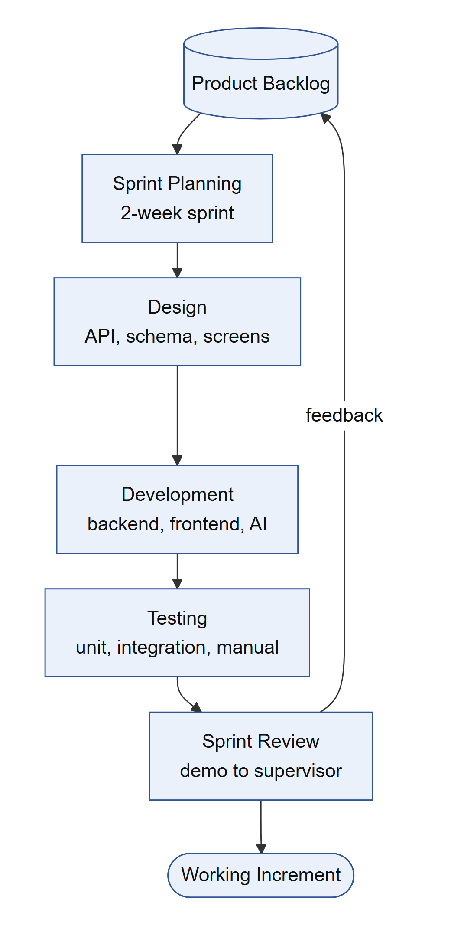
Fig 2: Agile Development Process of KarobarAI
Fig 2 shows the Agile cycle followed in every sprint. Features are picked from the product backlog during sprint planning, then designed, developed and tested. At the sprint review the working increment is demonstrated to the supervisor, and the feedback goes back into the backlog for the next sprint.
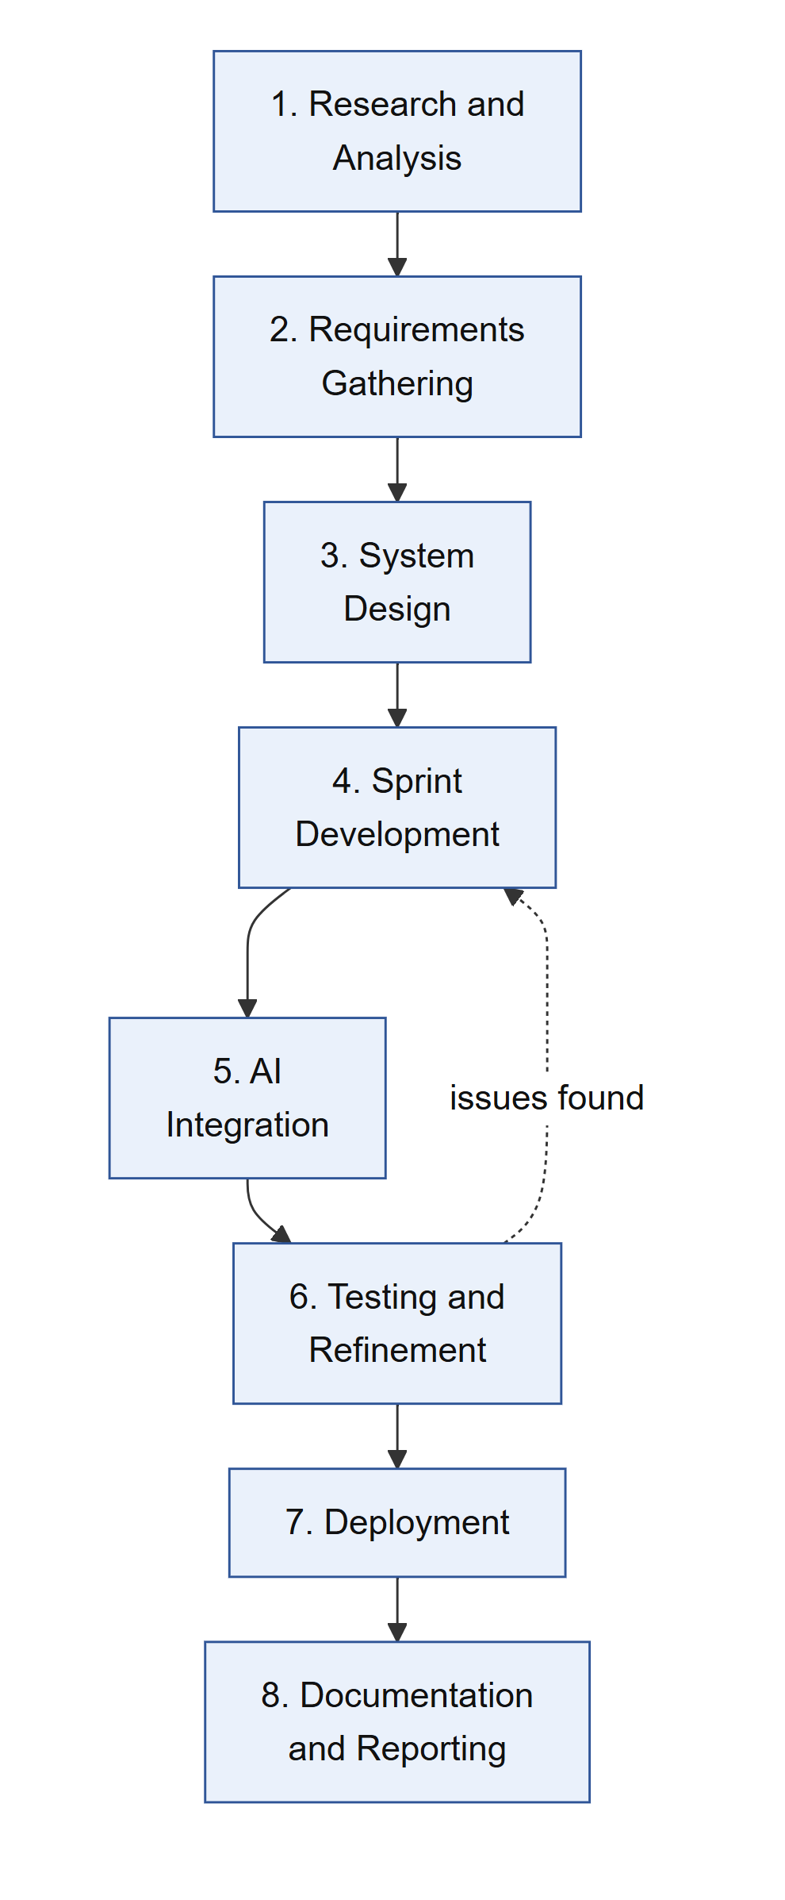
Fig 3: Methodology Diagram of KarobarAI
Fig 3 shows the eight phases from research to final reporting. The first three phases fixed the requirements and design, after which features were built in sprints and the AI models were integrated. Testing sent issues back to development until each feature passed, and the system was then containerized and documented. Each phase is explained below.

5.1 Research and Analysis
We studied how small Pakistani sellers sell online and the problems they face with listings, couriers and returns, and reviewed research on generative AI, logistics optimization and image-based fraud detection to choose practical techniques.

5.2 Requirements Gathering
We prepared the proposal and the SRS, giving every requirement an ID and priority so it could be traced to a feature and a test case. Key decisions, such as a single PostgreSQL database and adapters for external providers, were made here.

5.3 System Design
The architecture, database schema, application flow and user interface were designed before coding began. The system was divided into a frontend, a backend and an AI service, and the backend was split into independent modules for each business area.

5.4 Sprint Development
Development ran in two-week sprints, starting with authentication and the database and moving through stores, products, AI listings, checkout, orders, logistics, tracking, notifications, returns, settlement, analytics, admin and the AI assistants. A feature was complete only after its tests passed.

5.5 AI Integration
AI features run in a separate Python service. A local Qwen vision model was too slow on CPU, so listing generation uses hosted Gemini. The assistants use local Qwen through Ollama with pgvector retrieval, and return checks use DINOv2 image similarity because no labelled return dataset was available.

5.6 Testing and Refinement
Every module was tested with automated unit and integration tests against a real test database. Problems found during testing, such as gaps between the planned and actual behaviour, were fixed and re-tested before moving to the next feature.

5.7 Deployment
The complete system was containerized with Docker Compose, including the frontend, backend, AI service, PostgreSQL, Redis, MinIO and Nginx, so that it can be started on any machine with one command.

5.8 Documentation and Reporting
Throughout the project, each completed feature was recorded with what was built and how it was verified. These records, along with the planning documents, formed the basis of this report.

5.9 Tools and Technologies
Table 21: Tools and Technologies
Layer | Technology | Purpose
Frontend | React 18, TypeScript, Vite, Tailwind CSS | Progressive web app for buyers, sellers and admins
Backend | Node.js 20, Express, TypeScript | REST API and business logic
Database | PostgreSQL 16 with pgvector, Prisma ORM | Relational data, full-text and vector search
Cache and Queues | Redis 7, BullMQ | Rate limiting and background jobs
Real Time | Socket.IO | Live order tracking
AI Service | Python 3.11, FastAPI | Listing generation, chat, embeddings, image checks
AI Models | Gemini Flash-Lite, Qwen (Ollama), nomic-embed-text, DINOv2 | Vision, chat, embeddings, return checks
Payments | Stripe (test mode), Cash on Delivery | Online and offline payments
Storage | MinIO | Product, dispatch and return images
DevOps | Docker Compose, Nginx, pnpm, Git | Deployment and version control
Testing | Jest, Supertest, Pytest | Unit and integration testing

Chapter 6

DETAILED DESIGN AND ARCHITECTURE

6.1 System Architecture
KarobarAI has three parts: a React frontend, a Node.js backend and a Python AI service. The backend owns all business rules and database access, while the AI service only answers backend requests, keeping heavy AI libraries separate from transaction code.

6.1.1 Architecture Design Approach
A layered, modular approach was used. Each business area (authentication, catalogue, cart, orders, payments, logistics, tracking, returns, settlement, analytics, admin and chatbot) is a backend module with route, controller, service and repository layers. External providers sit behind adapters, so simulated ones can be replaced later without changing business logic. Full microservices were rejected as too heavy for a two-member team; only the AI work was separated.

6.1.2 Architecture Design
The system is organized into the following layers:
• Presentation Layer: the React progressive web app used by buyers, sellers and admins, served through Nginx.
• Application Layer: the Node.js REST API and Socket.IO server that apply all business rules, and the FastAPI AI service.
• Data Layer: PostgreSQL for all data, Redis for caching and queues, and MinIO for images.
• External Services Layer: Gemini and Ollama models, Stripe, and the courier, SMS and email adapters.
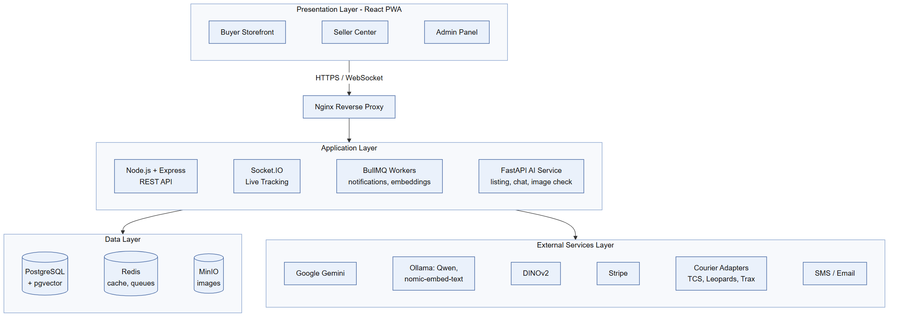
Fig 4: Architecture Diagram
Fig 4 shows the four layers of KarobarAI. Users reach the React app through Nginx over HTTPS and WebSocket. The application layer holds the REST API, the Socket.IO server, background workers and the AI service, which store data in PostgreSQL, Redis and MinIO. External services such as Gemini, Ollama, Stripe and the courier adapters are called only from the application layer.

6.1.3 Subsystem Architecture
Table 22: Subsystems and Responsibilities
Subsystem | Responsibility
Identity | Registration, OTP, login, tokens and roles
Store and Catalogue | Stores, products, images, categories and search
AI Store Builder | Image upload and AI listing drafts
Commerce | Cart, checkout, orders, payments and webhooks
Logistics and Tracking | Courier quotes, booking and live tracking
Notifications | Queued in-app, SMS and email messages
Returns | Return requests, image checks and disputes
Settlement | Commission and seller payouts
Analytics | Daily statistics and recommendations
Assistants | Buyer store chat and seller business chat
Administration | Users, moderation, configuration and audit log

6.2 Detailed System Design

6.2.1 Classification
Each subsystem is implemented as a backend module made of a route file, controller, service and repository, with AI features supported by routers in the Python AI service and shared types in a common package.

6.2.2 Definition
Each module implements one group of requirements from Chapter 4. For example, the AI Store Builder module implements the REQ-F-Store requirements and the returns module implements the REQ-F-Return requirements.

6.2.3 Responsibilities
• Validate every request and check the user's role and ownership.
• Apply business rules and keep data consistent through transactions.
• Call external providers only through adapters.
• Queue slow work such as notifications and embeddings.

6.2.4 Constraints
Only authorized roles can use each endpoint. Uploaded images must match allowed types and sizes. AI calls have time limits, and AI output must match a fixed schema before it is used.

6.2.5 Composition
Routes receive requests, controllers handle HTTP details, services hold business logic and repositories access the database through Prisma. Adapters wrap couriers, payments, messaging and storage.

6.2.6 Uses/Interactions
Modules call each other through service functions. For example, checkout uses the cart, order and payment services, and the order service triggers logistics, tracking and notification jobs.

6.2.7 Resources
The system uses PostgreSQL, Redis, MinIO, the AI service and external APIs. Stock reservation and payment updates run inside transactions to avoid race conditions, and webhook events are stored so the same event is never processed twice.

6.2.8 Processing
A request passes through authentication, validation, the service layer and the repository. Errors are converted into clear error codes that the frontend shows in plain language.

6.2.9 Interface/Exports
Each module exports REST endpoints, for example the authentication, product, cart, order, return and admin endpoints, along with internal service functions used by other modules.

6.2.10 Detailed Subsystem Design

Use Case Diagram
Fig 5 shows the four actors of KarobarAI and the fifteen use cases they perform. Sellers manage stores, listings, orders and analytics; Buyers shop, pay, track and return orders; Guests can search, track and chat without an account; and the Admin manages the platform. Register includes OTP verification, Place Order includes Make Payment and Arrange Courier, Request Return includes the AI Image Check, and File Appeal extends Request Return.
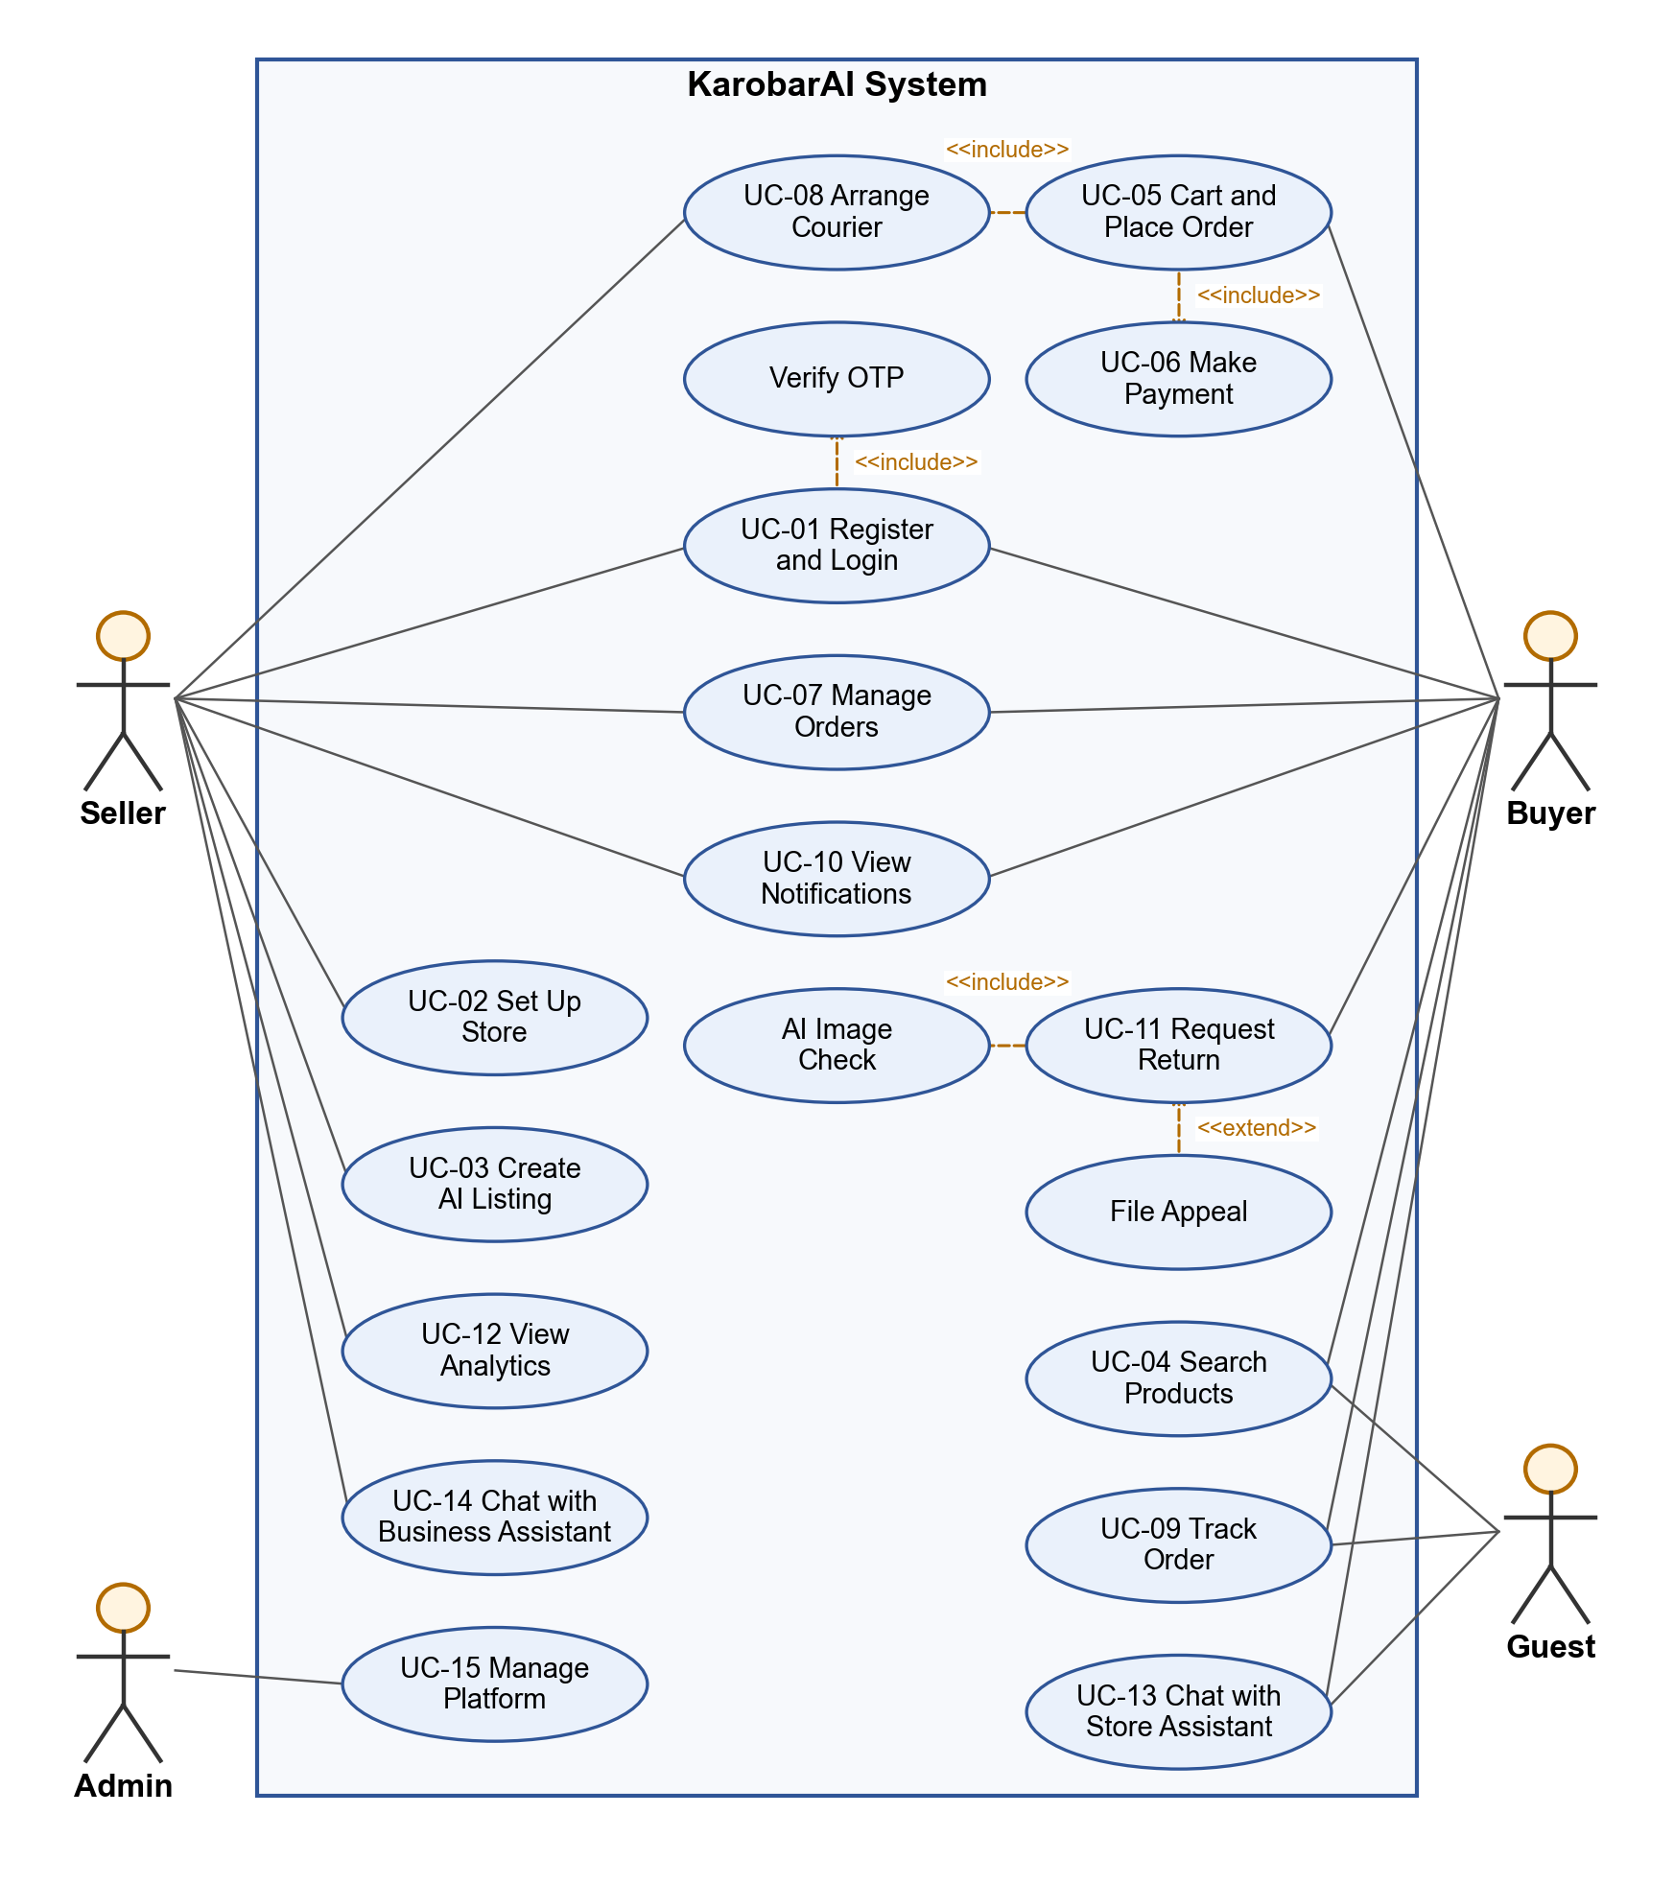
Fig 5: Use Case Diagram
Table 23: Use Case Descriptions
UC ID | Use Case | Actor | Description
UC-01 | Register and Login | Buyer, Seller | Create an account, verify OTP and log in
UC-02 | Set Up Store | Seller | Create store and add payout wallet
UC-03 | Create AI Listing | Seller | Upload photo and edit AI-generated listing
UC-04 | Search Products | Guest, Buyer | Search, filter and view products
UC-05 | Manage Cart and Checkout | Buyer | Add items and place an order
UC-06 | Make Payment | Buyer | Pay by COD or card
UC-07 | Manage Orders | Seller, Buyer | View and process orders
UC-08 | Book Courier | Seller | Confirm the recommended courier
UC-09 | Track Order | Buyer, Seller, Guest | View live tracking timeline
UC-10 | View Notifications | Buyer, Seller | Read order and return notifications
UC-11 | Request Return | Buyer | Submit return with photos
UC-12 | View Analytics | Seller | View sales and recommendations
UC-13 | Chat with Store Assistant | Buyer, Guest | Ask questions about store products
UC-14 | Chat with Business Assistant | Seller | Ask about own sales and stock
UC-15 | Manage Platform | Admin | Manage users, listings, disputes and settings

Entity Relationship Diagram
Fig 6 shows the main entities of KarobarAI and how they relate. A User can have a Seller or Buyer profile; sellers list Products and receive Orders, while buyers own a Cart and place Orders. Each Order contains Order Items and links to one Payment, Courier Shipment and Settlement, along with Tracking Events and possible Returns, and a Return can raise a Dispute.
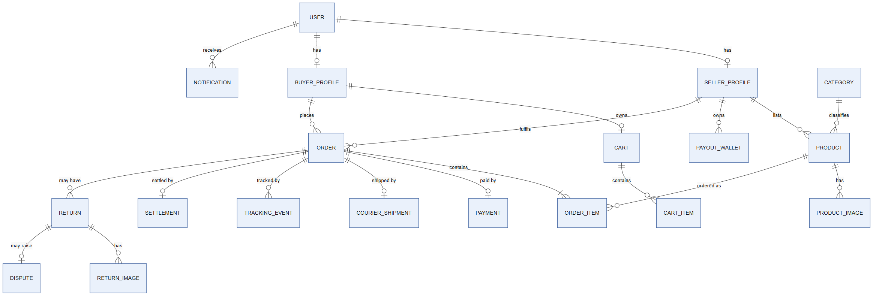
Fig 6: Entity Relationship Diagram

Database Diagram
Fig 7 shows the physical PostgreSQL tables behind the main entities, with their key columns, data types, primary keys (PK) and foreign keys (FK). Seller and buyer profiles share the user_id of the users table, and each order references both its buyer and its seller. Money values use decimal types and statuses are stored as enums, so only valid states can be saved.
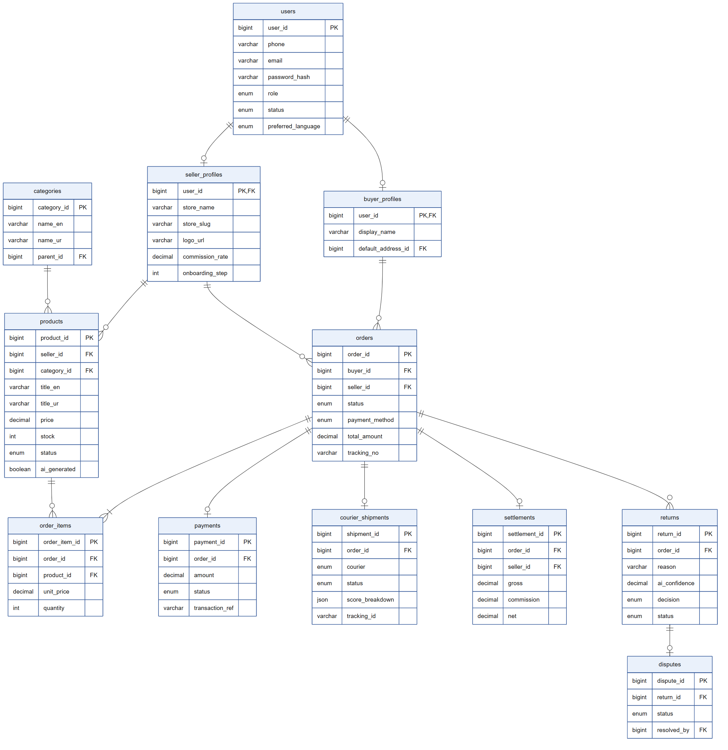
Fig 7: Database Diagram

Architectural Diagram
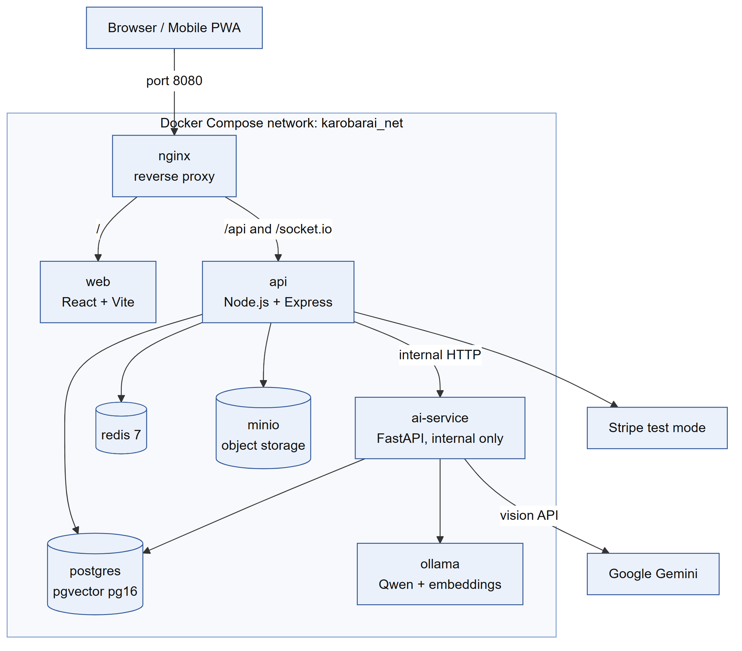
Fig 8: Architectural Diagram
Fig 8 shows how KarobarAI is deployed as Docker containers on one private network. Nginx is the only public entry point; it sends page requests to the web container and API and WebSocket traffic to the api container. The api container uses PostgreSQL, Redis and MinIO and calls the ai-service, which is never exposed outside the network and uses Ollama and the Gemini API.

Activity Diagrams
The following activity diagrams show the flow of the main processes of the system.
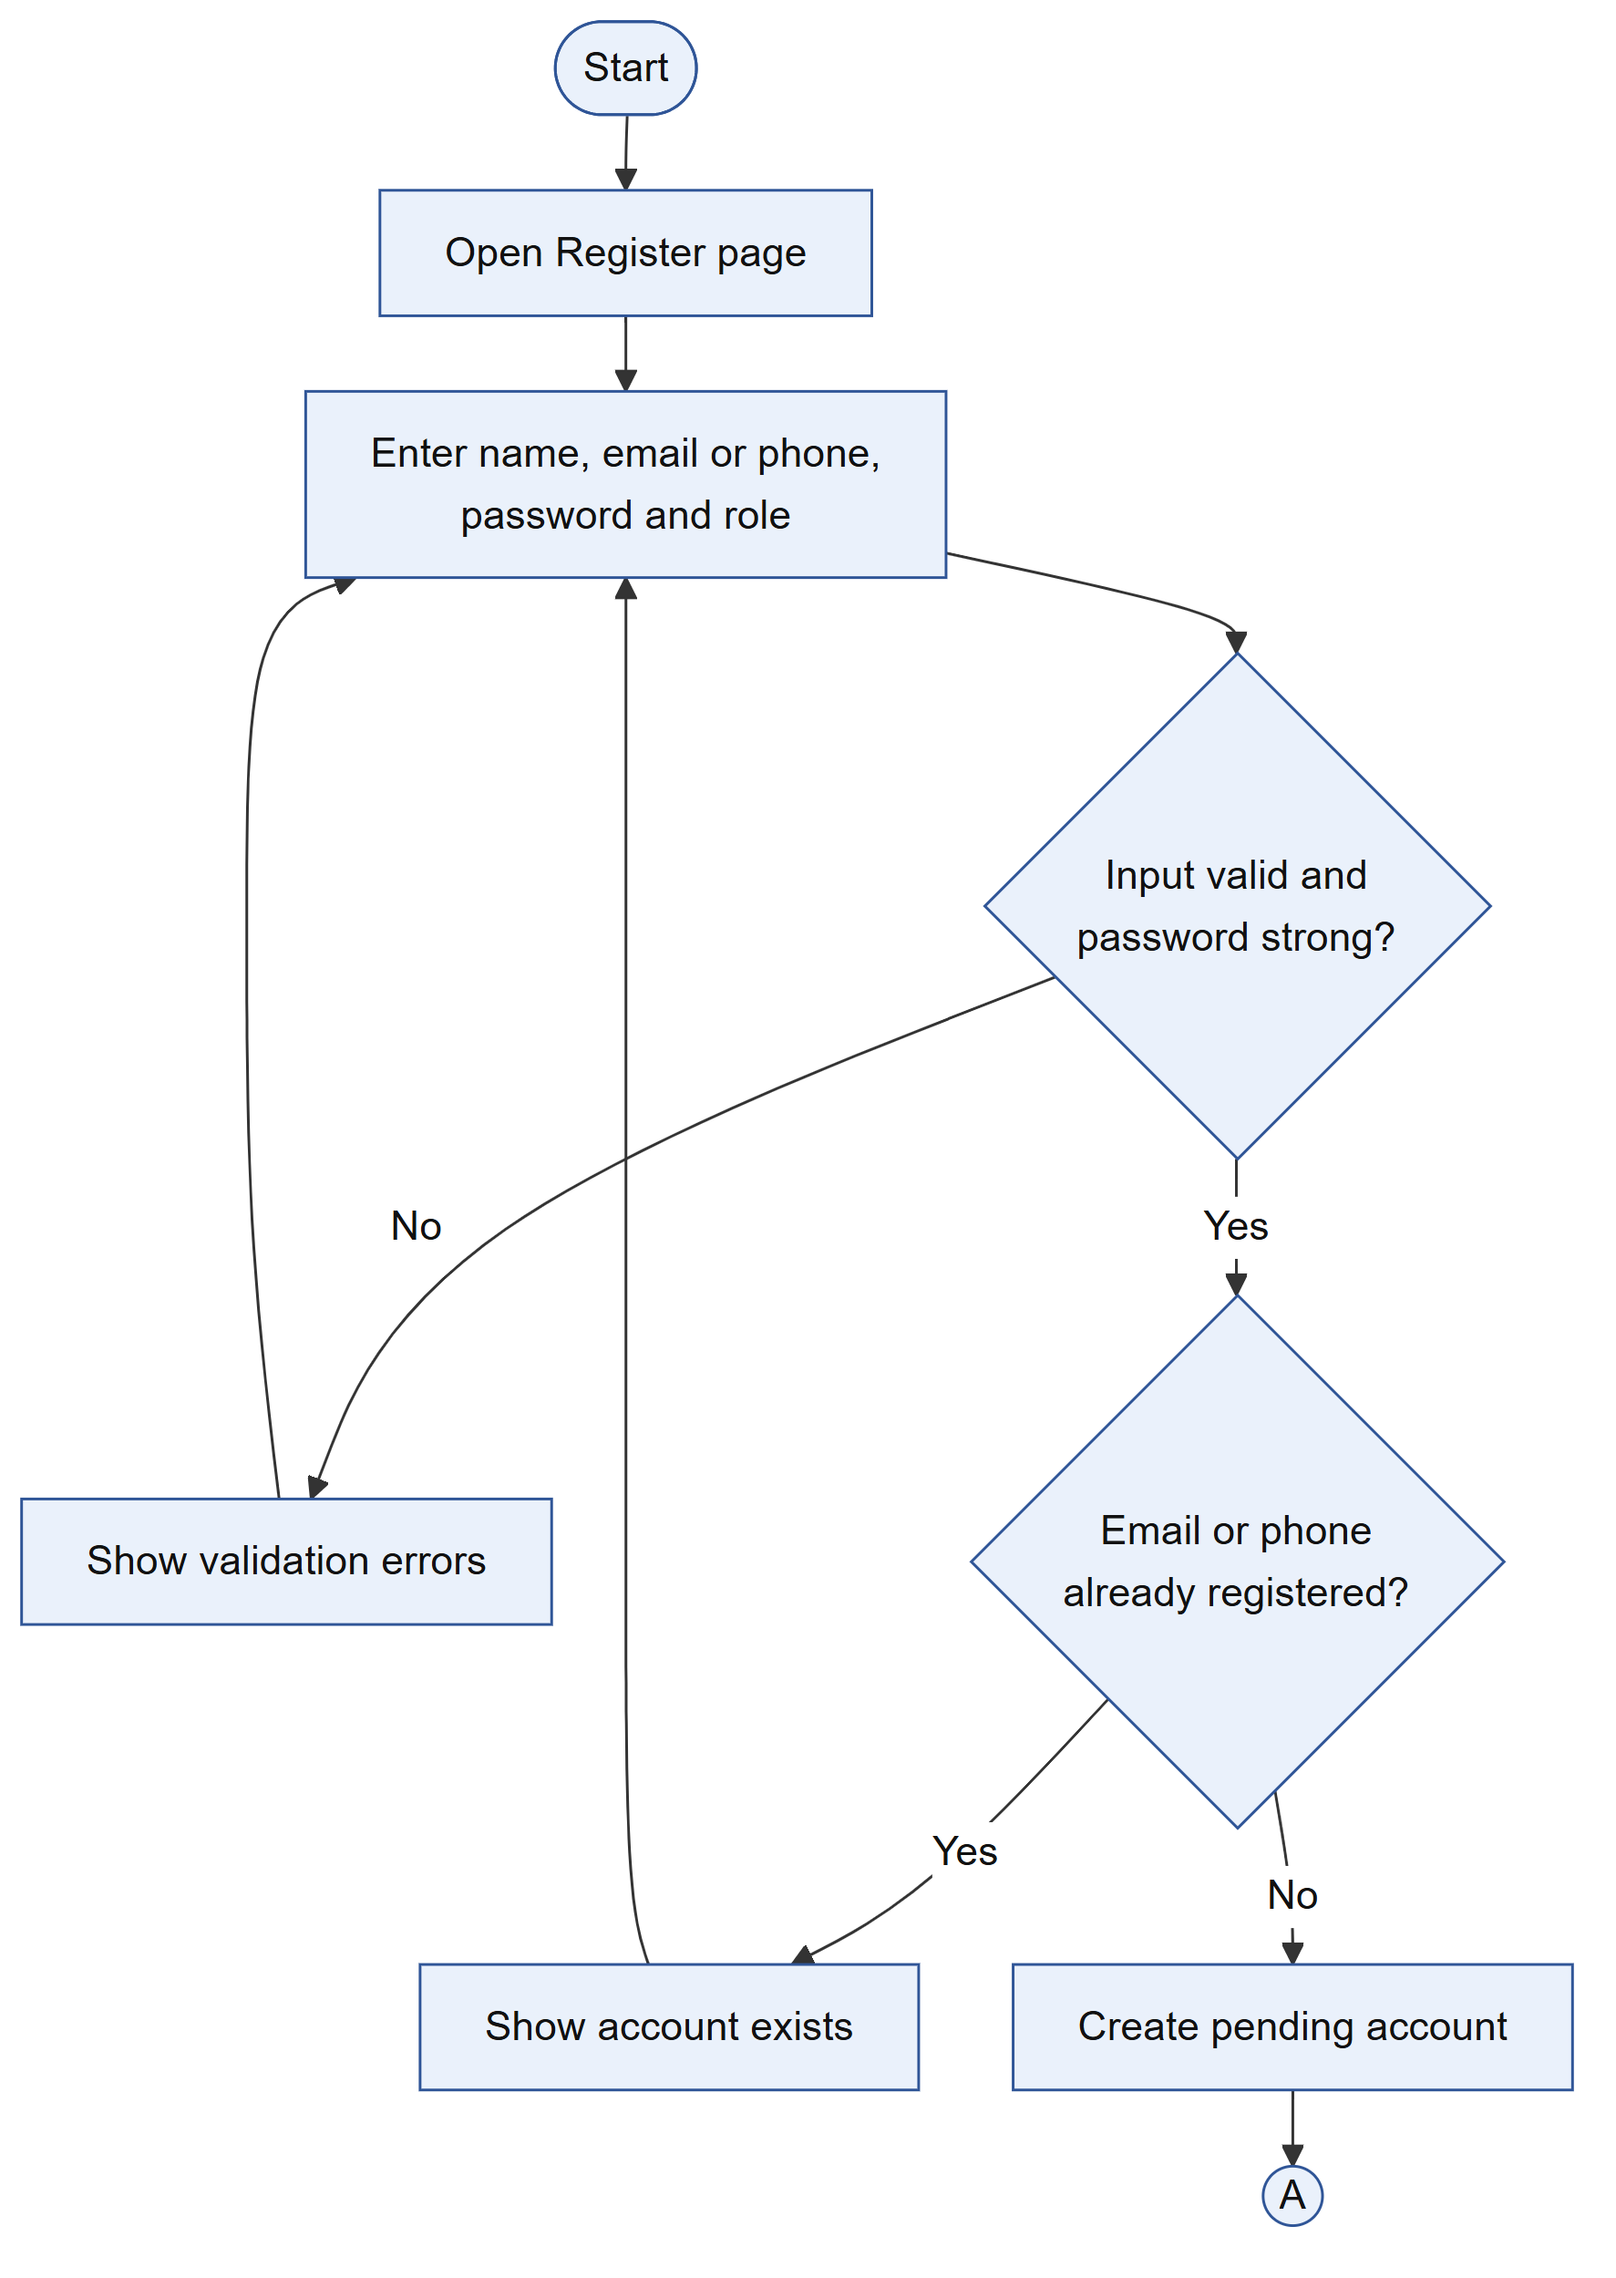
(a) Part 1
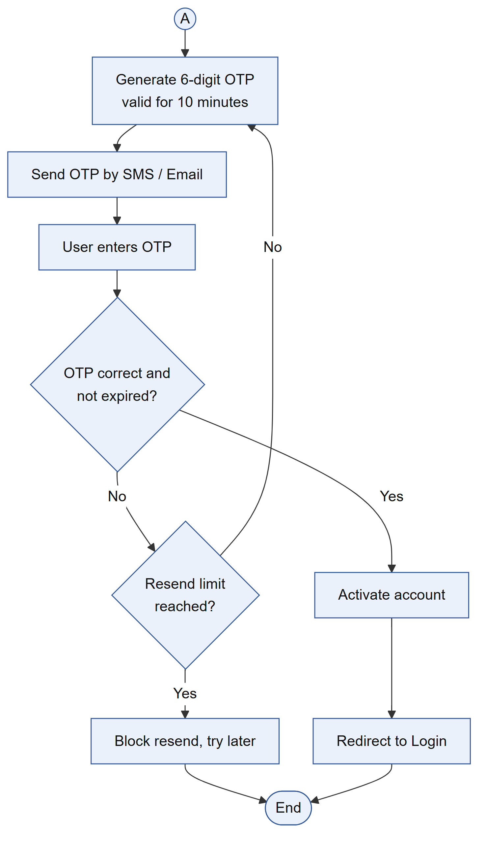
(b) Part 2
Fig 9: Activity Diagram for Registration and OTP Verification
Fig 9 shows how a new user creates an account. The form is validated and duplicate emails or phone numbers are rejected before a pending account is created. A 6-digit OTP valid for 10 minutes is then sent, and the account is activated only after the correct OTP is entered, with a limit on resends.
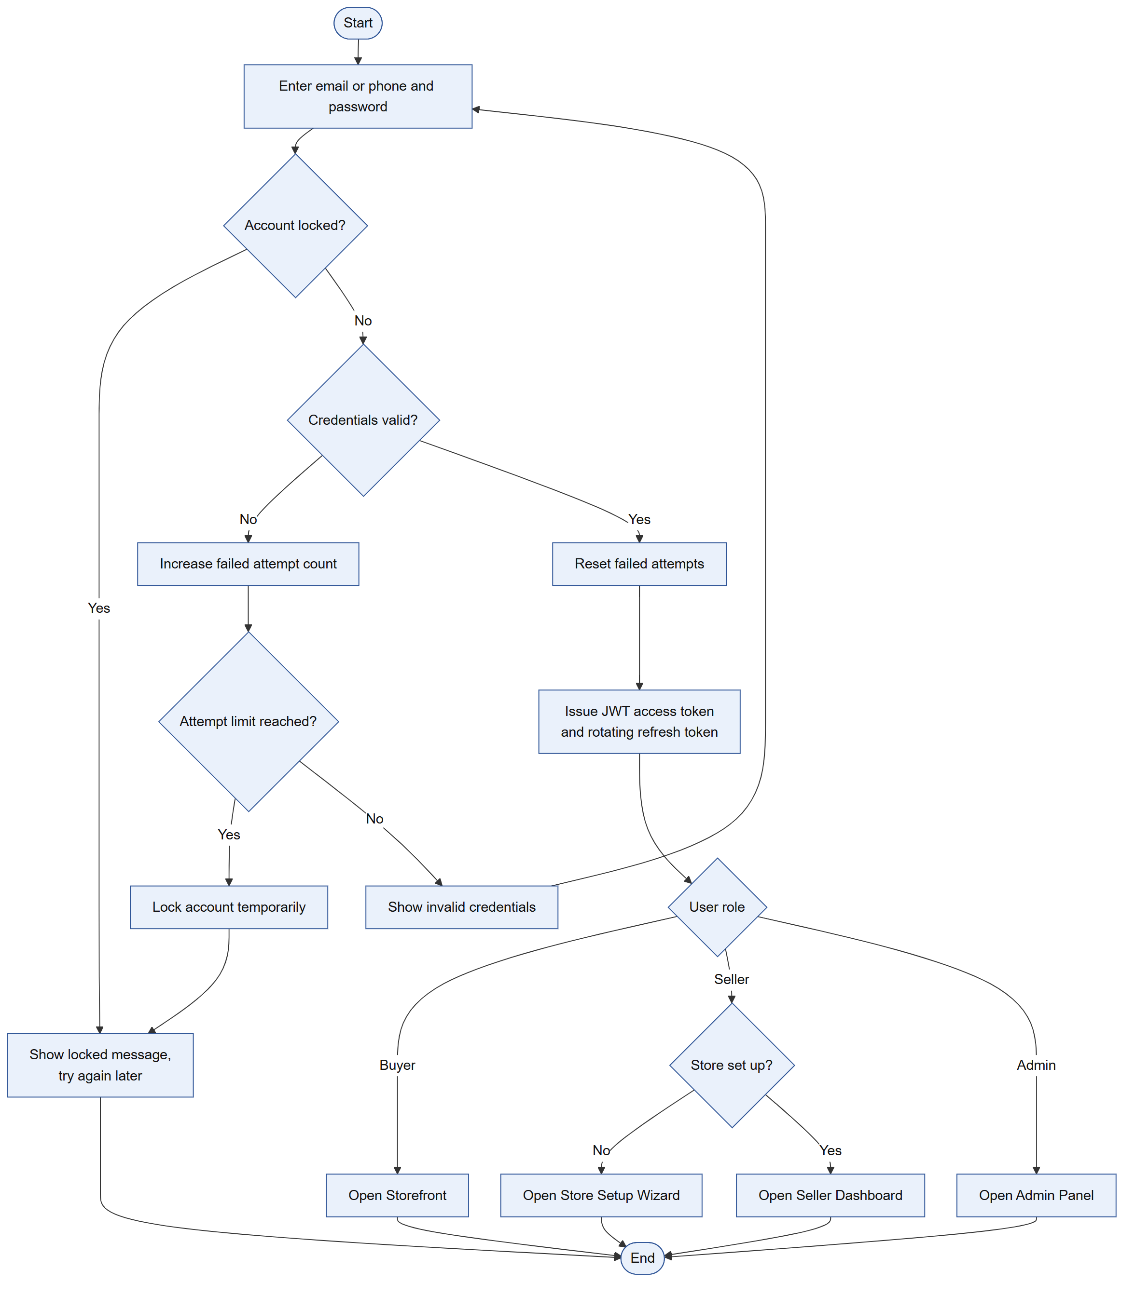
Fig 10: Activity Diagram for Login
Fig 10 shows the login process. Locked accounts are stopped first, and each wrong password increases a failure count until the account is temporarily locked. On success the system issues an access token and a refresh token and sends the user to the storefront, the seller dashboard or setup wizard, or the admin panel according to their role.
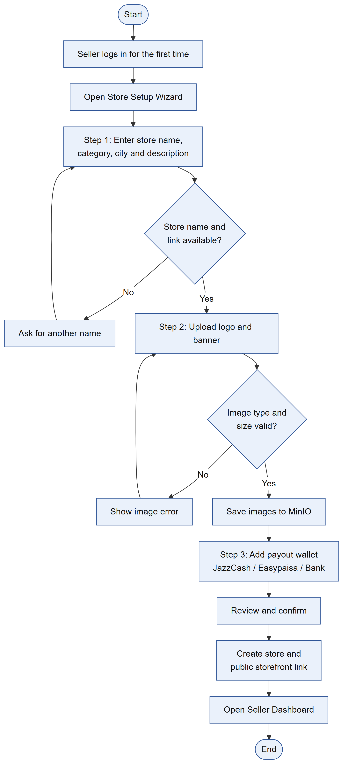
Fig 11: Activity Diagram for Store Setup
Fig 11 shows how a seller sets up a store on first login. The seller enters the store details, uploads a logo and banner that are validated and saved to MinIO, and adds a payout wallet. After confirmation the store and its public link are created and the seller is taken to the dashboard.
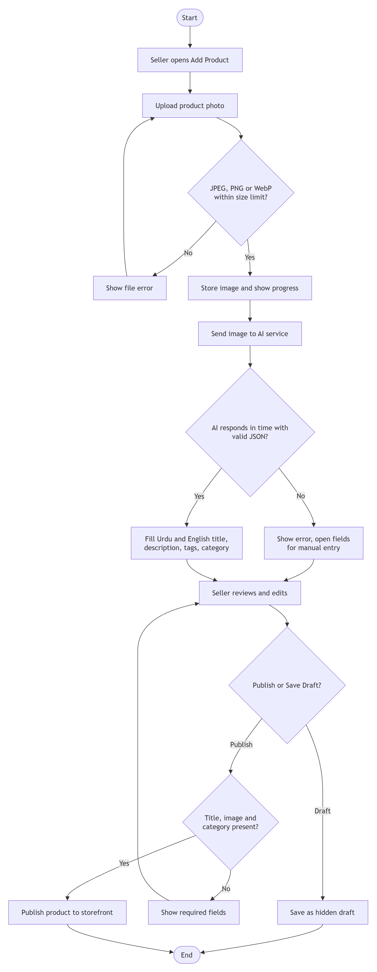
Fig 12: Activity Diagram for AI Listing Generation
Fig 12 shows how a seller creates a product listing with AI. The uploaded photo is checked for type and size, stored, and sent to the AI service while a progress indicator is shown. If the AI returns valid output, the Urdu and English fields are filled in; otherwise the seller enters them manually. The seller then edits the draft and either saves it as a hidden draft or publishes it once the required fields are present.
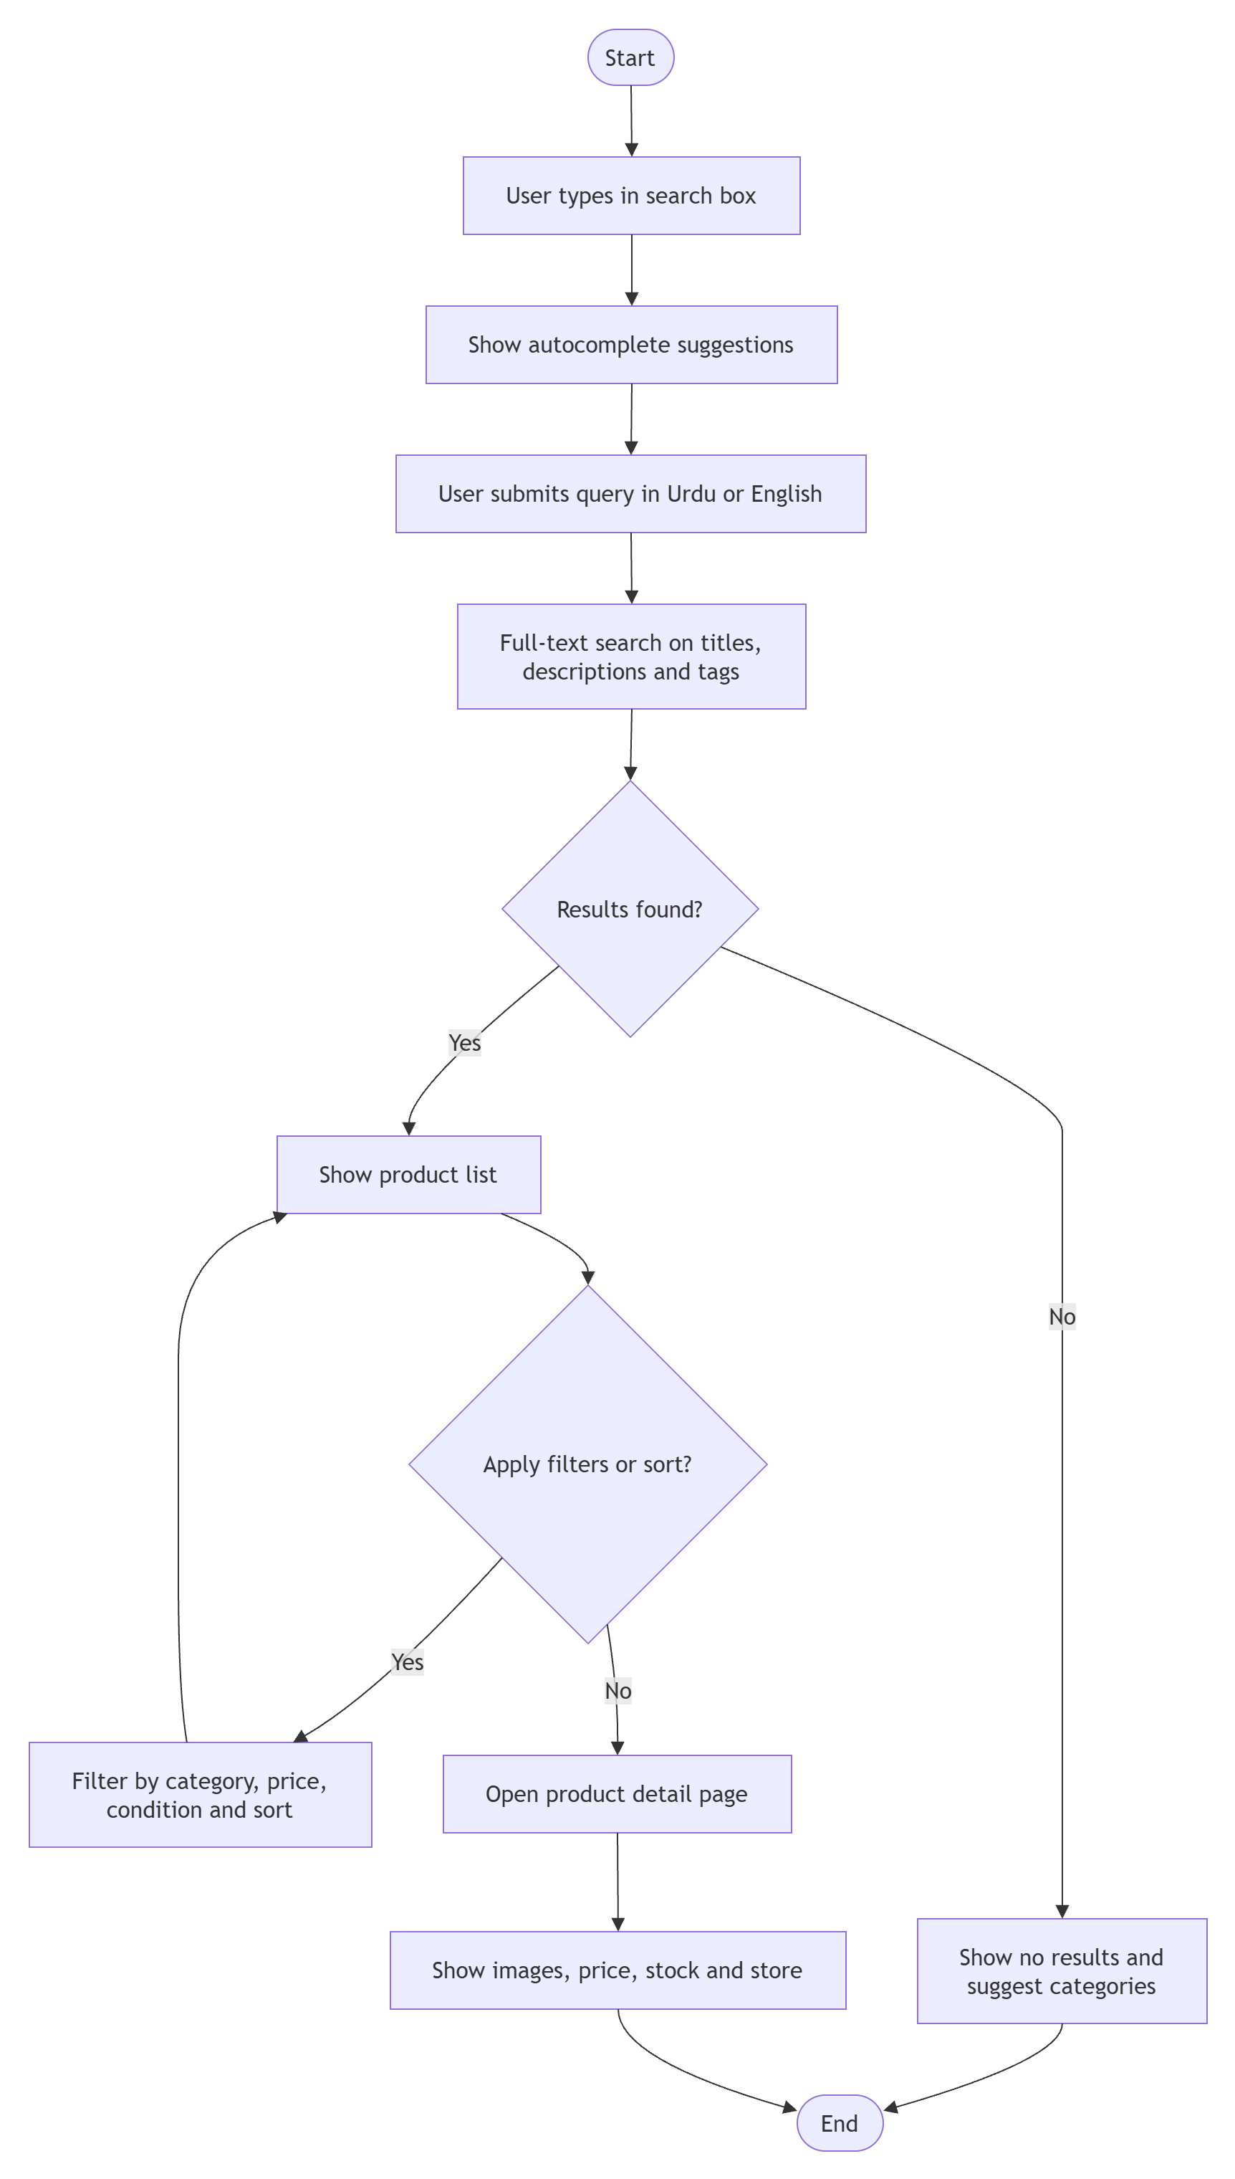
Fig 13: Activity Diagram for Product Search
Fig 13 shows how a buyer or guest finds products. Suggestions appear while typing, and the submitted query runs a full-text search in Urdu or English across titles, descriptions and tags. The results can be filtered by category, price and condition or sorted, and opening a product shows its images, price, stock and store.
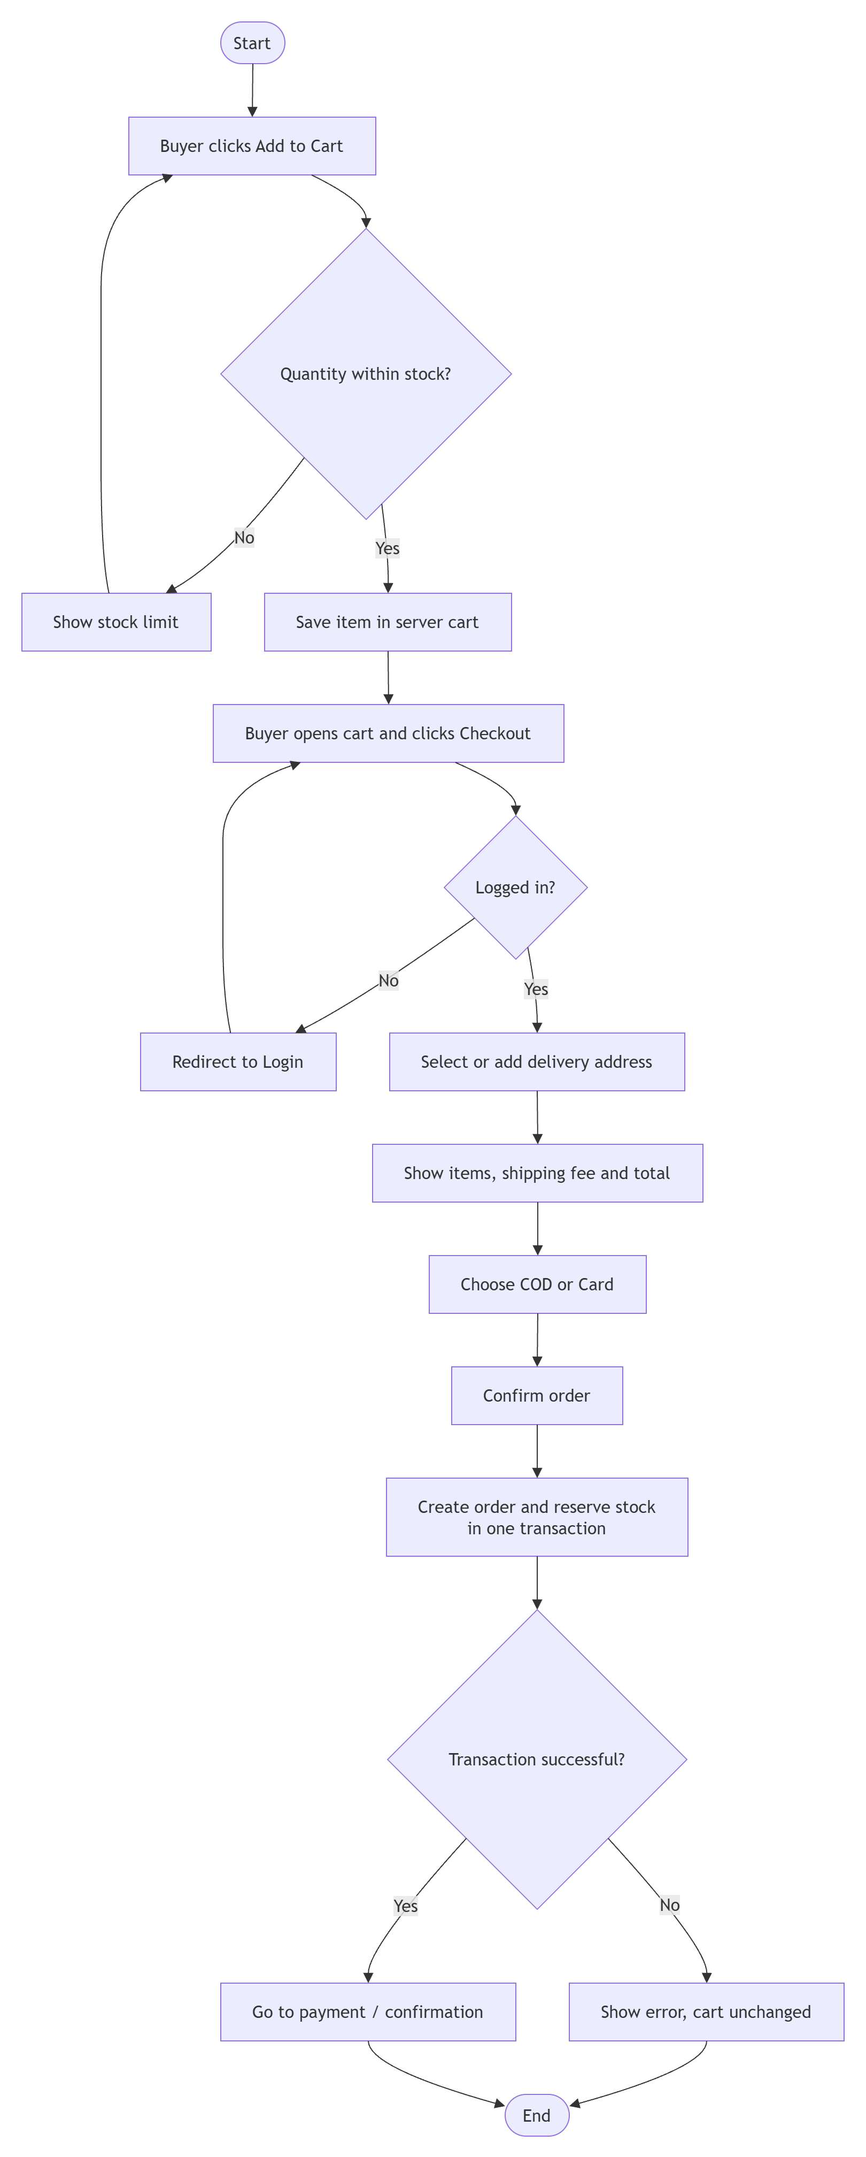
Fig 14: Activity Diagram for Cart and Checkout
Fig 14 shows the cart and checkout process. Each item is checked against stock and saved in a server-side cart, and guests are asked to log in before checkout. The buyer selects an address, reviews the total with shipping and chooses Cash on Delivery or card, after which the order is created and the stock reserved in a single transaction.
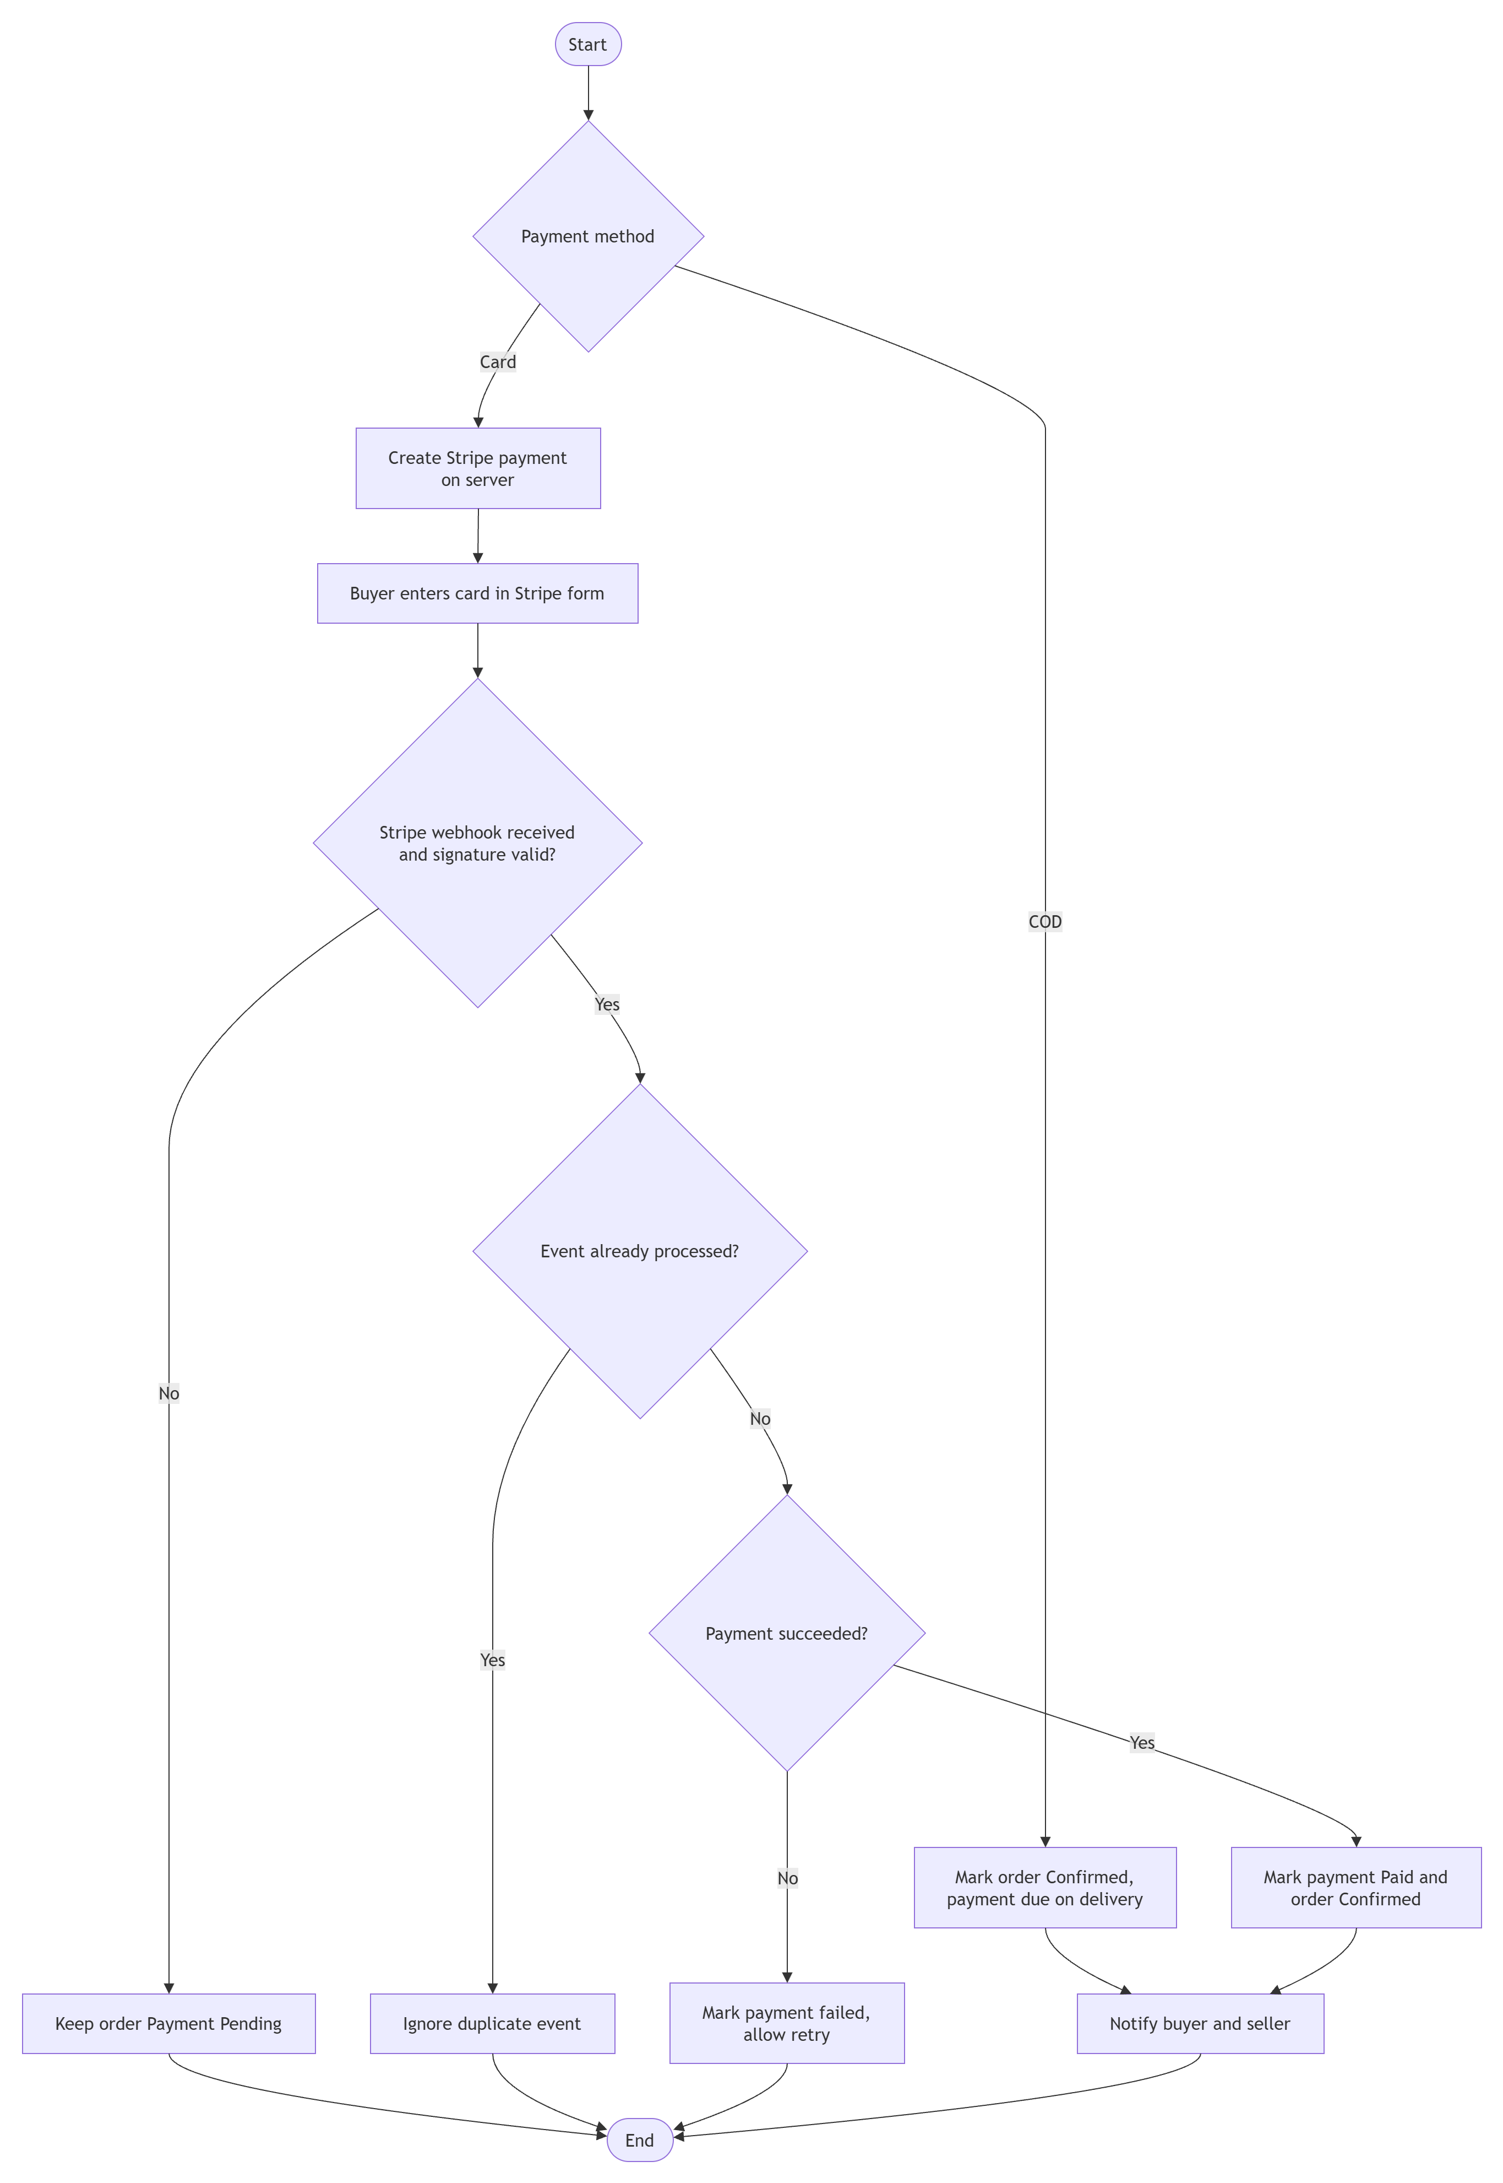
Fig 15: Activity Diagram for Payment
Fig 15 shows how payments are confirmed. Cash on Delivery orders are confirmed directly, while card orders wait for a Stripe webhook whose signature is verified. Duplicate events are ignored, failed payments can be retried, and a successful payment marks the order as confirmed and notifies both the buyer and the seller.
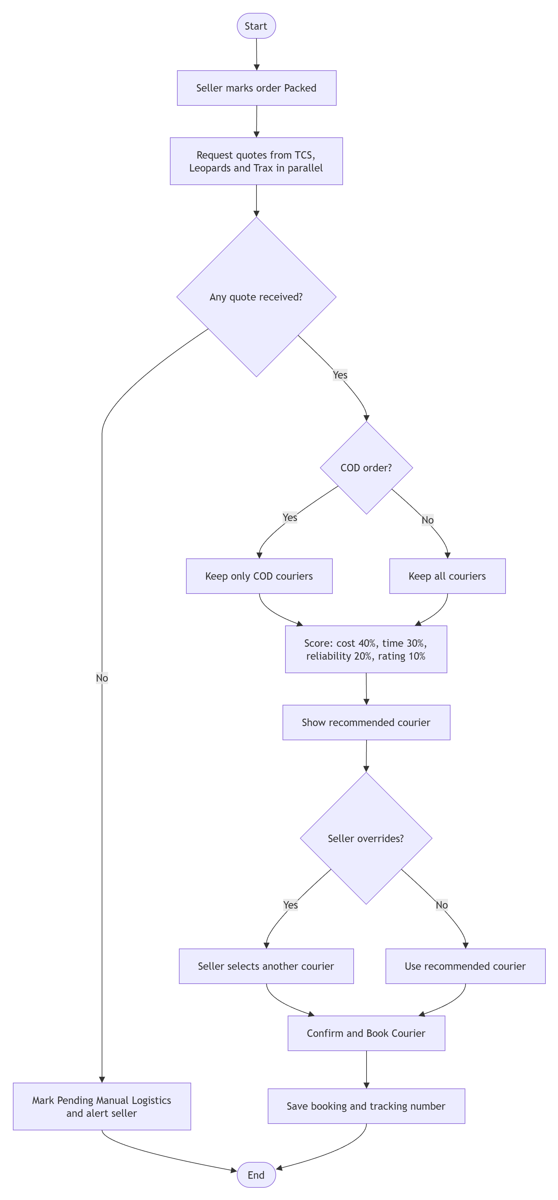
Fig 16: Activity Diagram for Courier Selection and Booking
Fig 16 shows how a courier is selected and booked. When an order is packed, quotes are requested from TCS, Leopards and Trax in parallel, and only COD-capable couriers are kept for COD orders. The couriers are scored on cost, delivery time, reliability and rating, and the seller books the recommended one or overrides it. If no courier responds, the order is flagged for manual logistics.
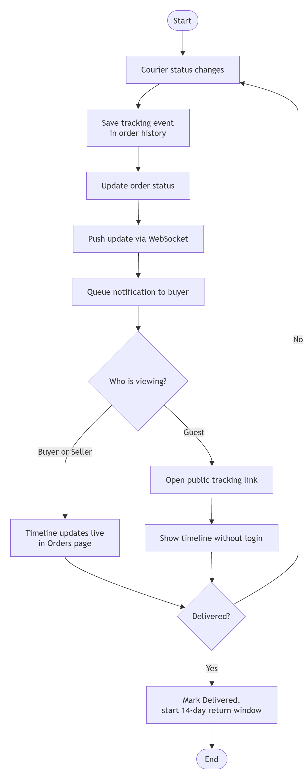
Fig 17: Activity Diagram for Order Tracking
Fig 17 shows how live tracking works. Every courier status change is stored as a tracking event, updates the order status and is pushed to open pages through WebSocket, along with a notification to the buyer. Buyers and sellers see the timeline in their orders page, guests use the public tracking link, and delivery starts the 14-day return window.
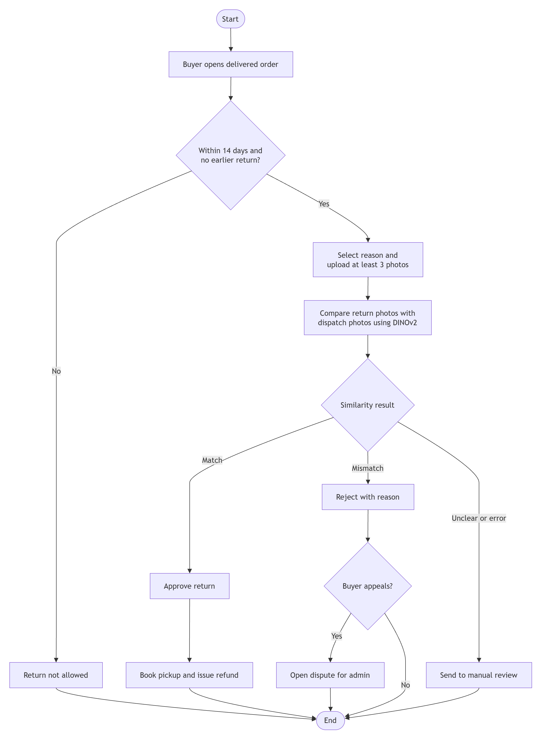
Fig 18: Activity Diagram for Return Request and AI Check
Fig 18 shows the return process with the AI image check. A buyer can request one return within 14 days of delivery by giving a reason and at least three photos. DINOv2 compares these photos with the dispatch photos: a match approves the return, a mismatch rejects it with a reason and an appeal option, and unclear results go to manual review.
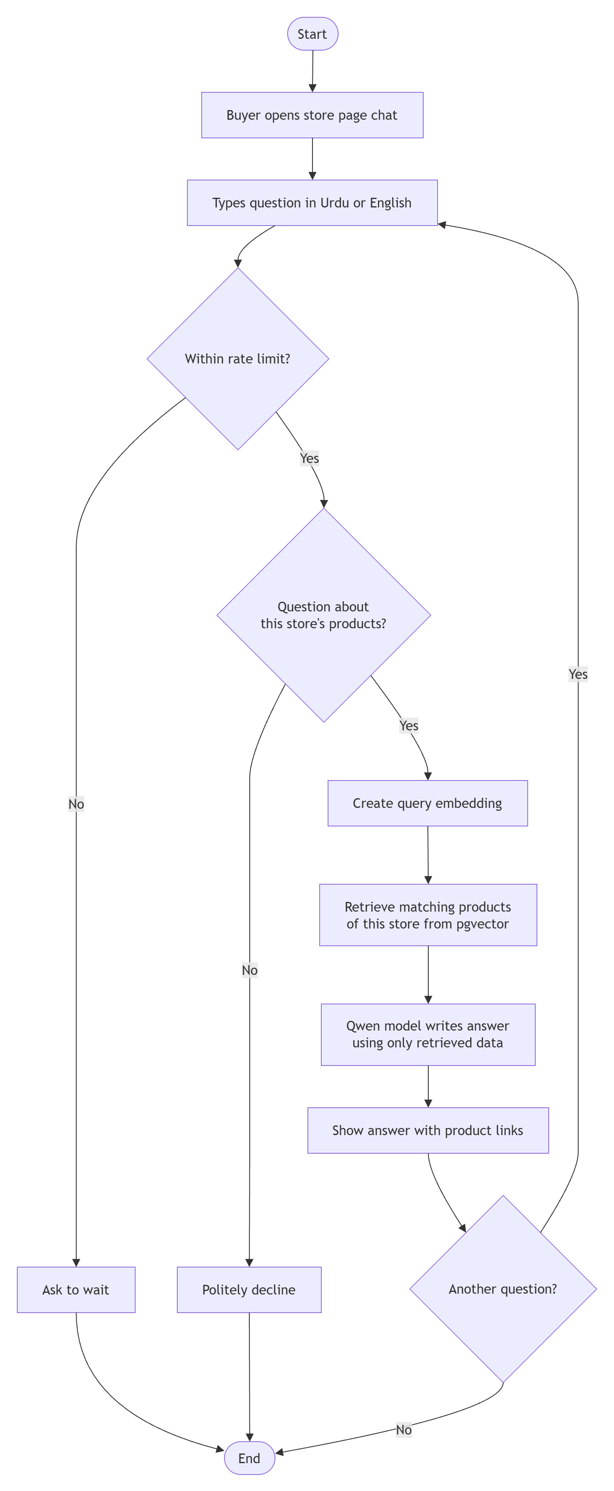
Fig 19: Activity Diagram for Store Assistant Chat
Fig 19 shows how the buyer store assistant answers questions. Requests are rate limited and off-topic questions are politely declined. For valid questions, the matching products of the current store are retrieved from pgvector and the Qwen model writes an answer using only that data, so it never invents prices or stock.
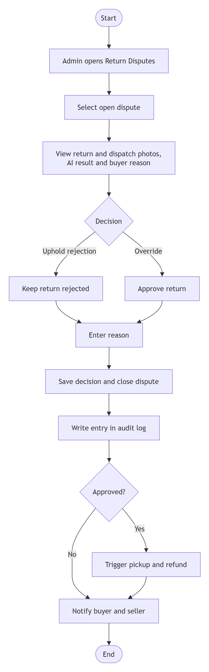
Fig 20: Activity Diagram for Admin Dispute Resolution
Fig 20 shows how an admin resolves a return dispute. The admin reviews the return and dispatch photos, the AI result and the buyer's reason, then either upholds the rejection or overrides it. A reason is required for every decision, the action is recorded in the audit log, and an approved return triggers pickup and refund.

Sequence Diagrams
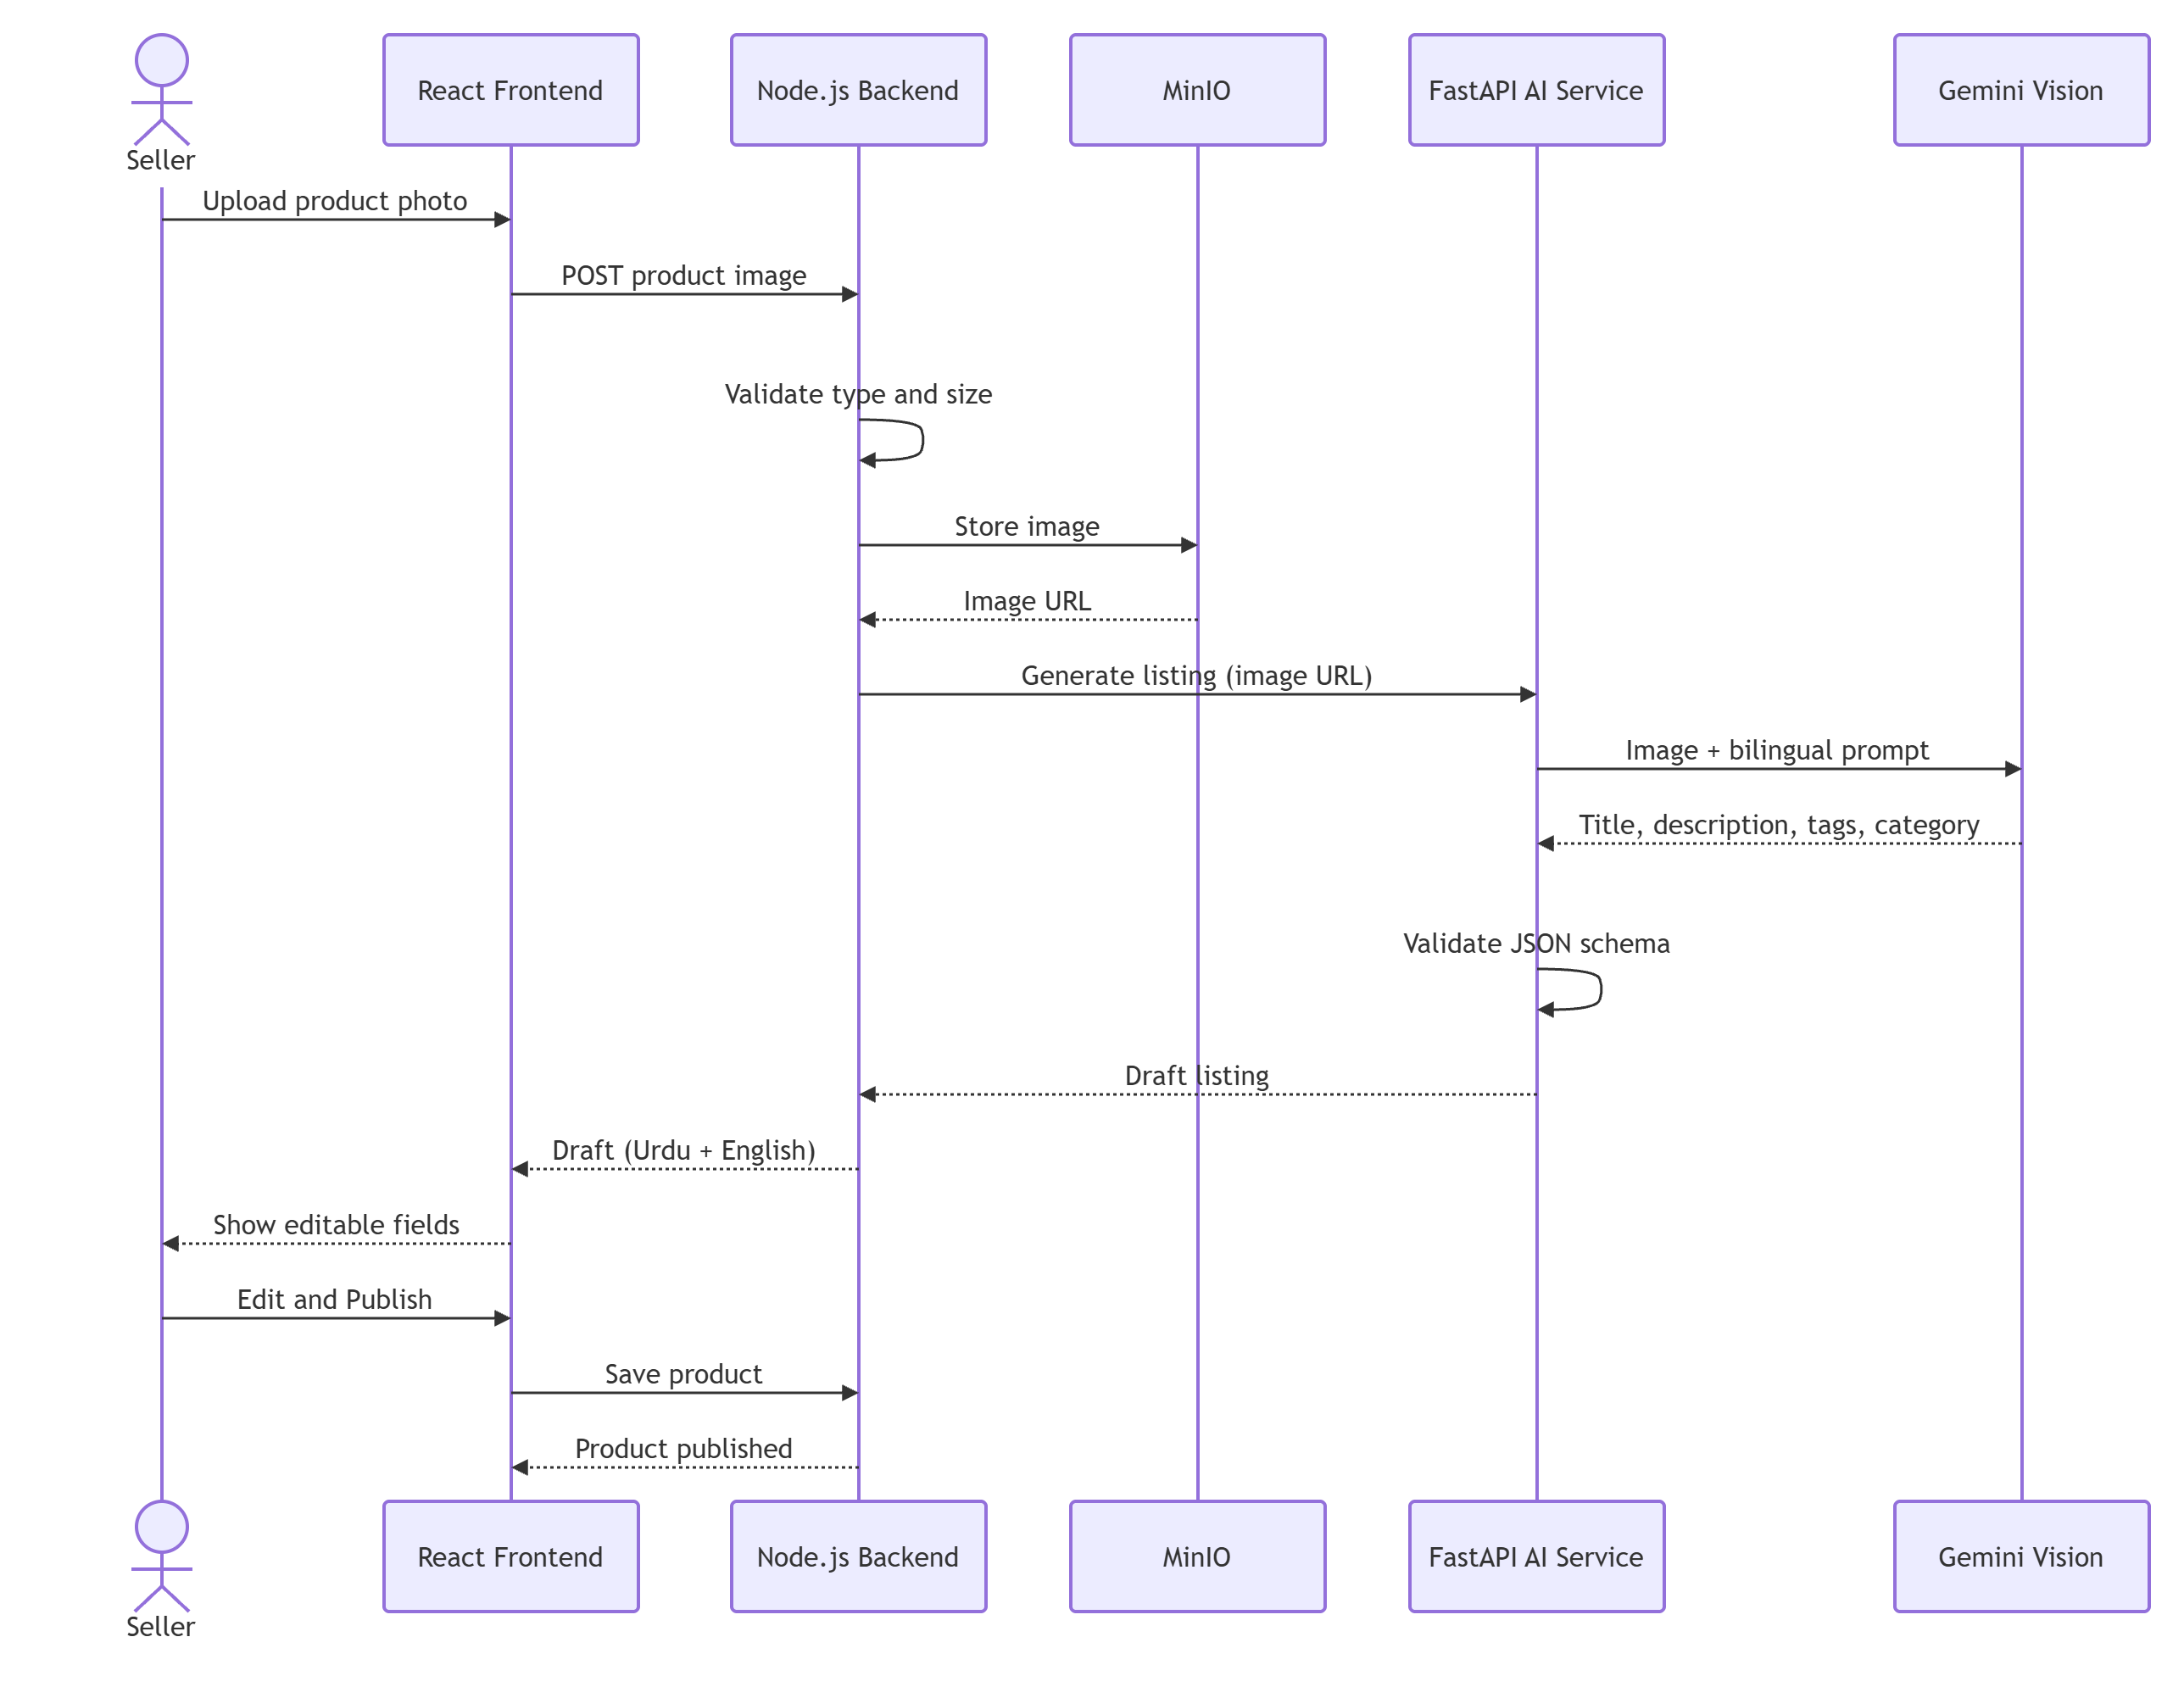
Fig 21: Sequence Diagram for AI Listing Generation
Fig 21 shows the messages exchanged when a listing is generated. The backend validates and stores the photo in MinIO, then asks the AI service for a draft. The AI service sends the image to Gemini with a bilingual prompt, validates the returned JSON and passes the draft back, which the seller edits and publishes.
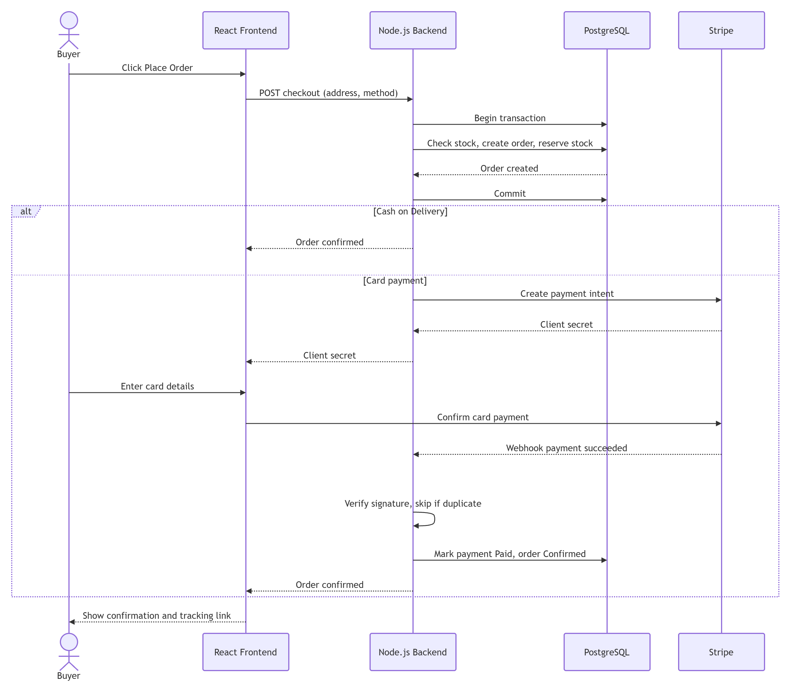
Fig 22: Sequence Diagram for Checkout and Payment
Fig 22 shows the messages exchanged during checkout. The backend checks stock, creates the order and reserves stock inside one database transaction. For Cash on Delivery the order is confirmed at once, while for card payments the backend creates a Stripe payment, and the order is confirmed only after a verified, non-duplicate Stripe webhook arrives.
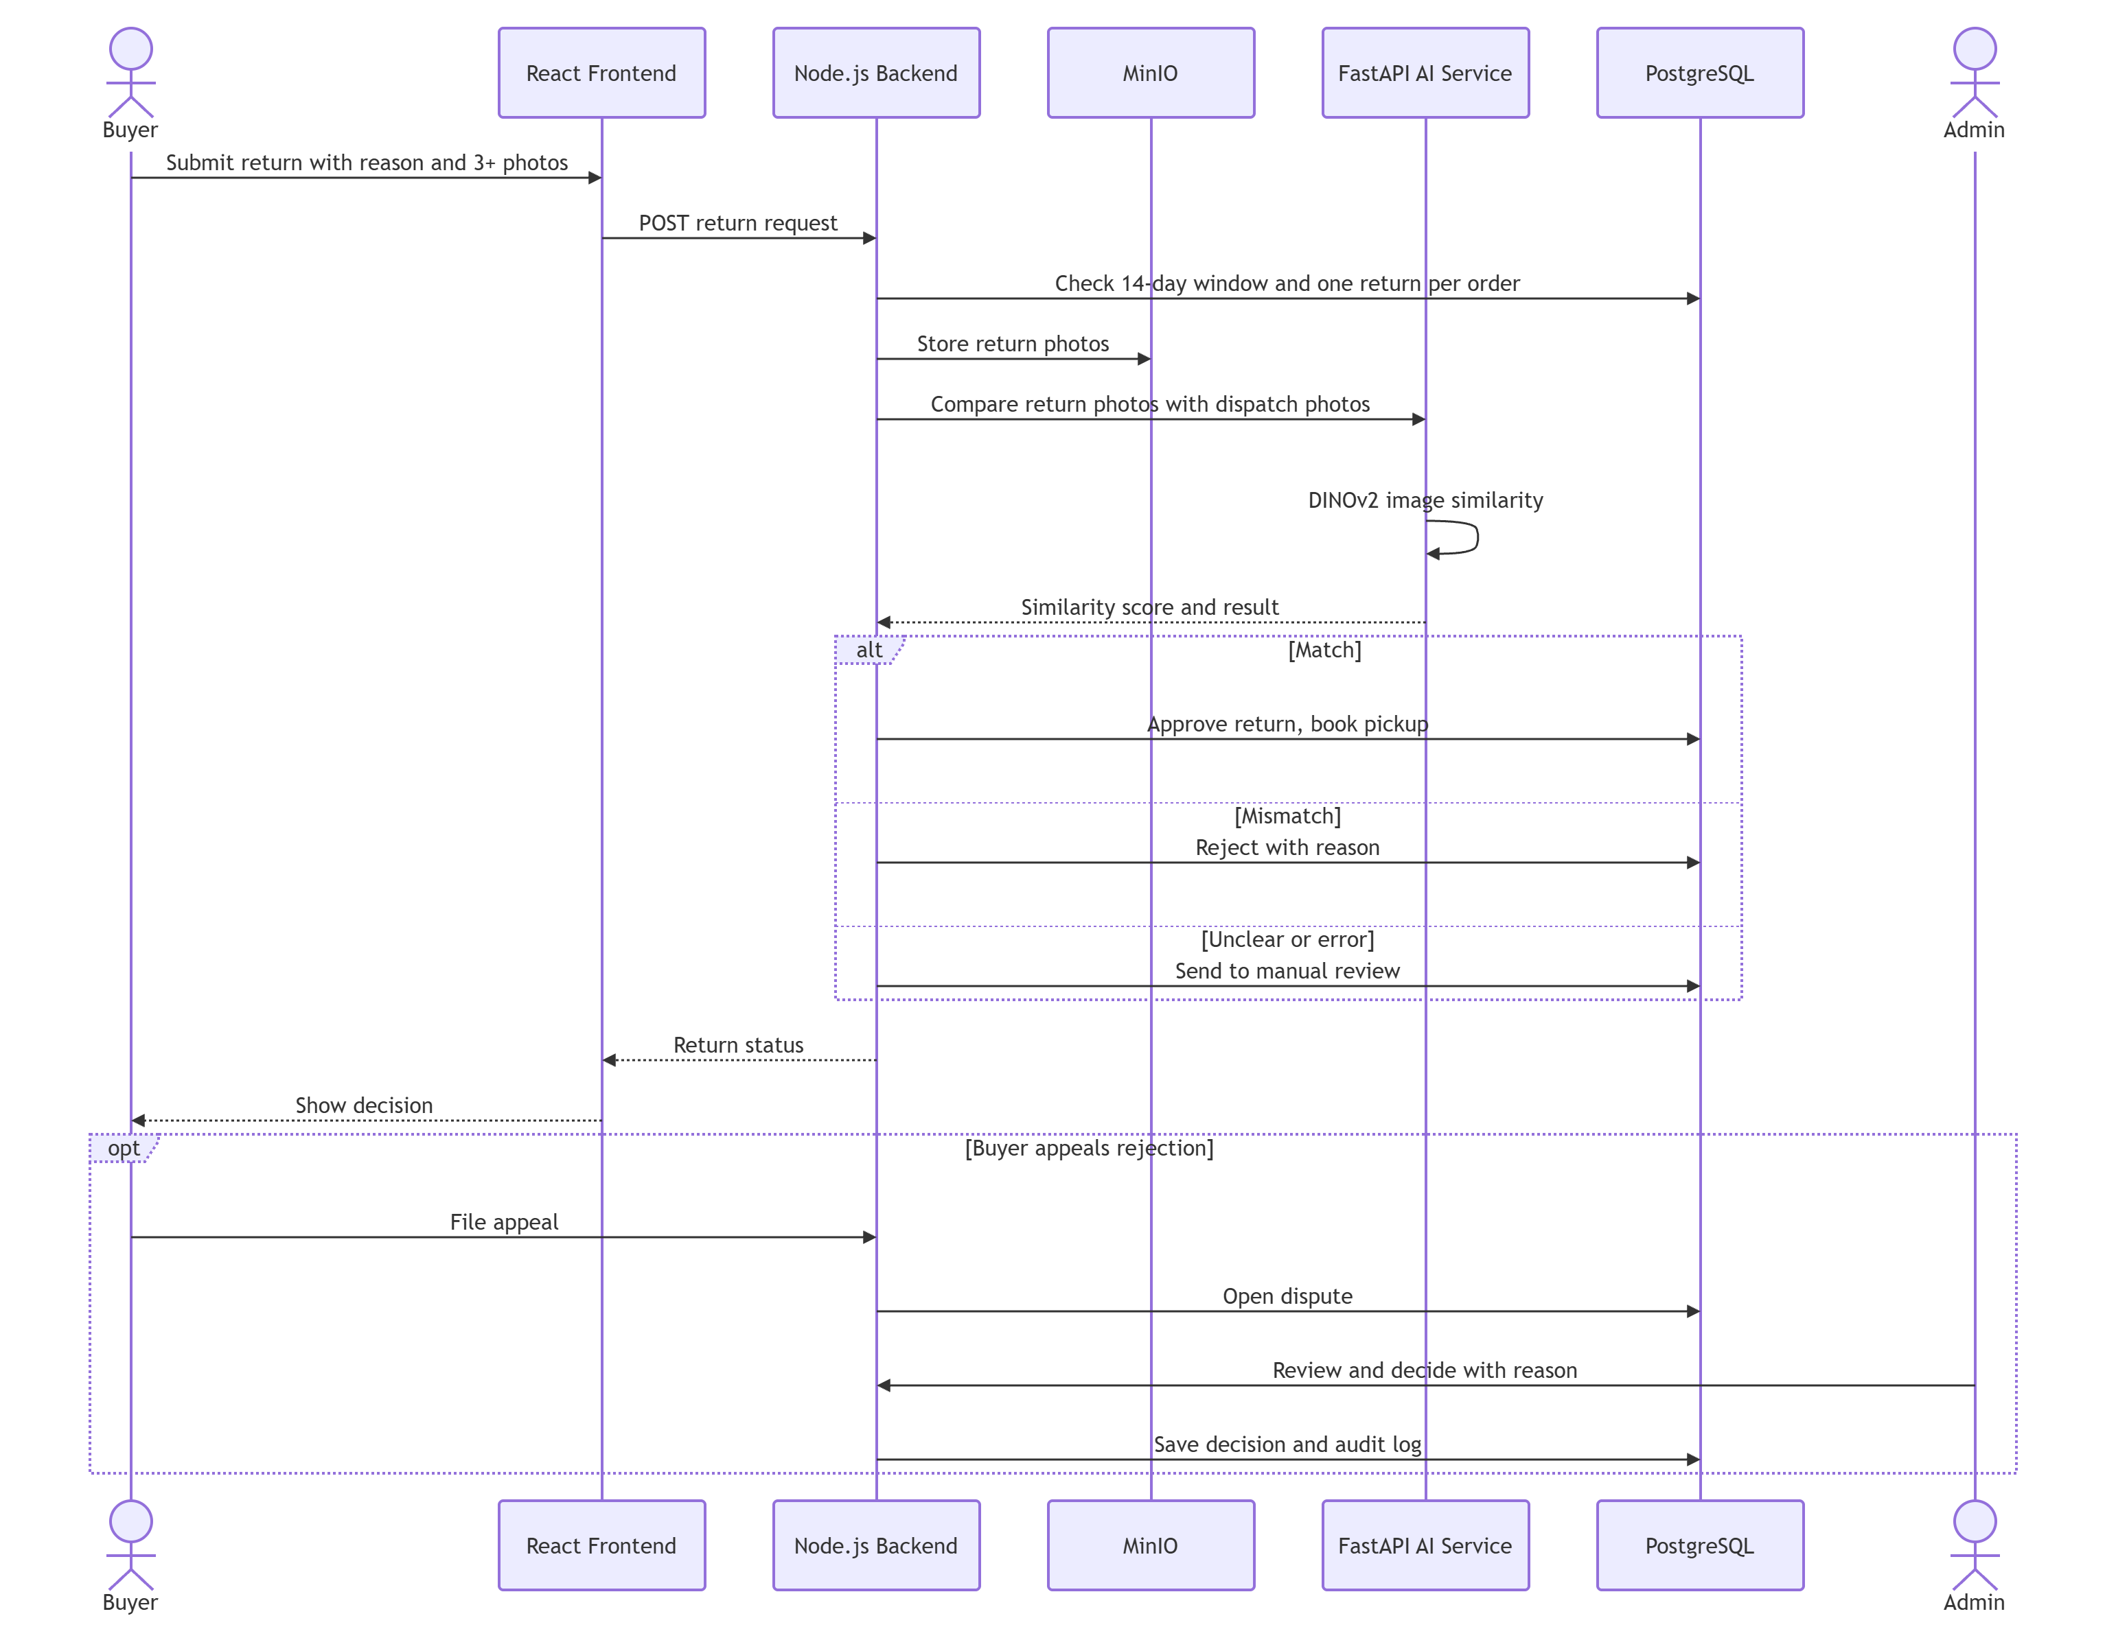
Fig 23: Sequence Diagram for Return Verification
Fig 23 shows how a return request is verified. The backend checks the return window, stores the buyer's photos in MinIO and asks the AI service to compare them with the dispatch photos using DINOv2. Depending on the result the return is approved, rejected or sent to manual review, and a rejected buyer can appeal to an admin, whose decision is saved in the audit log.

Component Diagram
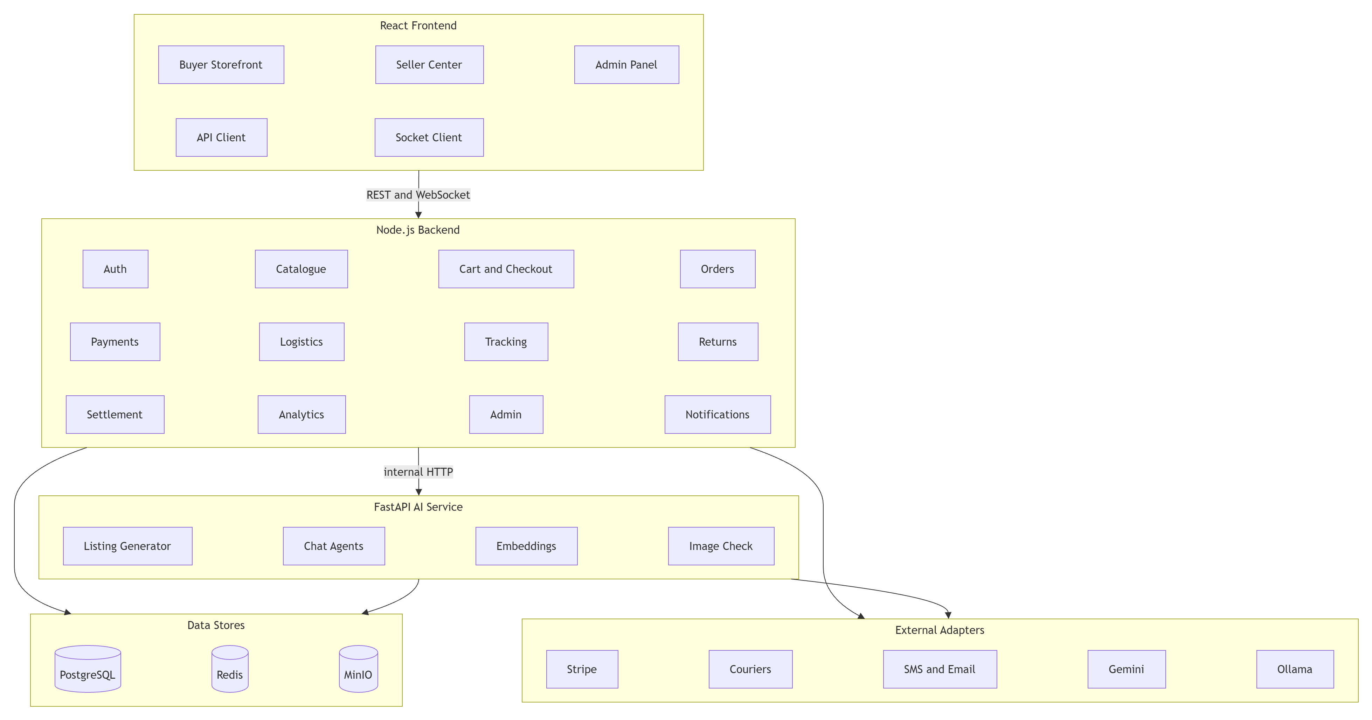
Fig 24: Component Diagram
Fig 24 shows the main software components and how they depend on each other. The three frontend panels talk to the backend through REST and WebSocket. The backend modules use the data stores and external adapters directly, while the AI service components handle listing generation, chat, embeddings and image checks for the backend.

State Machine Diagrams
The order moves through Payment Pending, Payment Confirmed, Processing, Packed, Handed Over to Courier, Picked Up, In Transit, Out for Delivery, Delivered and Completed, and can be Cancelled before hand-over. A return moves through Initiated, Images Submitted, Under AI Review, Manual Review, Approved or Rejected, Pickup Booked, Refund Issued, Under Dispute and Closed.
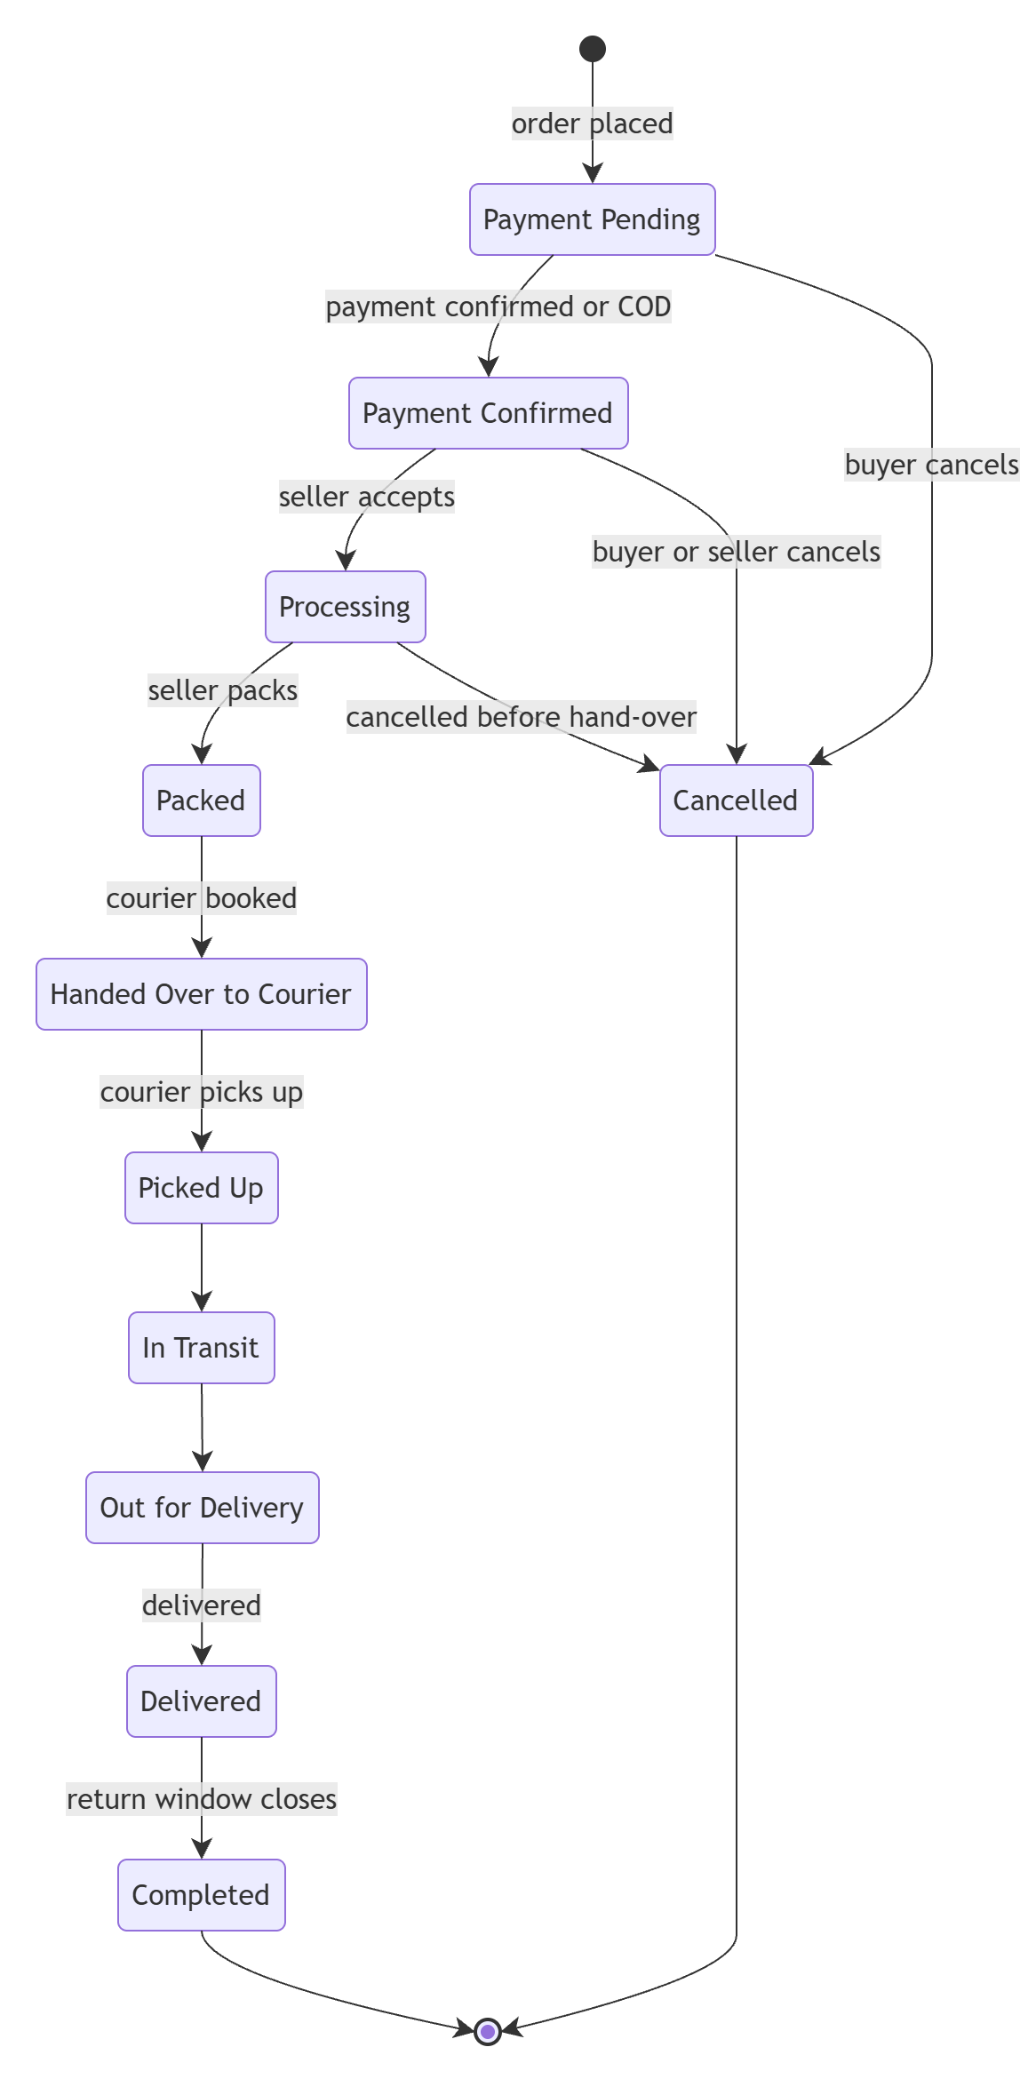
Fig 25: State Machine Diagram for Order
Fig 25 shows the life cycle of an order. An order starts as Payment Pending, moves to Payment Confirmed and then through processing, packing, courier hand-over and transit until it is Delivered. It becomes Completed when the return window closes, and it can be Cancelled only before it is handed over to the courier.
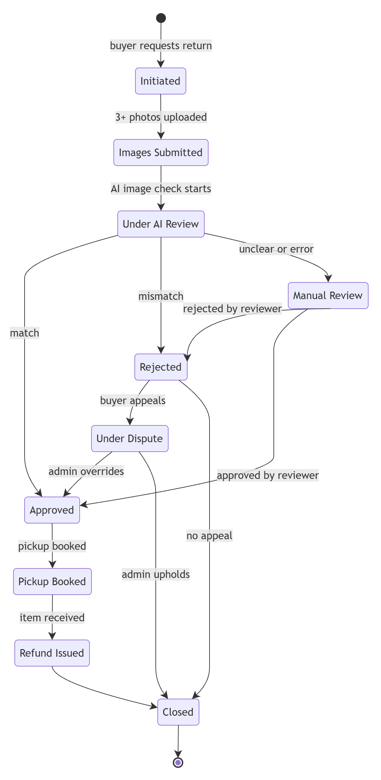
Fig 26: State Machine Diagram for Return
Fig 26 shows the life cycle of a return. After the photos are submitted, the AI review approves, rejects or sends the return to manual review. A rejected return can be appealed and resolved by an admin, while an approved return moves through pickup and refund before it is closed.

Class Diagram
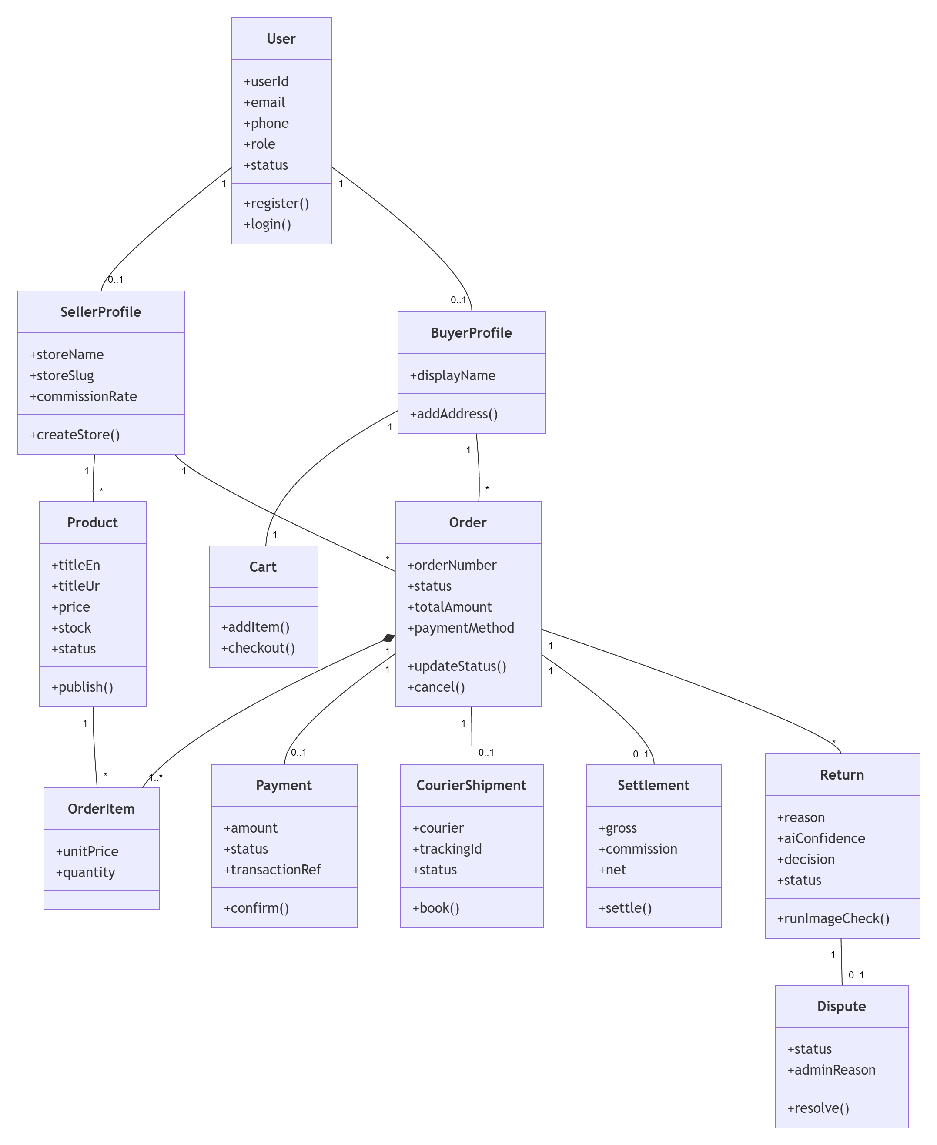
Fig 27: Class Diagram
Fig 27 shows the main classes of KarobarAI with their key attributes, operations and associations. A User has an optional Seller or Buyer profile, sellers own Products and buyers own a Cart and Orders. An Order is composed of Order Items and is linked to its Payment, Courier Shipment, Settlement and any Returns, and a Return may lead to a Dispute.

Data Flow Diagram
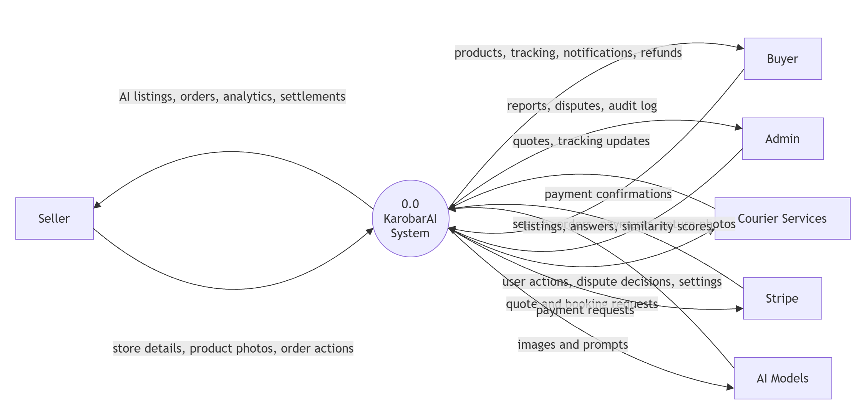
Fig 28: Data Flow Diagram Level 0
Fig 28 shows KarobarAI as a single process and the data it exchanges with external entities. Sellers, buyers and admins send requests and receive listings, orders, tracking, reports and settlements. The system also exchanges booking and tracking data with couriers, payment data with Stripe, and images and prompts with the AI models.
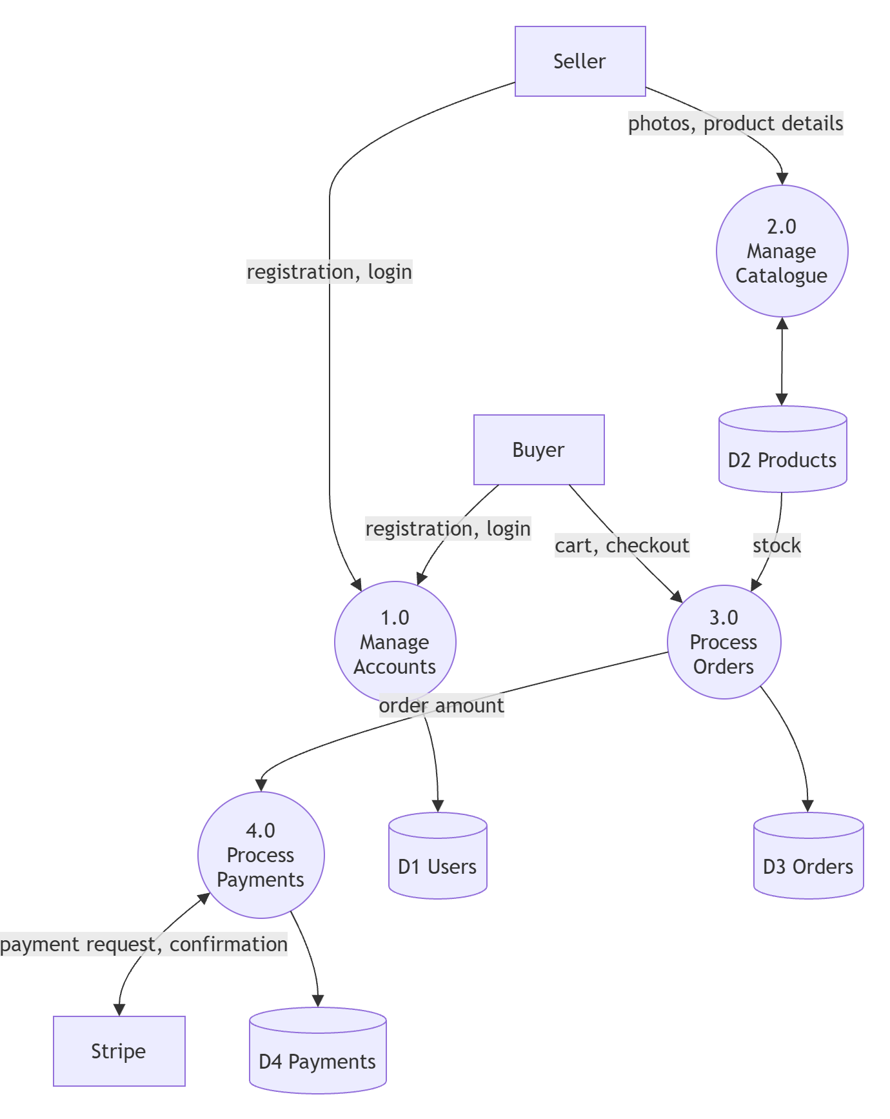
(a) Part 1
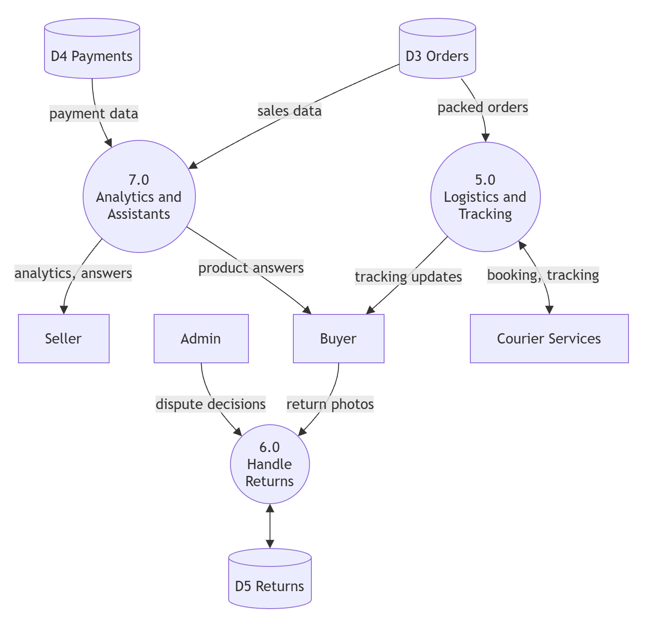
(b) Part 2
Fig 29: Data Flow Diagram Level 1
Fig 29 breaks the system into seven main processes, shown in two parts. Part (a) covers account management, the product catalogue, order processing and payments with their data stores. Part (b) covers logistics and tracking, return handling and the analytics and assistant features, which read from the orders and payments stores.

Chapter 7

IMPLEMENTATION AND TESTING

7.1 Implementation Phase
KarobarAI was implemented in Agile sprints. Abdullah Afzal developed the backend and Rafia Akbar the frontend, and both worked together on integration. The code lives in a single monorepo with three applications and a shared package, and TypeScript on both sides checks request and response shapes.
AI responses were sometimes incomplete, so every AI output is validated against a schema with manual entry as a fallback. Checkout and payment were made safe against duplicate webhooks, and slow local vision models led to hosted listing generation.

7.2 Testing Methodologies
Backend modules were tested with Jest and Supertest and the AI service with Pytest, against a real test database. Manual browser testing then covered real scenarios. Each use case was tested with positive and negative cases, shown in the following tables.

7.2.1 Test Case for Register and Login
Table 24: Validate Register and Login Functionality
Test Case ID | TC-01
Test Case Title | Validate Register and Login
Description | Checks that a user can register, verify OTP and log in, and that invalid attempts are rejected.
Pre-conditions | User is on the register screen.
Post-conditions | Account is verified and the user is logged in.
Test Steps | 1. Enter details and submit.  2. Enter the OTP.  3. Log in with email and password.
Test Input | Name, email or phone, password, OTP.
Expected Result | Positive: account is created, OTP is verified and the user is logged in.  Negative: wrong OTP, expired OTP or wrong password shows an error, and repeated failures lock the account.
Status | Pass

7.2.2 Test Case for Store Setup
Table 25: Validate Store Setup Functionality
Test Case ID | TC-02
Test Case Title | Validate Store Setup
Description | Checks that a new seller can create a store through the setup wizard.
Pre-conditions | Seller is logged in and has no store.
Post-conditions | Store is created and the seller reaches the dashboard.
Test Steps | 1. Open the setup wizard.  2. Enter store details and wallet.  3. Submit.
Test Input | Store name, description, logo, payout wallet.
Expected Result | Positive: store is created and its public page is available.  Negative: missing store name or invalid wallet shows a validation error.
Status | Pass

7.2.3 Test Case for Create AI Listing
Table 26: Validate Create AI Listing Functionality
Test Case ID | TC-03
Test Case Title | Validate AI Listing Generation
Description | Checks that the AI generates a bilingual draft from a product photo.
Pre-conditions | Seller is logged in and owns a store.
Post-conditions | Product is saved as draft or published.
Test Steps | 1. Open Add Product.  2. Upload a photo.  3. Review the AI draft and publish.
Test Input | Product image (JPEG, PNG or WebP).
Expected Result | Positive: Urdu and English title, description, tags and category are filled in and the product is published.  Negative: invalid file type is rejected; if the AI fails, an error is shown and fields stay open for manual entry.
Status | Pass

7.2.4 Test Case for Search Products
Table 27: Validate Search Products Functionality
Test Case ID | TC-04
Test Case Title | Validate Product Search
Description | Checks that products can be searched and filtered in Urdu and English.
Pre-conditions | Published products exist.
Post-conditions | Matching products are shown.
Test Steps | 1. Type a search term.  2. Apply a filter.
Test Input | Search text, category, price range.
Expected Result | Positive: suggestions appear and matching products are listed.  Negative: a term with no match shows an empty-state message.
Status | Pass

7.2.5 Test Case for Cart and Checkout
Table 28: Validate Cart and Checkout Functionality
Test Case ID | TC-05
Test Case Title | Validate Cart and Checkout
Description | Checks that a buyer can add items to the cart and place an order.
Pre-conditions | Buyer is logged in and products are in stock.
Post-conditions | Order is created and stock is reserved.
Test Steps | 1. Add product to cart.  2. Open checkout.  3. Enter address and confirm.
Test Input | Product, quantity, delivery address.
Expected Result | Positive: order is created and the cart is cleared.  Negative: quantity above stock is refused and stock remains unchanged.
Status | Pass

7.2.6 Test Case for Make Payment
Table 29: Validate Make Payment Functionality
Test Case ID | TC-06
Test Case Title | Validate Payment
Description | Checks Cash on Delivery and Stripe test-mode card payment.
Pre-conditions | Buyer is at the payment step of checkout.
Post-conditions | Payment is recorded and the order is confirmed.
Test Steps | 1. Select payment method.  2. Complete payment.  3. View confirmation.
Test Input | COD selection or Stripe test card.
Expected Result | Positive: COD order is confirmed directly; card order is confirmed after a verified webhook.  Negative: a declined card or invalid webhook signature does not confirm the order, and a duplicate webhook is ignored.
Status | Pass

7.2.7 Test Case for Manage Orders
Table 30: Validate Manage Orders Functionality
Test Case ID | TC-07
Test Case Title | Validate Order Management
Description | Checks that sellers can process orders and buyers can view them.
Pre-conditions | An order exists for the seller.
Post-conditions | Order status is updated.
Test Steps | 1. Open seller orders.  2. Mark order as packed.
Test Input | Order ID, new status.
Expected Result | Positive: status moves to the next stage and the buyer sees the update.  Negative: a seller cannot open another seller's order, and cancellation after hand-over is refused.
Status | Pass

7.2.8 Test Case for Book Courier
Table 31: Validate Book Courier Functionality
Test Case ID | TC-08
Test Case Title | Validate Courier Selection and Booking
Description | Checks that couriers are scored and the best courier is booked.
Pre-conditions | Order is packed.
Post-conditions | Courier is booked and a tracking number is saved.
Test Steps | 1. Open the order.  2. Review the recommended courier.  3. Click Confirm and Book Courier.
Test Input | Order with destination city and payment method.
Expected Result | Positive: highest-scoring courier is booked and quotes are saved.  Negative: if all couriers fail, the order is marked Pending Manual Logistics and the seller is alerted.
Status | Pass

7.2.9 Test Case for Track Order
Table 32: Validate Track Order Functionality
Test Case ID | TC-09
Test Case Title | Validate Live Tracking
Description | Checks that tracking updates appear in real time and through the public link.
Pre-conditions | Courier is booked for the order.
Post-conditions | Latest status is visible.
Test Steps | 1. Open the tracking page.  2. Trigger a status update.
Test Input | Order ID or public tracking link.
Expected Result | Positive: timeline updates without refreshing the page.  Negative: an invalid tracking link shows a not-found message.
Status | Pass

7.2.10 Test Case for View Notifications
Table 33: Validate View Notifications Functionality
Test Case ID | TC-10
Test Case Title | Validate Notifications
Description | Checks that notifications are created at order events and shown to the user.
Pre-conditions | User has an active order.
Post-conditions | Notification is delivered and marked read when opened.
Test Steps | 1. Change order status.  2. Open the notification bell.
Test Input | Order status event.
Expected Result | Positive: notification appears with unread count.  Negative: a disabled non-critical notification is not sent, and a user cannot read another user's notifications.
Status | Pass

7.2.11 Test Case for Request Return
Table 34: Validate Request Return Functionality
Test Case ID | TC-11
Test Case Title | Validate Return Request and AI Check
Description | Checks that a return is submitted and assessed by the AI image check.
Pre-conditions | Order is delivered within the last 14 days.
Post-conditions | Return is approved, rejected or sent for manual review.
Test Steps | 1. Open the order and click Return.  2. Select reason and upload photos.  3. Submit.
Test Input | Return reason and at least 3 photos.
Expected Result | Positive: return is submitted and a decision is shown.  Negative: fewer than 3 photos, a second return or a request after 14 days is refused; clearly different photos are flagged as a mismatch.
Status | Pass

7.2.12 Test Case for View Analytics
Table 35: Validate View Analytics Functionality
Test Case ID | TC-12
Test Case Title | Validate Seller Analytics
Description | Checks that sales data and recommendations are shown to the seller.
Pre-conditions | Seller has completed orders.
Post-conditions | Charts and recommendations are displayed.
Test Steps | 1. Open Analytics.  2. Change the date range.
Test Input | Date range.
Expected Result | Positive: revenue, top products and recommendations load for the selected period.  Negative: a new seller with no orders sees an empty-state message.
Status | Pass

7.2.13 Test Case for Chat with Store Assistant
Table 36: Validate Store Assistant Functionality
Test Case ID | TC-13
Test Case Title | Validate Buyer Storefront Agent
Description | Checks that the assistant answers from the current store's products only.
Pre-conditions | Store has published products.
Post-conditions | Answer is shown in the chat.
Test Steps | 1. Open a store page.  2. Ask about a product.
Test Input | Question in Urdu or English.
Expected Result | Positive: answer mentions only products from this store with correct price and stock.  Negative: off-topic questions or questions about other stores are declined.
Status | Pass

7.2.14 Test Case for Chat with Business Assistant
Table 37: Validate Business Assistant Functionality
Test Case ID | TC-14
Test Case Title | Validate Seller Business Agent
Description | Checks that the seller assistant answers from the seller's own data.
Pre-conditions | Seller is logged in.
Post-conditions | Answer is shown and the session is saved.
Test Steps | 1. Open the Assistant page.  2. Ask about sales or stock.
Test Input | Business question.
Expected Result | Positive: answer is based on the seller's own orders and products.  Negative: a buyer account is denied access, and data of other sellers is never returned.
Status | Pass

7.2.15 Test Case for Manage Platform
Table 38: Validate Manage Platform Functionality
Test Case ID | TC-15
Test Case Title | Validate Admin Panel
Description | Checks admin actions on users, listings, disputes and settings.
Pre-conditions | Admin is logged in.
Post-conditions | Action is applied and recorded in the audit log.
Test Steps | 1. Open the admin panel.  2. Suspend a user or resolve a dispute.
Test Input | User ID, dispute decision and reason.
Expected Result | Positive: action is applied and logged.  Negative: an override without a reason is refused, and non-admin users cannot open the panel.
Status | Pass

Chapter 8

RESULTS AND DISCUSSION
All planned modules were developed and tested, and every use case passed its test cases. The automated suites passed, a Stripe test payment was matched to its order and the AI listing flow was verified end to end. Because every AI call has a time limit and a manual fallback, model outages never blocked sellers. Courier and SMS services currently use simulated adapters.
The screens of each panel are shown below.

8.1 Buyer Storefront

8.1.1 Home Screen

Fig 30: Home Screen
The home screen shows categories, featured products and the search bar, with an Urdu and English language switch.

8.1.2 Register and OTP Verification Screen

Fig 31: Register and OTP Verification Screen
New users register with email or phone and verify the account with a 6-digit OTP before logging in.

8.1.3 Login Screen

Fig 32: Login Screen
Registered users log in here, with options for forgotten password and language switching.

8.1.4 Search and Category Screen

Fig 33: Search and Category Screen
Buyers search in Urdu or English, see suggestions while typing and filter products by category, price and condition.

8.1.5 Product Detail Screen

Fig 34: Product Detail Screen
Shows product images, bilingual description, price, stock and the seller's store, with Add to Cart.

8.1.6 Store Page with Assistant

Fig 35: Store Page with Assistant
Each store has a public page with its products and a chat assistant that answers questions about that store's products.

8.1.7 Cart and Checkout Screen

Fig 36: Cart and Checkout Screen
The buyer reviews cart items, enters the delivery address and chooses Cash on Delivery or card payment.

8.1.8 Orders and Tracking Screen

Fig 37: Orders and Tracking Screen
Buyers see their orders and a live tracking timeline that updates without refreshing.

8.1.9 Return Request Screen

Fig 38: Return Request Screen
Buyers select a reason, upload at least three photos and see the AI decision and return status.

8.1.10 Notifications Screen

Fig 39: Notifications Screen
Shows all order, payment and return notifications with unread markers.

8.2 Seller Center

8.2.1 Store Setup Wizard

Fig 40: Store Setup Wizard
New sellers create their store and add a payout wallet in a few simple steps.

8.2.2 Seller Dashboard

Fig 41: Seller Dashboard
Summary cards show sales, orders and return requests, with quick access to all seller features.

8.2.3 AI Store Builder Screen

Fig 42: AI Store Builder Screen
The seller uploads a photo and the AI fills in the Urdu and English title, description, tags and category for review.

8.2.4 Seller Orders Screen

Fig 43: Seller Orders Screen
Orders are grouped by status, and the seller can confirm the recommended courier with one click.

8.2.5 Seller Returns Screen

Fig 44: Seller Returns Screen
Shows return requests with the AI image check result, dispatch and return photos, and the decision.

8.2.6 Analytics Dashboard

Fig 45: Analytics Dashboard
Charts of revenue, orders and top products with plain-language recommendations.

8.2.7 Seller Assistant Screen

Fig 46: Seller Assistant Screen
The seller asks questions about sales, stock and returns and gets answers from their own data.

8.3 Admin Panel

8.3.1 Admin Dashboard and Reports

Fig 47: Admin Dashboard and Reports
Shows platform figures such as GMV, active users and orders.

8.3.2 User Management Screen

Fig 48: User Management Screen
Admins search, suspend and reactivate user accounts.

8.3.3 Listing Moderation Screen

Fig 49: Listing Moderation Screen
Admins review and remove listings that break platform rules.

8.3.4 Return Disputes Screen

Fig 50: Return Disputes Screen
Admins review appealed returns and record a final decision with a reason.

8.3.5 Platform Configuration Screen

Fig 51: Platform Configuration Screen
Admins change commission rate, return window and courier weights without changing code.

Chapter 9

CONCLUSION AND FUTURE WORK

9.1 Conclusion
KarobarAI makes online selling practical for small sellers in Pakistan. Sellers open a store, create bilingual listings from photos, accept COD or card payments, book couriers with one click and follow each order to settlement. Buyers get live tracking, fair returns and a store assistant, and admins control the platform. Testing shows that the system meets its SRS, and where AI is unreliable a person stays in control.

9.2 Future Work

9.2.1 Real Courier and Wallet Integration
Replace the simulated courier and payment adapters with live TCS, Leopards, Trax, JazzCash and Easypaisa integrations once merchant accounts are available.

9.2.2 Faster and More Accurate AI
Host the AI models on GPU servers for faster responses, and collect a labelled set of return photos to measure and improve the accuracy of the return checks.

9.2.3 Native Mobile Applications
Release Android and iOS apps with offline support and Urdu voice input for sellers who prefer not to type.

REFERENCES
[1] R. Dale, “Natural language generation: The commercial state of the art in 2019,” Natural Language Engineering, vol. 25, no. 6, pp. 1–18, 2019.
[2] OpenAI, “GPT-4 Technical Report,” arXiv:2303.08774, 2023.
[3] S. Kumar, S. Teichman, and T. Timpernagel, “A green supply chain is a requirement for profitability,” International Journal of Production Research, vol. 50, no. 5, pp. 1278–1296, 2017.
[4] S. F. Wamba et al., “Big data analytics and firm performance: Effects of dynamic capabilities,” Journal of Business Research, vol. 70, pp. 356–365, 2020.
[5] L. Akoglu, H. Tong, and D. Koutra, “Graph-based anomaly detection and description: A survey,” Data Mining and Knowledge Discovery, vol. 29, no. 3, pp. 626–688, 2015.
[6] Amazon, “Amazon Science: Computer vision and fraud detection systems,” 2020.
[7] International Finance Corporation, The Digital SME: How Digital Technologies Can Boost Growth in Emerging Markets. World Bank Group, 2021.
[8] OECD, The Digital Transformation of SMEs. OECD Publishing, 2020.
[9] A. Rehman and S. Khan, “Barriers to e-commerce adoption among small businesses in Pakistan,” Journal of Business and Technology, vol. 15, no. 2, pp. 88–104, 2020.
[10] World Bank, E-commerce and Digital Economy in Developing Countries. World Bank Group, 2021.
[11] IEEE, “IEEE Recommended Practice for Software Requirements Specifications,” IEEE Std 830-1998, New York, NY, USA, 1998.
[12] ISO/IEC/IEEE, “Systems and Software Engineering — Life Cycle Processes — Requirements Engineering,” ISO/IEC/IEEE 29148:2018, Geneva, Switzerland, 2018.
[13] P. Lewis et al., “Retrieval-augmented generation for knowledge-intensive NLP tasks,” in Advances in Neural Information Processing Systems, vol. 33, 2020, pp. 9459–9474.
[14] M. Oquab et al., “DINOv2: Learning robust visual features without supervision,” Transactions on Machine Learning Research, 2024.

