FYP SRS Document

Final Year Project
Software Requirement Specification
For
KarobarAI
SLM driven agentic and generative e-commerce platform for small scale sellers in Pakistan.
BSCS

By
S# | Name | Registration #/Roll #/Section | Mobile # | E-Mail
1. | Rafia Akbar | Sp23/bscs/007 | 03137506094 | Sp-23-bscs-007@cs.lgu.edu.pk
2. | Abdullah Afzal | Sp23/bscs/012 | 03117922590 | Sp-23-bscs-012@cs.lgu.edu.pk

Supervised by:
Miss Anila Amjad ____________________ (Signature)



Department of Computer Science
Lahore Garrison University
Lahore

Table of Contents
1. Introduction 4
1.1 Purpose 4
1.2 Document Conventions 4
1.3 Intended Audience 4
1.4 Product Scope 4
2. Overall Description 5
2.1 Product Perspective 5
2.2 Product Functions 6
2.3 User Classes 6
2.4 Operating Environment 7
2.5 Design and Implementation Constraints 7
2.6 User Documentation 7
2.7 Assumptions and Dependencies 7
2.7.1 Assumptions 8
2.7.2 Dependencies 8
3. External Interface Requirements 8
3.1 User Interfaces 8
3.1.1 Seller Portal 8
3.1.2 Buyer Storefront 9
3.1.3 Admin Dashboard 9
3.1.4 General UI Standards 9
3.2 Hardware Interfaces 10
3.3 Software Interfaces 10
3.3.1 AI and Machine Learning Services 10
3.3.2 Courier and Logistics APIs 11
3.3.3 Payment Gateway APIs 11
3.3.4 Notification Services 11
3.3.5 Mapping and Location Services 11
3.3.6 Internal Software Components 12
3.4 Communications Interfaces 12
4. System Features 12
4.1 AI Store Builder 12
4.1.1 Description — Priority: HIGH 13
4.1.2 Stimulus / Response Sequences 13
4.1.3 Functional Requirements 13
4.2 Intelligent Logistics Management 14
4.2.1 Description — Priority: HIGH 14
4.2.2 Stimulus / Response Sequences 14
4.2.3 Functional Requirements 15
4.3 Live Order Tracking 15
4.3.1 Description — Priority: HIGH 15
4.3.2 Stimulus / Response Sequences 15
4.3.3 Functional Requirements 16
4.4 ReturnsAI System 16
4.4.1 Description — Priority: HIGH 16
4.4.2 Stimulus / Response Sequences 16
4.4.3 Functional Requirements 17
4.5 Seller Analytics Dashboard 17
4.5.1 Description — Priority: MEDIUM 17
4.5.2 Stimulus / Response Sequences 18
4.5.3 Functional Requirements 18
4.6 User Authentication and Account Management 18
4.7 Payment Processing and Settlement 19
4.8 Product Search and Browse 20
4.9 Notification Center 20
5. Non-Functional Requirements 21
5.1 Performance Requirements 21
5.2 Safety Requirements 21
5.3 Security Requirements 22
5.4 Software Quality Attributes 23
5.5 Business Rules 24
5.6 Detailed Subsystem Design 24
5.6.1 Use Case Diagram 24
5.6.2 Entity-Relationship (ER) Diagram 26
5.6.3 System Architecture Diagram 28
5.6.4 Activity Diagrams 28
5.6.5 Sequence Diagrams 31
5.6.6 State Machine Diagrams 35
5.6.7 Class Diagram 38
5.6.8 Data Flow Diagram (DFD) 39
5.6.9 Database Schema Diagram 40
References 42

1. Introduction

KarobarAI (Version 1.0) is an AI-powered, SME-friendly e-commerce platform designed to empower micro-sellers and sellers in small shops in Pakistan to establish online stores with minimal technical effort. This SRS defines all functional and non-functional requirements for the platform, developed over a 20-week FYP timeline [1], [2].

1.1 Purpose

The platform eliminates operational barriers and enables small sellers to focus on business growth by automating product listing creation, courier selection, order tracking, returns process and seller analytics through intelligent algorithms. Integrated with local payment gateways (JazzCash, Easypaisa) and courier services, KarobarAI provides a complete, Urdu-supported solution tailored to Pakistan's e-commerce ecosystem. The platform integrates five core modules:

AI Store Builder – Auto-generates bilingual product listings from a single photo [3], [4].

Intelligent Logistics Management – Automatically selects and books the best courier per order [11].

Live Order Tracking – Real-time shipment visibility with SMS and WhatsApp notifications [8], [24].

ReturnsAI System – AI image analysis validates returns and prevents fraud [6], [7].

Seller Analytics Dashboard – Insights derived from data and powered by AI [3], [5].

Output consists of a web application, PWA, backend API, AI pipelines [4], [5], and integration with local delivery services [11] and payment systems [9], [10]. This SRS is the definitive reference for all development, testing, and evaluation activities [1].

1.2 Document Conventions

REQ-F-[Module]-[Number] refers to functional requirements while REQ-NF-[Category]-[Number] refers to non-functional requirements. REQ-AI-[Module]-[Number] is the format of the other type of requirement. Requirements can have one of the following levels of priority: HIGH, MEDIUM, and LOW.

1.3 Target Audience

Project managers and supervisors should read Sections 1–2. Developers focus on Sections 3–4. QA engineers use Sections 4–5 for test case design. DB admins and AI/ML engineers refer to Sections 2 and 5. All readers should start with Section 2 before navigating to their specific sections.

1.4 Product Scope

Pakistan has over 5.2 million registered small business and sellers, yet digital commerce adoption among micro-sellers remains low [12], [25]. The barrier is not willingness, it is complexity. KarobarAI closes this gap by letting any seller upload a product photo and have a live, bilingual listing within seconds [3], [4].

Version 1.0 is scoped to Pakistan only; PKR currency. It supports Urdu and English language. Local courier facility is integerated (TCS [11], Leopards, Trax). Payment methods used are local to facilitate the process (JazzCash [9], Easypaisa [10]). All transactions comply with standard rules and regulations [12] [13]. International expansion is Phase 2 work.

2. Overall Description

KarobarAI is a new, self-contained product that fills a gap left by global platforms not suitable for Pakistan’s local market [25], [12].

2.1 Product Perspective

The application acts as a standalone multi-layer web application [2], [16], which consists of the React.js web frontend, mobile frontend PWA, RESTful backend in Node.js/Python, ML/AI pipelines, and other services.

These are the primary subsystems of the application:

Web Frontend (React.js) [15] - Seller Portal and Buyer's Storefront; web frontend, available to use through any modern web browser.

Mobile Frontend (PWA) [22] - Designed for usage on mobile phones with limited network bandwidth on Android and iOS platforms.

Backend API (Node.js / Python) [16] - Orchestration Layer, coordinating the execution of all logic related to business processes.

ML/AI Services – Content generation (GPT-4 [3],[4], LLaMA, OLAMA [5]), image return analysis (Google Cloud Vision [6], custom CNN [7]), logistics optimization, analytics.

Data Layer – product/user data (MongoDB [19]), transaction data (MySQL [20]), caching/queueing (Redis [21]).
- Integration with Third Party Services – shipping providers (TCS [11], Leopards, Trax), payment gateways (JazzCash [9], Easypaisa [10]), WhatsApp/SMS messages [8],[24], Google Maps [23].

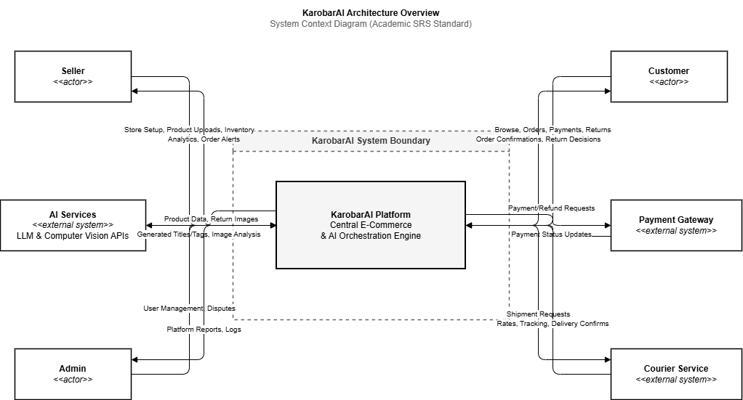
Figure 1 – System Context Diagram: KarobarAI Architecture Overview

2.2 Product Functionality

In general terms, KarobarAI should be able to:

Automatically create dual language product listings using just one uploaded photo.

Compare live rates from three different shipping providers and select the most optimal one [11].

Monitor shipping in real time and alert customers through SMS notifications [24] and WhatsApp [8].

Verify returns by performing AI-based analysis of uploaded images and make a judgment on whether the return request is legitimate or not [6],[7].

Offer seller analytics with AI-based suggestions [3],[5].

Manage the registration and authentication process, along with user roles of Sellers, Buyers, and Admins.

Process payments through JazzCash [9], Easypaisa [10], and cash-on-delivery methods.

Enable bilingual product searching with sorting, filtering, and auto-complete options.

2.3 User Classes

Micro-Seller (Primary). The small business owner who lists and sells products. The most critical user class. Basic smartphone literacy, no e-commerce experience. Needs maximum automation and minimum friction daily usage [25].

Buyer. The customer browsing and purchasing products. Ranges from people comfortable using tech to first-time online shoppers. Needs a fast, trustworthy purchase-to-delivery experience [15].

Platform Administrator. Internal team managing users, moderation, payments, and fraud review. Technically proficient, weekly usage.

Customer Support Staff. Agents handling disputes, return appeals, and seller queries. Needs quick access to order and return data.

2.4 Operating Environment

The application will run through any existing browser including Chrome, Firefox, Edge, and Safari and it will run through Android 8.0+ and iOS 14+ and there would be no need for additional installation. The Node.js and Python will be used as backend language. Data storage and caching will be done by MongoDB [19], MySQL [20], and Redis [21]. Application deployment will be done on AWS, GCP, and Azure through containerization [22]. Artificial intelligence algorithms in the application will be performed through GPT-4 API or Llama 3/Ollama 3 [4], [5], whereas the Google Cloud Vision API will conduct image analysis [6]. Moreover, SMS and WhatsApp messaging will be conducted through Twilio or AWS SNS [24] and Meta Cloud API [8], and at least 1 Mbps connectivity will suffice.

2.5 Design and Implementation Constraints
Timeline and budget. Fixed 20-week FYP schedule with no dedicated budget. Free tiers and open-source libraries preferred. GPT-4 costs monitored from Week 2, with LLaMA 3 [5] as fallback.
Geographic and language scope. Pakistan only. PKR currency. Urdu RTL rendering using Noto Nastaliq Urdu font. Language switching without page reload.
Integrations. Couriers: TCS [11], Leopards, Trax. Payments: JazzCash [9], Easypaisa [10]. Stripe, PayPal, and international shipping are out of scope.
Security and compliance. SBP digital payment guidelines [12], PCI-DSS [13], TLS 1.3 [17], bcrypt password hashing, AES-256 encryption at rest.
AI model accuracy. The ReturnsAI CNN must achieve ≥95% validation accuracy before production deployment [6],[7].

2.6 User Documentation
The system documentation will consist of user and seller manuals, a quick start guide, video tutorials, FAQs, API documentation, and an admin operations manual, available in both Urdu and English where applicable.
2.7 Assumptions and Dependencies
The following list shows the assumptions and dependencies.

2.7.1 Assumptions
The following are assumed true for this specification [1],[2]. If any prove incorrect, requirements will need revisiting:
- Sellers have basic smartphone literacy sufficient to upload images and fill simple forms [25].
- Buyers have access to a device with an internet connection [15].
- Courier APIs for TCS [11], Leopards, and Trax remain publicly accessible and stable throughout development.
- JazzCash [9] and Easypaisa [10] APIs support payment initiation, callbacks, and refunds in compliance with SBP regulations [12].
- OpenAI GPT-4 API [4] quota is sufficient for development; LLaMA 3 [5] is available as a self-hosted fallback.
- Google Cloud Vision API [6] delivers adequate accuracy for return image analysis, supported by the custom CNN [7].
- Internet connectivity in target areas meets the 1 Mbps minimum [25].
- Pakistan e-commerce regulations [12],[13] will not change significantly before project completion.

2.7.2 Dependencies
Critical external dependencies and their failure impacts:
- OpenAI GPT-4 / LLaMA 3 [4],[5] – if unavailable, sellers must write listings manually.
- Google Cloud Vision API [6] – if unavailable, returns require manual review.
- TCS, Leopards, Trax APIs [11] – if all fail, courier booking and tracking are disabled.
- JazzCash [9] / Easypaisa [10] APIs – if unavailable, digital payments cannot be processed.
- Twilio/AWS SNS [24] / WhatsApp Business API [8] – if down, SMS or WhatsApp notifications are disabled.
- Google Maps API [23] – if unavailable, map view is replaced by text-based tracking status.
- MongoDB [19] / MySQL [20] – if unavailable, platform is fully non-operational.

3. External Interface Requirements

This section covers all the external interfaces that are required in the project.

3.1 User Interfaces

KarobarAI has three separate interfaces for users.All of them should be responsive (320 px - 1920 px) and must also be compatible with Urdu RTL script, must be WCAG compliant (AA) [15] and must load in 3 seconds on 3G network.

3.1.1 Seller Portal
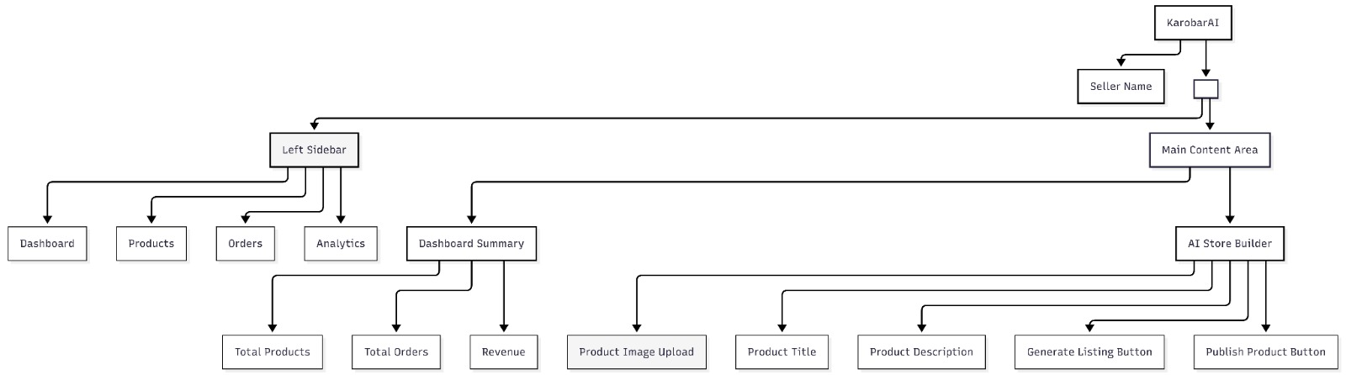
Specifically developed for micro-sellers who have no online sales experience [25]. Trend and summary are shown in the dashboard in the form of cards, that is, sales total, orders and return requests, as well as a sales trend graph for the last 7 days. Automatically completed fields with AI [3],[4] can be edited and there is a drag-and-drop space for images in the AI Store Builder. Order Management is a tabbed application (Pending, Confirmed, Shipped, Delivered, Cancelled), in which the details of the couriers are available in the inline boxes. AI assessment badges and image analysis reports [6],[7] appear on the Returns screen. The Analytics Dashboard displays date-range charts, an AI Recommendation card for easy export and a top 10 products table [3],[5]. It has a brand, a wallet setup [9],[10], notification toggles [8],[24] and security [14],[17] are all included.
Figure 2 – Seller Portal: Dashboard and AI Store Builder

3.1.2 Buyer Storefront

Attention to velocity and confidence in new time online buyers [15, 25]. A dual language search along with a category grid and language switcher is available on the Home page. Product pages also include filters: category, price, rating, condition and include infinite scroll [19]. There is a swiping functionality of images on Product detail page [15] and Add to Cart / Buy Now [16] button. The checkout process includes delivery address, preferred payment method (JazzCash [9] or Easypaisa [10] or Cash on Delivery) and complete order summary which is based on SBP [12] and PCI-DSS [13] standards. Order tracking provides real-time mapping, SMS notifications [24] and status notifications as well as WhatsApp notifications [8]. The returns wizard must have at least 3 product photos [6],[7] and the AI decision is made in 1 minute or less [3],[4].

3.1.3 Admin Dashboard

Admins have complete control of searching, suspending, and banning accounts, manual release of stuck payments, override of AI return decisions (with a required reason), listing moderation, and global GMV, active users, and API uptime. All the sellers/buyers are broadcasted with SMS/Whatsapp message using a broadcast tool provided and the commission rates and priority weights of the couriers are set in a config panel.

3.1.4 General UI Standards

All the pages should be responsive.

Font for Urdu language will be used (Noto Nastaliq) and will be easily loadable without reloading page

Minimum colour contrast 4.5:1; all interactive elements keyboard-navigable with descriptive alt text [15].

Progress bars or spinners for all AI-processing actions; skeleton loaders during data fetch.

Shared component library (Material UI or Ant Design) enforced across all screens

3.2 Hardware Interfaces

KarobarAI requires no custom hardware drivers. Users can capture images using their device camera or upload them manually. The application can also be added to the home screen on supported Android and iOS browsers.Service-worker provides offline web page storage. The cloud-based server should have minimum requirements of 4 vCPUs, 8 GB RAM, 100 GB SSD, and auto scaling functionality. For SMS, Twilio and AWS SNS REST API over HTTPS [24] can be used without additional hardware support.

3.3 Software Interfaces

KarobarAI integrates with a range of external software systems and services [2],[16]. Each integration below defines the purpose, data exchanged, and communication method used.

3.3.1 AI and Machine Learning Services

Four models power content generation and return validation [3],[4],[5],[6],[7]:

OpenAI GPT-4 API (gpt-4-turbo) undefined[3],[4] – main model for generating bilingual product listing. Provides title and description in English and Urdu as well as hints for categories. REST over HTTPS with API key. Cost fallback model: gpt-3.5-turbo.

OpenAI GPT-4 API (gpt-4-turbo) [3],[4] — primary model for bilingual product listing generation. Accepts image description and category hint; returns structured JSON. REST over HTTPS with API key. Cost fallback model: gpt-3.5-turbo.

LLaMA/Ollama 3 (Self-Hosted) [5] — open-weight fallback to GPT-4, hosted via vLLM or Ollama. Uses the same JSON schema, switchable via configuration change alone. Either 8B or 70B variant depending on infrastructure.

Google Cloud Vision API (v1) [6] — return image analysis: damage detection, authenticity check, usage classification. Accepts base64 images; returns JSON label annotations and object detection results. OAuth 2.0 via Google Service Account.

Custom CNN — ReturnsAI Model [7] — TensorFlow/PyTorch model trained in-project. Classifies products into undamaged, light damage, serious damage, or total destruction.

Internal FastAPI endpoint on the Python ML service.

3.3.2 Courier and Logistics APIs

Three couriers provide rate data, booking, and tracking feeds [11]. All are called in parallel on order placement (Promise.all, 10-second timeout per call). Credentials stored as encrypted environment variables — never in source code [14].

TCS Express [11] — availability checks, rate quotes, booking, and live tracking. Returns booking ID, tracking number, ETA, and status updates.

Leopards Courier — rate calculation, shipment booking, tracking, and cancellation. Returns shipment slip number, tracking URL, and delivery ETA.

Trax (Trax.pk) — coverage checks, rate quotes, order creation, and live tracking. Returns tracking ID, booking confirmation, and status event timeline.

3.3.3 Payment Gateway APIs

Limited to Pakistan’s two most widely used digital wallets [9],[10],[12],[13]. All calls are server-side only. Payment data must never be logged in plain text. Webhook callbacks must be signature-verified. Idempotency keys prevent duplicate charges [13].

JazzCash Integration: The system will use JazzCash for secure online payments, refunds, and transaction status verification [9].

Easypaisa Integration: The system will use Easypaisa to facilitate secure digital payments and transaction processing for users [10].

3.3.4 Notification Services

Notifications dispatched asynchronously across three channels [8],[24]. WhatsApp and SMS are prioritised given Pakistan’s high penetration of both [25].

SMS — Twilio or AWS SNS [24] — transactional messages at key order events. Accepts phone number and Urdu/English message template.

WhatsApp — Meta Business Cloud API [8] — pre-approved template messages at the same lifecycle milestones. Accepts WhatsApp number, template name, and variables (order ID, status, tracking link).

Email — SendGrid or AWS SES (optional) — order confirmation receipts, password resets, and account verification.

3.3.5 Mapping and Location Services

Two Google Maps services support live tracking and courier scoring [23]:

Google Maps JavaScript API + Geocoding API [23] — renders live shipment location on the tracking map and converts addresses to geocoordinates for courier scoring.

Google Distance Matrix API [23] — calculates road distance and travel time between seller and buyer for the courier scoring algorithm.

3.3.6 Internal Software Components

Core internal components [19],[20],[21],[22]:

MongoDB 6.0+ [19] — document store for users, products, notifications, returns, and AI-generated content. Accessed using Mongoose ODM.

MySQL 8.0+ [20] – ACID-compliant relational database to store orders, payments, settlements, and transactions' logs. Accessed via Sequelize ORM.

Redis 7.0+ [21] — cache and async notification queue. TTL: 5 minutes for products, 1 minute for courier rates.

AWS S3 / Cloudinary CDN — product images and return photos. CDN URL stored in MongoDB [19].

Node.js 18+ / Express.js — core REST API. Fully documented via Swagger/OpenAPI 3.0 [16].

Python 3.10+ / FastAPI — dedicated AI/ML service for content generation, ReturnsAI, and analytics. Called from Node.js via REST on the Docker private network [22]

3.4 Communications Interfaces

All browser-to-backend communication uses HTTPS with TLS 1.3 [17]. CORS headers are restricted to whitelisted domains — no wildcard origins in production.Standard response format is { success, data, error, timestamp }. Real-time tracking will use WebSocket (Socket.IO/WSS) with JWT authentication [18], as fallback HTTP long polling. Event types: order_status_update and tracking_location_update.

Backend-to-courier calls use TLS 1.2+ with HMAC signatures. Payment calls use TLS 1.3 with server-side HMAC or OAuth signing. Notifications are dispatched asynchronously via Bull/Redis [21]. None of the keys for API access is ever checked into version control. API responses are kept under 50 KB [16]. Product images compressed to under 200 KB. Lazy loading applied on all image-heavy pages.

4. System Features

This section defines the functional requirements of KarobarAI’s nine major features. Each feature includes a description, stimulus/response sequences, and a requirements table. Requirements are tagged per Section 1.2 conventions and assigned HIGH, MEDIUM, or LOW priority based on MVP importance [1],[2].

4.1 AI Store Builder

The AI Store Builder is KarobarAI’s flagship feature. A seller uploads a product photo and within thirty seconds has a fully written, bilingual, categorised, and publishable listing no writing skills or SEO knowledge needed.

4.1.1 Description — Priority: HIGH

The image is passed to GPT-4 Vision [3],[4] (or LLaMA 3 fallback [5]), which returns title, description, category, and 5–10 SEO tags in both Urdu and English. The seller reviews the editable output and publishes in under five minutes.

4.1.2 Stimulus / Response Sequences

The following sequences describe how the system responds to seller actions during the product creation flow [1],[2].

Seller clicks ‘Add Product’ → System displays the Add Product screen with the image upload zone.

Seller uploads a valid JPEG, PNG, or WebP image (max 10 MB) → System validates the file [3],[4], shows a thumbnail preview, and starts the AI generation progress bar.

Seller uploads an invalid file or exceeds 10 MB → System rejects the upload and shows an inline error message.

Image sent to AI pipeline → Spinner shows “AI is generating your product listing…” [3],[4],[5]. All fields locked during processing.

AI completes within 30 seconds → Title, Description, Category, and Tags in Urdu and English populate automatically [4],[5]. Success toast appears.

AI fails or times out → Fields left blank. Retry AI Generation button shown [2].

Seller reviews and edits content → All fields become fully editable. Changes tracked locally [1],[2].

Seller clicks ‘Publish’ → System validates Title, Category, and at least one image [19],[20], saves live to storefront, redirects to product detail page.

Seller clicks ‘Save as Draft’ → Product saved to database [19] with Draft status, hidden until manually published.

4.1.3 Functional Requirements
Table 1 – AI Store Builder Functional Requirements
Req. ID | Description | Priority
REQ-F-Store-001 | Each image size should not exceed more than 10 MB. | HIGH
REQ-F-Store-002 | The AI should create a bilingual title, 2-3 sentences of description, categorization, and 5-10 SEO terms. | HIGH
REQ-F-Store-003 | Editability is required for all AI-generated data. For publication, at least a title, an image, and a category is necessary. | HIGH
REQ-F-Store-004 | Show progress indicator during generation. Block submission until generation completes or fails. | HIGH
REQ-F-Store-005 | On failure or timeout: show error, provide Retry option, and leave fields blank for manual entry. | HIGH
REQ-F-Store-006 | Support Draft status — product hidden from storefront until manually published. | MEDIUM
REQ-F-Store-007 | Compress images to under 200 KB before CDN storage without perceptible quality loss. | MEDIUM
REQ-AI-Store-001 | GPT-4 Vision as primary; LLaMA 3 as fallback. Switching requires only a config change — no code change. | HIGH
REQ-AI-Store-002 | AI output should be in compliance with the following JSON structure: { title_en, title_ur, description_en, description_ur, category, tags }. | HIGH

4.2 Intelligent Logistics Management
Deciding which courier to use is time-consuming and error-prone for small sellers [25]. The Intelligent Logistics module removes this decision entirely.

4.2.1 Description — Priority: HIGH
When an order is placed, TCS [11], Leopards, and Trax will be checked simultaneously. Parameters like cost, delivery time, reliability, and delivery coverage will be analyzed by a weighted scoring model that utilizes the weights of 40%, 30%, 20%, and coverage of 10% respectively [2],[25].COD orders are routed only to couriers supporting COD at the destination [12]. If all APIs fail, the order is flagged for manual booking and the seller is alerted via SMS [24] and in-app notification [8].

4.2.2 Stimulus / Response Sequences
The following sequences describe how the system responds during the courier selection and booking flow [1],[2].
- Buyer places an order → System records the order [19],[20] with status ‘Pending’ and triggers the courier selection pipeline immediately.
- Courier selection pipeline starts → System calls TCS [11], Leopards, and Trax in parallel. 10-second timeout per call [2].
- One or more couriers respond with rates and ETAs → System runs the scoring algorithm [2],[25] and stores the optimal courier against the order [19].
- All courier APIs fail or time out → Order flagged as ‘Pending Manual Logistics’. Seller notified via SMS [24] and in-app alert.
- Seller opens the order → Seller sees recommended courier, cost breakdown, and ETA. One-click ‘Confirm & Book Courier’ button shown [2],[25].
- Seller clicks ‘Confirm & Book Courier’ → System calls courier booking API [11]. Order becomes ‘Confirmed’, tracking number saved [19], SMS sent to both parties [24].
- Booking API returns an error → System retries up to 3 times at 30-second intervals [2]. On all failures, falls back to next-best courier.
- Seller overrides AI-selected courier → System books the manually chosen courier [11] and logs the override for analytics [19],[25].

4.2.3 Functional Requirements
Table 2 – Intelligent Logistics Management Functional Requirements
Req. ID | Description | Priority
REQ-F-Logistics-001 | Integrate with at least 2 of 3 target couriers (TCS, Leopards, Trax) for rate retrieval and booking in v1.0. | HIGH
REQ-F-Logistics-002 | Call all courier APIs in parallel on order placement. | HIGH
REQ-F-Logistics-003 | Score couriers:cost 40%, delivery time 30%, reliability 20%, coverage 10%. Weights configurable via admin panel. | HIGH
REQ-F-Logistics-004 | Provide a one-click ‘Confirm & Book Courier’ button requiring no additional form input. | HIGH
REQ-F-Logistics-005 | Retry booking up to 3 times at 30-second intervals before falling back to next-best courier. | HIGH
REQ-F-Logistics-006 | Route COD orders only to couriers supporting COD at the destination city. | HIGH
REQ-F-Logistics-007 | If all APIs unavailable, flag order as ‘Pending Manual Logistics’ and notify seller via SMS and in-app alert. | HIGH
REQ-F-Logistics-008 | Allow seller to override AI courier selection. Overrides must be logged for analytics. | MEDIUM

4.3 Live Order Tracking
Buyers in Pakistan historically receive no communication after placing an order. KarobarAI changes this with live shipment visibility for both parties, with zero manual effort from the seller.

4.3.1 Description — Priority: HIGH
The system polls the courier tracking API every 5 minutes [11], pushes updates via WebSocket [18], and automatically fires SMS [24] and WhatsApp [8] notifications at each milestone. A public, login-free tracking URL [15],[16] is included in every notification.

4.3.2 Stimulus / Response Sequences
The following sequences describe how the system responds during the live order tracking flow [1],[2].
- Courier booking confirmed, tracking number assigned → System begins a recurring 5-minute polling job for this order [2],[11].
- Courier API returns a status update (e.g., ‘Picked Up’) → Order status updated in database [19],[20]. WebSocket event [18] emitted to both active sessions. SMS [24] and WhatsApp [8] notification queued via Bull/Redis [21].
- Seller or buyer opens the tracking page → Visual status timeline and Google Maps embed [23] shown with last known location. Notification history displayed below [19].
- Courier API unreachable during poll → Failure logged [2], status not updated, retried next poll. After 3 consecutive failures, seller notified via SMS [24] and in-app alert.
- Order status changes to ‘Delivered’ → Order marked complete [19],[20], polling job cancelled. Buyer receives final SMS [24] and WhatsApp [8] message. Seller dashboard updated in real time [2].
- Buyer opens tracking link from SMS → Read-only public tracking page rendered — no login required [15],[16] — showing current status and map position [23].

4.3.3 Functional Requirements
Table 3 – Live order Tracking Functional Requirements
Req. ID | Description | riority
REQ-F-Track-001 | Poll courier tracking API every 5 minutes for all active orders. | HIGH
REQ-F-Track-002 | Push status updates to seller and buyer via WebSocket in real time, without page refresh. | HIGH
REQ-F-Track-003 | Display Google Maps embed with last known location and visual delivery stage timeline. | HIGH
REQ-F-Track-004 | SMS notification auto-sending on: Order Confirmed, Picked Up, In Transit, Out for Delivery, and Delivered. | HIGH
REQ-F-Track-005 | Create an accessible login-free tracking link for each individual order. Include it in the SMS notification. | MEDIUM
REQ-F-Track-006 | After 3 consecutive failed polls, notify seller of tracking delay via in-app alert. | MEDIUM
REQ-F-Track-007 | Store tracking history per order for at least 12 months after delivery. | MEDIUM
REQ-F-Track-008 | All notifications available in Urdu and English, matching the buyer’s account language preference. | MEDIUM

4.4 ReturnsAI System
Return fraud costs small sellers in Pakistan significantly. A buyer claims damage, returns a used or substitute product, and the seller absorbs the loss. The ReturnsAI System provides an objective AI-driven response [6],[7].

4.4.1 Description — Priority: HIGH
The buyer is required to provide at least three pictures of the returned item. Two-stage artificial intelligence model processing takes place: first, Google Cloud Vision [6], where object detection and image labels are applied, and second, custom CNN [7] identifies whether the condition is intact, slight damage, severe damage, or totally destroyed. Approved returns trigger automatic courier pickup and a refund [9],[10]. Rejected returns provide a plain-language reason and an appeal option.

4.4.2 Stimulus / Response Sequences
The following sequences describe how the system responds during the return initiation and AI analysis flow [1],[2].
- Buyer clicks ‘Initiate Return’ within 14-day window → System verifies window and checks no previous return exists [19],[20].
- Buyer attempts return outside 14-day window → System blocks initiation and shows a closure message [2].
- Buyer selects reason and uploads minimum 3 photos → System validates photo count and file types [6],[7]. Next button stays disabled until 3 valid images are uploaded.
- Buyer submits return request → Images stored securely [19]. Return record created as ‘Under Review’. Images dispatched to AI pipeline [6],[7].
- AI pipeline completes within 60 seconds → Decision logic applied [3],[6],[7]: undamaged + matches listing → rejected. Confirmed damage → approved.
- Return approved → Status updates to ‘Return Approved’ [19],[20]. Courier pickup is auto-booked [11]. Both parties notified via SMS [24] and in-app.
- Return rejected → Buyer notified with plain-language reason. Appeal option presented [2],[8].
- Buyer submits appeal → Dispute case created in admin queue [19],[20]. Seller notified; admin may make final override [2].
- AI pipeline fails or times out → Return flagged for manual review [2]. Seller and admin notified via SMS [24] and in-app.

4.4.3 Functional Requirements
Table 4 – Returns AI System Functional Requirements
Req. ID | Description | Priority
REQ-F-Return-001 | Enforce 14-day return window from delivery date. Block initiation after this period. | HIGH
REQ-F-Return-002 | Require minimum 3 product photos. Submit button disabled until condition is met. | HIGH
REQ-F-Return-003 | AI pipeline classifies condition (undamaged / minor / major / destroyed) and checks visual authenticity. | HIGH
REQ-F-Return-004 | Produce automated approve/reject decision within 60 seconds. | HIGH
REQ-F-Return-005 | On approval: auto-book courier pickup and queue full refund within 24 hours. | HIGH
REQ-F-Return-006 | On rejection: provide human-readable reason and offer appeal pathway. | HIGH
REQ-F-Return-007 | On AI pipeline failure: flag for manual review and notify seller and admin immediately. | HIGH
REQ-F-Return-008 | Sellers may manually override AI decisions, subject to logging and admin visibility. | MEDIUM
REQ-F-Return-009 | Buyer appeals resolved within 5 business days. Admin decisions are final. | MEDIUM
REQ-AI-Return-001 | Custom CNN must achieve ≥95% validation accuracy before production deployment. | HIGH
REQ-AI-Return-002 | Images not visually matching the original listing must be flagged for manual review, not auto-approved. | HIGH

4.5 Seller Analytics Dashboard
The Analytics Dashboard gives real data in a way that’s useful for analyzing the progress.

4.5.1 Description — Priority: MEDIUM

It is the AI Recommendation Card that contains the weekly AI-generated recommendation in simple language using the data generated by the seller. E.g., "Your electronic products have a return percentage of 32%; think about changing their descriptions" and "Your sales rise on Fridays; schedule promotions on Thursday."

4.5.2 Stimulus / Response Sequences
The following sequences describe system response when seller interacts with the Analytics Dashboard [1],[2].
- Seller navigates to Analytics → System loads default 30-day view from pre-aggregated data [19],[20],[21].
- Seller changes date range → System re-queries [19],[20] and re-renders all charts within 3 seconds [2].
- Seller clicks a product in the top-products table → System shows product-specific analytics: views, conversion rate, return rate, and revenue trend [3],[5].
- Seller dismisses an AI Recommendation card → Dismissal recorded [19]. Card suppressed for 14 days [3],[5].
- New seller with no orders → If the seller is new then he sees nothing with the text: ‘Your analytics will appear here once your first order is placed.’ [25].

4.5.3 Functional Requirements
Table 5 – Sellers Analytics Dashboard Functional Requirements
Req. ID | Description | Priority
REQ-F-Analytics-001 | Show total revenue: current month, previous month, YTD, with percentage change indicators. | MEDIUM
REQ-F-Analytics-002 | Display daily sales trend chart and revenue breakdown by product category. | MEDIUM
REQ-F-Analytics-003 | Display a list of top products. | MEDIUM
REQ-F-Analytics-004 | Generate at least one AI Recommendation per seller. | MEDIUM
REQ-F-Analytics-005 | Support date range filtering: 7 days, 30 days, 3 months, and custom. Reload within 3 seconds. | MEDIUM
REQ-F-Analytics-006 | Allow export of analytics report as PDF or Excel. | LOW

4.6 User Authentication and Account Management

A number of Pakistani sellers don't have any business email account therefore we provide them with the ease of registering by entering their mobile number for SMS OTP [24]. Email registration is also available.

Description — Priority: HIGH

Once order delivery is verified, the payment system pays the seller (order value – 5% commission) within 24–48 hours if the order was placed in advance and 48–72 hours if the order was made on COD basis. Upon approval of a return, a full refund will be automatically issued within 24 hours.

Functional Requirements
Table 6 – User Authentication and Account Management Functional Requirements
Req. ID | Description | Priority
REQ-F-Auth-001 | OTPs: 6 digits, 10 minutes validity period, maximum of five resends per hour. | HIGH
REQ-F-Auth-002 | Passwords: min 8 characters including uppercase, lowercase, digit, and special character. | HIGH
REQ-F-Auth-003 | JWT access tokens (1-hour expiry, RS256 signed) [18] paired with HttpOnly refresh tokens (7-day expiry). | HIGH
REQ-F-Auth-004 | Role-based access control: Buyer, Seller, and Admin with defined permitted API endpoints. | HIGH
REQ-F-Auth-005 | First-login store setup wizard: store name, description, and at least one payment wallet. | HIGH
REQ-F-Auth-006 | Admin can suspend or permanently deactivate accounts. Suspension invalidates all active sessions immediately. | HIGH
REQ-F-Auth-007 | Account lockout after 5 failed logins within 15 minutes. Lockout lasts 30 minutes or until password reset [14]. | HIGH
REQ-F-Auth-008 | Optional 2FA for sellers via SMS OTP. | LOW

4.7 Payment Processing and Settlement

The supported forms of payments are JazzCash [9], Easypaisa [10], and COD (Cash On Delivery). All payment API transactions are executed only on the server-side so there’s no direct connection between the front-end and payment gateway services [13].

Description — Priority: HIGH

Once order delivery has been confirmed, the payment system will settle the seller (order value – 5% commission) within 24-48 hours in case of pre-order and 48-72 hours in case of order via COD option. In case a return has been approved, a refund will be issued automatically within 24 hours.

Functional Requirements
Table 7 – Payment Processing and Settlement Functional Requirements
Req. ID | Description | Priority
REQ-F-Payment-001 | Support JazzCash wallet, Easypaisa wallet, and Cash on Delivery. | HIGH
REQ-F-Payment-002 | All payment API calls server-side only. Webhook callbacks must be HMAC/signature-verified before status updates. | HIGH
REQ-F-Payment-003 | Retry failed payments up to 3 times at 1-minute intervals. Cancel and notify buyer if all retries fail. | HIGH
REQ-F-Payment-004 | Use idempotency keys for all payment API calls to prevent duplicate charges [13]. | HIGH
REQ-F-Payment-005 | Settle seller payout within 48 hours of confirmed delivery (72 hours for COD). | HIGH
REQ-F-Payment-006 | Platform commission rate admin-configurable without code changes. Default: 5%. | MEDIUM
REQ-F-Payment-007 | Trigger full refund to buyer’s original payment method within 24 hours of return approval. | HIGH
REQ-F-Payment-008 | No payment credentials or wallet PINs stored in the database. Only gateway-issued transaction reference IDs stored. | HIGH

4.8 Product Search and Browse

Search functionality is based on full-text indexing of title, description, and tags written in Urdu and English [19].

Description — Priority: MEDIUM

Suggestions will pop up once users type a certain number of characters into the search field. Filters allow sorting by categories, price range, ratings, and products’ conditions.

Functional Requirements
Table 8 – Product Search and Browse Functional Requirements
Req. ID | Description | Priority
REQ-F-Browse-001 | Full-text search in Urdu and English across titles, descriptions, and tags. | MEDIUM
REQ-F-Browse-002 | Autocomplete suggestions after some characters typed. | MEDIUM
REQ-F-Browse-003 | Filters: category, price range, seller rating, product condition. Sorting: relevance, price, newest, highest rating. | MEDIUM
REQ-F-Browse-004 | Allow buyers to submit a star rating (1–5) and written review for purchased products. | MEDIUM
REQ-F-Browse-005 | Allow buyers to add products to a wish list from listing and product detail pages. | LOW

4.9 Notification Center

Due to high penetration rates of WhatsApp and SMS in Pakistan, they are used first and foremost [25] for notifications.

Description — Priority: MEDIUM
All notifications get delivered asynchronously through a Bull/Redis queue [21] – they never delay order handling in any way. Notification templates are separated from code, enabling easy switching between Urdu/English without a deployment cycle.

Functional Requirements
Table 9 Notification Center Functional Requirements
Req. ID | Description | Priority
REQ-F-Notif-001 | Send SMS [24] and WhatsApp [8] notifications at: order placed, confirmed, picked up, in transit, out for delivery, delivered, return decision, and refund issued. | MEDIUM
REQ-F-Notif-002 | In-app notification bell with unread count and chronological list. | MEDIUM
REQ-F-Notif-003 | All templates in Urdu and English. Language determined by recipient’s account preference. | MEDIUM
REQ-F-Notif-004 | Critical transactional notifications cannot be disabled. Non-critical ones individually configurable per user. | MEDIUM
REQ-F-Notif-005 | All notifications dispatched asynchronously via Bull/Redis queue [21]. | MEDIUM

5. Non-Functional Requirements

Non-functional requirements are no less obligatory than functional ones and should be incorporated right from the start as they define the efficiency of a system.

5.1 Performance Requirements
Accessibility directly depends on performance in many cases. Most users browse KarobarAI using their phones on 3G or unreliable 4G connection [3]. A page should not take longer than 3 seconds to load on 3G since otherwise, users will most probably leave. Redis caching, CDN for serving static resources, lazy image loading and thorough k6/JMeter testing are required before submitting anything.
Table 10 – Performance Requirements Non-Functional Requirements
Req. ID | Description | Priority
REQ-NF-Perf-001 | All primary screens must load in under 3 seconds on a simulated 3G connection (1 Mbps). | < 3 seconds
REQ-NF-Perf-002 | Image upload and AI content generation must complete within 30 seconds under normal load. | < 30 seconds
REQ-NF-Perf-003 | Product search results returned within 1 second for datasets up to 100,000 listings. | < 1 second
REQ-NF-Perf-004 | Backend REST API p95 latency under 1 second for all non-AI endpoints under normal load. | p95 < 1 second
REQ-NF-Perf-005 | Support at least 1,000 simultaneous active users without response time degradation. | 1,000 concurrent
REQ-NF-Perf-006 | Tracking page (including Google Maps embed) loads within 2 seconds [23]. | < 2 seconds
REQ-NF-Perf-007 | PWA supports offline access for previously loaded pages via service worker caching [22]. | Offline support

5.2 Safety Requirements
For a platform handling financial transactions and seller livelihoods, outages and data loss cause real harm. The safety strategy rests on prevention through robust input validation, resilience through automated backups and graceful degradation, and recovery through defined rollback procedures [14].
Table 11 – Safety Requirements Non-Functional Requirements
Req. ID | Description | Priority
REQ-NF-Safety-001 | Automated DB backups every 24 hours. Minimum 3 copies in geographically separate cloud availability zones. | HIGH
REQ-NF-Safety-002 | Disaster Recovery Plan documented: RTO of 4 hours, RPO of 1 hour. | HIGH
REQ-NF-Safety-003 | All user-facing errors handled gracefully — no raw server errors or stack traces ever shown to end users. | HIGH
REQ-NF-Safety-004 | Graceful degradation when any critical dependency fails. Affected features show maintenance message; all others remain operational. | HIGH
REQ-NF-Safety-005 | API gateway rate limiting: 100 requests per minute per IP address by default. | HIGH
REQ-NF-Safety-006 | Deployment rollback to last stable version within 30 minutes of a failed deployment. | HIGH
REQ-NF-Safety-007 | Completed payment and settlement records immutable once written. Corrections via compensating transactions only. | HIGH

5.3 Security Requirements
Security must always be designed into the system from the get-go. All inputs will be assumed to be potentially malicious, all endpoints to be publicly accessible, and all sensitive data to be problematic. Requirements are derived from OWASP Top 10 [14], PCI-DSS [13], and Pakistan’s data protection framework [12].
Data Transmission
- REQ-NF-Security-001 — HIGH — All client-server communication must use HTTPS with TLS 1.3 as the minimum protocol version [17]. Any HTTP request must be automatically redirected to HTTPS, unencrypted connections are never permitted in production.
- REQ-NF-Security-002 — HIGH — CORS headers must be configured to allow requests only from explicitly whitelisted frontend domains. Wildcard origins are strictly prohibited in any production environment.
Authentication and Authorisation
Every user interaction involving personal data or protected resources must be secured by a robust identity and access control system [14], [18].
- REQ-NF-Security-003 — HIGH — We need to keep user passwords safe by using bcrypt to scramble them. The scrambling process should be strong with a setting of 12 [13]. Passwords should never be kept, recorded or sent in a way that anyone can read them.
- REQ-NF-Security-004 — HIGH — For JWT tokens we should use a kind of security called the RS256 algorithm. This helps keep the tokens safe. [18].
- REQ-NF-Security-005 — HIGH — All API endpoints need to check who is trying to access them and make sure they are allowed to.API endpoints should have authentication and role-based access control to prevent access.
- REQ-NF-Security-006 — HIGH — OTP codes shall also expire after 10 minutes so they cannot be used after that time. It is also important that OTP codes are not reusable after they expire or after they have been verified successfully. This helps to keep OTP codes secure.
Data Protection
All sensitive data stored within the KarobarAI platform must be treated as a liability to be minimised and protected at every layer [13], [14].
- REQ-NF-Security-007 — HIGH — All sensitive personal data stored at rest, including phone numbers, payment wallet IDs, and delivery addresses, must be encrypted.
- REQ-NF-Security-008 — HIGH — Store API keys, credentials, and service tokens in a secrets manager such as AWS Secrets Manager.
Application-Level Controls (OWASP Top 10)
All external inputs are assumed to be potentially malicious. The following controls address the most critical application-level attack vectors [14].
- REQ-NF-Security-009 — HIGH — All database queries must use parameterised queries or ORM-level abstractions (Mongoose / Sequelize). Raw string concatenation with user input is strictly prohibited [14].
- REQ-NF-Security-010 — HIGH — All user-supplied text rendered in the browser must be escaped to prevent XSS attacks. React's dangerouslySetInnerHTML must never be used [14].
- REQ-NF-Security-011 — HIGH — Payment webhook endpoints must verify the provider's HMAC signature on every incoming request. Invalid or missing signatures must be rejected with HTTP 401 [13].
- REQ-NF-Security-012 — HIGH — File uploads must be validated server-side for file type (using magic bytes, not file extension) and size before any processing or storage occurs.
- REQ-NF-Security-013 — HIGH — A full OWASP Top 10 security review must be conducted before the final FYP submission. All HIGH and CRITICAL findings must be resolved before deployment [14].

5.4 Software Quality Attributes
This section mentions the attributes that are important to ensure the quality of product.
Reliability and Availability
The platform must remain consistently available to sellers and buyers operating across Pakistan [1],[2].
- REQ-NF-Quality-001 — 99.5% monthly — Platform uptime must meet or exceed 99.5% measured monthly.
- REQ-NF-Quality-002 — < 24 hours — Critical bugs involving data loss, incorrect payments, or full feature unavailability must be detected and resolved within 24 hours of detection.
Maintainability and Testability
Table 12 – Maintainability and Testing Non-Functional Requirements
Req. ID | Description | Priority
REQ-NF-Quality-003 | Backend unit test coverage ≥80% measured with Jest and Istanbul. Coverage reports generated in CI pipeline. | 80% coverage
REQ-NF-Quality-004 | All REST API endpoints documented using Swagger/OpenAPI 3.0 through auto-generation based on code comments, found at /api-docs [16]. | Full Swagger docs
REQ-NF-Quality-005 | Entire stack Docker-containerised with Docker Compose [22]. Full platform runnable locally with a single command. | One-command setup
REQ-NF-Quality-006 | ESLint for JavaScript and TypeScript and Flake8 for Python incorporated in CI workflow. | Zero lint errors
Usability and Accessibility
Table 13 – User and Accessibility Non-Functional Requirements
Req. ID | Description | Priority
REQ-NF-Quality-007 | It must meet the requirements of WCAG 2.1 AAA [15] LIKE keyboard accessibility, and descriptive alt attributes for images. | WCAG 2.1 AA
REQ-NF-Quality-008 | The seller onboarding process, starting with registration and ending with publishing the first product will be verified using tests. | < 10 min onboarding
REQ-NF-Quality-009 | Tests for functional correctness will be conducted on Android (Chrome), iOS (Safari), Windows (Chrome and Edge), and macOS (Safari). Cross-platform tested | Cross-platform tested

5.5 Business Rules
All configurable parameters (commission percentages, return window, minimum order size) shall be configured parameters, not hard-coded values, so that they can be updated without code update.
Table 14 – Business Rules Non-Functional Requirements
Req. ID | Description | Priority
BR-001 | Sellers may not list items prohibited under Pakistani law (weapons, controlled substances, counterfeit goods, adult content). | —
BR-002 | Buyers may initiate returns within 14 calendar days of confirmed delivery. After this, returns are automatically blocked. Window is admin-configurable. | —
BR-003 | KarobarAI charges 5% commission on every completed transaction, deducted before settlement. Rate is admin-configurable [12]. | —
BR-004 | Seller payouts within 24–48 hours of confirmed delivery for prepaid; 48–72 hours for COD [12]. | —
BR-005 | Minimum order value: PKR 100. Orders below this blocked at checkout. Admin-configurable. | —
BR-006 | Seller accounts flagged if return fraud rate exceeds 20% in any rolling 30-day window; automatically suspended at 40%. | —
BR-007 | One return request permitted per order. Second attempts are blocked by the system. | —
BR-008 | Admin override decisions on return disputes are final and cannot be further appealed within the platform. | —
BR-009 | KarobarAI operates within Pakistan only for v1.0 [12]. All values displayed and processed exclusively in PKR. | —

5.6 Detailed Subsystem Design
The following architectural and design diagrams must be produced as part of the KarobarAI FYP deliverable.

5.6.1 Use Case Diagram
This UML model depicts the relationship between the actors: Micro-Seller, Buyer, Admin, and Support Staff with use cases: Create Account, Setup Shop, Add Item via AI Shop Builder, Discover and Search for Products, Buy, Track Order, Refund Request, Analyze Analytics, User Administration (for Admin), and Refund Appeal Evaluation (by Admin).
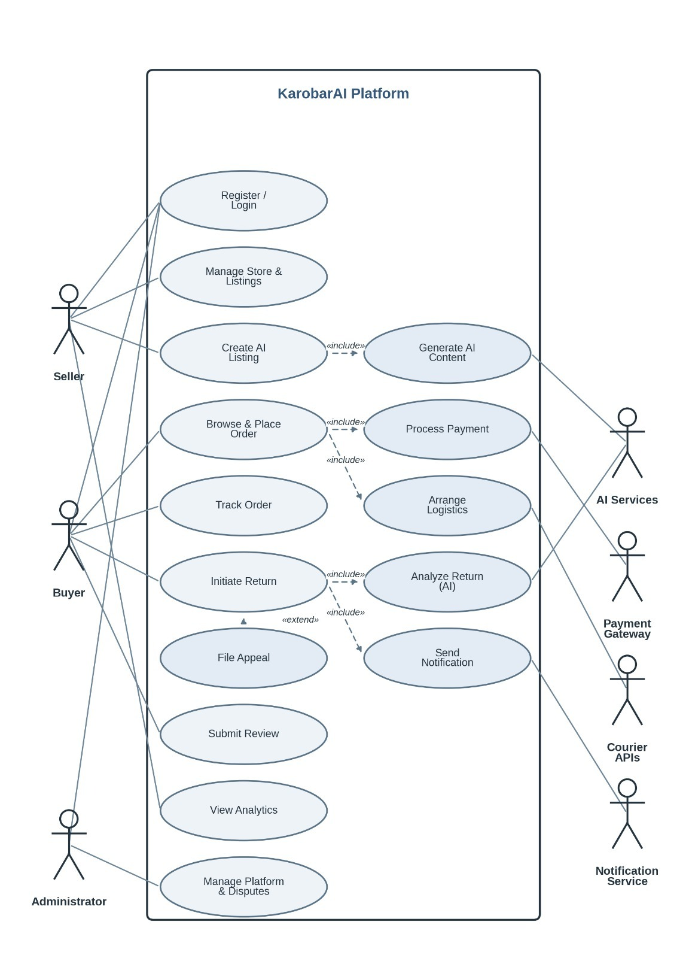
Figure 3 – Use Case Diagram: KarobarAI System Actors and Use Cases

5.6.2 Entity-Relationship (ER) Diagram
The KarobarAI relational database is built around ten core entities. The central concept is User (user_id, phone, email, password_hash, role, status, created_at), specialized into Seller and Buyer.
- Seller - Inherits User attributes and has additional fields like store_name, store_description, jazzcash_wallet, easypaisa_wallet, and commission_rate.
- Buyer – Extends User with default_address and preferred_language. Places many Orders and submits many Reviews.
- Product – Owned by one Seller. Has many ProductImages, OrderItems, and Reviews. Stores bilingual title and description fields.
- Order – Links Buyer and Seller. Inherits OrderItems, includes one Payment, and may include one Return.
- OrderItem - Order item level details like order_id (FK), product_id (FK), quantity, unit price.
- Payment – One per Order: gateway, transaction_ref, amount, status, timestamp.
- Return – One per Order: reason, images[], ai_condition, ai_authenticity, decision, decided_at. May have one Dispute.
- Notification – Many per User: channel, message, event_type, sent_at, status.
- Review – One per Buyer per Product: rating (1–5), comment, created_at.
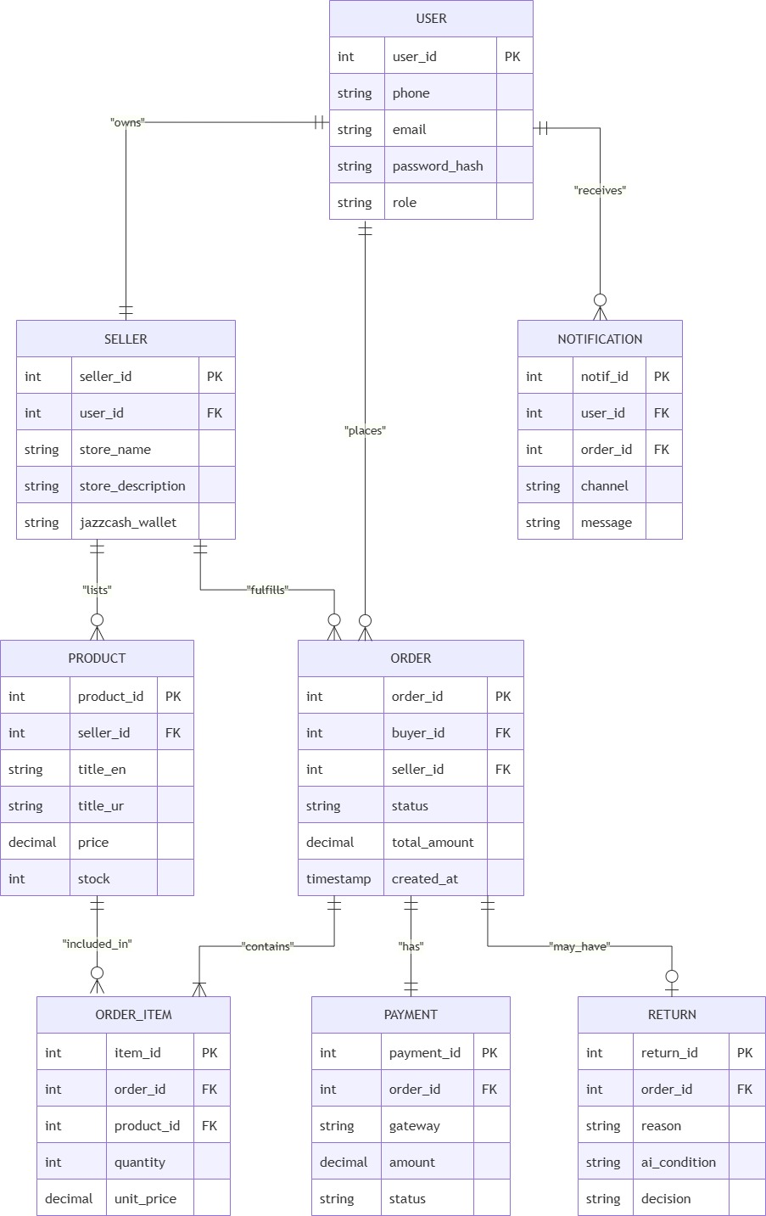
Figure 4 – ER Diagram: KarobarAI Relational Database Schema

5.6.3 System Architecture Diagram
Multi-tier architecture that comprises of 5 levels including Presentation Layer (React Web App, PWA), API Gateway Layer (Nginx reverse proxy and load balancing layer), Application Layer (Node.js/Express RESTful web service and Python/FastAPI AI/ML service), Data Layer (MongoDB, MySQL, Redis databases), and External Services Layer (Courier APIs, payment gateways, Google Cloud Vision, OpenAI / LLaMA / Olama services and notifications).
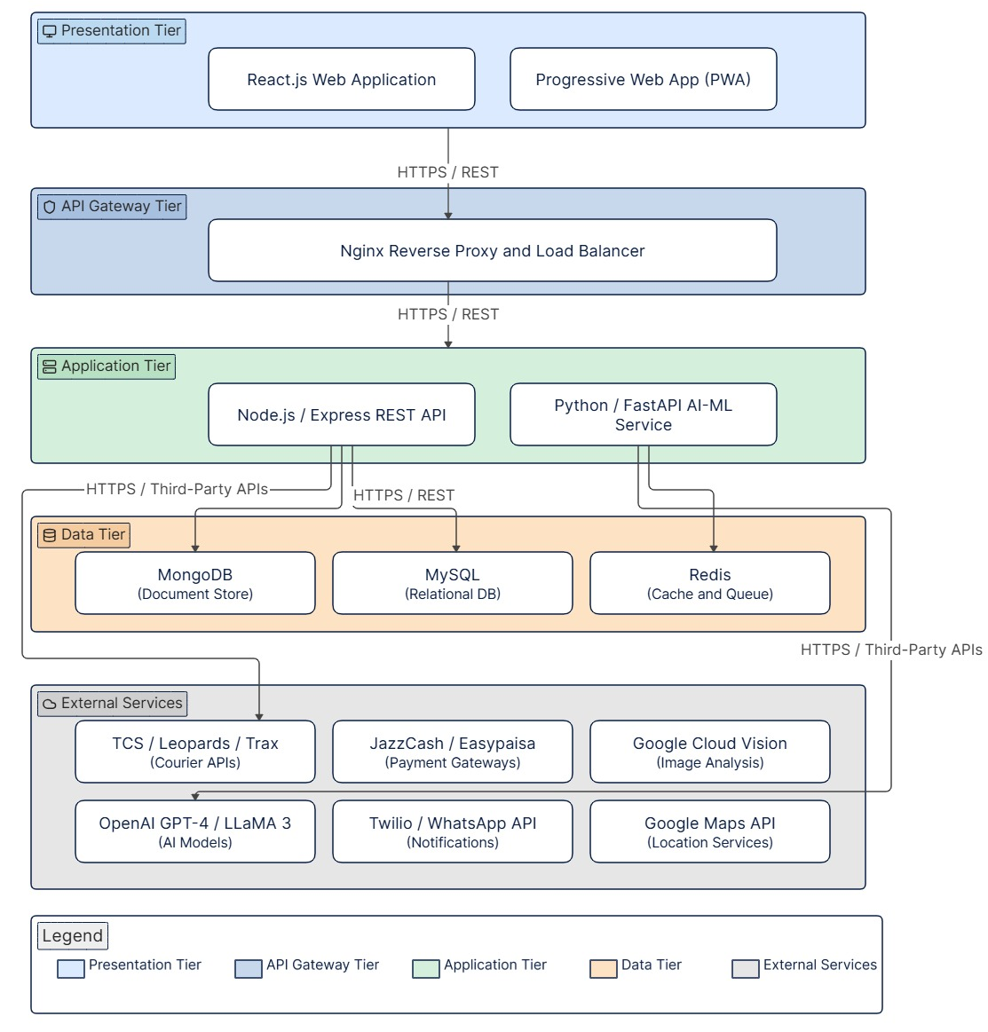
Figure 5 – System Architecture Diagram: KarobarAI Layered Service Architecture

5.6.4 Activity Diagrams
Three activity diagrams covering the most complex conditional and parallel flows:
- Product Upload and AI Content Generation Flow
- Order Placement and Courier Booking Flow
- Return Initiation, AI Analysis, and Decision Flow
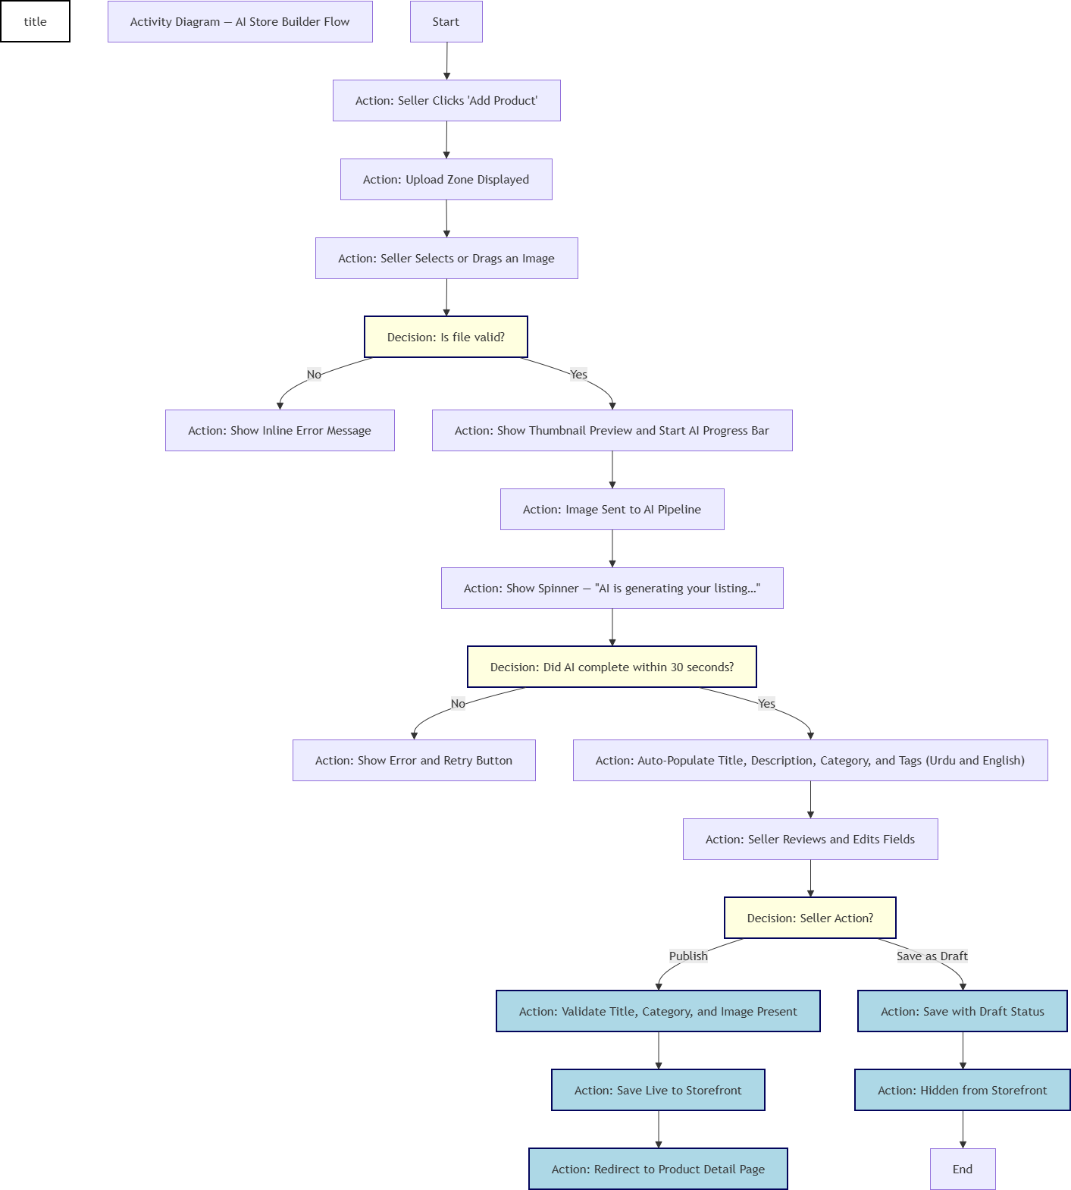
Figure 6a – Activity Diagram: Intelligent Logistics – Courier Selection & Booking
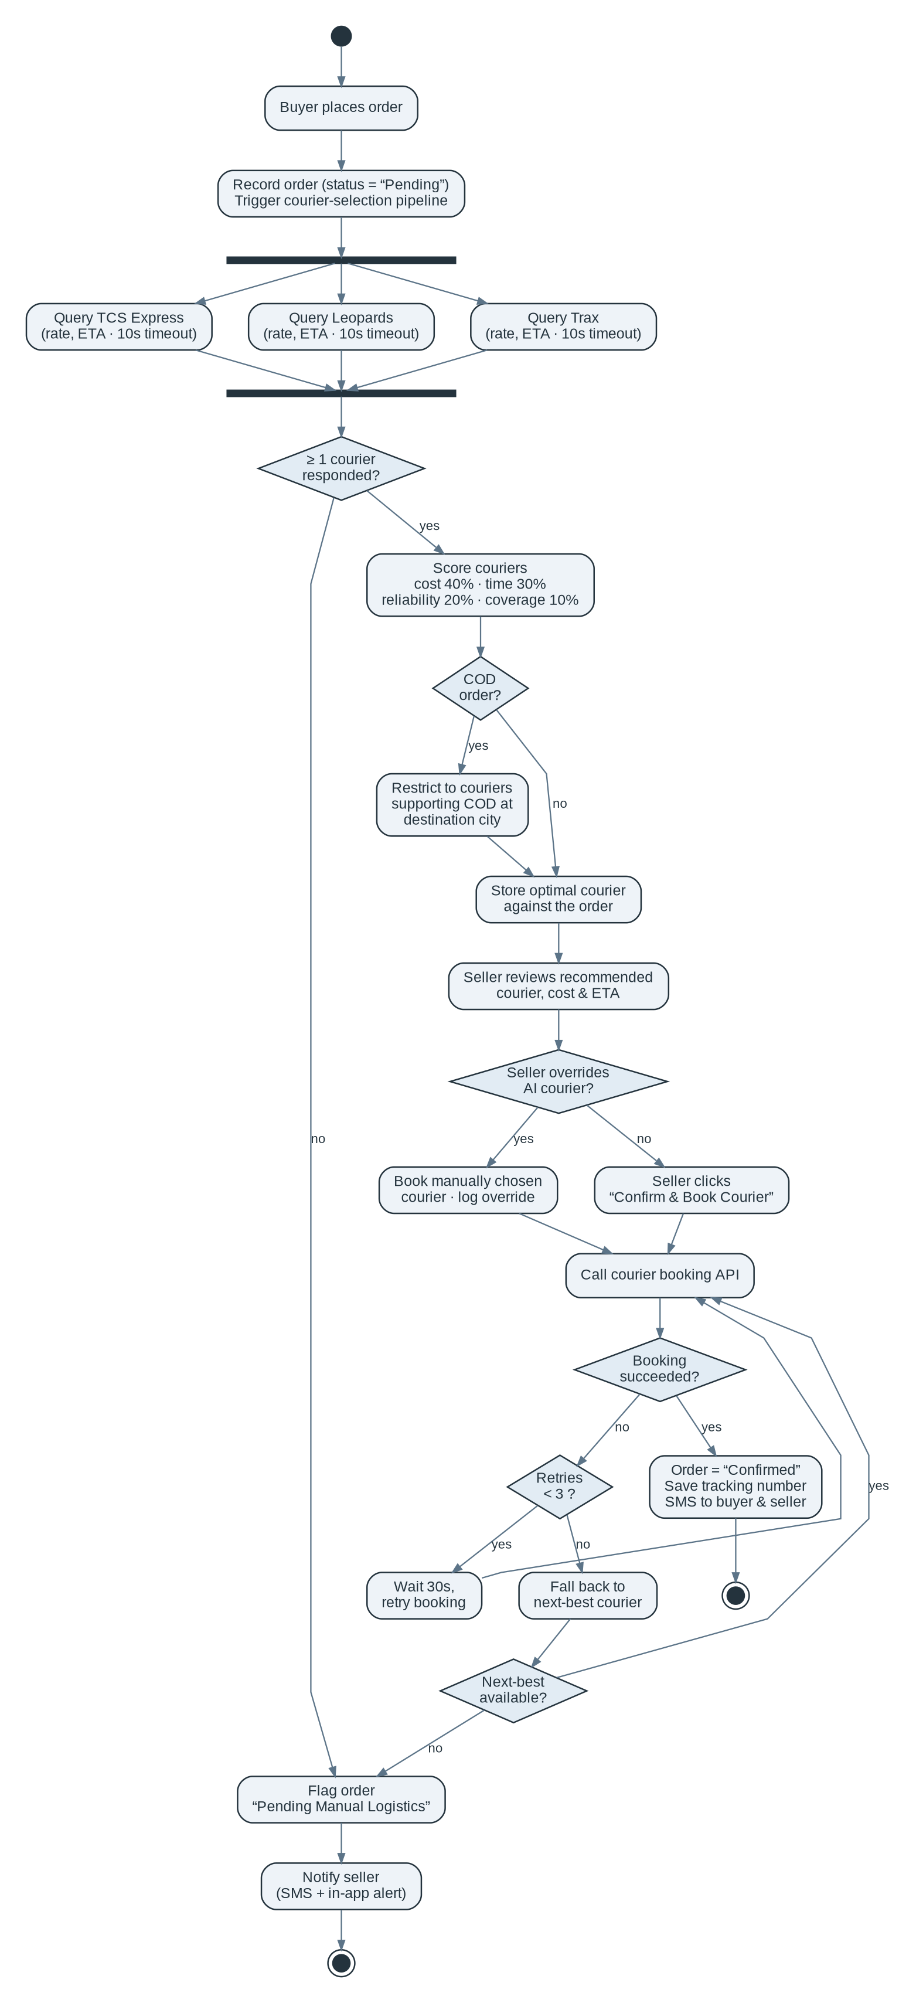
Figure 6b – Activity Diagram: Intelligent Logistics – Courier Selection & Booking
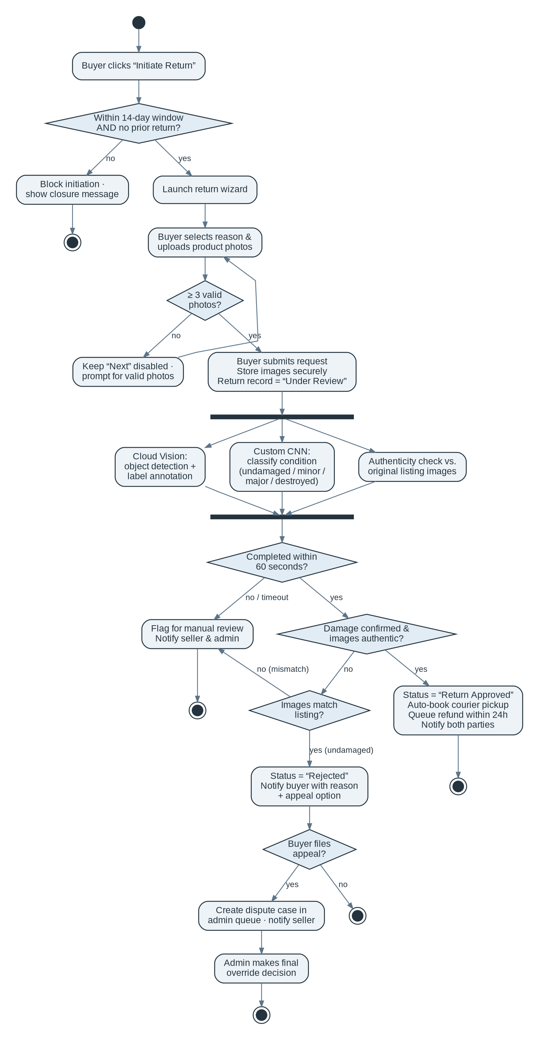
Figure 6c – Activity Diagram: ReturnsAI – Return Initiation & AI Analysis

5.6.5 Sequence Diagrams
Four sequence diagrams showing time-ordered component interactions:
- AI Content Generation — Client to GPT-4 and back
- Courier Selection and Booking — Order placement to tracking number
- ReturnsAI Image Analysis Pipeline
- Payment Processing and Seller Settlement
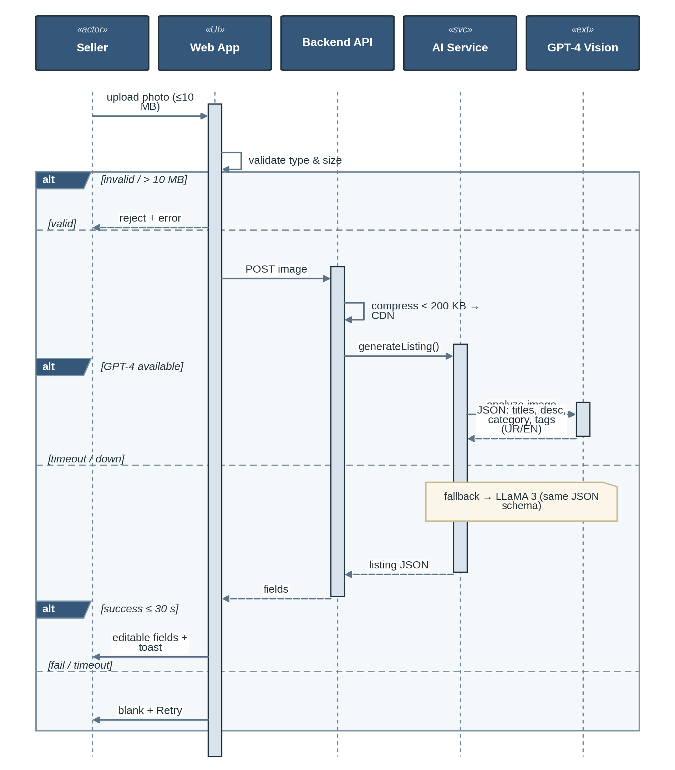
Figure 7a – Sequence Diagram: AI Content Generation (GPT-4 Vision / LLaMA 3)
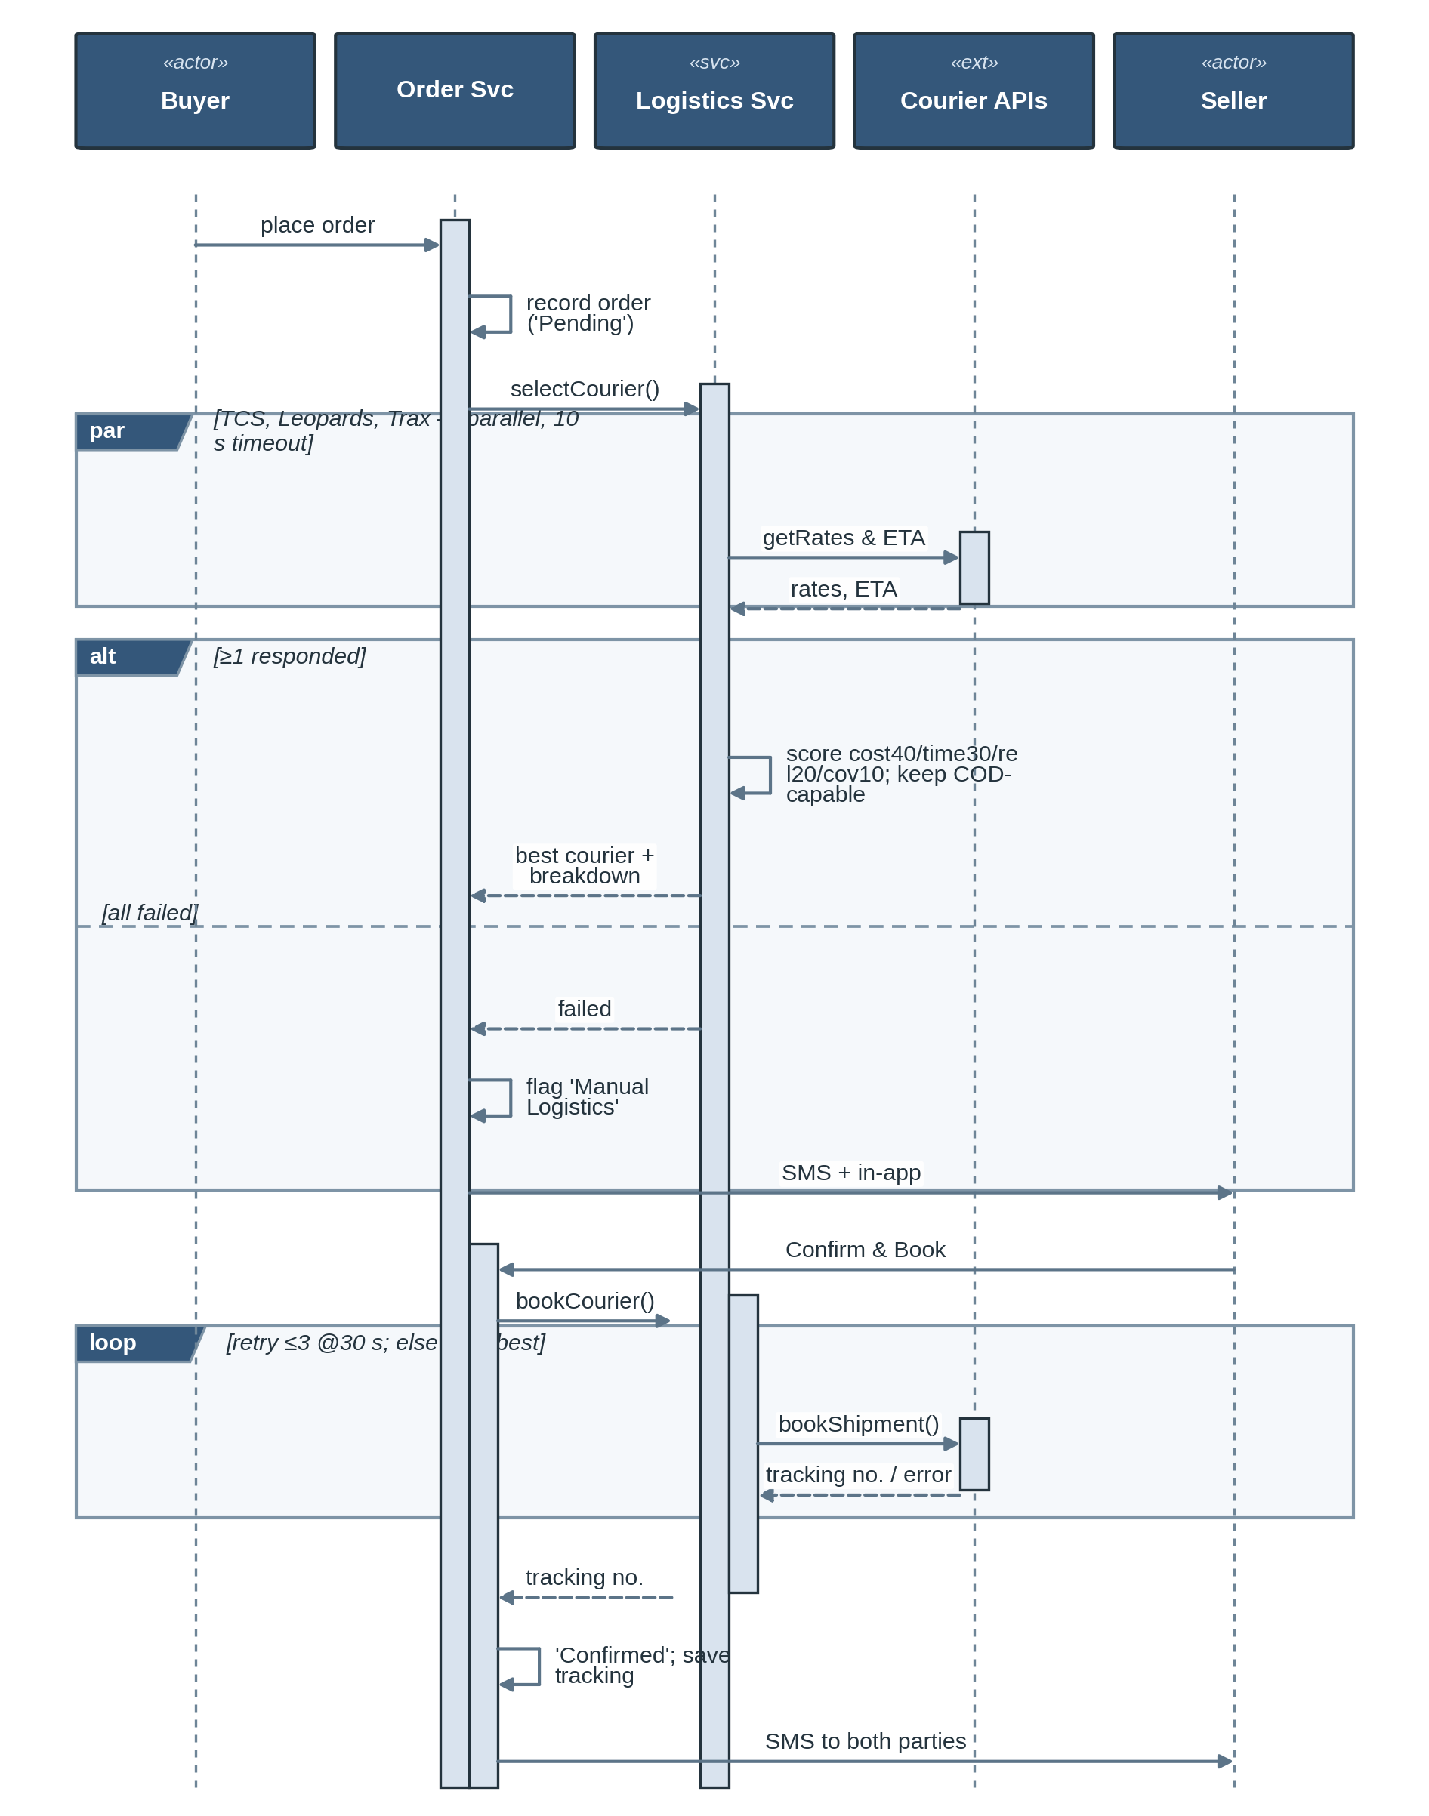
Figure 7b – Sequence Diagram: Courier Selection & Booking
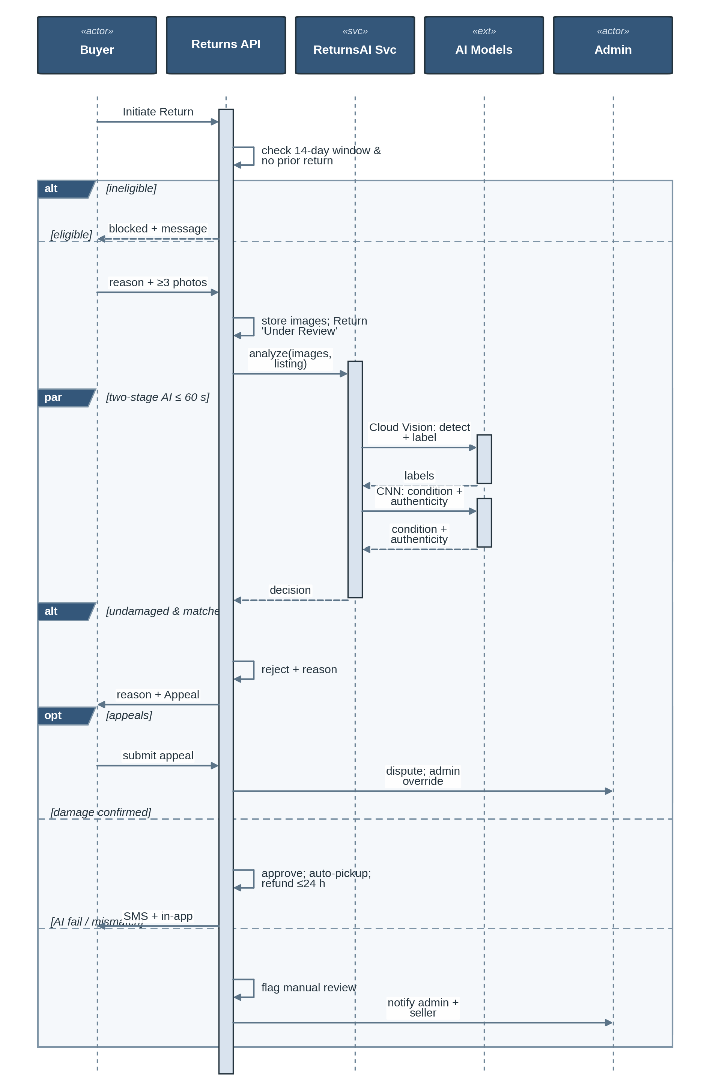
Figure 7c – Sequence Diagram: ReturnsAI Image Analysis Pipeline
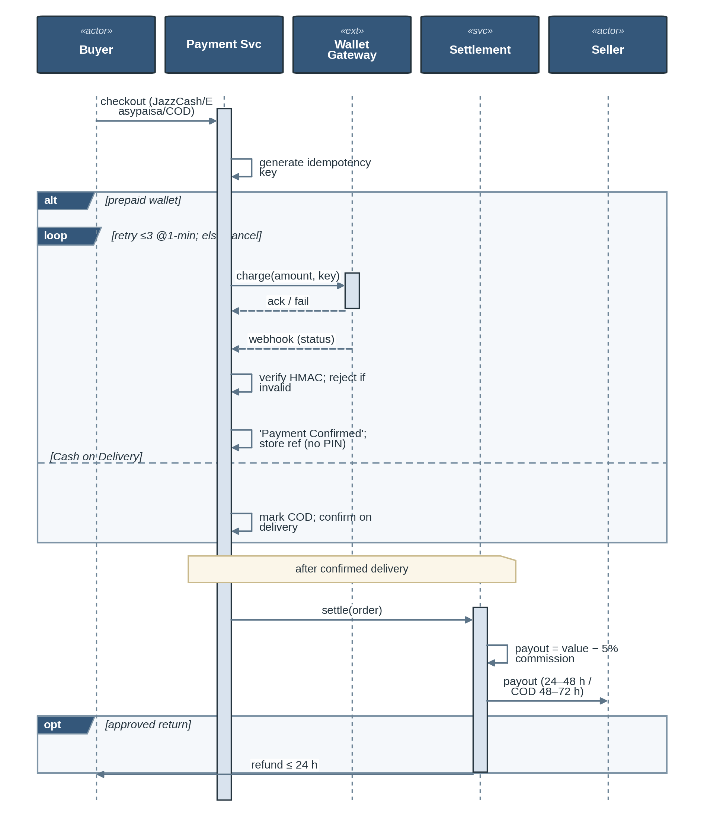
Figure 7d – Sequence Diagram: Payment Processing & Seller Settlement

5.6.6 State Machine Diagrams
The two state machines to be used as references for valid states transition:
- Order State Machine: Payment Pending -> Payment Confirmed -> Processing -> Picked Up -> In Transit -> Out For Delivery -> Delivered -> Completed. Cancellation only possible from Payment Pending or Processing.
- Return Lifecycle: Initiated → Images Submitted → Under AI Review → Approved/Rejected → (if Approved) Pickup Booked → Refund Issued. Appeal possible from Rejected; manual override from Under AI Review.
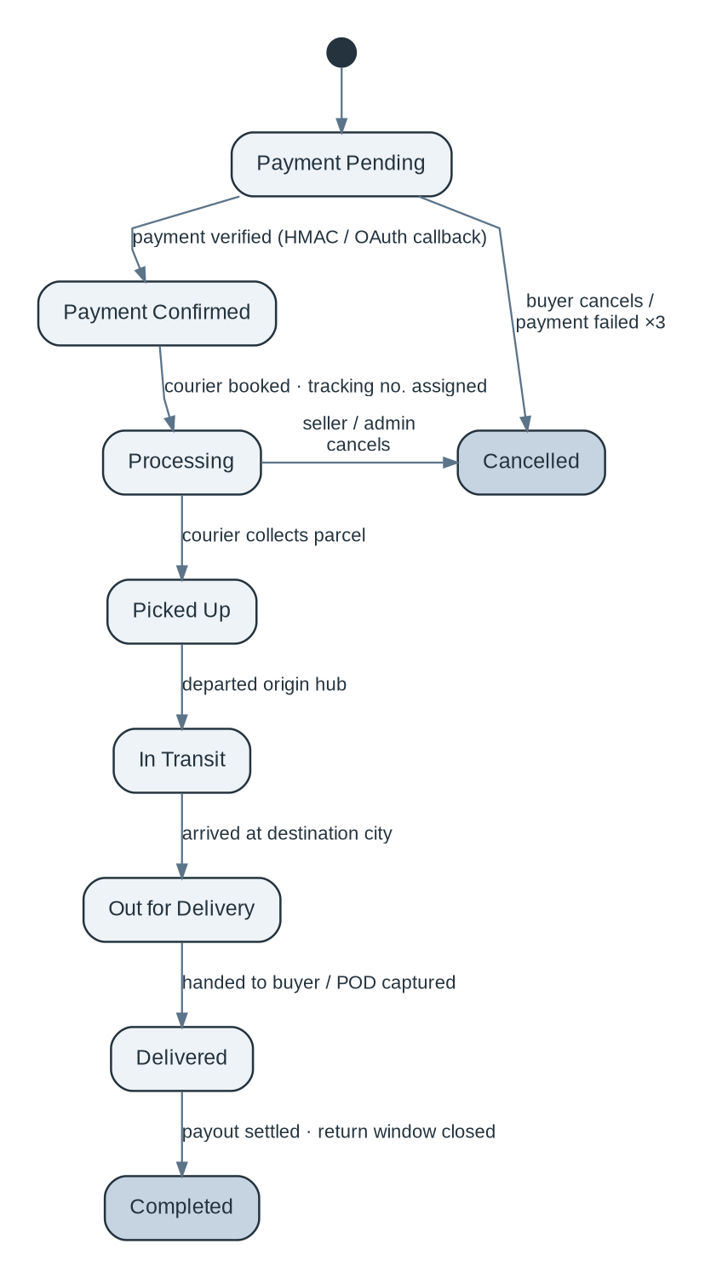
Figure 8a – State Machine Diagram: Order Lifecycle
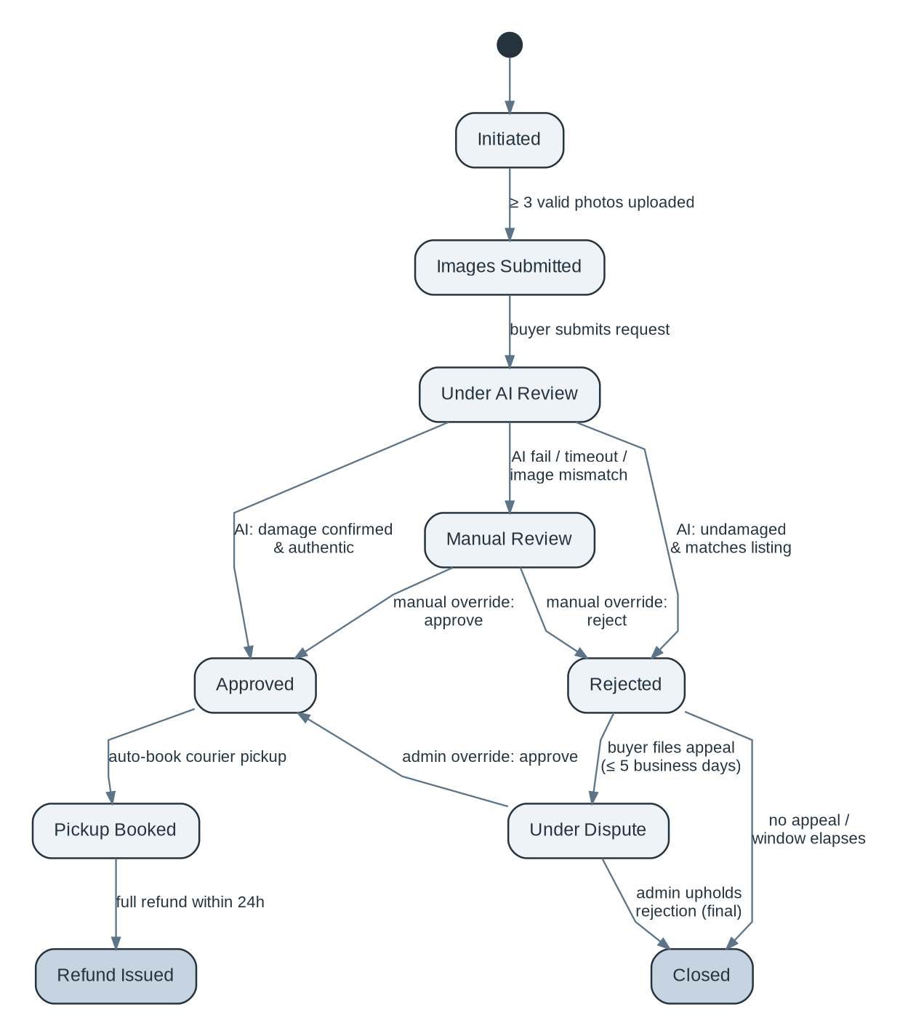
Figure 8b – State Machine Diagram: Return Lifecycle

5.6.7 Class Diagram
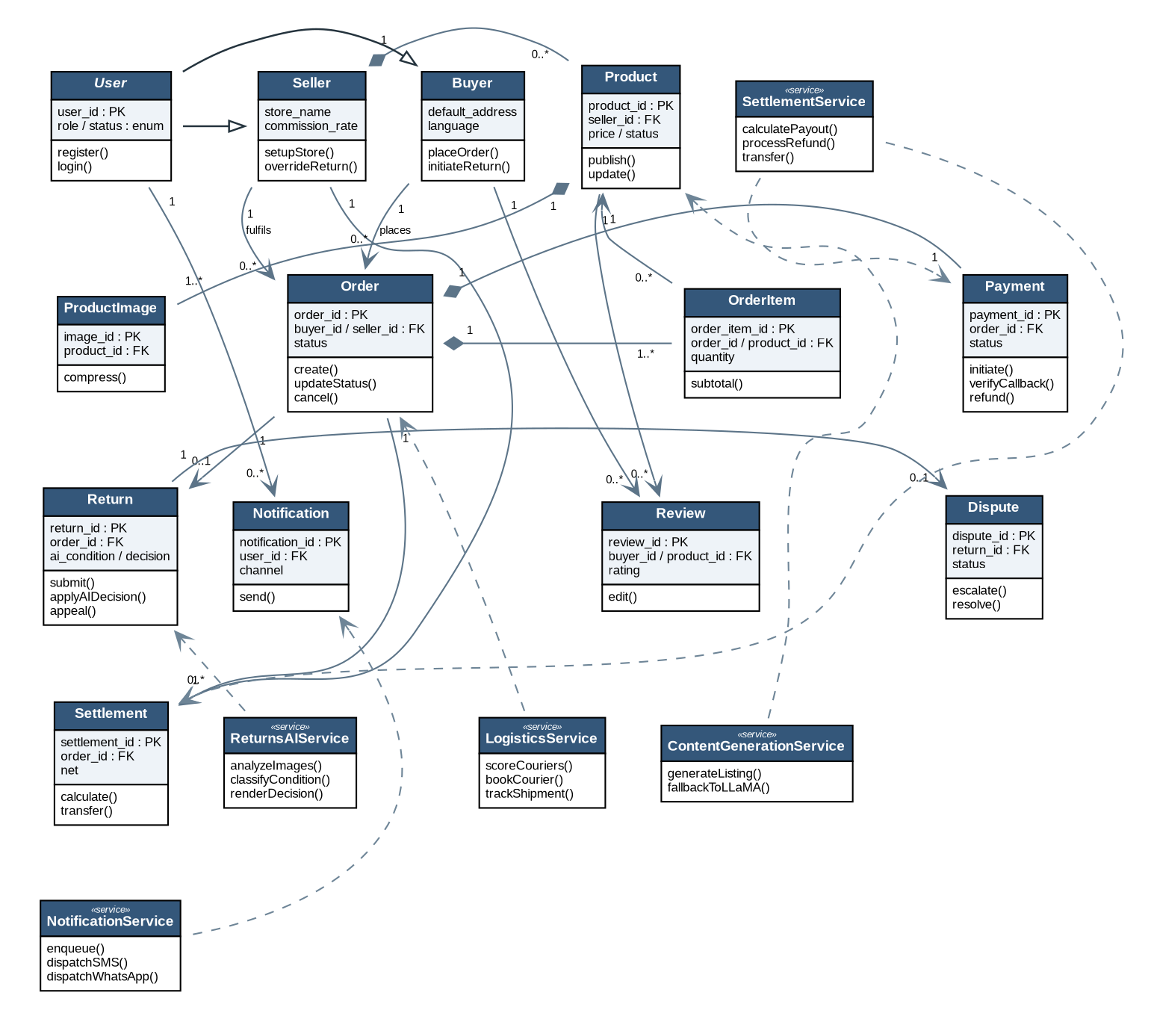
This model highlights the backend domain entities including properties, methods/behaviors, along with their multiplicity: User, Seller, Buyer, Product, Order, Order Item, Payment, Return, Notification, Review, Logistics Service, Content Generation Service, Returns AIS Service, Notification Service, and Settlement Service.
Figure 9 – Class Diagram: KarobarAI Backend Domain Model

5.6.8 Data Flow Diagram (DFD)

Level 0 (Context Diagram) — KarobarAI as a single process with all external entities and data flows.

Level 1 DFD – Processors together with data store.
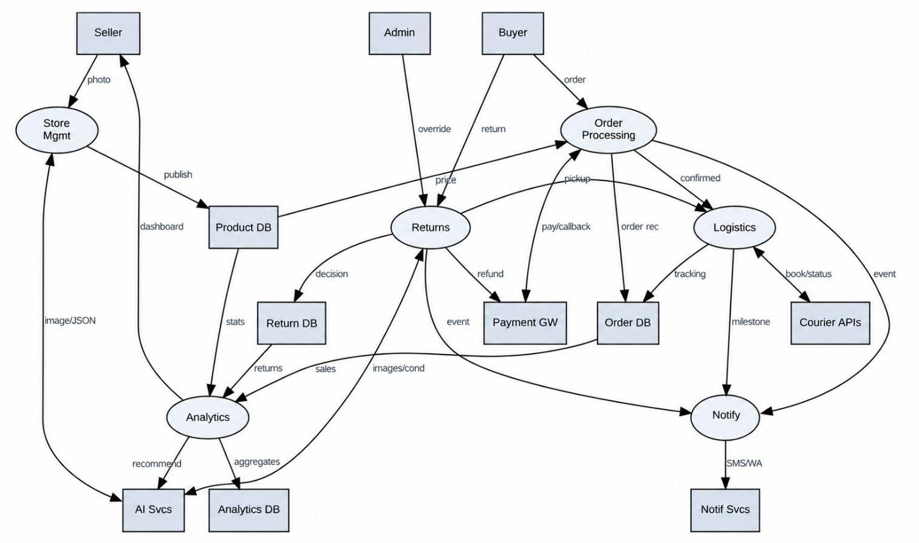
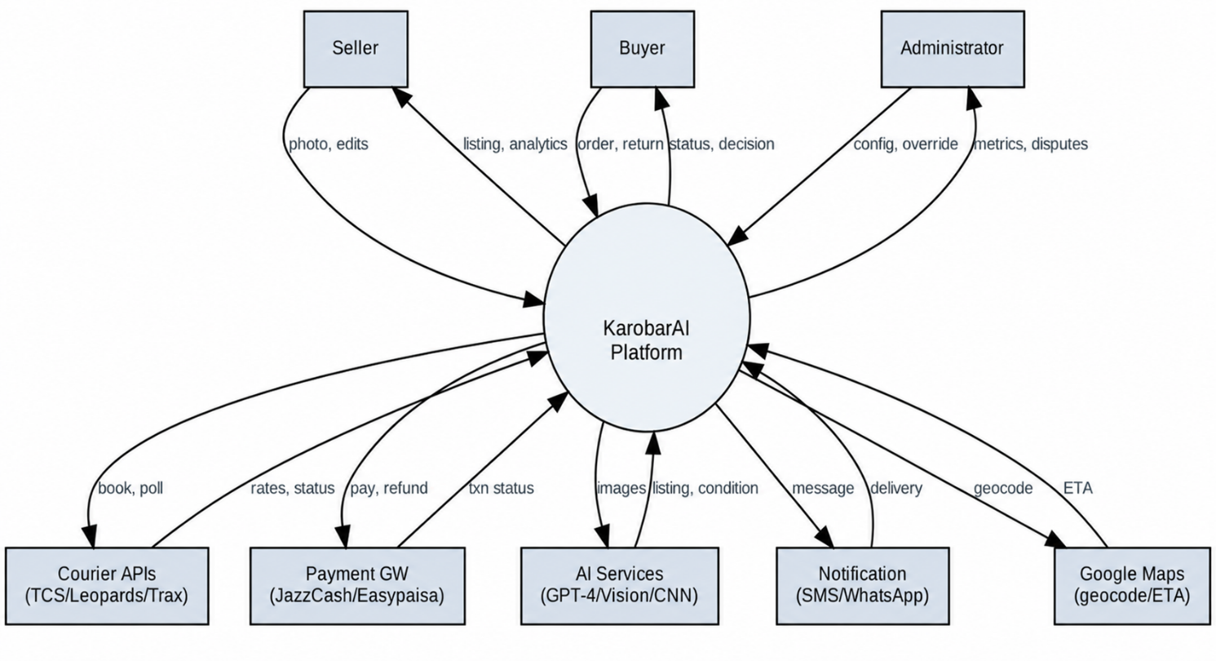
Figure 10a – Data Flow Diagram (Level 0): System Context
Figure 10b – Data Flow Diagram (Level 1): Process Decomposition

5.6.9 Database Schema Diagram
Physical MySQL schema with all tables, column data types, constraints (PRIMARY KEY, FOREIGN KEY, NOT NULL, UNIQUE, DEFAULT), foreign key relationships with cardinality, and index annotations for query performance.
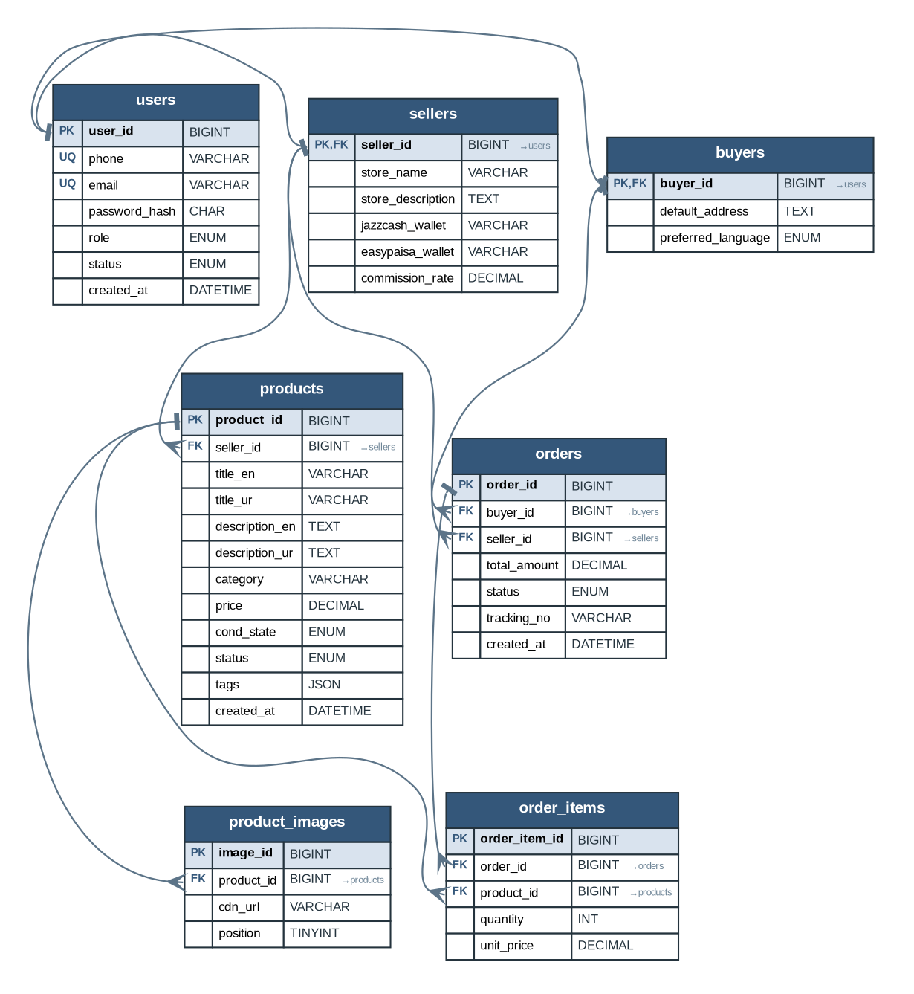
Figure 11 — Panel 1 of 2 : Users, Catalog & Orders

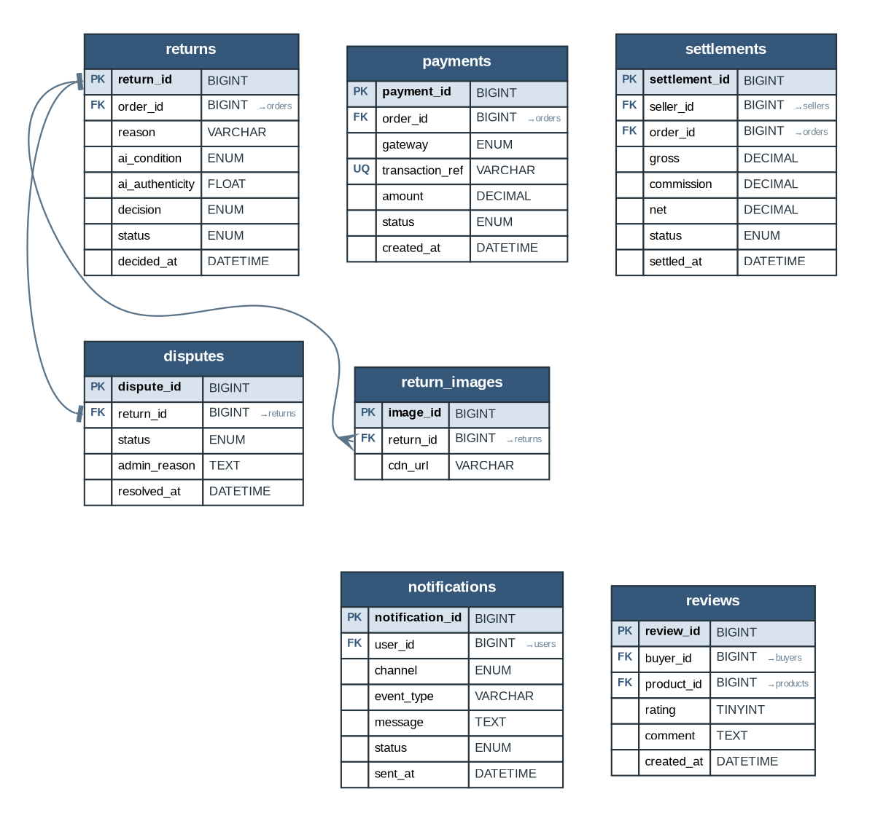
Figure 11 — Panel 2 of 2 : Payments, Returns & Engagement

References
[1] IEEE, “IEEE Recommended Practice for Software Requirements Specifications,” IEEE Std 830-1998, IEEE, New York, NY, USA, 1998.
[2] International Organization for Standardization, “ISO/IEC/IEEE 29148:2018 — Systems and Software Engineering — Life Cycle Processes — Requirements Engineering,” ISO, Geneva, Switzerland, 2018.
[3] OpenAI, “GPT-4 Technical Report,” arXiv:2303.08774 [cs.CL], Mar. 2023. [Online]. Available: https://arxiv.org/abs/2303.08774
[4] OpenAI, “OpenAI API Documentation — GPT-4 Vision,” OpenAI, 2024. [Online]. Available: https://platform.openai.com/docs
[5] Meta AI, “LLaMA 3 Model Card and Documentation,” Meta AI, Menlo Park, CA, USA, 2024. [Online]. Available: https://ai.meta.com/llama
[6] Google Cloud, “Cloud Vision API Documentation,” Google LLC, Mountain View, CA, USA, 2024. [Online]. Available: https://cloud.google.com/vision/docs
[7] Y. LeCun, Y. Bengio, and G. Hinton, “Deep learning,” Nature, vol. 521, no. 7553, pp. 436–444, May 2015.
[8] Meta, “WhatsApp Business Cloud API Documentation,” Meta Platforms Inc., Menlo Park, CA, USA, 2024. [Online]. Available: https://developers.facebook.com/docs/whatsapp
[9] Jazz / Mobilink, “JazzCash Payment Gateway API Documentation,” Jazz Pvt. Ltd., Islamabad, Pakistan, 2024. Available to registered merchant partners.
[10] Telenor Microfinance Bank, “Easypaisa API Documentation,” Telenor Microfinance Bank Ltd., Islamabad, Pakistan, 2024. Available to registered merchant partners.
[11] TCS Pvt. Ltd., “TCS Express API Documentation,” TCS Pvt. Ltd., Karachi, Pakistan, 2024.
[12] State Bank of Pakistan, “Payment Systems Regulations,” SBP, Karachi, Pakistan, 2023. [Online]. Available: https://www.sbp.org.pk
[13] Payment Card Industry Security Standards Council, “PCI Data Security Standard (PCI DSS) v4.0,” PCI SSC, Wakefield, MA, USA, 2022. [Online]. Available: https://www.pcisecuritystandards.org
[14] OWASP Foundation, “OWASP Top 10 — 2021 Edition,” OWASP Foundation, 2021. [Online]. Available: https://owasp.org/Top10
[15] World Wide Web Consortium (W3C), “Web Content Accessibility Guidelines (WCAG) 2.1,” W3C Recommendation, Jun. 2018. [Online]. Available: https://www.w3.org/TR/WCAG21
[16] T. Berners-Lee, R. Fielding, and L. Masinter, “Uniform Resource Identifier (URI): Generic Syntax,” RFC 3986, IETF, Jan. 2005. [Online]. Available: https://datatracker.ietf.org/doc/html/rfc3986
[17] E. Rescorla, “The Transport Layer Security (TLS) Protocol Version 1.3,” RFC 8446, IETF, Aug. 2018. [Online]. Available: https://datatracker.ietf.org/doc/html/rfc8446
[18] M. Jones, J. Bradley, and N. Sakimura, “JSON Web Token (JWT),” RFC 7519, IETF, May 2015. [Online]. Available: https://datatracker.ietf.org/doc/html/rfc7519
[19] MongoDB Inc., “MongoDB 6.0 Documentation,” MongoDB Inc., New York, NY, USA, 2024. [Online]. Available: https://www.mongodb.com/docs/v6.0
[20] Oracle Corporation, “MySQL 8.0 Reference Manual,” Oracle Corporation, Redwood City, CA, USA, 2024. [Online]. Available: https://dev.mysql.com/doc/refman/8.0/en
[21] Salvatore Sanfilippo, “Redis 7.0 Documentation,” Redis Ltd., Mountain View, CA, USA, 2024. [Online]. Available: https://redis.io/docs
[22] Docker Inc., “Docker Documentation,” Docker Inc., San Francisco, CA, USA, 2024. [Online]. Available: https://docs.docker.com
[23] Google LLC, “Maps JavaScript API Documentation,” Google LLC, Mountain View, CA, USA, 2024. [Online]. Available: https://developers.google.com/maps/documentation/javascript
[24] Twilio Inc., “Twilio SMS API Documentation,” Twilio Inc., San Francisco, CA, USA, 2024. [Online]. Available: https://www.twilio.com/docs/sms
[25] FYP Team, “KarobarAI Project Proposal,” Department of Computer Science, Lahore Garrison University, Lahore, Pakistan, 2024.

