

Al Imam Muhammad ibn Saud Islamic University College of Computer and Information System

Computer Science Department

1st semester 1442 H – 2020 G

**CS 438 – Internet Technologies**

**Project**

**[booking playground]**

**By**

|  |  |
| --- | --- |
| Student Name | ID |
| jalal hafiz | 439012119 |
| Abdullah AlDrewaish | 434014636 |
| abdullah alwheed | 435014281 |
| fasil alrsheed | 437014135 |

2022/8/16

The aim of web:

In this project, we made a web page to make easier booking for user.

We made six pages in this project.

The first page it is the home page or the main page, its show the news and the most thinks that’s the user want to see.

The second page is the login page, that let the user to sign in and put his information.

The third page it is abut us page, and in this page the user can know some information about us.

The fourth page it is contact with us.

## 1. Site Map

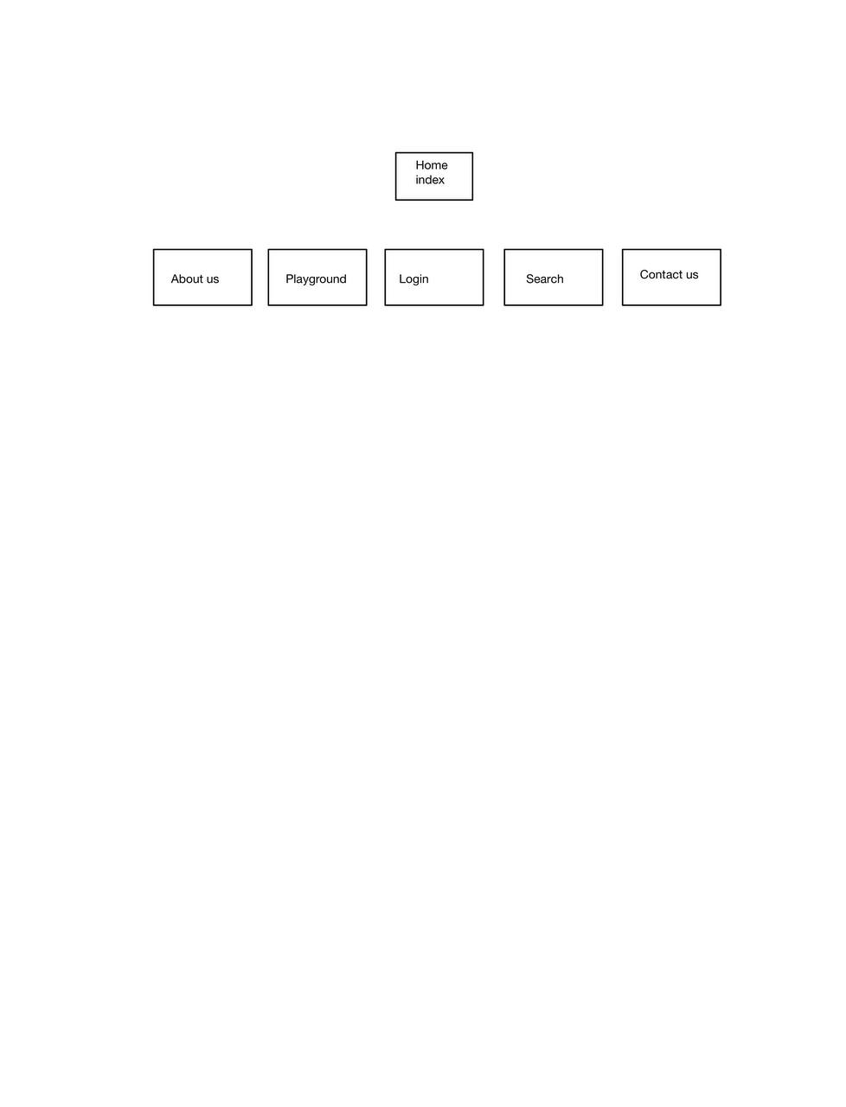

football

location

basketball

paddle

## 2. Look & Feel

in our website we used our style, in our style we made header and we put the logo and list of other page like home page, playground and about us.

And in the body of website, we putted three images foe football, basketball and paddle.

In the same body we put login button and the box checking for the free playground.

In the footer we putted the pay way, contact us and social network.

We use fontowesome.com

We take the icon, we use google font for the font of the style.

## 3. Dynamic Components

we use JavaScript in the home page. We use function that change the background image in the home page, and search function to see the free playground.

## 4. Business Logic

Database is simple within two attribute E-mail and Password

Sin-up: Create a new User in Database

Sin-in: Match the information’s inserted by User with Database

# References

<https://fonts.google.com/>

<https://fontawesome.com/icons>