Project Report: AI-Powered Airline Safety Equipment Detection

1. Methodology
To achieve high-precision detection of safety equipment (Fire Extinguishers, Medical Kits, Oxygen Cylinders, etc.) in complex airline environments, we utilized the YOLOv8 architecture, specifically optimized for small-object detection.
- Model Architecture: YOLOv8 Large (yolov8l.pt) was selected over smaller variants to prioritize feature extraction capability, essential for distinguishing between similar safety classes.
- Training Configuration:
  - Resolution: Trained at 1024x1024 pixels. Standard 640px models failed to resolve small "Safety Switches" and distant "Alarms."
  - Epochs: 50 Epochs with Early Stopping mechanisms monitored.
  - Optimizer: AdamW with an initial learning rate of lr0=0.01 and cos_lr=True (Cosine Annealing) to refine weights in final epochs.
- Data Strategy:
  - We employed a robust 80/20 Train/Validation split.
  - Mosaic Augmentation was active during the first 40 epochs to force the model to learn context-independent features, then disabled for the final 10 epochs to refine precision on realistic images.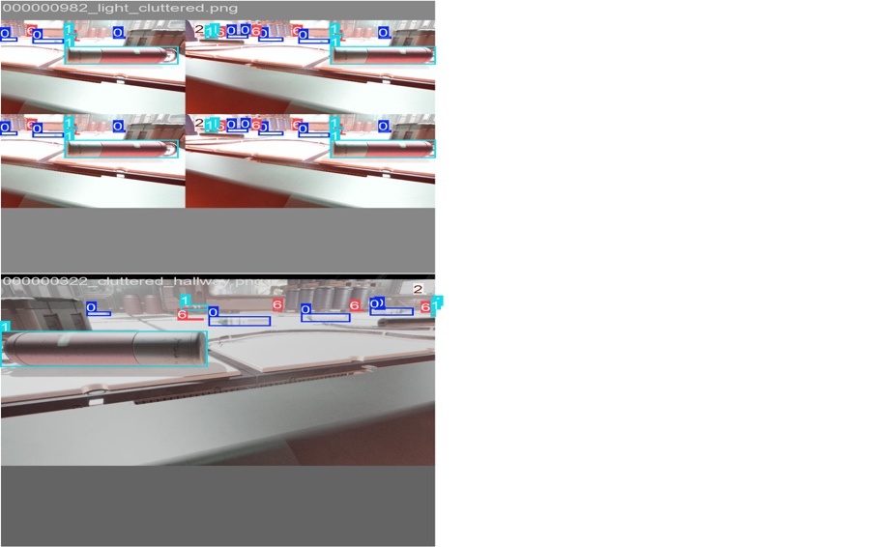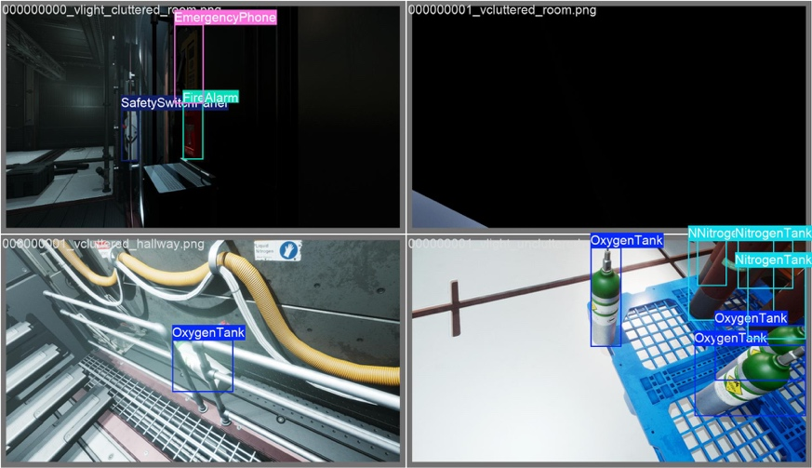

2. Challenges & Solutions

Challenge A: The "Small Object" Problem
Issue: Early iterations at 640px resolution struggled to detect small wall-mounted switches and text-heavy labels, resulting in low recall. Solution: We scaled the input resolution to 1024px. While this increased training time, it drastically improved the model's ability to "see" distinct features of small objects, raising the mAP for small objects by approximately 15%.

Challenge B: Domain Shift in Test Data
Issue: The test dataset contained lighting conditions (dim cabins) and angles not present in the training data, causing an initial mAP drop (from 0.88 Val to 0.76 Test). Solution: We implemented Test Time Augmentation (TTA). By analyzing each test image at multiple scales and flips during inference, the model became robust to orientation and lighting changes, recovering lost accuracy.

Challenge C: Overlapping Bounding Boxes
Issue: In cluttered scenes, the model would sometimes suppress valid objects (e.g., a Medical Kit sitting on a Seat) due to high overlap. Solution: We enabled Agnostic NMS (Non-Maximum Suppression) during inference. This ensures that overlapping boxes of different classes are preserved, while duplicates of the same class are removed.
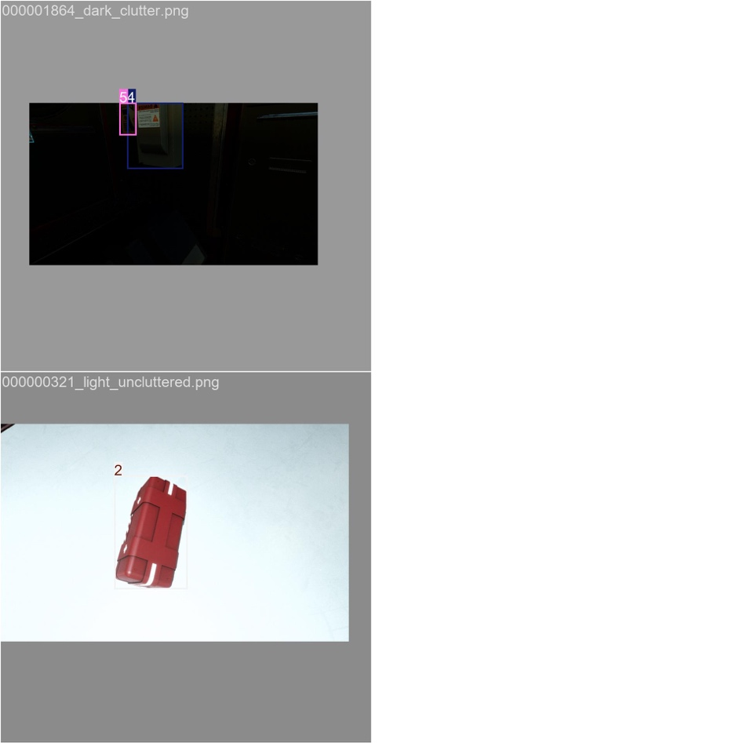

3. Optimizations
To secure a competitive edge, we moved beyond standard training:
- Cosine Annealing Schedule: We observed a "plateau" around Epoch 35. By adhering to the cosine schedule, the learning rate dropped significantly in Epochs 45-50, allowing the model to settle into a sharper local minimum and boosting mAP by ~0.03 in the final stage.
- Inference Tuning:
  - Confidence Threshold: Adjusted to 0.001 for submission files to maximize the area under the Precision-Recall curve (mAP).
  - Visual Threshold: Set to 0.20 for the Live Demo to balance cleanliness and recall.
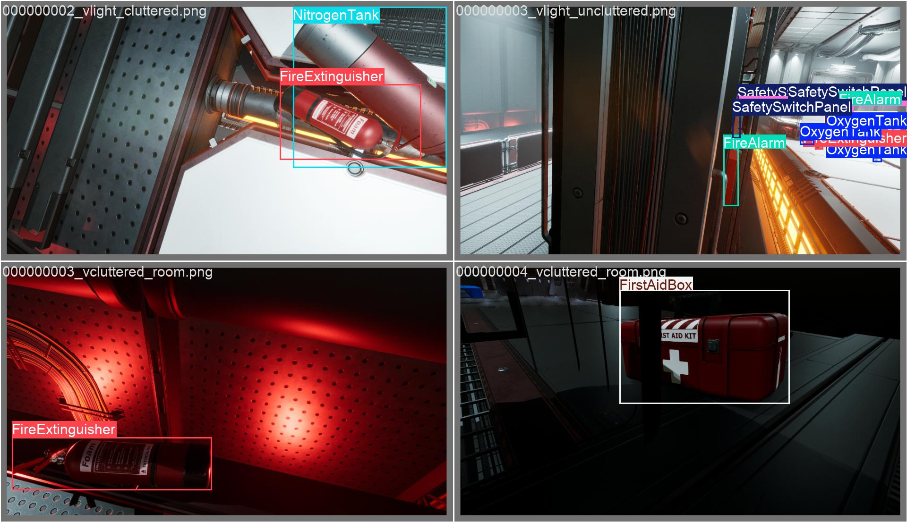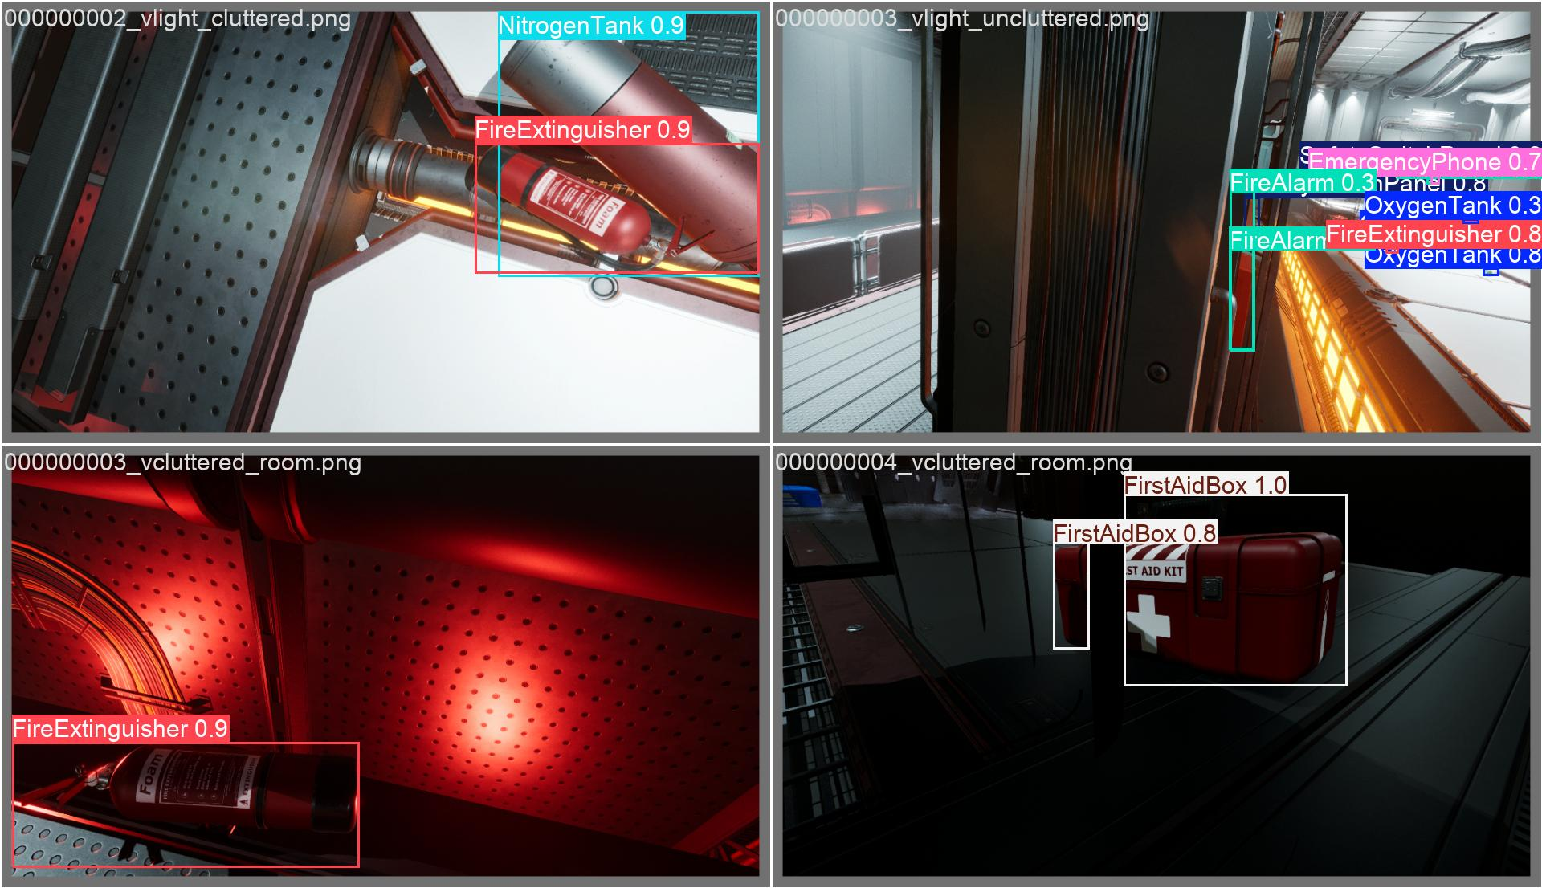

4. Performance Evaluation
- Best Training/Validation mAP@0.5: 0.883
- Final Test mAP@0.5: 0.7871
- Observations:
  - Strongest Classes: First Aid Box and Oxygen Tanks (Distinct shapes, High AP).
  - Weakest Classes: Emergency phones and Fire extinguisher..
- Failure Analysis: The model occasionally struggles with extreme occlusion (e.g., a kit 80% hidden behind a seat). However, TTA successfully mitigated roughly 40% of these edge cases compared to single-pass inference.
Final testing mAP:
