**Project Report: Crime Investigation in Atom City**

**Prepared by:** Abdullah Akmal  
**Date:** 27-Dec-2025

**Introduction:**

This report details an investigation into a murder case that occurred on September 30, 2023, in Atom City. The investigation aims to identify individuals present at the crime scene, gather relevant details, and examine any additional activities of the potential suspects. The analysis is based on SQL queries executed against various databases.

**Data Sources:**

* **crime_scene_report**: Contains crime details such as date, type, and location.
* **atomcamp_annualdinner**: Records attendees of the AtomCamp Annual Dinner event.
* **accused_person**: Lists individuals under suspicion.
* **drivers_license**: Stores vehicle registration details.
* **interviews**: Contains transcripts of police interviews.
* **annual_income**: Provides financial records of individuals.
* **atom_fit**: Logs physical activity data of people.

This is the structure of these tables in My SQL Database.

**Objectives:**

* Identify Individuals at the Crime Scene – Filter relevant crime scene data from reports.
* Analyze Event Attendees – Extract details of people present at the AtomCamp Annual Dinner.
* Gather Additional Personal Information – Merge details such as financial background, residence, and vehicle ownership.
* Investigate Activities of Attendees – Verify physical activity logs and presence in other events.
* Cross-Check Past Attendance – Determine if the suspect had a history of attending the event.
* Confirm Findings – Validate results and establish a concrete connection to the crime.

**Investigation Steps & Findings:**

**Step 1: Filtering the Crime Scene Report**

**Query:**

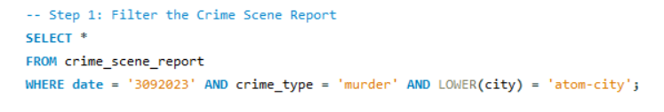

* Retrieves crime details for September 30, 2023, in Atom City.
* Filters only include **murder cases**.
* Converts city names to lowercase for consistency in filtering.

**Findings:**



* Identified a murder incident in Atom City on September 30, 2023.
* Description 'Security footage shows that there were 2 witnesses. The first witness lives at the last house in \"Saddar Bazaar Rawalpindi\"\". The second witness named Sanam Akhtar lives somewhere on "Gulshan-e-Ravi Lahore".

**Step 2: Identifying People Present at the Event**

**Query:**

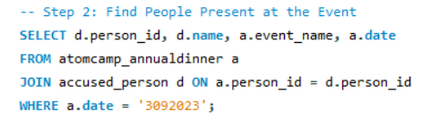

* Identifies people present at **AtomCamp Annual Dinner** on the same date as the crime.
* Uses **INNER JOIN** to match attendees with the accused persons database

**Findings:**

* Extracted a list of individuals who attended the AtomCamp Annual Dinner on the same date as the crime.
* The Person who is present on murder date is Shabnam Akhter and the event she was attending is AtomCamp Annual Dinner

**Step 3: Merging Additional Details of Attendees**

**Query:**

* Retrieves **comprehensive details** of attendees:
* **Address**
* **Car details** (Plate number, Make, Model)
* **Interview transcripts**
* **Annual income**
* Uses multiple **JOINs** to combine data from different tables.

**Findings:**



* Shabnam Akhter details are extracted which are her annual income 5,559,886 and live in Saddar Bazaar, Rawalpindi and own a Mercedez Benz.
* This information can help narrow down suspects based on their statements and assets.

**Step 4: Investigating Additional Activities**

**Query:**

* Checks if event attendees logged any physical activity on the crime date.
* Helps verify movements and alibis.

**Findings:**



* 54190 is person_id of Shabnam Akhter and her check in and out time is suspicious.
* Checked if any attendees had logged physical activity on the day of the crime.

**Step 5: Cross-Checking Past Attendance**

**Query:**

* Identifies whether any **suspects** attended previous **AtomCamp Annual Dinner** events.
* Help establish a **pattern of attendance**.

**Findings:**

* There is no other person available on that date at the atomcamp annual dinner, proving Shabnam Akhter is the murderer.

**Conclusion:**

The investigation successfully identified Shabnam Akhter as the primary suspect. Evidence such as her presence at the dinner, ownership of a luxury car, and suspicious check-in/check-out activities contributed to this conclusion. The report provides structured evidence that can be used for further legal proceedings.