|  |  |
| --- | --- |
| Role position | Quality/Test Engineer - Testing Standard - Junior |
| Location | Frankfurt am Main |
| Number of fte | N/A |
| Rgs id | N/A |
| Remote onsite | Remote with onsite in Germany as needed |
| Onsite frequency week | N/A |
| Project duration | N/A |
| Working hours per day | N/A |
| Contract mode | N/A |
| Daily rate | N/A |
| Language proficiency | German |
| Start date of engagement | N/A |
| Experience required | Experience in conception and execution of software system tests |
| Must | Experience in conception and execution of software system tests, Proficient knowledge of relevant test tools (especially Jira with Zephyr), Routine use of methods for test case creation |
| Target | Knowledge of unit tests and integration tests, Experience in testing enterprise applications with heterogeneous systems, Knowledge in testing IT projects at railway companies |

# Framework Agreement CoMPass IT

Domain 1 Quality/Test Engineering - Testing Standard - Junior Project: Implementation of TAP TSI at DB Regio (Existing Project)

# Description of Project/Procedure Context

The European Union defines the requirements for the development of interoperable telematics applications in freight and passenger transport (TAF and TAP) for all railway stakeholders (railway infrastructure companies, railway undertakings, freight forwarders, wagon keepers, etc.) across Europe with the Technical Specifications for Interoperability (TSI). The corresponding EU regulations, 1305/2014 (TAF TSI) and 454/2011 (TAP TSI), include, among other things, the guidelines and requirements for standardization for path requests and offers as well as the exchange of operational messages concerning trains. The operational messages listed in TAP-TSI between railway undertakings (EVU) and infrastructure managers (EIU) are partially mandatory for both parties. The new format for path requests is mandatory. The project primarily implements the transition to the new TAP TSI messages in the system for path ordering and in the dispatching system for operational messages.

# Service Provider Responsibilities

The service provider performs the services independently and on their own responsibility. In carrying out their activities, the service provider is not subject to instructions from the client. The order-related specifications required for proper contract execution and compliance with project-related time specifications are not considered instructions in the aforementioned sense. In the event of poor performance by a person employed by the service provider, they may be rejected by the client.

# Documentation Language

The documentation language for all committee documents and all sprint content is German. Coordination with the client and other stakeholders of DB is carried out using technical tools such as MS Teams, telephone, and email, while adhering to the communication structure. The communication tools are agreed upon by the client and contractor at the start of service delivery.

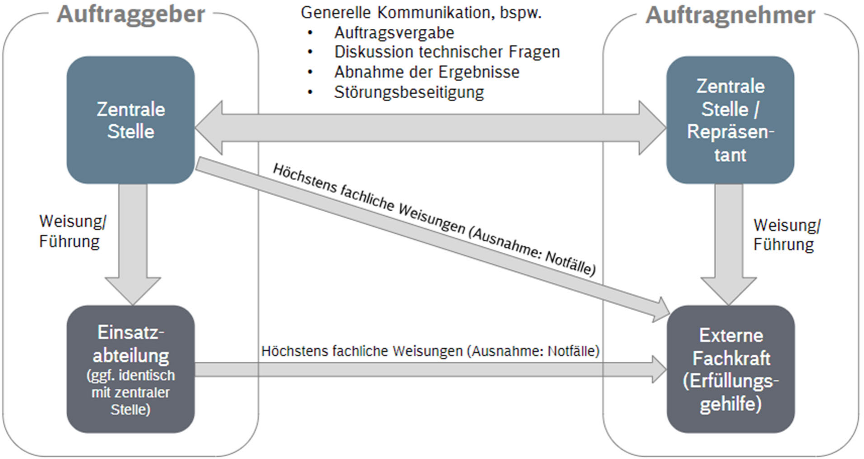

# Inquiries

Inquiries regarding the contents of the request can be submitted via the "question option" in the request tool (or easIT). Questions and answers are visible to all framework contract partners, so please pay attention to the "anonymity" of the inquiries.