

Systems & Biomedical Engineering Department

Faculty of Engineering

Cairo University



Database System For CMMS In Tertiary Hospital

Ahmed Salah El-Din Fouad |Sec: 1 | B.N: 5

Ahmed Abdelmageed Ahmed |Sec: 1 | B.N: 8

Ahmed Mahdy Mohammed |Sec: 1 | B.N: 9

Abdullah Mohammed Sabry |Sec: 2 | B.N: 8

Fady Tadrous |Sec: 2 | B.N: 13

Submitted to: **Dr. Bassel Tawfik**

2019 – 2020

Table of Contents

1. Description 4

2. Features 4

3. Workflow 4

3.1 Login Page 4

3.2 Home Page 5

3.3 Data Tables 5

3.3.1 Departments Data 5

3.3.2 Users Data 6

3.3.3 Devices Data 7

3 Results 13

Table of Figures

Figure 1: Login Page 4

Figure 2: Home Page – Admin 5

Figure 3: Departments Table 6

Figure 4: Users List 6

Figure 5: Devices Table 7

# Description

Design a database system for CMMS in a tertiary hospital. The main target of this project is to storage and organize the devices data, staff’s information, work orders, different types of reports and other data of a hospital in a good and interactive way so the hospital’s staff could use it perfectly without any bugs.

# Features

The website has many features. The user could be an admin, an engineer or a technician, so not all features are available for any user, which make the database more secured. Let’s talk about some features starting from the beginning of workflow to the end:

* Login System with security authorization
* Some statistics about the stored data and work orders.
* Viewing each stored data in a separate table in a nice-look view.
* Adding a new data to the database or modifying the existing data.
* A notification system for viewing the work orders to be done.
* Creating different types of work orders for each device in a specific department or for all the devices in a certain department.
* Generate different types of reports such as repair, PPM and daily inspection reports, display and save them as PDF files.

# Workflow

In this section we will explain how the website works and the steps from starting the website until generating a certain report.

## 3.1 Login Page

As you see in Figure 1 you need to login first to access the database and use it. And of course, for the sake of security, the users’ passwords are encrypted.

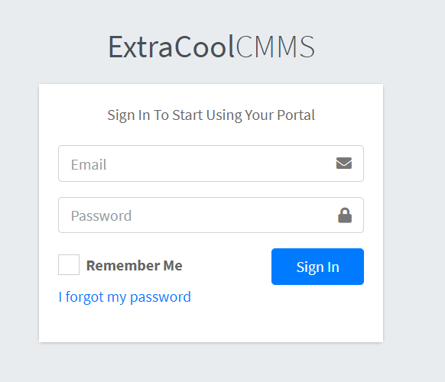

Figure 1: Login Page

## 3.2 Home Page

After you’ve logged in you will be redirected to the home page of the website, see Figure 2. In this figure the logged in user is ad admin so the view is different and he can access different data.

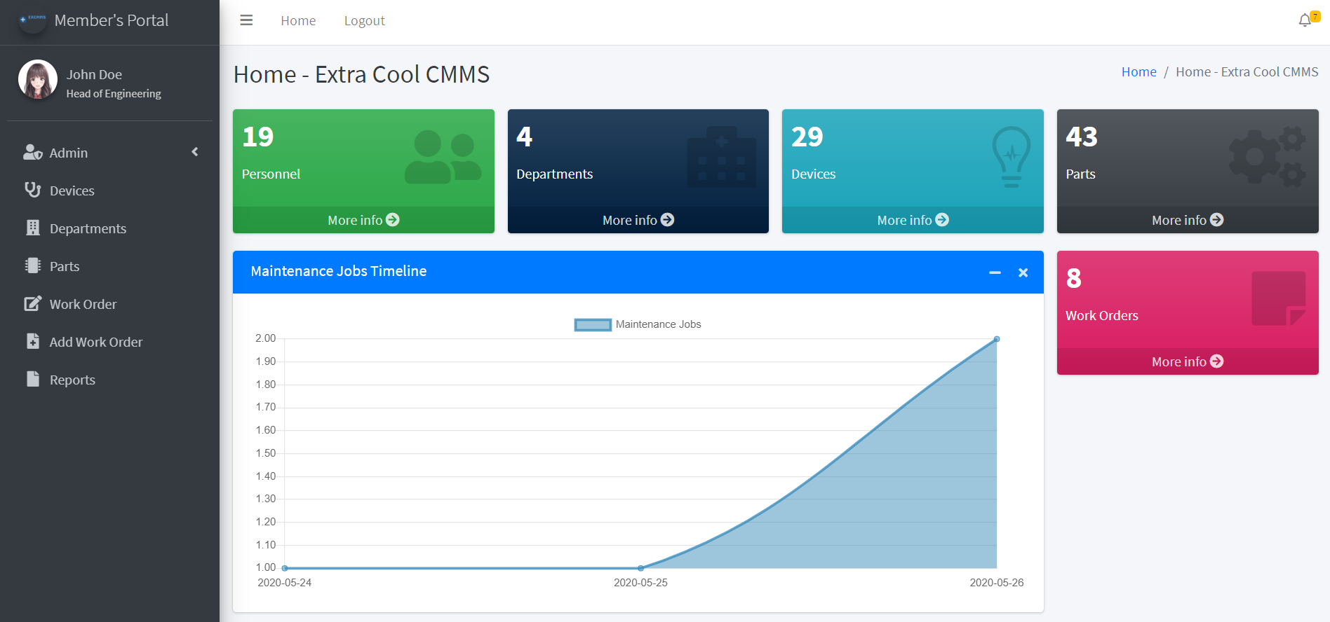

Figure 2: Home Page – Admin

In the home page you could see some information about each part of the database such as the users, departments, devices, parts and the work orders. These data are related to each other and connected together i.e. each department has some devices and each device is formed of some parts.

## Data Tables

In the following figures you could see each table of the data we added in the database, as we mentioned above, we’re now logged in as an admin, so you would see an option for the adding or deleting operation. We added some features to each table such as searching, sorting and panning for more flexibility and user experience.

### 3.3.1 Departments Data

There are four departments in this database as it’s a beta version as you could see in Figure 3.

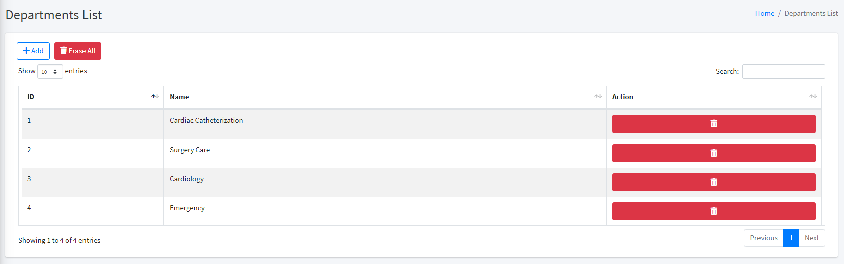

Figure 3: Departments Table

### 3.3.2 Users Data

The users list is divided to 3 types, an admin, an engineer and a technician, see Figure 4. The admin can access more data and make different actions that the engineer or the technician can’t do it such as adding a new department, device and part. And only the admin can perform a delete operation to an existing data.

As you see in the figure, each user belongs to one department and has a certain role.

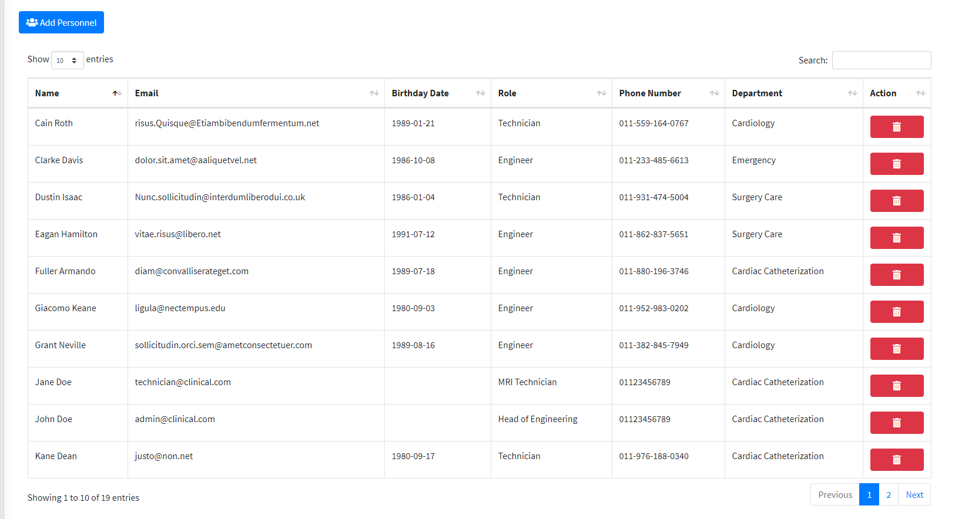

Figure 4: Users List

### Devices Data

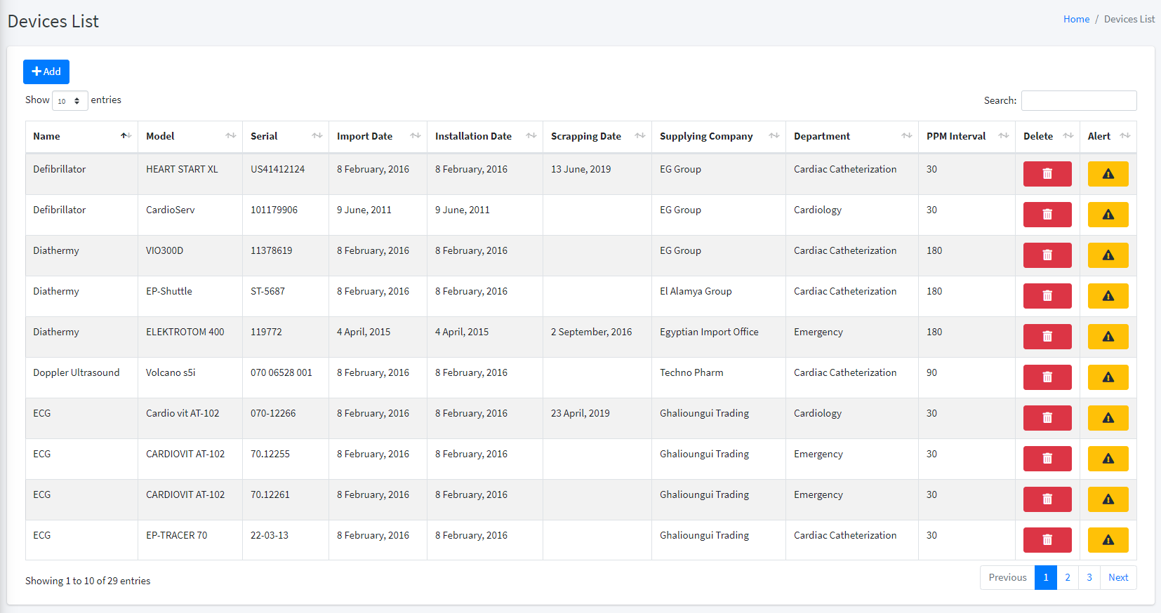

Figure 5: Devices Table

Each device has some important data we need for generating the required reports. The warning icon purpose is to make an alert on this device when any problem occurs to this device or if sudden failure happens. After executing this alert, a new notification would appear in the notifications badge.

## Notifications System

After generating a work order, a notification would appear in the notifications badge. Each work order has a certain type such as ‘**Repair’**, ‘**PPM’** and ‘**Daily** **Inspection’**. After creating some work orders:

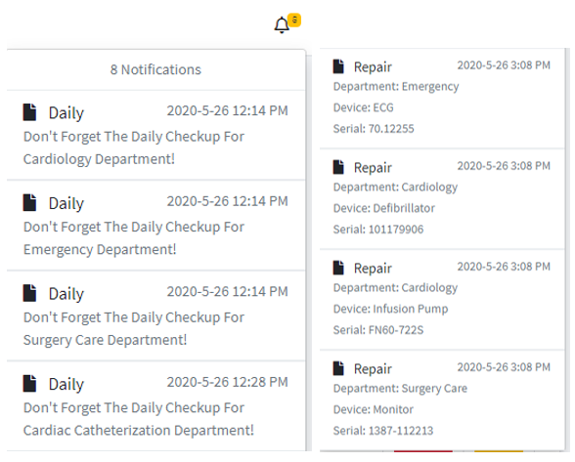

Figure 6: Notifications Bar

When you click on this notification you would be redirected to a form for creating a new work order on this device with the associated report type in the notification.

## Creating Work Order

Each work order has different form to fill it with the needed data. You will be redirected to the specific form depending on the type of work order, as you saw previously in the notifications bar, the type of the work order is displayed with some useful data such as department and device names.

### 3.5.1 Repair Type

For the ‘repair’ type, the form of creating its work order is shown in Figure 7. The department, device and user names are automatically filled after clicking on the notification.

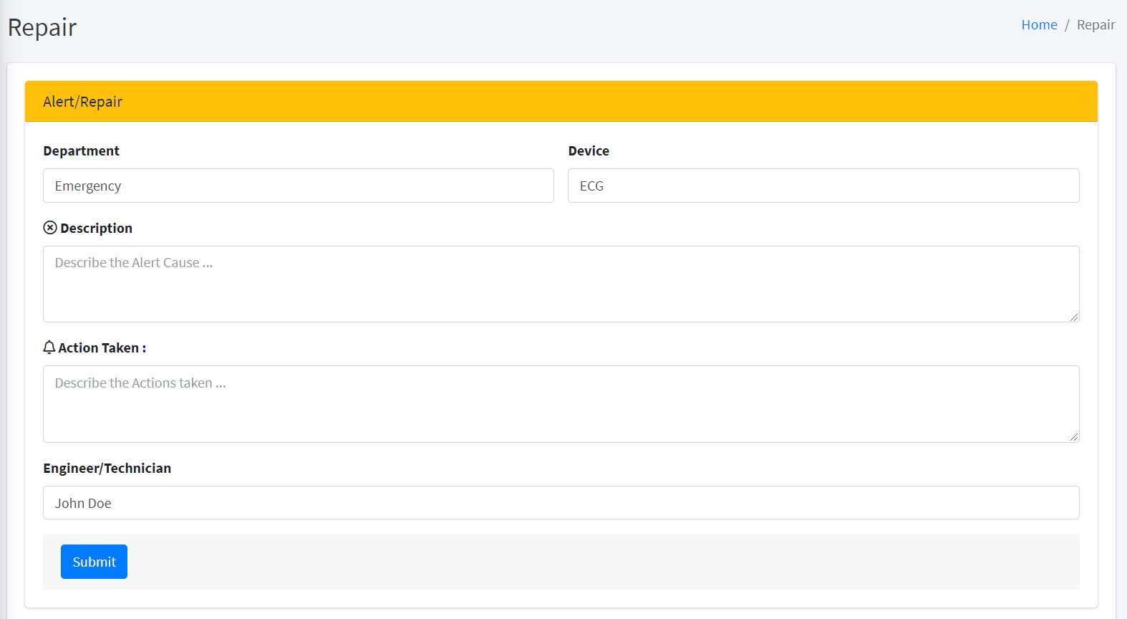

Figure 7: Repair Work Order

The user can fill this form with the required information and describe the work order and what he have done.

### 3.5.2 Daily Type

For the ‘repair’ type, the form of creating its work order is shown in Figure 8. In this case it’s for all the devices in The user

After submitting the form, a new work order has been generated and recorded in the database successfully. Here is a list of some recorded work orders that we have made, see Figure 8.

# Results